National Park Service  U.S. Department of the Interior | Zion National Park  March 2015  Use the complete site name here (e.g. Palo Alto Battlefield Historic Site). |  | Springdale, Utah 84767  435 772-3256 phone  435 772-3426 fax  www.nps.gov/zion
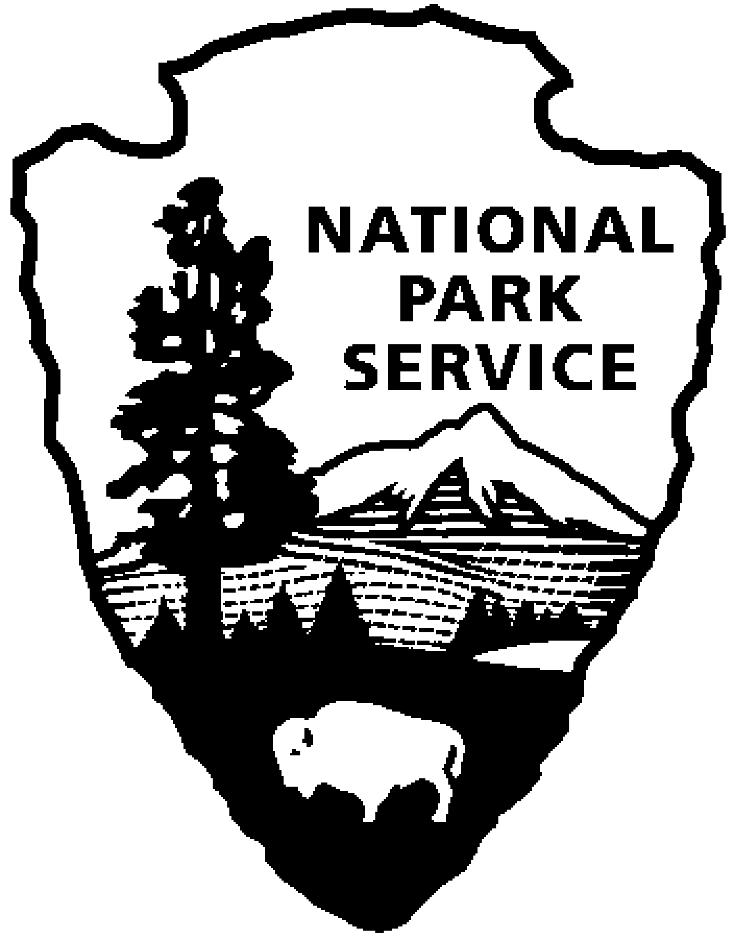
Zion National Park Fire Management
Use a “short-hand” version of the site name here (e.g. Palo Alto Battlefield not Palo Alto Battlefield National Historical Site).
Zion Fire Facts

Park Overview
Zion encompasses 148,016 acres, of which 132,615 acres (90%) is wilderness.

Zion’s perimeter (boundary) is 98 miles, with adjacent lands consisting of 57% Bureau of Land Management, 34.5% private and 8.5% state owned.

There are 3,490 acres of privately held lands (inholdings) within the park, 2% of the total acreage. These occur mostly on the west side of the park, along the Kolob Terrace Road. There are few structures on these inholdings, and few permanent dwellings. The boundaries of these inholdings within the park total 37 miles.

Zion Canyon averages approximately 15” (1928-2011) of precipitation a year. The plateau areas receive more precipitation and in some years get over 10’ of snow during the winter.

Zion has 1,100+ native plants species (the richest diversity in Utah), many of which are adapted to and some that are dependent on fire.

Pinyon pine and juniper woodlands make up the most extensive vegetation type in the park, covering approximately half of the vegetated area. (Harper et. al 2001). Mountain shrub species are the next most common vegetation community.

Most of the large, accessible ponderosa pine trees located on the park’s plateaus were logged in the early 1900’s utilizing the historic Cable Draw Works on Cable Mountain.

Zion is listed as a Class I airshed area under the Clean Air Act. This designation permits the least degradation of air quality related values, including smoke from wildland or prescribed fires.

Fire History
A fire history study conducted within the park found wildland fire to be significant only above 6,500 feet in elevation. Fire was too infrequent in pinyon-juniper woodlands to warrant detailed research at the time (West and Loope 1977).

Prior to 1882, in ponderosa pine stands, fire frequency was 3-25 years (4-7 years on average for Horse Pasture Plateau) (Madany and West 1981) and fires were typically small in size – averaging 8 acres (West and Loope, 1977). This frequency declined from settlement in 1862 to 1926, and from NPS fire suppression from 1926 on.

Wildland fires were rare after 1882, 45 years before any active fire control program. Livestock grazing (both cattle and sheep) was the primary factor in decreasing fire frequency. Fire suppression was a secondary factor and has increased the crown fire potential.

Grazing eliminated fine fuels such as grasses and forbs, which are the primary carriers of low intensity surface fires. This led to an overall increase in unpalatable woody vegetation and shrub density and lower fire frequency. Shrubs and small trees create a fuel ladder that allows for the spread of more fast moving, high intensity crown fires rather than lower intensity surface fires.

Most known fires in the park are lightning-caused above 6,500 feet in ponderosa pine stands. There have been few large fires in pinyon-juniper ecosystem, with the last major ones around 160 years ago (West and Loope, 1977). The major exception to this was the 2006 Kolob Fire which burned 10,516 acres in the park, with the majority of this acreage in the pinyon-juniper vegetation community.

From 1965 - 2015 there have been 598 wildland fires in Zion that burned 38,865 acres. Of these fires, 80% were lightning-caused, burning 26,176 acres and 20% were human-caused fires that burned 12,701 acres.

In the last 45 years, Zion has averaged approximately12 wildland fires annually.

Only 2% of the wildfires in park history account for the majority of acreage burned.

From 1965-2015, there have been 28 management ignited prescribed fires (Rx) in the park that treated 16,700+ acres. The largest was the Clear Trap Rx in 2004 that treated 4,416 acres.

90% of the fires occur May-October, with a peak in early July to late August. Fires can and have occurred in every month of the year.

Through 2015, the most acreage burned in the park in one year was 2006 when 24 wildland fires burned 10,793 acres (10,516 of these acres were from the Kolob Fire).

The most active fire year in the park was 2001, when 35 wildland fires burned 1,237 acres. There were 23 days that had fire starts and one day alone had 6.

The largest fire in the park’s history was the Kolob Fire. It was a human caused fire (undetermined source) that began on June 24, 2006. It burned a total of 17,632 acres of which 10,516 acres were in the park. Its effects were unprecedented and altered the landscape on a large scale. It was the first large fire recorded in the pinyon-juniper ecosystem of the park since European settlement. The fire was driven by a combination of fuel accumulation, encroachment of cheatgrass and strong winds.

Approximately 25% of the total reported fires in the park have occurred on Horse Pasture Plateau, including two of the largest in the park’s history, the Wildcat Fire (7,917 acres, 1996) and the Hiker Fire (1,325 acres, 1988). The second highest percentage (12%) is in the northeast area of the park.

Prior to 1985, all wildfires in the park were suppressed as soon as possible.
Zion’s first major prescribed fire (the 500-acre East Boundary Rx) was ignited in October of 1992. There had been smaller ones in 1980’s dealing with exotic plant and fuel debris burning.

Fire Management
Zion’s first Fire Management Plan (FMP) was completed in 1985 and revised in 1993. The current FMP and Environmental Assessment were completed in the spring of 2005. The current FMP allows for Zion to be able to manage wildfires for both resource and protection objectives based upon values at risk, both public and private. These management options can range from full suppression to allowing the fire to perform its natural role in the ecosystem if there are no values at risk. Prescribed fire (management ignited fire) and mechanical treatments may also be used to manage the park’s natural landscape. A wildfire may be concurrently managed for one or more objectives and these can change as the fire moves across the landscape.

Zion is divided up into four types of fire management areas; suppression, conditional, natural and modified. Management decisions regarding wildfires are determined based on which fire management area the fire is burning in and the values at risk. A risk assessment is conducted on each fire based on factors including location, size, time of season, weather conditions, fire danger and potential fire behavior.

Largest Wildland Fires in Zion NP
Fire Year Acres
Kolob# 2006 10,516 (plus 7,116 acres out of park)
Wildcat 1996 7,917
Dakota Hill Complex+ 2007 5,848 (plus 3,230 acres out of park)
Horse 2009 2,110
Hiker# 1988 1,325
Subway 2010 966
Oak Road 1982 800
Langston 2001 610
Wynopits 2001 595
Rerun 1986 427
Stinker 1999 415
Timber Top 2003 365
Cliffs 2009 306
Big 1991 280
Fire Pit 1986 280
Mt. Majestic 2006 249
Coal Pits 2005 244

# - Human-caused
+ - Two main fires (East and West)

