Zion National Park News Release

Zion National Park

State Route 9

Springdale, UT 84767

435-772-3256

www.nps.gov/zion

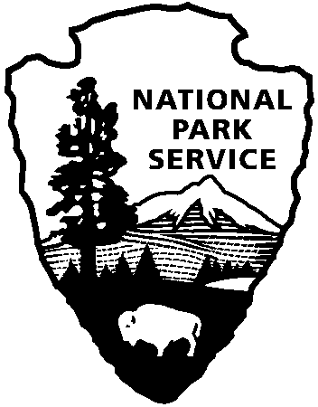

National Park Service

U.S. Department of the Interior

For Immediate Release

David Eaker 435-772-7811

August 31, 2011

11-24

Trails in the Kolob Canyon Section of Zion National Closed Due to Wildfire

All trails in the Kolob Canyon section of Zion National Park have been closed due to threats from a wildfire in the area. Kolob Canyons is the northern section of the park and is located just off I-15 approximately 15 miles south of Cedar City, UT. This precautionary closure includes all the trails in that area and others that lead into it. The decision to close the trails was made to ensure the safety of hikers that may be using or planning to use the trails. Trails that are closed at this time include the LaVerkin Creek Trail, Hop Valley Trail and the Timber Creek Overlook Trail.

The Toquerville Falls Fire is located on Black Ridge near Toquerville Falls, on Bureau of Land Management lands, north of Toquerville, Utah. The lightning caused fire is currently estimated at 150 acres and is burning in a north/northeastern direction toward the park. The fire is being pushed by gusty winds up to 40mph. Due to its remote location, the fire is being suppressed using aerial resources at this time including three helicopters and three Single Engine Air Tankers (SEATS). Firefighters will need to be taken into the incident by helicopter as there are no roads nearby. There are no immediate threats to structures or property at this time.

The Kolob Canyons Scenic Drive and Visitor Center will be open tomorrow unless the fire poses a safety risk to visitors.

A Red Flag Warning for high temperatures, low humidity and gusty winds of up to 30-40 mph has been issued for tomorrow by the National Weather Service.

More information on the fire and closures will be coming out tomorrow morning as it becomes available.

-NPS-