National Park Service  U.S. Department of the Interior | Zion National Park  Use the complete site name here (e.g. Palo Alto Battlefield Historic Site). |  | Springdale, Utah 84767  435 772-3256 phone  435 772-3426 fax  www.nps.gov/zion
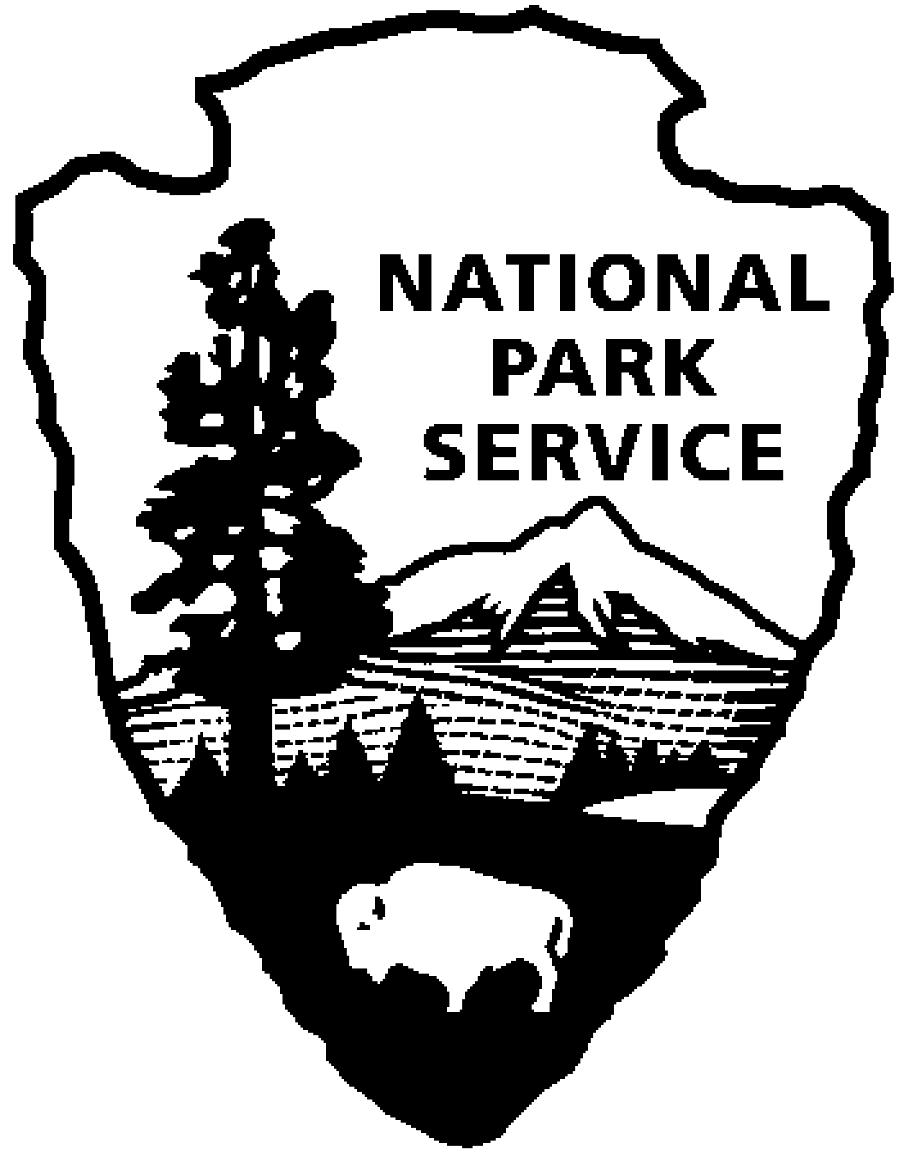
Zion National Park News Release
Use a “short-hand” version of the site name here (e.g. Palo Alto Battlefield not Palo Alto Battlefield National Historical Site).
May 11, 2011
For Immediate Release
David Eaker 435 772-7811
11-15

Prescribed Fires Planned in Zion Canyon

Zion National Park will be implementing a series of four small prescribed fires totaling 50 acres this spring in Zion Canyon. The first of these burns is planned in the vicinity of park headquarters on or after May 15. The exact dates of the burns will depend on predicted weather conditions and current fuel conditions. The primary objectives of these burns are to reduce the amount of exotic vegetation and their associated fire hazard, thus providing safety to park visitors, staff and park infrastructure, while simultaneously restoring native perennial grasses. These fires will only be ignited if favorable weather conditions exist and required firefighting personnel are available. Short-term impacts from these prescribed burns may include smoky conditions, temporary traffic control measures in the vicinity of the burn units and temporary trail closures along portions of the Parus Trail.

In recent years, Zion Canyon has seen a number of exotic, annual grasses (mainly cheatgrass and ripgut brome) take over and out compete the native perennial grasses that once covered the area. Because these fine, flashy exotic grasses cure late in the spring, they represent a considerable fire danger throughout the summer. The reduction of these exotic grasses by prescribed fire will help to reduce the fire danger in Zion Canyon and also provide the native grasses an opportunity to re-establish themselves.

The goal of the prescribed fire program in Zion is to use management-ignited prescribed fire, where appropriate, for the restoration of fire-dependent ecosystems and species-specific resource management goals. Prescribed fire projects are to be conducted in a manner consistent with land and resource management plans, public health considerations, and approved prescribed fire plans. The policy of using fire as a tool will help decrease risks to life, property, and resources and will help perpetuate the natural resource values for which Zion National Park was established.

For more information about these prescribed fires or other fire management projects in Zion, call 435-772-7811 or visit our website at http://www.nps.gov/zion/naturescience/fire-management-homepage.htm

-NPS-

