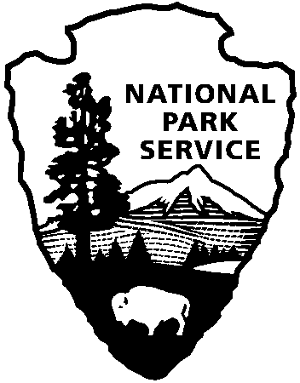**Commercial Use Authorization Application Questions**

**Concessions Management Office**

**P.O. Box 168**

**Yellowstone Park, WY 82190**

**(307) 344-2320 phone**

**(307) 344-2279 fax**

***Business Name:***

***Contact Name:***

**CUA Activity and Tour Specific Information**

1. Describe in detail the type of activities will you be offering during your tours within Yellowstone? [attach diagram, attach additional pages, if necessary; include locations within the park, frequency, estimated number of participants (per trip and annually), number of vehicles, support equipment (trailers, generators, etc.)]
2. Which areas of the park will you visit during your tours?
3. Which seasons will you operate in the park? (Please note your last trip date)
4. Approximately how many clients will you bring into the park in a single trip?
5. Approximately how many trips will you bring into the park each year?
6. Will you prepare or provide prepared food for your clients?
7. If you provide food, please answer the following questions. (**Please be aware that Food Handler’s Certification is required for guides as specified in the Yellowstone Special Park Conditions of the CUA 10-115.**)
   * Who is preparing the food (owner/guide or commercial kitchen)?
   * Where is the food prepared?
   * How will you transport the food on trip days?
   * How will you ensure that food is being prepared and/or transported in a safe manner to ensure that time and temperature requirements are followed?

**Administrative Requirements** – Please submit the items below to the Concessions Management Office to complete your CUA application packet. Applications are accepted year-round, but must be submitted 45 days prior to your first trip in the park.

* **CUA Application**
* **Application Questions**
* **Proof of payment for application fees through** [**www.pay.gov**](http://www.pay.gov)
* **Accord certificate showing proof of commercial general liability insurance**
* **Accord certificate showing proof of automobile insurance (if transporting clients or using a vehicle to provide a service within the park)**
* **Risk Acknowledgement Form (if you require clients to sign one)**

Applications must be submitted via email to: [yell_cua_admins@nps.gov](mailto:yell_cua_admins@nps.gov).