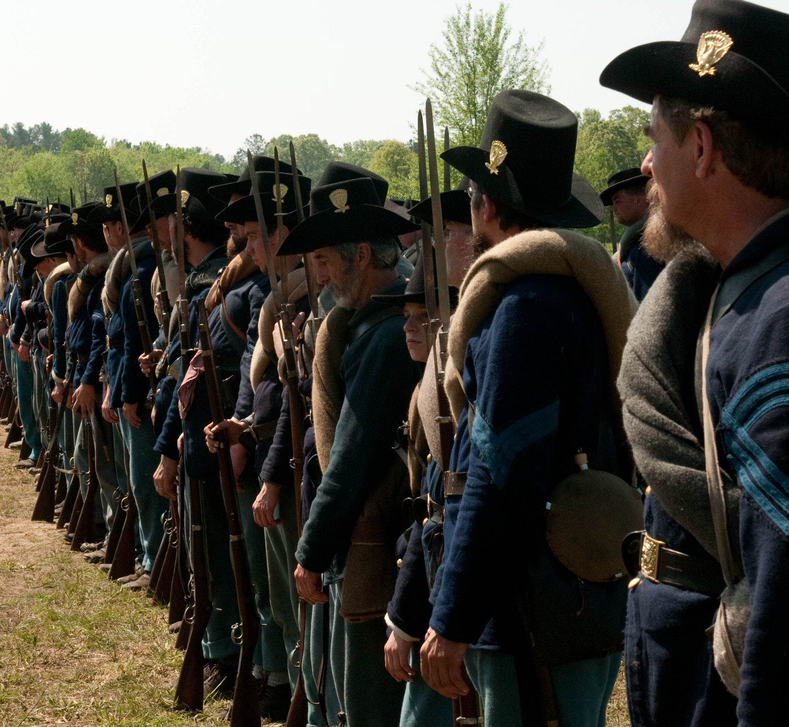
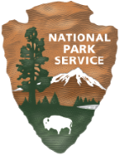
National Park Service | Department of the Interior

Accessibility Self-Evaluation and Transition Plan

WILSON’S CREEK

NATIONAL BATTLEFIELD | MISSOURI

SEPTEMBER 2018

EXECUTIVE SUMMARY
Wilson’s Creek National Battlefield’s Accessibility Self-Evaluation and Transition Plan (SETP) includes findings from the self-evaluation process, as well as a plan for improving accessibility parkwide. The Accessibility Self-Evaluation and Transition Plan resulted from the work of an NPS interdisciplinary team, including planning, design, and construction professionals; and interpretive, resource, visitor safety, maintenance, and accessibility specialists. Site plans, photographs, and specific actions for identified park areas were developed. Associated time frames and implementation strategies were established to assist NPS park staff in scheduling and performing required actions and to document completed work. Park policies, practices, communication, and training needs were also addressed. The goals of the plan are to 1) document existing park barriers to accessibility for people with disabilities, 2) provide an effective approach for upgrading facilities, services, activities, and programs, and 3) instill a culture around creating universal access.
The following are the key park experiences and associated park areas addressed in the transition plan:
Learn about events related to the Battle of Wilson’s Creek and understand the role the battle played in the Civil War. – Bloody Hill Trail, Ray House and Trail, Ray Springhouse and Trail, Stop #1, Stop #2, Stop #3, Stop #5, Stop #6, Stop #7, and the Wilson’s Creek National Battlefield Visitor Center.
Tour major points on the battlefield. – Bloody Hill Trail, Ray House and Trail, Ray Springhouse and Trail, Stop #1, Stop #2, Stop #3, Stop #5, Stop #6, and Stop #7.
Reflect on the impacts of war and tragedy of loss in a preserved rural park setting that is much the same as at the time of the battle. – Bloody Hill Trail, Ray House and Trail, Ray Springhouse and Trail, Stop #1, Stop #2, Stop #3, Stop #5, Stop #6, and Stop #7.
View museum collections, exhibits, artifacts and media. – Bloody Hill Trail, Ray House and Trail, Ray Springhouse and Trail, Stop #5, Stop #6, Stop #7, and the Wilson’s Creek National Battlefield Visitor Center.
Research extensive library materials and collections related to the Civil War in the Trans-Mississippi West. – Wilson’s Creek National Battlefield Visitor Center.
Enjoy passive recreation opportunities such as wildlife viewing, picnicking, horseback riding, jogging, hiking, and biking. – Bloody Hill Trail, Picnic Area Stop #1, Stop #2, Stop #3, Stop #5, Stop #6, Stop #7.
Overall, similar services, activities, and programs were found throughout park areas, as were assessment findings for physical and program accessibility.

Physical Accessibility
Recurring barriers to physical accessibility were generally identified for parking areas, accessible paths of travel, outdoor recreational access routes, and visitor information areas, such as wayside panels and trailhead signage. These findings included slopes that exceeded maximum requirements, a lack of clear ground space in front of waysides and alongside benches, and items located out of reach range. Some restroom features did not meet required standards, and mechanisms to open trash and recycling receptacles were not operable with a closed fist. Amenities offered for picnicking such as tables, grills, and drinking fountains did not always meet appropriate access route and clearance standards and failed to meet required dimensions for accessibility.
Other physical access issues where improvements are recommended include providing designating signage at accessible car and van parking, slope corrections in accessible parking stalls, and providing accessible routes through historic buildings such as the Ray House. Upgrades are also necessary at information desks, meeting/community spaces, and for the research library services that are offered. Particularly important trails such as the Bloody Hill Trail require simple modifications to improve accessibility such as firming up surfaces, removing obstacles, and providing clear ground space to access waysides along the way. Assessments for trails not specifically identified in this plan will need to be conducted in the future. Refer to Appendix H: “Trail Assessment Protocol” for additional information on how hiking trails are assessed and what standards apply.

Program Accessibility
Reoccurring findings related to programmatic accessibility included font and contrast issues at interpretive waysides that require modifications to meet font type and readability standards. In general, interpretive panels, waysides, and publications did not have alternate formats in braille, large print, open captioning, or audio or electronic formats. While assistive listening devices are available, park staff lack standards for maintenance, and handing out and retrieving the devices to visitors. Audio description for ranger-led interpretive tours and self-guided tours that describe visual elements to persons with low or no vision were also not available. Tactile exhibits were limited.
Specific program areas would better serve visitors with increased accessible formats such as upgrades to exhibits and programs at the visitor center. Complicated elements of the battle including tactical movements and positioning could greatly benefit from the use of tactile maps and maps that use more contrasting imagery as opposed to colors such as reds and greens, which cause contrast issues for visitors who are colorblind. The accessibility page of the park website could be improved to provide more information on physical conditions of trails and park areas, available alternative formats for park programs, and information for visitors on how to request sign language interpreters.

Parkwide Accessibility
Some of the more noteworthy parkwide accessibility challenges that were discussed by the planning team during the self-evaluation and assessment process include: providing accessible paths of travel in culturally sensitive areas, providing clear ground space in front of services offered throughout the park, and providing alternative formats for interpretive information allowing visitors to have a rich and independent experience.
It is recommended that the park employ trained consultants to assist in determining how best to address accessibility improvements parkwide and to ensure that design and implementation of alternate format programs meet the needs of the intended audiences. Notify visitors through signage placed in appropriate locations and in park publications that alternative formats are available.
Creating parkwide accessibility requires staff awareness, understanding, and appropriate action. The assessment process served as a field training tool that increases staff knowledge and commitment toward embracing accessibility as a core park value. Continued training in physical and programmatic access requirements for all park staff, particularly those in maintenance and interpretation, is strongly advised.
Because of fiscal constraints and limited park resources, staff will need to determine which park area improvements will benefit the greatest numbers of park visitors with disabilities. Suggested implementation time frames and relative costs need to be factored into all accessibility investment decisions.
Wilson’s Creek National Battlefield strives to be inclusive and welcoming. With the majority of sites being accessed along the tour road, the park has focused on making those experiences not only physically accessible, but also programmatically accessible through the development of a cell phone tour. With the exception of periodic trail segments with slope or surface concerns, most trails are substantially accessible. With that said, trail segments that do contain barriers need their conditions to be better communicated so that individuals can determine for themselves if those barriers are within their ability to overcome. Park staff is aware of accessibility issues in their services, activities, and programs and are committed to making improvements that will accommodate a wider diversity of visitors.

This page intentionally left blank.

CONTENTS
EXECUTIVE SUMMARY 3
Physical Accessibility 4
Program Accessibility 4
Parkwide Accessibility 5
INTRODUCTION 11
Park Description 12
Park Purpose and Significance Statements 14
Park Purpose 14
Park Significance 14
Accessibility Self-Evaluation and Transition Plan 14
Implementation of the Plan 15
ACCESSIBILITY SELF-EVALUATION AND TRANSITION PLAN PROCESS 17
Self-Evaluation 17
Step 1: Identify Key Park Experiences and Park Areas 17
Step 2: Identify Park Areas to be Assessed 18
Step 3: Identify Services, Activities, and Programs in Each Park Area 18
Step 4: Conduct Accessibility Assessment 18
Transition Plan 19
Step 5: Draft and Finalize Transition Plan 19
IMPLEMENTATION STRATEGY FOR Wilson’s Creek National Battlefield 21
Park Areas Assessed 21
Iimplementation Strategy for Park Areas Assessed 23
Bloody Hill Trail 24
Site Plan 24
Implementation Strategy 25
Ray House and Trail 28
Site Plan 28
Implementation Strategy 29
Ray Springhouse and Trail 32
Site Plan 32
Implementation Strategy 33
Stop #1 36
Site Plan 36
Implementation Strategy 37
Stop #3 40
Site Plan 40
Implementation Strategy 41
Stop #5 44
Site Plan 44
Implementation Strategy 45
Stop #6 48
Site Plan 48
Implementation Strategy 49
Stop #7 50
Site Plan 50
Implementation Strategy 51
Visitor Center Picnic Area 54
Site Plan 54
Implementation Strategy 55
Visitor Center 60
Site Plan 60
Implementation Strategy 61
Wilson’s Creek National Battlefield Policies, Practices, Communication, and Training 68
Park Features 68
Implementation Strategy 69
Posting and Publications 69
Staff Training and Park Protocols 69
Audio and Visual Programs 71
Visitor Information 72
Concessions and Partnerships 72
CONCLUSION 73
Appendix A: Accessibility Laws, Standards, Guidelines, and NPS Policies Applicable to Wilson’s Creek National Battlefield 75
Appendix B: Glossary of Terms 86
Appendix C: Contributors 89
Appendix D: Park Areas Not Assessed 90
Appendix E: Actions Taken by the Park 92
Appendix F: Guidance for Preparing PMIS Packages for Accessibility Improvements 93
Appendix G: Trail Summary Sheets 95
Appendix H: Trail Assessment Protocol 97

This page intentionally left blank.

INTRODUCTION
Since 1916, the National Park Service (NPS) has preserved, unimpaired, the natural and cultural resources and values of the national park system, while also providing for the enjoyment, education, and inspiration of current and future generations.
Many of our national parks were founded because of their stunning views, extreme and unique geography, challenging and sensitive natural environments, and historic and fragile structures. This park, Wilson’s Creek National Battlefield, and other parks exist because of their history and resources. The NPS mission balances protection of resources (both natural and cultural) with visitation. Facilities, services, activities, and programs were designed and built within parks to accommodate our visitors and help them better understand each park purpose and significance.
Many facilities were constructed prior to the passage of laws and policies that reflect the commitment of the National Park Service to provide access to the widest cross section of the public, and to ensure compliance with the Architectural Barriers Act of 1968, the Rehabilitation Act of 1973, the Equal Employment Opportunity Act of 1972, and the Americans with Disabilities Act of 1990 (42 USC 12207). The accessibility of commercial services within national parks is also governed by all applicable federal laws. After 100 years of operation, the National Park Service continues to work toward a more inclusive environment. The more than 400 park units that comprise the national park system today include not only the large western parks, for which the agency is well known, but also nationally significant urban parks, historic sites, monuments, parkways, battlefields, and a diversity of other park types across the country.
For a century, the National Park Service has been a leader in connecting people to both our natural and cultural heritage. Visitors today have different needs and expectations, and the agency must adapt to meet these changing demands. Modern scientific research and visitor trend analysis provide new insight into accessibility opportunities and challenges in the national park system. There are approximately 60 million people with disabilities in the United States today, and the number is expected to rise to 71 million in upcoming years as more baby boomers reach retirement age (people 65 and older). This information helps the National Park Service understand changing visitation patterns, the nexus between resource stewardship and accessibility, and the impacts of managing visitors, resources, and infrastructure against the threat of decreased funding. Adequate planning can identify solutions to challenges and provide services with the knowledge and understanding that serves as a trajectory full of opportunity for current and future visitors. The National Park Service is committed to making NPS facilities, programs, services, and employment opportunities accessible to all people, including those with disabilities.

Park Description
Wilson’s Creek National Battlefield is approximately 10 miles southwest of Springfield, Missouri, in Greene and Christian Counties. The park was established on April 22, 1960, to preserve and commemorate the site of the Battle of Wilson’s Creek, the second major battle of the Civil War and the first major battle west of the Mississippi River. The area where major military operations took place west of the Mississippi River is known as the Trans-Mississippi Theater of the Civil War. On August 10, 1861, 5,400 Union troops under the command of General Nathaniel Lyon clashed in a brutal fight with 12,000 Confederate and Missouri State Guard soldiers under Generals Benjamin McCulloch, Nicholas Pearce, and Sterling Price. The casualties were about equal on both sides—1,317 Union and 1,222 Confederate, and included General Lyon who was the first Union general killed in battle. Although the Union lost the Battle of Wilson’s Creek, its defeat signaled that Union reinforcements were desperately needed to prevent Missouri’s total fall to the Confederacy. The decisive Union victory at Pea Ridge on March 7–8, 1862, ended any serious Confederate threat to Missouri for the next two years, and this victory by Union forces was, in part, the result of lessons learned at Wilson’s Creek. The war in the Trans-Mississippi Theater was characterized by brutal small-scale battles, complex logistical challenges due to the undeveloped condition of the region, and vicious guerilla warfare. Missouri ranks third in the number of Civil War military actions within its border.
Wilson’s Creek National Battlefield encompasses 2,369 acres and preserves 2,011 acres of the battleground; 172 acres are protected by Ozark Greenways, Inc., in easement outside park boundaries. Most visitors drive along the 4.9-mile tour road and stop at the eight pullouts featuring the major historic points of the battle. Many visitors bicycle around the tour road or spend time walking or horseback riding on the trails in the park. Although many of the park’s 50 known archeological sites are associated with the battle, more than half date to pre-European contact. The park preserves cultural landscapes and historic Civil War-era structures including the Ray House, a 19th-century home that was used as a field hospital and where General Lyon’s body was taken after the battle.
The Wilson’s Creek National Battlefield’s Civil War Museum is home to one of the finest publicly held museum collections and contains the nation’s largest archival and materials collections related to the Civil War in the Trans-Mississippi West. In August 2005, purchase of the Sweeney Museum collections added over 8,500 unique items specific to the Civil War in the Trans-Mississippi West to the park’s extant collection of more than 60,000 items. The outstanding collection includes the sword belt and sash of Arkansas General Patrick Cleburne and the flag of the Confederate Cherokee Braves. The museum collections include objects and documents from many of the Trans-Mississippi battles. The collections also contain objects from prisoner-of-war camps in which Trans-Mississippi soldiers were detained and perished, items documenting battlefield medicine and advances in treatment, objects and documents that provide a greater understanding of the role of women in the Civil War, and items documenting the naval aspect of warfare in the Trans-Mississippi Theater. One-of-a kind pieces related to the battle include items such as General Lyon’s presentation sword and scabbard, the Lyon bed, and the counterpane used to cover Lyon’s body. The main battlefield library collections contain more than 11,000 volumes and extensive primary documentation.
Interpretation and education at Wilson’s Creek National Battlefield are based on what is symbolically described as a “three-legged stool”— the cultural landscape that is one of the finest preserved battlefields in the national park system, the finest Trans-Mississippi library collection in the United States, and the finest collection of Trans-Mississippi artifacts in the United States. Researchers contact the park weekly requesting information as they research their topics on the Trans-Mississippi Theater. During the past 12 years, the Wilson’s Creek National Battlefield Foundation has assisted with construction of a new library wing, the addition of acres purchased or protected through conservation easements, and the purchase of the Sweeney Collection.
Interpretation and visitor services are centered at the visitor center, which offers a 30-minute film overview of the battle, permanent exhibits of the battle and the war in the Trans-Mississippi Theater, a gift shop, rotating interpretive exhibits, and a multipurpose room that is frequently used for special programs and interpretive exhibits. The Ray House, open for tours when staff is available, offers an opportunity to interpret the role of the house as a field hospital for the battle wounded, slavery, and the experience of civilians caught up in the conflict. Interpretive wayside exhibits are placed at the tour road pullouts and along the Bloody Hill interpretive trail. A Junior Ranger program is offered.
Educational programs, offered primarily in the spring, include programs on the life of the average soldier, Civil War medicine, tours of the Ray House, historic weapons firing programs, and special events. Due to the park’s location near a significant urban area, it has the potential to provide educational programs to schools through on-site visits and outreach services. Although serving as a memorial to the battle, the park also is a place where nature can be enjoyed by cyclists, walkers, equestrians, and runners who use the tour road and 10.6 miles of trails, including the historic Wire Road. With Springfield’s population expected to increase 40% by 2020, Wilson’s Creek National Battlefield may increasingly serve as a natural and recreational oasis. The park also is a sanctuary for wildlife and plant life disturbed by human encroachment including two federally threatened species and an endangered species.
Wilson’s Creek National Battlefield is a member of the Climate Friendly Parks program, a network of parks nationwide that are putting climate friendly behavior at the forefront of park operations and resource management. Wilson’s Creek National Battlefield is committed to implementing a sound environmental management program and demonstrating environmental leadership in the preservation and conservation of the park’s cultural and natural features. This commitment includes energy, water, solid waste, chemical use, and greenhouse gas emissions reductions (collectively called sustainability).

Park Purpose and Significance Statements
In 2017, Wilson’s Creek National Battlefield completed a foundation document. Foundation documents provide basic guidance for planning and management decisions by identifying the park purpose, significance, and fundamental resources and values. The Wilson’s Creek National Battlefield foundation plan identifies special mandates and administrative commitments and provides an assessment and prioritization of park planning and data needs. Understanding these elements helps set the stage for appropriately integrating accessibility into the overall park priorities and plans. The following foundation elements were identified for Wilson’s Creek National Battlefield.

Park Purpose
The purpose of Wilson’s Creek National Battlefield is to commemorate the Battle of Wilson’s Creek, preserve the associated battlefield, and interpret the battle within the context of the Civil War in the Trans-Mississippi West.

Park Significance
- The Battle of Wilson’s Creek was the second major battle of the Civil War and the first major battle west of the Mississippi River.

- Wilson’s Creek National Battlefield was the site of the death of General Nathaniel Lyon, the first Union general killed in the Civil War. Lyon’s death focused national attention on the potential loss of Missouri to the Confederacy.

- Wilson’s Creek National Battlefield’s comprehensive cultural landscape and rural character evoke the setting at the time of the battle that allows for interpretation and understanding of the events.

- Wilson’s Creek National Battlefield’s extensive research library, archives, and museum collections represent a nationally prominent and in-depth record of the battle and the Civil War in the Trans-Mississippi West.

Accessibility Self-Evaluation and Transition Plan
The creation of a transition plan is mandated by regulations under the Rehabilitation Act of 1973, as they apply to the US Department of the Interior, which states that “No otherwise qualified handicapped individual in the United States . . . shall, solely by reason of his handicap, be excluded from participation in, be denied the benefits of, or be subjected to discrimination under any program or activity receiving federal assistance.” It specifically requires parks to document architectural barriers, solutions, and time frames for making improvements to increase accessibility.

This Accessibility Self-Evaluation and Transition Plan has been prepared to provide Wilson’s Creek National Battlefield a tool for addressing overall needs associated with making the park accessible when viewed in its entirety. The plan is based on an understanding of key park experiences and establishes a methodical process that identifies, prioritizes, and outlines improvements to park accessibility. The plan proposes strategies for implementation over time and in a manner consistent with park requirements and protocols.
All key park experiences and all park areas were identified to ensure that the plan would consider all park programs. Park areas were then evaluated against measurable criteria to determine which would be assessed for purposes of the plan. Each park area assessed was evaluated to identify barriers that prevented participation in park programs, and the best manner in which access could be improved. In some situations, it is not reasonably practicable to create physical or universal design solutions.

Implementation of the Plan
One of the goals of the plan is to increase accessibility awareness and understanding among staff and volunteers of Wilson’s Creek National Battlefield. The park superintendent is responsible for implementing and integrating the plan. The park-designated accessibility coordinator ensures adequate communication to park employees and works with the superintendent to follow up on the implementation and relevancy of the plan by documenting improvements and keeping the plan updated.

This page intentionally left blank.

ACCESSIBILITY SELF-EVALUATION AND TRANSITION PLAN PROCESS

Self-Evaluation
The following graphic illustrates the primary steps in the self-evaluation process. Each step is further described in the following text.
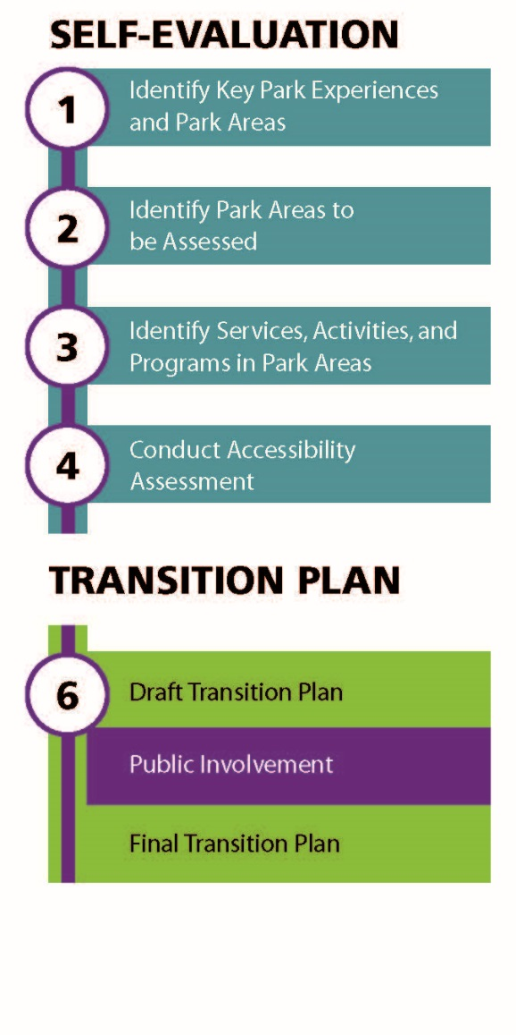

Step 1: Identify Key Park Experiences and Park Areas
Key park experiences are those park experiences that are iconic and important for visitors to understand the purpose and significance of the park unit. They are “musts” for park visitors. Park legislation serves as the foundation for key park experiences, which are identified through park purpose, significance, interpretive themes, and those programs or activities highlighted in park communications. Key park experiences were identified at Wilson’s Creek National Battlefield to ensure that planned improvements were prioritized to best increase overall access to the experiences available at Wilson’s Creek National Battlefield.
- Learn about events related to the Battle of Wilson’s Creek and understand the role the battle played in the Civil War.
- Tour major points on the battlefield.
- Reflect on the impacts of war and tragedy of loss, in a preserved rural park setting that is much the same as at the time of the battle.
- View museum collections, exhibits, artifacts and media.
- Research extensive library materials and collections related to the Civil War in the Trans-Mississippi West.
- Enjoy passive recreation opportunities such as wildlife viewing, picnicking, horseback riding, jogging, hiking, and biking.
After key park experiences were identified, all park areas were listed. Next, a matrix was developed to determine which key experiences occurred in each park area. A park area is a place defined by the park for visitor or administrative use. All park areas within Wilson’s Creek National Battlefield were evaluated per criteria in step 2, to determine which, if not all, areas would be assessed.

Step 2: Identify Park Areas to be Assessed
The criteria below were used to determine which park areas would receive assessments:
- Level of visitation
- Diversity of services, activities, and programs offered in the area
- Geographic favorability (as a whole, the park areas selected reflect a broad distribution throughout the park)
- Other unique characteristics of the site
The areas selected for assessment provide the best and greatest opportunities for the public to access all key park experiences. These park areas received comprehensive assessments as outlined in steps 3 and 4. Areas not assessed at this time are to be assessed and improved as part of future facility alterations or as a component of a future planned construction project.

Step 3: Identify Services, Activities, and Programs in Each Park Area
Step 3 is the identification of all services, activities, and programs within each park area. This process ensured that during step 4 all visitor amenities within a park area, including both physical and programmatic elements, are reviewed for accessibility. The comprehensive lists of services, activities, and programs were the basis for conducting the 10 assessments and documenting all elements as they pertain to improving access to park experiences.

Step 4: Conduct Accessibility Assessment
During step 4, an interdisciplinary assessment team identified physical and programmatic barriers and reviewed possible solutions within each park area.
Existing conditions and barriers to services, activities, and programs were discussed on-site by the assessment team. The assessment team then developed a reasonable range of recommended actions for consideration, including solutions that would provide universal access. Barrier-specific solutions, as well as alternative ways to improve access overall, were addressed and included both physical changes and/or the addition of alternate format methods. In some cases, programmatic alternatives needed to be examined because it was not always possible to eliminate physical barriers due to historic designations, environmental concerns, topography, or sensitive cultural and natural resources. Therefore, a full range of programmatic alternatives was considered that would provide access to the key experience for as many visitors as possible. All field results, including collected data, findings, preliminary options, and conceptual site plans, are organized by park area and formalized with recommendations in the transition plan.

Transition Plan
The following graphic illustrates the primary steps taken in developing the Wilson’s Creek National Battlefield transition plan. Public involvement occurred at the draft stage of the transition plan. The park hosted a public meeting on June 12, 2018 to solicit public involvement and review of the plan. Park staff invited people with disabilities and organizations that represent people with disabilities, to provide comments and thoughts on whether the document represents a reasonable review of the park’s barriers and a feasible and appropriate strategy for overcoming the barriers. There were no comments submitted during the public involvement period and the implementation strategy was finalized. Once finalized, a notification was sent to the public to announce the plan’s availability.
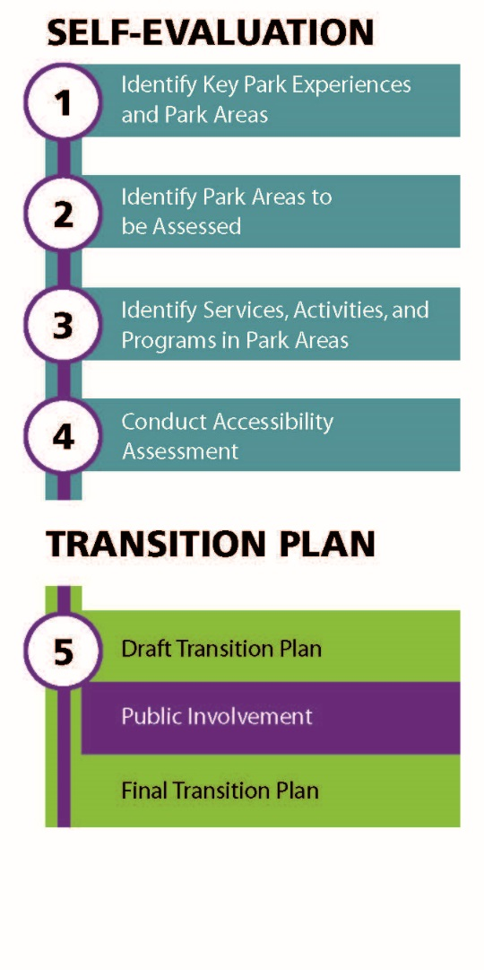

Step 5: Draft and Finalize Transition Plan
The final step of the process is drafting and finalizing the transition plan and implementation strategy. Developing an implementation strategy can be complex because of a large range of coordination efforts associated with scheduling accessibility improvements. All improvement efforts need to consider park activities and operational requirements. The final plan recommends accessibility improvements, identifies improvement time frames, and identifies responsible parties for such actions.
Implementation time frames are based on the park’s ability to complete the improvements within normal scheduling of park operations and planned projects. Time frames are categorized as follows:
- Immediate (0–1 year): Improvements that are easy, quick, and inexpensive to fix internally. It does not require supplemental NPS project funding.
immediate

- Short-term (1–3 years): If the improvement does not require supplemental NPS project funding, park staff will initiate the elimination of the barrier internally; or, if a project is currently scheduled for funding, the improvement will be incorporated into the project and the barrier eliminated.
short-term
- Mid-term (3–7 years): The park will develop a proposal and submit it for those projects requiring supplemental NPS project funding in the next annual servicewide budget call. For those projects requiring supplemental NPS project funding, the park will submit a request in the next budget call. Improvements will be scheduled dependent upon the year funding is received. If the improvement does not require supplemental NPS project funding, park staff will continue the elimination of the barrier internally.
mid-term
- Long-term (>7 years): The park will eliminate the barrier when other work is taking place as part of facility alterations or as a component of a future planned construction project.
long-term

IMPLEMENTATION STRATEGY FOR Wilson’s Creek National Battlefield

Park Areas Assessed
All key park experiences at Wilson’s Creek National Battlefield are represented within the park areas assessed. Park areas not included in the park area list will be upgraded to current code requirements when facility alteration and/or new construction is planned. Each park area identified for assessment is addressed during the implementation strategy exercise. Refer to Appendix D: “Park Areas Not Assessed” for a rationale on why park areas were determined to not be assessed in this planning effort. All park areas assessed are listed in alphabetical order and identified in the associated map below.
- Bloody Hill Trail
- Ray House and Trail
- Ray Springhouse and Trail
- Stop #1
- Stop #3
- Stop #5
- Stop #6
- Stop #7
- Visitor Center Picnic Area
- Visitor Center

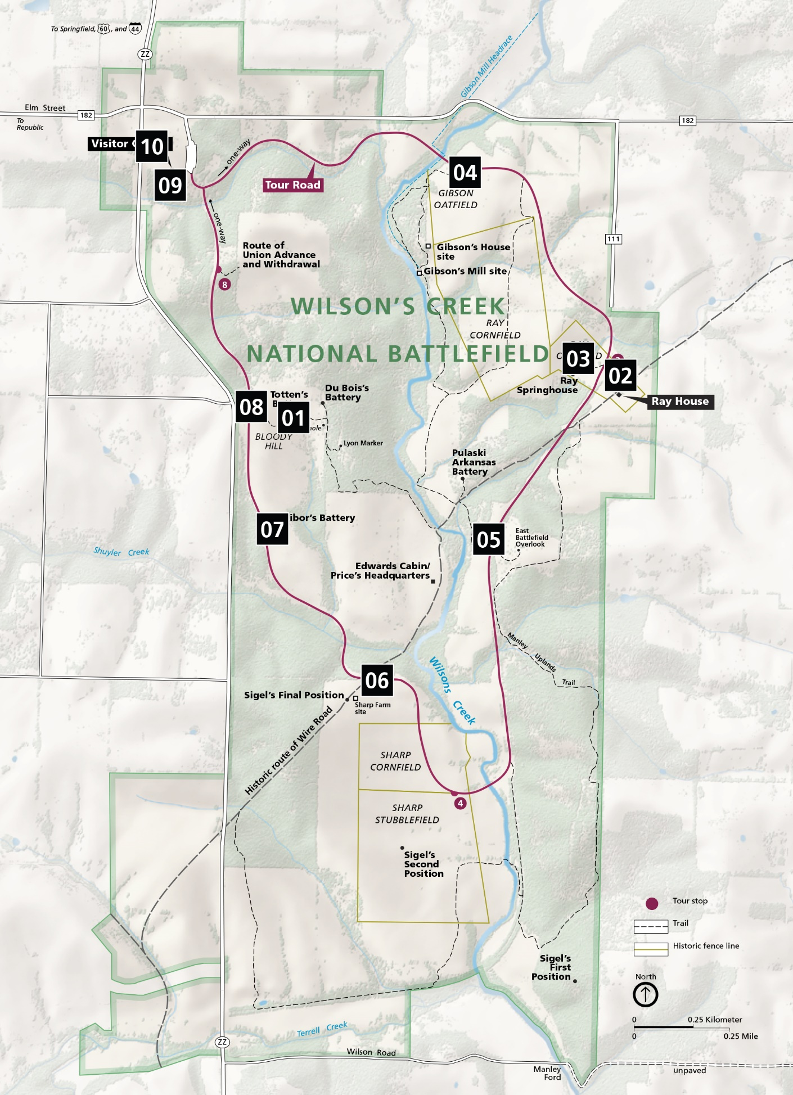

Iimplementation Strategy for Park Areas Assessed
The Architectural Barrier Act (ABA) of 1968 requires that any building or facility designed, constructed, altered, or leased with federal funds be accessible and usable by any individuals with disabilities. The Uniform Federal Accessibility Standards (UFAS) and the Architectural Barriers Act Accessibility Standards (ABAAS) were adopted for federal facilities in 1984 and 2006, respectively. Subsequently in 2011, standards for recreational facilities were incorporated into ABAAS as chapter 10.
Dependent upon the date of a building’s construction or alteration, different design standards apply. In conducting the transition plan facility assessments, the 2011 ABAAS standards were used as the on-site assessments. Although a barrier may be identified by the current assessment for improvement, facilities constructed pre-1984, or between 1984 and 2011, are only required to be in compliance with the standard in place at the time of construction and/or alteration. Therefore, they may not be in violation of ABAAS. However, any renovation or upgrade of that building will be required to meet the most current standard at the time of work.
Recommended improvements for park policies, practices, communication and training are included. Park policies are adopted by the park and are those defined courses of action for reaching a desired outcome. Park practices are those habitual and/or customary performances or operations park staff employs for reaching a desired outcome. Communication and training strategies help park staff keep informed on how to best deliver services, activities, and programs to visitors with disabilities in the most appropriate and accessible formats.
This document does not include strategies for transitioning employee work spaces to be accessible. In the event an employee with a disability is hired by Wilson’s Creek National Battlefield, the supervisor and employee will discuss the employee’s needs. The supervisor will then determine what accommodations are reasonable within the given work environment and determine a plan of action to meet those needs.
For each park area, site plans illustrate existing conditions and recommended improvements. During the implementation phase, reassessment of the project site conditions and consultation with the Architectural Barriers Act Accessibility Standards is necessary to ensure that specific design and programmatic solutions are addressed correctly. Assistance is available at the Denver Service Center and through the Midwest Region Accessibility Coordinator.

Bloody Hill Trail

Site Plan
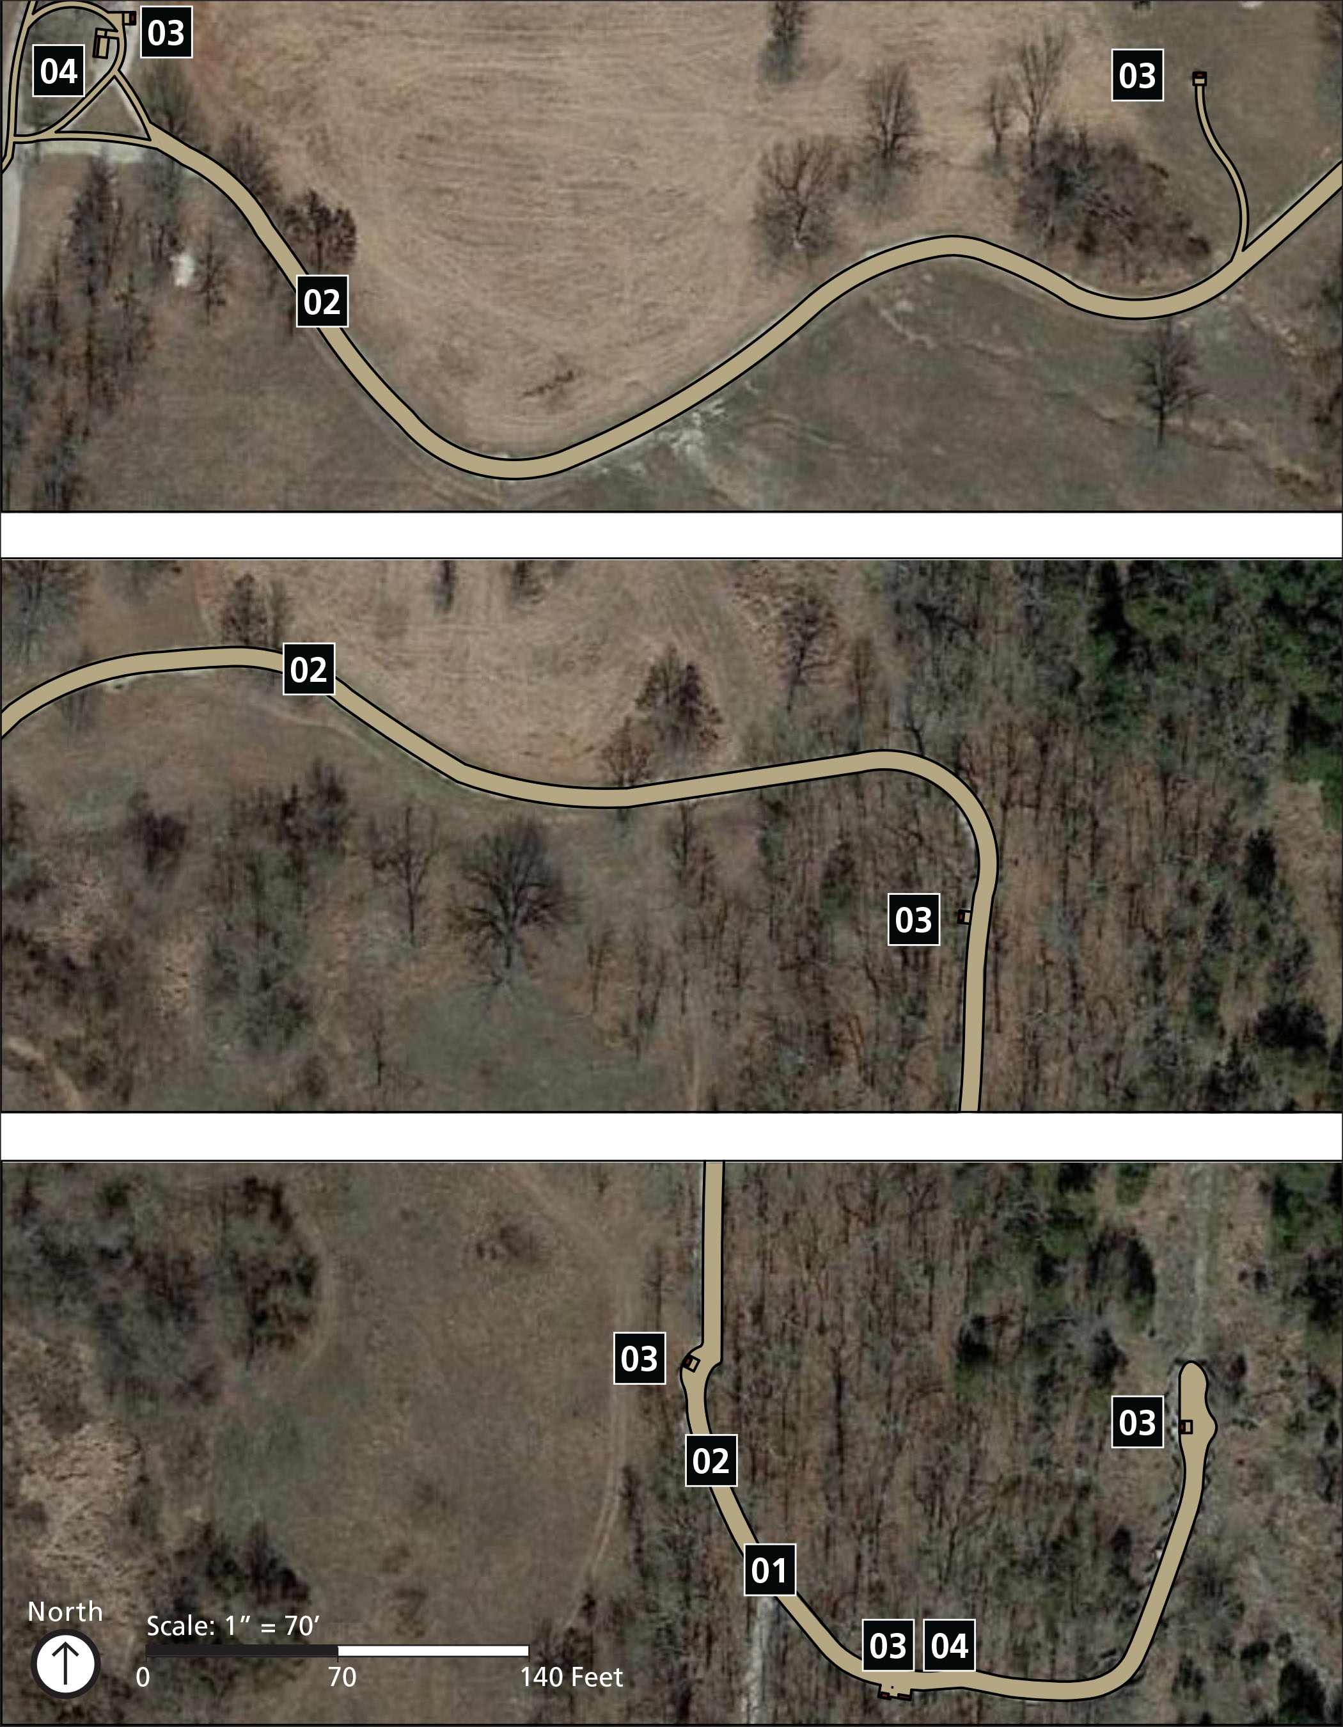

Implementation Strategy
The Bloody Hill Trail is connected to five key experiences of the park including; learning about events related to the Battle of Wilson’s Creek and understanding the role the battle played in the Civil War; touring major points on the battlefield; reflecting on the impacts of war and tragedy of loss, in a preserved rural park setting that is much the same as at the time of the battle; viewing museum collections, exhibits, artifacts and media; and enjoying passive recreation opportunities such as wildlife viewing, picnicking, horseback riding, jogging, hiking, and biking.
The activities and programs provided for visitors in this area primarily include interpretation through tours and waysides, viewing areas, and hiking. The existing services that support these activities and programs include a parking lot, accessible routes, hiking trails and trailheads, benches, as well as wayfinding and orientation signage.
Perhaps the most emotion-provoking place in the park, the Bloody Hill Trail leads visitors through one of the most tragic and deadly events in the battle. The quiet trail is fairly accessible given the even terrain. Barriers primarily include areas where the trail surface is not firm and stable and waysides that could use increased contrast.
The following improvements to this park area are planned:

01 Hiking Trail
- Remove the rock or grind it down to not exceed 2" maximum height measured vertically to the highest point.
short-term

02 Hiking Trail
- Improve the surface of the trail, passing spaces, and resting spaces to be firm and stable.
mid-term

03 Interpretive Waysides
- For all waysides, provide a firm and stable clear ground space 30" by 48" minimum at 2% maximum slope in all directions.
short-term
- As a best practice, ensure that all printed signs and notifications use 24-point minimum text, avoid the use of italics and all caps, and use high contrast images and text.
long-term

04 Benches
- As a best practice, the surface of the bench seat shall be 17" minimum and 19" maximum from the ground surface. As a best practice, install a backrest and at least one armrest on the accessible bench.
long-term
- Provide a 36" by 48" minimum clear space at 2% maximum slope in all directions adjacent to the accessible bench.
short-term

This page intentionally left blank.

Ray House and Trail

Site Plan
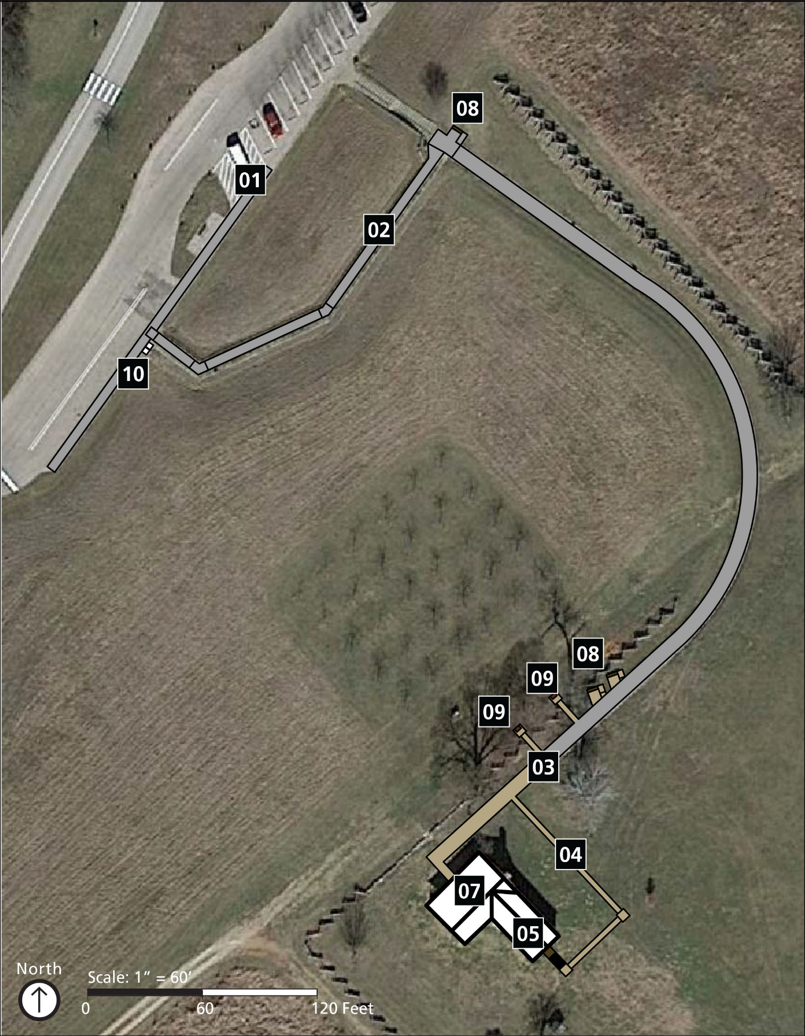

Implementation Strategy
The Ray House and Trail are connected to four key experiences of the park including; learning about events related to the Battle of Wilson’s Creek and understanding the role the battle played in the Civil War; touring major points on the battlefield; viewing museum collections, exhibits, artifacts and media; and enjoying passive recreation opportunities such as wildlife viewing, picnicking, horseback riding, jogging, hiking, and biking.
The activities and programs provided for visitors in this area primarily include interpretation through waysides, audio tours, exhibits, and maps, as well as viewing the landscape. The existing services that support these activities and programs include a parking lot, accessible routes, outdoor recreational access routes, trash and recycling receptacles, as well as wayfinding and orientation signage.
One of the few remaining structures from the battle, the Ray House is one of the most visited stops along the tour road, offering a peek into the life of the Ray family as their house became the center of a battlefield and a refuge for Confederate soldiers. There are two primary barriers at the Ray House. The first is the route from the parking lot leading up a steep hillside to the Ray House. The long ramp structure needs some slope corrections and alterations to the handrails. Once the hill is traversed, access through the front door requires steps up to the porch so an alternative route needs to be identified without adversely impacting historic assets.
The following improvements to this park area are planned:

01 Car Parking Area
- Provide “van accessible” designation on the van-accessible stall as well as a sign designating the standard accessible stalls.
short-term

02 Accessible Route (to Ray House)
- Correct sections of the ramp so that ramp runs do not exceed 8.33% running slope and 2% cross slope. Provide landings at the top and bottom of each ramp run that measure 60" long minimum, extend the full width of the path, are firm, stable, and do not exceed 2% slope in all directions. Landings measuring 60" by 60" minimum must be provided at landings where the ramp changes direction.

- The top of handrails are 34" minimum and 38" maximum vertically above the walking surface. Clearance between handrail gripping surfaces and adjacent surfaces shall be 1½" minimum. Handrail gripping surfaces shall be continuous along their length and shall not be obstructed along their tops or sides. The bottom of handrail gripping surfaces shall not be obstructed for more than 20% of their length.
long-term

03 Accessible Route (to Ray House)
- Provide an outdoor recreational access route between the termination of the paved path and the Ray House rear entrance with a firm and stable surface with a minimum width of 36" and slopes not to exceed 8.33% running slope for a maximum of 50' or 10% running slope for a maximum of 10'.
mid-term

04 Accessible Route (to Ray House)
- For special events, provide a temporary firm and stable surface from the end of the paving to the event location. Cross slope must still not exceed 2% and running slopes have a maximum of 8%.
mid-term

05 Accessible Route (Ray House)
- Lower the threshold at the Ray House rear entrance to not exceed ½" in height with a ¼" maximum vertical change and a ¼" beveled change in grade.
short-term

06 Accessible Route (Ray House)
- Replace the existing ramp to the rear entrance with one that does not exceed 8.33% running slope and 2% cross slope. The rise of the slope shall not exceed 6"or handrails must be provided. A landing at the top and bottom of the ramp shall be provided measuring 60"in length and the same width of the ramp. The landings shall be firm, stable, and not exceed 2% slope in all directions. The top of handrails are 34" minimum and 38" maximum vertically above the walking surface. Clearance between handrail gripping surfaces and adjacent surfaces shall be 1½" minimum. Handrail gripping surfaces shall be continuous along their length and shall not be obstructed along their tops or sides. The bottom of handrail gripping surfaces shall not be obstructed for more than 20% of their length.
mid-term

07 Accessible Route (Ray House)
- Lower the threshold at the transition from the kitchen to the mailroom/Lyon’s bedroom to not exceed ½" in height with a ¼" maximum vertical change and a ¼" beveled change in grade.
short-term

08 Benches
- Provide a firm and stable clear space in front of the bench measuring 36" by 48" and not exceeding 2% slope in all directions. Connect the clear space to the nearby outdoor recreation access route.
- As best practice, install a backrest and at least one armrest on the accessible bench. The bench seat should be between 42" long minimum and between 20" and 24" deep.
long-term

09 Interpretive Waysides
- Provide a firm and stable clear ground space in front of the waysides measuring 30" by 48" with 27" of knee clearance from the ground surface to the bottom of the mounted panel. The clear space shall not exceed 2% slope in all directions. The clear space for the wayside may not overlap into the path of travel.
- As a best practice, ensure that all waysides use 24-point minimum text, avoid the use of italics and all caps, and use high contrast images and text. Avoid the use of red and green together to distinguish between items as they are undiscernible by visitors who are colorblind.
short-term

10 Trash and Recycling Receptacles
- Locate receptacles on firm and stable surfaces with a clear ground space of 36" by 48"for a forward approach and 30" by 60" for a parallel approach. Slope of the clear ground space does not exceed 2% or 5% if necessary for drainage.
- Operable parts of the receptacles are located between 15" and 48" above the ground, are operable with a closed fist, and do not require more than 5 pounds of force to operate. Receptacles designed to keep animals out must comply to the extent practicable.
mid-term

Ray Springhouse and Trail

Site Plan
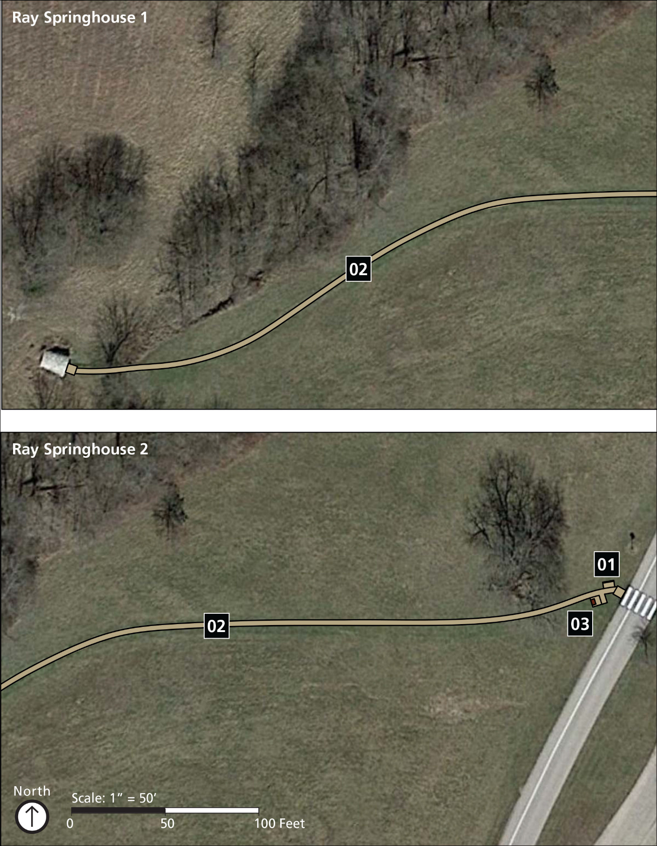

Implementation Strategy
The Ray Springhouse and Trail are connected to five key experiences of the park including; learning about events related to the Battle of Wilson’s Creek and understanding the role the battle played in the Civil War; touring major points on the battlefield; reflecting on the impacts of war and tragedy of loss, in a preserved rural park setting that is much the same as at the time of the battle; viewing museum collections, exhibits, artifacts and media; and enjoying passive recreation opportunities such as wildlife viewing, picnicking, horseback riding, jogging, hiking, and biking.
The activities and programs provided for visitors in this area primarily include interpretation through an audio tour and hiking. The existing services that support these activities and programs include a hiking trail and a parking lot located on the opposite side of the road by the Ray House.
Life in rural Missouri at the time of the Civil War was seldom easy. Down the steep rolling hillside from the Ray House, nestled along a shady ravine, is the stream the Ray family depended on for water. Cut into the hillside, cool water pools on the ground of a small springhouse. The children would haul water from the springhouse to supply the main house. Considered a trail, the route is fairly undefined as it traverses a mowed hillside of short grasses. Trail signage could greatly improve the accessibility of the trail by simply informing visitors of the trail conditions and potential hazards such as large holes in the ground surface dug by animals. While there is an interpretive wayside near the Ray House that covers the Ray Springhouse, there is no wayside near the trail entry or at the springhouse itself. This lack of interpretation prevents visitors who cannot physically access the springhouse from sharing in that experience.
The following improvements to this park area are planned:

01 Trailhead
- Provide trail signage by the parking lot describing trail conditions such as the length of the trail, typical and minimum tread width, surface type, typical and maximum running and cross slopes, and potential hazards such as animal holes.
mid-term

02 Hiking Trail
- Remove any tread obstacles exceeding 2"measured from the ground surface to the farthest point of vertical change such as with animal holes.
short-term

03 Springhouse
- Improve programmatic access for the springhouse for those visitors who cannot take the trail, such as an improved wayside about the springhouse with photos and notification of the availability of the audio tour.
mid-term

This page intentionally left blank.

Stop #1

Site Plan
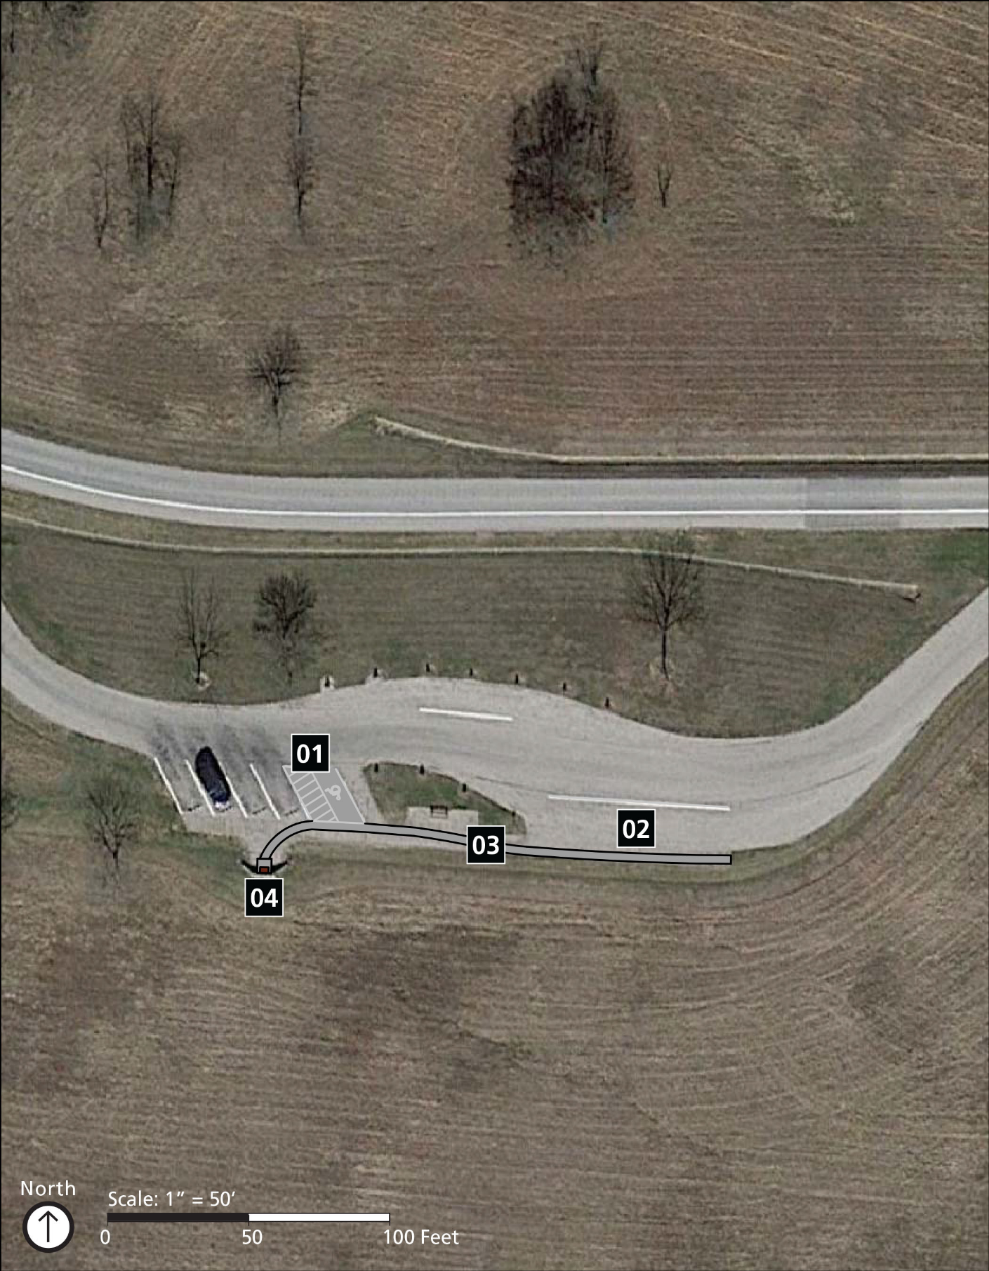

Implementation Strategy
Stop #1 along the tour road is connected to four key experiences of the park including; learning about events related to the Battle of Wilson’s Creek and understanding the role the battle played in the Civil War; touring major points on the battlefield; reflecting on the impacts of war and tragedy of loss, in a preserved rural park setting that is much the same as at the time of the battle; and enjoying passive recreation opportunities such as wildlife viewing, picnicking, horseback riding, jogging, hiking, and biking.
The activities and programs provided for visitors in this area primarily include interpretation through waysides and audio tours, hiking, and viewing the landscape. The existing services that support these activities and programs include a parking lot, accessible routes, outdoor recreational access routes, benches, and viewing areas.
Stop #1 brings visitors to the site of the Southern Army’s most northern camp and the Gibson’s Mill trailhead. The assessment focused on the car parking area and the viewing area with an interpretive wayside. Primary barriers at this location include steep slopes and a lack of signage designating accessible stalls; a lack of space and surface conditions needed to access the wayside; low contrasting images and text; and steep slopes along the accessible route connecting different site features.
The following improvements to this park area are planned:

01 Car Parking Area
- Correct the slopes on the accessible parking stalls to not exceed 2% in all directions.
mid-term
- Provide “van accessible” designation on the van-accessible stall as well as a sign designating the standard accessible stalls. Signs shall be mounted 60” minimum measured from the ground surface to the bottom of the sign.
short-term

02 Oversized-vehicle Parking
- Provide a bus parking stall measuring a minimum of 20' wide. It shall not exceed 2% slope in all directions.
mid-term

03 Accessible Route
- Provide an accessible route connecting the bus parking stall to the wayside and other site features that may be present. The accessible route shall measure a minimum of 36" in width and not exceed 2% cross slope or 5% running slope.
mid-term

04 Interpretive Waysides
- Relocate the wayside closer to the paved area or extend the paving to the wayside to eliminate change in surface material within the clear space. Provide a firm and stable approach that does not exceed a 2% slope in all directions.
mid-term
- Recommend replacing the wayside panel with one that has at least 70% contrast between text and images. Replace the map image to not include colors green and red in low contrast to each other.
short-term

This page intentionally left blank.

Stop #3

Site Plan
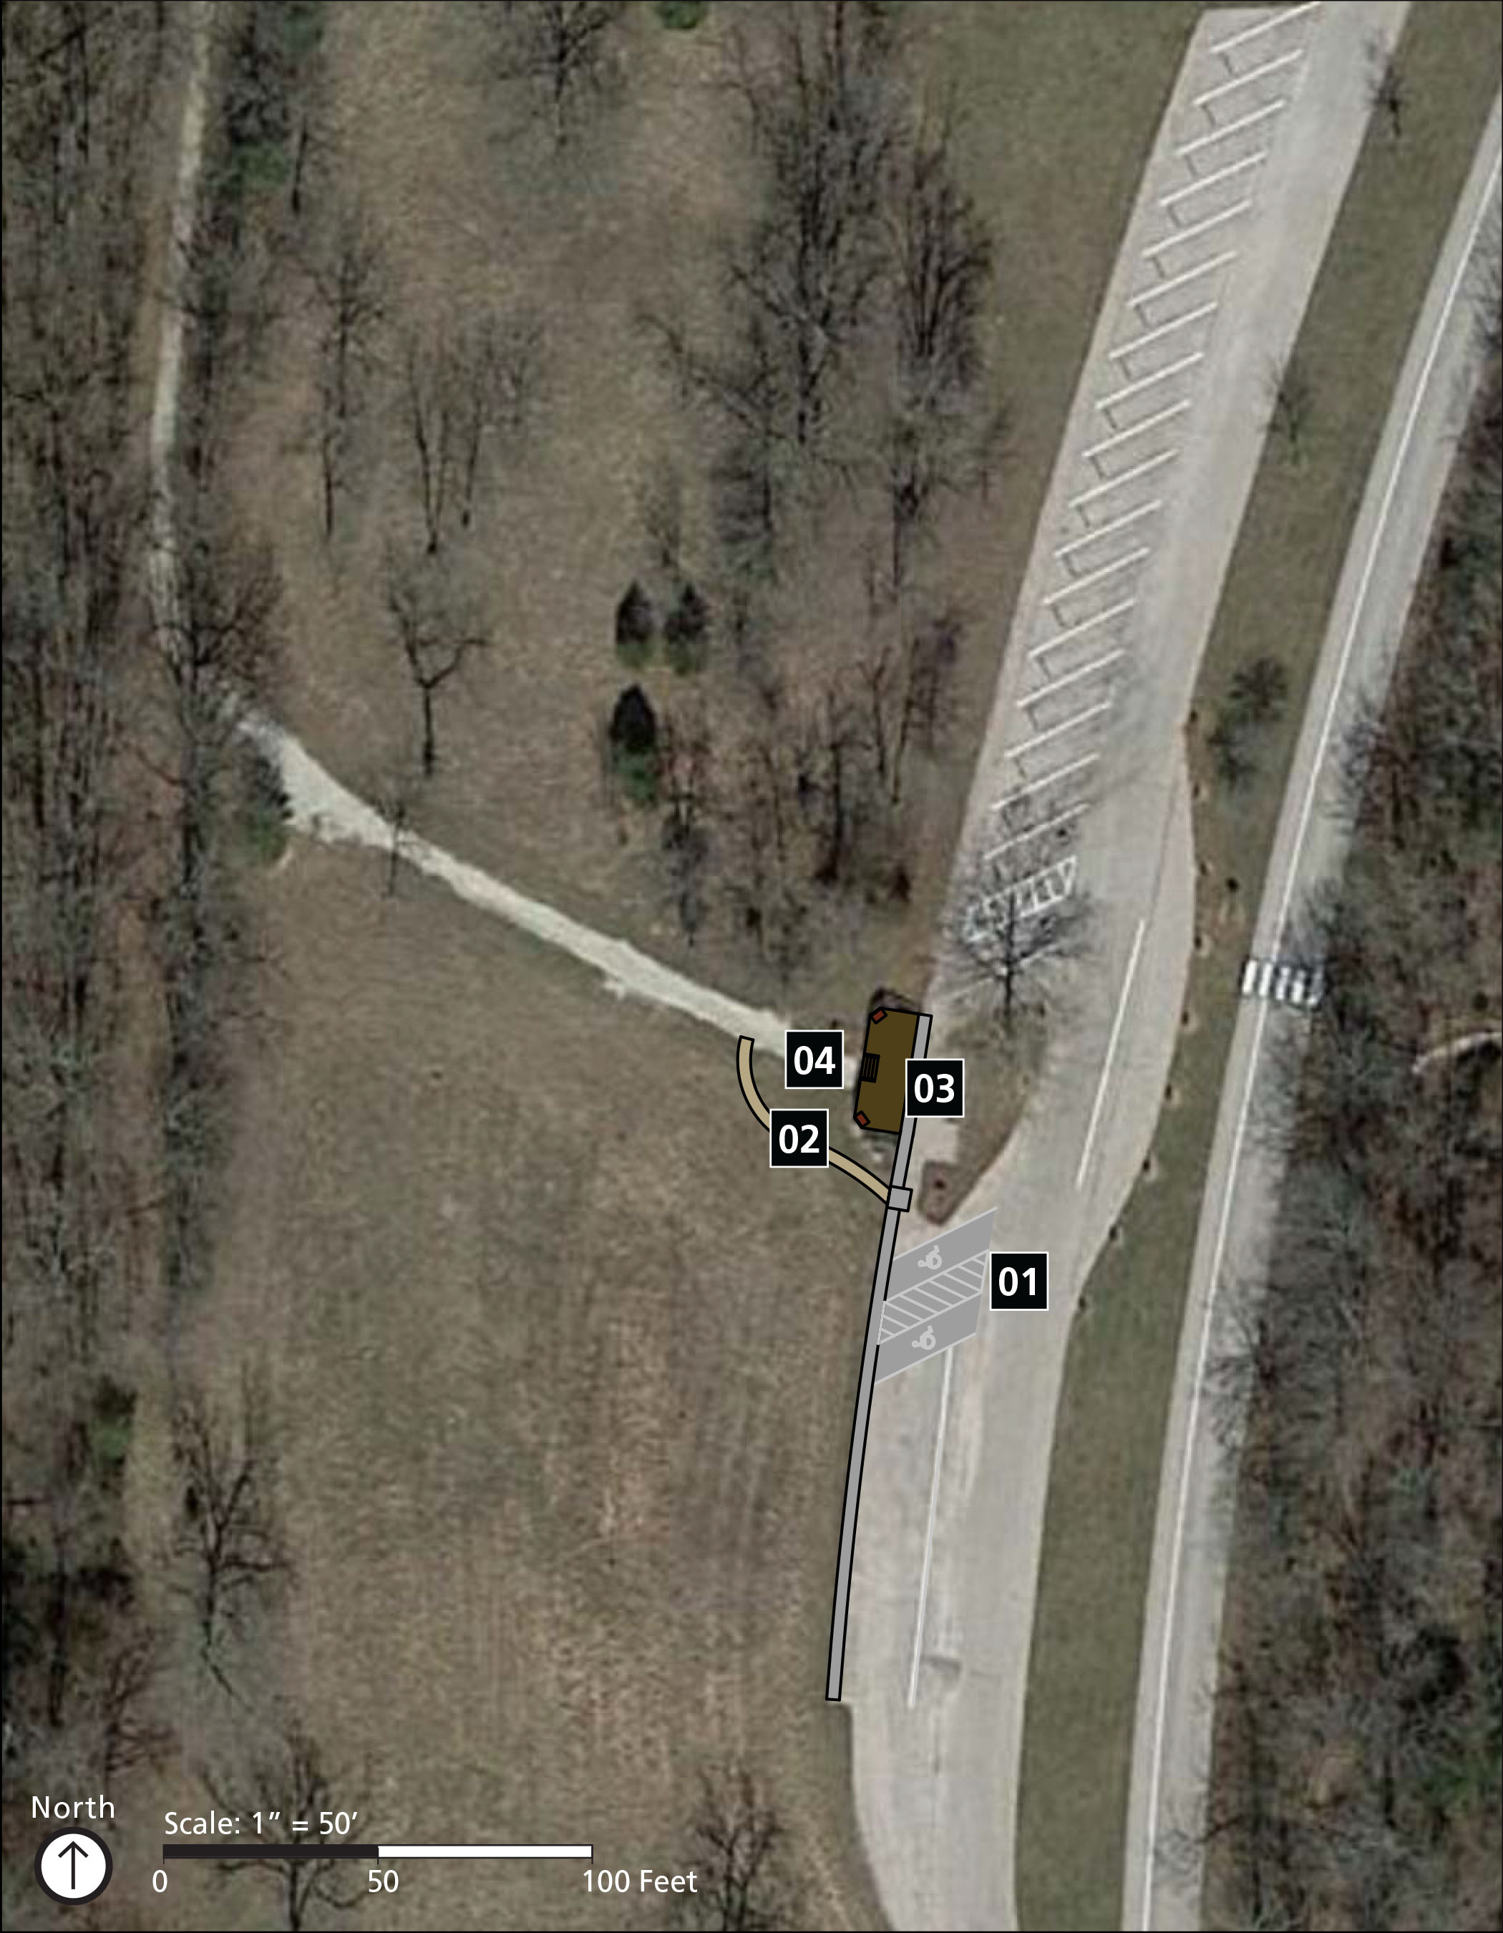

Implementation Strategy
Stop #3 along the tour road is connected to four key experiences of the park including; learning about events related to the Battle of Wilson’s Creek and understanding the role the battle played in the Civil War; touring major points on the battlefield; reflecting on the impacts of war and tragedy of loss, in a preserved rural park setting that is much the same as at the time of the battle; and enjoying passive recreation opportunities such as wildlife viewing, picnicking, horseback riding, jogging, hiking, and biking.
The activities and programs provided for visitors in this area primarily include interpretation through audio tours and interpretive waysides and viewing the landscape. The existing services that support these activities and programs include a parking lot, accessible routes, outdoor recreational access routes, viewing areas, benches, and trash and recycling receptacles.
Stop #3 shows visitors the site of the Pulaski Light Battery as they helped to slow the Union advance across Bloody Hill. A trailhead marking the route to the Edwards Cabin site is also located at Stop #3. Primary barriers include steep slopes in accessible route and accessible parking stalls connecting to the viewing area, gaps in the viewing deck, low contrast between text and images in the wayside, and no outdoor recreational access route connecting the viewing deck to the trail below.
The following improvements to this park area are planned:

01 Car Parking Area
- Relocate the accessible stalls to the other side of the tree by the bus parking. Provide one van-accessible stall measuring 11' minimum in width with a 5' minimum width access aisle or 8' minimum in width with an 8' wide access aisle. The standard accessible stall shall be 8' wide minimum with a 5' wide access aisle. All stalls are located on a firm, stable, and flat surface measuring 2% maximum slope in all directions.
mid-term
- Provide an accessible parking sign on each designated accessible stall to be mounted 60" minimum above the ground to the bottom of the sign. Provide “van accessible” designation on the van-accessible stall.
short-term

02 Outdoor Recreation Access Route
- Provide a ramp leading around the stairs and the viewing deck to the start of the trail. The ramp shall have a landing at the top and bottom of the run measuring a minimum of 60" in length and a minimum of 36" wide measured between handrails. Ramp slope cannot exceed 8.33%. See ABAAS 505 for handrail requirements.
mid-term

03 Viewing Area
- Eliminate openings in the decking so that there are no gaps wider than ½"and so that openings are perpendicular to the direction of travel.
mid-term

04 Interpretive Waysides
- As a best practice, replace the wayside panel to include images and text with at least 70% contrast and avoid the use of green and red to differentiate between content.
short-term

This page intentionally left blank.

Stop #5

Site Plan
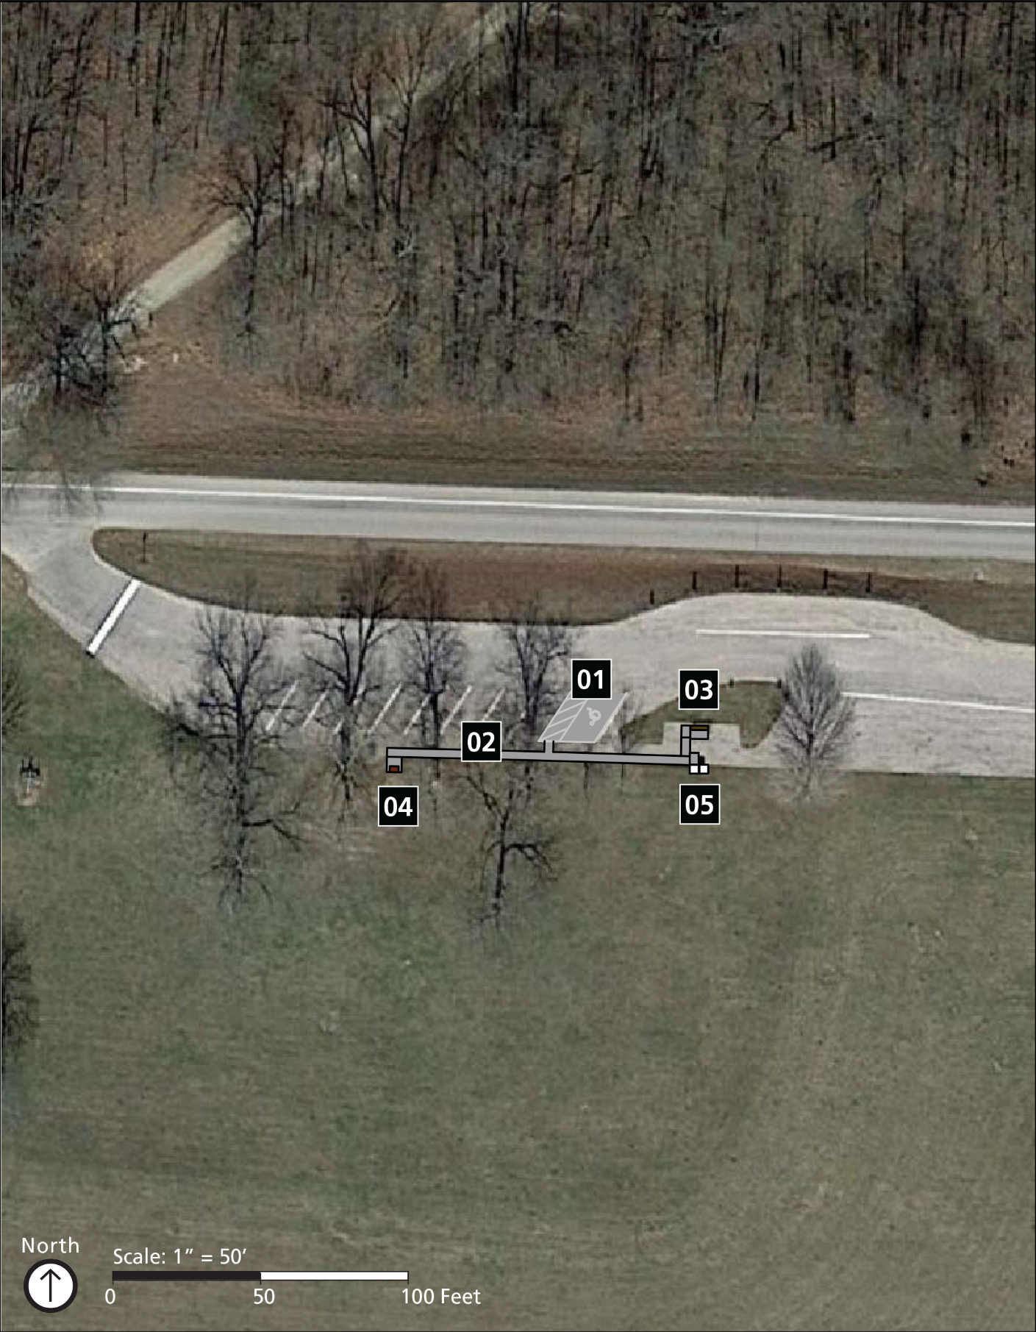

Implementation Strategy
Stop #5 along the tour road is connected to five key experiences of the park including; learning about events related to the Battle of Wilson’s Creek and understanding the role the battle played in the Civil War; touring major points on the battlefield; reflecting on the impacts of war and tragedy of loss, in a preserved rural park setting that is much the same as at the time of the battle; viewing museum collections, exhibits, artifacts and media; and enjoying passive recreation opportunities such as wildlife viewing, picnicking, horseback riding, jogging, hiking, and biking.
The activities and programs provided for visitors in this area primarily include interpretation through waysides and audio tours, hiking, and viewing the landscape. The existing services that support these activities and programs include a parking lot, accessible routes, outdoor recreational access routes, trash and recycling receptacles, and benches.
Stop #5 brings visitors to the site of Sigel’s Final Position. Here, a critical case of mistaken identity sent Sigel’s force directly into the hands of the Confederacy, turning the battle in favor of the Southerners. One of the primary accessibility concerns at this site is the access to accessible bench locations. Tours and events use the benches that are scattered throughout the mowed area. None of the benches are specifically connected to an outdoor recreational access route or have space for companion seating. The interpretive wayside has some issues with contrast concerning images and text and the route connecting to the wayside and clear space in front has an uneven surface. Accessible parking lacks signage and has high slopes. Trash and recycling receptacles are not located along an accessible route and cannot be operated with a closed fist.
The following improvements to this park area are planned:

01 Car Parking Area
- Correct slopes in the accessible stall and access aisle locations to not exceed 2% maximum slope in all directions.
mid-term
- Provide “van accessible” designation on the van-accessible stall as well as a sign designating the standard accessible stall. Signs shall be mounted 60" from the ground surface to the bottom of the sign.
short-term

02 Accessible Route
- Provide a firm and stable accessible route from the accessible parking stalls to the wayside as well as to accessible bench locations measuring a minimum of 36" wide and not exceeding 5% running slope and 2% cross slope.
mid-term

03 Benches
- As a best practice, install a backrest and at least one armrest on the accessible bench.
- Provide a 36" by 48" minimum clear space at 2% maximum slope in all directions adjacent to two benches.
- Create a standard operating procedure to provide accessible bench locations during special events. Twenty percent of benches provided need to be located along an outdoor recreation access route and have adjacent clear ground space.
mid-term

04 Interpretive Waysides
- As a best practice, replace the wayside panel to include images and text with at least 70% contrast and avoid the use of green and red to differentiate between content.
short-term

05 Trash and Recycling Receptacles
- Locate receptacles on firm and stable surfaces with a clear ground space of 36" by 48"for a forward approach and 30" by 60" for a parallel approach. Slope of the clear ground space does not exceed 2%.
- Operable parts of the receptacles are located between 15" and 48" above the ground, are operable with a closed fist, and do not require more than 5 pounds of force to operate. Receptacles designed to keep animals out must comply to the extent practicable.
mid-term

This page intentionally left blank.

Stop #6

Site Plan
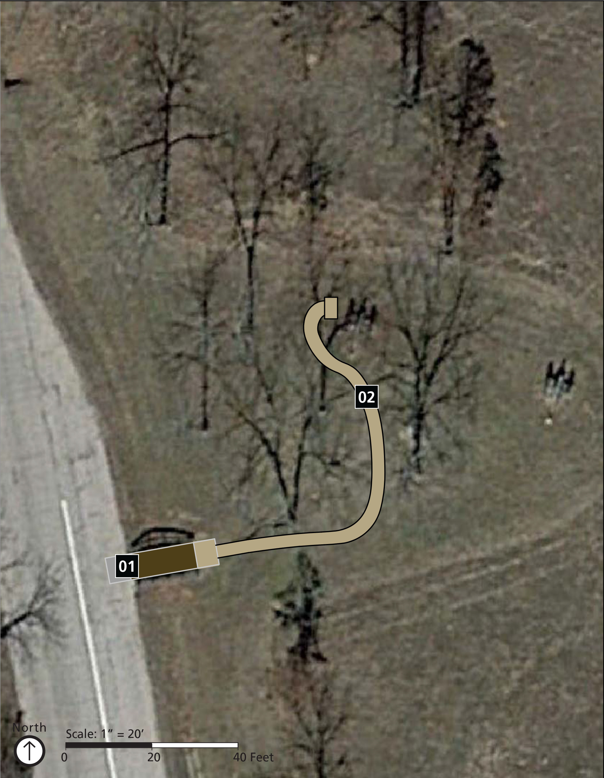

Implementation Strategy
Stop #6 along the tour road is connected to five key experiences of the park including; learning about events related to the Battle of Wilson’s Creek and understanding the role the battle played in the Civil War; touring major points on the battlefield; reflecting on the impacts of war and tragedy of loss, in a preserved rural park setting that is much the same as at the time of the battle; viewing museum collections, exhibits, artifacts and media; and enjoying passive recreation opportunities such as wildlife viewing, picnicking, horseback riding, jogging, hiking, and biking.
The activities and programs provided for visitors in this area primarily include interpretation through audio tours and waysides, viewing the landscape, and hiking. The existing services that support these activities and programs include a parking lot, accessible routes, hiking trails, outdoor recreational access routes, benches, viewing areas, and trash and recycling receptacles.
As visitors walk along the quiet grass path, it is hard to imagine the four 6-pounder guns on the hill firing across the peaceful landscape. Captain Guibor’s Battery performed the first assault against the Union soldiers driving across Bloody Hill. After crossing a small bridge, visitors can follow a short path to view the battery. The site requires very few improvements to make it more accessible. There are a few gaps in the bridge planking that need to be closed and a threshold adjustment at the transition on and off the bridge. The path turns to a mowed turf as it approached the battery. Some sections of the mowed area are tufted creating an unstable surface.
The following improvements to this park area are planned:

01 Outdoor Recreation Access Route
- Smooth the transition from the paving to the bridge planking ensuring that the vertical change does not exceed ½".
short-term

02 Outdoor Recreation Access Route
- Smooth and maintain the path to the cannons ensuring that the vertical change does not exceed ½".
mid-term

Stop #7

Site Plan
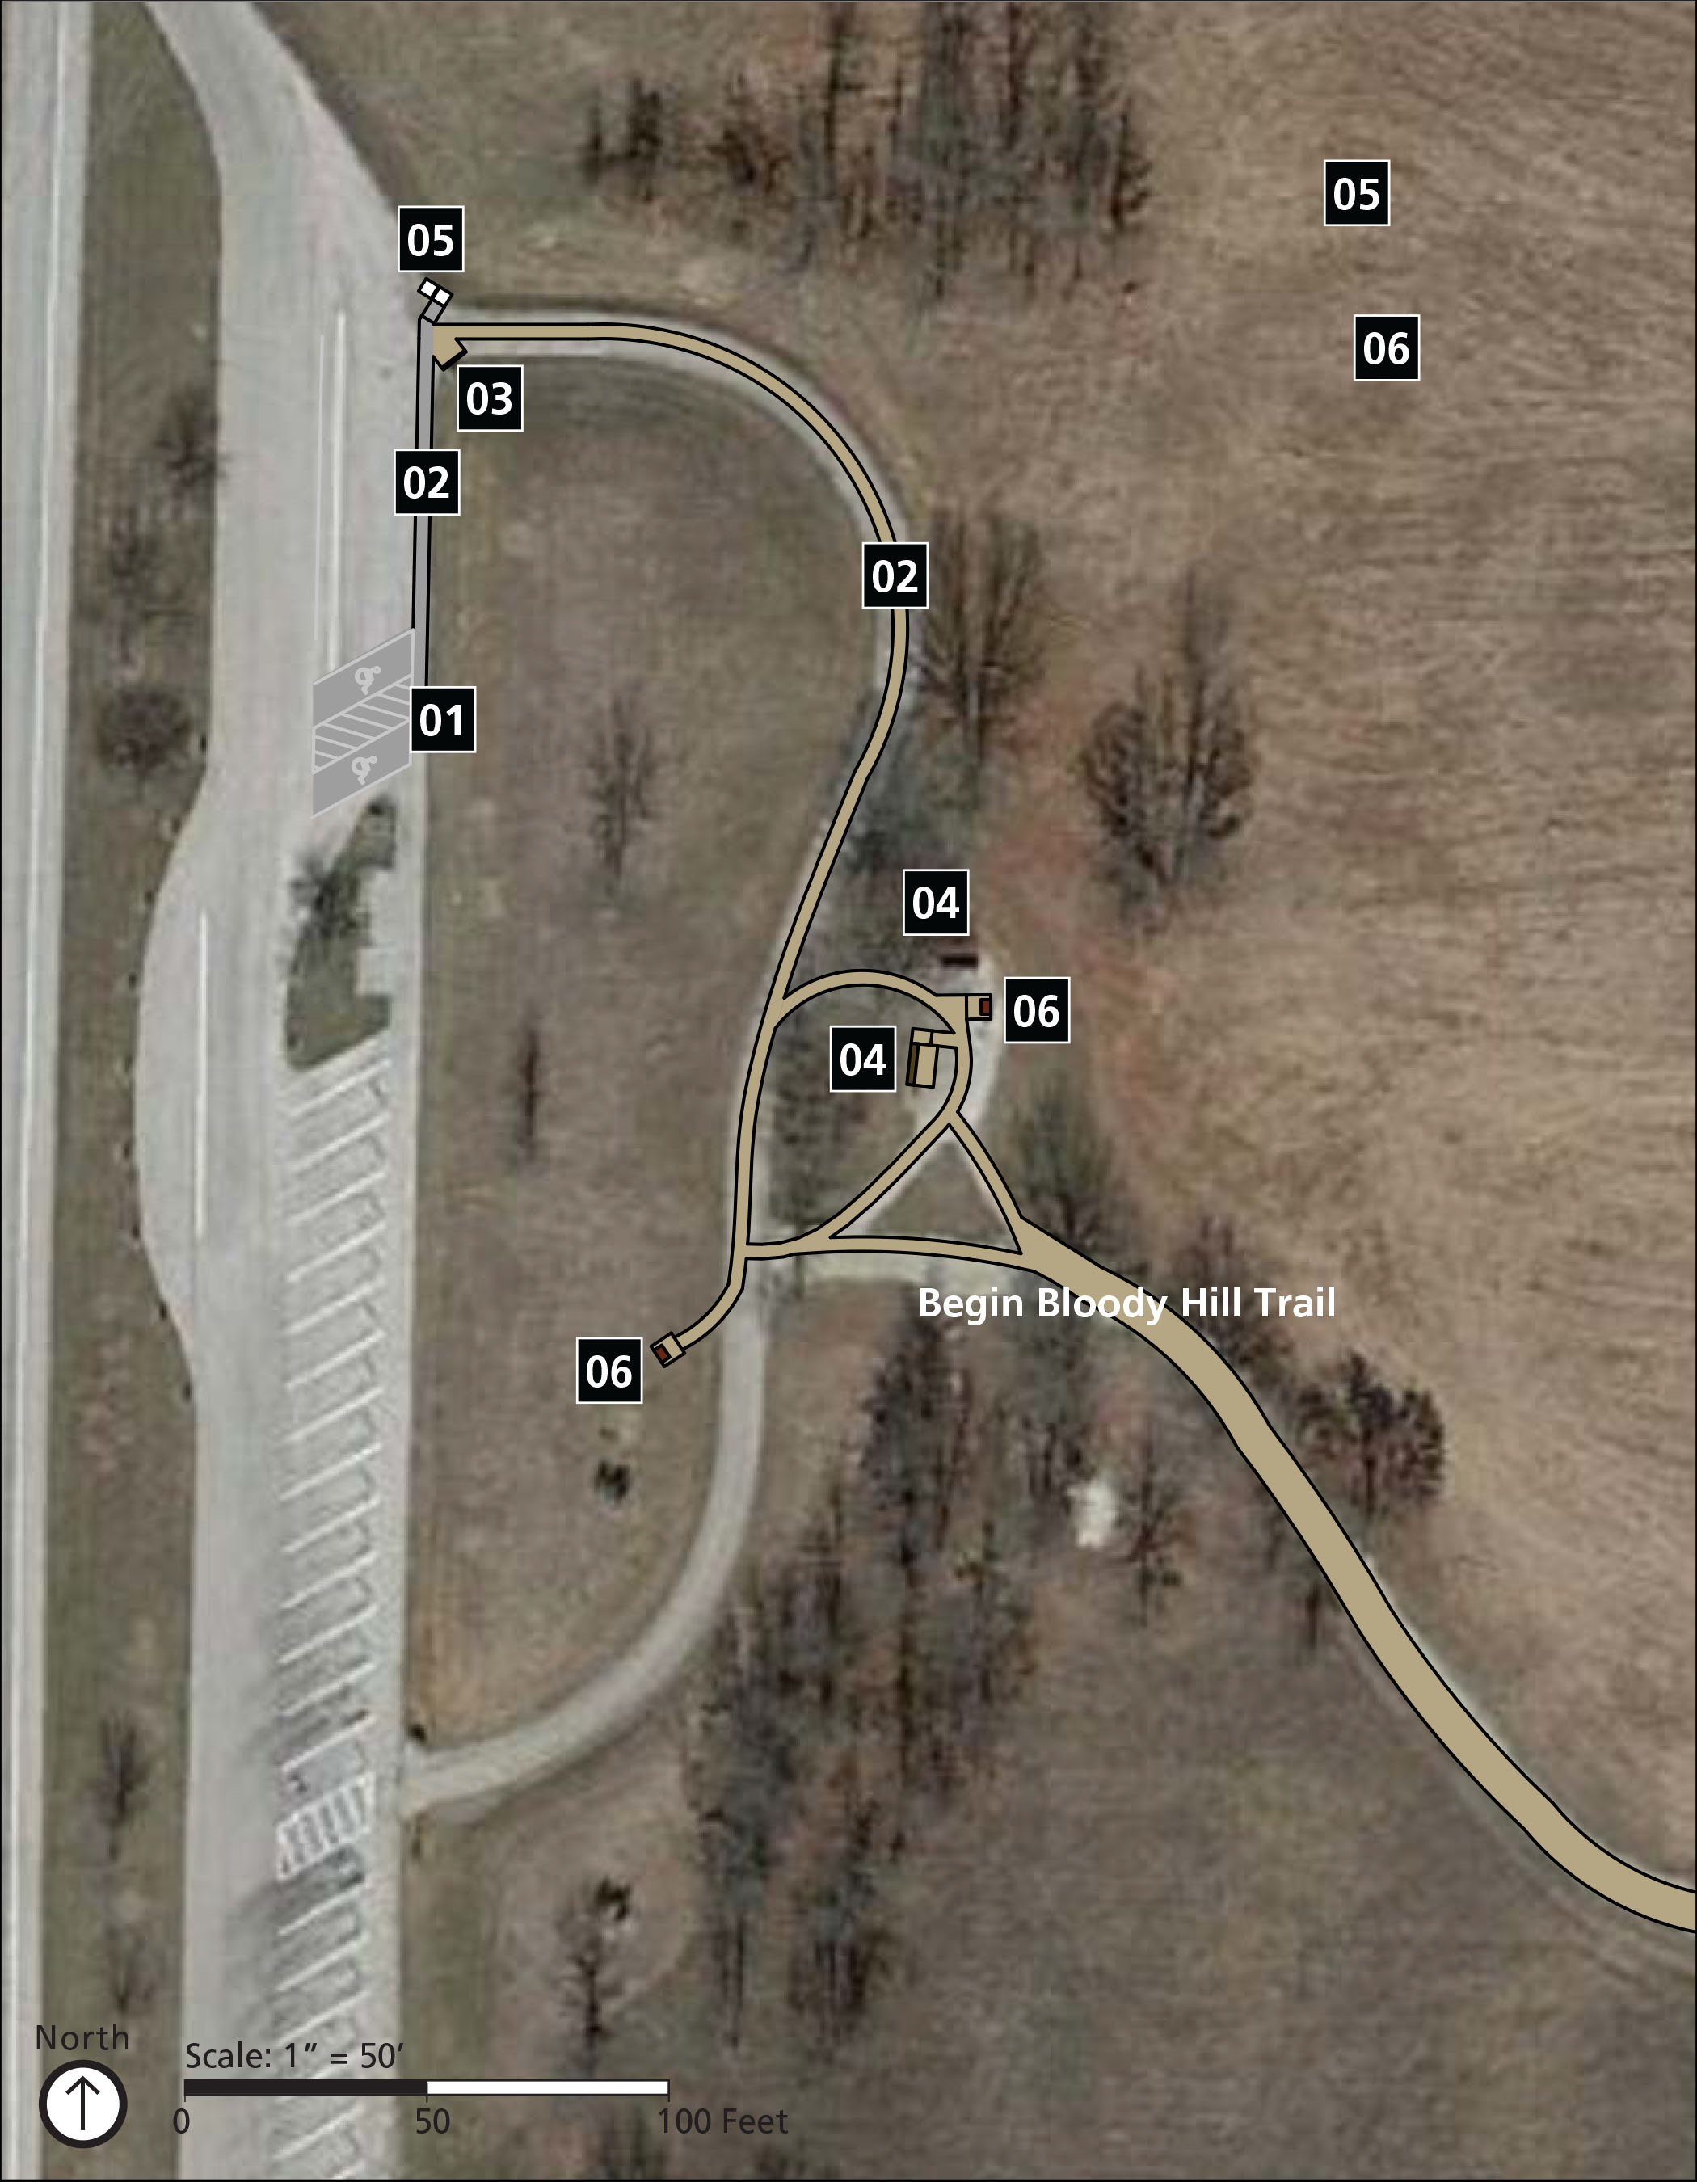

Implementation Strategy
Stop #7 along the tour road is connected to five key experiences of the park including; learning about events related to the Battle of Wilson’s Creek and understanding the role the battle played in the Civil War; touring major points on the battlefield; reflecting on the impacts of war and tragedy of loss, in a preserved rural park setting that is much the same as at the time of the battle; viewing museum collections, exhibits, artifacts and media; researching extensive library materials and collections related to the Civil War in the Trans-Mississippi West; and enjoying passive recreation opportunities such as wildlife viewing, picnicking, horseback riding, jogging, hiking, and biking.
The activities and programs provided for visitors in this area primarily include interpretation through audio tours and waysides, viewing the landscape, and hiking. The existing services that support these activities and programs include a parking lot, oversized vehicle parking, accessible routes, hiking trails, outdoor recreational access routes, benches, viewing areas, trash and recycling receptacles, and wayfinding and orientation signage.
It is at this stop that visitors begin the journey towards the end of the violent battle at Bloody Hill. What began as a Union advance soon became the scene of a costly retreat, which saw the loss of the first Union commander. The trailhead for the Bloody Hill Trail is located at this stop. Fortunately, this popular stop along the tour road requires only fairly minor corrections to improve accessibility. Providing a trailhead sign that further outlines the trail conditions and potential hazards would allow for visitors to decide for themselves if they are physically able to take the trail. This makes it that much more important to improve the experience in the site before the trail begins for those who decide to not take the trail. The site rests uphill from the parking lot, making the initial route to the viewing area a challenge. Accessible parking stalls need to be moved up slope by the bus parking where the grade is lower and access to the less steep outdoor recreation access route can be accomplished. The route too will need some minor slope adjustments to bring it into compliance. Other improvements are more minor and include providing trash and recycling receptacles that are operable with a closed fist and have a firm and stable clear ground space as well as companion seating for benches at the viewing area. The route to and clear ground space at the wayside need some work to provide a firm and stable surface across the mowed turf surface.
The following improvements to this park area are planned:

01 Car Parking Area
- Relocate accessible stalls to the other side of the bike rack and tree by the bus parking location where the slopes are not as steep. Provide one van-accessible stall measuring 8' with an 8' access aisle or 11' wide with a 5' access aisle. Standard accessible stalls measure 8' wide with a 5' access aisle. Stalls and access aisles are not to exceed 2% slope in all directions.
- Provide “van accessible” designation on the van-accessible stall as well as a sign designating the standard accessible stall. Signs shall be mounted 60" from the ground surface to the bottom of the sign.
mid-term

02 Accessible Route
- Adjust the grade along the accessible route to not exceed a 5% running slope and a 2% cross slope. Resurface the transition from the route to the trail so that it is firm and stable.
mid-term

03 Trailhead
- Provide trail signage by the parking lot describing trail conditions such as the length of the trail, typical and minimum tread width, surface type, typical and maximum running and cross slopes, and potential hazards such as animal holes.
mid-term

04 Benches
- Provide a 36" by 48" minimum clear space at 2% maximum slope in all directions adjacent to the accessible bench.
- As a best practice, install a backrest and at least one armrest on 20% of benches provided.
mid-term

05 Trash and Recycling Receptacles
- Locate receptacles on firm and stable surfaces with a clear ground space of 36" by 48"for a forward approach and 30" by 60" for a parallel approach. Slope of the clear ground space does not exceed 2% or 5% if necessary for drainage.
- Operable parts of the receptacles are located between 15" and 48" above the ground, are operable with a closed fist, and do not require more than 5 pounds of force to operate. Receptacles designed to keep animals out must comply to the extent practicable.
mid-term

06 Interpretive Waysides
- Relocate the wayside closer to the path or correct and maintain an accessible route measuring a minimum width of 36" wide through the turf leading up to the wayside to be firm, stable, not exceed 5% running slope and 2% cross slope, and avoid surface changes over ½".
short-term
- As a best practice ensure that all fonts used on waysides are a minimum 24-point text, san serif, no italics or all bold, and maintains 70% contrast between images and text.
long-term

Visitor Center Picnic Area

Site Plan
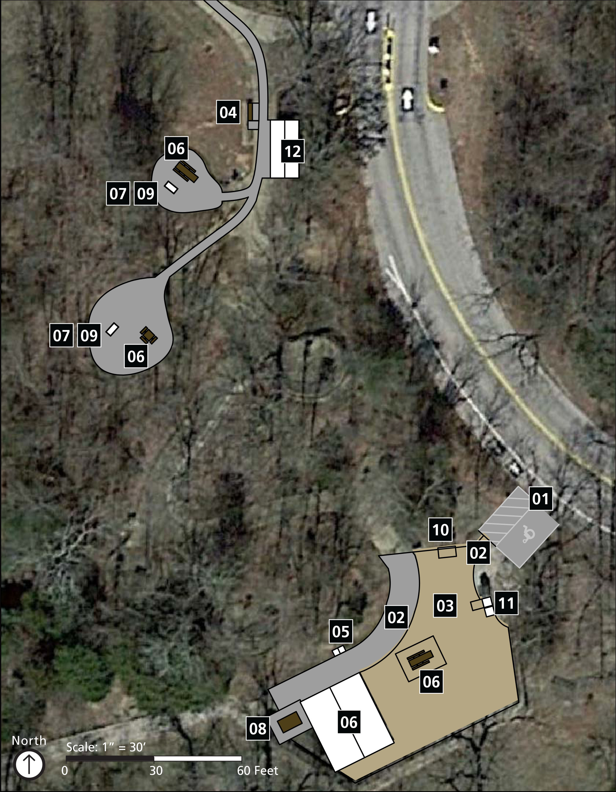

Implementation Strategy
The visitor center picnic area is connected to one key experience of the park: enjoying passive recreation opportunities such as wildlife viewing, picnicking, horseback riding, jogging, hiking, and biking.
The activities and programs provided for visitors in this area primarily include picnicking and hiking. The existing services that support these activities and programs include a parking lot, accessible routes, outdoor recreational access routes, picnic tables, grills, loading/off-loading area, drinking fountains, benches, trash and recycling facilities, wayfinding and orientation signage, and a vending machine.
Wilson’s Creek National Battlefield is not only a historic marker of American legacy, but also a natural asset to the local community and visitors alike. Located at the entry of the tour road, the picnic area invites visitors to slow down and make a day of all the history and natural beauty the park has to offer. The most challenging accessibility barrier at this site may be the access to the group picnic area. While there is a dirt pullout area used for unloading supplies and occasional bus parking, there is no accessible parking. Access from the upper parking lot contains steep slopes. Some other barriers include grill and drinking fountain heights, unstable surfaces, trash and recycling receptacles that are inoperable with a closed fist, and inoperable parts on a vending machine.
The following improvements to this park area are planned:

01 Car Parking Area
- Provide one van-accessible parking stall by the group picnic area measuring 8' wide minimum with a 5' wide minimum access aisle extending the full length of the stall. The ground surface shall be firm, stable, and not exceed 2% slope in all directions.
- Install a “van accessible” sign designating the van-accessible stall. The sign shall be mounted 60" minimum from the ground surface to the bottom of the sign.
mid-term

02 Outdoor Recreation Access Route
- Improve the route between accessible parking and picnic facilities to be 36" wide minimum at a 5% maximum running slope (where possible) and a 2% maximum cross slope (unless necessary for drainage).
mid-term

03 Outdoor Recreation Access Route
- Fix and maintain the ground surface of the outdoor recreational access route to be firm, stable, and to not exceed 2% cross slope or 8% maximum running slope for distances up to 50' or up to 10% maximum slope for up to 30'.
mid-term

04 Benches (by vending machine)
- Provide clear ground space of 36" by 48" with a 2% maximum slope in all directions positioned near the bench with one side of the space adjoining an outdoor recreation access route.
short-term
- As a best practice, improve the bench to include armrests and backrests. As a best practice, adjust the seat height to be between 17" and 19".
mid-term

05 Drinking Fountains
- Drinking spout heights must be provided for both standing and sitting persons. Spout outlets for tall drinking fountains shall be located between 38" minimum and 43" maximum with 27" knee clearance provided under the unit. Spout heights for short fountains shall be positioned at a maximum of 36" above the finish ground.
- Provide a firm and stable clear ground space in front of each fountain measuring 30" by 48" minimum for a forward approach.
mid-term

06 Picnic Facilities (group picnic area)
- Improve 20% of picnic pod locations to be accessible. Identify two minimum accessible picnic table locations, one in the covered area and one in the open area.
- Locate tables to provide access to at least one integrated wheelchair seating space per table at a minimum size of 30" by 48". At each location, provide 36" clear space at 2% maximum slope in all directions around all sides of the accessible picnic tables.
mid-term

07 Picnic Facilities (smaller pods)
- Improve 20% of picnic pod locations to be accessible (a minimum of two).
- Provide tables with at least one integrated wheelchair seating space at a minimum size of 30" by 48". Tabletop surfaces are between 28" and 34" above the finish ground with 27" minimum knee clearance under the space with 9" minimum toe clearance.
- At each location, provide 36" clear space at 2% maximum slope in all directions around all sides of the accessible picnic tables.
mid-term

08 Grills (at group picnic area)
- Provide a firm and stable clear ground space of 48" by 48" on all usable sides of the grill with a maximum 2% slope in all directions or 5% if necessary for drainage. This would require moving the picnic table that is adjacent to the grill.
short-term
- The fire building surface of the grill is 9"minimum above the ground and the cooking surface is between 15” and 34" above the ground. This may require relocating, rebuilding, or raising the ground surface to meet the required height.
- To the extent practicable, ensure operable parts of the grills are operable with a closed fist and do not require more than 5 pounds of force to operate.
mid-term

09 Grills (at pod locations)
- Ensure that 20% of grills provided are accessible and dispersed throughout the picnicking area along with the accessible picnic table locations.
- Provide a firm and stable clear ground space of 48" by 48" on all usable sides of the grill with a maximum 2% slope in all directions or 5% if necessary for drainage. This would require moving the picnic table that is adjacent to the grill.
- The fire building surface of the grill is 9"minimum above the ground and the cooking surface is between 15” and 34" above the ground. This may require relocating, rebuilding, or raising the ground surface to meet the required height.
- To the extent practicable, ensure operable parts of the grills are operable with a closed fist and do not require more than 5 pounds of force to operate.
mid-term

10 Information Board
- Provide a firm and stable clear ground space at the approach to the information board measuring 30" by 48" minimum and not exceeding 2% slope in all directions.
mid-term
- As a best practice, ensure that all printed signs and notifications use 24-point minimum text, use san serif fonts, avoid the use of italics and all caps, and use high contrast images and text.
short-term

11 Trash and Recycling Receptacles
- Locate receptacles on firm and stable surfaces with a clear ground space of 30" by 48"for a forward approach and 30" by 60" for a parallel approach. Slope of the clear ground space shall not exceed 2%.
- Operable parts of the receptacles are located between 15" and 48" above the ground, are operable with a closed fist, and do not require more than 5 pounds of force to operate. Receptacles designed to keep animals out must comply to the extent practicable.
mid-term

12 Vending Machine
- Provide signage notifying visitors that assistance for the vending machine is available at the visitor center.
short-term

This page intentionally left blank.

Visitor Center

Site Plan
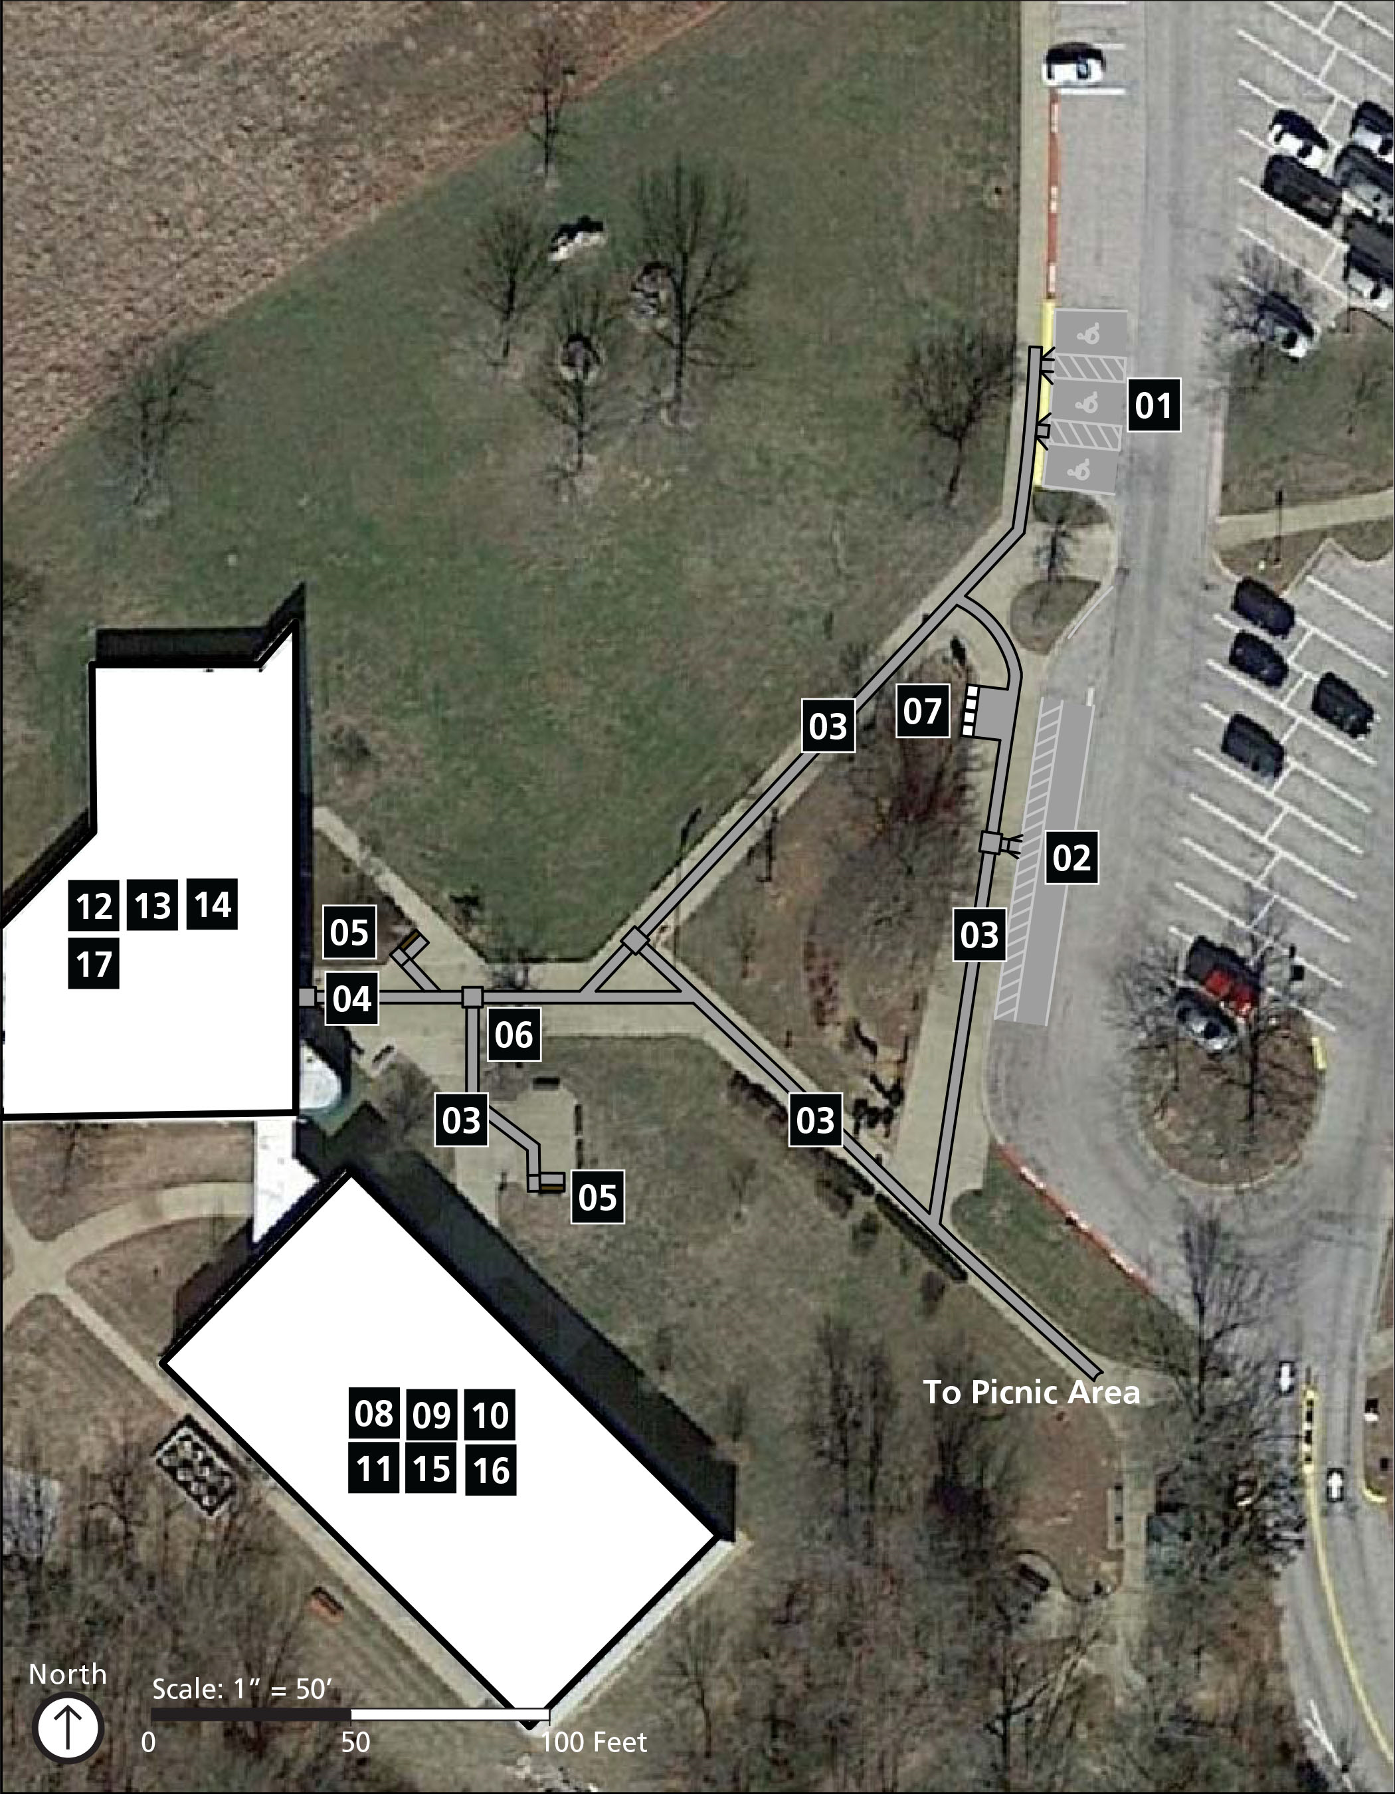

Implementation Strategy
The Wilson’s Creek National Battlefield Visitor Center is connected to four key experiences of the park including; learning about events related to the Battle of Wilson’s Creek and understanding the role the battle played in the Civil War; reflecting on the impacts of war and tragedy of loss, in a preserved rural park setting that is much the same as at the time of the battle; viewing museum collections, exhibits, artifacts and media; and researching extensive library materials and collections related to the Civil War in the Trans-Mississippi West.
The activities and programs provided for visitors in this area primarily include interpretation through exhibits, maps, and videos as well as shopping. The existing services that support these activities and programs include a parking lot, restroom, oversized vehicle parking, accessible routes, drinking fountains, benches, a gift shop, guest box, service counters, a small hot beverage table as well as wayfinding and orientation signage.
The complexities of a past war can be challenging to convey to a diverse audience of visitors from around the world. From slavery to munitions, Wilson’s Creek National Battlefield Visitor Center strives to provide the visitor with a complete and balanced look into the events and conditions that led to the tragic event that transpired on that very ground. From classic interpretive exhibit panels and cases to interactive maps and videos, the park has put a substantial effort towards providing access to multiple themes through multiple types of media. Some key areas that could use accessibility improvements include access into the library, and signage offering assistance to visitors using the rolling shelves or print and scanning tools; modifications to restroom stall sizes and furnishing heights; adjustments to the exhibit area exit with the humidity control door to allow for fewer pounds of force required for opening or closing it.
The following improvements to this park area are planned:

01 Car Parking
- Correct slopes in parking stalls and access aisles to not exceed 2% in all directions.
- Provide “van accessible” designation on the van-accessible stall as well as signs designating the standard accessible stalls. Signs are to be mounted 60" minimum above the finished floor or ground surface measured to the bottom of the sign.
- Provide a landing at the top of the curb ramp with a 36" minimum depth at 2% maximum slope in all directions.
long-term

02 Passenger Loading Zone
- Provide a vehicular pull-up space measuring 96" wide minimum and 20' long minimum. Slopes are not to exceed 2% in all directions. Provide a passenger loading zone measuring 60" wide minimum and running the full length of the pull-up space they serve. Slopes are not to exceed 2% in all directions. Access aisles should be striped to discourage parking in them.
short-term

03 Accessible Route (exterior)
- Correct slopes along the accessible route from the accessible parking stalls, drop-off area and between site elements such as benches and trash receptacles. The accessible route shall not exceed 5% running slope and 2% cross slope.
long-term

04 Accessible Route (exterior)
- At the visitor center entrance doors, provide a landing with 2% maximum slope in all directions measuring a minimum of 36" width and 60" minimum diameter.
long-term

05 Benches (exterior)
- As best practice, improve some of the benches to include armrests and backrests. As best practice, adjust seat heights to be between 17" and 19".
mid-term

06 Drinking Fountain (exterior)
- Provide a drinking fountain with both low and high heights. Provide a low position spout height that is 36" maximum above the finished floor or ground surface and a high position fountain with a spout height between 38" minimum and 43"maximum above the finished floor.
mid-term

07 Trash and Recycling Receptacles
- Improve receptacles to have operable parts between 15" and 48" above the ground, operable with a closed fist, and requiring no more than 5 pounds of force to operate. Receptacles designed to keep animals out must comply to the extent practicable.
- Locate receptacles on firm and stable surfaces with a clear ground space of 36" by 48"for a forward approach and 30" by 60" for a parallel approach. Slope of the clear ground space does not exceed 2% or 5% if necessary for drainage. Ensure receptacles are located along an outdoor recreation access route.
mid-term

08 Accessible Route (library)
- Provide an entrance sign identifying the library with both visual and tactile characters. The sign shall be mounted on the wall adjacent to the handle side of the door. The bottom line of tactile characters shall begin at a minimum of 48" from the finished floor and the bottom of the top line of characters shall be located a maximum of 60" from the finished floor.
short-term
- As best practice, adjust the entry doors into the library so that it does not require more than 5 pounds of force to operate, or install an automatic door opener.
mid-term

09 Coffee Area
- Disperse brochures to ensure that all types are available within reach range. Brochure displays need to be within 48" from the finished floor to the brochure.
immediate
- Provide signage asking to request assistance at the service counter if needed. Relocate items on the table to be within 20" of the table edge.
short-term

10 Conference Room
- Develop a standard operating procedure outlining the proper assembly of movable seating to allow for two accessible wheelchair spaces.
- Provide four accessible seating spaces measuring 36" by 48" for a rear entry and 27" minimum knee clearance from the finished floor to the bottom of the table surface. Seating spaces should be dispersed throughout the conference room to allow for seating options.
short-term

11 Exhibits (conference room)
- As a best practice, ensure that all exhibits use 24-point minimum text, avoid the use of italics, serif fonts, and all caps, and use high contrast images and text with a minimum of 70% contrast.
- Suggest providing large print brochures for temporary exhibits.
short-term

12 Exhibits and Maps
- As a best practice, ensure that all exhibits use 24-point minimum text, avoid the use of italics, serif fonts, and all caps, and use high contrast images and text with a minimum of 70% contrast.
- Provide clear ground space in front of the “What does the Civil War mean to you?” exhibit measuring 30" by 48" for a forward or parallel approach and not exceeding 2% in all directions.
- Consider providing a downloadable script of the audio exhibit provided around the battle map.
- Consider providing alternative formats for labeling the tactile objects such as braille labels. Consider providing more tactile displays of items such as replica rifles or objects in the slavery exhibit.
- Consider providing an audio tour of the visitor center exhibits.
short-term
- Fix the door by the “What does the Civil War mean to you?” exhibit to open without exceeding the maximum of 5 pounds of force. Consider an automatic door opener to ensure closure and to maintain humidity control.
mid-term

13 Gift Shop
- Locate merchandise racks and shelves so that a clear path of travel measuring 36" minimum in width is provided between merchandise.
- Provide all available merchandise within the 48" maximum reach range and/or provide signage offering assistance at the service counter.
- Recess the AED unit into the wall or purchase a new unit that does not exceed 4"from the wall to the protruding edge of the unit. Alternatively, locate the AED unit to be more than 27" and less than 80" from the floor surface.
short-term

14 Restrooms (by gift shop)
- Relocate coat hooks to be between 15" and 48" above the finish floor in both restrooms.
immediate
- Relocate tactile signage to the latch side of restroom doors.
short-term
- Provide stalls that are 60" wide minimum measured perpendicular to the sidewall and 56" deep minimum for wall-hung partitions and 59" deep minimum for floor-mounted partitions measured perpendicular to the rear wall.
- Locate toilets so that they are positioned between 16" and 18" maximum from the sidewall or partition, measured to the centerline of the toilet. The seat height of toilets shall be between 17" and 19" measured from the finish floor to the top of the seat.
- Provide a urinal in the men's room that is a maximum of 17" above the finish floor, measured to the rim.
mid-term

15 Restrooms (by library)
- Lower the restroom signage to be adjacent to the latch side of the restroom door with the base of the lowest tactile characters 48" minimum in height above the finish floor and the tops of the highest tactile characters 60" minimum in height above the finish floor.
short-term
- Relocate hand dryers to above the trash receptacles. Relocate toilet seat cover dispensers so that they are located a minimum of 12" above the grab bar and so that the outlet of the seat cover dispensers do not exceed 48" from the finish floor. Relocate toilet paper dispensers to be between 7" and 9" in front of the toilet measured to the centerline of the dispenser, with the dispenser outlet between 15" and 19" above the finish floor. Relocate coat hooks to be between 15" and 48" above the finish floor.
- Ensure that accessible stall doors are self-closing and door pulls are provided on both sides of the door.
- Provide a urinal in the men's room that is a maximum of 17" above the finish floor, measured to the rim. Ensure that there is a 30" by 48" minimum clear floor space at the urinal approach.
mid-term

16 Service Desk and Counters (library)
- Create an SOP for library staff instructing them to lower the monitor to the accessible height counter surface when assisting a visitor using a wheelchair.
- Provide signage offering assistance to those who wish to use the print and scan area as well as any items on the service counter, such as staples. Signage shall also be provided on the rolling bookshelves instructing visitors to request assistance at the service counter.
short-term

17 Theater
- Provide two accessible seating spaces measuring 36" by 48" for a rear entry or 36" by 60" for a side entry. Seating spaces should be dispersed throughout the theater to allow for seating options. Provide signage where the accessible spaces are provided.
immediate
- Replace the theater door handle with a handle that is operable with a closed fist and no more than 5 pounds of force.
- Develop a standard operating procedure outlining the proper assembly of movable seating to allow for two accessible wheelchair spaces.
short-term

This page intentionally left blank.

Wilson’s Creek National Battlefield Policies, Practices, Communication, and Training

Park Features
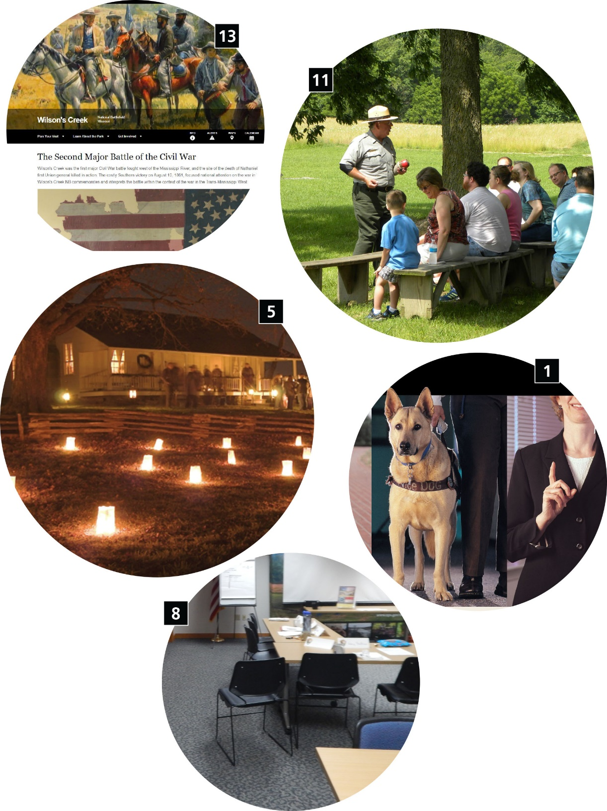

Implementation Strategy
Park policies and practices are specific to the park unit and provide guidance for reaching desired outcomes. Park policies are defined courses of action adopted by the park, while park practices are those habitual and/or customary performances of operations that the park employs.

Posting and Publications

1 Accessibility Flyers Posted in Common Areas
- Place posters in common areas of staff and visitor buildings that provide accessibility-related information, including requirements, contacts, questions, and complaints.
immediate

2 Publications
- Provide large-print format publications. Use a minimum readable typeface at 18-point font. Align flush left and rag right. Avoid hyphens. Use black or white type color and avoid red text. Avoid italicized and underlined text. Provide graphics with at least 70% contrast.
mid-term

Staff Training and Park Protocols

3 Accessibility Awareness Training
- Provide ongoing accessibility awareness training for all staff, including permanent and nonpermanent employees.
immediate

4 Accessible Facilities and Maintenance Training
- Provide ongoing training for maintenance staff on planning, maintaining and constructing accessible facilities, including, but not limited to, restrooms, walks and trails, door pressure requirements, assistive devices, accessible routes, and universal design principles.
immediate

5 Accessible Interpretive Training
- Provide ongoing training for the interpretation and education division.
- Training may include, but is not limited to, how to evaluate programs for accessibility compliance; which websites offer more information; information about service animals; information about Other Power-Driven Mobility Devices (OPDMDs); how and when to offer live audio description programming; accessibility specifications for interpretive tactile models and maps; what assistive technologies are available; universal design principles; visitor services and communication about accessibility. It is also important to provide regular and ongoing visitor information and interpretive staff training in use of, distribution, and procedures for wheelchairs and assistive technology—assistive listening devices, T-coil hearing loops, neck loops, and text telephone machines.
immediate

6 Communication with Law Enforcement
- Provide a standard operation procedure that outlines methods for law enforcement to communicate with a person with a disability.
short-term

7 Emergency Preparedness
- Develop, distribute, and practice standard operating procedures for assisting people with disabilities in the case of an emergency.

8 Movable Seating
- Develop and distribute standard operating procedures for movable cubicles and conference rooms, so there is adequate clear space and accessible routes to all elements in a room or building. Post a map in an area with accessible layout and instructions for use of the space.
- Develop and distribute standard operating procedures for movable seating arrangements and moving things to create an accessible route and maintain integrated accessible seating. Post a map in an area with accessible layout and instructions for use of the space.
short-term

9 Wheelchairs
- Provide a standard operating procedure or guidance for checking out and returning wheelchairs.
- Provide a standard operating procedure or guidance on protocol for pre- and post-inspecting, cleaning, and maintenance of wheelchairs.
- Inform visitors and program participants that wheelchairs are available upon request. Provide information on wheelchair availability in all publications and on signage. Inform visitors using services, activities, and programs that wheelchairs are available upon request.
short-term

Audio and Visual Programs

10 Assistive Listening Devices (ALDs)
- Develop and distribute standard operating procedures or guidance for checking out and returning assistive listening devices.
- Develop and distribute standard operating procedures or guidance describing protocol for pre -and post-inspection of the devices and for cleaning and maintaining all devices.
- Provide signage and information where programs are offered stating device availability. Verbally inform visitors and program participants that auxiliary aids are available. Add information to all publications and communications stating that assistive listening devices are available and provide information on how they can be attained.
short-term

11 Live Audio Description
- Provide live audio descriptions on guided interpretive tours when needed.
short-term

12 Text Telephone (TTY) Machines
- Include TTY number on publications and on the park’s website with the park contact information and phone number.
short-term

Visitor Information

13 Communication
- Provide park e-mail address and telephone number on the park’s website and in publications for questions: gary_p_sullivan@nps.gov
- Develop an accessibility guide for Wilson’s Creek National Battlefield that outlines accessible services, activities, and programs.
mid-term

14 Outreach
- Conduct outreach via social media (Pinterest, Facebook, Snapchat, Twitter, etc.) to describe accessible programs, services, and activities available at the park.
- Conduct outreach via traditional media and other advertising methods to describe accessible programs, services, and activities available at the park.
- Contact groups with disabilities to inform them about the accessible programs, services, and activities that have become available at the park as solutions are implemented.
- Outreach to and engage groups with disabilities to determine appropriate ways to involve them in park accessibility improvement projects as they occur (case-by-case basis).
short-term

15 Sign Language Interpreters
- Develop and distribute standard operating procedures for contacting and scheduling sign language interpreters.
short-term

Concessions and Partnerships

16 Park Partner, Lessee, and Concessionaire Services, Activities, and Programs
- Prepare a standard operating procedure for lessees and park partners about providing accessible programs, services, and activities within the park unit.
mid-term

CONCLUSION
Wilson’s Creek National Battlefield is committed to providing all visitors the opportunity to connect with and learn about the park’s unique natural, cultural, and recreational resources. Accessibility improvements identified in the Wilson’s Creek National Battlefield Self-Evaluation and Transition Plan will make it easier for individuals with cognitive, hearing, vision, and mobility disabilities to discover, understand, and enjoy the range of experiences available at the park. Implementation of the plan will ensure that Wilson’s Creek National Battlefield will continue to work toward accommodating all park visitors while sustaining its legacy to preserve and protect our nation’s history.
The Self-Evaluation and Transition Plan for Wilson’s Creek National Battlefield is a living document intended to be used as a guiding reference for the park as it implements accessibility upgrades and documents accessibility accomplishments. As barriers to accessibility are removed and/or improved, the changes will be updated in this plan. The park will conduct periodic reviews to evaluate and update conditions to reflect accomplishments and to document new programs or other changes that occur over time. Revisions to the plan may include conducting additional assessments for areas not originally conducted as a part of this plan.
The primary goal of the transition plan is to define key park experiences and document modifications needed to provide independent program participation for the widest range of disabilities possible. As the park works towards its accessibility goals and makes the implementation strategy a reality, both physical and programmatic accessibility will improve across the breadth of key park experiences at Wilson’s Creek National Battlefield.
For visitors with mobility disabilities, access will be improved from the moment they enter the park. Facilities, as well as numerous programs, services, and activities the park offers will be more universally accessible. Experiences such as picnicking with friends and family, touring historic battlefield sites, and learning about the human history and environment of the park, will be enhanced.
Park programs will be created and delivered for all visitors, including visitors with mild to severe disabilities impacting their mobility, vision, hearing, and/or cognitive abilities. Ranger-led walks/talks, visitor center exhibits, films, trail waysides, and all materials that interpret park resources to the public will be provided in formats that allow visitors with disabilities to participate fully. Some of those formats include, but are not limited to: large-print transcripts for printed materials, audio description for exhibits and films, assistive listening devices and sign language interpreters for ranger-led tours and programs, T-coil hearing loops for park films.
Over time, the results of this collective effort will make Wilson’s Creek National Battlefield a truly welcoming and accommodating place for all visitors and will provide equal opportunity to access the many places, resources, stories, and experiences the park has to offer.
This page intentionally left blank.

Appendix A: Accessibility Laws, Standards, Guidelines, and NPS Policies Applicable to Wilson’s Creek National Battlefield
As a national park, Wilson’s Creek National Battlefield is required to comply with specific federal laws that mandate that discriminatory barriers be removed to provide equal opportunities to persons with disabilities. The following laws, design guidelines, and Director’s Orders specifically pertain to Wilson’s Creek National Battlefield.

Laws and Standards
A law is a principle and regulation established in a community by some authority and applicable to its people, whether in the form of legislation or of custom and policies recognized and enforced by judicial decision. A standard is something considered by an authority or by general consent as a basis of comparison; an approved model. It is a specific low-level mandatory control that helps enforce and support a law.

Architectural Barriers Act of 1968
http://www.access-board.gov/guidelines-and-standards/buildings-and-sites/about-the-aba-standards/guide-to-the-aba-standards
The Architectural Barriers Act of 1968 requires physical access to facilities designed, built, altered, or leased with federal funds. The Uniform Federal Accessibility Standards (UFAS) are the design guidelines used as the basis for enforcement of the law. The UFAS regulations were adopted in 1984. Architectural Barriers Act Accessibility Standards (ABAAS) were revised and adopted in November 2005. Four federal agencies are responsible for the standards: the Department of Defense, the Department of Housing and Urban Development, the General Services Administration, and the US Postal Service. The United States Access Board was created to enforce the Architectural Barriers Act, which it does through the investigation of complaints. Anyone concerned about the accessibility of a facility that may have received federal funds can easily file a complaint with the United States Access Board.

Section 504 of the Rehabilitation Act of 1973
http://www.law.cornell.edu/cfr/text/43/17.550
To the extent that section 504 of the Rehabilitation Act of 1973 applies to departments and agencies of the federal government, the parks operated by the National Park Service are subject to the provisions of that statute. As will be discussed in the following text, both section 504 and the Architectural Barriers Act require the application of stringent access standards to new construction and the alteration of existing facilities. The Rehabilitation, Comprehensive Services, and Developmental Disabilities Amendments of 1978 (PL 95-602) extends the scope of section 504 of the Rehabilitation Act of 1973 (PL 93-112) to include Executive Branch agencies of the federal government. As amended, section 504 states:
Section 504: No otherwise qualified handicapped individual in the United States, as defined in Section 7 (6), shall, solely by reason of his handicap, be excluded from the participation in, be denied the benefits of, or be subjected to discrimination under any program or activity receiving federal financial assistance or under any program or activity conducted by any Executive agency or by the United States Postal Service. The head of each such agency shall promulgate such regulations as may be necessary to carry out the amendments to this section made by the Rehabilitation, Comprehensive Services, and Developmental Disabilities Act of 1978. Copies of any proposed regulation shall be submitted to appropriate authorizing committees of Congress, and such regulation may take effect no earlier than the thirtieth day after the date on which such regulation is so submitted to such committees.
As noted above, section 504 and the Architectural Barriers Act govern new construction and alterations. However, as a civil rights law, section 504 goes further. Unlike the construction-driven ABA mandates, section 504 also requires covered entities to consider the accessibility of programs, services, and activities.

Section 508 of the Rehabilitation Act of 1973
http://www.section508.gov/
In 1998, Congress amended the Rehabilitation Act of 1973 to require federal agencies to make their electronic and information technology (EIT) accessible to people with disabilities. Inaccessible technology interferes with an ability to obtain and use information quickly and easily. Section 508 was enacted to eliminate barriers in information technology, open new opportunities for people with disabilities, and encourage development of technologies that will help achieve these goals. The law applies to all federal agencies when they develop, procure, maintain, or use electronic and information technology. Under section 508 (29 USC §794 d), agencies must give disabled employees and members of the public access to information that is comparable to access available to others. It is recommended that you review the laws and regulations discussed in the following sections to further your understanding about section 508 and how you can support implementation.

Accessibility Standards for Outdoor Developed Areas
http://www.access-board.gov/guidelines-and-standards/recreation-facilities/outdoor-developed-areas/final-guidelines-for-outdoor-developed-areas
Achieving accessibility in outdoor environments has long been a source of inquiry because of challenges and constraints posed by terrain, the degree of development, construction practices and materials, and other factors. The new provisions address access to trails, picnic and camping areas, viewing areas, beach access routes, and other components of outdoor developed areas on federal sites when newly built or altered. They also provide exceptions for situations where terrain and other factors make compliance impracticable. In 2013, this final rule amended the Architectural Barriers Act Accessibility Guidelines by adding scoping and technical requirements for camping facilities, picnic facilities, viewing areas, trails, and beach access routes constructed or altered by or on behalf of federal agencies. The final rule ensures that these facilities are readily accessible to and usable by individuals with disabilities. The final rule applies to the following federal agencies and their components that administer outdoor areas developed for recreational purposes: Department of Agriculture (Forest Service); Department of Defense (Army Corps of Engineers); and Department of the Interior (Bureau of Land Management, Bureau of Reclamation, Fish and Wildlife Service, National Park Service). The final rule also applies to nonfederal entities that construct or alter recreation facilities on federal land on behalf of the federal agencies pursuant to a concession contract, partnership agreement, or similar arrangement.

Accessibility Standards for Shared Use Paths
http://www.access-board.gov/guidelines-and-standards/streets-sidewalks/shared-use-paths
Shared use paths provide a means of off-road transportation and recreation for various users, including pedestrians, bicyclists, skaters, and others, including people with disabilities. In its rulemaking on public rights-of-way and on trails and other outdoor developed areas, comments from the public urged the board to address access to shared use paths because they are distinct from sidewalks and trails. Shared-use paths, unlike most sidewalks, are physically separated from streets by an open space or barrier. They also differ from trails because they are designed not just for recreation purposes but for transportation as well.
In response, the board is supplementing its rulemaking on public rights-of-way to also cover shared-use paths. The proposed rights-of-way guidelines, which address access to sidewalks, streets, and other pedestrian facilities, provide requirements for pedestrian access routes, including specifications for route width, grade, cross slope, surfaces, and other features. The board proposes to apply these and other relevant requirements to shared-use paths as well. This supplementary rulemaking also would add provisions tailored to shared-use paths into the rights-of-way guidelines.

Draft Accessibility Standards for Public Rights-of-Way
http://www.access-board.gov/guidelines-and-standards/streets-sidewalks/public-rights-of-way
Sidewalks, street crossings, and other elements in the public right-of-way can pose challenges to accessibility. The United States Access Board’s ADA and ABA Accessibility Guidelines focus mainly on facilities on sites. While they address certain features common to public sidewalks, such as curb ramps, further guidance is necessary to address conditions and constraints unique to public rights-of-way.
The board is developing new guidelines for public rights-of-way that will address various issues, including access for blind pedestrians at street crossings, wheelchair access to on-street parking, and various constraints posed by space limitations, roadway design practices, slope, and terrain. The new guidelines will cover pedestrian access to sidewalks and streets, including crosswalks, curb ramps, street furnishings, pedestrian signals, parking, and other components of public rights-of-way. The board’s aim in developing these guidelines is to ensure that access for persons with disabilities is provided wherever a pedestrian way is newly built or altered, and that the same degree of convenience, connection, and safety afforded the public generally is available to pedestrians with disabilities. Once these guidelines are adopted by the Department of Justice, they will become enforceable standards under ADA Title II.

Effective Communication
http://www.ada.gov/effective-comm.htm
People who have vision, hearing, or speech disabilities (“communication disabilities”) use different ways to communicate. For example, people who are blind may give and receive information audibly rather than in writing and people who are deaf may give and receive information through writing or sign language rather than through speech. The ADA requires that Title II entities (state and local governments) and Title III entities (businesses and nonprofit organizations that serve the public) communicate effectively with people who have communication disabilities. The goal is to ensure that communication with people with disabilities is equally effective as communication with people without disabilities.
- The purpose of the effective communication rules is to ensure that the person with a vision, hearing, or speech disability can communicate with, receive information from, and convey information to, the covered entity.
- Covered entities must provide auxiliary aids and services when needed to communicate effectively with people who have communication disabilities.
- The key to communicating effectively is to consider the nature, length, complexity, and context of the communication and the person’s normal method(s) of communication.
The rules apply to communicating with the person who is receiving the covered entity’s goods or services, as well as with that person’s parent, spouse, or companion in appropriate circumstances.

Reasonable Accommodations
http://www.opm.gov/policy-data-oversight/disability-employment/reasonable-accommodations/
Federal agencies are required by law to provide reasonable accommodation to qualified employees with disabilities. The federal government may provide reasonable accommodation based on appropriate requests (unless so doing will result in undue hardship to the agencies). For more information, see the Equal Employment Opportunity Commission’s Enforcement Guidance: Reasonable Accommodation and Undue Hardship under the Americans with Disabilities Act (external link).
Reasonable accommodations can apply to the duties of the job and/or where and how job tasks are performed. The accommodation should make it easier for the employee to successfully perform the duties of the position. Examples of reasonable accommodations include providing interpreters, readers, or other personal assistance; modifying job duties; restructuring work sites; providing flexible work schedules or work sites (i.e., telework); and providing accessible technology or other workplace adaptive equipment. Telework (external link) provides employees additional flexibility by allowing them to work at a geographically convenient alternative worksite, such as home or a telecenter, on an average of at least one day per week.
Requests are considered on a case-by-case basis. To request reasonable accommodations:
- Look at the vacancy announcement.
- Work directly with person arranging the interviews.
- Contact the agency Selective Placement Program Coordinator.
- Contact the hiring manager and engage in an interactive process to clarify what the person needs and identify reasonable accommodations.
- Make an oral or written request; no special language is needed.

Other Power-Driven Mobility Devices
http://www.ada.gov/regs2010/ADAregs2010.htm
The definition and regulation to permit the use of mobility devices has been amended. The rule adopts a two-tiered approach to mobility devices, drawing distinctions between wheelchairs and other power-driven mobility devices such as the Segway Human Transporter. Wheelchairs (and other devices designed for use by people with mobility impairments) must be permitted in all areas open to pedestrian use. Other power-driven mobility devices must be permitted for use unless the covered entity can demonstrate that such use would fundamentally alter its programs, services, or activities, create a direct threat, or create a safety hazard. The rule also lists factors to consider in making this determination.

Service Animals
http://www.nps.gov/goga/planyourvisit/service-animals.htm
The following is excerpted from the Department of Justice and Americans with Disabilities Act Revised Regulations (effective 3/15/2011).
34.104 Definitions: Service animal means any dog [or miniature horse as outlined in the following text] that is individually trained to do work or perform tasks for the benefit of an individual with a disability, including a physical, sensory, psychiatric, intellectual, or other mental disability. Other species of animals, whether wild or domestic, trained or untrained, are not service animals for the purposes of this definition. The work or tasks performed by a service animal must be directly related to the handler’s disability. Examples of work or tasks include, but are not limited to, assisting individuals who are blind or have low vision with navigation and other tasks, alerting individuals who are deaf or hard of hearing to the presence of people or sounds, providing nonviolent protection or rescue work, pulling a wheelchair, assisting an individual during a seizure, alerting individuals to the presence of allergens, retrieving items such as medicine or the telephone, providing physical support and assistance with balance and stability to individuals with mobility disabilities, and helping persons with psychiatric and neurological disabilities by preventing or interrupting impulsive or destructive behaviors. The crime deterrent effects of an animal’s presence and the provision of emotional support, well-being, comfort, or companionship do not constitute work or tasks for the purposes of this definition.
  - General. Generally, a public entity shall modify its policies, practices, or procedures to permit the use of a service animal by an individual with a disability.
  - Exceptions. A public entity may ask an individual with a disability to remove a service animal from the premises if-
      - The animal is out of control and the animal’s handler does not take effective action to control it; or
      - The animal is not housebroken.
  - If an animal is properly excluded. If a public entity properly excludes a service animal under § 35.136(b), it shall give the individual with a disability the opportunity to participate in the service, program, or activity without having the service animal on the premises.
  - Animal under handler’s control. A service animal shall be under the control of its handler. A service animal shall have a harness, leash, or other tether, unless either the handler is unable because of a disability to use a harness, leash, or other tether, or the use of a harness, leash, or other tether would interfere with the service animal’s safe, effective performance of work or tasks, in which case the service animal must be otherwise under the handler’s control (e.g., voice control, signals, or other effective means).
  - Care or supervision. A public entity is not responsible for the care or supervision of a service animal.
  - Inquiries. A public entity shall not ask about the nature or extent of a person’s disability, but may make two inquiries to determine whether an animal qualifies as a service animal. A public entity may ask if the animal is required because of a disability and what work or task the animal has been trained to perform. A public entity shall not require documentation, such as proof that the animal has been certified, trained, or licensed as a service animal. Generally, a public entity may not make these inquiries about a service animal when it is readily apparent that an animal is trained to do work or perform tasks for an individual with a disability (e.g., the dog is observed guiding an individual who is blind or has low vision, pulling a person’s wheelchair, or providing assistance with stability or balance to an individual with an observable mobility disability).
  - Access to areas of a public entity. Individuals with disabilities shall be permitted to be accompanied by their service animals in all areas of a public entity’s facilities where members of the public, participants in services, programs or activities, or invitees, as relevant, are allowed to go.
  - Surcharges. A public entity shall not ask or require an individual with a disability to pay a surcharge, even if people accompanied by pets are required to pay fees, or to comply with other requirements generally not applicable to people without pets. If a public entity normally charges individuals for the damage they cause, an individual with a disability may be charged for damage caused by his or her service animal.
  - Miniature horses.
      - Reasonable modifications. A public entity shall make reasonable modifications in policies, practices, or procedures to permit the use of a miniature horse by an individual with a disability if the miniature horse has been individually trained to do work or perform tasks for the benefit of the individual with a disability.
      - Assessment factors. In determining whether reasonable modifications in policies, practices, or procedures can be made to allow a miniature horse into a specific facility, a public entity shall consider-
        - The type, size, and weight of the miniature horse and whether the facility can accommodate these features;
        - Whether the handler has sufficient control of the miniature horse;
        - Whether the miniature horse is housebroken; and
        - Whether the miniature horse’s presence in a specific facility compromises legitimate safety requirements that are necessary for safe operation.
        - Other requirements. Paragraphs 35.136 (c) through (h) of this section, which apply to service animals, shall also apply to miniature horses.

Section 17.549 Program Accessibility: Discrimination Prohibited
http://www.law.cornell.edu/cfr/text/43/17.549
Except as otherwise provided in §17.550, no qualified handicapped person shall, because the agency’s facilities are inaccessible to or unusable by handicapped persons, be denied the benefits of, be excluded from participation in, or otherwise be subjected to discrimination under any program or activity conducted by the agency.
The reference to §17.550 in the below quotes is intended to address exclusions available to covered entities in connection with existing facilities.

Section 17.550 Program Accessibility: Existing Facilities
http://www.law.cornell.edu/cfr/text/43/17.550
- General. The agency shall operate each program or activity so that the program or activity, when viewed in its entirety, is readily accessible to and usable by people with disabilities. This paragraph does not:
- Necessarily require the agency to make each of its existing facilities or every part of a facility accessible to and usable by people with disabilities;
- In the case of historic preservation programs, require the agency to take any action that would result in a substantial impairment of significant historic features of an historic property; or
- Require the agency to take any action that it can demonstrate would result in a fundamental alteration in the nature of a program or activity or in undue financial and administrative burdens. In those circumstances where agency personnel believe that the proposed action would fundamentally alter the program or activity or would result in undue financial and administrative burdens, the agency has the burden of proving that compliance with §17.550(a) would result in such an alteration or burdens. The decision that compliance would result in such alteration or burdens must be made by the agency head or his or her designee after considering all agency resources available for use in the funding and operation of the conducted program or activity, and must be accompanied by a written statement of the reasons for reaching that conclusion. If an action would result in such an alteration or such burdens, the agency shall take any other action that would not result in such an alteration or such burdens but would nevertheless ensure that handicapped persons receive the benefits and services of the program or activity.
- Methods.
- General. The agency may comply with the requirements of this section through such means as redesign of equipment, reassignment of services to accessible locations, assignment of aides to beneficiaries, home visits, delivery of services at alternate accessible sites, alteration of existing facilities and construction of new facilities, use of accessible rolling stock, or any other methods that result in making its programs or activities readily accessible to and usable by people with disabilities. The agency is not required to make structural changes in existing facilities where other methods are effective in achieving compliance with this section. The agency, in making alterations to existing buildings, shall meet accessibility requirements to the extent compelled by the Architectural Barriers Act of 1968, as amended (42 USC 4151–4157) and any regulations implementing it. In choosing among available methods for meeting the requirements of this section, the agency shall give priority to those methods that offer programs and activities to qualified handicapped persons in the most integrated setting appropriate.
- Historic preservation programs. In meeting the requirements of paragraph (a) of this section in historic preservation programs, the agency shall give priority to methods that provide physical access to handicapped persons. In cases where a physical alteration to an historic property is not required because of paragraph (a)(2) or (a)(3) of this section, alternative, methods of achieving program accessibility include:
- Using audio-visual materials and devices to depict those portions of an historic property that cannot otherwise be made accessible;
- Assigning persons to guide people with disabilities into or through portions of historic properties that cannot otherwise be made accessible; or
- Adopting other innovative methods.
- Recreation programs. In meeting the requirements of paragraph (a) in recreation programs, the agency shall provide that the program or activity, when viewed in its entirety, is readily accessible to and usable by people with disabilities. When it is not reasonable to alter natural and physical features, accessibility may be achieved by alternative methods as noted in paragraph (b)(1) of this section.

Section 17.551 Program Accessibility: New Construction and Alterations
http://www.law.cornell.edu/cfr/text/43/17.551
Each building or part of a building that is constructed or altered by, on behalf of, or for the use of the agency shall be designed, constructed, or altered so as to be readily accessible to and usable by handicapped persons. The definitions, requirements, and standards of the Architectural Barriers Act (42 USC 4151–4157) as established in 41 CFR 101 – 19.600 to 101 – 19.607 apply to buildings covered by this section.

National Park Service Director’s Orders and Management Policies
A policy is a definite course of action adopted and pursed by a government, ruler, or political party. It is an action or procedure conforming to or considered with reference to prudence or expediency.

Director’s Order 16A
http://www.nps.gov/policy/DOrders/DOrder16a.html
Director’s Order 16A establishes the framework for meeting reasonable accommodation requirements in all areas of employment, including: application, hiring, retention, promotion, recognition, and special hiring authority. Within this framework, NPS Human Resources and Equal Opportunity Program officials will take the lead in providing specific guidance and services to applicants, employees, and supervisors and other managers with respect to the provision of reasonable accommodation.

Director’s Order 42
http://www.nps.gov/policy/DOrders/DOrder42.html
Director’s Order 42 addresses accessibility for visitors with disabilities in National Park Service programs and services. It is the goal of the National Park Service to ensure that all people, including persons with disabilities, have the highest level of access that is reasonable to NPS programs, facilities, and services. The order gives detailed guidance based on the minimum requirements set forth in laws, rules, and regulations with the goal to provide the highest level of access that is reasonable, exceeding the minimum level of access required by law. The order sets forth six implementation strategies:
- to increase employee awareness and technical understanding of accessibility requirements
- to ensure all new and renovated buildings and facilities, and all new services and programs (including those offered by concessioners and interpreters) will be “universally designed” and implemented in conformance with applicable regulations and standards
- to ensure existing programs, facilities and services will be evaluated to determine the degree to which they are currently accessible to and useable by individuals with disabilities
- to ensure that barriers that limit access be identified and incorporated into the NPS Assets Management Program
- to develop action plans identifying how identified barriers will be removed (where feasible)
- to ensure action will be taken on a day-to-day basis to eliminate identified barriers, using existing operational funds or other funding sources or partnerships

National Park Service Management Policies: Section 1.9.3 – Accessibility for Persons with Disabilities
http://www.nps.gov/policy/mp/policies.html
All practicable efforts will be made to make NPS facilities, programs, services, employment, and meaningful work opportunities accessible and usable by all people, including those with disabilities. This policy reflects the commitment to provide access to the widest cross section of the public and ensure compliance with the Architectural Barriers Act of 1968, the Rehabilitation Act of 1973, the Equal Employment Opportunity Act of 1972, and Americans with Disabilities Act of 1990. Specific guidance for implementing these laws is found in the Secretary of the Interior’s regulations regarding enforcement and nondiscrimination on the basis of disability in Department of the Interior programs (43 CFR par 17, subpart E), and the General Service Administration’s regulations adopting accessibility standards for the Architectural Barriers Act (41 CFR part 102-76, subpart C).
A primary principle of accessibility is that, to the highest degree practicable, people with disabilities should be able to participate in the same programs, activities, and employment opportunities available to everyone else. In choosing among methods of providing accessibility, higher priority will be given to methods that offer programs and activities in the most integrated setting appropriate. Special, separate, or alternative facilities, programs, or services will be provided only when existing ones cannot reasonable be made accessible. The determination of what is practicable will be made only after careful consultations with persons with disabilities or their representatives. Any decisions that would result in less than equal opportunity is subject the filing of an official disability right complain under the departmental regulations cited above.

Guidelines
A guideline is an indication of a future course of action. It consists of recommended, nonmandatory controls that help support standards or serve as a reference when no applicable standard is in place.

Programmatic Accessibility Guidelines for National Park Service Interpretive Media
http://www.nps.gov/hfc/accessibility/
The “Programmatic Accessibility Guidelines for National Park Service Interpretive Media” is for media specialists, superintendents, and other NPS employees and contractors who develop and approve interpretive media. Publications, exhibits, audiovisual programs and tours, wayside exhibits, signage, and web-based media provide park visitors with information and context so that their experience of visiting national parks can be both safe and meaningful. Park visitors who have physical, sensory, or cognitive disabilities have legally established civil rights to receive the same information and context that NPS interpretive media products have always provided to their fellow citizens.

Appendix B: Glossary of Terms
Accessibility assessment: A process in which physical and programmatic barriers to accessibility are identified at a park unit.
Accessibility assessment team: This group is a subgroup of the Interdisciplinary Design Team (see definition below) and includes an accessibility specialist and/or technician, coordinators, a regional representative, the primary facilitator for the process, architect, engineer and/or landscape architect, and typically the chiefs of interpretation, resources management, and facilities management.
Accessibility Self-Evaluation and Transition Plan: A tool that establishes a methodical process for identifying and improving parkwide access and proposes strategies for implementing the plan over time, in a manner consistent with park requirements and protocols.
Architectural Barriers Act Accessibility Standard (ABAAS): Standards issued under the Architectural Barriers Act apply to facilities designed, built, altered, or leased with certain federal funds. Passed in 1968, the Architectural Barriers Act is one of the first laws to address access to the built environment. The law applies to federal buildings, including post offices, social security offices, federal courthouses and prisons, and national parks.
Barrier: Architectural and programmatic obstacles to accessibility that make it difficult, and sometimes impossible, for people with disabilities to maneuver, understand, or experience.
Best practice: A method or technique that has consistently shown results superior to those achieved with other means, and that is used as a benchmark for meeting accessibility requirements.
Consultation: A formal or informal process for discussing an action or process for implementing a solution, such as section 106 (cultural resource compliance), or design for an Accessibility Self-Evaluation and Transition Plan.
Facility Management Software System (FMSS) work order: The process for documenting work needs and collecting information to aid the work scheduling and assignment process within the Facility Management Software System. Information collected should include labor, equipment and material costs, hours, types, and quantities.
Guideline: A guideline is an indication of a future course of action. It consists of recommended, nonmandatory controls that help support standards or serve as a reference when no applicable standard is in place.
Interdisciplinary design team: This team is composed of all the people involved in the workshop at the park unit, potentially including planning, design, and construction professionals; and interpretive, resource (natural and cultural), visitor safety, maintenance and accessibility specialists.
Key park experience: For the purpose of the Self-Evaluation and Transition Plan, key park experiences are those experiences that are iconic and essential for visitors to understand the purpose and significance of a given park unit. They are those experiences that are “musts” for all park visitors. Key park experiences can be identified through a consideration of park purpose, significance, interpretive themes, and those programs or activities highlighted in park communications.
Law: A law is a principle and regulation established in a community by some authority and applicable to its people, whether in the form of legislation or of custom and policies recognized and enforced by judicial decision.
National Environmental Policy Act (NEPA) Requirements: NEPA defines a process that federal agencies must follow when proposing to take actions that have environmental impacts. NEPA requires federal agencies to fully consider the impacts of proposals that would affect the human environment prior to deciding to take an action. NEPA also requires federal agencies to involve the interested and affected public in the decision-making process.
Park area: A park area is the geographic location that is home to a single or multiple key park experience(s).
Park Asset Management Plan-Optimizer Banding (PAMP-OB): Provides a 5-year asset management strategy for park units, allowing for annual updates that coincide with the budget and planning processes already occurring in park units. As this approach includes life cycle total cost of ownership, analysis, processing, and calculations, it also helps park units and the service as a whole to manage the gap between what should be spent on facilities and what is actually being spent.
Park policy: A policy is a definite course of action adopted and pursed by a government, ruler, or political party. It is an action or procedure conforming to or considered with reference to prudence or expediency.
Park practice: Those habitual and/or customary performances or operations for reaching a desired outcome that the park employs.
People-first language: A type of disability etiquette that aims to avoid perceived and subconscious dehumanization when discussing people with disabilities. It emphasizes the person rather than the disability, noting that the disability is not the primary defining characteristic of the individual but one of several aspects of the whole person.
Project Management Information System (PMIS) Facility: A separate and individual building, structure, or other constructed real property improvement.
Project Management Information System (PMIS) Nonfacility: A project that includes anything not covered by the definition for PMIS facility
Project Management Information System (PMIS) # (number): A unique Project ID Number that is automatically generated when adding a new project into the Project Management Information System
Project planning team: This group is a subgroup of the interdisciplinary design team and includes DSC planners and MWR staff. This team collects baseline data, facilitates calls, develops the participant guide, plans for and facilitates the workshop, and produces the draft and final documents.
Readily achievable: Easily accomplished and able to be carried out without much difficulty or expense.
Recommended solution: The action to eliminate the identified barrier.
Responsible person: The person/position responsible for seeing that the elimination of a barrier is completed.
Service, activity, and program: A service, activity, or program that is undertaken by a department and affords benefits, information, opportunities, and activities to one or more members of the public.
Standard: A standard is something considered by an authority or by general consent as a basis of comparison; an approved model. It is a specific low-level mandatory control that helps enforce and support a law.
Time frame: Time frames for implementation of a recommended solution are primarily based on park’s ability of the park to complete the improvements within normal scheduling of park operations and planned projects. They describe when staff will eliminate the barrier. Recommended solutions are divided into four time frames including: immediate, short-term, mid-term, and long-term.

Appendix C: Contributors
Wilson’s Creek National Battlefield
Ted Hillmer, Superintendent
Gary Sullivan, Supervisory Natural Resource Management Specialist
and Accessibility Coordinator
Angie Pirotte, Administrative Assistant
Jeff Patrick, Librarian
Jordan Foster, Protection Park Ranger
John Sutton, Supervisory Park Ranger
Connie Langum, Historian
Billie Aschwege, Visitor Use Assistant
Brian Beeson, Maintenance Mechanic
Shawn (Matthew) Pearce, Supervisory Facilities Operations Specialist

Midwest Regional Office
David Thompson, Midwest Region Program Manager
Holly Griesemer, Program Analyst

Denver Service Center
Tamara Delaplane, Project Manager and Landscape Architect
Katie Ryan, Project Specialist and Landscape Architect
Laura Watt, Editor

Appendix D: Park Areas Not Assessed
The following park areas are those not assessed for this Accessibility Self-Evaluation and Transition Plan. The selection process determined that key park experiences provided in these park areas were available in an equivalent way within the areas that were assessed. If any of the park areas not assessed are improved by new construction or alterations in the future, the area will be assessed and improved to comply with the current Architectural Barriers Act Accessibility Standards.
Rationales are provided below for park areas not assessed for this plan:
Park Area | Rationale
East Battlefield Overlook and Trail | This park area is connected to four key park experiences, including learning about events related to the Battle of Wilson’s Creek; touring major points on the battlefield; reflecting on impacts of war and tragedy of loss; and enjoying passive recreation opportunities. It has very low visitation levels and a very low diversity of services, activities, and programs. The overlook is steep and contains stairs. A similar visitor experience is provided at Stop #3. .
Edwards Cabin/Price's Headquarters and Trail | This park area is connected to four key park experiences, including learning about events related to the Battle of Wilson’s Creek; touring major points on the battlefield; reflecting on impacts of war and tragedy of loss; and enjoying passive recreation opportunities. It has low visitation levels and a very low diversity of services, activities, and programs. The site requires a lengthy section of trail to access. A similar visitor experience is provided at Stop #5.
Gibson's Mill Trail | This park area is connected to four key park experiences, including learning about events related to the Battle of Wilson’s Creek; touring major points on the battlefield; reflecting on impacts of war and tragedy of loss; and enjoying passive recreation opportunities. It has low visitation levels and a low diversity of services, activities, and programs. Visitation is low in part due to the low number of services, activities, and programs provided and presence of all these missing elements at Stop #1 where the trail is accessed. A similar visitor experience is provided at Stop #1.
Pulaski Arkansas Battery and Trail | This park area is connected to five key park experiences, including learning about events related to the Battle of Wilson’s Creek; touring major points on the battlefield; reflecting on impacts of war and tragedy of loss; viewing museum collections, exhibits, artifacts, and media; and enjoying passive recreation opportunities. It has very low visitation levels and a very low diversity of services, activities, and programs. The trail is very steep in areas making it difficult to access. A similar visitor experience is provided at Stop #3.
Stop #4 | This park area is connected to four key park experiences, including learning about events related to the Battle of Wilson’s Creek; touring major points on the battlefield; reflecting on impacts of war and tragedy of loss; and enjoying passive recreation opportunities. It has fairly low visitation levels and a fairly low diversity of services, activities, and programs. Stop #4 offers the least amount of services, activities, and programs as it is a drive-by wayside. Visitors do not stay long and often don’t exit their vehicles A similar visitor experience is provided at Stop #5.
Stop #8 | This park area is connected to four key park experiences, including learning about events related to the Battle of Wilson’s Creek; touring major points on the battlefield; reflecting on impacts of war and tragedy of loss; and enjoying passive recreation opportunities. It has low visitation levels and a low diversity of services, activities, and programs. Stop #8 consists of a small trail that requires several steps to complete. A similar visitor experience is provided at Stop #5.

Appendix E: Actions Taken by the Park
Identification no. ______
Record this identification number in the implementation table where this action is identified. Use this template to track and document accessibility actions and accomplishments throughout the park.

Action Taken by Wilson’s Creek National Battlefield

Location: [Park Area]
Barrier:
Action taken:
Date work was completed:
PMIS Number(s) and Title(s):
Cost:
Photograph(s), sketches, or notes documenting completed work:

Submitted by:
Date:

Appendix F: Guidance for Preparing PMIS Packages for Accessibility Improvements
Project description: Clearly identify what improvements will be addressed as part of the package. Also identify the park location and facility for planned work. Reference work orders for all applicable types of planned work, e.g., deteriorated conditions to be improved (deferred maintenance), health and safety improvements, and code compliance issues such as accessibility improvements. Provide measurements of areas to be improved, e.g., square footage, lineal footage, etc.

Project justification: Reference the recently completed “Accessibility Self-Evaluation and Transition Plan” for your park and the implementation strategy dates. Identify the number of visitors affected and other beneficial aspects of the project. You can cite legal and management policies as noted below:
- The Architectural Barriers Act (ABA) of 1968 requires that any building or facility designed, constructed, altered, or leased with federal funds be accessible and usable by any individuals with disabilities. In addition, Section 504 of the Rehabilitation Act of 1973 requires covered entities to consider the accessibility of programs, services, and activities. In 2006, the Architectural Barriers Act Accessibility Standards (ABAAS) were adopted for federal facilities. Subsequently in 2011, standards for Recreational Facilities were added to ABAAS as Chapter 10.
- The National Park Service recommitted to making our parks and programs truly accessible to all in the “A Call to Action”. The recently released “ALL IN! Accessibility in the National Park Service 2015-2020” included three goals for improved visitor access. This project addresses: Goal 1: Create a welcoming environment by increasing the ability of the National Park Service to serve visitors and staff with disabilities; Goal 2: Ensure that new facilities and programs are inclusive and accessible to people with disabilities; and Goal 3: Upgrade existing facilities, programs, and services to be accessible to people with disabilities.
Potential eligible fund sources: Accessibility projects are potentially eligible for a number of NPS fund sources and can be competitive in regard to the capital investment strategy. The following is a list of possible fund sources:
- Repair/rehabilitation program—identify all work orders that pertain for deferred maintenance, code compliance, health and safety, etc.
- Flex park base—accessibility is an NPS emphasis area for years 2015-2020.
- Recreation fee 80% park—excellent fund source for accessibility as the project provides for visitor improvements. This should be a top choice for Fee80 parks.
- Recreation fee 20% park—excellent fund source for accessibility as the project provides for visitor improvements.
- Concession/permitted facilities—consider these fund sources when the facility is included in a Concession contract or permit.
- Regular cyclic maintenance—excellent fund source for replacement of picnic tables, grills, trash containers, etc.
- Exhibit cyclic maintenance—excellent fund source for replacing non-compliant waysides, exhibits, etc.
- FLHP—include accessibility improvements with parking lot, parking spaces, accessible routes, curb cuts, sidewalks, signage, etc. as part of road improvement projects where appropriate.
- Line item construction (LIC) —if you have a project in the LIC program, ensure inclusion of all appropriate accessibility improvements.
PMIS packages: Conduct a search in PMIS for projects previously funded for accessibility.

Appendix G: Trail Summary Sheets

[name of trail]
Trail Access Information Summary
Park Name | Wilson’s Creek National Battlefield | —
Trail Name | [Name of trail] | —
Segment | [Segment information] | —
Type | — | —
Length | [Length information] | —
Elevation Gain | [Elevation gain] file] | —
Elevation Loss | [Elevation loss information] | —
Trail Uses Allowed | — | —
— | — | —
— | — | —
Trail Uses NOT Allowed | — | —
— | — | —
— | — | —
Typical Grade | [%] | Max = [X%]
Intermediate | — | —
Maximum | — | —
— | Standard Ramp Grade is [X%] | —
Typical Cross Slope | [%] | Max = [X%]
Intermediate | — | —
Maximum | — | —
Typical Tread Width | [X in (X cm)] | Min = [X in (X cm)]
Intermediate | — | —
Minimum | — | —
Surface Type | [Surface Type] | —
Surface Category | X % of Trail is [Surface Type] | X % of Trail is [Surface Type]
— | X % of Trail is [Surface Type] | X % of Trail is [Surface Type]
— | X % of Trail is [Surface Type] | —
Firmness | Typical: X | Minimum: X
Stability | Typical: X | Minimum: X
*Dashes were added to make table 508 compliant. Please replace with applicable information where needed.

Obstructions:
Type: | Size (Height): | Remaining Tread: | Location:
X | X in (X cm) | X in (X cm) | X ft. (X m)
X | X in (X cm) | X in (X cm) | X ft. (X m)
X | X in (X cm) | X in (X cm) | X ft. (X m)
Warning: [Add notes from rtf file]
[Add notes from rtf file]
Signage created by Beneficial Designs Inc. from data collected by a Certified Trail Assessment Coordinator using the High Efficiency Trail Assessment Process (HETAP).

Appendix H: Trail Assessment Protocol
References: Architectural Barrier Act Accessibility Standards (ABAAS)
- Chapter 2 Scoping Requirements: Section F247 Trails, Section F216.13 Trailhead Signs
- Chapter 10 Recreation Facilities, Section 1017 Trails, Section 1019 Condition for Exceptions
Background standards: The ABAAS trail accessibility requirements are included in “Chapter 2 Scoping Requirements” and “Chapter 10 Recreation Facilities.” Refer to ABAAS for the complete standards prior to planning any trail work or conducting assessments; the following bullets highlight some pertinent sections of the standards in regard to conducting assessments:
- F216.13 Trailhead Signs. Where new trail information signs are provided at trailheads on newly constructed or altered trails designed for use by hikers or pedestrians, the signs shall comply with 1017.10.
- F247.1 General. Where a trail is designed for use by hikers or pedestrians and directly connects to a trailhead or another trail that substantially meets the requirements in 1017, the trail shall comply with 1017. A trail system may include a series of connecting trails. Only trails that directly connect to a trailhead or another trail that substantially meets the requirements in 1017 are required to comply with 1017.
- F247.1 Advisory Trails. Trails that have a designed use for hikers or pedestrians are required to comply with 1017. Trails that have a designed use for other than hikers or pedestrians are not required to comply with 1017.
- F247.2 Existing Trails. Where the original design, function, or purpose of an existing trail is changed and the altered portion of the trail directly connects to a trailhead or another trail that substantially meets the requirements in 1017, the altered portion of the trail shall comply with 1017.
- F247.4 Advisory Trail Facilities. Facilities are required to comply with F247.4 regardless of whether the trail complies with 1017. (Note: this includes camping facilities, picnic facilities, and viewing areas that must comply with appropriate standards.)
- F247.5 Outdoor Constructed Features. Where outdoor constructed features are provided on trails, other than within facilities specified in F247.4, at least 20 percent, but not less than one, of each type of outdoor constructed feature at each location shall comply with 1011.
- 1017.1 General. Trails shall comply with 1017.
  - Exception 1. When an entity determines that a condition in 1019 (see below) does not permit full compliance with a specific provision in 1017 on a portion of a trail, the portion of the trail shall comply with the provision to the extent practicable.
  - Exception 2. After applying Exception 1, when an entity determines that it is impracticable for the entire trail to comply with 1017, the trail shall not be required to comply with 1017.
- 1017.1 Advisory General Exception 2. An entity must apply Exception 1 before using Exception 2. The entity should consider the portions of the trail that can and cannot fully comply with the specific provisions in 1017 and the extent of compliance where full compliance cannot be achieved when determining whether it would be impracticable for the entire trail to comply with 1017. The determination is made on a case-by-case basis. Federal agencies must document the basis for their determination when using Exceptions 1 or 2, and must notify the Access Board when using Exception 2.
- 1019.1 General (Conditions for Exceptions). Exceptions to specific provisions in 1017 shall be permitted when an entity determines that any of the following conditions does not permit full compliance with the provision:
- Compliance is not practicable due to terrain.
Compliance cannot be accomplished with the prevailing construction practices.
Compliance would fundamentally alter the function or purpose of the facility or the setting.
Compliance is limited or precluded by any of the following laws, or by decisions or opinions issued or agreements executed pursuant to any of the following laws:
  - Endangered Species Act (16 U.S.C. §§ 1531 et seq.);
  - National Environmental Policy Act (42 U.S.C. §§ 4321 et seq.);
  - National Historic Preservation Act (16 U.S.C. §§ 470 et seq.);
  - Wilderness Act (16 U.S.C. §§ 1131 et seq.); or
  - Other federal, state, or local law the purpose of which is to preserve threatened or endangered species; the environment; or archaeological, cultural, historical, or other significant natural features.
- 1019.1 Clarification. Entities should consider all design options before using the exceptions. On trails, the exceptions apply only on the portion of the route where the condition applies. The trail is required to fully comply with the provisions in 1017, as applicable, at all other portions of the route where the conditions do not apply. There are additional exceptions that apply to an entire trail in 1017.1.
Identifying trails for assessments: Parks vary considerably in what key experiences are provided to visitors. A small historical park may have minimal or no trails but will have various walks and outdoor recreation access routes providing universal access. Some parks may have a few identified trails that they provide for universal access. While at other parks, the primary key experience for visitors may be the recreational trail system.
There are various sources of information to inform a decision on which trails to assess as part of the SETP process. The following sources can be researched and actions taken when identifying what trails are appropriate for assessment:
Sources:
- Trails that the park has identified in visitor information as being wheelchair accessible to visitors with disabilities.
- There are five classifications of trails defined within FMSS including:
  - Class 1 primitive/undeveloped
  - Class 2 simple/minor development
  - Class 3 developed/improved
  - Class 4 highly developed
  - Class 5 fully developed.
Note: Class 4 and class 5 trails by definition have potential for universal access.
- FMSS trail listings in which parks have identified those trails that are ABA compliant and/or ABA designated trails. In December 2015, there were 98 trails in 32 parks identified in the region meeting those requirements.
Actions:
- Select a representative number of trails for assessment to provide visitors the maximum access to key park experiences. Eliminate those trails that are not practical because of terrain, cannot be altered to meet standards with prevailing construction practices, or exempt as a result of environmental or historical laws. For each trail, document within the park evaluation the reasons for elimination.
- Outdoor recreation facilities are often targeted in ABAAS to provide for access to at least 20% of the facilities but not less than one of each type of facility at each location. The 20% figure could be used as a general guide in identifying the number of trails to be assessed at various locations.
- Evaluate what is a reasonable expectation for making trail improvements in the 10-year time-frame of the transition plan. Possibly four to six trail assessments would be the maximum scheduling capacity for trail improvements at a park within 10 years. Identify planned trail assessments and improvements for each time frame category.
- Requirements for trail assessments: ABAAS Section 1017 provides the access standards for constructing and altering trails. These standards shall also be used for the assessment process. It is critical to note that although a trail may not meet Section 1017 accessibility standards, all constructed facilities on the trail or at the destination must comply with ABAAS standards, i.e., camping, picnicking, view areas, restrooms and other constructed facilities. Many visitors with disabilities can navigate non-standard trails into the backcountry but upon arrival may be unable to use constructed facilities with physical barriers. The only exemption for backcountry facilities is the primitive outhouse with riser on a hole dug into the ground.
Trailhead signs: Trail information signs at trailheads shall include the following:
- Length of the trail or trail segment
- Surface type
- Typical and minimum tread width
- Typical and maximum running slope
- Typical and maximum cross slope
Conducting trail assessments: The High Efficiency Trail Assessment Process (HETAP) tool provides the most effective means of conducting trail assessments. This tool is a wheeled carriage (baby jogger size) with a mounted computer that stores photos, barrier observations, and field data such as length, running slope, and cross-slope measurements at designated intervals. A Rotational Penetrometer (RP) should be used in tandem with the HETAP tool to measure the firmness and stability of the trail surface. The data collected can be used for evaluating the trail in meeting ABAAS Section 1017 requirements, including trail length, width, surface, running slope, cross slope, and tread obstacles. The park can generate a report from the data to estimate and plan trail improvements. In addition, the data can be used in providing information for trailhead signage. The final HETAP trail data is presented in excel spreadsheets and should be left with the park for future planning purposes. If HETAP equipment is not available, information can be collected by a measuring wheel, tape measure, and smart level. (Note: The HETAP equipment is manufactured by Beneficial Design, Inc. and is used by several parks. Other manufacturers may carry this equipment.

WILSON’S CREEK NATIONAL BATTLEFIELD
ACCESSIBILITY SELF-EVALUATION AND TRANSITION PLAN
SEPTEMBER 2018

This Accessibility Self-Evaluation and Transition Plan has been prepared as a collaborative effort between Wilson’s Creek National Battlefield, Midwest Regional staff, and the Denver Service Center and is recommended for approval by the superintendent.
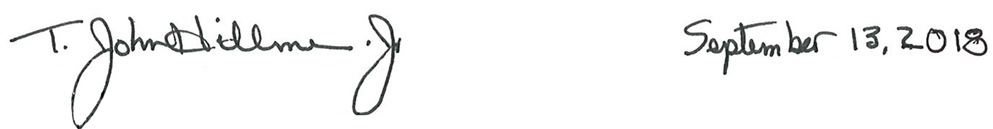

Approved Date
Superintendent, Wilson’s Creek National Battlefield

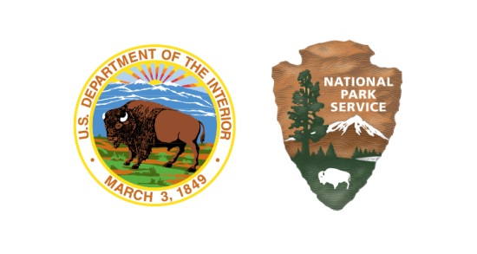
As the nation’s principal conservation agency, the Department of the Interior has responsibility for most of our nationally owned public lands and natural resources. This includes fostering sound use of our land and water resources; protecting our fish, wildlife, and biological diversity; preserving the environmental and cultural values of our national parks and historic places; and providing for the enjoyment of life through outdoor recreation. The department assesses our energy and mineral resources and works to ensure that their development is in the best interests of all our people by encouraging stewardship and citizen participation in their care. The department also has a major responsibility for American Indian reservation communities and for people who live in island territories under U.S. administration.

WICR 410/147857
September 2018

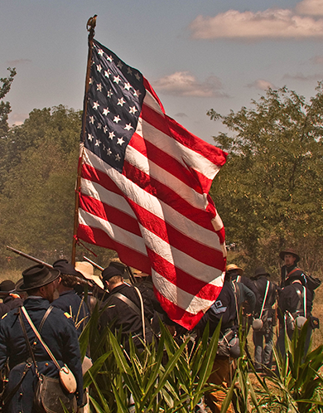

ACCESSIBILITY SELF-EVALUATION AND TRANSITION PLAN

WILSON’S CREEK

NATIONAL BATTLEFIELD | MISSOURI

