Whitman Mission National Historic Site
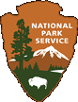

Junior Ranger Booklet – Ages 8 - 12

Earn a Junior Ranger Badge and Certificate!

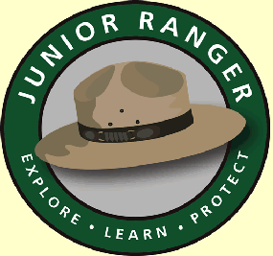

The mission at Waiilatpu is the site founded among the Cayuse Nation in 1836 by Marcus and Narcissa Whitman and others. They were part of a series of missions established by the American Board of Foreign Missions in the Oregon Country. The missions lasted eleven years until events led to their closure.

Your Name: __________________________________

Whitman Mission National Historic Site Website: www.nps.gov/whmi/

Mail completed packet certificate for ranger signature to:
Whitman Mission National Historic Site
Education Specialist/Junior Ranger Program
328 Whitman Mission Road
Walla Walla, WA 99362

The Story of the Mission at Waiilatpu

Fill in the blanks from the word bank at the bottom of the page.

In 1836 five people, Dr. Marcus & Narcissa ___ ___ ___ ___ ___ ___ ___ , the Reverend Henry and Eliza ___ ___ ___ ___ ___ ___ ___ ___ , and William H. ___ ___ ___ ___ , successfully crossed the North American continent from ___ ___ ___ ___ ___ ___ ___ State to the largely unknown land called the Oregon Country. At Waiilatpu and Lapwai, among the Cayuse and Nez Percé Indians, they founded the first two missions on the Columbia __ ___ ___ ___ ___ ___ ___ . The trail they followed, established by ___ ___ ___ ___ ___ ___ ___ and fur traders, was later to be called the ___ ___ ___ ___ ___ ___ ___ ___ ___ ___ ___ . The Whitman’s baby, ___ ___ ___ ___ ___ ___ ___ ___ ___ ___ ___ ___ ___ ___ was the first child born of US citizens in the Pacific Northwest. In the winter of 1842-43, Dr. Whitman rode in a desperate journey to the east to save the missions from closure. On his return to the ___ ___ ___ ___ ___ ___ ___ ___ ___ ___ ___ ___ ___, he helped to guide the first great wagon train of emigrants to the ___ ___ ___ ___ ___ ___ ___ ___ River. The Whitman’s mission during its existence became a haven for the overland traveler. For eleven years, Marcus and ___ ___ ___ ___ ___ ___ ___ ___ Whitman worked with the ___ ___ ___ ___ ___ ___ Indians, bringing them Christianity, teaching them ___ ___ ___ ___ ___ ___ ___ ___ ___ ___ ___ and treating their diseases. Then, in a time of troubles when two opposing forces failed to understand each other, the ___ ___ ___ ___ ___ ___ ___ effort ended. The lives of the Whitman’s were an example of perseverance, misunderstandings, and dedication to a cause. The missions represented one aspect of American expansion into the vast lands of the ___ ___ ___ ___ ___ ___ ___ ___ ___ ___ ___ ___ ___ ___ ___ ___.
Word Bank: agriculture Cayuse Columbia Alice Clarissa Gray
Indians mission Narcissa Pacific Northwest Oregon Trail
Plateau Spalding Whitman New York Oregon Country
Coloring Map
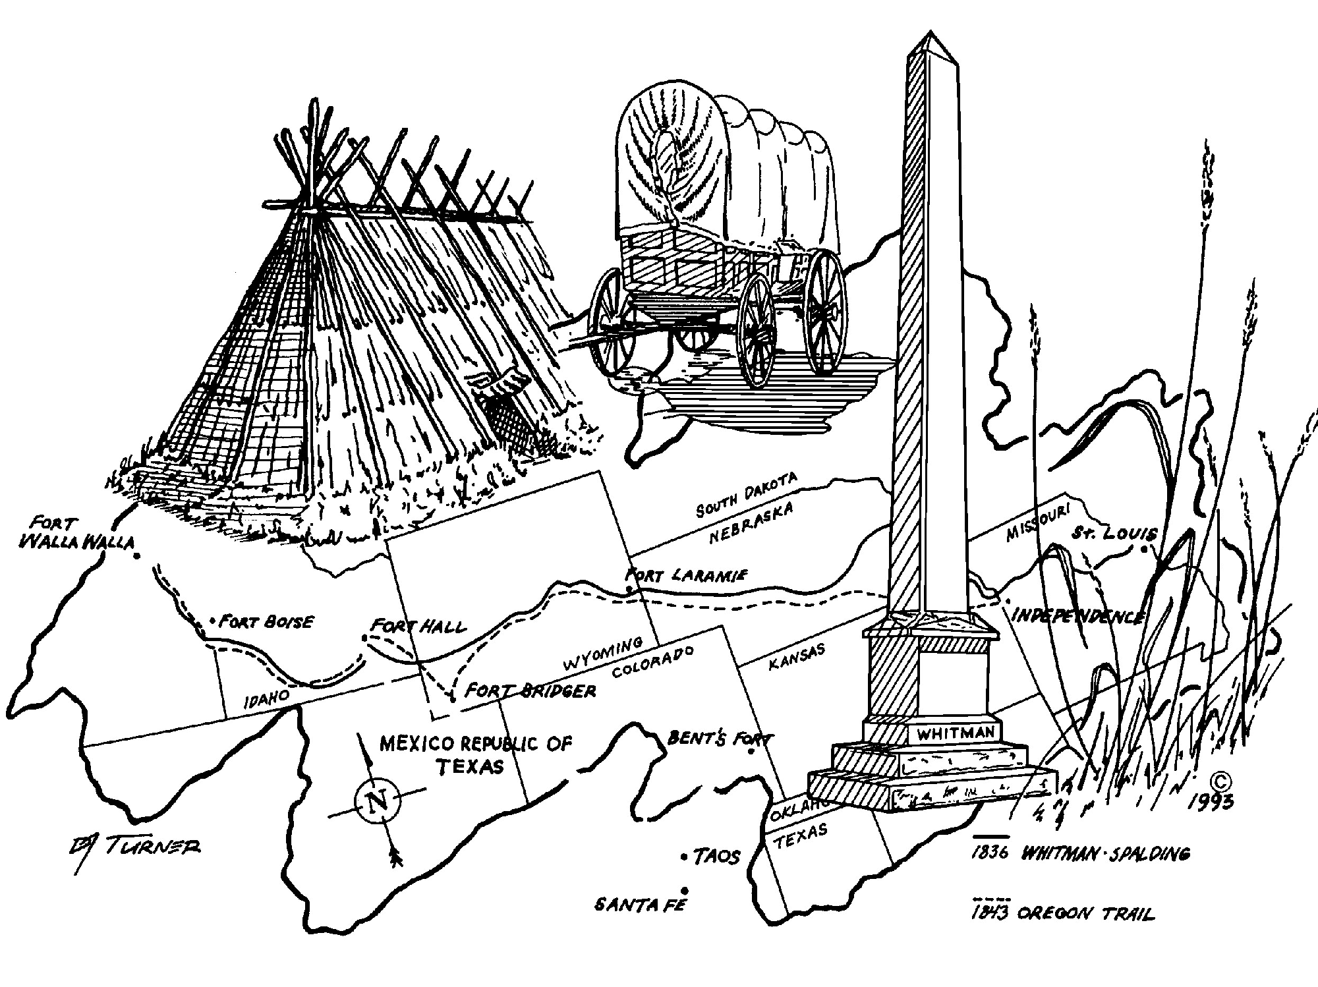

1. The Tule lodge is made from a grass reed and poles for support. It protected the Cayuse people from the weather and offered a place for families to live. What are some activities you think the families did together?

2. The wagon was a way for people to travel along the Oregon Trail to the Oregon Country. It held all their belongings. What did you bring on your trip today that the emigrants may have brought on their trip?

3. The monument is on the hill top at Whitman Mission National Historic Site. What other monuments do you know about and what do they remind you of?

4. The mission was called Waiilatpu. It is named after the grass growing here. What is the name of the grass and the part used for food by the emigrants, missionaries and Cayuse people?

People of the Whitman Mission National Historic Site
Word Search

Now that you know why these words are important to Whitman Mission National Historic Site find them in the puzzle. The words can be up, down, backwards, forwards, or diagonally.

P | G | I | R | C | N | E | W | Y | O | R | K | H | R | E | K | I | I
E | N | Y | B | E | A | A | R | A | G | N | E | Z | P | E | R | C | E
P | I | M | T | G | G | W | U | U | I | E | V | W | N | A | T | S | L
C | D | E | S | U | Y | A | C | C | T | I | T | A | Y | L | A | I | Y
U | L | E | E | O | O | H | O | O | I | L | L | I | R | A | A | E | L
L | A | P | W | A | I | E | M | L | P | A | U | A | O | R | S | A | P
L | P | E | H | S | W | N | E | U | Z | R | N | C | T | Y | V | R | I
N | S | G | T | P | I | R | O | M | U | U | T | N | I | P | N | A | T
U | A | N | R | A | L | Y | V | B | I | G | O | G | R | R | U | B | W
N | Z | N | O | R | L | S | A | I | A | G | A | R | R | G | G | A | I
E | I | L | N | Y | I | P | C | A | E | N | R | M | E | D | G | A | H
N | L | S | C | R | A | A | A | R | S | C | O | A | T | O | N | A | S
I | E | B | I | W | M | L | O | I | A | M | T | A | N | P | A | R | I
U | E | I | F | E | H | D | M | V | B | L | D | T | O | T | G | E | P
E | G | G | I | T | G | I | M | E | O | M | R | A | G | I | S | I | I
C | N | T | C | G | R | N | I | R | N | A | U | T | E | O | E | H | B
N | E | S | A | D | A | G | C | U | I | E | V | L | R | E | O | U | G
S | I | E | P | A | Y | E | E | N | C | A | G | G | O | O | R | S | L
U | G | N | L | I | N | A | M | T | I | H | W | S | U | C | R | A | M

agriculture | Cayuse | Columbia Plateau
Columbia River | Eliza Spalding | emigrants
Henry Spalding | Lapwai | Marcus Whitman
New York | Nez Perce | Oregon Territory
Oregon Trail | Pacific Northwest | wagon train
Waiilatpu | William H Gray

A Poem for Whitman Mission National Historic Site

Think of what you would like to remember about your visit to the Whitman Mission National Historic Site. Write a poem about it called a “cinquain” using the following rules:

Line 1: Write one word to name what you are writing about (noun).
Line 2: Write two words to describe it (adjectives).
Line 3: Write three action words (ending in “ing”) about it (verbs).
Line 4: Write a four word sentence about it.
Line 5: Write one new word that names the subject (noun).

Here’s an Example:
Mission Waiilatpu
Historic, tragic
Inspiring, saving, caring
Preserving history for all
National Historic Site

Now it’s your turn:

Line 1: ____________________

Line 2: ____________________ ____________________

Line 3: __________________ __________________ __________________

Line 4: ___________________________________________________________

Line 5: ____________________

Congratulations! You’re a poet and now you know it.

Mission BINGO

When you find an object below draw a picture of it or describe it in the box. When you get four in a row you have a Mission BINGO!

A Bird  Can you name it? | A Flag  Where is it? | Something Made of Wood  Where is it? | A Tree  Can you name it?
A National Park Service Arrowhead  Where was it? | Something from the 1800’s  Where was it? | An Old Building Site  Where is it? | A Plant  What is it called?
A Pond  What is it called? | A Ranger  What is their name? | A Visitor Center Sign  Where was it? | A Lizard  What color is it?
A Museum Object  What is it called? | An Animal  What is it? | A Junior Ranger  What is their name? | A Monument  Where is it?

Plant and Animal Word Scrambles

Unscramble the words to find some of the plants and animals of Whitman Mission National Historic Site.

Plants:

elirwdy ___ ___ ___ ___ ___ ___ ___

etwgarhsas ___ ___ ___ ___ ___ ___ ___ ___ ___ ___

lueb errerbydel ___ ___ ___ ___ ___ ___ ___ ___ ___ ___ ___ ___ ___ ___

lwwoil ___ ___ ___ ___ ___ ___

dwonottcoo ___ ___ ___ ___ ___ ___ ___ ___ ___ ___

ldwi odwgodo ___ ___ ___ ___ ___ ___ ___ ___ ___ ___ ___

ldawinb lpaep ___ ___ ___ ___ ___ ___ ___ ___ ___ ___ ___ ___

barkclreyb ___ ___ ___ ___ ___ ___ ___ ___ ___ ___

Animals:

dere esomu ___ ___ ___ ___ ___ ___ ___ ___ ___

otnnaem ovel ___ ___ ___ ___ ___ ___ ___ ___ ___ ___ ___

opetkc phorge ___ ___ ___ ___ ___ ___ ___ ___ ___ ___ ___ ___

wtheiiealtd eder ___ ___ ___ ___ ___ ___ ___ ___ ___ ___ ___ ___ ___ ___ ___

ndorgu elriqusr ___ ___ ___ ___ ___ ___ ___ ___ ___ ___ ___ ___ ___ ___

aadnca gsoeo ___ ___ ___ ___ ___ ___ ___ ___ ___ ___ ___

edr eatdli kwha ___ ___ ___ ___ ___ ___ ___ ___ ___ ___ ___ ___ ___

grhepo naeks ___ ___ ___ ___ ___ ___ ___ ___ ___ ___ ___

ccafipi oefergrt ___ ___ ___ ___ ___ ___ ___ ___ ___ ___ ___ ___ ___ ___ ___

ptiadne tertul ___ ___ ___ ___ ___ ___ ___ ___ ___ ___ ___ ___ ____
Draw It As You See It

In the box below draw your favorite Whitman Mission National Historic Site plant.

In the box below draw your favorite Whitman Mission National Historic Site animal.

What Or Who Am I?

See if you can figure out what or who the following are describing.

I came here to start a mission for the Cayuse Indians in 1836. I went to Washington, DC in October of 1842 to convince the American Board of Foreign Missions to keep the Oregon missions open and returned with the first wagon train to reach the Columbia River in 1843. I was killed by a group of the Cayuse Indians I was helping on November 29, 1847.

Who am I? __________________________________________

Our nation of people numbered over 500 when the Whitman’s built their mission. Our lands were along the upper Walla Walla and Umatilla Rivers. Our neighbors were the Nez Percé, Walla Walla and Umatilla Indians. More than half of us lost our lives to measles spread from sick people in a passing wagon train.

Who are we? __________________________________________

I started as many animal trails that grew into a series of Indian and fur trapper trails. These trails were widened and lengthened over time until they reached all the way to the Columbia River and the Pacific Ocean. Emigrants used me to come to Oregon.

What am I called? __________________________________________

I stretch from the Rocky Mountains to the Pacific Ocean and from the Russian settlements in the north to Spanish Alta California. Lewis and Clark mapped me while looking for a water route to the Pacific Ocean. Emigrants crossed through me, stopping at the mission at Waiilatpu for rest and supplies, as they traveled west. I officially became a Territory of the United States after the Whitman’s were killed.

What am I? __________________________________________

Dr. Marcus and Narcissa Whitman established a mission here in 1836. For eleven years, the Whitman’s worked here among the Cayuse Indians, bringing them the principles of Christianity, agriculture, writing, and treating their diseases. Today I protect the site of their mission and other buildings, their grave, a portion of the Oregon Trail, and a hill with a memorial to the Whitman’s at its top. Rangers are at my Visitor Center to help you and answer questions.

What am I? __________________________________________
The People of Whitman Mission National Historic Site

Use the clues to fill in the blanks below

1. He came west with the Whitman’s and Spalding’s.
2. The Sager children were this twice.
3. Young people found around the mission.
4. These people hunted for beaver and other animals throughout the west.
5. Founding family of the mission at Waiilatpu among the Cayuse Indians.
6. Native Americans whose land the mission was built on.
7. What the Whitman’s and Spalding’s were.
8. Travelers on the Oregon Trail.
9. White men who lived in the wilderness areas of North America.
10. People who brought goods to the Mission to exchange for other goods.
11. Founding family of the mission at Lapwai among the Nez Percé Indians.
12. Before photographs these people traveled the west creating pictures of what they saw.
13. People who explored the Oregon Country and other wilderness areas.
14. Nations of People who lived here before the Oregon Trail brought many.

1. W __ __ __ __ __ __ __ __ __ __

2. __ __ __ H __ __ __

3. __ __ I __ __ __ __ __

4. __ __ __ T __ __ __ __ __ __ __

5. __ __ __ __ M __ __ __

6. __ A __ __ __ __

7. __ __ __ __ __ __ N __ __ __ __ __

8. __ M __ __ __ __ __ __ __

9. __ __ __ __ __ __ I __ __ __ __

10. __ __ __ __ __ __ S

11. S __ __ __ __ __ __ __ __

12. __ __ __ I __ __ __

13. __ __ __ __ O __ __ __ __

14. __ N __ __ __ __ __

Interview a Whitman Mission National Historic Site
National Park Service Employee

Find an employee of Whitman Mission National Historic Site and ask them about their job.

Date this Interview was done: __________________________________________________

What is your name? _________________________________________________________

What is your job? ____________________________________________________________

__________________________________________________________________________

What do you like best about your job? ___________________________________________

__________________________________________________________________________

How long have you worked here? _______________________________________________

__________________________________________________________________________

Have you worked at other National Park Sites? Which ones? _________________________

__________________________________________________________________________

__________________________________________________________________________

What is your favorite part of Whitman Mission National Historic Site? ____________________

__________________________________________________________________________

__________________________________________________________________________

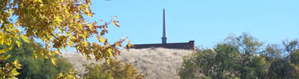

The National Park Service and You

Color in the National Park Service Arrowhead and then name what each symbol represents to you.

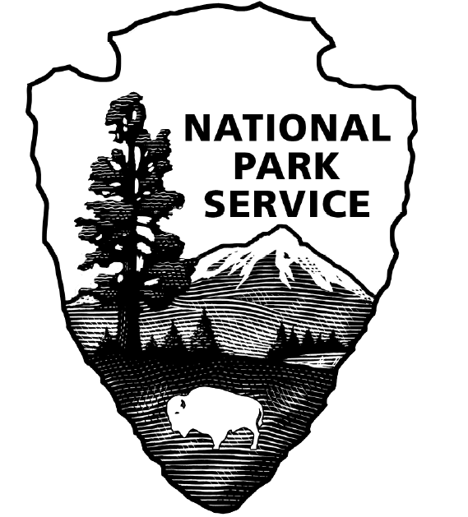

Sequoia Tree ______________________________________________________

Bison ____________________________________________________________

Mountain _________________________________________________________

Lake _____________________________________________________________

Arrowhead ________________________________________________________

What do you think is the work of the National Park Service? _________________

Answers:

The Story of Whitman Mission National Historic Site

In 1836 five people, Dr. Marcus and Narcissa Whitman, the Reverend Henry and Eliza Spalding, and William H. Gray, successfully crossed the North American continent from New York State to the large area of land called the Oregon Country. At Waiilatpu and Lapwai, among the Cayuse & Nez Percé Indians, they founded the first two missions on the Columbia Plateau. The trail they followed, established by Indians and fur traders, was later to be called the Oregon Trail.

The Whitman’s baby, Alice Clarissa, was the first child born of US citizens in the Pacific Northwest. The mission and her birth were two events which inspired families to follow.

In the winter of 1842-43, Dr. Whitman rode in a desperate journey to the east to save the missions from closure. On his return to the Oregon Country he helped to guide the first great wagon train of emigrants to the Columbia River. The Whitman’s mission throughout its existence was a haven for the overland traveler.

For 11 years, the Whitman’s worked with the Cayuse Indians, bringing them Christianity, teaching them agriculture and treating their diseases. Then, in a time of troubles when two opposing forces failed to understand each other, the mission effort ended in violence. The lives of the Whitman’s were an example of selflessness, perseverance, and dedication to a cause. The missions represented one aspect of American expansion into the vast, lands of the Pacific Northwest.

Word Search

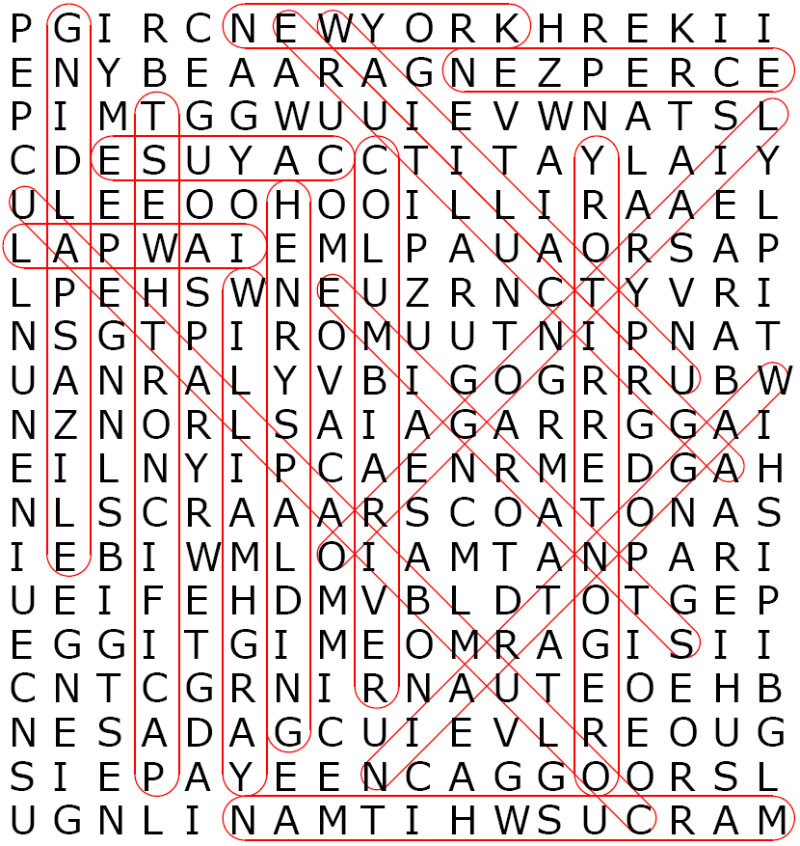
More Answers:

Plant and Animal Word Scrambles
Plants: Animals:
atger bisna elirwdy great basin wildrye dere esomu deer mouse
etwgarhsas wheatgrass otnnaem ovel montane vole
Lueb errerbydel blue elderberry opetkc phorge pocket gopher
lwwoil willow wtheiiealtd eder whitetailed deer
dwonottcoo cottonwood ndorgu elriqusr ground squirrel
ldwi odwgodo wild dogwood aadnca gsoeo Canada goose
ldawinb lpaep baldwin apple edr eatdli kwha red tailed hawk
barkclreyb blackberry grhepo naeks gopher snake
ccafipi oefergrt pacific treefrog
ptiadne tertul painted turtle

What Or Who Am I?

Dr. Marcus Whitman
The Cayuse Indians
The Oregon Trail
Oregon Country
Whitmans Mission National Historic Site

People of Whitman Mission National Historic Site

1. W illiam Gray
2. Orp H ans
3. Ch I ldren
4. Fur T rappers
5. Whit M ans
6. C A yuse
7. Missio N aries

8. E M igrants
9. Mounta I n Men
10. Trader S
11. S paldings
12. Art I sts
13. Expl O rers
14. I N dians

Congratulations

This is to certify that

__________________________________________

Is now an Official Junior Ranger at

Whitman Mission
National Historic Site

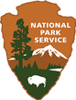

____________ ____________
Ranger Signature Junior Ranger Signature

