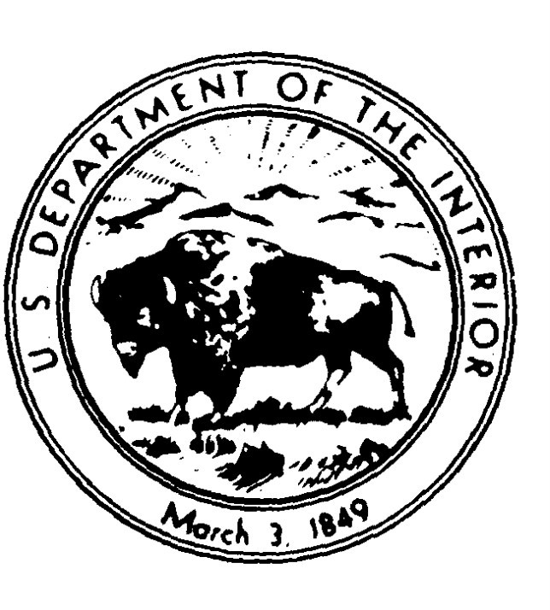

IN REPLY REFER TO:

(UPDE – 4870) 1.B. x 1.C.

Dear Applicant:
United States Department of the Interior
NATIONAL PARK SERVICE
Upper Delaware Scenic and Recreational River 274 River Road,
Beach Lake PA 18405

Thank you for your request. Please download a copy of the Special Use Permit application for your special use. Please read, fill out the application, sign it and return it to me at the above address for processing. Please make sure your email address is on the application. Your Employer Identification number (EIN) or Tax Identification number must be on the application if applicable. If you do not have one, the IRS issues EINs at no charge via: Apply for an Employer Identification Number (EIN) Online | Internal Revenue Service (irs.gov)

Special Use Permit applications must be completed and returned at least six (6) weeks prior to the event to allow the Superintendent time to determine if the activity is appropriate for the area(s) you have selected, to complete compliance and to allow time to process the paperwork A Certification of Liability Insurance from your insurance company for at least $1,000,000 must accompany the application, and the certificate must have United States Government, National Park Service, Upper Delaware S & RR at the above address listed as 'additionally insured' . A fillable form is attached for your insurance company's convenience with that section already filled in.

Please do not submit any application fees with your application. A Bill for Collection will be issued and emailed to you once the application is accepted. Once this bill is received please pay it upon receipt as you will only have 30 days to access Pay.gov to pay this bill before it goes to the US Treasury for collection. Please send me a copy of the payment receipt via email. A permit will not be issued until this payment receipt is received.

If you should have any questions, please don't hesitate to contact me at 570-729-7134, ext. 2234, or by email at debby_seaboldt@nps.gov.

We look forward to receiving your application. Sincerely,

Debby Seaboldt
Special Park Uses Permit Coordinator

