# Grade Level

Grade 5

# Lesson Duration

One hour

# State Standards

Massachusetts Curriculum Frameworks: Social Studies

Grade 5

Topic 1. Early colonization and growth of colonies

Compare and contrast the living and working conditions of enslaved and free Africans in the colonies in the 18th century, and explain how some enslaved people sought their freedom.

a. Enslaved African Americans were property that could be bought, sold, and separated from their families by their owners; they were generally not taught to read or write, and generally owned no property; they suffered many kinds of abuse and could be punished if they were caught after running away from their masters. A number of slave rebellions resulted from these harsh conditions.

# Guiding Question

What was life and work like for enslaved people on Southern plantations?

# Objectives

After completing this lesson, students will be able to:

• Describe some conditions of the lives of enslaved people.

• Explain two of the ways in which enslaved people exercised agency.

# Background

Students will use primary sources to examine the institution of chattel slavery in the United States, to achieve a better understanding of the lives of enslaved people on Southern plantations.

Students do not need significant prior knowledge for this activity, but they must understand the definition of African chattel slavery in America (See attached essay).

# Preparation

Print primary source documents and images

Other items needed: Poster paper, different color markers

Copy Essay, Narrative Analysis Sheet, Essay Analysis Sheet.

# Lesson Hook/Preview

We learn about history to understand our past – where we came from, and how we got where we are today. Slavery is part of the history of the world and the United States.

# Procedure

1. Copy and distribute the Essay Analysis Sheet. Student will answer the first question: “What do you already know about slavery in the United States.”
2. Copy and distribute copies of the background essay to each student. Allow students time to read quietly. As students finish the reading, have them fill out the rest of the Essay Analysis Sheet. The next two questions ask them what they already knew that the reading reinforced, and what information they found that was different from what they knew.
3. Lead class in a discussion of the reading. Ask students to share some of their answers from the Essay Analysis Sheet. This is a time for sharing — all thoughts, questions, and opinions must be treated with respect.
4. Divide class into eight groups. Give each group the corresponding document 1-8, and a Narrative Analysis Worksheet
   * Document 1: Narrative of Sarah Ashley
   * Document 2: Narrative of Arnold Gragston
   * Document 3: Narrative of Mary Reynolds
   * Document 4: Narrative of Hal Hutson
   * Document 5: Narrative of Sarah Dudger
   * Document 6: Narrative of Adeline Marshal
   * Document 7: The Weeping Time
   * Document 8: Narrative of Marriah Hines

* Groups will take 5-10 minutes to read the narrative and discuss it, then fill out their worksheets.

# Vocabulary

* Slave/enslaved person: Someone who is legally owned by another person and forced to obey that person and to work for that person without pay
* Hand: Another word for an enslaved person who works in fields planting and harvesting crops
* Speculator: Someone who bought and sold enslaved people
* Victuals: Food
* Lashing: Whipping
* Federal Writer’s Project: In 1937, the Federal Writers Project staff interviewed many former enslaved people to document their lives. Most of the interviewees were very old and the memories of their lives as young men and women were sometimes clouded by time. *Please note: The attached narratives are from the Federal Writer’s Project. The interviewers recorded the oral history in the dialect in which the interview subject spoke. The oral histories included here have been re-written so that students will better understand the content. You can find a complete catalogue of FWP narratives at* [*Library of Congress*](http://www.loc.gov/)*.*

# Assessment Materials

Give each group the image that corresponds to their document number. Using the information from their Narrative Analysis Sheet, each group will write a 3-4 sentence caption for their image. The caption can be purely descriptive, or it can be written in narrative form from the point of view of an enslaved person or a Northern anti-slavery writer.

# Rubric/Answer Key

Note to teachers: Students will use the Essay Analysis Sheet and Narrative Analysis Sheet to complete the final assessment, writing a caption for one of the images. The rubric is for the caption only.

|  | **1** | **2** | **3** |
| --- | --- | --- | --- |
| **Caption Length** | Captions are written as fragments | Captions are written as sentences, but have fewer than 3 | Captions are 3 or 4 sentences in length |
| **Caption Focus** | Captions are too broad without a focus | Captions are adequate, but need more detail or information to support the image | Captions use information from the reading to accurately depict the picture without the need for further details |
| **Spelling and grammar** | Several spelling or grammar mistakes | 1-3 spelling or grammar mistakes | No spelling or grammar mistakes |

# Supports for Struggling Learners

For younger students, students with special needs, or ELL students, written documents can be highlighted so that students can read a few sentences and still have an understanding of what the person was saying.

Choose one image to show to the class as a whole. Each group will write a caption for that image.

# Slavery in the American South

*One day Master takes us to town and puts us on that auction block and a man name Bill Dunn bought me. I was about seven years old. Talk about something awful, you should have been there. The slave owners were shoutin’ and sellin’ children to one man and the mamma and pappy to another. The slaves cried and carried on somthin’ awful.*

* Millie Williams, born into slavery in 1851

**Why do we learn about slavery?** We learn about history to understand our past – where we came from, and how we got where we are today. Slavery is part of the history of the world and of the United States. It is very hard for many of us to understand how and why slavery happened here – by our own people, to our own people. As you go through this lesson, it is okay to feel angry or sad. You may question why we even learn about something as bad as slavery. It is important, though, to learn what happened in the past. We need to honor the lives of the men, women and children who endured and survived these hardships and tragedies so that we will not repeat the acts of destroying other human lives.

**What did it mean to be an enslaved person in the southern United States?** People in the United States practiced a form of slavery called *chattel slavery*. Chattel slaves were considered property and could be bought and sold just like any other piece of property. Enslaved people had no rights and were expected to perform labor on the orders of a slave master. The lives of enslaved people were controlled completely – where they lived, and what they did for work, even whether or not their family could stay together. This also meant that children born to enslaved people were also enslaved. Enslaved people were bought and sold at their owner’s whim.

**Why did slavery happen in the United States?** Slavery existed in the American colonies, beginning in the 1619, before the formation of the United States. Wealthy people wanted others to do work for them so they could make more money and have time for other tasks. Slavery was one option for labor. Slavery was not just a Southern institution. At one point there were enslaved people in all of the Northern states as well as Southern states. By 1790, slavery had mostly vanished in the North, with only 6% of the enslaved people in the northern United States. It was around this time that slavery began to grow in the South. The invention of the cotton gin made growing cotton on plantations very profitable. More enslaved people meant more cotton plants to grow which equaled more money for the plantation owners. By 1860, there were almost four million enslaved people in this country, with the majority of them living and working on cotton plantations.

**How could the United States’ government and people let this happen?** There were people in the North and South who thought slavery was wrong. Some fought hard to free all enslaved people and end slavery. Most white people thought of slavery as a normal part of the United States’ society and economy. Some thought people of other races were meant to be controlled. Many even came to believe that people of African descent were naturally suited to slavery, or could not take care of themselves if they were free. This false idea was used to justify and promote the enslavement of people of one race.

**Why would Northerners support slavery?** The southern part of the Untied States was primarily agriculture, with plantations growing cotton, rice and tobacco among other crops. The North was a growing industrial center. Many Northern industries, like cotton mills, depended on the South for raw materials – raw materials that required enslaved people to produce. If slavery was abolished, many feared that the price of raw materials might rise, meaning less money for everyone.

**How did enslaved people respond?** Enslaved people resisted in many ways. Some stole food and hid it so they could have enough to eat. Some snuck away in the night to meet with others to pray and sing. Some found ways to learn to read and write, which was against the law in many states. If caught, they would surely have been punished, but they risked punishment to make their stand against their masters. For some, the ultimate resistance was to run away. If a freedom-seeker made it to the North, he or she could be free. According to a law called the “Fugitive Slave Act”, if a run-a-way person was caught, it meant the ultimate punishment of severe beatings, or perhaps being sold away from family.

**When did enslaved people in the United States achieve freedom?** In 1863, President Abraham Lincoln issued the Emancipation Proclamation stating that all enslaved people in the southern United States were free. This did not go into full effect until the end of the American Civil War. Formerly enslaved people were then free to make their own decisions about their lives and work. Some formerly enslaved people stayed on the plantations to work for pay. They may have stayed hoping that long lost family members would return, or because they didn’t know where else to go. Others quickly left to make lives for themselves in new places.

**How do we know what we know?** Many people who had escaped from slavery shared their stories. They wrote books, and presented speeches about their lives. They tried to raise awareness of slavery, so that others would realize how wrong it was. Another source of knowledge is from a special government project. In 1937, the federal government set out to record the stories of formerly enslaved people. Slavery had ended 70 years before, and many former enslaved people had already died. Many of those still alive were interviewed. They were asked about their lives as slaves, how they were treated, and how they reacted when they learned they were free.

# Essay Analysis Sheet

**Before** reading the essay:

1. What do you already know about slavery in the United States?

**After** reading the essay:

1. What pieces of your prior knowledge were reinforced by the reading?
2. What information did you find that was different from what you thought you knew about slavery?

**Document 1: Narrative of Sarah Ashley, age 93**

I was born in Mississippi in 1844 and Master Henry Thomas bought us and brought us here. He was a speculator and bought up a lot of slaves to sell them. My family got separated. My two sisters and my papa were sold to a man in Georgia. Then they put me on a block and sold me off. That was in New Orleans and I was scared and cried.

I used to have to pick cotton and sometime I pick 300 pounds and tote it a mile to the cotton house. Some pick 300 to 800 pounds of cotton and have to tote the bag the whole mile to the gin. If they didn’t do their work they would get whipped till they have blisters on ‘em. I never got whipped, ‘cause I always got my 300 pounds. We have to go early to do that, when the horn goes early, before daylight. We have to take our food in the bucket to the field.

We never got enough to eat, so we kept stealing stuff. We had to. Master gave us the peck of meal to last the week and two or three pounds of bacon in chunk. We never had flour or sugar, just cornmeal and the meat and potatoes. We had a big box under the fireplace, where we kept all the pigs and chickens that we stole, down in salt.

When the boss man told us freedom had come he didn’t like it, but he gave us the bale of cotton and some corn. He asked us to stay and help with the crop but we were so glad to get away that nobody stayed.

Now, I’m all alone and think of them old times that were so bad, and I’m ready for the Lord to call me.

_____________________________________________________________________________

Speculator: Someone who bought and sold slaves for a profit.

Block: Auction block

Tote: Carry

Cotton house: Where the cotton gin was located

Gin: Machine that separated the seeds from the cotton fiber

Peck: Two gallons

Meal: Cornmeal

*Library of Congress, Federal Writer’s Project, 1937*

**Document 2: Narrative of Arnold Gragston, age 97**

Before I got my freedom, I helped a lot of others get theirs. Lord only knows how many; might have been as much as two or three hundred. It was way more than a hundred, I know.

I was born on a plantation that belonged to Mr. Jack Tabb in Mason County, just across the river [from Ohio – a free state] in Kentucky. Mr. Tabb was a pretty good man. He used to beat us, sure; but not nearly so much as others did.

Mr. Tabb was always especially good to me. He used to let me go all about. It was because he used to let me go around in the day and night so much that I came to be the one who took the running away slaves over the river to freedom.

My first trip, it took me a long time to get over my scared feeling, but I finally did, and I soon found myself going back across the river, with two and three people, and sometimes a whole boatload. I got so I used to make three or four trips a month.

I guess you wonder what I did with them after I got them over the river. Well, there in Ripley [Ohio] was a man named Mr. Rankins.

Mr. Rankin he had a big lighthouse in his yard, about thirty feet high and he kept it burning all night. It always meant freedom for a slave if he could get to this light.

After I had made a few trips I got to like it, and even though I could have been free any night myself, I figured I wasn’t getting along so bad so I would stay on Mr. Tabb’s place and help the others get free. I did it for four years.

Finally, I saw that I could never do any more good in Mason County, so I decided to take my freedom, too. I had a wife by this time, and one night we quietly slipped across and headed for Mr. Rankin’s bell and light. It looked like we had to go almost to China to get across that river, and I knew if I didn’t make it I’d get killed. But finally, I pulled up by the lighthouse, and went on to my freedom—just a few months before all of the slaves got theirs.

*Library of Congress, Federal Writer’s Project, 1937*

**Document 3: Narrative of Mary Reynolds, age over 90**

Slavery was the worst days ever seen in the world. I got the scars from beatings on my old body to show to this day. I saw worse than what happened to me. I saw them put the men and women in the stock with their hands screwed down through holes in the board and their feet tied together. Solomon the overseer beat them with a big whip and master looked on. The slaves better not stop in the fields when they hear them yelling.

The conch shell blew before daylight and all hands better get out for roll call or Solomon bust the door down and get them out. It was work hard, get beatings and half fed. They brought the food and water to the fields on a slide pulled by an old mule. Plenty of times there was only a half barrel water and it was stale and hot, for all of us on the hottest days. Mostly we ate pickled pork and corn bread and peas and beans and potatoes. There never was as much as we needed.

The times I hated most was picking cotton when the frost was on the bolls. My hands would get sore and crack open and bleed.

We prayed for the end of beatings and for shoes that fit our feet. We prayed that we could have all we wanted to eat and especially for fresh meat. What I hated most was when they’d beat me and I didn’t know what they beat me for.

_____________________________________________________________________________

Stock: A wooden structure with holes to hold the hands and feet to keep the person from moving. It was used to keep a person still while whipping them.

Conch shell: Large shell that, when blown, sounds like a horn

Boll: The white fluffy part of the cotton plant that is picked and then processed to make into cloth.

*Library of Congress, Federal Writer’s Project, 1937*

**Document 4: Narrative of Hal Hutson, age 90**

I was born at Galveston, Tennessee, October 12, 1847. There were 11 children: 7 brothers and 3 girls. Together with my mother and father we worked for the same man whose name was Mr. Barton Brown.

Master Brown had a good weather-board house, two story, with five or six rooms. They lived pretty well. We lived in one-room huts. There was a long string of them huts. We slept on the floor like hogs. Everybody slept everywhere. We never knew what biscuits were! We ate rabbits, possums baked with potatoes, beans and bean soup. No chicken, fish or anything like that.

I learned to read, write and figure [do math] at an early age. Master Brown would send me to school to protect his kids, so while sitting there I listened to what the white teacher was telling the kids, and caught on how to read, write and figure--but I never let on ‘cause if I was caught trying to read or figure they would whip me something terrible.

I think it’s a good thing that slavery is over. It ought to have been over a good while ago, but it’s going to be slavery all over again if things don’t get better.

______________________________________________________________________________

Weather-board: overlapping, horizontal strips of wood covering the exterior of a building.

*Library of Congress, Federal Writer’s Project, 1937*

**Document 5: Narrative of Sarah Gudger, age 121**

I sure have had a hard life. Just work, and work, and work. I never knew nothing but work. My boss was old man Andy Hemphill. He had a large plantation in the valley. He had plenty of everything. All kinds of hogs, cows, mules, and horses. When Master Andy died I went with his son, William Hemphill.

No, I never knew what it was to rest. I just work all the time from morning till late at night. I had to do everything there was to do outside. Work in the field, chop wood, hoe corn, ‘til sometime I felt like my back would surely break.

Old Master whipped us good if we did anything he didn’t like. Lordy, Honey, I took a thousand lashings in my day. Sometimes my poor old body would be sore for a week.

The rich white folks never did any work; they had slaves to do it for them. In the summer we had to work outdoors, in the winter in the house. I had to card and spin till ten o’clock. Never got much rest, had to get up at four the next morning and start again. Didn’t get much to eat, neither, just a little corn bread and molasses. Lordy, Honey, you can’t know what a time I had. All cold and hungry. No, ma’am, I’m not telling no lies.

I never slept on a bed until after freedom, not until after freedom. Just an old pile of rags in the corner. Hardly enough to keep us from freezing. Nobody knows how mean the slaves were treated. Why, they were way better to the animals than they were to us.

Hoe:  A tool used for digging up weeds, and arranging the earth around plants in fields.

Lashings: Being hit with the whip—usually on the back

Card: One of the steps in cloth making. Carding is the process of brushing the cotton fibers.

Spin: A step in cloth making. Spinning takes the carded fibers and twists them into thread.

*Library of Congress, Federal Writer’s Project, 1937*

**Document 6: Narrative of Adeline Marshal, age unknown**

Yes, Sir, Adeline Marshal is my name all right, but folks around here just call me “Grandma.”

(Slavery days) sure were bad times—black folks just raised like cattle in the stable, only Captain Brevard, he owned me, treated his horses and cattle better than he did his slaves.

Captain Brevard says I’m from South Carolina and he brought me to Texas when I was just a baby. I guess it’s the truth because I’ve never known a mother or father, neither one.

Captain was a bad man, and he drove us hard, too, all the time whipping the slaves to make them work harder. Didn’t make a difference to Captain how little you were, you went out to the field almost as soon as you could walk.

We worked every day except Sunday and had to do our washing then. If anyone was sick on week days, he had to work Sunday to make it up. When we came in at night we had to go right to bed. They didn’t allow any light in the quarters and you better be in bed if you didn’t want a whipping.

Old Captain had a big house but I just saw it from the quarters, because we weren’t allowed in the yard.

I know I was almost grown when Old Captain called us in to say we were free, but nobody told me how old I am and I never found out.

*Library of Congress, Federal Writer’s Project, 1937***Document 7: “The Weeping Time”**

Background: For two days in March, 1859, 436 enslaved people from the plantation of Pierce M. Butler were sold to pay off his debts. This was an ancestral property, inherited by Mr. Butler. The enslaved people had lived and worked on the plantation for generations.

“The buyers, about two hundred of them, clustered around the platform; while the slaves, who would not be sold immediately, gathered into sad groups in the back-ground. The wind howled outside, and through the open side of the building the driving rain came pouring in and the first lot of human chattels was led upon the stand. It had been announced that the slaves would be sold in “families,” that is to say, a man would not be parted from his wife, or a mother from a very young child. In this way many old or unserviceable people are sold who otherwise would not find a ready sale.

The first family brought out were announced on the catalogue as:

| CHATTEL NUMBER | NAME | AGE | REMARKS |
| --- | --- | --- | --- |
|  | George | 27 | Prime Cotton Planter |
|  | Sue | 26 | Prime Rice Planter |
|  | George | 6 | Boy Child |
|  | Harry | 2 | Boy Child |

This family brought $620 each, or $2,480 for the whole.

| CHATTEL NUMBER | NAME | AGE | REMARKS |
| --- | --- | --- | --- |
| 99. | Kate’s John | 31 | Rice, prime man |
| 100. | Betsey | 20 | Rice, unsound |
| 101. | Kate | 6 |  |
| 102. | Violet | 3 months |  |

Sold for $510 each

| CHATTEL NUMBER | NAME | AGE | REMARKS |
| --- | --- | --- | --- |
| 103. | Wooster | 45 | Hand and fair mason |
| 104. | Mary | 40 | Cotton Hand |

Sold for $300 each

| CHATTEL NUMBER | NAME | AGE | REMARKS |
| --- | --- | --- | --- |
| 105. | Commodore Bob | Aged | Rice Hand |
| 106. | Kate | Aged | Cotton |
| 107. | Linda | 19 | Cotton, prime young woman |
| 108. | Joe | 13 | Rice, prime boy |

Sold for $600 each

*Great auction sale of slaves, at Savannah, Georgia, Doesticks G. K. Philander, Danliel Murray Pamphlet Collection (Library of Congress)*

**Document 8: Narrative of Marriah Hines**

I lived with good people, my white folks treated us good. There was plenty of them [slaves on other plantations] that didn't fare as we did. Some of the poor folks almost starved to death. Why the way their masters treated them was scandalous, treated them like cats and dogs. We always had plenty of food, never knew what it was to want food bad enough to have to steal it like a whole lot of them. Master would always give us plenty when he give us our rations.

Of course we slaves were given food and clothing and just enough to keep us going good. Why master would buy cloth by the loads and heaps, shoes by the big box full; then he'd call us to the house and give each of us our share. Plenty to keep us comfortable, course it wasn’t silk nor satin, no ways the best there was, but 'twas plenty good enough for us, and we was plenty glad to get it. When we would look and see how the slaves on the adjoining farms was faring, it would almost make us shed tears. It made us feel like we was getting along most fine. That's why we loved and respected master; 'cause he was so good to us.

*Library of Congress, Federal Writer’s Project, 1937*

# Narrative Analysis Sheet

Document number:

1. List two things the document tells you about life for enslaved people in the United States.
2. List two things the author says, different from your answers to question #1, that you think are important.
3. Write a question to the narrator that he/she left unanswered by this document.

Caption the image: (Using the information you gathered above, work with your group to write a 3-4 sentence caption for your image. The caption can be purely descriptive, or it can be written in narrative form from the point of view of an enslaved person or a Northern anti-slavery writer.)

**Image 1**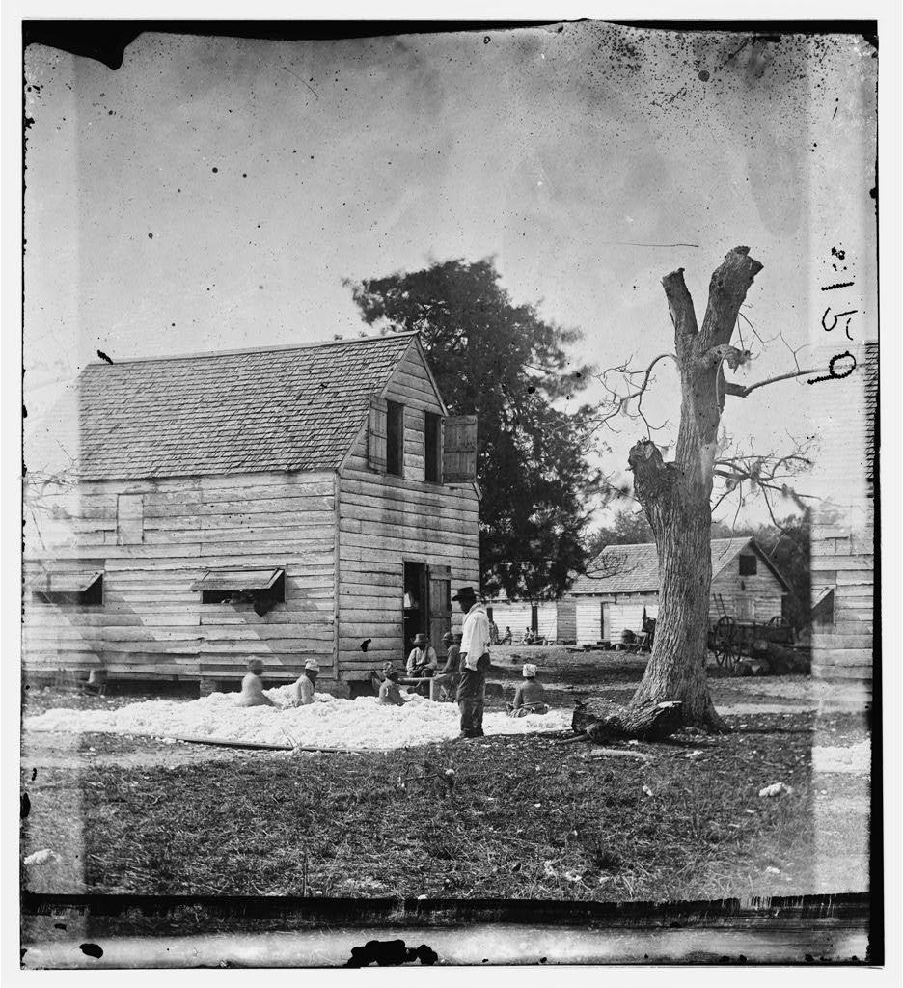

*Timothy H. O’Sullivan photograph, Library of Congress*

**Image 2**

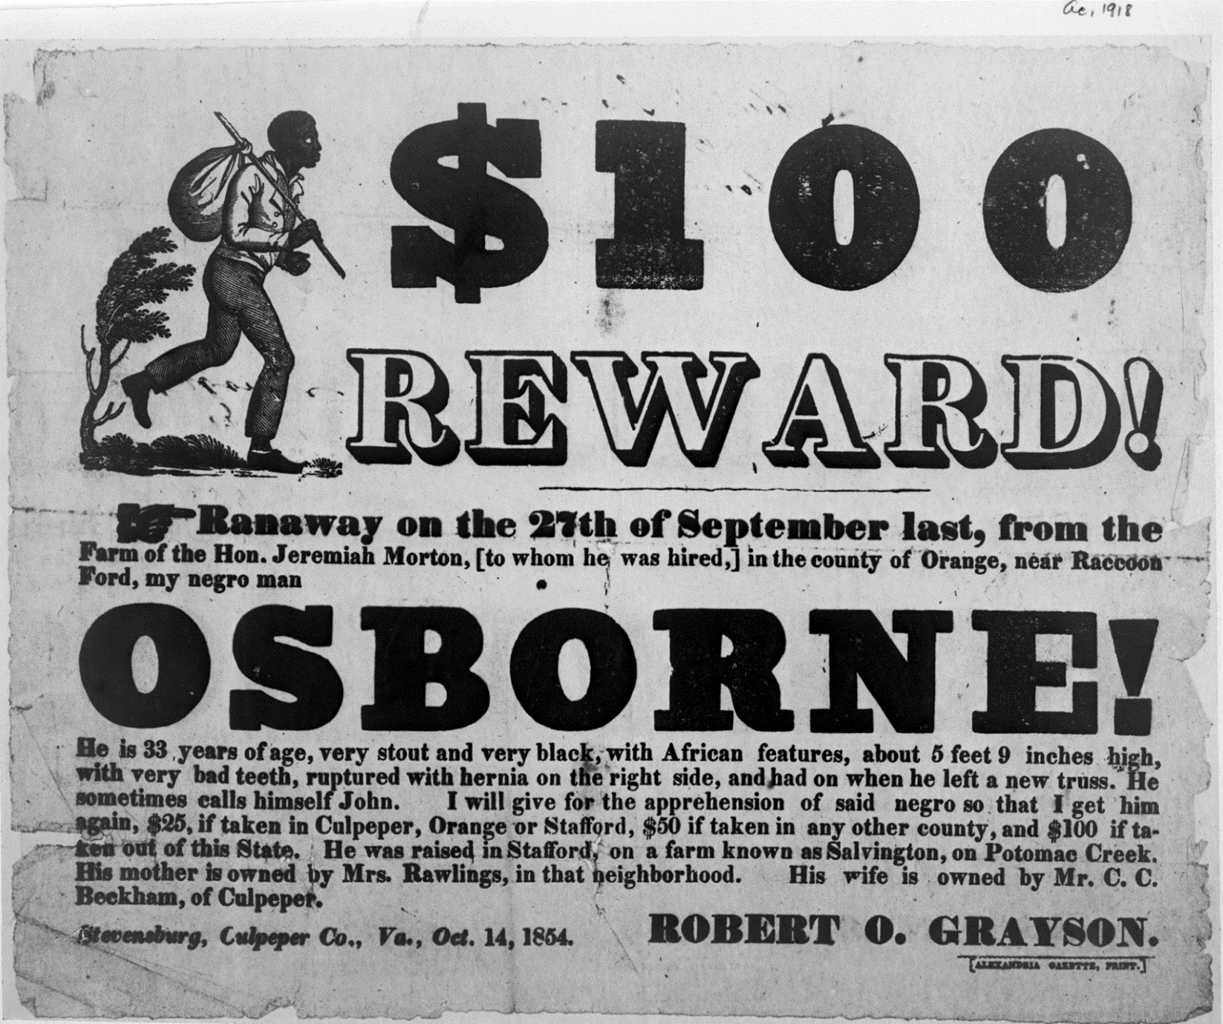

*Library of Congress*

**Image 3**

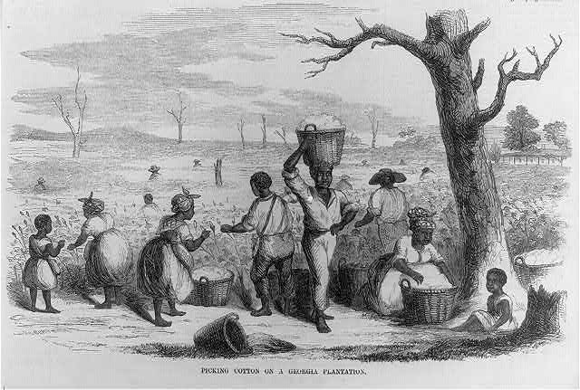

*Library of Congress*

**Image 4**

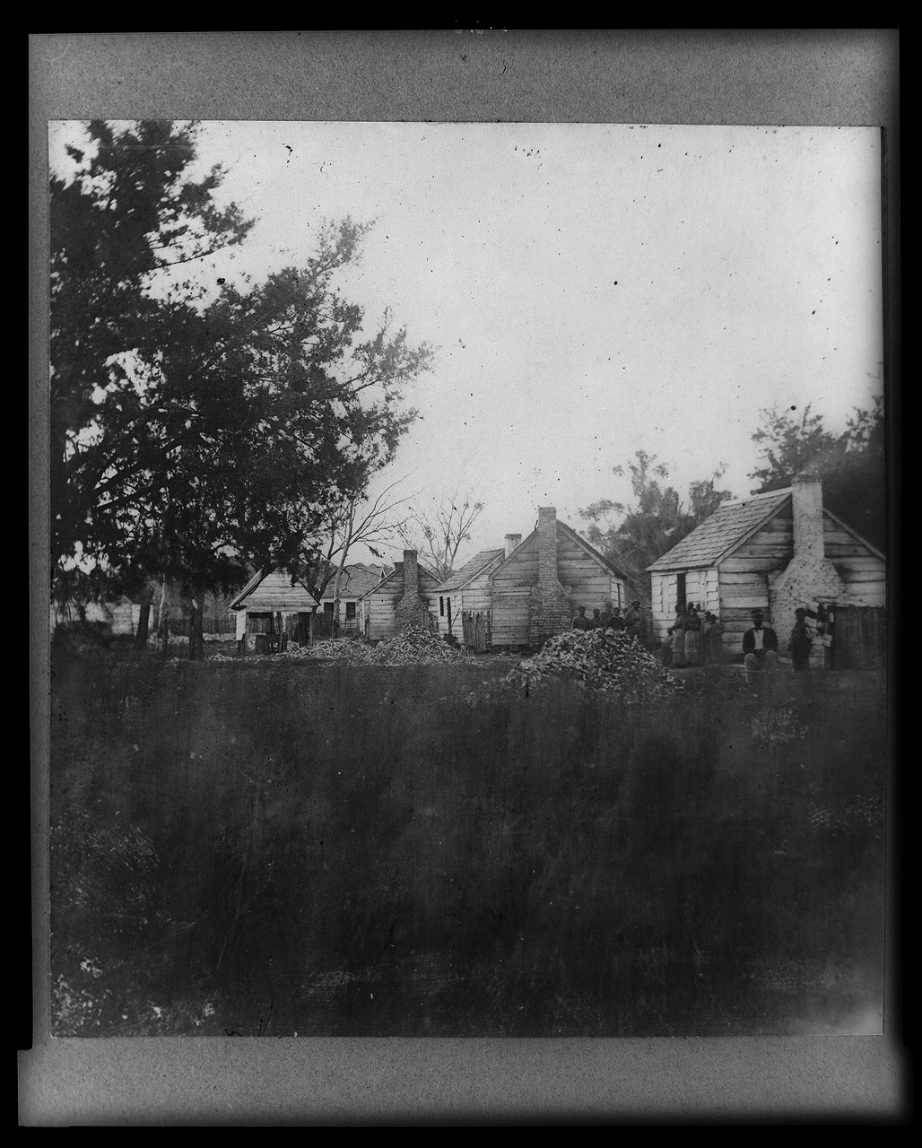

*Library of Congress*

**Image 5**

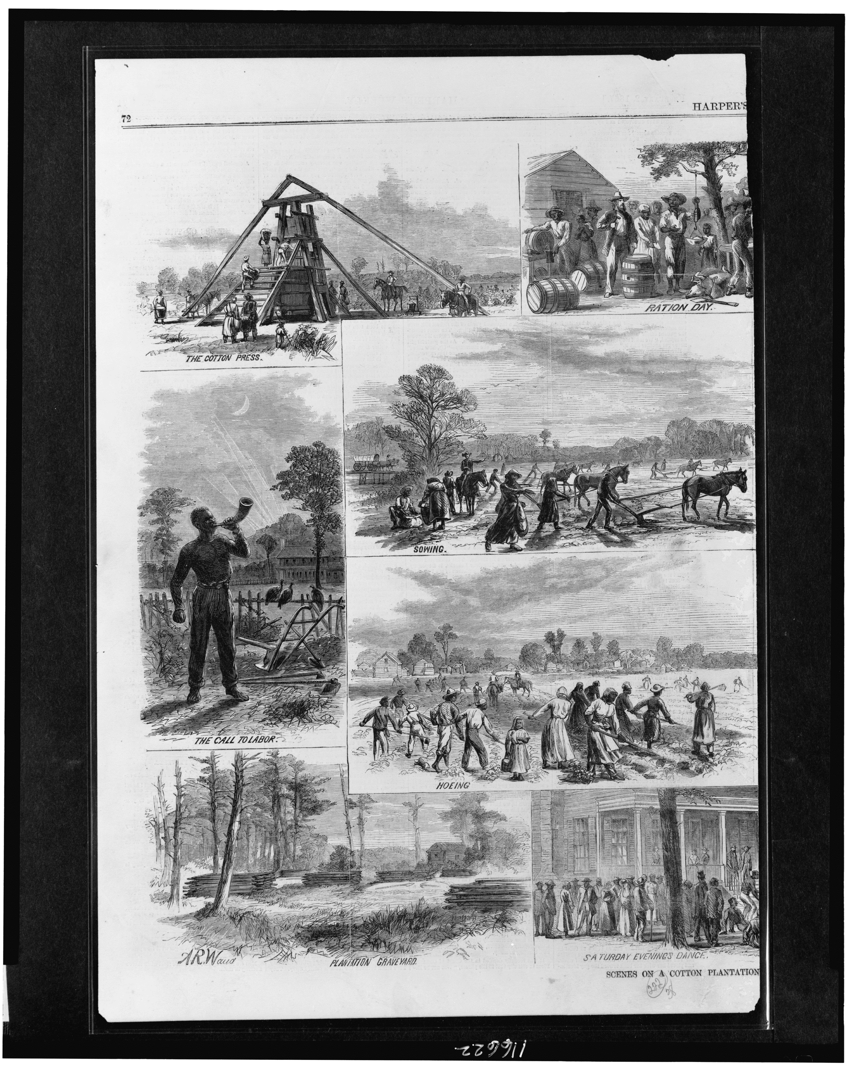

*Library of Congress*

**Image 6**

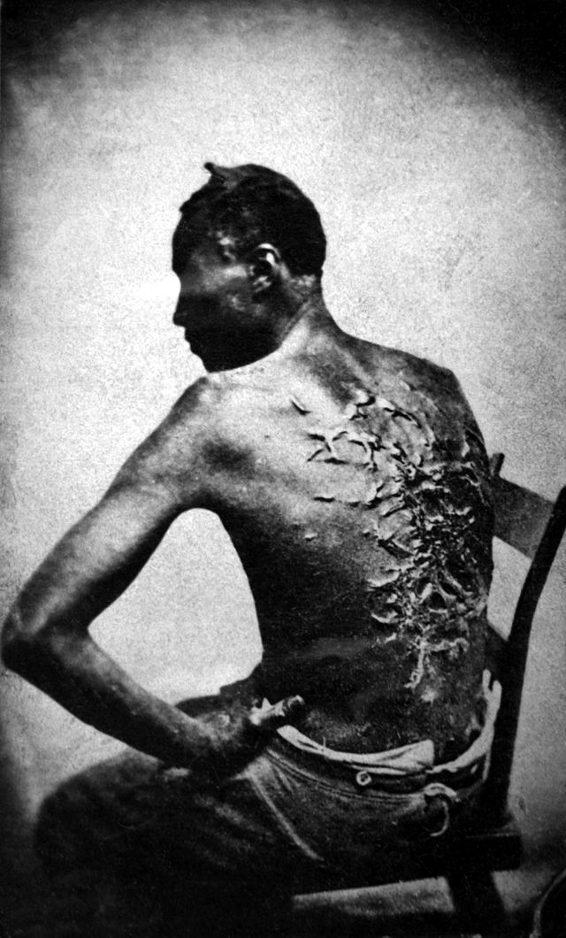

*National Archives*

**Image 7**

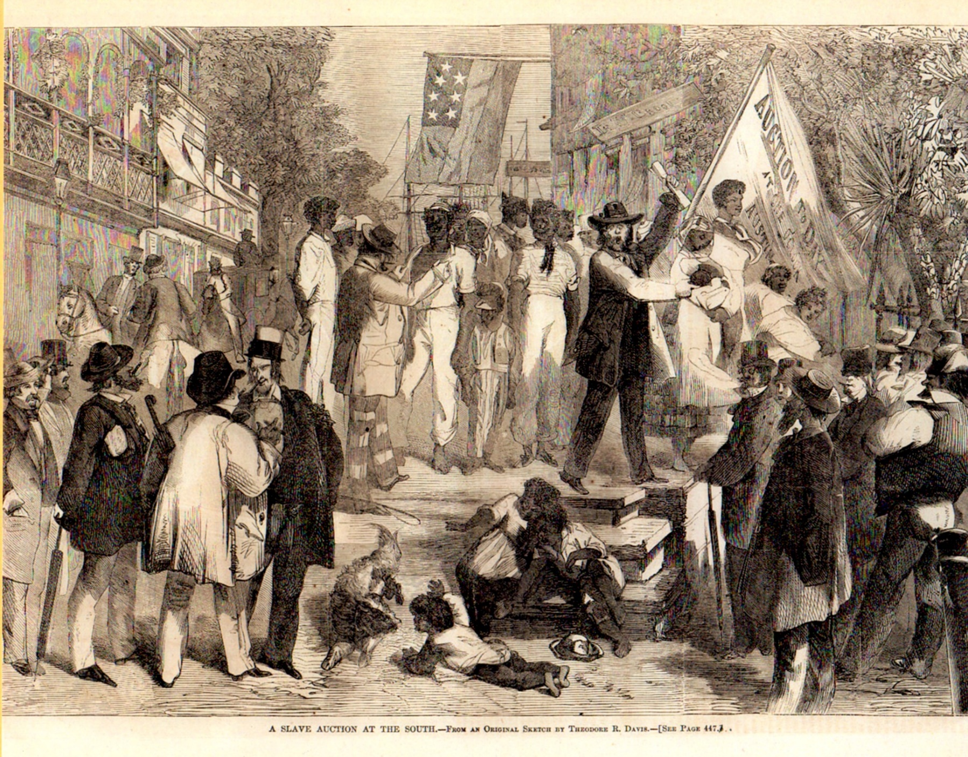

*Library of Congress*

**Image 8**

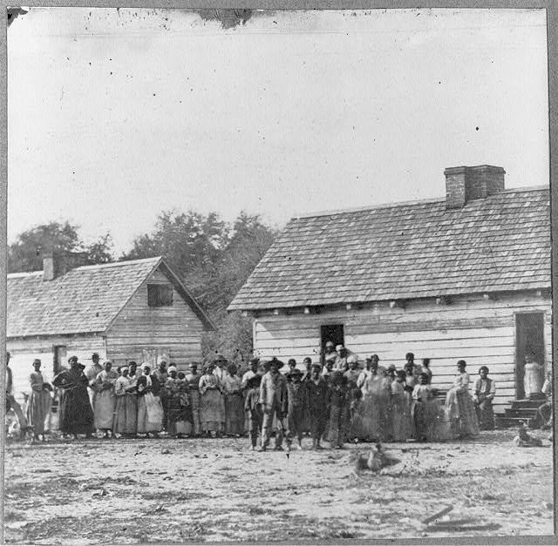

*Library of Congress*