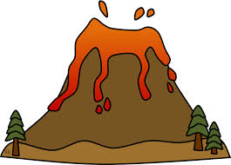
Think: How do a volcano and its glaciers interact and work together at Mount Rainier?

______________________________________________________________________________
______________________________________________________________________________
______________________________________________________________________________
______________________________________________________________________________
______________________________________________________________________________
______________________________________________________________________________
______________________________________________________________________________
Compare: A Volcano and its Glaciers interact and work together like __________________________________________________________.
Explain your simile below either in words or images.
______________________________________________________________________________
______________________________________________________________________________
______________________________________________________________________________
______________________________________________________________________________
______________________________________________________________________________
______________________________________________________________________________
______________________________________________________________________________
After the Gallery Walk: To which of your classmates’ similes would you give a “Most Creative” Award? Why?

