Trail of Tears Writing: Step into the Painting
Name _______________________________ Date___
Directions: You will write a diary entry of the experience of the Trail of Tears from the perspective of an individual in the painting below. Circle from the painting below the individual whose perspective you will depict. Use information gained from the photo and interview analysis, as well as any further research. Write diary on separate lined paper.
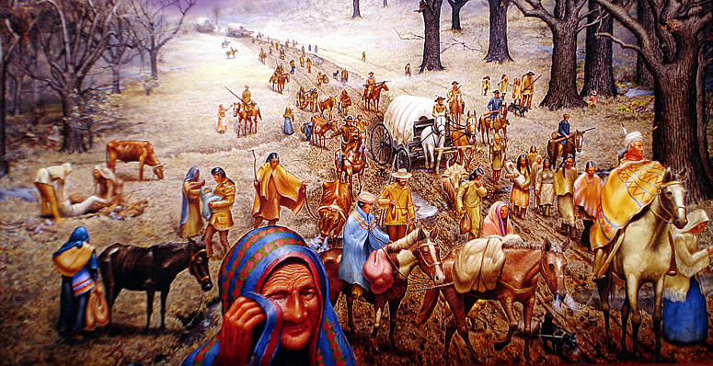
Brainstorm about the individual you chose: Is the individual a woman or a man? What age? What is he/she doing? What emotions do you notice about this individual? Were any personal accounts that seem similar to this person?

