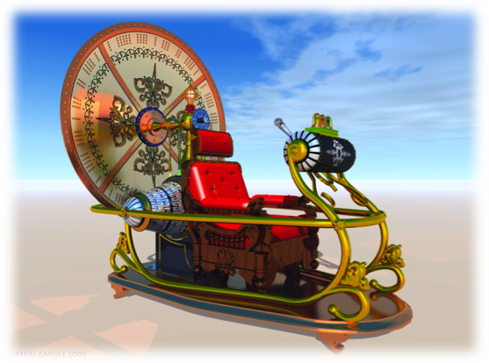
Major Breakthrough: Time Machine Invented
Name______________________________________
Directions: Describe of the homesteads from the photographs. Then, explain what you would send back to that homesteader from the 21st century to make his or her life simpler. Be careful! If you are thinking of an electronic device such as a TV, remember that electricity has not yet been invented! You may only send back one item!
______________________________________________________________________________________________________________
______________________________________________________________________________________________________________
______________________________________________________________________________________________________________
______________________________________________________________________________________________________________
______________________________________________________________________________________________________________
______________________________________________________________________________________________________________
______________________________________________________________________________________________________________
______________________________________________________________________________________________________________
______________________________________________________________________________________________________________
______________________________________________________________________________________________________________
______________________________________________________________________________________________________________
______________________________________________________________________________________________________________
______________________________________________________________________________________________________________
______________________________________________________________________________________________________________
______________________________________________________________________________________________________________
______________________________________________________________________________________________________________
______________________________________________________________________________________________________________
______________________________________________________________________________________________________________
______________________________________________________________________________________________________________

