The Arrowhead Emblem: What Do You Think?
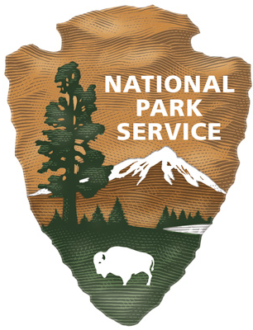
Name ___________________________________
- Which element of the emblem do you think is the most important to the identity of the National Park Service? Why?

- Which element of the emblem do you think is the least important or significant to symbolize as part of the NPS identity? Why?

- If you could re-design the NPS Arrowhead Emblem, what would you add or change?

The Arrowhead Emblem: What Do You Think?
Name ___________________________________
- Which element of the emblem do you think is the most important to the identity of the National Park Service? Why?

- Which element of the emblem do you think is the least important or significant to symbolize as part of the NPS identity? Why?

- If you could re-design the NPS Arrowhead Emblem, what would you add or change?

