**Lesson Plan Unit**

**Salinas Pueblo Missions National Monument**

**Pre-Planning Night Sky Trip Unit**

**Compiled by Vincent Zamora**

**TRT – 2019**

**Mountainair High School**

***Objective: Students will learn about the night sky, and create a knowledge base before visiting the sites on a field trip. Students will learn the planets, the cycle of the moon, learn how to look at the night sky in their area, as well as the constellations and sky the way that the peoples that lived in these areas once did.***

***Project Background***

The Monument is located in central New Mexico and is made up of 1,071 acres across three units: Quarai, Abó, and Gran Quivira. The Monument’s headquarters and main visitor center are located in Mountainair, NM. The solitude, remoteness, and arid landscapes of Salinas Pueblo Missions National Monument make it an ideal place for stargazers, amateur astronomers, and astrophotographers. The Monument is dedicated to enhancing these experiences for visitors, using interpretation and public education to increase awareness and heighten visitor connection to the night sky. The Monument conducts at least four night sky events per year. Typical night sky programming includes:

• Annual star party at Gran Quivira, in partnership with Lake County Astronomical Society, Magdalena Ridge Observatory, New Mexico Tech, and the Very Large Array (VLA)/National Radio Astronomy Observatory.

• Night sky interpretive programs at Abo and Quarai.

• Occasional interpretive talks and telescope viewing opportunities using volunteers.

• Promoting youth involvement in astronomy through presentations at local elementary schools and via the Night Sky Junior Ranger booklet.

• A poster displayed in each of the Monument’s four visitor centers discussing dark skies and the prevention of light pollution.

• Information on the Monument’s website about the importance of night skies.

• Sales items at the Monument’s bookstores that promote night sky protection and interpretation. Press releases and event invitations are sent to media and other contacts in Albuquerque, Santa Fe, Socorro, and Belen; the Monument’s mailing list; and are posted on the Monument’s website as well as other organization’s websites (New Mexico True, Chamber of Commerce, etc.). (Norma Pineda, Marc LeFrancois, Patrick Malone , 2014 )

***To register for a field trip to Salinas or for more information on the night sky events please contact Norma Pineda at Salinas Pueblo Missions National Monument.***

***505- 847-2585 ext 220 or visit our website at*** <https://www.nps.gov/sapu/index.htm>

***NM Science Standards***: (Can be modified by grade level).

Standard III (Earth and Space Science): Understand the structure of Earth, the solar system, and the universe, the interconnections among them, and the processes and interactions of Earth’s systems.

* ***5-8 Benchmark I***: Describe how the concepts of energy, matter, and force can be used to explain the observed behavior of the solar system, the universe, and their structures.
* Universe 1. Describe the objects in the universe, including:
* Billions of galaxies, each containing billions of stars
* Different sizes, temperatures, and colors of stars in the Milky Way galaxy.
  + Solar System
  + 2. Locate the solar system in the Milky Way galaxy.
  + 3. Identify the components of the solar system, and describe their defining characteristics and motions in space, including:
    - sun as a medium sized star • sun’s composition (i.e., hydrogen, helium) and energy production
    - nine planets, their moons, asteroids.
* Know that the regular and predictable motions of the Earth-moon-sun system explain phenomena on Earth, including:
* Earth’s motion in relation to a year, a day, the seasons, the phases of the moon, eclipses, tides, and shadows.
* Moon’s orbit around Earth once in 28 days in relation to the phases of the moon.

***Vocabulary:***

***Universe***: the whole body of things and phenomena observed

***Galaxy***: any of the very large groups of stars and associated matter that are found throughout the universe

***Star***: a self-luminous gaseous spheroidal celestial body of great mass which produces energy by means of nuclear fusion reactions

***Solar System***: the sun together with the group of celestial bodies that are held by its attraction and revolve around it

***Milky Way Galaxy***: the galaxy of which the sun and the solar system are a part and which contains the myriads of stars that create the light of the Milky Way

***Sun***: the luminous celestial body around which the earth and other planets revolve, from which they receive heat and light, which is composed mainly of hydrogen and helium, and which has a mean distance from earth of about 93,000,000 miles

***Hydrogen***: a nonmetallic gaseous chemical element with atomic number 1 that is the simplest and lightest of the elements

***Helium***: a light colorless inert gaseous element found especially in natural gases and used chiefly for inflating airships and balloons, in lamps, in cryogenic research, and as a component of inert atmospheres

***Moon***: the earth's natural satellite that shines by the sun's reflected light, revolves about the earth from west to east

***Asteroid***: any of the small rocky celestial bodies found especially between the orbits of Mars and Jupiter

The Junior Ranger Night Explorer booklet is included in the teacher kits, and can be completed in class as well or can be sent as homework. Upon visiting Salinas Pueblo Missions for the Night Sky Program or by simply visiting the Headquarters Visitor Center the students can receive a Night Sky junior ranger badge.

***Background:***

***Night Sky Introduction:***

Materials Needed:

* Internet Access
* Projector or Interactive Display or Tablet
* Star Search Graphic Organizer
* Night Sky – Guide to the constellations

Procedure:

* Open or have the students open the following website: google.com/sky/
  + Website is a interactive display of the night sky, and allows students to open their perspective to the stars and planets.
* Give the students 10-15 minutes to explore the website.
* Have the students write down 5 “Id like to know” questions, this will have them begin to think outside the normal sky processes including; how stars are brite, distance, travel, size, atmosphere/temperature, etc.

***Introduction into the Night Sky & Solar System:***

Read the introductory section of “night sky” book. While the students still have their maps open, go through, and read the different parts of the night sky in our hemisphere out of the Night Sky book. The students can follow along and see visual make ups of the area on their google sky account. This will give the students an understanding of the sky in our area at night.

***Solar System*** (Claire Thoma, 2018)(Thalassoudis, 2000-2019)

Materials:

* Section of Junior Ranger Booklet for Solar System
* Balls, Fruit, Spheres of any kind (brought in by students)
* Teacher needs to create a “sun”

Pre-Planning:

* Have student (groups) bring in 8 different sized spheres whether they be fruits, sports balls or other spherical objects. Can be small as marbles, on up. Have them look at the different sizes of the planets, and try to bring in spheres to model the different sizes.

Procedure:

* Have students work in groups to complete the solar system section of the Jr Ranger Booklet.
* Once completed have groups collect their 8 spheres, and using your sun build a mini model of the solar system by using the following distances to give them an understanding of the spacing between the planets.
* 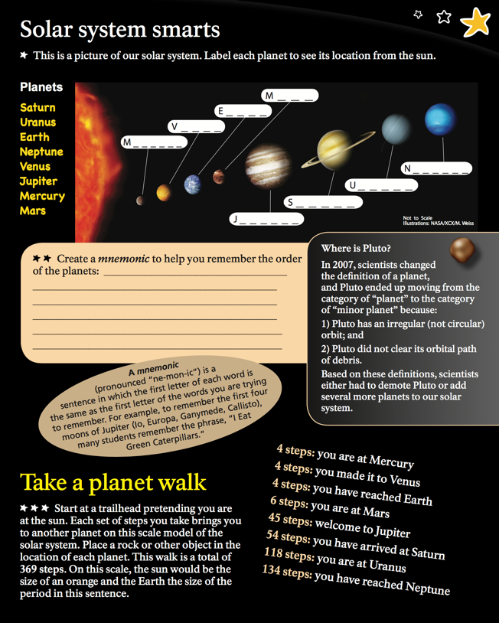Planets should be the following distances from the sun:
* Mercury: 1 inch
* Venus: 1 1/2 inches
* Earth: 2 inches
* Mars: 3 inches
* Jupiter: 11 1/2 inches
* Saturn: 19 inches
* Uranus: 38 inches
* Neptune: 60 inches

***Alternative Lesson:***

Materials:

* At Least 8 Balloons
* Fishing line or Wire
* News papers / Tissue Paper
* Water and Flour
* Paint or Markers

Procedure:

* In groups, as a class have groups pick a planet, and blow up the balloon to meet the estimated size of their planet compared to the other groups.
* Have students tear news papers into strips approx. 2-3” wide by about 12” long.
* Help students to create a consistent paper mache mix. The mix should be wet enough to moisten the newspaper, but needs to be thick enough to stick to the paper.
* Have students completely coat the balloons with the mache, several coverings are necessary.
* Put balloon planets to the side to dry.
* As a class, create a giant sun in one of the corners of the room, this will serve as the sun for the mache solar system.
* Once the balloons are dry, you can just let them deflate inside the mache
* Paint the balloons to match the planet that the group chose.
  + You could cut out rings from cardboard or poster board for the rings of Jupiter, Saturn, Uranus, and Neptune.
* Once planets are dry, and painted, attach them to the wire or fishing line in the order from the sun starting with Mercury, Venus, Earth, Mars, Jupiter, Saturn, Uranus, Neptune. You can add Pluto as a “star” if you’d like.
  + Attach to the roof of class, can stay up for the year as a class project.

***Moon Phases:***

Materials Needed:

* Junior Ranger Booklet (Included in the teacher kit) Page 8
* One Pack of Oreo Cookies
* Plastic Knives
* Butcher Paper

Procedure:

* Put students into groups.
* Have students turn to page 8 of night sky junior ranger booklet.
* Students need to read “Changing faces of the Moon” and Answer the following questions as a group:
  1. How many days does it take to orbit around the earth?
  2. When is a moon considered a full moon?
  3. What makes a moon, a “new” moon?
  4. Please explain what the differences are between a waxing and waning moon.
* Once the students are done, have them put the booklet to the side, and have them complete the second half of the section “Telescope Eyes” at home when they can observe the moon at night.
* Now, have students wash their hands thoroughly. Each group needs to cover an area with butcher paper.
* Give each group 8 oreo cookies and a few plastic knives.
* Students need to take the oreos, take off one side of the cookie revealing the icing, and re-create the phases of the moon using their oreos. They should begin from a whole oreo as a “New Moon” and by scraping off the icing, they can progress all the way through the final phase of a “Waning Crescent”
* Oreos need to be in their order on the butcher paper labeled as the phase that they are in.
* Check students’ finish products as well as any questions that may be unanswered.
* Eat the MOON - OREOS! Hand out extra Oreos.

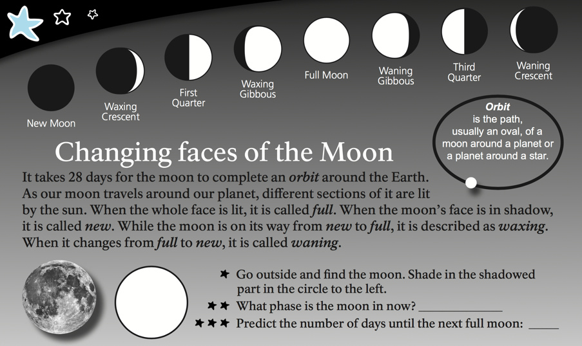

***Night Sky in our Hemisphere***

Materials needed:

* Night Sky Map – Easily found at - http://www.skymaps.com
* Planishperes pages from the Junior Ranger Book (pages 9 and 11)

Procedure:

* Have students tear out the page (or print) the page of the junior ranger booklet of the green planisphere pg 11.
* Have the students turn to page 9 in the junior ranger booklet (or print out), and cut out the constellation map.
* Construct the planisphere as instructed, to hold the star map.
* Have students get to the date to where the night sky currently at the time of the lesson.
* Let students get comfortable with the planisphere as needed
* Hand out the Night sky map for the month that you are currently presenting the lesson in.
* Have the students compare and contrast the night sky map print out compared to if they line up their planisphere to the direct day and month, to see the similarities and differences.

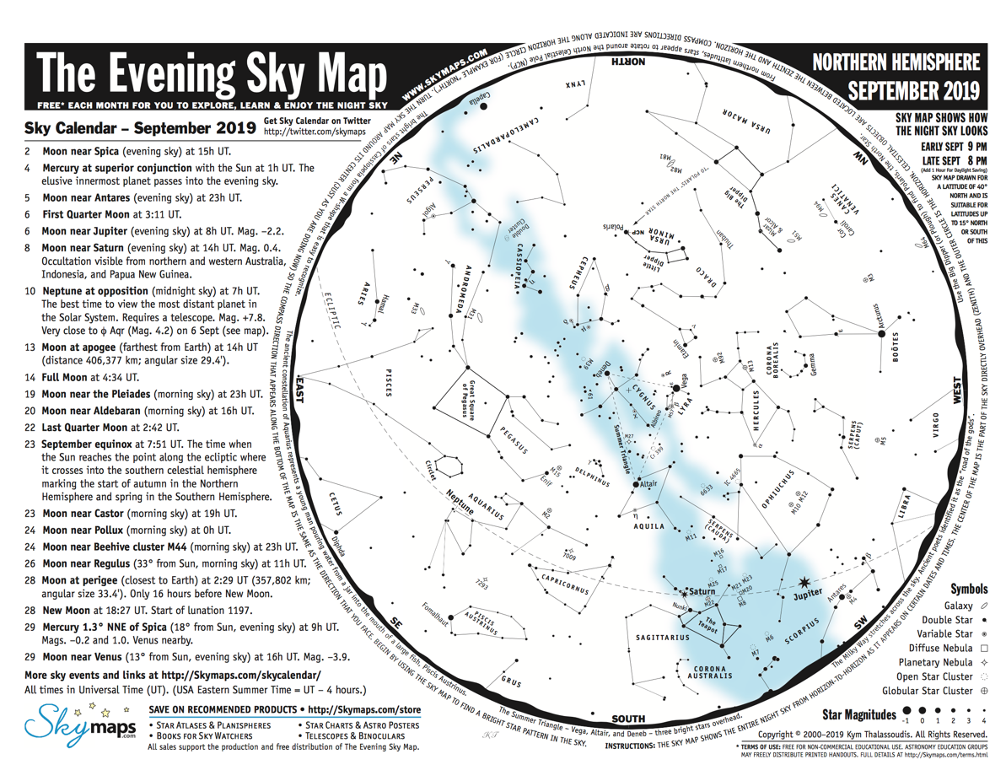

This document drew from and is indebted to the following sources and people:

# Works Cited

Junior Ranger Night Explorer National Park Service Claire Thoma, Chad Moore, Teresa Jiles, and Angie Richman.

(2018). *National Park Service NSNSD.* Retrieved from NPS NSNSD : https://www.nps.gov/orgs/1050/index.htm

Norma Pineda, Marc LeFrancois, Patrick Malone . (2014 ). NPS Night Sky Foundation Document . *Salinas Pueblo Missions National Monument. 2014. Foundation Document.* .

Thalassoudis, K. (2000-2019). *Sky Maps .* Retrieved from http://www.skymaps.com/skymaps/tesmn1909.pdf