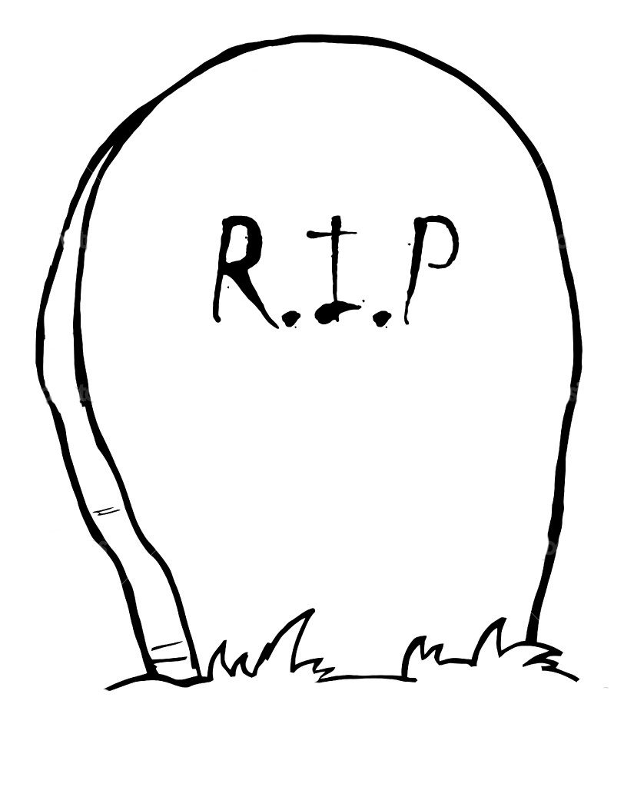
Remembering the Dawes Act
Different individuals will remember the Dawes Act in different ways. Here is how several Americans have remembered the Dawes Act:
*"The Indian may now become a free man; free from the thralldom of the tribe; free from the domination of the reservation system; free to enter into the body of our citizens. This bill may therefore be considered as the Magna Carta of the Indians of our country." Alice Fletcher
*"The Dawes Act was a way to break up the whole tribal structure of Native American nations. Instead of saying you are a group of people, all of a sudden you are individual landowners ─ you are Americans. And so it was designed to break up community, to civilize people, make us farmers, and also break up our tribal structure." Charlotte Black Elk
*"Alice explained... the land allotment... and her wish that the whole people would see the wisdom of the great change... At length one man stood up, a tall, broad-shouldered fellow... He said, 'We do not want our land cut up in little pieces...' A groan of assent ran along the dark line of Sphinxes... 'We must come together and decide whether we will have this law...' She told them that there is nothing for them to decide... The law must be obeyed." Jane Gay
A eulogy is a statement of how someone will be remembered. Write a eulogy for the Dawes Act that describes whether you think it was a success or a failure and how it will be remembered:
_________________________________________________________________________________________________
_________________________________________________________________________________________________
_________________________________________________________________________________________________
_________________________________________________________________________________________________
_________________________________________________________________________________________________
_________________________________________________________________________________________________
_________________________________________________________________________________________________
_________________________________________________________________________________________________
_________________________________________________________________________________________________
_________________________________________________________________________________________________
_________________________________________________________________________________________________
_________________________________________________________________________________________________
_________________________________________________________________________________________________
_________________________________________________________________________________________________

