Picky Eaters 3-2-1 Name __________________________________
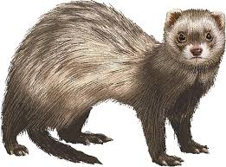
Three: What are three differences between generalist species and specialist species?

Two: What are two reasons why Black-Footed Ferrets are endangered when other animals on the prairie are not?

One:In one sentence, explain what types of animals are most likely to become endangered or extinct?

Picky Eaters 3-2-1 Name __________________________________
Three: What are three differences between generalist species and specialist species?

Two: What are two reasons why Black-Footed Ferrets are endangered when other animals on the prairie are not?

One:In one sentence, explain what types of animals are most likely to become endangered or extinct?

