# Grade Level

Grade 3-6

# Lesson Duration

30-45 minutes

# State Standards

## Massachusetts Frameworks

Topic 5. The Puritans, the Massachusetts Bay Colony, Native Peoples, and Africans

3. Using visual primary sources such as paintings, artifacts, historic buildings, or text sources, analyze details of daily life, housing, education, and work of the Puritan men, women, and children of the Massachusetts Bay Colony, including self-employed farmers and artisans, indentured servants, employees, and enslaved people.

## New Hampshire Frameworks

Economic Systems & Technology

SS:HI:4:4.1: Explore major developments and changes in economic productivity, e.g., adoption of Native American crops or use of mass production.

SS:HI:4:4.3: Investigate the evolution of the United States economy, e.g., the transition from farms to factories

## Common Core State Standards

Engage effectively in a range of collaborative discussions (one-on-one, in groups, and teacher-led) with diverse partners on grade topics and text, building on others’ ideas and expressing own clearly.

# Guiding Question

How was life different when people had to make everything by hand?

# Objectives

After completing this lesson, students will be able to:

* Explain how farm families produced necessary food stuffs 200 years ago
* Describe two differences between their lives today and life before the Industrial

Revolution

# Background

See “Life on a Farm” essay.

# Preparation

Photocopy worksheets

# Lesson Hook/Preview

Students will compare the process of making a sandwich on a farm before the Industrial Revolution with how one makes a sandwich today. Students should understand that 200 years ago on New England farms people had to make what they needed by hand. Many products readily available to us today were not available back then.

# Procedure

1. Working in pairs or small groups, students will use the following questions to describe how to make a grilled cheese sandwich today and fill out the “Today” section of the “Making a Grilled Cheese Sandwich” worksheet

What would you need? How do you get it/where does it come from?

*(Bread-from a store, butter-from a store, cheese-from a store, frying pan-from a store, stove-from a store, spatula-from a store. Need money from a job to purchase items etc.)*

How do you do it?

*(Turn on the stove, heat the pan, butter the bread, add cheese in between two slices of bread, put buttered bread into pan, cook on one side, flip with spatula, cook on the other side. Eat and enjoy!)*

1. Ask students: What if you lived 200 years ago before the Industrial Revolution – before items were made in factories and available in stores or before people had money to purchase items?
2. Distribute “Life on a Farm” to students and read aloud. While reading aloud, students should underline words and phrases that explain how the family would get the items that they needed. As a class, create a list of what the family had to do to get what they needed.
3. Working in the same or different groups, students fill out the “200 Years Ago” side of the “Making a Grilled Cheese Sandwich” worksheet. Encourage them to think about how the family would get each item.

*(Bread: Farmer would need to plant rye or corn. The rye or corn would have to be harvested and ground into flour at the grist mill. The farmer would have to trade something to the miller to get the flour)*

*Butter: Milk the cow, take the cream and churn it into butter*

*Cheese: Milk the cow and turn milk into cheese*

*Pan: Trade items to the blacksmith (extra wool, extra flour, a day’s work in his field)*

*Stove: There would be a fireplace in the house. Chop wood to fuel the stove.*

Ask a few students to share their thoughts on life on a farm. Is life on a farm 200 years ago a life they would have wanted to live? Why or why not?

# Vocabulary

**Barter**: trading goods or services for other goods or services

**Gristmill**: a small building where rye and corn were ground into flour using two large, circular stones grinding together

**Miller**: the person who ran the grist mill

**Rye:** a grass, similar to wheat, that is used for flour

# Assessment Materials

Homework: Choose one item in your house. Write one paragraph explaining how your life would be different without that item and what you would do/use instead.

For example: refrigerator *(can’t store food),* microwave *(have to heat up food in the oven, can’t defrost easily)* etc.

# Rubric/Answer Key

|  | **4** | **3** | **2** | **1** |
| --- | --- | --- | --- | --- |
| **Completion** | All items attempted | ¾ of items attempted | At least ½ of the items attempted | Less than ½ of all items attempted |
| **Demonstrated Knowledge of difference between life on farm 200 years go and modern life** | Shows complete understanding of the questions and idea. Integrates new vocabulary. | Shows substantial understanding of the questions and ideas | Response shows some understanding of the questions and ideas | Response shows a complete lack of understanding of the questions and ideas |
| **Describe differences between their lives today and life before the Industrial Revolution** | In discussion, can list more than two differences | In discussion, can list two differences | In discussion, can list one difference | In discussion, cannot list any differences |

# Supports for Struggling Learners

After reading “Farm Life” aloud to students, students can draw a picture of what farm life might have been like.

# Enrichment Activities

For grades 6 and up: After completing the above activity students will write a diary entry about a day on the farm. They should be as specific as possible about what chores they did that day. Students should think about the time of year and corrolate appropriate chores.

**Farm to Factory Production: Making a Grilled Cheese Sandwich**

# Life on a Farm

The Industrial Revolution was the time in our history during which huge changes took place in the way people lived and worked. 200 years ago most people lived on farms. They couldn’t go to the store and buy things like they do today, everyday items needed to be made at home, by hand, by the family. Each family member had jobs to do that changed with the seasons.

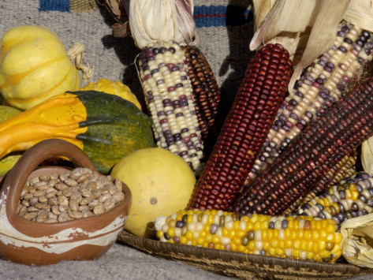

There was work to do throughout the day and little time for school or play. Farmers grew rye and corn for flour. Vegetables were planted in the spring, cared for during the hot summer months and harvested in early fall. They preserved food for the winter so the family could eat even when nothing was growing. Farm families stored beans, squash, pumpkins, and apples in a cool, dry root cellar. Men cut wood year-round for the fires that kept the house warm and cooked the food. Animals that provided milk, eggs, and meat needed to be cared for. Cows were milked and the cream turned into butter and cheese. Farmers cut and gathered hay so the horses could eat all winter.

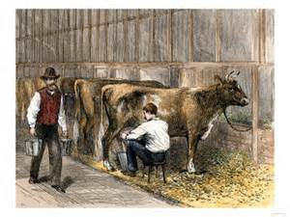

The families took rye and corn to the gristmill where the miller ground it into flour so the family could have bread. Often, farm families had no cash and had to barter or trade for goods and services. To pay the miller a farmer may trade wool, vegetables, or a day’s work on the farm. Families also had to barter for other items that they could not make, like cooking pans and horse-shoes.

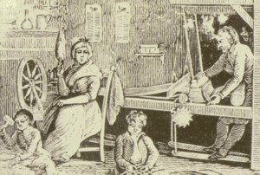

The family made all their clothing by hand. Making cloth took a lot of time and effort: farmers sheared (shaved) sheep, and then they cleaned and straightened the wool, before spinning it into yarn and woven into cloth. Women and girls spent a lot of time throughout the year making cloth and clothing for the family.

Some things did not exist back then. There was no electricity, no cars or phones. Plastic had not been invented yet and houses did not have running water. Think about how different your life would be if you lived on a farm 200 years ago.

# Making a Grilled Cheese Sandwich Worksheet

|  |  |
| --- | --- |
| **Today** | |
| **What do you need?** | **Where does it come from?** |
| **How do you get it?** |
| **What steps do you take to make the sandwich?** | |

|  |  |
| --- | --- |
| **200 Years Ago** | |
| **What do you need?** | **Where does it come from?** |
| **How do you get it?** |
| **What steps do you take to make the sandwich?** | |