MILITARY REPORT CARD
TEACHER: ___________________________
Use your experience from the Tangania and Gagoola simulation, as well as the “Civil War Strategies” reading to grade the strategies of each side of the Civil War before the war began. You are not judging what they are fighting for, but instead the quality of their military plans.
UNION NORTH  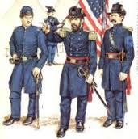 | GRADE EARNED:  A – EXCELLENT  B – GOOD  C – AVERAGE  D – BELOW AVERAGE  F – FAILING | COMMENTS:
CONFEDERATE SOUTH  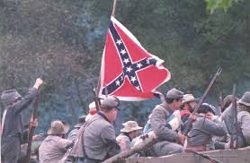 | GRADE EARNED:  A – EXCELLENT  B – GOOD  C – AVERAGE  D – BELOW AVERAGE  F – FAILING | COMMENTS:

THINK ABOUT IT: Could the South have won the Civil War? Why or why not?

