Letter to the Geologists of Mount Rainier:
Why were layers of Tephra found at Mount Rainier from other volcanoes in the Cascade Mountain Range?
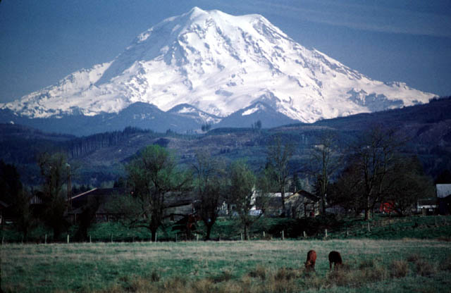
Dear Sir or Madam:

_________________________________________________________________________________________________________________

_________________________________________________________________________________________________________________

_________________________________________________________________________________________________________________

_________________________________________________________________________________________________________________

_________________________________________________________________________________________________________________

_________________________________________________________________________________________________________________

_________________________________________________________________________________________________________________

_________________________________________________________________________________________________________________

_________________________________________________________________________________________________________________

_________________________________________________________________________________________________________________

_________________________________________________________________________________________________________________

_________________________________________________________________________________________________________________

Sincerely,

____________________________________________________

Did you make a strong argument in your letter? Use this checklist to make sure!

_______ I included an explanation of the original mystery.
_______ I explained my theory in my own words.
_______ I supported my theory with multiple pieces of evidence from the maps.
_______ I wrote in a professional manner with correct spelling and grammar.

