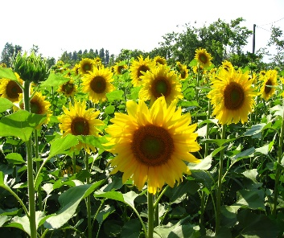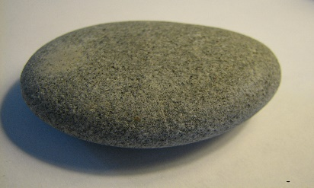
This Photo by Unknown Author is licensed under CC BY-SA
This Photo by Unknown Author is licensed under CC BY-SA
Is It Alive? (Engage)
Type: Lesson Plan
Grade Level: Kindergarten
Subject: Life Science
Duration: 30 min
Standard: SKL1. Obtain, evaluate, and communicate information about how organisms (alive and not alive) and non-living objects are grouped.
Tag: living, non-living, organisms, alive
Overview: As students learn more about their surroundings, it is important for them to understand the difference between living and non-living organisms. This activity will teach them the characteristics of living things.
Objective: Determine the difference between living and non-living
Background: As students learn more about their surroundings, it is important for them to understand the difference between living and non-living organisms. This activity will teach them the characteristics of living things.
Materials:
- Chart paper
- Markers
- Laminated living/nonliving sort

Procedure:
- (Already know how students are going to be grouped based on a similarity- height, shirt color, how their hair is styled, etc. Try to pick something visual)
- Discuss with students that things can be put into groups based on similarities, or how they are alike.
- Tell students that you are going to practice this concept by putting them into groups and they must try and figure out how they are similar. (They are allowed to talk to each other to try and figure out how they are sorted.)
- If you have more than one way to group the students, repeat the process.
- Gather the students back together and record who was in the groups.
- Ask the students to share how they were grouped and label the groups on the chart. Explain to the students that they will be looking at the characteristics of things to sort them into groups.
- Divide students into groups, give them living/nonliving sort, monitor and record how the students are sorting. (They will complete this again at another time)
- Allow students a chance to share how they grouped their pictures.

Assessment: Discussion of their sort
Vocabulary: living, non-living

Living and Nonliving Sort
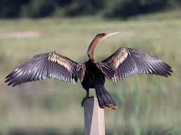 |  | 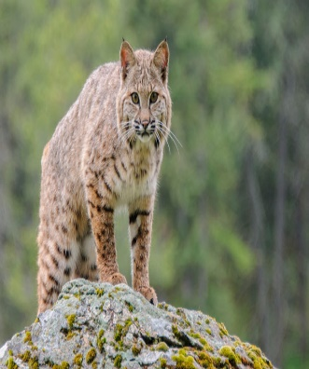 | 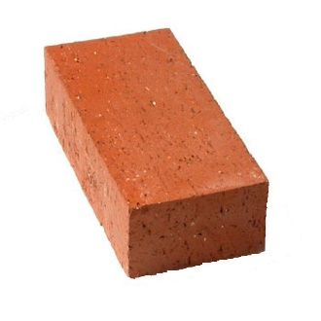
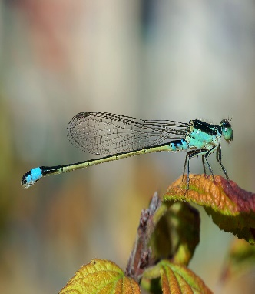 | 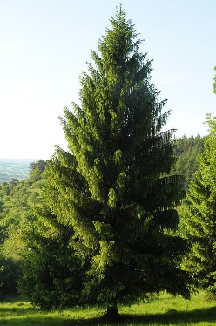 | 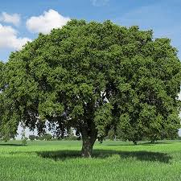
 | 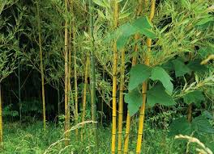 | 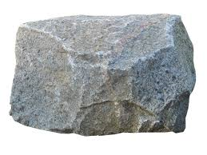 | 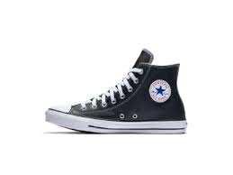
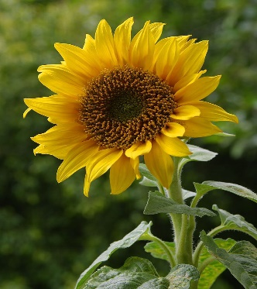 | 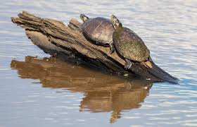

Is It Alive? (Explore)
Type: Lesson Plan
Grade Level: Kindergarten
Subject: Life Science
Duration: 30 min
Standard: SKL1. Obtain, evaluate, and communicate information about how organisms (alive and not alive) and non-living objects are grouped.
Tag: living, nonliving, organisms, animals, plants
Overview: As students learn more about their surroundings, it is important for them to understand the difference between living and non-living organisms. This activity will teach them the characteristics of living things.
Objective:
- Determine if something is living or nonliving

Background: As students learn more about their surroundings, it is important for them to understand the difference between living and non-living organisms. This activity will teach them the characteristics of living things.
Materials:
- Bag of objects with pictures or toys of living and nonliving things
- Checklist/recording sheet
Procedure:
- Students will pull an object out of their bag and use the checklist to determine whether or not the object is living or nonliving
Assessment:
- Recording sheet/checklist
- Discuss their results
Vocabulary: living, non-living

Is It Alive Checklist
Object | Move?  This Photo by Unknown Author is licensed under CC BY-NC-ND | Seeds/babies?  This Photo by Unknown Author is licensed under CC BY-NC-ND | Air? | Grow?  This Photo by Unknown Author is licensed under CC BY-SA

1. What is living? ______________________________________________________________________________________________________________________________________
2. What in nonliving? ______________________________________________________________________________________________________________________________________
Is It Alive (Explain)
Type: Lesson
Grade Level: Kindergarten
Subject: Life Science
Duration: 60 min (might need 2 sessions)
Standard: SKL1. Obtain, evaluate, and communicate information about how organisms (alive and not alive) and non-living objects are grouped.
Tag: living, nonliving, organisms, animals, plants
Overview: As students learn more about their surroundings, it is important for them to understand the difference between living and non-living organisms. This activity will teach them the characteristics of living things.
Objective: Students will show understanding of information by created a picture vocabulary book.
Background: As students learn more about their surroundings, it is important for them to understand the difference between living and non-living organisms. This activity will teach them the characteristics of living things.
Materials: Construction paper, white paper, pencil, crayons, colored pencils
Procedure:
- Create a cover using construction paper
- Use white paper to draw a picture that shows each vocabulary word
Assessment:
- Completed picture book
Vocabulary: living, non-living, organism, need, grow, change, reproduce

Is It Alive (Extend)
GOAL | Your goal is to name an object and determine whether or not the object that was found is living or nonliving.
ROLE | You are a scientist
AUDIENCE | Your friends that you were playing with
SITUATION | You and your friends were digging in the backyard. Your friend finds something strange and wants to know what it is and whether or not is living.
PRODUCT | You will use your living/non-living checklist to determine whether or not it is living and give it a name and functions.
STANDARDS | K- SKL1. Obtain, evaluate, and communicate information about how organisms (alive and not alive) and non-living objects are grouped.

