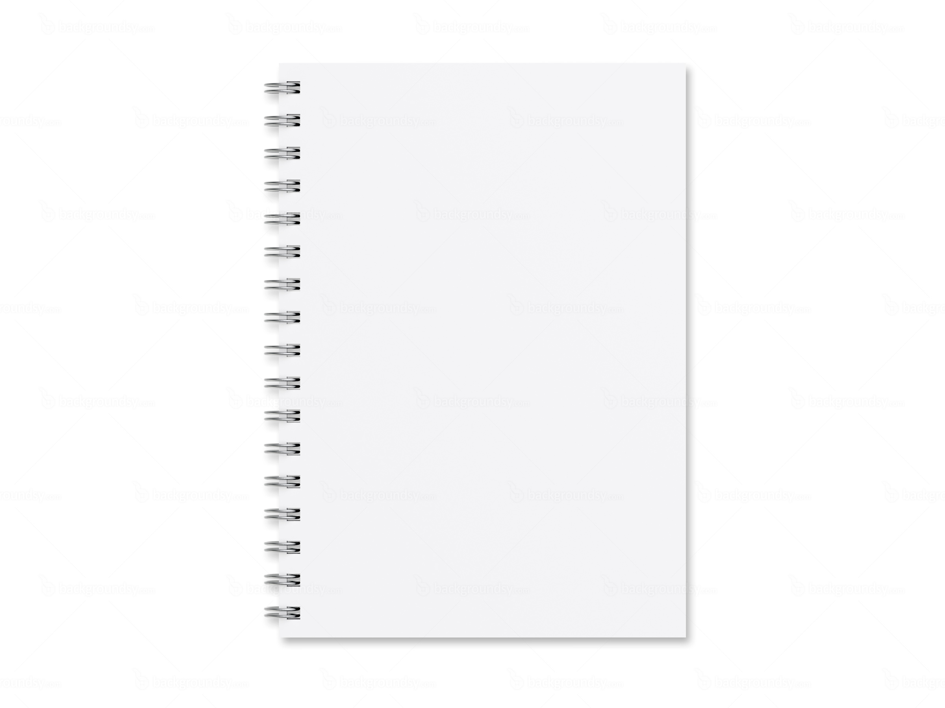
Journal of Archeologist _________________
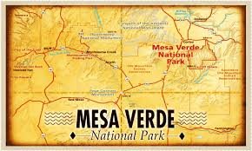
Write a paragraph explaining first hypothesis you wrote before the investigation, the evidence you found during the investigation, and then explain your revised hypothesis from after the investigation. Also, explain any further investigations you think will help confirm or further revise their final hypothesis.

