Western New York: A Hotbed for Early Reform Movements

- Western New York: A Hotbed for Early Reform Movements

- Developer: Nancy Spagnola, Greater Amsterdam School District
- Grade Level: Intermediate, Middle and High School
- Number of Sessions in the Lesson Unit Plan: 45-minute lesson

- Overview
- Park Name: Women’s Rights National Historical Park, Seneca Falls, New York https://www.nps.gov/wori/index.htm
- Description: The theme of this unit is the growth of 19c reform movements in western New York. Listed below are the topics of the lesson plans the teacher will use to teach students about the factors that led to the rise in reform movements of the mid to late 1800s in Western New York State. Students will participate in many small group hands-on activities while exploring and understanding how the building of the Eric Canal had an impact on parts of Western New York leading to the Second Great Awakening. Finally, students will learn how this newfound religious zeal led to the questioning of social and political norms that spurred a number of reform movements to grow throughout western New York. The three lessons provide all sources and source locations needed to teach each lesson.
- Essential Question: Why was Western New York the birthplace of reform movements in the mid to late 19c?
- New York State Standards
NYS 1.3 Students will use a variety of intellectual skills to demonstrate their understanding of major ideas, eras, themes, developments, and turning points in the history of the United States and New York. Study about the major social, political, economic, cultural, and religious developments in New York State and United States history involves learning about the important roles and contributions of individuals and groups.

NYS 1.4 The skills of historical analysis include the ability to: explain the significance of historical evidence; weigh the importance, reliability, and validity of evidence; understand the concept of multiple causation; understand the importance of changing and competing interpretations of different historical developments.

NYS 3.1 Students will use a variety of intellectual skills to demonstrate their understanding of the geography of the interdependent world in which we live—local, national, and global—including the distribution of people, places, and environments over the Earth’s surface. Geography can be divided into six essential elements which can be used to analyze important historic, geographic, economic, and environmental questions and issues.

NYS 5.1 Students will use a variety of intellectual skills to demonstrate their understanding of the necessity for establishing governments; the governmental system of the U.S. and other nations; the U.S. Constitution; the basic civic values of American constitutional democracy; and the roles, rights, and responsibilities of citizenship, including avenues of participation.

NYS 5.3 Students will understand how citizenship includes the exercise of certain personal responsibilities, including voting, considering the rights and interests of others, behaving in a civil manner, and accepting responsibility for the consequences of one’s actions, analyze issues at the local, state, and national levels and prescribe responses that promote the public interest or general welfare, such as planning and carrying out a voter registration campaign, describe how citizenship is defined by the Constitution and important laws and explore how citizens influence public policy in a representative democracy.

- Student Learning Objectives
- Students will understand how the reasons for constructing the Erie Canal as well as the effect that it had on the development of Western New York, leading to the transport of not only people but ideas.

- Background and Historical Context
This pre-visit lesson will teach park goers why the Seneca Falls Convention took place in western New York. They will get a better understanding of why the authors as well as many of the signatories of the Declaration of Sentiments came from western New York. This will set up the context for what happened in Seneca Falls in July, 1898 when the Women’s Rights Convention was held in the Wesleyan Chapel. This background knowledge will also help students to understand why families like the M’Clintocks, the Hunts and the Stantons became activists for more than just the women’s suffrage movement. This will provide the context for the sites in Seneca Falls that are a part of the Women’s Rights National Historical Park, the Wesleyan Chapel, The M’Clintock House, The Richard Hunt House, and the Elizabeth Cady Stanton House.

- Vocabulary

2nd Great Awakening
Abolition/Abolitionists
Aqueduct
Barge
Burned-Over District
Canal
Canal Stores
Cargo
Clinton’s Ditch
Declaration of Sentiments
Erie Canal
Lock
Manufactured Goods
Mormons
Mule
Mule Driver
Natural Resources
Quakers
Revivals
Seneca Falls Convention
Suffrage
Temperance
Towpath
Underground Railroad
Utopian Communities

- Lesson Implementation Procedures

Lesson One: Erie Canal Gallery Walk

- Students will be grouped into teams of three to five, depending on the size of the class. Each group will start at a different station.
- At their first station, groups will read or watch what is posted and one recorder will write the group’s responses to the prompt responses on the worksheet.
- After five to six minutes, the groups rotate to the next station and respond to the prompts. This will repeat until all groups have visited each station. To involve all group members the group will switch recorders at each station.
- The class will come back together to discuss what was learned and make final conclusions about what they saw and discussed.

Erie Canal Gallery Walk

Prompt #1 Map of the Erie Canal:
What waterways did the Erie Canal connect?
Name 6 major cities located along the Erie Canal, include the cities that it connects.
Prompt #2 Floating Ideas: How the Erie Canal Helped Shape America (watch up to 5:02):
How did the Erie Canal serve as the “Information Highway of its day?”
What early reform movements could be linked to travel on the Erie Canal?
Why was Western New York referred to as the burned over district?
What was one think that was unique about relationships between men and women in the utopian settlements of the “Burned over District?”

Prompt #3 Background of the Erie Canal Video (2:51):
Who was the Governor of NYS that wanted the canal built?
How much did New York State budget for the canal project?
Before the canal was built how long would it take for a ton of flour to be transported from Buffalo to NYC? How much would it cost?
After the canal was built how long would it take for a ton of flour to be transported from Buffalo to NYC? How much would it cost?

Prompt #4 Timeline:
Which New York lawmaker was the biggest proponent of the Erie Canal project?
What did opponents of the project call the Erie Canal?
What waterways did the canal connect?
When did revenue from the canal (tolls) pay for itself?

Prompt #5 Letter from Jesse Hawley, to David Hosack, M.D.:
What was Mr. Hawley’s occupation before proposing the canal project?
Why does Jesse Hawley think the government should pay to build the canal?
How were his ideas received by New Yorkers?
What waterways did Hawley propose to connect?

Prompt #1 Map of the Erie Canal:

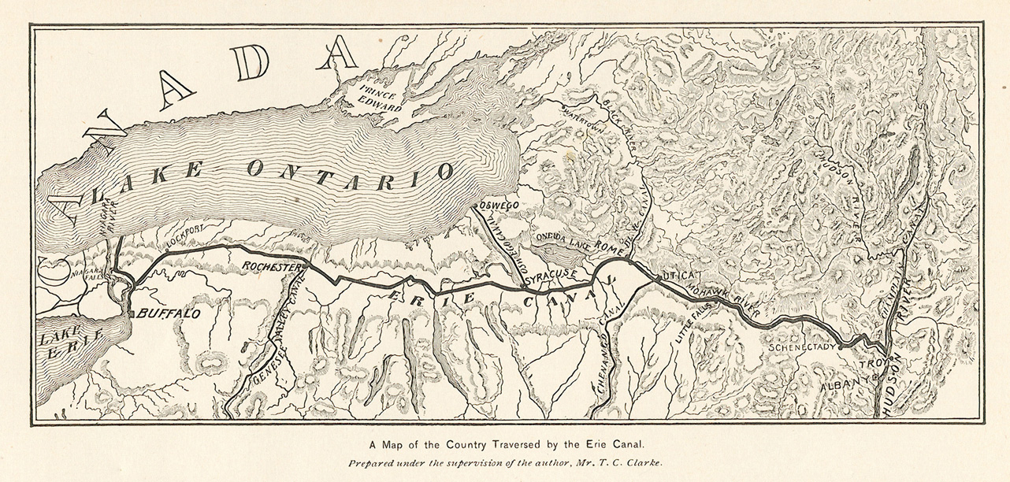

https://www.eriecanal.org/maps/NYScanalmap-1896.jpg
Prompt #2 Floating Ideas: How the Erie Canal Helped Shape America:

https://www.youtube.com/watch?v=Y2hh0XXHUGo
Prompt #3 Background of the Erie Canal Video:

https://www.youtube.com/watch?v=8BCYGLBYlz4

Prompt #4 Erie Canal Timeline:

1807: Jesse Hawley from Geneva N.Y., publishes essays in the Genesee Messenger describing the costs and benefits of building a water route connecting Lake Erie to the Hudson River.

1809 Representatives from the State of New York traveled to the nation's capital to meet with President Thomas Jefferson asking for money for a 363-mile canal that would link Lake Erie with the Hudson River. Thomas Jefferson was the President of the United States referred to the idea as "a little short of madness. "

1810 Thomas Eddy, Treasurer of the Western Inland Lock Navigation Company and State Senator Jonas Platt, hoping to move plans for the canal forward, approached New York State Senator DeWitt Clinton.

1811 New York State Senator Clinton introduced a bill into the New York Senate to appoint a commission to explore suggested routes for a canal across New York state.

1817 The New York State Legislature approves construction of the Erie Canal, authorizing $7 million for construction of the 363-mile long waterway, 40 feet wide and four feet deep. Construction would begin on July 4th, in Rome, NY and would take eight years.

1817 DeWitt Clinton becomes governor of New York State. Many begin referring to the Canal as "Clinton's big ditch" and "Clinton's Folly." Some believed "in the big ditch would be buried the treasury of the state to be watered by the tears of posterity."

1820 Regulations for conduct are first established on the canal and tolls are levied on July 1st.

1821 The Canal is completed from Utica to Little Falls.

1823 The first boats from the west and north pass through the canal into the Hudson River at Albany. The Canal is completed from Rochester to Brockport and Schenectady to Albany.

1824 Between Utica and Albany 300 bridges are built and from Utica to Little Falls 80 bridges are completed.

1825 The canal opened October 26, 1825. It was 40 feet wide and 4 feet deep. Governor Clinton was among one of the first travelers to sail all 363 miles of the Canal in his packet boat, the "Seneca Chief." They set sail on October 26 from Buffalo with two other boats. Nine days later it arrived in New York harbor when Governor Clinton emptied two barrels of water from Lake Erie into the Atlantic Ocean signaling “the Wedding of the Waters,” as it united the waters of Lake Superior with the Atlantic Ocean. Over 13,000 boats used the canal in the first year and, at least, 4,000 people traveled on the canal.

1835 The canal paid for itself with the collection of tolls.

1836 The Canal was rebuilt between 1836 and 1862 and was known as the enlarged Erie. It was widened to 70 feet and deepened to 7 feet.

1862 The enlarged Erie Canal reached a depth of 7 feet and could now handle freights carrying up to 240 tons. The earlier Canal could only hold boats with a 70-ton capacity. Prior to the Civil War, horses were frequently used to tow canal boats. When large numbers of horses were called to duty in the Civil War, canallers replaced them with mules.

1882 Tolls were abolished on the Canal, which already raised funds in excess of $113 million above its original cost.

1895 The State launched the second enlargement of the canal, called the “Nine Million Dollar Improvement," deepening the canal to nine feet.

1898 Work suddenly stopped on the partially completed "Nine Million Dollar Improvement" due to insufficient funds. The Canal was on the verge of abandonment.

1899 Governor Theodore Roosevelt appointed the Committee on Canals to study New York's Canal System and make recommendations as to a future course of action.

1905 A new enlarged Canal, the Barge Canal System began construction in order to accommodate large barges. Major course changes were made and most of the original channel was abandoned, except in Western New York, and rivers that were originally avoided became part of the system.

1917 After the navigation season ends, the towpath completely disappears.

1918 All branches of the Canal System were finished and opened for traffic. When the canal reopens for the navigation season, boats are either motorized or propelled with the aid of tugboats.

1991 The people of New York ratify an amendment to the State's constitution allowing long-term leasing of Canal System lands to encourage development along the Canal.

1995 The Canal Recreationway Commission was created, to advise the Thruway Authority on its canal-related activities. The Commission finalized the Canal Recreation Way Plan in September.

1996 A $32 million, five-year Canal Revitalization Program was developed in 1996 to preserve and rehabilitate the Canal infrastructure so that it is safe, accessible and available for future use; to enhance recreational opportunities; and to promote and foster economic development throughout the Canal Corridor.

2000 The New York State Canal System celebrated its 175th anniversary. The year-long celebration marked the historic, cultural and economic contributions of the New York State Canal System to New York State.

Present Today, the mule-towed barges have given way to pleasure boats, hikers and cyclists as the waterways of the 524-mile New York State Canal System have evolved into a world-class tourism and recreation destination. 73.5 percent of New York State residents live within two miles of the waterways. The Canal System continues to produce dramatic growth for the state and the nation, creating an inland trade route and propelling economic development.

Adapted from http://www.nycanal.com/history/ericanaltimeline.html
Prompt #5 Letter from Jesse Hawley, to David Hosack, M.D.:

ROCHESTER, 24th July, 1828.
DEAR SIR,
...In April 1805, then a merchant at Geneva and concerned in forwarding flour from Mynderse's mills, owing to the very imperfect navigation of the old Mohawk canal, and various methods being proposed for improving it, I suggested the idea of an overland canal from the foot of Lake Erie, at Buffalo...to Utica, and thence down the Mohawk to Hudson River. These impediments to navigation would often call forth the expression of our wishes, that an arm of the North River had been extended into the Genesee country by the Author of nature, for our facilities of transport; -but no one yet had suggested the idea of effecting this object by a canal! I occasionally mentioned my suggestion to my friends, and was generally laughed at for my whim!
...My plan was a canal of 100 feet wide and 10 feet deep, laid on an inclined plane, from Buffalo to Utica, and thence down the channel of the Mohawk, with improvements in it, to Schenectady, and thence over the portage to Albany, for a time-to be constructed by the national government, rather than by an incorporated company of individuals-not conceiving, then, the state treasury, or finances, adequate to the undertaking. These essays were treated with much ridicule, and, by some, were considered as " the effusions of a maniac." The writer was unknown for some time. In 1809, Gen. Micah Brooks, a member from Ontario, borrowed and took them with him to Albany; but nothing was done by the legislature of that session, and he left them with Simeon De Witt, Esq. the surveyor general, to investigate the subject.
In 1810, the legislature appointed the first board of commissioners to explore and report, of which the surveyor general and Mr. Clinton were members. The former took my essays with him on the route. After their return, he sent them back to me with the compliments of the commissioners for their use.
In their report, of 1811, they embraced several leading points which I had advanced in my essays... of its being a national work and proposing to construct it on an inclined plane. The former they applied to congress for, but failed to obtain. The latter, as from Buffalo to Albany, was found impracticable, owing to the great elevation of the hills at the Little Falls on the Mohawk River. I never heard, that, under these circumstances, Mr. Morris made any claim to the original idea of the overland route. I believe Mr. Morris, if alive, would say for himself, that his first idea was the lake route, and the locking up of the Niagara Falls into Lake Erie. Such was decidedly the idea of Messrs. Gallatin, Porter, and Woodward, who wrote on the subject after I had written; and in which Judge Woodward was very tenacious, terming the overland route, then under discussion, a short-sighted and selfish policy in New-York.
In 1812, Mr. Clinton borrowed my essays, through my brother, with whom he had become acquainted as a member of the Masonic fraternity and special business together, and not then acquainted with me-and returned them, through Mr. Granger, in 1820. These are the chief incidents that occurred between us.
...The great merit of Mr. Clinton, in relation to the canal, consists in his having put his powerful mind to the investigation of the subject, and, probably with great labour, comprehending the magnitude of its utility and the splendour of its enterprise; and failing to render it a national work, he conceived the idea of rendering it a state undertaking ...
I am, respectfully, yours, &c.
J. HAWLEY.
http://xroads.virginia.edu/~MA02/volpe/canal/hawley_intro.html

