To Go or Not To Go: The Westward Expansion Question

Journal Prompt and Rubric: Student Name ___________________________________________ Date______

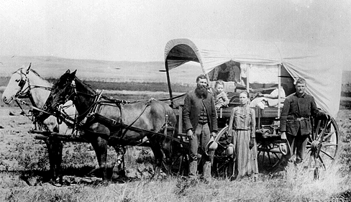
Prompt
Should you and your family decide to go to Washington State? Why or why not?

Consider information from Summary of the Homestead Act of 1862 and your What To Take graphic organizer. Decide whether to argue for or against heading west towards Washington with your family.

If you decide to go…
Include at least four reasons why you are going citing examples from the Summary of the Homestead Act or the What to Take graphic organizer. Also include how much money you have decided to spend to get ready to go, how much you will spend while on the trip and how much you think they will need once they get to Washington. Also include how far they expect to travel in one day (20 miles, if dry, 10 miles, if raining). Typically, the trip required four months to complete.

If you decide not to go…
Include at least four reasons why you are not going citing examples from the Summary of the Homestead Act or the What to Take graphic organizer. Describe an alternative for your money that can help support your family. Make sure to include a detailed plan with specific examples of your daily life and challenges if you don’t go west.

How will I be assessed?
Requirements | Give Yourself Feedback:  Did you meet all the requirements? | Teacher Feedback
State your position: Are you going or not going towards Washington? | _____ out of 1 point | _____ out of 1 point
Include at least three reasons to support your position | _____ out of 3 points | _____ out of 3 points
For each of the three reasons, cite information or examples from the Summary of the Homestead Act or the What to Take graphic organizer | _____ out of 3 points | _____ out of 3 points
Include details of your plan:  If you decided to go: Include how much money you have decided to spend to get ready to go, how much you will spend while on the trip and how much you think they will need once they get to Washington. Also include how far they expect to travel in one day (20 miles, if dry, 10 miles, if raining). Typically, the trip required four months to complete.  If you decided not to go: Describe an alternative for your money that can help support your family. Make sure to include a detailed plan with specific examples of your daily life and challenges if you don’t go west. | _____ out of 3 points | _____ out of 3 points
Total Points Earned: | _____ out of 10 points | _____ out of 10 points

