Inspired By Ike - Name_____________________________________________ Date___________
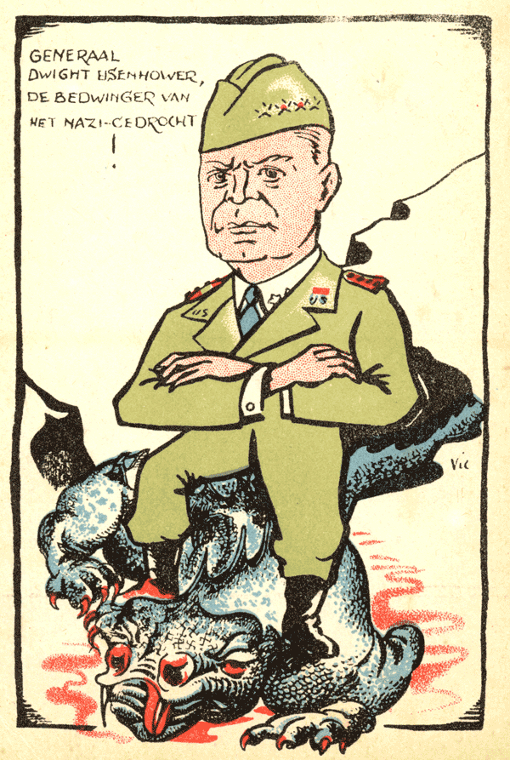
Throughout history and even today, many artists, musicians, writers, and average citizens have been inspired by Eisenhower’s character and achievements. For example, the cartoon shown to the left depicts Eisenhower’s triumph over the “Nazi Dragon” in Europe.

Your Assignment: You have just analyzed Eisenhower’s quotes and achievements, as well as character traits. Use these as inspiration to create a political cartoon, song, poem, painting, or other product in the box below. Then, explain in a paragraph on the back how Eisenhower’s character and life events can be seen in what you created.

