Name: _________________________ Date:___________________
Fruit Bat Assessment Answer Key
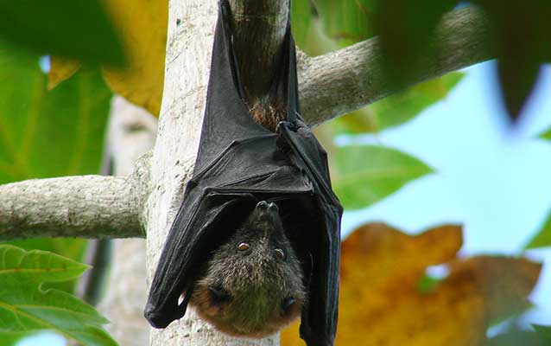

- What is the role of the fruit bat in nature?
Student answers may vary.
Fruit bats help transfer pollen from one tree to another and are also important for seed dispersal.
_______________________________________________________________________________

_______________________________________________________________________________

_______________________________________________________________________________

_______________________________________________________________________________

