Name: _________________________ Date:___________________
Fruit Bat Assessment
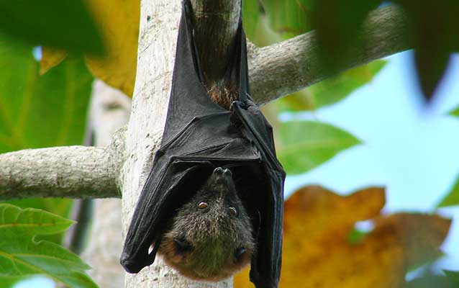

- What is the role of the fruit bat in nature?
_______________________________________________________________________________

_______________________________________________________________________________

_______________________________________________________________________________

_______________________________________________________________________________

