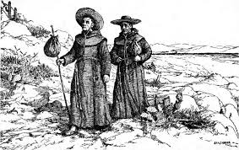
Early 1800’s New Mexican Diary
Name__________________________________________ Date _______________
Who are you writing as?
Native Person of New Mexico in 1800  A native person at this time uses mostly natural resources. You might start using certain man-made resources through trading with Spanish settlers, but you don’t have very many currently.  Make sure to include in your diary entry:  *Three examples of natural resources used by native persons.  *The good things about using mostly natural resources  *The challenges about using mostly natural resources, and what you think about | Spanish Settler in New Mexico in 1800  A Spanish settler uses mostly man-made resources. Some of these man-made resources work very well in New Mexico, but others just make life harder. You don’t know much about the natural resources available.  Make sure to include in your diary entry:  *Three examples of man-made resources used by Spanish settlers  *Man-made resources that make life easier and how you use them  *Man-made resources that make life in New Mexico more challenging and why

Dear Diary,
________________________________________________________
________________________________________________________
________________________________________________________
________________________________________________________
________________________________________________________
________________________________________________________
________________________________________________________
Love, ____________________________

