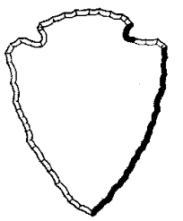
Name ____________________________________________________________

I think the best National Park Service Arrowhead Emblem

was designed by _____________________________________________________.

I believe this arrowhead emblem best represents the National Park Service and Sleeping Bear Dunes National Lakeshore because…

____________________________________________________________________________________________

____________________________________________________________________________________________

____________________________________________________________________________________________

____________________________________________________________________________________________

Name ____________________________________________________________

I think the best National Park Service Arrowhead Emblem

was designed by _____________________________________________________.

I believe this arrowhead emblem best represents the National Park Service and Sleeping Bear Dunes National Lakeshore because…

____________________________________________________________________________________________

____________________________________________________________________________________________

____________________________________________________________________________________________

____________________________________________________________________________________________

