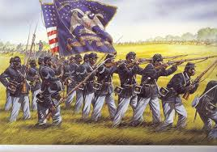
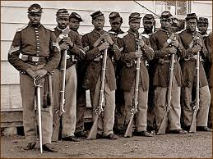
African American Civil War Accomplishments
Name __________________________________________ Date ________
Directions: Create a timeline from 1860 to the passage of the fifteenth amendment highlighting the top ten most important accomplishments of African Americans and colored troops during that time period. After placing the top ten accomplishments on your timeline, rank and justify your choices using evidence found in the primary and secondary sources.

1860
15th Amendment

Describe the Event, achievement, or accomplishment! | Justify why this event is on the timeline! Why is this event more significant than other events you learned about in your research? | Rank the Events with #1 being the most significant!

Show what you’ve learned!
Now when you hear the terms “Civil War” and “African Americans”, what do you think of? What connects those terms?

