Grand Canyon National Park
Wildlife Safe Distance Campaign
Social Media Posts and Timeline
Note: All links have been shortened with custom URLs for tracking purposes for research. Below each post that contains a link is a description of the web page it should link to. Times were selected based on general effective posting times for each platform and desired audience (weekend visitors who may be up and browsing social media earlier in the morning than typical). Consider using Hootsuite (free version) or another manager of choice to schedule posts ahead of time within a single interface. Otherwise, both Facebook and Twitter for business have options to schedule posts in advance, but Instagram does not. Syncing Hootsuite with your mobile device and NPS Instagram account is required to post to Instagram: https://blog.hootsuite.com/how-to-schedule-instagram-posts/
Thursday, June 22: 1 post each to Twitter, Facebook, Instagram
Twitter at Noon
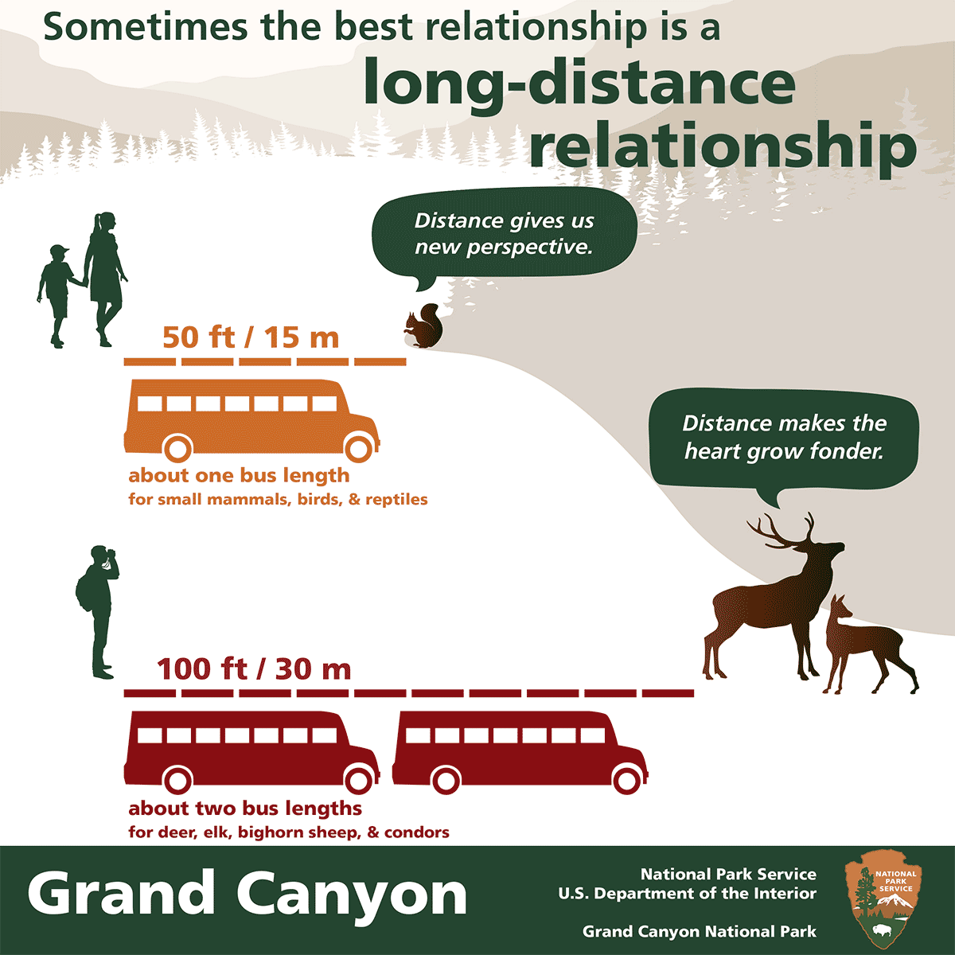
Image: 6-22_wildlife_distance_graphic.png
Caption/text: A great #GrandCanyon National Park experience starts w/ a little distance from wildlife. For more on how to view wildlife: goo.gl/MNtYPD #FindYourDistance
Link should direct to Wildlife Viewing and Safety page: https://www.nps.gov/grca/learn/nature/wildlife_alert.htm

Facebook at 1:00 p.m.
Image: 6-22_wildlife_distance_graphic.png
Caption/text: A great Grand Canyon National Park experience starts with a little distance from wildlife. We think a long-distance relationship is the best kind of relationship because it allows you to stay safe and give wildlife the space they need. For more on how to view wildlife in our park, go to: https://goo.gl/wjwJ58
Link should direct to Wildlife Viewing and Safety page: https://www.nps.gov/grca/learn/nature/wildlife_alert.htm

Instagram at 5:00 p.m.
Image: 6-22_wildlife_distance_graphic.png
Caption/text: A great #GrandCanyon National Park experience starts with a little distance from wildlife. We think a long-distance relationship is the best kind of relationship because it allows you to stay safe and give wildlife the space they need. For more on how to view wildlife in our park, go to the link in our bio. #FindYourDistance
Replace the profile/bio link with: https://goo.gl/YHYp0I (this link can remain in bio through the weekend since it also contains the link to the photography page)
Link should direct to Wildlife Viewing and Safety page: https://www.nps.gov/grca/learn/nature/wildlife_alert.htm

Friday, June 23: 1 post each to Facebook and Instagram
Facebook at 1:00 p.m.
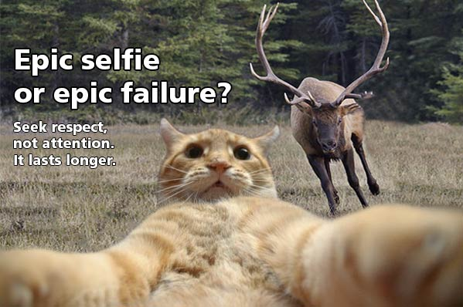
Image: 6-23_facebook_selfie-cat-elk-respect.jpg
Caption/text: Wildlife photos can still be epic, even at the safe distance: about two bus lengths for condors and animals like deer and elk, and about one bus length for all other wildlife. What are your tips for getting great pics of wildlife? See ours at https://goo.gl/wQAaUF
Instagram at 8:30 a.m.
Image: 6-23_instagram_selfie-cat-elk-humor.jpg
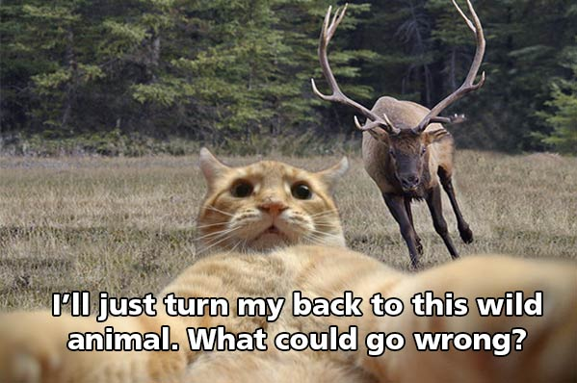
Caption/text: A lot more could go right if you take your wildlife photos at the safe distance: about two bus lengths for condors and animals like deer and elk, and about one bus length for all other wildlife. What are your tips for getting great pics of wildlife? Comment here or share yours using #GrandCanyon #FindYourDistance. See link in bio for our tips!

Saturday, June 24: 1 post each to Twitter, Facebook, Instagram
Twitter at 8:30 a.m.
Image: 6-24_squirrel-photo-tip.jpg
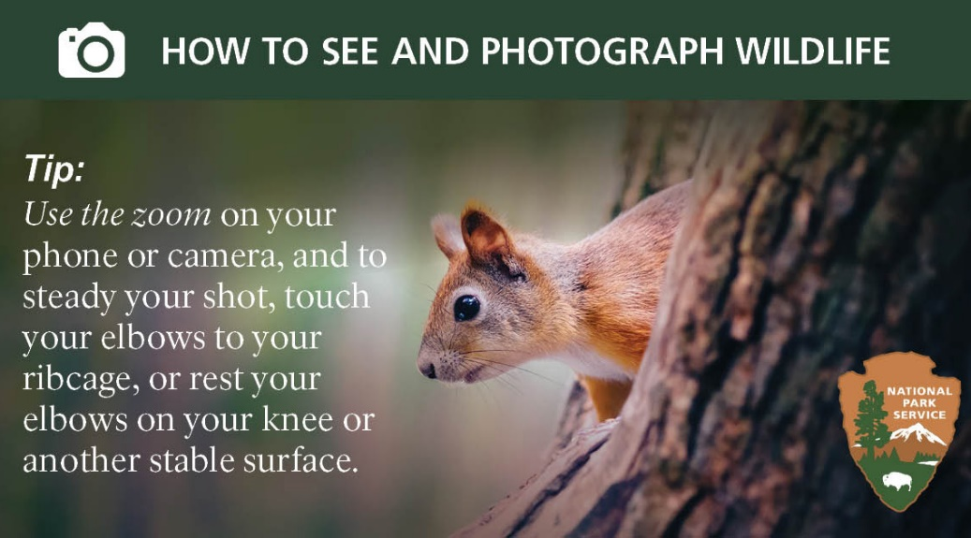
Caption/text: Share your wildlife photos taken from the safe distance using #GrandCanyon #FindYourDistance. More wildlife viewing and photo tips: https://goo.gl/OaSRlW

Facebook at 8:30 a.m.
Image: 6-24_squirrel-photo-tip.jpg
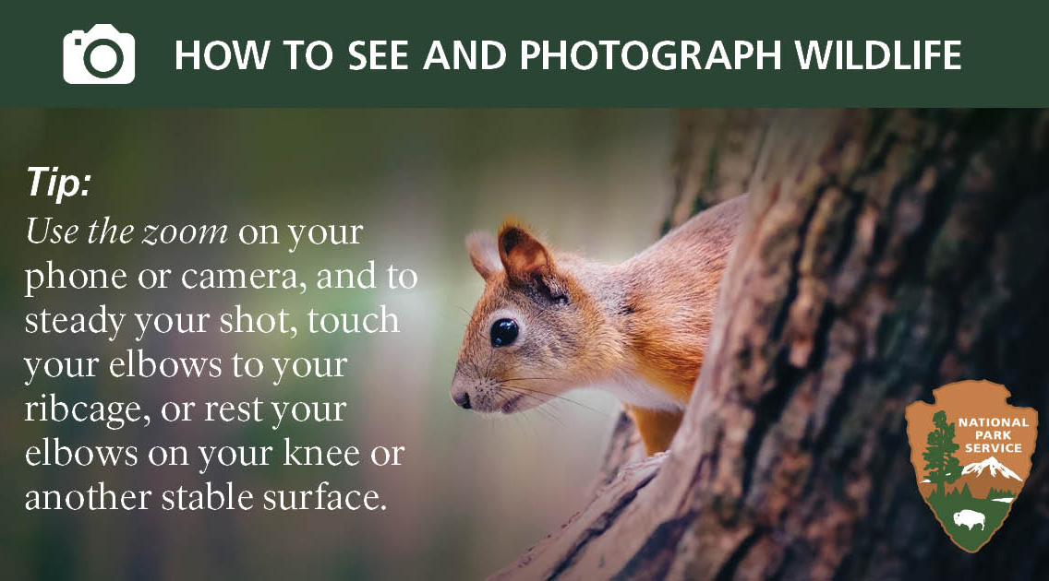
Caption/text: The key to making a long-distance relationship work? Never get too close to begin with! Quietly watching wildlife from a distance can be even more rewarding, and you can still get some great photos. For more Grand Canyon wildlife viewing and photography tips https://goo.gl/HjtqlY

Instagram at 8:30 a.m.
Image: 6-24_squirrel-photo-tip.jpg
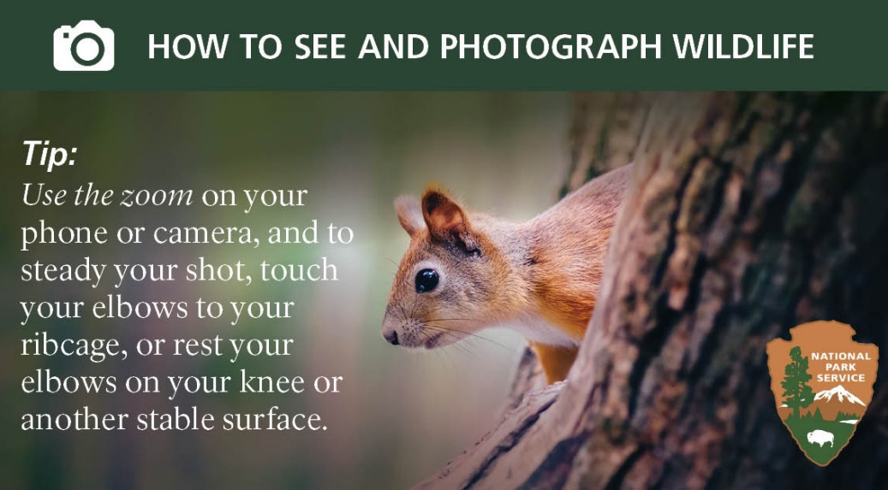
Caption/text: The key to making a long-distance relationship work? Never get too close to begin with! Quietly watching wildlife from a distance can be even more rewarding, and you can still get some great photos. Share your wildlife photos taken from the safe distance using #GrandCanyon #FindYourDistance
Sunday, June 25: 1 post each to Facebook and Instagram
Facebook at 8:30 a.m.
Image: 6-25_fawn-space.jpg
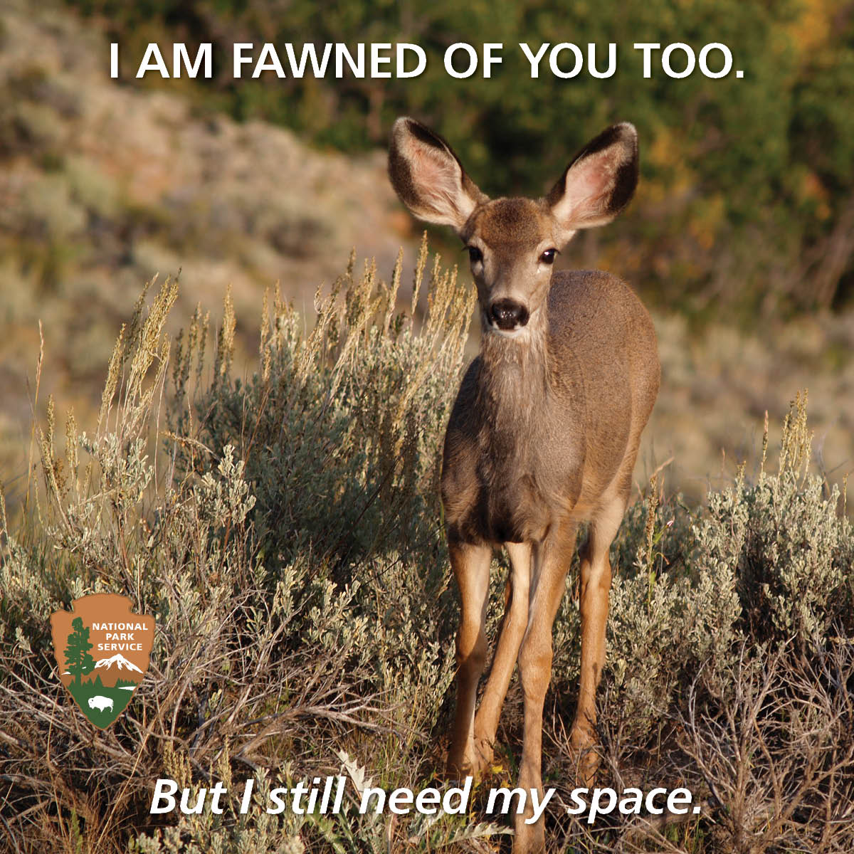
Caption/text: Many know to keep their distance from animals with claws and teeth. But even seemingly docile wildlife can have a fierce temper, especially when their young are nearby. Remember, distance makes the heart grow fonder. For more on wildlife viewing and safety: https://goo.gl/KmjtVC

Instagram at 8:30 a.m.
Image: 6-25_fawn-space.jpg
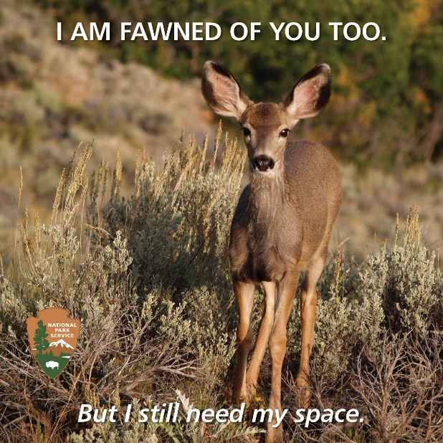
Caption/text: Many know to keep their distance from animals with claws and teeth. But even seemingly docile wildlife can have a fierce temper, especially when their young are nearby. Remember, distance makes the heart grow fonder. For more on wildlife viewing and safety, see link in bio. #GrandCanyon #FindYourDistance

