Example Tables and Figures for NRCA Reports

This document contains various examples of tables and figures (including photos) for authors to use when formatting these elements in their NRCA document. Additionally, things to avoid when creating tables and figures for NRCAs are reviewed. As always, consistency is highly encouraged between and within all tables and figures in the report. See the NRCA Author Template for other examples.

1. Table Examples

Authors may use any of the following formatting for tables, or make their own formatting according to their preferences, so long as tables throughout the report are as consistently formatted as possible. For example, strive to make basic design elements such as font, text size and bolding, row shading, and outside borders very similar (if not the same) across all tables

* 1. Table with all borders and shading

**Table 1.** Successional stage classes and criteria utilized by the CUPN forest vegetation monitoring program (White et al. 2011).

| Stage | Criteria |
| --- | --- |
| Pole | ≥67% BA in pole plus mature sizes, with more BA in pole than mature size |
| Mature | ≥67% BA in pole plus mature sizes, with more BA in mature than pole size OR ≥67% BA in mature plus large sizes, with more BA in mature than large size |
| Late-successional | ≥67% BA in mature plus large sizes, with more BA in large than mature size |

1.2. Table with shading, no outside borders, some inside borders and one note

**Table 2.** Area (in acres) of different burn severity categories (MTBS 2015).

| Date of Fire  Inside Preserve | Severity Level (acres) | | | | |
| --- | --- | --- | --- | --- | --- |
| Unburned to Low | Low | Moderate | High | Increased Greenness* |
| 24 March 1986 | 1,251.1 | 1,057.2 | 394.3 | 144.4 | 5.0 |
| 28 July 1998 | 56.7 | 210.9 | 151.8 | 128.3 | -- |
| 13 July 2001 | 654.1 | 445.6 | 56.8 | 4.2 | 17.9 |
| 9 August 2001 | 304.8 | 182.6 | 69.2 | 11.8 | 1.1 |
| 21 July 2004 | 480.6 | 368.2 | 94.8 | 2.2 | -- |
| **Total** | **2,747.3** | **2,264.5** | **766.9** | **290.9** | **24.0** |
| Outside Preserve |  |  |  |  |  |
| 1 April 1996 | 30.7 | 180.7 | 449.0 | 1,214.2 | -- |

*“Increased greenness” indicates an increased post -fire vegetation response.

1.3. Table with no outside borders or shading, and multiple table notes

**Table 3.** Certainty and alternative vulnerability scores for woodland plant community assessment variables.

| Variable | Certainty ScoreA | Vulnerability ScoreB | Alternative ScoresC |
| --- | --- | --- | --- |
| Location in geographical range/distribution of plant community | 2 | 4 | 3 |
| Sensitivity to extreme climatic events (e.g., drought, flash floods, windstorms) | 3 | 3 |  |
| Dependence on specific hydrologic conditions | 3 | 1 |  |
| Intrinsic adaptive capacity | 3 | 3 |  |
| Vulnerability of ecologically influential species to climate change | 2 | 3 | 4 |
| Potential for climate change to exacerbate impacts of non-climate stressors | 2 | 3 | 4 |
| **Total** | **15** | **17** | **16-19** |

A For individual variables, certainty scores are 3 = high, 2 = moderate, and 1 = low

B The certainty ranges are 6-10 = low confidence, 11-14 = moderate confidence, 15-18 = high confidence

C The vulnerability ranges are 6-13 = least vulnerable, 14-19 = moderately vulnerable, 20-25 = highly vulnerable, 26-30 = critically vulnerable

**Continued on next page**

1.4. Condition score tables

Summary of Weighted Condition Scores of each component, found in Chapter 5 of the NRCA document (optional).

**Table 4.** Summary of current condition and condition trend for featured NRCA components.

| Component | WCS | Condition |
| --- | --- | --- |
| Biotic Composition | | |
| Ecological Communities | | |
| Pinyon-juniper Woodlands/Savannas | 0.56 |  |
| Riparian Habitats/Large Dry Washes | 0.33 |  |
| Seeps and Springs and Tinaja Habitats | 0.58 |  |
| Birds |  |  |
| Raptors | N/A |  |
| Mammals |  |  |
| Bighorn Sheep | 0.20 |  |
| Kit Fox | 0.83 |  |
| Bats | N/A |  |
| Environmental Quality |  |  |
| Air Quality | 0.67 |  |
| Dark Night Skies | 0.67 |  |

**Continued on next page**

One component of the measured condition scores found at the beginning or end of each section in chapter 4 (optional).

**Table 5.** Condition, trend, and interpretation for the Florida Panther.

|  |  |  |  |
| --- | --- | --- | --- |
| Attribute |  | Condition & Trend | Interpretation |
| Florida Panther |  |  | BICY supports 35% of the known panther population and encompasses 32% of the panthers’ habitat with the highest conservation value (Primary Zone). Big Cypress is located in the geographic center of the population’s observed range. |

**Continued on next page**

**2. Figure Examples**

The following are examples of the types of figures that are typically found in NRCA reports. Authors can decide if they want their figures to have borders around them or not (see examples below).

2.1. Figures generated in other programs

This figure was originally copied directly from MS Excel to MS Word, and then re-copied as a picture after formatting was completed (Axis text formatted to be Arial font size 10)

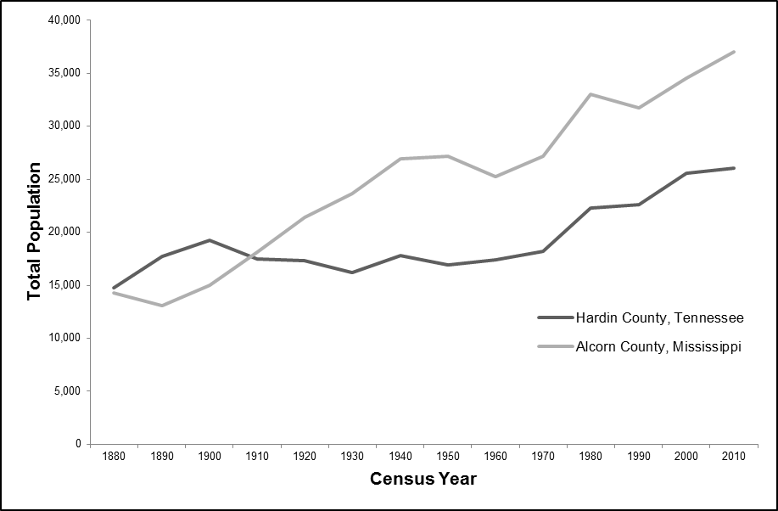

**Figure 1.** The graph articulates total population for both Hardin County, Tennessee and Alcorn County, Mississippi (USCB 1996).

**Continued on next page**

This figure was copied into the Word document as a picture, and so the font sizes were not changed from the original submitted document

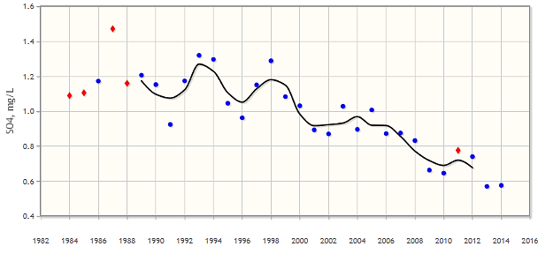

**Figure 2.** Annual weighted mean concentration of sulfate in wet deposition from Hatchie NWR (NTN Site TN 14) (NADP 2016b). The black line represents a smoothed 3-yr moving average.

2.2. New to Template: Photos* are now labeled as figures

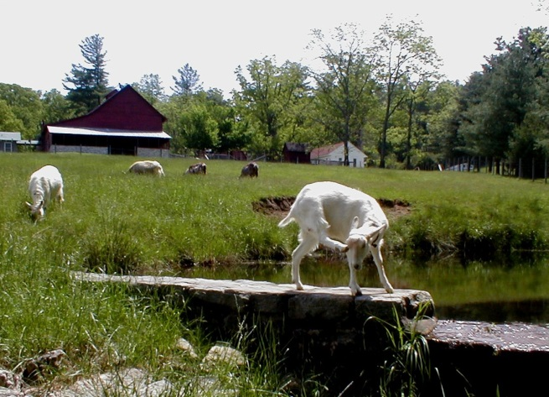

**Figure 3.** Livestock grazing threatens water quality within the park (NPS).

**\*Note:**  If photos are purely decorative, they do not need to be referenced in the text, nor do they need to be numbered and listed in the list of Figures (no longer using a list of Photos).

**Continued on next page**

2.3. GIS, or similar software developed figure

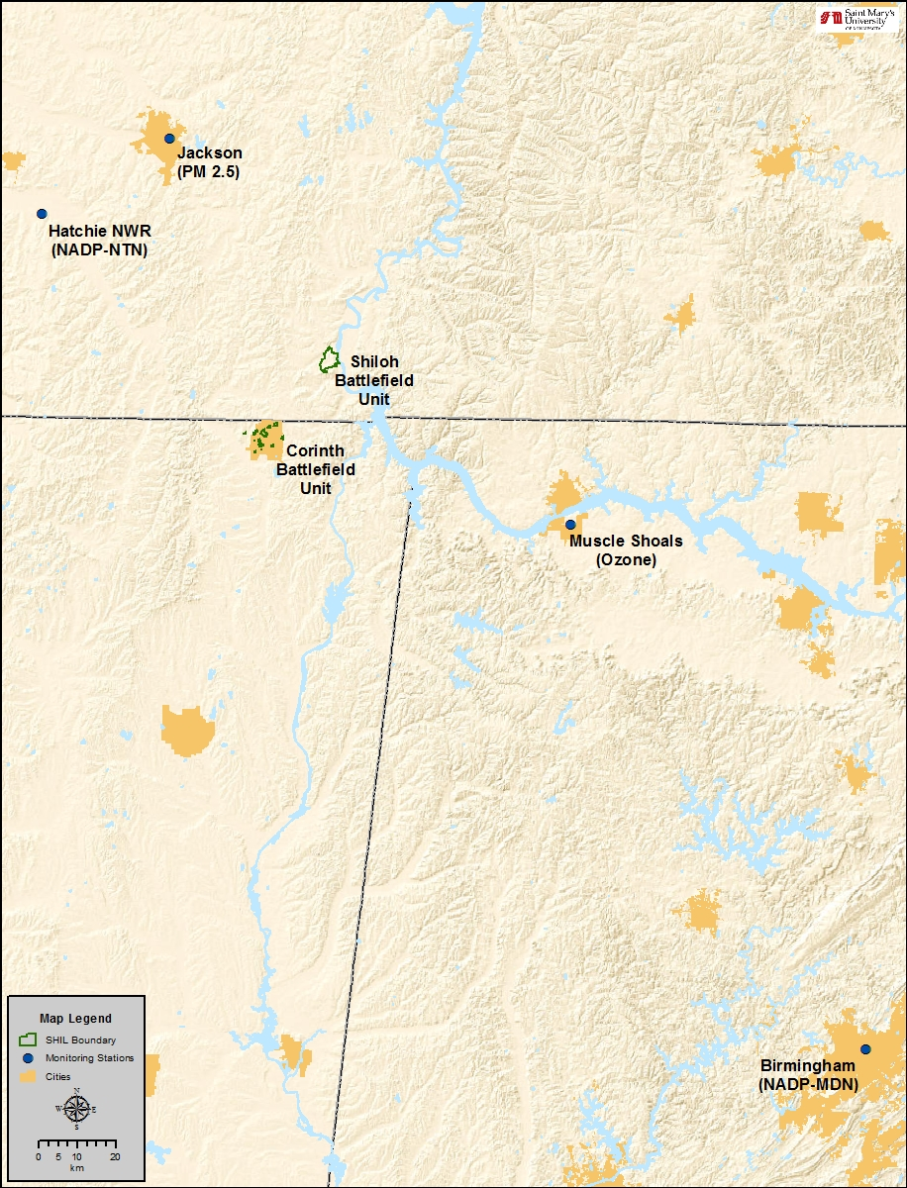

**Figure 4.** Air quality monitoring locations in relation to SHIL.

2.4. If many of your figures have borders around them, or many of them don’t, you may want to consider keeping that pattern consistent.

Example Figure without a border around it

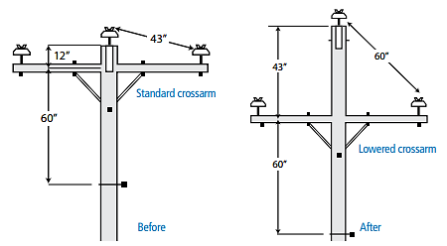

**Figure 5.** Caption to go here.

Example Figure with a border around it

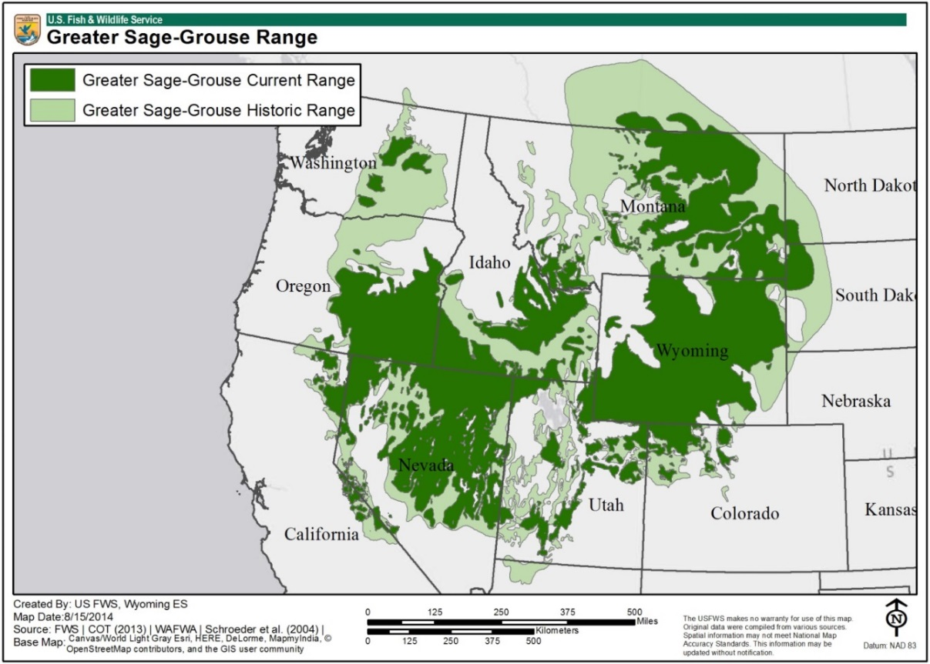

**Figure 6.** Caption to go here. **Note:** GIS (or other such maps) tend to already have a border around them; it is up to the authors to decide if they want to follow that formatting for all figures in their NRCA.

3. Examples of things to avoid when creating tables and figures for NRCA reports

**3.1. Tables**

This is an example of a table that is hard to follow; plus, the formatting (i.e. bolded words vs. underlined) is inconsistent.

**Table 1.** Representative fossils from X Formation fossil basin

|  |  |  |  |  |
| --- | --- | --- | --- | --- |
| Fish (23 Genera) | Amphibians and reptiles (19 Genera) | | Mammals (26 Genera) | |
| **Stingrays** | **Alligators** | | **Bat** | |
| *Asterotrygon maloneyi* | *Alligator* sp. | | *Icaronycteris index* | |
| *Heliobatis radians* | *Allognathosuchus* sp. | | *Onychonyctris finneyi* | |
|  | *Procaimanoidea* sp. | |  | |
| **Gar** |  | | **Condylarths** | |
| *Lepisosteus bemisi* | **Crocodilian** | | *Hyopsodus minusculus* | |
| *Atractosteus simplex* | *Borealosuchus wilsoni* | | *Hyopsodus vicarious* | |
| *Atractosteus atrox* | *Leidyosuchus wilsoni* | |  | |
|  | *Crocodylus acer* | | **Carnivores** | |
| **Bowfin** | *Crocodylus affinis* | | *Miacis gracilis* | |
| *Amia pattersoni* | *Pristichampsus vorax* | | *Vulpavus profectus* | |
| *Cyclurus gurleyi* |  | | *Vulpavus australis* | |
|  | **Turtles** | | *Viverravus minutes* | |
| **Bonytongue** | *Baaena arenosa* | | *Viverravus eucristadens* | |
| *Phareodus encaustus* | *Echmatemys septaria* | | *Mesonyx* sp.(wolf-like) | |
| *Phareodus testis* | *Echmatemys wyomingensis* | | *Metacheiromy* sp. | |
| Birds (14 Genera) | | | | |
| Frigatebird | | | Others | |
| *Limnofregata azygosternon* | | | *Presbyornis pervetus* (waterbird) | |
| *Limnofregata. hasegawai* | | | *Gallinuloides wyomingensis* (land fowl) | |
|  | | | *Messelornis nearctica* (bittern-like) | |
| Parrot relative | | | *Fluvioviridavis platyrhamphus* (oilbird) | |
| *Cyrilavis colburnorum* | | | *Prefica nivea* (goatsucker) | |
| *Avolatavis tenens* | | | *Primobucco mcgrewi* (perching bird) | |
|  | | | *Tynskya eocaena* (raptor-like bird) | |

3.2. Figures

Figures generated in MS Excel (or similar program) with text boxes on top (even if they do not have borders).

Problem

Many things get moved around in the documents as we format different parts; as such, text boxes that are on top of figures (or other separated pieces such as shapes) may not stay with the figure as it moves.

Our suggestion

If authors want to include text boxes relaying legend-type information to their figures, we ask that they be grouped in Excel and copied into the Word document as a picture, or that authors send the original figure in an Excel spreadsheet so that we (NRCA Publication Team) can do this.

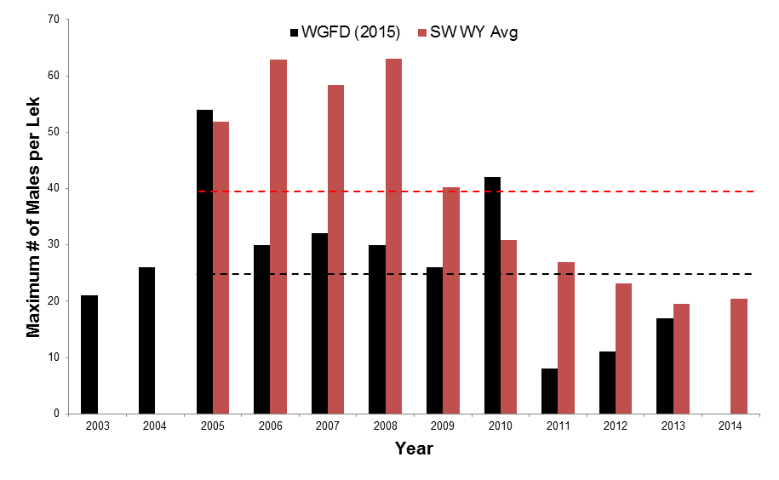

WGFD (2015) Male

Attendance Avg (25 males/lek)

SW WY Male Attendance Avg (39.71 males/lek)

**Continued on next page**

Figures with text that is hard to read

Legend text is too small

When generating figures, especially in GIS, Excel, or other similar programs, be sure to format the legend to where it can be easily read. Also consider only including those keys that are essential.

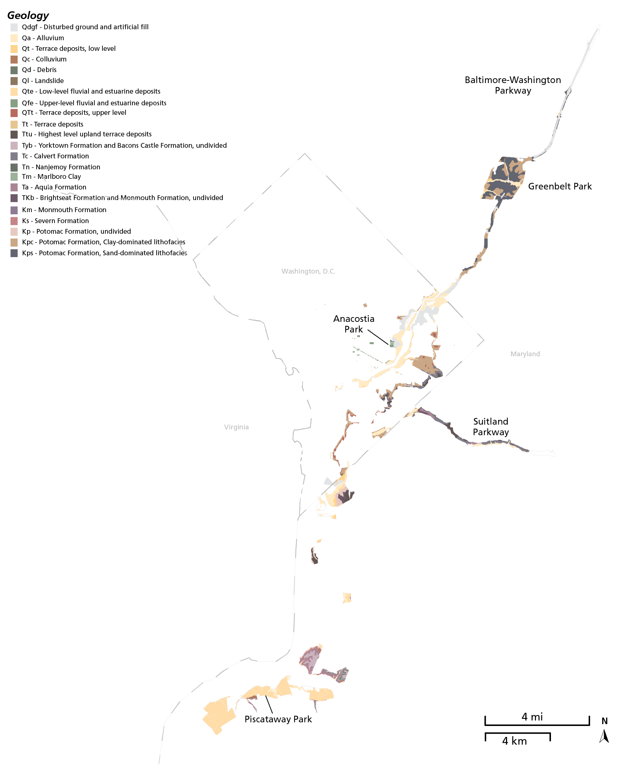

**Continued on next page**

Text has not been increased as much as it could be (Arial, 8-10 pt.); therefore, it is difficult to read the axes titles and the legends.

If you copy an image into the Word file as a picture, be sure to format the text (at least the axes titles) to font Arial, size 8 – 10, in order for your figure to be easily readable.

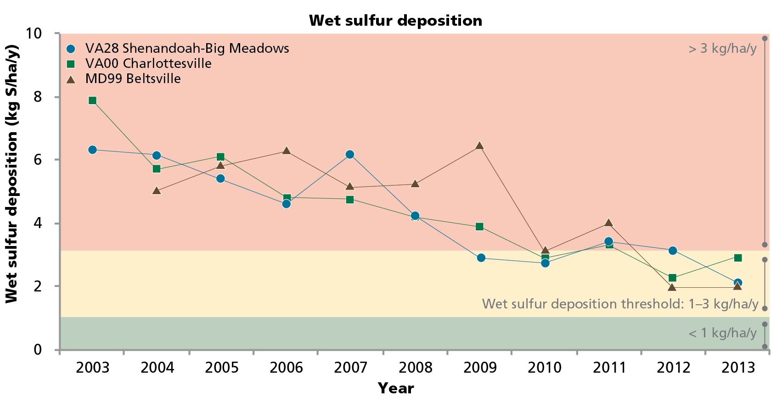

Figure that has been reduced in size, to where it is unreadable

We recommend that authors do not reduce the size of figures to less than 60% of their original size

Night sky quality monitoring report for Rubey Point, Fossil Butte National Monument for night of 13 October 2004.

Figure has been made too large – bad resolution

We recommend that authors do not increase the size of figures to more than 130% of their original size.

