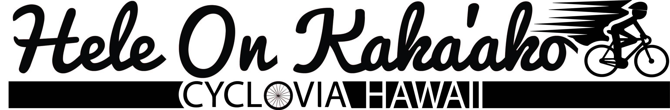

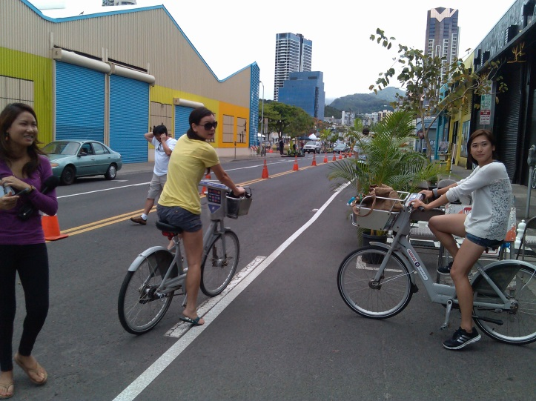
Last May, Kaka‘ako experienced Oahu’s second cyclovia. The success of the event came from the volunteers who dedicated time, energy, and hard work to create a complete street demonstration and opened up streets for play for the day. The National Park Service worked with Cycle On Hawaii, the American Society of Landscape Architects, Hawaii Chapter (ASLA Hawaii Chapter) and numerous organizations and volunteers to make the event possible. A special thank you goes out to the tireless landscape architects who dedicated expertise and contacts to turn a typical urban concrete street into a vibrant, bike and pedestrian friendly street full of trees, plants, and innovative green infrastructure examples.
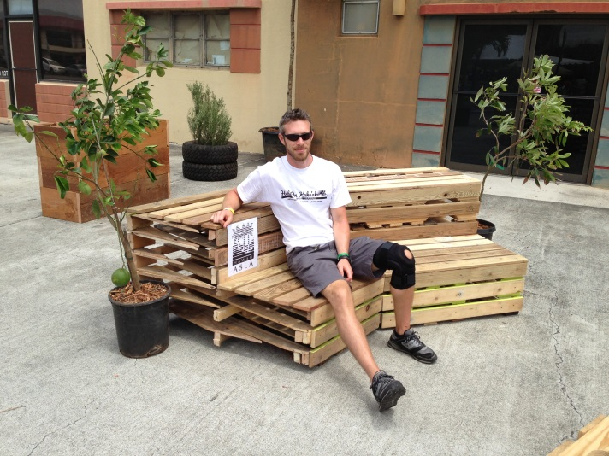
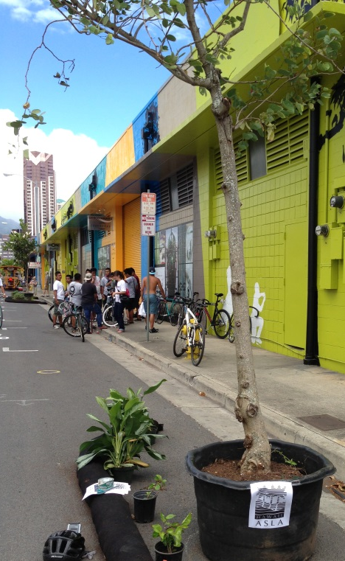
Hele On Kaka‘ako, took place on Mother’s Day, May 12, 2013, and featured a cyclovia event, which closed many streets to motorized transportation. Hele On Kaka‘ako combined the cyclovia event with a demonstration complete street project that allowed people to experience a bike and pedestrian friendly street with outside spaces for people and businesses to utilize. It aimed to educate and inspire people to support healthy, sustainable community designs. The complete street demonstration required approval from the City and County of Honolulu with professional support required. ASLA Hawaii Chapter provided much needed expertise to make the complete streets demonstration a reality. Sponsorship also included trees and benches.

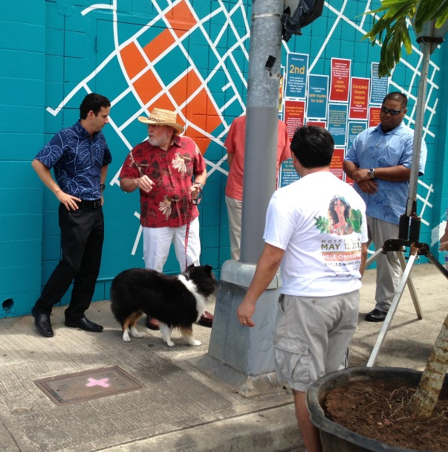
Cycle On Hawai‘i created the vision and support to implement the event. However, to make it happen, the event required an enormous amount of professional volunteer support. The ASLA Hawaii Chapter came out to support the event through donations of time for the planning, donations of trees and benches, and lots of sweat with implementation. Parklettes, green infrastructure, mini traffic circles, and an urban food forest were designed and installed for the day. It was an effort that included participation and encouragement from U.S. Senator Schatz, Governor Neil Abercrombie, and numerous organizations such as bicyclist advocacy groups, public health groups and agencies, the diverse Kaka‘ako community, businesses and artists, professional landscape architects, engineering groups and firms, architects, green building professionals, environmental advocacy groups, large land owners and developers, and youth and volunteer groups. It was an amazing representation of interests across the state.

