Use only for **human remains** and **associated funerary objects** AFTER responding to a request for repatriation (see [43 CFR 10.10(g)](https://www.ecfr.gov/current/title-43/part-10/section-10.10#p-10.10(g)) *Step 7 – Respond to a request for repatriation*). Please note: A museum or Federal agency may combine a response to a request for repatriation (Step 7) and a repatriation statement (Step 8) provided all required information is included in a single written document.

No later than 90 days after responding to a request for repatriation that meets the criteria, use this template to complete [43 CFR 10.10(h)](https://www.ecfr.gov/current/title-43/part-10/section-10.10#p-10.10(h)) *Step 8 – Repatriation of the human remains or associated funerary objects*.The museum or Federal agency may include in a single statement any human remains or associated funerary objects having the same requestor identified in item 3 below.

**Insert the following five pieces of information** in the appropriate places in this template, indicated by {#. Required information and *additional instructions*}. This is the MINIMUM information required. The format is only a recommendation and not a requirement.

1. Museum or Federal Agency. *Full name can be abbreviated or referred to by initials after the first instance, i.e. Museum of Natural Science (MONS).*

2. Date signed and sent. *Documents are timely based on the date sent (*[*43 CFR 10.1(f)(2)*](https://www.ecfr.gov/current/title-43/part-10/section-10.1#p-10.1(f)(2))*).*

3. Requesting lineal descendant (whose name may be withheld), Indian Tribe, or Native Hawaiian organization. *In the case of joint requests for repatriation, a repatriation statement must identify and be sent to all requestors. Countersignature by requesting parties is NOT required or recommended.*

4. The corresponding *Federal Register* notice(s). *For each notice, include information found in the Document Details tab on Federalregister.gov. Include Document Citation, Document Number, and Publication Date. From the image below, as an example,* 89 FR 77184, 2024-21541, 9/20/2024. *If the repatriation statement only partially covers the human remains and associated funerary objects listed in the notice(s), please note the specific paragraphs in the notice that are included in the repatriation statement.*

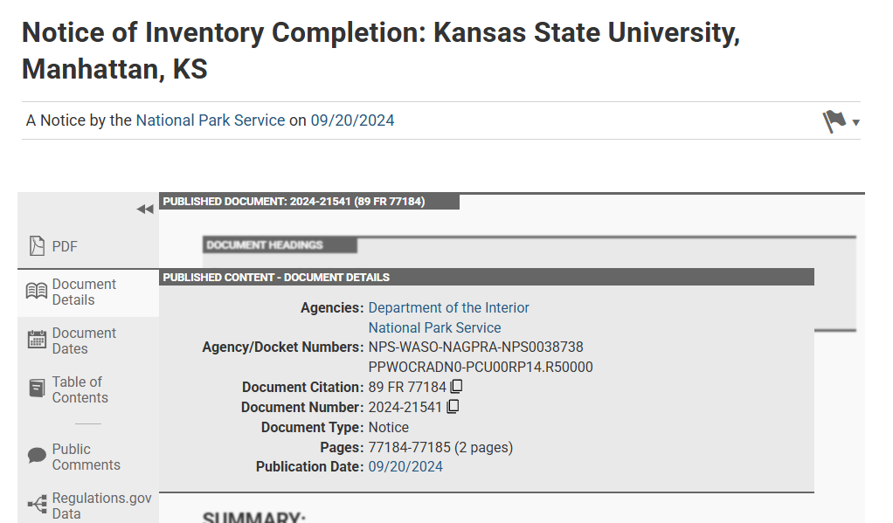

5. *Optional but recommended:* Statement that information is or is not available about the human remains or associated funerary objects being treated with pesticides, preservatives, or other substances that represent a potential hazard to the human remains or object(s) or to the person(s) handling the human remains or object(s).

**REMOVE** these instructions, highlighting, italics, and {braces} before submission.

**Send a repatriation statement** to the requestor(s) identified in item 3 above and to the Manager, National NAGPRA Program, ([nagpra_info@nps.gov](mailto:nagpra_info@nps.gov))*.* The National NAGPRA Program will file the statement and enter item 2, Document date, next to the appropriate entry in the Notices database. See <https://apps.cr.nps.gov/nagprapublic/Home/Notice>. **To prevent delays or errors in recording the statement, please ensure the information in item 4 above is accurate and complete.**

{INSERT Letterhead} *OR* {1. Museum/Federal agency Name, City and State}

{2. Date}

In accordance with the Native American Graves Protection and Repatriation Act (NAGPRA; 25 U.S.C. 3001 et seq) and its implementing regulations (43 CFR part 10), this statement certifies the following:

* The {1. Museum or Federal Agency} relinquishes possession or control of
* the {human remains} and {associated funerary objects} listed in the attached *Federal Register* notice(s) to
* {3. list the requesting lineal descendant (whose name may be withheld), Indian Tribe, or Native Hawaiian organization}.

The human remains and associated funerary objects were published in the following *Federal Register* notice(s) of inventory completion: {4. Identify each notice by Document Citation, Document Number, and Publication Date}

* {Document Citation as Vol. FR Page No.}; {Document Number as YYYY-#####}; and {Publication Date as MM/DD/YYYY} *Repeat as necessary and attach notices.*

{OPTIONAL but recommended statement} The {1. Museum or Federal Agency} has {*choose as appropriate:* 5. Information about *OR* no information about} the human remains or associated funerary objects being treated with pesticides, preservatives, or other substances that represent a potential hazard to the human remains or object(s) or to person(s) handling the human remains or object(s). Any information about these treatments was previously shared with the recipients.

After sending this repatriation statement, {1. Museum or Federal Agency}will:

1. Consult with the parties above on custody and physical transfer,
2. Document any physical transfer, and
3. Protect sensitive information from disclosure to the general public to the extent consistent with applicable law.

Nothing in the Act or this part limits the authority of the {1. Museum or Federal Agency} to enter into any agreement with the requestor concerning the human remains or associated funerary objects.

The {1. Museum or Federal Agency} will send a copy of this repatriation statement to all parties identified above and the Manager, National NAGPRA Program.

{Museum or Federal agency authorized representative signature block}

Enclosure(s): Federal Register notice(s)

CC: National NAGPRA Program (nagpra_info@nps.gov) and {3. Requesting lineal descendant, Indian Tribe, or Native Hawaiian organization}