Use only for **human remains or cultural items** that have been **removed from Federal lands** AFTER responding to a claim for disposition (see [43 CFR 10.7(c)(4)](https://www.ecfr.gov/current/title-43/part-10/section-10.7#p-10.7(c)(4)) *Step 4 – Respond to a claim for disposition*). Please note: A Federal agency or DHHL may combine a response to a claim for disposition (Step 4) and a disposition statement (Step 5) provided all required information is included in a single written document.

No later than 90 days after responding to a claim for disposition that meets the criteria, use this template to complete [43 CFR 10.7(c)(5)](https://www.ecfr.gov/current/title-43/part-10/section-10.7#p-10.7(c)(5)) *Step 5 – Disposition of the human remains or cultural items.* The Federal agency or DHHL may include in a single statement any human remains or cultural items having the same requestor identified in item 3 below.

**Insert the following four pieces of information** in the appropriate places in this template, indicated by {#. Required information and *additional instructions*}. This is the MINIMUM information required. The format is only a recommendation and not a requirement.

1. Federal agency or State of Hawaii Department of Hawaiian Home Lands (DHHL). *Full name can be abbreviated or referred to by initials after the first instance, i.e. U.S. Department of the Interior, Bureau of Land Management (BLM) or State of Hawaii Department of Hawaiian home Lands (DHHL).*

2. Date signed and sent. *Documents are timely based on the date sent (*[*43 CFR 10.1(f)(2)*](https://www.ecfr.gov/current/title-43/part-10/section-10.1#p-10.1(f)(2)))*.*

3. Claimant(s) – lineal descendant (whose name may be withheld), Indian Tribe, or Native Hawaiian organization. *In the case of joint claims for disposition, a disposition statement must identify and be sent to all claimants. Countersignature by claimant(s) is NOT required or recommended.*

4. The corresponding *Federal Register* notice(s). *For each notice, include information found in the Document Details tab on Federalregister.gov. Include Document Citation, Document Number, and Publication Date. From the image below, as an example,* 89 FR 77184, 2024-21541, 9/20/2024. *If the disposition statement only partially covers the human remains or cultural items listed in the notice(s), please note the specific paragraphs in the notice that are included in the disposition statement.*

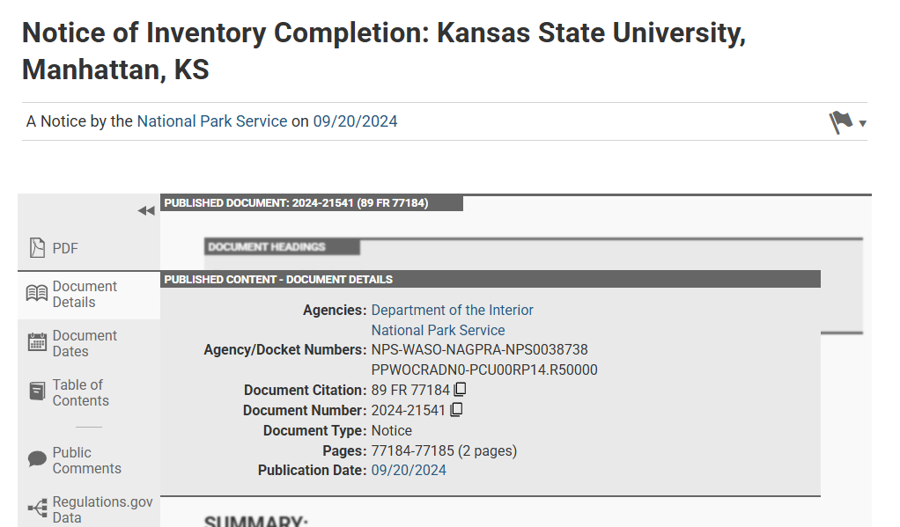

**REMOVE** these instructions, highlighting, italics, and {braces} before submission.

**Send a disposition statement** to the claimant(s) identified in item 3 above and to the Manager, National NAGPRA Program, (<nagpra_info@nps.gov>). The National NAGPRA Program will file the statement and enter item 2, Document date, next to the appropriate entry in the Notices database. See <https://apps.cr.nps.gov/nagprapublic/Home/Notice>. **To prevent delays or errors in recording the statement, please ensure the information in item 4 above is accurate and complete.**

{INSERT Letterhead} *OR* {1. Federal agency/DHHL Name, City and State}

{2. DATE}

In accordance with the Native American Graves Protection and Repatriation Act (NAGPRA; 25 U.S.C. 3001 et seq) and its implementing regulations (43 CFR part 10), this statement certifies the following:

* The {1. Federal Agency or DHHL} recognizes that ownership or control of
* the human remains or cultural items listed in the attached *Federal Register* notice(s) is with
* {3. list the claimant(s) – lineal descendant (whose names may be withheld), Indian Tribe, or Native Hawaiian organization}.

The human remains or cultural items were published in the following *Federal Register* notice(s) of intended disposition: {4. Identify each notice by Document Citation, Document Number, and Publication Date}

* {Document Citation as Vol. FR Page No.}; {Document Number as YYYY-#####}; {Publication Date as MM/DD/YYYY} *Repeat as necessary and attach notices.*

After sending this disposition statement, {1. Federal Agency or DHHL}will:

1. Consult with the parties above on custody and physical transfer,
2. Document any physical transfer, and
3. Protect sensitive information from disclosure to the general public to the extent consistent with applicable law.

Nothing in the Act or this part:

1. limits the authority of the {1. Federal Agency or DHHL} to enter into any agreement with the claimant concerning the human remains or cultural items;
2. limits any procedural or substantive right which may otherwise be secured to the lineal descendant, Indian Tribe, or Native Hawaiian organization; or
3. prevents the governing body of an Indian Tribe or Native Hawaiian organization from expressly relinquishing its ownership or control of human remains, funerary objects, or sacred objects.

The {1. Federal Agency or DHHL} will send a copy of this disposition statement to all parties identified above and the Manager, National NAGPRA Program.

{Federal agency or DHHL appropriate official signature block}

Enclosure(s): Federal Register notice(s)

CC: National NAGPRA Program (nagpra_info@nps.gov) and {3. Claimant(s) – lineal descendant, Indian Tribe, or Native Hawaiian organization}