WORLD HERITAGE TENTATIVE LIST

STATE PARTY: United States of America

DATE OF SUBMISSION: January 2008

Submission prepared by:

Office of the Assistant Secretary for Fish and Wildlife and Parks
U.S. Department of the Interior

Name: Stephen A. Morris
Chief, Office of International Affairs

E-mail : stephen_morris@nps.gov

Address: 1201 Eye Street, NW, Room 550A
Washington, DC 20005

Fax: 202-371-1446

Institution: U.S. National Park Service

Telephone: 202-354-1803

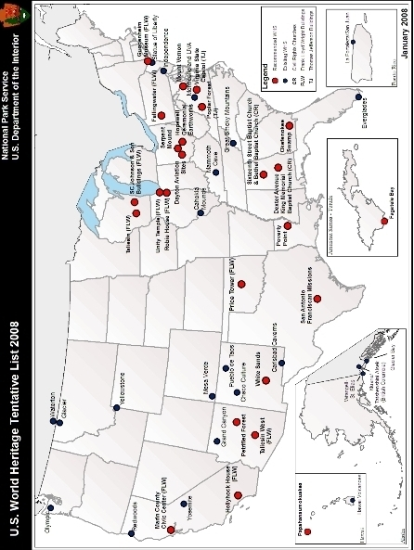

U.S. WORLD HERITAGE TENTATIVE LIST 2008:

Title Page 1

U.S. World Heritage Tentative List 2008 (map) 2

Table of Contents 3

Cultural Properties (9): 4

Civil Rights Movement Sites, Alabama 5
Dayton Aviation Sites, Ohio 8
Hopewell Ceremonial Earthworks, Ohio 12
Thomas Jefferson Buildings: Poplar Forest and Virginia State Capitol 17
Mount Vernon, Virginia 22
Poverty Point State Historic Site, Louisiana 25
San Antonio Franciscan Missions, Texas 29
Serpent Mound, Ohio 34
Frank Lloyd Wright Buildings, Arizona, California, Illinois, New York, Oklahoma,
Pennsylvania, and Wisconsin 37

Mixed Property (1): 44

Paphanaumokuakea National Monument, Hawaii 45

Natural Properties (4): 51

Fagatele Bay National Marine Sanctuary, American Samoa 52
Okefenokee Swamp National Wildlife Refuge, Georgia 55
Petrified Forest National Park, Arizona 58
White Sands National Monument, New Mexico 61

NOTE: All geographical data utilizes North American Datum of 1927 (NAD 27)

CULTURAL PROPERTIES (9)
NAME OF PROPERTY

Civil Rights Movement Sites

STATE: Alabama

LATITUDE AND LONGITUDE and UTM COORDINATES:

Dexter Avenue King Memorial Baptist Church, Montgomery

86°18'10.001"W 32°22'37.72"N Z16N 565592 3582263

Bethel Baptist Church, Birmingham

86°48'6.252"W 33°33'5.118"N Z16N 518405.304 3712244.923

16th Street Baptist Church, Birmingham

86°48'52.298"W 33°30'58.677"N Z16N 517224.881 3708348.820

DESCRIPTION:

This serial nomination proposal is for the three above-named historically African-American churches. Dexter Avenue King Memorial Church was built in stages in 1883-88. It is a Gothic Revival-style rectangular brick structure with a gable roof; its entrance bay has a 2-stage belfry with a pyramidal roof. It is still an active church. Bethel, built in 1926, is a relatively small 3-story L-shaped Gothic Revival style building of wood frame with brick veneer that was vacated by its congregation in 1997, but remains in their ownership. The 16th Street Church, a much larger structure than Bethel, was built in 1909-11 with a combination of what has been described as Romanesque and Byzantine Revival features; it is a 3-story rectangular structure with twin belltowers.

JUSTIFICATION OF OUTSTANDING UNIVERSAL VALUE:

These three churches are the locations of iconic events in the mid-20th century civil rights movement for African-Americans in the United States of America. This movement both drew from and had a profound influence on human rights movements elsewhere in the world, particularly insofar as they embody techniques of non-violent social change hitherto most powerfully expressed by Mahatma Gandhi. There were also many other types of sites and many other churches in the United States, especially in the Southern States, that played a role in this movement, but the impact and renown of the events that took place at these three properties are preeminent.
CRITERIA CONSIDERED TO BE MET:

(vi) Be directly or tangibly associated with events or living traditions, with ideas, or with beliefs, with artistic and literary works of outstanding universal significance. (This criterion should preferably be used in conjunction with other criteria.)

The events associated with these three churches had both national and international influence in the struggle for civil rights. They are the 1955-56 Montgomery bus boycott led by Rev. Martin Luther King, Jr., of Dexter Avenue Baptist Church; the 1965 voting rights march from Selma, Alabama to Montgomery that ended at that church, the 1963 street demonstrations in Birmingham inspired in part by Rev. Fred Lee Shettlesworth of Bethel Baptist Church, and the 1963 bombing of the 16th Street Church that martyred four young girls.

STATEMENT OF AUTHENTICITY AND/OR INTEGRITY:

All three churches retain substantially their appearance as of the time of the most historically significant events associated with them. Repairs and some changes were made after the three bombings at Bethel and portions of the 16th Street Church had to be changed and rebuilt after the 1963 bombing. There is excellent documentation to inform restoration efforts.

COMPARISON WITH OTHER SIMILAR PROPERTIES:

The subject events in Montgomery and Birmingham were among the most important elements in the movement for African-American civil rights. Although the events with which these churches are associated were so important and influential that they can be recognized in their own right, additional sites in other cities might be included in the series to represent other aspects of the movement. Such sites might include the Martin Luther King, Jr., National Historic Site in Atlanta, Georgia; the Brown v. Board of Education National Historic Site, in Topeka, Kansas; and the Little Rock Central High School (Arkansas) National Historic Site in relation to the desegregation of U.S. public schools; and the Shelley House in St. Louis, Missouri, key in the struggle to eliminate racial restrictions in property deeds. The Selma to Montgomery National Historic Trail, which commemorates the full route of the 1965 voting rights march, is another potential component.

Internationally, there are relatively few sites devoted to human rights struggles, although there are some that were scenes of oppression. There seem to be, as yet, none that so fully represent efforts aimed at non-violent social change.

Civil Rights Movement Sites, continued

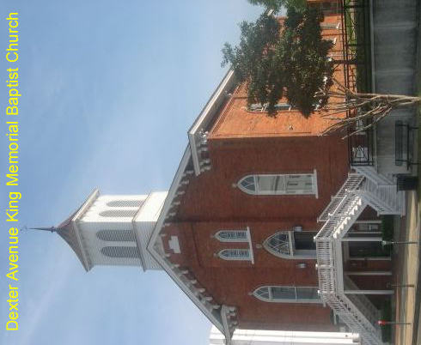
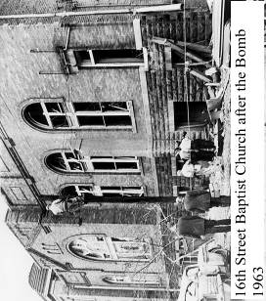 | 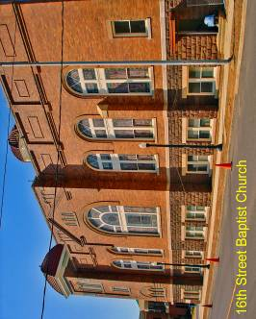

NAME OF PROPERTY

Dayton Aviation Sites

STATE: Ohio

LATITUDE AND LONGITUDE and UTM COORDINATES:

Huffman Prairie Flying Field

84°4'16.229"W 39°48'28.067"N Z17N 237082.107 4410728.836

Wright Cycle Company and Wright & Wright Printing

84°12'42.967"W 39°45'19.25"N Z17N 224820.500 4405329.640

Wright Hall

84°12'5.4"W 39°43'40.23"N Z17N 225605.526 4402244.075

Hawthorn Hill

84°10'34.68"W 39°43'20.244"N Z17N 227743.905 4401550.835

DESCRIPTION:

This proposed serial nomination includes the four above-named sites associated with the Wright Brothers’ pioneering efforts in human flight, in and around the city of Dayton. The first three components are part of Dayton Aviation Heritage National Historical Park, a unit of the National Park System, although Huffman Prairie is owned by the U.S. Air Force and Wright Hall by Dayton History. Hawthorn Hill is owned by the Wright Family Foundation; there are plans to add the property to the park.

Huffman Prairie was a cow pasture when the Wrights began to use it in 1904 for test flights; it remains an open landscape. The small 2-story brick building that housed the Wright Cycle Company and Wright and Wright Printing in 1895-97 today houses exhibits and National Park Service offices. The Wright Flyer III, the first practical airplane, was tested at Huffman Prairie by the Wrights in 1905; it is enshrined in Wright Hall, a building constructed in the 1940s specifically to house it. Hawthorn Hill, a 2-1/2 story brick mansion, was the primary residence of Orville Wright between 1914 and 1948.

JUSTIFICATION FOR OUTSTANDING UNIVERSAL VALUE:

In 1905 in Dayton, Ohio, Orville and Wilbur Wright constructed and tested the Wright Flyer III, the first airplane that could take off, fly until it exhausted its fuel supply, land safely, and do so repeatedly. The result turned the airplane into a practical reality that has, in just over a century, incalculably affected numerous aspects of human life. The sites include one of the shops where their early experiments were conducted; the field where the first sustained and controlled flights took place; the most significant of their early aircraft; and the long-time home of Orville Wright that reflects his success and stature in the new field of aviation. Together, these sites preserve critical evidence of events that have transformed the world.

CRITERIA CONSIDERED TO BE MET:

(ii) Exhibit an important interchange of human values, over a span of time or within a cultural area of the world, on developments in architecture or technology, monumental arts, town-planning or landscape design.

The Dayton aviation sites, where the Wrights developed practical flight through their construction and testing of the Wright Flyers, are key sites in the birth of a technology that has had world-wide influence. The four components together comprehensively illustrate the research, the technology, the place and the results of their achievement. Drawing on the efforts of their predecessors, the Wrights’ work has in turn powerfully influenced the entire history of aviation.

STATEMENT OF AUTHENTICITY AND/OR INTEGRITY:

Huffman Prairie retains the key elements of its historic appearance as pasture land when it was used for the Wrights’ test flights, including its original boundary markers.

The Wright Cycle Company and Wright & Wright Printing Company building essentially retains its historic exterior appearance. The first floor of the interior retains its original floor, but now accommodates exhibits and, on the second floor, National Park Service offices.

Wright Hall, containing the Wright Flyer III airplane, is a structure specifically built to house the plane, in an important early step to preserve the history of aviation. The building is little altered. The aircraft retains integrity of design and workmanship and about 85% of its original materials; Orville Wright himself supervised the restoration of the plane and the construction of Wright Hall.

Hawthorn Hill retains its exterior appearance and setting and has been altered very little on the interior since Orville Wright’s residence.

COMPARISON WITH OTHER SIMILAR PROPERTIES:

The Wrights’ first four flights, which were shorter, took place at Kitty Hawk, North Carolina, a site now included in the National Park System as the Wright Brothers National Memorial. This site was nominated by the United States in 1981, but withdrawn when ICOMOS recommended against its listing, primarily due to a perception of a loss of integrity at the site. If and when a nomination of the Dayton sites is considered, the issue of whether Kitty Hawk might be included as part of the series will be reexamined.

There are no other sites associated with the Wrights’ American contemporaries that retain a high enough degree of integrity to be considered. The site in Paris of Brazilian Alberto Santos-Dumont’s first powered flight in Europe in 1906, a year after those at Huffman Prairie, is marked with a monument but is not preserved as an aviation site. The most comparable intact early aviation sites in Europe are several associated with gliders, not powered craft. The combination of site integrity with the significance of the technological achievement in Dayton in 1905 makes this group of sites exceptional.

NOTES:

Criterion ii is well supported. It has been suggested that criteria iv and vi might also be considered, but they have not been documented at this time.

Dayton Aviation Sites, continued

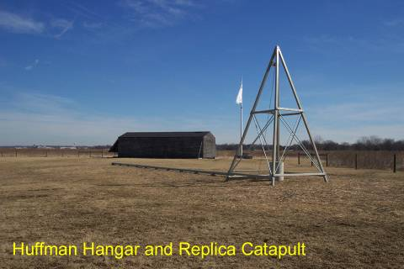
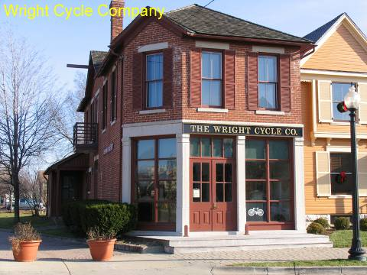

NAME OF PROPERTY

Hopewell Ceremonial Earthworks

STATE: Ohio

LATITUDE AND LONGITUDE and UTM COORDINATES:

Fort Ancient State Memorial

84°5'25.311"W 39°24'27.86"N Z16N 750525.645 4365856.770

Hopewell Culture National Historical Park (5 geographically separate elements):

83°2'33.436"W 39°20'0. 236"N Z17N 323946.963 4355556.139

Mound City Group

83°0'18.814"W 39°22'40.119"N Z17N 327279.719 4360413.181

Hopewell Mound Group

83°5'35.313"W 39°21'40.282"N Z17N 319663.637 4358740.284

Seip Earthworks

83°13'8.381"W 39°14'13.517"N Z17N 308481.643 4345225.040

High Bank Earthworks

82°55'8.198"W 39°17'39.395"N Z17N 334515.326 4350980.341

Hopeton Earthworks

82°58'58.467"W 39°23'1.487"N Z17N 329216.757 4361029.511

Newark Earthworks State Memorial

82°27'4.713"W 40°3'36.472"N Z17N 376219.859 4435230.123
DESCRIPTION:

This proposed serial nomination includes nine archeological sites of monumental earthworks constructed by the Ohio Hopewell culture during the Woodland Period (1-1000 CE). They are located within the three above-named archeological preserves in the south-central portion of the State.

These sites are ceremonial centers characterized by large earthwork constructions that feature precise geometric shapes and standard units of measure. The mounds contain extensive ritual deposits of finely crafted artifacts. This nomination proposal encompasses the variety in Hopewell earthworks and includes examples from each of the valleys of several principal northern tributaries of the Ohio River.

Fort Ancient State Memorial is a 310 hectare (766 acre) site located between Cincinnati and Dayton situated on a ridge above the Little Miami River. It contains the well-preserved walls and mounds of one type of Hopewell earthworks, the hill top enclosure. The 6,000 meter (20,000 feet) of walls are the best preserved of the Ohio Hopewell earthworks and enclose over 50 hectares (123 acres). The site also features typical Hopewellian characteristics such as mounds, parallel walls, and the division of the interior into three enclosures.

Each of the five sites included in Hopewell Culture National Historical Park, a unit of the National Park System, includes a major (15-45 hectare) earthwork enclosure. Three (Mound City Group, Hopewell Mound Group, and Seip Earthworks), contain large ceremonial mounds. Excavations of these mounds revealed a wide variety of numerous, finely crafted objects, many of materials from other regions such as the Great Lakes basin, the Blue Ridge Mountains, the Caribbean, and the Yellowstone basin, the latter of which is 2,300 km (1,400 miles) distant.

Hopewell Mound Group and Mound City Group are large burial complexes surrounded by irregularly shaped earthen walls. The smaller Mound City Group has a very high density of mounds (23 in 5.26 hectares). The mounds and earthen wall at Mound City Group have been reconstructed. The larger Hopewell Mound Group site contains more than 30 mounds including the largest Hopewell mound and has the added complexity of separate earthworks within the outer walls. The outer walls of the Hopewell Mound Group enclose an area of 45 hectares (111 acres), larger than 100 football fields. Within the outer wall are a smaller “D”-shaped earthwork and a circular enclosure. The Group also features a precise 6.5 hectare (16 acre) square abutting the eastern wall that is a smaller copy of squares that are included in other earthworks. The combined earthworks at the site would contain three sites the size of the Taj Mahal and its gardens.

Hopeton Earthworks, High Bank Works, and Seip Earthworks represent variations on the more precise geometric earthworks. Hopeton features a circle and a square enclosing 15.5 hectares. High Bank Works, whose main earthworks encompass 15.38 hectares, are formed from a circle and an octagon and very likely have several astronomical alignments. Hopeton and High Bank Works all feature parallel walls that connect the large earthworks to smaller features or to rivers or to both. Seip is an example of a class of earthworks called “tripartite” that combine portions of three geometric shapes. Its 3,048 meters of walls enclose about 49 hectares. The square portion of the Seip Earthworks is a slightly larger version of the square attached to the Hopewell Mound Group, but more significantly is identical to squares in at least five other “tripartite” earthworks which have not survived. Seip also contains the second largest Hopewell mound.

The Newark Earthworks in the cities of Newark and Heath is composed of three features that were once connected to each other and to other -- now destroyed -- earthworks by sets of parallel walls. The three components are the Octagon Earthworks, the Great Circle Earthworks, and the Wright Earthworks. The preserve of 83 hectares (206 acres) is on a valley terrace above the Licking River. The Octagon Earthworks include an eight-sided structure with lunar alignments that encloses about 20 hectares. It is connected to a large circular enclosure by a short neck of parallel walls. The Great Circle Earthworks encloses about 8 hectares. The Wright Earthworks preserves a small portion of the walls of a large, square earthwork. In addition to the geometric forms and apparent use of a standard unit of measure there are other mathematical consistencies in the spacing of the earthworks.

JUSTIFICATION OF OUTSTANDING UNIVERSAL VALUE:

Together, these earthworks are the best preserved examples of the more than 40 monumental earthworks constructed by the Ohio Hopewell culture during the Woodland Period (1-1000 CE), which trace a cultural florescence distinct from other mound-building cultures in Eastern North America. The earth walls of the enclosures are among the largest earthworks in the world that are not fortifications or defensive structures. Their scale is imposing by any standard: the Great Pyramid of Cheops would have fit inside the Wright Earthworks; four structures the size of the Colosseum of Rome would fit in the Octagon; and the circle of monoliths at Stonehenge would fit into one of the small auxiliary earthwork circles adjacent to the Octagon. The presence of artifacts from far distant sources, especially of materials that were not widely traded 2,000 years ago, indicates that these sites were important ceremonial centers that interacted with communities in much of eastern North America.

CRITERIA CONSIDERED TO BE MET:

(iii) Bears a unique or at least exceptional testimony to a cultural tradition or to a civilization which is living or which has disappeared.

These Ohio Hopewell sites bear exceptional testimony to the cultural florescence of a distinctive
American Indian culture that occupied the valleys of tributaries of the Ohio River between 200 BCE and 500 CE. The earthworks are outstanding examples and rare survivors of an architectural form and landscape design which prevailed in the region during the roughly seven centuries of the Hopewell culture, which is recognized as the climax of the Woodland Period cultures (1-1000 CE) in North America.

(vi) Be directly or tangibly associated with events or living traditions, with ideas, or with beliefs, with artistic and literary works of outstanding universal significance. (This criterion should preferably be used in conjunction with other criteria.)

The Hopewell culture is distinguished from other prehistoric American Indian cultures in eastern North America by the complex geometric earthworks they built and by the elaborate and finely crafted ceremonial and other objects that are among the most outstanding art objects produced in pre-Columbian North America. These Hopewell culture sites also have associations with the origins of modern scientific archeology in the late 19th century, being the focus of a long debate over their origins that led to establishment of the Smithsonian Institution’s Bureau of Ethnology and helped set the pattern for the work of other institutions.
STATEMENT OF AUTHENTICITY AND/OR INTEGRITY:

All three preserves have a high degree of authenticity. The Fort Ancient Earthworks are the best preserved ancient earthwork site in eastern North America. The Octagon and Great Circle at Newark are also well preserved. There is some intrusion of discordant elements, such as a golf course at the Octagon Earthworks, but the scale of the Hopewell architecture dwarfs these intrusions and the visual unity of the major surviving remnants remains intact and impressive. The earthworks at Hopewell Culture National Historical Park were preserved later and the earthworks have been somewhat deflated. The earthworks and mounds at Mound City Group and Seip Earthworks have been reconstructed or partially reconstructed, using historical sources. The preserved portions of the Newark Earthworks include all of two of the major enclosures and part of a third and are largely original, with some restoration work done to repair damage from earlier public purposes.

COMPARISON WITH OTHER SIMILAR PROERTIES:

The Hopewell Culture, as the climax of what is called the Woodland Period in the most commonly used classification of prehistoric Native American cultures, is distinguished from the earlier Archaic Period and later Mississippian Period, to which the Cahokia World Heritage Site belongs. The Woodland cultures featured hunting and gathering, like those of the Archaic Period, but also practiced agriculture, albeit on a small scale in garden plots, and lived in widely dispersed settlements, unlike their Mississippian successors, who lived in large villages and practiced agriculture on a large scale.

Within the Woodland period, the Hopewell culture was distinguished from its contemporaries by their construction of exceptionally large (more than 50 hectare) earthworks that included major enclosures, often in exact geometric shapes of a wide variety using a standard unit of measure. The earthworks were used for ceremonial or community purposes, not for habitation or defense. Some were precisely aligned for astronomical purposes. These characteristics distinguish the Ohio mounds from other earthworks, including tumuli (usually burial structures) and hill forts that have been constructed in many places, including Europe, India, and New Zealand.

NOTES:

Evidence suggests that the ceremonial centers in Ohio influenced Hopewell culture elsewhere and other Hopewell era sites do exist. Pinson Mounds in Tennessee by itself lacks the variety of geometric forms and earthen architecture that exists at the Ohio sites, but could be a logical
extension to this proposal. Other Hopewell sites include mounds, but tend to lack earthwork enclosures.
Other properties, in addition to Pinson Mounds, that might be considered for eventual addition to this serial proposal are Spruce Hill, Ross County, Ohio (which may be added to Hopewell Culture National Historical Park); Fort Hill State Memorial, Highland County, Ohio (owned by the Ohio Historical Society, but not yet a National Historic Landmark); Flint Ridge State Memorial, Licking County, Ohio (an Ohio Historical Society site, and not yet a National Historic Landmark); and the Marietta Earthworks, Washington County, Ohio (City of Marietta property, not yet a National Historic Landmark). (Sites not possessing National Historic Landmark or equivalent documented national significance are not legally eligible for nomination by the United States to the World Heritage List.)
Hopewell Ceremonial Earthworks, continued

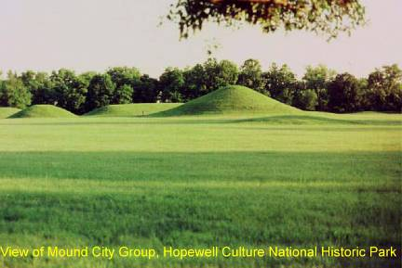
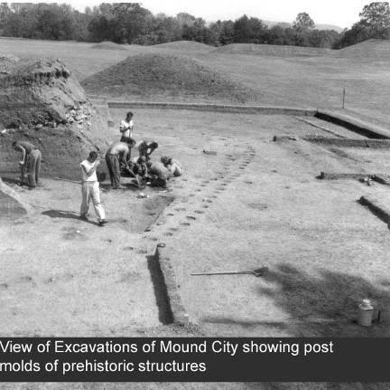
NAME OF PROPERTY

Thomas Jefferson Buildings

STATE: Virginia

LATITUDE AND LONGITUDE and UTM COORDINATES:

Poplar Forest, Bedford County

79°16'1.513"W 37°20'48.837"N Z17N 653494.511 4134560.481

Virginia State Capitol, Richmond

77°26'3.082"W 37°32'18.477"N Z18N 284930.111 4157188.858

DESCRIPTION:

These two buildings, both notable architectural works by Thomas Jefferson, are recommended together as a joint extension to the World Heritage listing that includes Monticello and the University of Virginia.

The Virginia State Capitol was constructed in 1785-98 on the Capitol Square Site in Richmond selected by Jefferson in 1780 when he was Governor of Virginia during the American Revolution. The Roman temple form of the original Jeffersonian central portion of the building is an enlarged version of the Maison Carrée at Nimes, France, which Jefferson visited during his service as American Minister to France. The design was also directly influenced by his association with two French master designers, Charles-Louis Clerisseau and Jean-Pierre Fouquet. The interior plan was modeled on the earlier Virginia colonial capitol in Williamsburg. Flanking wings set back from the original building were constructed in 1904-06. The State Capitol continues to serve its historic use.

Poplar Forest is a rural retreat designed by Jefferson, the finishing details of which were largely executed for him by his slave John Hemings beginning before Jefferson retired from the U.S. presidency in 1809. At the historic core of the property and set just south of the remains of a grove of poplars that gave the place its name is a 2-story brick house built in a perfect octagon around a central cube. Each side of the octagon is 7 meters (22 feet); the cube at the center measures about 6 meters (20 feet) on each side. The service wing to the east was added in 1814. Also surviving from Jefferson’s era are designed landscape features, including mounds flanking the house (“pavilions”) and a sunken lawn. The landscaping was inspired by English gardens. Modern buildings on the property are used for administrative and visitor facilities and are slated for eventual removal as the managing private non-profit corporation that owns and manages the property acquires more land.

JUSTIFICATION OF OUTSTANDING UNIVERSAL VALUE:

These properties, much like the two already listed, reflect Jefferson’s eclectic Classicism. Poplar Forest, one of America’s first octagonal houses, draws on Roman Classical details derived from Palladio and aspects of French late 18th century architecture, such as floor-to-ceiling windows and the use of skylights. The Virginia State Capitol, as the first adaptation of the Roman temple form to a public building, has been enduringly influential in the use of Classical models for such structures.

Together with Monticello and the University of Virginia, these two buildings present the most notable types of architecture with which Jefferson was concerned: domestic, educational, and governmental.

CRITERIA CONSIDERED TO BE MET:

(i) Represents a masterpiece of human creative genius.

Thomas Jefferson was one of the major figures in 18th century neoclassical architecture, adapting his designs specifically to an American context. Poplar Forest and the Virginia State Capitol are essential contributing pieces necessary to understand his architecture fully. The University of Virginia is symbolic of American public values in the emphasis that Jefferson placed on education for the new nation. Monticello is an “essay in architecture” for a new style of domestic architecture that has also been called one of the world’s best architectural autobiographies. Poplar Forest demonstrates his originality and ingenuity and his intimate and personal idealism. It is the equivalent of his private architectural diary. Finally, in the Virginia State Capitol, he set the style for an era in which numerous public buildings were to be constructed on classical models.

(iv) Be an outstanding example of a type of building, architectural or technological ensemble or landscape which illustrates a significant stage in human history.

Jefferson’s designs reflect and represent the era of the international neoclassical movement in architecture. He drew on a number of architectural traditions. At Poplar Forest, he drew from his familiarity with Roman architecture, Renaissance interpretations of it by Palladio, and the French domestic architecture of his own day. His landscaping there drew on English sources and reflected attention to English and French concepts of the relationship of a building to its natural setting. The State Capitol pays clear homage to its Roman temple antecedent but adapts it to governmental purposes.

(vi) Be directly or tangibly associated with events or living traditions, with ideas, or with beliefs, with artistic and literary works of outstanding universal significance. (This criterion should preferably be used in conjunction with other criteria.)

It is quite difficult to separate Jefferson entirely from his ideology and the European and classical models with which he was familiar, partly because there is a tendency to see those influences and his ideals embodied in his architecture. An important theme in Jefferson’s work is his admiration for republican Rome, which he deemed an inspiration for the new United States. Another aspect of his ideology is seen in a telling comment that associates him with the Vitruvian “Man of Perfect Proportions,” a figure that dominated European aesthetics from antiquity onward with a vision of an heroic mankind proportionately in accord with ideal geometric shapes.

STATEMENT OF AUTHENTICITY AND/OR INTEGRITY:

Except for the removal of two rooms in the service wing in the 1840s and alteration of the other two (now being restored), the principal change at Poplar Forest is the restoration of the central room to its more than 6 meter (20 foot) height; it had previously been lowered to less than 4 meters (12 feet). The Getty Conservation Institute has assisted heavily in the conservation of original fabric. The garden retains many original features and is exceptionally well documented.

At the Virginia State Capitol, flanking wings were constructed in 1904-06 to provide new legislative chambers. (The old chambers have since been restored.) The wings are smaller, lower, and set back to respect the importance of the central structure.

COMPARISON WITH OTHER SIMILAR PROPERTIES:

In terms of representing Jefferson’s contributions to world architecture, the addition of these two properties would complete the collection. To his primary residence and the university he designed would be added his other most important domestic design and the classically inspired seat of government of the State he served in numerous capacities.

NOTES:

The same criteria are proposed for these two sites as were used in the original nomination of Monticello and the University of Virginia.

The Virginia State Capitol was the capitol building of the Confederate States of America, as well as of Virginia, for most of the American Civil War, but that aspect of its history is not the basis for the recommendation to nominate it for inclusion in the World Heritage List.

Thomas Jefferson Buildings, continued

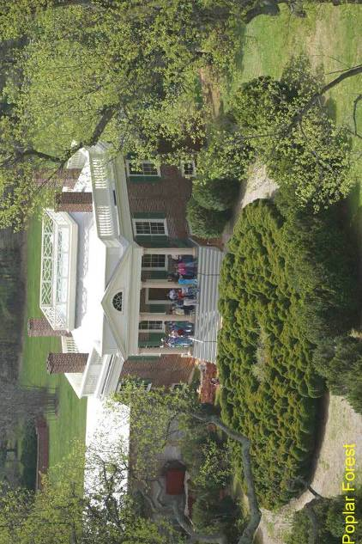

Thomas Jefferson Buildings, continued

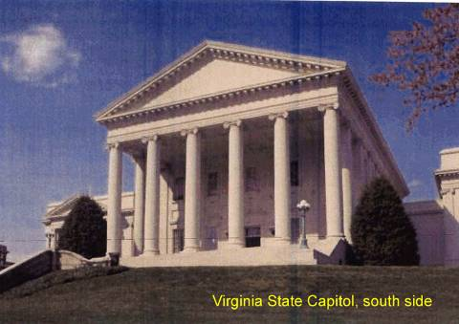
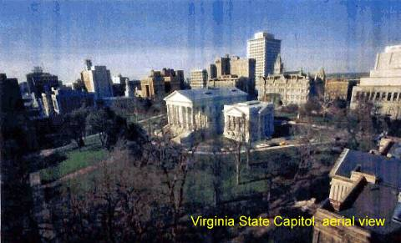

NAME OF PROPERTY

Mount Vernon

STATE: Virginia

LATITUDE AND LONGITUDE and UTM COORDINATES

77°5'10.37"W 38°42'37.881"N Z18N 318603.858 4286512.227

DESCRIPTION:

The property consists of a core of 16 surviving 18th-century structures situated within a cultural landscape of associated gardens, fences, lanes, walkways, and other features, situated along the Potomac River. The historic core of the property is contained within an area that is roughly 20 hectares in size. The surviving 18th-century structures consist of the Mansion, kitchen, servants’ hall, gardener’s house, a salt house, spinning house, store house, smoke house, wash house, stable, ice house, the original tomb, and four garden buildings (two necessaries and two seed houses).

JUSTIFICATION OF OUTSTANDING UNIVERSAL VALUE:

George Washington’s home and the associated gardens and grounds together form a remarkably well-preserved example of an evolved cultural landscape of the 18th-century American south, based on English models, that is unique in the extent of its documentation. The estate formed the core of an extensive plantation operation that included hundreds of enslaved workers. The combination of surviving structures and landscape features, archaeological data, and archival evidence make Mount Vernon arguably the best documented and most completely preserved example of this important period in landscape design.

CRITERIA CONSIDERED TO BE MET:

(iv) Be an outstanding example of a type of building, architectural or technological ensemble or landscape which illustrates a significant stage in human history.

The Mount Vernon Mansion and its associated outbuildings, gardens, and grounds, together constitute a rare survival of an 18th –century cultural landscape. Established as an elite Anglo-American tobacco plantation, its housing, outbuildings, gardens and other landscape features reflected contemporary English fashions as modified and adapted to the American context, notably the dependence on a slave-based plantation economy. Over the course of Washington’s lifetime, the plantation’s design evolved from a functional vernacular Georgian ensemble to a more ambitious rendering of English high style design that combined Adamesque architectural ornamentation with a picturesque or naturalistic landscape.

STATEMENT OF AUTHENTICITY AND/OR INTEGRITY:

As a result of its association with George Washington, the leading General of the Continental Army during the American Revolution and first President of the United States of America, which led to early efforts to protect it, the property is remarkably well preserved. As it has been restored over a long period of time, however, some aspects of the landscape reflect Colonial Revival style as well as the authentic original features.

COMPARISON WITH OTHER SIMILAR PROPERTIES:

Brimstone Hill Fortress in St. Kitts, Lunenburg Old Town and the Historic Area of Quebec in Canada, and Monticello and the University of Virginia in the United States have been inscribed as World Heritage sites reflecting the nature and the impact of British colonization. Of these, only Monticello relates to the plantation form, but is focused on Jefferson’s unique architectural vision. Before preparing a nomination for this property, it will be necessary to examine in more depth and detail the comparable documentation and features of other 18th-century American plantations – such as Hampton and Sotterly in Maryland, and Stratford Hall, Carter’s Grove, and Sully in Virginia.

NOTES:

It is recognized that the World Heritage Committee has, almost without exception, not listed the homes of prominent political and military figures, when they were proposed for such significance alone. It is therefore recommended that this property be brought forward based on criterion (iv) alone and not criterion (vi).

Mount Vernon, continued

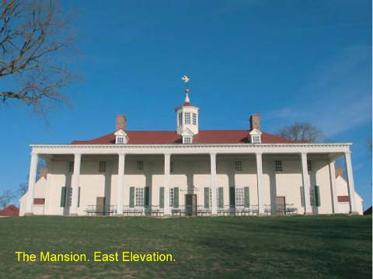
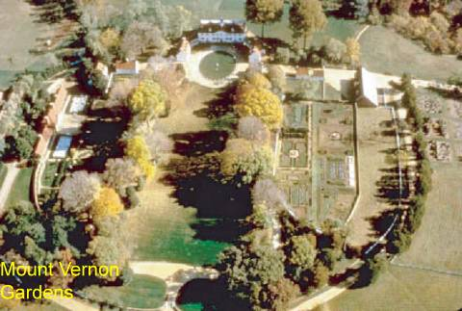

NAME OF PROPERTY

Poverty Point State Historic Site

STATE: Louisiana

LATITUDE AND LONGITUDE and UTM COORDINATES:

91°24'41.906"W 32°38'13.364"N Z15N 648993.726 3611975.030

DESCRIPTION:

Between 1700 BCE and 1100 BCE, an integrated architectural complex consisting of three or four earthen mounds (of the five at the site), a series of six vast concentric semi-elliptical earthen ridges (ranging in diameter from 600 to 1200 meters), a large flat plaza defined by the innermost ridge (14 hectares or 35 acres in size), and several borrow areas was constructed at this site on a bayou (a marshy tributary) not far from the west bank of the Mississippi River.

The ridges are believed to have served as living areas. Three mounds, one of which is the second largest earthen structure in North America, are outside the ridged enclosure; two are inside it.

JUSTIFICATION OF OUTSTANDING UNIVERSAL VALUE:

The vast earthen architecture of this site was constructed by a foraging society of hunter- gatherers, not a settled agricultural people, which makes it all the more remarkable a site. It is still not understood how and why such a society could so totally transform this landscape. It may well be the largest hunter-gatherer settlement that has ever existed. Not only was it the largest settlement of its time in North America, but its design was absolutely unique and its construction required an unprecedented amount (over 750,000 cubic meters) of earth-moving. Poverty Point was also the center of a major exchange network with goods brought in from as far as 1,600 kilometers (1,000 miles) distant.

CRITERIA CONSIDERED TO BE MET:

(iii) Bears a unique or at least exceptional testimony to a cultural tradition or to a civilization which is living or which has disappeared.

These magnificent earthworks represent the most spectacular product of the “Poverty Point culture,” centered in the lower Mississippi Valley during the Late Archaic period (2,000-500 BCE). This massive earthen complex was the largest and most culturally elaborate hunter-gatherer settlement of its time in North America and has no real parallel in world archeological and ethnographic records, challenging anthropology’s basic assumptions about hunter-gatherer societies. Poverty Point is a most exceptional witness to a vanished culture.

STATEMENT OF AUTHENTICITY AND/OR INTEGRITY:

There are no reconstructions at the site and only a small portion has been excavated. Agricultural use in the 19th and 20th centuries caused some deflation of the southern sectors of the concentric earthen ridges and more severe damage to a small part of one of the ridges. Other damage includes an historic road that bisected one of the mounds.

COMPARISON WITH OTHER SIMILAR PROPERTIES:

It seems clear that Poverty Point was the largest center of its type in the lower Mississippi region and had the largest and most elaborate earthworks. Its art, expressed in clay figurines, stone
jewelry, and the lapidary industry, was unsurpassed in North America during its early time period.

Poverty Point has been compared to the slightly younger Olmec and Chavin Cultures
of coastal Mesoamerica and Peru, respectively. But those societies, while comparable in their cultural elaborations—monumental architecture, art, and lapidary technology -- both represent agriculturally based subsistence adaptations.

Poverty Point, continued

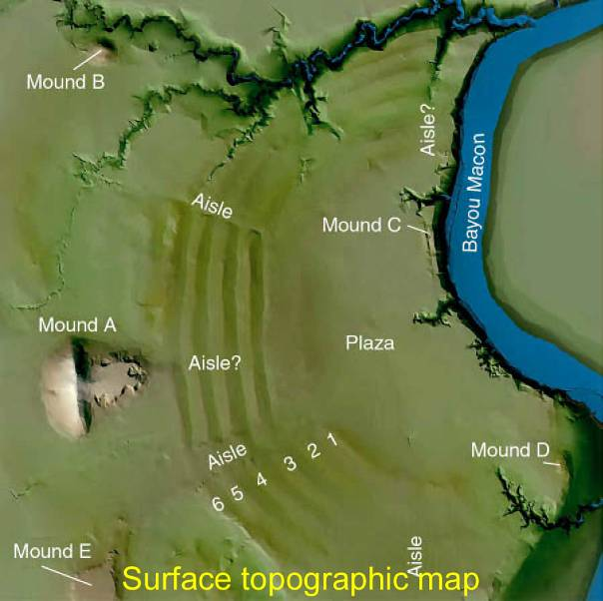

Poverty Point, continued

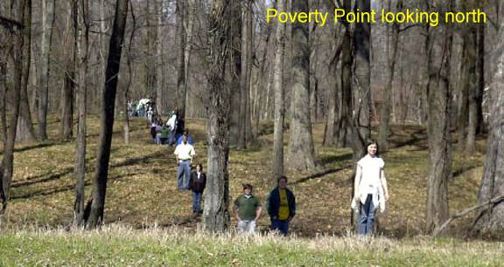
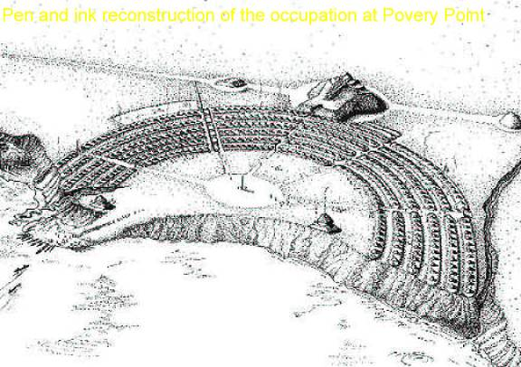

NAME OF PROPERTY

San Antonio Franciscan Missions

STATE: Texas

LATITUDE AND LONGITUDE and UTM COORDINATES:

Mission San Antonio (The Alamo)

98°29'8.804"W 29°25'30.464"N Z14N 549880.133 3255020.019

Mission Concepcion

98°29'30.007"W 29°23'29.999"N Z14N 549324.950 3251309.988

Mission San Jose

98°28'44.777"W 29°21'43.063"N Z14N 550558.754 3248024.233

Mission San Juan

98°27'15.875"W 29°19'55.07"N Z14N 552971.255 3244711.503

Mission Espada

98°27'1.101"W 29°19'3.228"N Z14N 553377.197 3243117.857

DESCRIPTION:

This is a serial grouping of five Spanish Roman Catholic mission properties that includes a total of some 80 structures built in stages from 1724 to 1782 on “open village” plans within walled compounds. They are located in and near the modern city of San Antonio, Texas, which grew up around them. Except for San José, the mission churches and some ancillary buildings were designed by Antonio de Tello, a master mason and sculptor, after 1740. The latter four of the five are included in San Antonio Missions National Historical Park; their churches are in religious use. The fifth, the Alamo, is under the charge of the Daughters of the Republic of Texas as a historic site.

The missions are in order from north to south (using popular short forms of their names):

Mission San Antonio (The Alamo): The distinctive mission church and convento (long
Barracks) are the principal remaining features.

Mission Concepción: The stone church on a cruciform plan and several rooms of the friars’ precinct (convento) are the most important elements at this compound.

Mission San José: This elaborately decorated stone church dominates its mission compound.

Mission San Juan: Includes both the present church and several auxiliary structures, as well as separated support sites--the San Juan Dam, the San Juan Acequía (irrigation ditch), and the San Juan Labores (fields):

Mission Espada: Includes the mission church, auxiliary structures, and separated support sites: the Espada Dam, Espada Aqueduct, Espada Labores, Espada Acequía, and Rancho de las Cabras, the latter of which was a grazing ranch, with “mini-mission” compound, now in ruins, near
Floresville in Wilson County.

JUSTIFICATION OF OUTSTANDING UNIVERSAL VALUE:

The Franciscan missions of San Antonio are a remarkable concentration of surviving structures that are a spectacular representation of the Spanish colonial influence in the New World. The religious, economic, and technological system instituted by the friars transformed a nomadic aboriginal society into a settled one, which in turn became the basis of an ethnically diverse society that continues to influence what is today a major city.

CRITERIA CONSIDERED TO BE MET:

(ii) Exhibit an important interchange of human values, over a span of time or within a cultural area of the world, on developments in architecture or technology, monumental arts, town-planning or landscape design.

The San Antonio missions illustrate the spread of Spanish religious, economic, and architectural traditions that gradually transformed the society of native peoples of the Americas. The friars who founded the missions developed a system for converting nomadic indigenous cultures in the eastern corridor of “New Spain” (today northeast Mexico and Texas) to the Roman Catholic Church and for settling them into permanent communities surrounded by farms and ranches. In order to overcome resistance to their efforts, they fortified the mission compounds. In order to irrigate the land, they made an extensive system of irrigation ditches. These building elements today are evident on the city plan of San Antonio.

(iii) Bear a unique or at least exceptional testimony to a cultural tradition or to a civilization which is living or which has disappeared.

The San Antonio Missions evidence the cultural encounter of the Spanish missions with the nomadic hunters and gatherers of the Texas northern frontier, which resulted in the local Tejano culture, a modern society of Texas Native Americans, Native Mexicans, Spanish and other European peoples. The intermingling of the missionaries, soldiers, technical experts, and Native Americans in the same compounds using the Spanish language accelerated the influence of the Spanish on the Native Americans. These influences are seen in the mission complexes: the designs and colors of the church façades blend elements of Moorish culture, Catholic Spain, and the cultures of central Mexico. Other cultural aspects, including laws, music and religion show similar influences.

(iv) Be an outstanding example of a type of building, architectural or technological ensemble or landscape which illustrates a significant stage in human history.

Unique architectural and engineering features remain within an exceptionally large group of surviving Spanish Colonial buildings. They contain large numbers of colonial era frescoes and other rich decoration. Key portions of the irrigation system, including a dam, an aqueduct, and a system of acequías still serve to demonstrate their original functions.

STATEMENT OF AUTHENTICITY AND/OR INTEGRITY:

Except for the Alamo, which has undergone significant restoration because of the ravages of war and time, the missions’ churches are essentially intact, remaining in their original use. The degree of intactness of the auxiliary structures around them varies somewhat, with a higher degree of integrity at the more southerly complexes.

COMPARISON WITH OTHER SIMILAR PROPERTIES:

There were a number of Spanish Mission complexes built in the 16th-18th centuries in the present southern and southwestern United States. There is no comparable group surviving that is as early and relatively well preserved. It has been suggested that properties in other southwestern States might be added to this serial proposal, notably in a 1980s study of the topic by
US/ICOMOS, but it is believed that this group would qualify on its own and can therefore be nominated as the first element of such a possibly larger serial nomination. Because the San Antonio missions are an extension of a network of missions that extended from northeastern Mexico, it is strongly recommended that the Mexican government be invited to consider Catholic religious structures for inclusion in a binational nomination, including but by no means limited to the five Sierra Gorda missions already included as a group in the World Heritage List.

The extraordinary scope of the Spanish missionary efforts is probably most effectively demonstrated by including well preserved examples on various continents and in different countries. Jesuit missions in South America are already also included; the addition of these sites in the United States would help in that endeavor.

San Antonio Franciscan Missions, continued

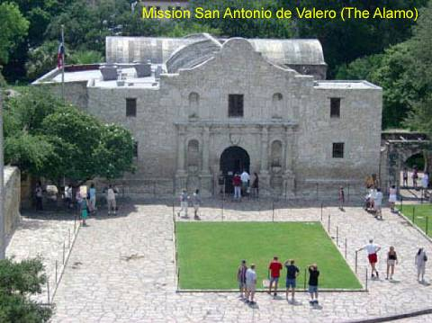
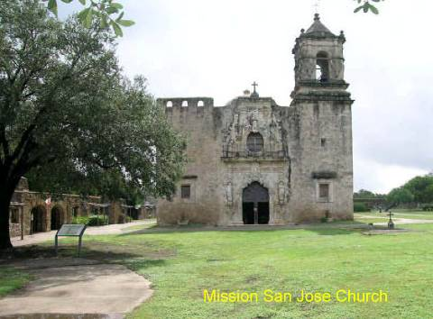

San Antonio Franciscan Missions, continued
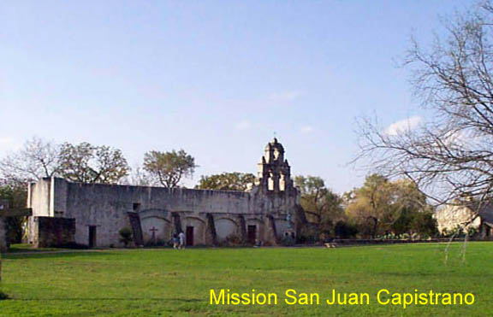
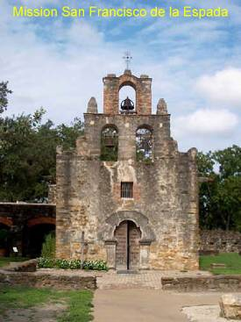 | 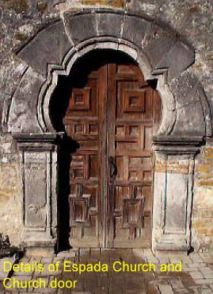

NAME OF PROPERTY

Serpent Mound

STATE: Ohio

LATITUDE AND LONGITUDE and UTM COORDINATES:

83°25'47.435"W 39°1'27.084"N Z17N 289648.707 4322062.359

DESCRIPTION:

Serpent Mound, in Adams County, is the largest documented surviving example of a prehistoric effigy mound in the world. It is a sinuous earthen embankment 411 meters long, including an oval embankment at one end, which has been interpreted variously as the serpent's eye, part of its head, or a secondary object, such as an egg, grasped in the serpent's open jaws. The effigy ranges from 1.2 to 1.5 meters in height and from 6 to 7.6 meters in width. Radiocarbon dates obtained from samples from the effigy, combined with stylistic analyses of the iconography, indicate Serpent Mound was built by the Fort Ancient Culture about the year 1120 CE. This state memorial also preserves three Native American burial mounds as well as evidence of contemporary habitation sites.

JUSTIFICATION OF OUTSTANDING UNIVERSAL VALUE:

This monumental geoglyph embodies fundamental cosmological principles of an indigenous ancient American Indian culture. Serpent Mound represents the acme of prehistoric effigy mound-building in the world and is part of a tradition of effigy mound building among some American Indian cultures of the present Eastern United States. Its remarkably naturalistic quality makes it immediately recognizable as a representation of a serpent, and the form also aligns astronomically to mark the passage of the seasons. The Great Serpent was a source of enormous spiritual power that a widespread pre-Columbian culture could invoke to aid them in hunting and in curing illnesses.

CRITERIA CONSIDERED TO BE MET:

(i) Represents a masterpiece of human creative genius.

As an artistically striking monumental sculptural rendering of a serpent, Serpent Mound is the largest serpent effigy mound in North America and perhaps the world and the site that best reflects the iconographical interests and spiritual beliefs of Native American peoples of the Fort Ancient culture. Its scale and elegance are without peer. The alignment of its head and coils to the positions of the sun at the solstices and equinox evidence a sophisticated knowledge of astronomy.

(iii) Bears a unique or at least exceptional testimony to a cultural tradition or to a civilization which is living or which has disappeared.

Serpent Mound is the site that best reflects the indigenous belief system of Native American peoples of the Fort Ancient culture, which flourished during the Mississippian/Late Prehistoric period (circa 900-1650 CE). This bears a strong resemblance to the belief system of the partially contemporaneous Late Woodland Period (700-1200 CE) Effigy Mound culture in the Upper Midwest. The Great Serpent was "a universally known figure in the Eastern Woodlands for many centuries" that appeared "not only in myth, but also in graphic designs, both prehistoric and historic." Although these cultures considered it to be primarily a creature of the Beneath World, it sometimes could appear in various guises in the world and in the overarching Above World.

(iv) Be an outstanding example of a type of building, architectural or technological ensemble or landscape which illustrates a significant stage in human history.

Serpent Mound is the foremost and best-known expression of effigy mound building in North America and perhaps the world. Its form, positioning, and alignments represent a unique integration of cosmological beliefs, monumental sculpture and landscape design. The construction techniques relating to effigy mound building are distinct from those of other types of geoglyphs: effigy mounds are fully three dimensional and were built by excavating the earth and transporting it in baskets to the chosen location where it was piled into the desired shapes.

STATEMENT OF AUTHENTICITY AND/OR INTEGRITY:

Although Serpent Mound was somewhat degraded by 19th century farming and looting, it has been carefully restored and protected, beginning in 1887. Only limited archeological digging has been carried out and what remains has a high degree of authenticity.

COMPARISON WITH OTHER SIMILAR PROERTIES;

Geoglyphs in the form of animal or human effigy mounds, or intaglios, appear around the world. The Lines and Geoglyphs of Nasca and Pampas de Jumana (in Peru) is the only such site currently inscribed on the World Heritage List. Other examples include the Uffington Horse (UK), the Cerne Abbas Giant (UK), the Serpent Mound at Loch Nell (UK), the Serpent Mound at Rice Lake (California), Effigy Mounds National Monument (Iowa), and the Blythe Intaglios (California). The scale of Serpent Mound dwarfs all other securely documented effigy mounds and is larger than most of the geoglyphs in the world.

NOTE:

It is recommended that Serpent Mound be considered as the first element in a serial nomination including other effigy mounds of Eastern North America.

Serpent Mound, continued


NAME OF PROPERTY

Frank Lloyd Wright Buildings

STATES: Arizona, California, Illinois, New York, Oklahoma, Pennsylvania, Wisconsin

LATITUDE AND LONGITUDE and UTM COORDINATES:

Unity Temple, Oak Park, Illinois

87°47'47.767"W 41°53'18.308"N Z16N 433910.149 4637481.012

Frederick C. Robie House, Chicago, Illinois

87°35'45.053"W 41°47'23.001"N Z16N 450489.692 4626388.121

Hollyhock House, Los Angeles, California

118°17'34"W 34°5'0.54"N Z11N 380740 3773817

Taliesin, Spring Green, Wisconsin

90°4'12.979"W 43°8'27.962"N Z15N 738263.782 4780436.124

Fallingwater, Mill Run, Pennsylvania

79°27'59.312"W 39°54'20.055"N Z17N 631087.548 4418192.314

S. C. Johnson & Son, Inc., Administration Building and Research Tower, Racine, Wisconsin

87°47'26.558"W 42°42'48.645"N Z16N 435249.894 4729090.130

Taliesin West, Scottsdale, Arizona

111°50'44.31"W 33°36'32.834"N Z12N 421548.090 3718944.720

Price Tower, Bartlesville, Oklahoma

95°58'34.409"W 36°44'53.944"N Z15N 234276.298 4070881.842
Solomon R. Guggenheim Museum, New York, New York

73°57'35.353"W 40°46'57.72"N Z18N 587770.439 4514944.090

Marin County Civic Center, San Rafael, California

122°31'53.655"W 37°59'50.055"N Z10N 541129.502 4205406.336

DESCRIPTION:

Ten properties are proposed as a serial nomination. They are, in generally chronological order:

Unity Temple (1905-08) has exposed concrete walls that define a series of geometric units that appear to be independent of one another and interpenetrate each other in both vertical and horizontal directions. It is comprised of a cube and a rectangular parallelepiped, linked by an entrance foyer. The northern two-and-one-half-story Temple section, the larger of the two, contains the auditorium/worship space. The lower and wider two-story southern section (Unity House), contains classroom and meeting space. Stylized piers support the cantilevered flat roofs that extend beyond the wall planes. On the interior, plaster walls are accented with applied oak strips that create geometric patterns relating to the organization of the space.

Robie House (1908-10), exemplifies Wright’s “Prairie” houses, the horizontality of whose designs were intended to complement the flat and expansive prairie landscape. Its shifting planes and abstract masses drew the attention of European modernists. Built of red-orange Roman brick, the house rises for three levels to low-hipped roofs covered with red clay tiles. Oversized brick corner piers and a central chimney core flank bands of windows at each level. Casements of geometrically patterned art glass are fronted by continuous balconies at the main and upper levels.

Hollyhock House (1919-21) is a dramatic expression of Wright’s approach to creating an architecture for a southern California setting. The design seamlessly melds exterior and interior living space via terraces for each room and an intricate circulation pattern. Set on a cast-concrete base, the house has canted walls of hollow terra-cotta tile covered with stucco that rise in almost monolithic fashion. Cast-concrete ornamentation in the form of stylized hollyhocks rest on beltcourses, and masonry walls covered with stucco extend out from the major ground floor rooms to enclose terraces. Furniture designed by Wright is integral to the design, and all the principal rooms contain windows and doors with elaborate geometrically patterned art glass.

Taliesin (1911 and later) was Wright’s long-time home and studio. Rebuilt and expanded by Wright after two major fires, it is closely integrated into the hillside. It is part of 600-acre estate in rural Wisconsin that includes a number of other structures designed by Wright; the landscaped grounds, roads, dam and pond are all part of the overall composition and setting. The exteriors of the buildings consist of local Wisconsin limestone forming chimneys and walls, alternating with sand-finished stucco on wood frame, cypress fascia and base trim boards, and cedar shingled roofs. The walls are sand-textured plaster. Covered passageways, constructed of stone, link the buildings together.

Fallingwater (1936-38), a house whose reinforced concrete floor slabs are cantilevered over a small waterfall in rural western Pennsylvania, is also noted for its noted for its intimate relationship to its natural setting and for its striking walls of roughly laid stone. Spacious terraces articulate the house at each of its three levels, and a massive chimney of native sandstone anchors the composition. The interior spaces incorporate floors of native sandstone and built-in furniture and cabinetry of black walnut, all designed by Wright. Steel and glass casement windows and doors open onto the terraces and flank the chimney, providing a contrasting sense of light and openness against the solid mass.

The S.C. Johnson and Son, Inc., buildings (1936-39; 1943-50) occupy a city block and are the corporate headquarters of the original company that commissioned them. They have been described as Wright’s “interpretation of streamlined design in…a suitable environment for the workforce of corporate America.” The Administration Building has two sections: the great workroom and offices, and the garage and carports, linked by a bridge with a driveway beneath. The reinforced concrete structure is clad in custom “Cherokee red” brick with curved corners. Both the rooms over the carport and the great workroom are supported on dendriform (lily-pad) columns, a continuation of Wright’s innovations in concrete. All the spaces were lit by a novel system of glass tubing that formed streamlined bands and admitted natural light. The 14-story Research Tower was added in the middle of the north section. On its exterior, horizontal bands of brick alternate with bands of glass tubing. Much of the original Wright-designed furniture remains.
Taliesin West (1938) was Wright’s low slung winter home in the Arizona desert on the outskirts of Scottsdale, as well as his architectural school and studio until his death in 1959. It remains in the hands of the Taliesin Fellowship. In its dramatic siting and innovative use of materials, it supplemented Taliesin as Wright’s design laboratory. The 412-acre property lies half in the foothills of the McDowell Mountains and half on the gentle sloping terrain of the Sonoran desert. The principal structures built of desert masonry are linked to each other and to the terrain by low retaining walls, walks, and broad terraces. The composition uses a 16-foot square unit system, rotating at 45 degrees on itself. Walls and roofs are set at 15-degree slopes. Indoors and outdoors flow into each other, and the experience of movement through the complex is an important part of the architectural effect.

The Price Tower (1953-56), Wright’s only free-standing skyscraper and tallest built structure, uses a central mast from which the 19 floors are cantilevered, a concept that he developed in the late 1920s for an unbuilt project in New York. The tower imitates a tree in its design – the “trunk” is comprised of four elevator shafts, the floors are cantilevered and tapered much like the branches of a tree, and its embossed patinated copper cladding and sun louvers can be interpreted as representations of leaves. Two covered carports of reinforced concrete, supported by tapering patinated copper columns, are located on either side of the tower. The geometric language of the design includes a grid of parallelograms, comprised of four triangles. All walls, partitions, furnishings and details conform to this grid.

The Guggenheim Museum (1956-59) helped define a new form of museum architecture. The fusion of spatial drama with the spiral form represents a culmination of Wright’s ideas of organic architecture. Located on Fifth Avenue facing Central Park, its modern aesthetic and sculptural qualities distinguish the building from its more traditionally styled neighbors. The museum is constructed of reinforced concrete and seamlessly integrates form and materials. The three major components are the main spiral Rotunda, which coils five times around to a sky-lit dome or oculus 95 feet above the floor; the smaller, circular “monitor” to the north; and the horizontal cantilevered bridge that connects the two and wraps around three sides of the building at the second-story level. The entire design is based on geometric modules of circles, triangles and lozenges through a series of interlocking forms. A narrow 10-story annex, completed in 1992, is set behind the museum on the footprint of an earlier four-story annex.

Marin County Civic Center (1960-69) was the last major work of Wright’s career and the only one built for a government entity. In its siting, use of materials, and melding of exterior and interior space, it reflects Wright’s ideas of organic architecture as they evolved through his long career. The building is composed of two long sections, the Administration Building and the Hall of Justice, set at a 120-degree angle to each other. They are joined by a rotunda with a shallow dome flanked by a polygonal tower. The rounded ends of the two sections are built into the sides of two low hills. A system of roads passes through archways of the buildings and follows the contours of the site. The building is built of steel with poured concrete and precast and prestressed concrete elements. The roof system is a series of precast concrete trusses supporting a thin, barrel-arched shell of reinforced concrete.

JUSTIFICATION OF OUTSTANDING UNIVERSAL VALUE:

The ten properties presented as an updated serial proposal for nomination are among the most iconic, most intact, most representative, most innovative and most influential of the more than 400 Frank Lloyd Wright (1867-1959) designs that have been erected. They span almost sixty
years of his efforts to create an “organic architecture” that integrates buildings with nature and dramatically melds form with space. All aspects of design, from siting to furnishings, reinforce this concept. The properties include homes, workplaces and offices, places of worship, educational institutions and museums, and seats of government.

CRITERIA CONSIDERED TO BE MET:
Criterion: Represents a masterpiece of human creative genius
( i): Represents a masterpiece of human creative genius

Wright’s work represents an outstanding creative contribution to both twentieth-century architecture and to architecture as a whole. The 10 properties illustrate his genius in the creation of an architecture of dynamic interior space designed around the physical, emotional, and psychological needs of the individual and with the goal of integrating the building with its setting. Each also represents a reconceptualization of programmatic requirements in modern terms and a unique expression of the relationship between form and function. Each example is given a powerful symbolic form directly expressive of the institution it houses, whether it be the family, the workplace, the place of worship or of cultural or civic activity. The properties proposed have been acclaimed as masterworks by architects, scholars, and critics, virtually from the time of construction.

(ii): Exhibit an important interchange of human values, over a span of time or within a cultural area of the world, on developments in architecture or technology, monumental arts, town planning or landscape design.

The work of Frank Lloyd Wright has made outstanding contributions to the development of modern architecture through his treatment of space, his development of an abstract geometry of form, and his expression of the ideals of an organic architecture. Wright’s work became widely known through publications and exhibitions, influenced several generations of architects in the United States, Europe, and Asia, and still exerts its fascination because of his masterful integration of form, materials, and setting. Of the properties proposed for this serial nomination, Robie House and Unity Temple are widely cited as his two most influential early works. The Hollyhock House, Taliesin and Taliesin West are particularly noted for their spatial qualities and their approaches to exterior and interior space. The S. C. Johnson & Son Administration Building and Research Tower and the Price Tower presented new concepts for the workplace and the skyscraper. Fallingwater and the Guggenheim Museum continue to capture the imagination because of their daring forms, construction, and settings. The Marin County Civic Center represented a new approach to the design of a multi-purpose government building that fit function into setting and accommodated the automobile and the highway.

STATEMENT OF AUTHENTICITY AND/OR INTEGRITY:

Of the properties that have been altered or experienced damage, careful restoration has been aided by good documentation and public interest in the value of the architecture. The only two that have undergone alterations of consequence are the Guggenheim and the Marin County Civic Center.

COMPARISON WITH OTHER SIMILAR PROPERTIES:

The properties presented here were selected by a committee of leading Wright scholars and restoration architects convened for that purpose by the Frank Lloyd Wright Building Conservancy. The committee reviewed the voluminous scholarship on Wright and consulted the results of the opening of the Wright archives in the late 1980s; considered the entire body of Wright’s work; and examined such factors as chronology; typological, spatial, and structural innovation; historical significance and influence; poetic expression; symbolic meaning,; relationships to sites; and social value and purpose. The committee concluded that these represent the fullest and most compelling achievements of Wright as an architect as well as some of the greatest works of the art of architecture in the late 19th and early 20th centuries.

NOTES:

This proposal is an expansion of the 1992 nomination of Wright’s Taliesin and Taliesin West, which ICOMOS and the World Heritage Committee deferred, pending further study of Wright’s work as a whole. In the interim, at the most recent meeting of the World Heritage Committee, the Sydney Opera House, the architect of which is still living, was inscribed on the World Heritage List. The nomination presented by Australia for that building credits some of Wright’s works as a precursor, even though no Wright sites have yet been inscribed.

All of the properties proposed have been designated as National Historic Landmarks, except the Guggenheim Museum, whose nomination is pending. It is expected that the Guggenheim will be designated in early 2008. Until it is designated, it cannot be included in a U.S. World Heritage nomination.

None of Wright’s “Usonian” houses, meant to be artistic houses of low cost for average Americans, has been included in this proposal. It is expected that this issue would be examined further and addressed when a revised Wright Buildings proposal is presented.

Frank Lloyd Wright Buildings, continued

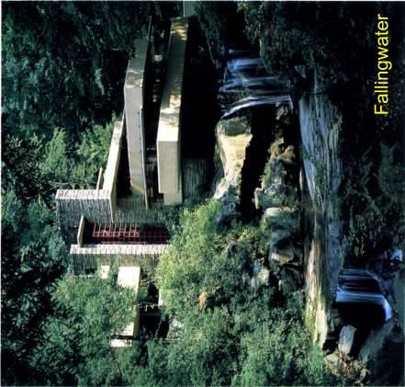
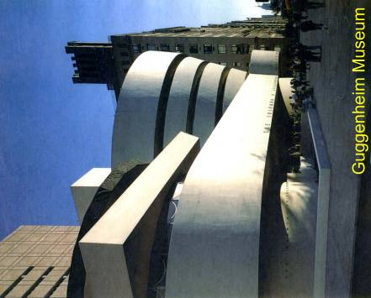

Frank Lloyd Wright Buildings, continued

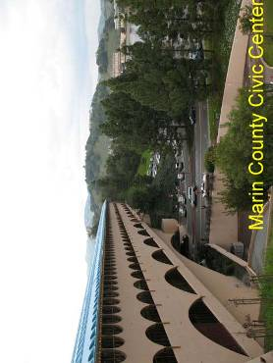
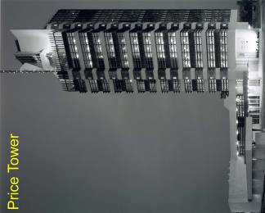 | 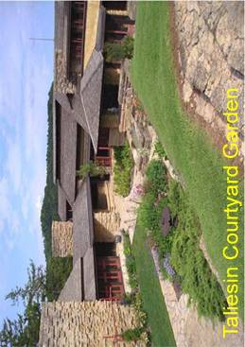

MIXED PROPERTY (1)
NAME OF PROPERTY

Papahanaumokuakea Marine National Monument
(Northwest Hawaiian Islands)

STATE: Hawaii

LATITUDE AND LONGITUDE and UTM COORDINATES:

170°8'45.586"W 25°20'56.76"N Z2N 585935.744 2803718.700

DESCRIPTION:

This is a mixed cultural and natural proposal for a vast Pacific Ocean area running northwest from the island of Kauai in the present main chain of the Hawaiian Islands for 2,000 km (1,200 miles). Scattered in the vast and deep ocean are some 10 small islands, collectively embracing about 1,300 hectares (5 square miles) of land area, along with reefs and shoals. In this remote and still relatively pristine part of the Pacific, marine life remains abundant and diverse, with a large number of endemic species. The area provides refuge to a wide array of threatened and endangered species, including sea turtles, sharks, monk seals, whales, albatross and other seabirds.

These waters were crossed by the native Hawaiians at least 1,000 years before any other people did so. The Hawaiians planted settlements on some of the islands, which now have important archeological sites and continuing cultural significance. The islands also figured in the European exploration of the Pacific and in Pacific whaling, communications, and early aviation. One of them, Midway, became the focus of its namesake battle in June 1942--the turning point of World War II in the Pacific. In addition to World War II-era wrecks of ships and aircraft present in the water, there are about 60 known shipwrecks, including important 19th century whaling vessels, some of which were based in Honolulu and Lahaina and utilized native Hawaiian labor. There are also at least 67 downed aircraft.

The establishment of the Marine National Monument in June 2006 brought together the island chain and adjoining waters under the joint responsibility of the National Oceanic and Atmospheric Administration, the U.S. Fish and Wildlife Service and the State of Hawaii.

JUSTIFICATION OF OUTSTANDING UNIVERSAL VALUE:

There is extraordinary ecology and biodiversity in this area that would, if inscribed, be one of the largest World Heritage Sites in area and one of the few marine sites. The Monument’s size, remoteness, high level of biodiversity and endemism clearly make it one of the world’s most important marine sites. It is also important for its centrality to Hawaiian culture and its importance in the settlement of the Pacific. In addition, the small islands, reefs, and shoals in this vast oceanic expanse are all that remain of what were, some 7 to 27 million years ago, large islands formed by volcanic action. The 2,000 km (1,200-mile)-long string of islands represents the longest, clearest, and oldest example of island formation and atoll evolution in the world. Nowhere else is this progression illustrated in such an unambiguous and linear fashion.

The visitation and settlement of these small islands by the native Hawaiians were epic feats of seafaring at least a millennium, if not longer, before Europeans first crossed the Pacific. Indeed, even the main Hawaiian chain was not reached by any Europeans until 1778. These isolated islands are of exceptional cultural and spiritual importance to Native Hawaiians for the islands both generated the rest of the archipelago and are in the direction from which they believe the source of all life originated.

CRITERIA CONSIDERED TO BE MET:

(ii) Bear a unique or at least exceptional testimony to a cultural tradition or to a civilization which is living or which has disappeared.

Papahanaumokuakea embraces waters and islands that are related to traditional Hawaiian beliefs about creation, including the origin of their islands and their people. It is also the area where the spirits of ancestors are said to reside after death. The archaeological sites on the islands confirm the long-standing presence and use of the islands by native Hawaiians, despite their small size and remote location. It has also been posited that the first settlers of Hawaii may have resided on these islands, which were reached only by their remarkable navigational skills.

(iii) Be an outstanding example of a type of building, architectural or technological ensemble or landscape which illustrates (a) significant stage(s) in human history.

On the islands are found ceremonial terraces and platform foundations with upright stones
that resemble those of inland Tahiti and stone figures that appear related to those in the Marquesas. Given their size, the islands contain an impressive number of habitation sites, agricultural terraces, and religious shrines.

(vi) Be directly or tangibly associated with events or living traditions, with ideas, or with beliefs, or with artistic and literary works of outstanding universal significance. (This criterion should preferably be used in conjunction with other criteria.)

Here in one of the world’s most remote areas, the epic and decisive battle of Midway took place in June 1942, near and on the island of that name

(viii) Be outstanding examples representing major stages of earth’s history, including the record of life, significant on-going geological processes in the development of landforms, or significant geomorphic or physiographic features.

The formation and subsidence of volcanic islands is strikingly represented in this chain of islands. It also contains coral reefs at the northern limit of atoll existence, north of which coral growth rates are matched by subsidence. The 2,000 km (1,200) mile-long string of islands represents the longest, clearest, and oldest example of island formation and atoll evolution in the world.

(ix) Be outstanding examples representing significant on-going ecological and biological processes in the evolution and development of terrestrial, fresh-water, coastal and marine ecosystems and communities of plants and animals.
One quarter of the 7,000 marine species found in Papahanaumokuakea exist nowhere else, reflecting a high degree of endemism overall that even varies dramatically from the waters surrounding one island to another in the chain, as well as the deeper waters. Endemism also prevails on the islands, though to a lesser degree.

(x) Contain the most important and significant natural habitats for in-situ conservation of biological diversity, including those containing threatened species of outstanding universal value from the point of view of science or conservation.

Some 19 species found in the National Monument are listed under the U.S. Endangered Species Act. The islands collectively form the largest tropical seabird rookery in the world, providing critical refuge for the vast majority of two types of threatened albatrosses and four endangered land birds that exist nowhere else. The coral reefs system supports an abundance of wide-ranging top predators that represent 54% of the biomass in the national monument, as opposed to 3% in the main Hawaiian islands, the latter figure being typical of populated regions worldwide.

STATEMENT OF AUTHENTICITY AND/OR INTEGRITY:

The natural resources of this area are so vast that the cultural resources contained within it, while deemed of be of outstanding universal value in their own right, have not been significantly affected by humans--except on and in the immediate vicinity of some of the islands, particularly Midway. Given the remoteness of the islands they have been largely undisturbed, except for their brief importance in exploration, whaling and fishing, communication, and World War II and subsequent military use, again essentially restricted to Midway. The Marine National Monument has strong management protocols and procedures in place to address such issues as marine debris, illegal fishing, and other potential threats.

COMPARISON WITH OTHER SIMILAR PROPERTIES:

There are no sites on the World Heritage List that are mixed marine and terrestrial natural and cultural heritage sites. Although the Galapagos (World Heritage Nomination # 1) is representative of an isolated Pacific archipelago with a marine component, it does not share the Polynesian cultural history of Papahanaumokuakea. The same is true of Costa Rica’s Cocos Island. Rapa Nui National Park (Easter Island), Chile, is listed for culture alone.

The endemism of the marine portion of the national monument is comparable with and often higher than that of other Pacific Ocean archipelagos; fish endemism is as high as or higher than any other isolated island system in the world. Land endemism is also high both for species of land birds, insects and spiders, land snails, and some plants.

Among reefs inscribed in the World Heritage List, the closest comparisons to Papahanaumokuakea are the Great Barrier Reef of Australia and the Belize Barrier reef, but both those reefs are affected by their locations near continental landmasses and thus have marine fauna more representative of their regions as a whole, rather than the highly endemic fauna of Papahanaumokuakea.

In terms of its significance as a cultural site, Papahanaumokuakea plays a critical role in understanding the nature of Polynesian migration and settlement in the Pacific; it would be the first World Heritage Site that commemorates and perpetuates the wayfinding and seafaring culture of Polynesia -- the Maori of Tongariro, New Zealand (already a World Heritage Site) not being a voyaging people in the same manner.

NOTES:

There are some precedents for the inscription of sites associated with war, including two directly associated with World War II (Auschwitz and the Hiroshima Dome) and many listed that have been affected by it and other wars (e.g., parts of London and Dresden), although the U.S. (when disassociating itself from the inscription of the Hiroshima Dome) stated opposition to the inclusion of war sites in the World Heritage List, pending the development of a policy on the issue by the World Heritage Committee. No such policy has been developed to date.

The inclusion of the submerged wrecks of ships and aircraft in the national monument as qualifying elements in a World Heritage nomination will require further study. At this time they have not been designated as National Historic Landmarks, or otherwise specifically recognized as nationally significant, a legal requirement for nomination by the U.S. Some may potentially raise issues of national jurisdiction and of salvage. An agreement that governs the relationship between the submerged cultural heritage convention and the World Heritage listing process would probably be a necessary prerequisite. At this time the submerged cultural resources are not regarded as critical elements for a nomination of Papahanaumokuakea.

Papahanaumokuakea, continued

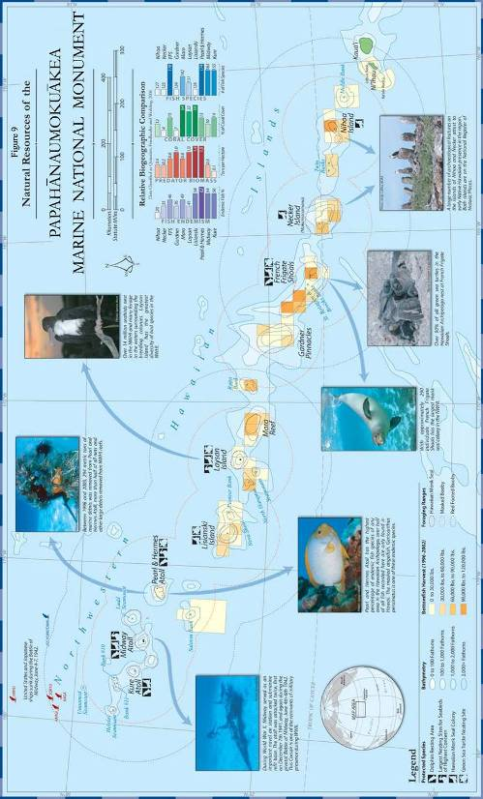
Papahanaumokuakea, continued

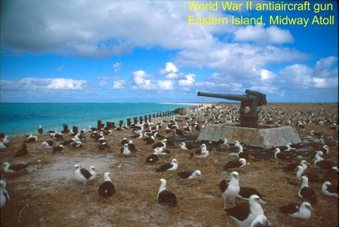
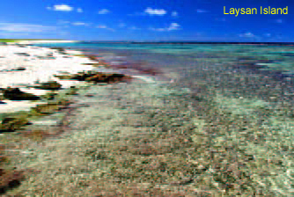

NATURAL PROPERTIES (4)

Fagatele Bay National Marine Sanctuary

TERRITORY: American Samoa

LATITUDE AND LONGITUDE, or UTM COORDINATES:

170°45'51.14"W 14°21'53.769"S Z2S 525423 8411900

DESCRIPTION:

Fagatele Bay National Marine Sanctuary protects 66 hectares (163 acres) of bay area on the island of Tutuila, American Samoa. It does not include immediately adjacent shorelands. The Marine Sanctuary comprises a fringing coral reef ecosystem within an eroded volcanic crater.

JUSTIFICATION OF OUTSTANDING UNIVERSAL VALUE:

Fagatele Bay contains a vast array of tropical marine organisms, including corals, marine mammals, and threatened and endangered species including hawksbill and green sea turtles. The Bay is a vibrant tropical reef marine ecosystem, filled with populations of coral reef fish and marine invertebrates. The scenic beauty of the bay and its surroundings are also exceptional.

CRITERIA CONSIDERED TO BE MET:

(vii) Contain superlative natural phenomena or areas of exceptional natural beauty and aesthetic importance.

Fagatele Bay is cradled within an extinct volcanic caldera that was breached by the ocean on one side to form a spectacular protected embayment on one of the South Pacific’s most wild and inaccessible coastlines. Massive volcanic promontories, where southern ocean swells pound the basalt rocks, frame the bay’s entrance. Beneath these waves and the calmer waters of the bay, a riot of marine life has constructed a coral reef ecosystem of great beauty and diversity.

(x) Contain the most important and significant natural habitats for in-situ conservation of biological diversity, including those containing threatened species of outstanding universal value from the point of science and conservation.

The fringing reef system contains more than 140 species of coral and related organisms. The sanctuary provides a refuge for several threatened and endangered species, including hawksbill and green sea turtles, and sperm and humpback whales.

STATEMENT OF AUTHENTICITY AND/OR INTEGRITY

The reefs of Fagatele Bay are intact and are outstanding examples of a mid-South Pacific coral reef ecosystem. They have recovered naturally from natural and human disturbances. The introduction of non-native marine organisms is possible, but the relative isolation of Fagatele Bay makes the potential of humans to cause such an event small. The sanctuary has a strong monitoring program in place to identify and respond to any threats to the site’s integrity.

COMPARISON WITH OTHER SIMILAR PROPERTIES:

It is recommended that other marine sites, including adjacent shorelines in American Samoa, in independent Samoa and in other nearby island nations, be reviewed with an eye to possibly developing a serial nomination including sites in more than one country. The National Park of American Samoa should also be reviewed in such a study.

It will also be essential to review any sites selected for both natural and cultural aspects, i.e., as mixed sites, or they should at least in each case be examined for potential cultural merits.

Fagatele Bay, continued

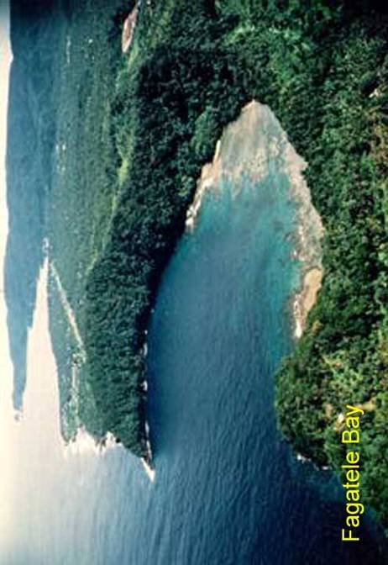

NAME OF PROPERTY

Okefenokee National Wildlife Refuge

STATE: Georgia

LATITUDE AND LONGITUDE and UTM COORDINATES:

82°21'13.923"W 30°49'9.221"N Z17N 370500 3410000

DESCRIPTION:

This National Wildlife Refuge consists of more than 162,000 hectares (about 400,000 acres) embracing 92% of the Okefenokee Swamp, a large hydrologically intact swamp that is the source of two rivers, one that flows into the Atlantic and the other into the Gulf of Mexico. The Refuge also has extensive and essentially undisturbed peat deposits.

JUSTIFICATION OF OUTSTANDING UNIVERSAL VALUE:

Okefenokee is one of the world’s largest naturally driven freshwater ecosystems with a diversity of habitat types, including 21 vegetative types. The Refuge’s fauna is also renowned worldwide for its diversity of amphibians and reptiles, mammals, birds, fishes, and invertebrates and perhaps as many as 1,000 species of moths. Unlike many other significant wetland areas, the swamp is the source of rivers rather than their recipient, as in a delta, and therefore escapes most disturbances to natural hydrology and water flow. The Refuge’s undisturbed peat beds store valuable information on environmental conditions over the past 5,000 years and are a significant source of information related to global changes.

CRITERIA CONSIDERED TO BE MET:

(viii) Be outstanding examples representing major stages of earth’s history, including the record of life, significant on-going geological processes in the development of landforms, or significant geomorphic or physiographic features.

Okefenokee is one of the world’s most important sites for the largely undisturbed formation of peat, offering an excellent opportunity to study environmental conditions over the past 5,000 years. It is also significant as an ecological analog for the forests that formed the world’s great coal deposits.

(ix) Be outstanding examples representing significant on-going ecological and biological processes in the evolution and development of terrestrial, fresh-water, coastal and marine ecosystems and communities of plants and animals.
The Okefenokee Swamp is one of the world’s largest naturally driven freshwater ecosystems. Its 5,000 year-old peat beds provide important information about the development of terrestrial and fresh-water ecosystems throughout the Atlantic Coastal Plain.

(x) Contain the most important and significant natural habitats for in-situ conservation of biological diversity, including those containing threatened species of outstanding universal value from the point of view of science or conservation.

The Okefenokee is an excellent venue for the conservation of biological diversity because it is a relatively intact system with few direct influences from outside sources. It is world-renowned for its biological diversity, particularly its diversity of amphibian and reptile species. Some significant endangered species protected within the Refuge include the wood stork, red-cockaded woodpecker, indigo snake, gopher tortoise, alligator snapping turtle, and the parrot pitcher plant.

STATEMENT OF AUTHENTICITY AND/OR INTEGRITY:

Though past logging took its toll on parts of Okefenokee, the site’s ecological integrity has improved significantly through on-going protection and an active restoration program. Expanded regional water demand on the aquifer is a source of concern. Management has promoted natural processes to benefit the landscape, and human manipulation of the landscape is used primarily to restore native vegetative communities. The planned acquisition and restoration of the upland pine landscape around the refuge will gradually enhance management options and provide a buffer from outside influences.

COMPARISON WITH OTHER SIMILAR PROPERTIES:

In contrast to the Everglades and many other wetlands around the world, Okefenokee is hydrologically much more intact. This is mainly because it is the origin of waterflows, rather than their destination; in this critical respect, it is unlike Everglades. The Dismal Swamp in North Carolina and Virginia has similar habitats but has been significantly influenced by human activity that changed its waterflows and essentially destroyed half of it. Brazil’s Pantanal (on the World Heritage List) is larger and has more nutrients but is in a delta. The other principal peat deposits around the world such as the Flow Country of Scotland, Kapuatai Peat Dome in New Zealand, and Indonesia’s Berbak Nature Reserve are different in character and in their collection of species; they have also been more impacted by human activity.
Okefenokee, continued

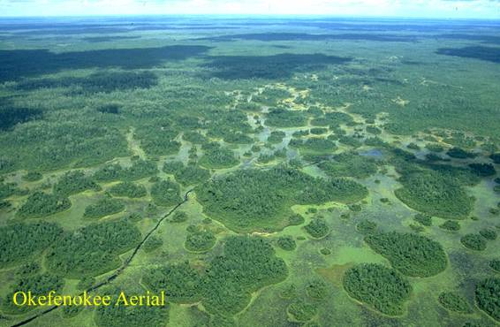
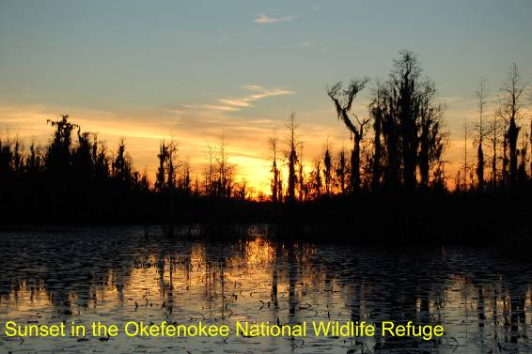

NAME OF PROPERTY:

Petrified Forest National Park

STATE: Arizona

LATITUDE AND LONGITUDE and UTM COORDINATES:

109°46'10.853"W 34°56'55.922"N Z12N 612344 3867866.282

DESCRIPTION:

This national park currently includes 37,852 hectares (93,533 acres) on the southern part of the Colorado Plateau. It was set aside in 1906 to preserve the scientific value of paleontological resources of the Late Triassic period (some 225 to 205 million years ago), most notably vast, colorful, and well preserved deposits of petrified wood. The wood appears at a variety of stratigraphic levels; there are exceptionally large deposits in five areas termed “forests.” Some 78 species of fossil animals have also been identified and studied. (The park is authorized to expand by an additional 125,000 adjacent acres that will add significant natural and cultural resources and serve to protect all those included.)

JUSTIFICATION OF OUTSTANDING UNIVERSAL VALUE:

This park, with its scenic vistas and spectacles of colorful rocks, is one of the premier places in the world for the study of the ecosystem of the Late Triassic Epoch. It contains the largest deposits of petrified wood in the world, as well as important fossils of plants and animals, including early dinosaurs, all in a detailed stratigraphic setting that allows changes in the ecosystem and biota to be effectively traced through the end of the Triassic. Fossil discoveries at Petrified Forest National Park have shaped the understanding of the late Triassic world, and new discoveries continue to highlight its global significance.

CRITERIA CONSIDERED TO BE MET:

(vii) Contain superlative natural phenomena or areas of exceptional natural beauty and aesthetic importance.

The petrified wood deposits of this national park are a natural phenomenon distinguished by their size and natural beauty, affording spectacular views. For more than a century, the Painted Desert has attracted photographers, authors, and painters, including Thomas Moran.

(viii) Be outstanding examples representing major stages of earth’s history, including the record of life, significant on-going geological processes in the development of landforms, or significant geomorphic or physiographic features.

The park is one of the few places in the world where an excellent fossil record, combined with vast geological exposure, offers an unrivaled opportunity for scientific study of ecological change in the Late Triassic ecosystem. Not just the “forests,” but the fossils of other plants and animals, especially early dinosaurs, are abundant.

STATEMENT OF AUTHENTICITY AND/OR INTEGRITY:

Neither non-native plants and animals nor human activities constitute serious threats to the park’s integrity. Before the establishment of the park, some exploitative removal of the petrified trees did occur.

COMPARISON WITH OTHER SIMILAR PROPERTIES:

No other area in the U.S. has such large exposed petrified wood deposits or the diversity of animal and other plant fossils as exists here. Worldwide, Levros Island in Greece has deposits of similar size but they are much younger, being from the Cenozoic era of roughly 20 million years ago. On the World Heritage List, Argentina’s Ischigualasto Provincial Park also contains Triassic era fossils, but of different plant and animal species and of different ecosystems—Petrified Forest representing a tropical ecosystem and Ischigualasto a high latitude one. Furthermore, the fossils of Petrified Forest exceed Ischigualasto’s in their amount of outcrop exposure and fossil diversity, and rival the latter in terms of the early dinosaur record.

Petrified Forest, continued

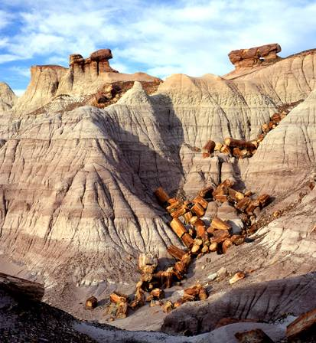
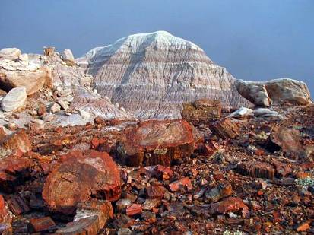
NAME OF PROPERTY:

White Sands National Monument

STATE: New Mexico

LATITUDE AND LONGITUDE and UTM COORDINATES:

106°19'48.892"W 32°46'43.84"N Z13N 375417.322 3627362.743

DESCRIPTION:

This property is a unit of the National Park System that includes more than 58,000 hectares (143,733 acres) at the northern end of the Chihuahuan desert. It was established to protect vast dunes of gypsum sand that have engulfed more than 176,000 acres--along with the plants and animals that have adjusted to this changed environment.

JUSTIFICATION OF OUTSTANDING UNIVERSAL VALUE:

White Sands National Monument is the world’s largest and best protected surface deposit of gypsum sand, unlike the far more abundant lake and seashore quartz sand dunes. Elsewhere in the world, most large gypsum-sand deposits have been heavily mined. Despite the current aridity of White Sands, which evolved over eons, it is biologically rich and diverse, with endemic species of animals, which afford exceptional opportunities for scientific research into evolution. The geology is an analog to that of Mars.

CRITERIA CONSIDERED TO BE MET:

(vii) Contain superlative natural phenomena or areas of exceptional natural beauty and aesthetic importance.

White Sands National Monument is the world’s largest gypsum sand dune field. It has long attracted photographers and other artists to its stunning landscape of huge white sand dune fields, the last remaining intact such area in the world.

(viii) Be outstanding examples representing major stages of earth’s history, including the record of life, significant on-going geological processes in the development of landforms, or significant geomorphic or physiographic features.

The dunes were formed at the bottom of a shallow sea some 250 million years ago and these gypsum-bearing marine deposits were uplifted 70 million years ago when the Rocky Mountains formed. Drying and warming since the last glacial retreat dried up the lake in the area, leaving the gypsum that formed the present-day gypsum fields. The formation of the dunes remains dynamic today.
(ix) Be outstanding examples representing significant on-going ecological and biological processes in the evolution and development of terrestrial, fresh-water, coastal and marine ecosystems and communities of plants and animals.

The site is located in a biologically rich and diverse desert. White Sands presents a natural selection regime of recent origin, wherein species are evolving in the absence of a barrier to gene flow. Exceptional animals (arthropods, amphibians, lizard and rodents) have become white or pale. The isolated features in the park, such as dunes and dry lakebeds, harbor endemic species that offer rich potential for continuing biological research.

(x) Contains the most important and significant natural habitats for in-situ conservation of biological diversity, including those containing threatened species of outstanding universal value from the point of view of science or conservation.

The White Sands contain 12 or more species of animals that can be found nowhere else in the world; it is an important habitat for migrating birds and wintering waterfowl on what is termed the Central Flyway.

STATEMENT OF AUTHENTICITY AND/OR INTEGRITY:

Being somewhat inhospitable to widespread human settlement, the key features of White Sands have been little affected by agriculture, grazing, and military use, except for the increasing presence of mesquite, which has caused limited erosion.

COMPARISON WITH OTHER SIMILAR PROPERTIES:

There are no gypsum deserts on the World Heritage List. Of the five desert sites inscribed, all exhibit dune formation, but the variety of dune features at White Sands is likely distinctive and wider than the other sites.

NOTE:

The use of criteria (ix) and (x) will require further research to determine whether it is appropriate to include them in a nomination.
White Sands, continued

