The United States National Park Service has reached out to Great Smoky Mountains National Park rangers to help provide training for 10 park officials from Cambodia and Thailand. The international park officials, all women, are participating in field training in the Smokies focusing on resource law enforcement techniques. The training is in partnership with the US State Department Global Women's Issues Office, the Maddox Jolie-Pitt Foundation (MJP), and ranger instructors from the National Park Service (NPS) Law Enforcement Training Center located in Georgia.

“The National Park Service has an international role to play in sharing our expertise in conservation law enforcement,” said Jill Hawk, Superintendent of the National Park Service Law Enforcement Training Center. “This program was designed, with our partners, to provide an opportunity for the women of the Lower Mekong countries in Southeast Asia to learn the concepts of law enforcement and park management.”

Rangers are leading hands-on field activities including crime scene processing. The Smokies shares similar habitats with the parks in Cambodia and Thailand along with similar resource issues such as plant and wildlife poaching. Teams will be learning field investigate techniques and incident management coordination. This field training provides the park another opportunity to share resources with Cambodia and Thailand after establishing a Sister Park Agreement with Samlout Protected Area (Cambodia) in 2007 and Khao Yai National Park (Thailand) in 2013.

“We are honored to host park leaders from Thailand and Cambodia not only to teach skills, but also to learn from them,” said Acting Superintendent Clay Jordan. “This is a unique opportunity to exchange information and ideas to help us all to be better stewards of these special places entrusted to us.”

Beginning with a Sister Park Agreement between Sequoia-Kings Canyon National Park and Samlout Protected Area in Cambodia, the National Park Service and MJP have been working together since 2007. The partnership has allowed for the development of a variety of programs, including training for women in environmental leadership positions in SE Asia. “It’s time for more women to get actively engaged in protecting the environment in the Lower Mekong countries from female park superintendents to female rangers trained in law enforcement,” said Stephan Bognar, Chief Executive Officer of the Maddox Jolie-Pitt Foundation. “The United States NPS has the knowledge, skills, and the rangers to teach and mentor these women to become leaders, and not just followers, in protecting our future.”

In 2010, staff participated in a NPS-MJP workshop promoting partnerships and the creation of a trans-boundary peace park in the tropical forest regions in northwestern Cambodia and northeastern Thailand. Rangers from both countries, along with two US National Park Service rangers, attended the park management training workshop in Samlout, Cambodia. The proposed peace park area contains 110,000 hectares of tropical forest and is home to Asian elephants and Indochinese tigers. By working together, Bognar was hoping that the Thai and Cambodian governments could tighten control over illegal activities and promote sustainable development across the Lower Mekong region.

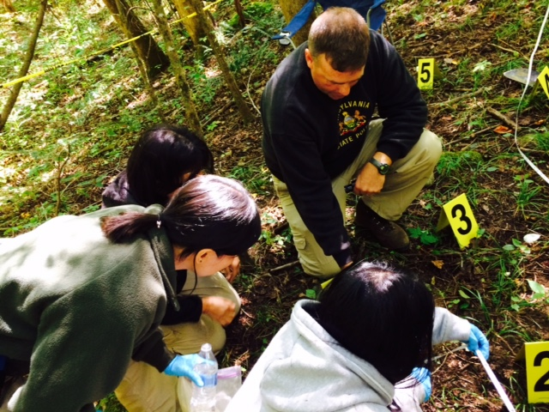
The trainees learned how to conduct a crime scene investigation.

