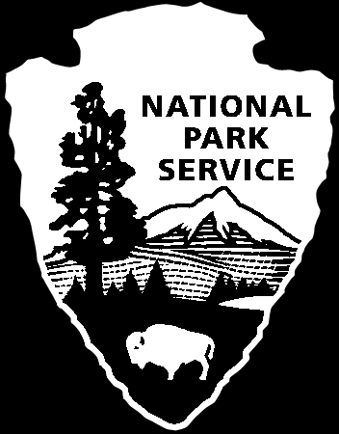NPS International Volunteer (IVIP) Application

The purpose of this form is to gather information that National Park Service (NPS) will use to determine if you meet the requirements for an IVIP program.

This information will be apart of your official immigration record. Please type or print neatly. All blanks must be filled in and the information must be accurate. We cannot process your application unless every line is completed.

PART 1

NAME: Last ____________________First ___________Middle___________
SEX: ____ -Male ___ -Female DATE OF BIRTH: Month___ Day ___ Year___
CITY AND COUNTRY OF BIRTH: ______________________________________
COUNTRY OF CITIZENSHIP: _____________
COUNTRY OF PERMANENT RESIDENCE: _____________
IF EMPLOYED FULL TIME, CURRENT WORK POSITION AND TYPE OF EMPLOYER: (government (local, central), private business, non-profit organization etc): ________________________________________________________________
________________________________________________________________
NUMBER OF YEARS IN UNIVERSITY: ________________________________
MAJOR AREA OF STUDY:________________________________________________________
DEGREES AND DATE(s) RECEIVED: __________________________________________

PREVIOUS JOB RELATED EXPERIENCE: _______________________________________________
____________________________________________________________________________

PREVIOUS VISA to U.S. ? YES: ___ NO: ___ If yes, dates and types visas: ________

FUNDING SOURCE FOR PROGRAM
The State Department requires that you have the financial resources to cover all your expenses during your stay in the U.S.

Please indicate the amount of available funds which you have available on the corresponding blanks.
Home country Government: _________________
University/International Organizations:_________________
Personal Funds:____________________________
Other: ____________________________________
You must identify at least one source and provide an amount in US dollars to be eligible for an NPS IVIP Program.

MAILING ADDRESS: Print very neatly and carefully. Write address as it should appear on an envelope. (No Post Office Boxes)
________________________________________________________________________________________________________________________________
________________________________________________________________
*Telephone number(s):______________________ (important!)______________________________

E-MAIL ADDRESS (if any):______________________________________

WHEN WOULD YOU LIKE TO BEGIN VOLUNTEERING? HOW LONG ARE YOU AVAILABLE?

National Park Service
U.S. Department of the Interior
NPS International Volunteers-in-Parks Program
National Park Service
U.S. Department of the Interior

PART 2

PLEASE ANSWER THE FOLLOWING QUESTION: (use additional sheets of paper if more space is needed for answers.)

1. How would you rate your comprehension of English? (speaking and writing abilities) – Excellent? Good? Fair? Poor?

2. Why do you want to participate in a volunteer program with the U.S. National Park Service (NPS) and how would it benefit you in your future career?

3. What type of training would you like to receive and what relevant experience, university courses or skills do you possess which will prepare you for such training?

4. Where would you like to train in the National Park Service? (For a list of national parks, go to www.nps.gov/parks.)

5. Do you have funds to cover your travel to and from the United States, medical insurance, and all your expenses in the United States?

6. How did you learn about our international internship program?

7. Have you ever traveled or lived abroad and if so when?

8. Have you ever lived and worked in a remote location? (If so, when and where?) (Many but not all volunteer positions are in remote locations.)

9. Have you ever participated in field work in extreme heat and cold?

10. What is you current physical health? Do you have any physical or medical conditions that your hosting national park should be aware of?

11. Do you have special needs for working conditions?

12. If your internships requires you to participate in strenuous activities such as hiking, backpacking camping, or carrying equipment, are you able to do so? List experiences that you have had in these activities if they apply to your internship in the national parks?

13. Do you plan to return to your country after your volunteer program ends or remain in the United States?

14. What are your future career goals?

