Trailhead Signage Annotated Examples:

Outdoor Developed Areas
Contents
Background 2
Purpose 2
Examples 2
Baseline Requirements for Trailhead Signage 3
Pertinent ABAAS References and Requirements 3
Abraham Lincoln Birthplace National Historical Park (ABLI) 4
ABLI Trailhead Signage: Detail of Graphic Panel 5
ABLI Trailhead Signage: Detail of Tactile Panel 6
Sitka National Historical Park (SITK) 7
SITK Trailhead Characteristics Option One 8
SITK Trailhead Characteristics Option Two 9
Grand Canyon National Park (GRCA) 10
Sleeping Bear Dunes Draft (SLBD) 11
Conclusions and Additional Considerations 12
More Information 12

Background
On November 25, 2013, legal requirements for federal outdoor developed areas were mandated. As described by the United States Access Board, the “provisions address access to trails, picnic and camping areas, viewing areas, beach access routes and other components of outdoor developed areas on federal sites when newly built or altered.” These requirements were incorporated into the Architectural Barriers Act Accessibility Standards (ABAAS).

Purpose
This document provides additional graphic design guidance on the application of trailhead signage requirements through annotated examples. For comprehensive information about outdoor developed areas requirements, go to the U.S. Access Board’s Webpage: About the Standards for Outdoor Developed Areas.

Examples
The examples in this document represent an evolution of graphic design options with one of Harpers Ferry Center’s most recently produced trailhead signs presented first. As technologies, fabrication materials, production techniques and a better understanding of effective communication evolve, so too will these examples.

Baseline Requirements for Trailhead Signage
- Length of the trail or trail segment
- Surface type
- Typical and minimum tread width
- Typical and maximum running slope
- Typical and maximum cross slope

Pertinent ABAAS References and Requirements
F216.13 Trailhead Signs. Where new trail information signs are provided at trailheads on newly constructed or altered trails designed for use by hikers or pedestrians, the signs shall comply with 1017.10.
Advisory F216.13 Trailhead Signs. New trail information signs are required to comply with 1017.10 regardless of whether the newly constructed or altered trails comply with 1017. If trail information signs designate the name of the trail, only the name of the trail is required to comply with 703.5. See F216.2. Tactile characters are not required on exterior signs. Trail information signs are not required to display the International Symbol of Accessibility.
1017.10 Trailhead Signs. Trail information signs at trailheads shall include: (1) Length of the trail or trail segment; (2) Surface type; (3) Typical and minimum tread width; (4) Typical and maximum running slope; and, (5) Typical and maximum cross slope.

Abraham Lincoln Birthplace National Historical Park (ABLI)
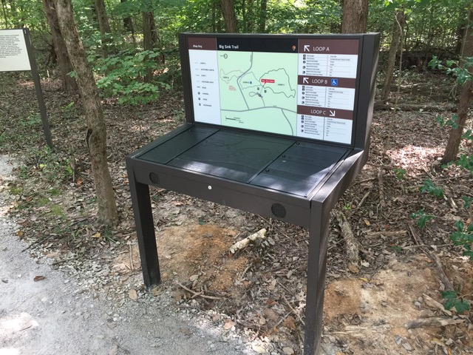
Figure 1. ABLI trailhead panel, Harpers Ferry Center
To date, this example is the most comprehensive approach to effectively communicating trailhead information. In addition to required information, information is delivered multi-modally. The upright panel provides information visually. The horizontal panel provides the same information tactilely, with braille and textures to differentiate areas. Speakers on the front edge deliver audio description on demand to provide information aurally.
The tactile panel was developed for 3-D print production. At the time of the project (2016), only one-color printing was available. If multi-colored 3-D printing is possible, future designs might consider presenting all information on a single panel. Regardless, the tactile panel must be placed horizontally or at a low angle for use by people who are blind or have low vision. Maintenance of panels must also be planned as replacement every few years is anticipated.

ABLI Trailhead Signage: Detail of Graphic Panel
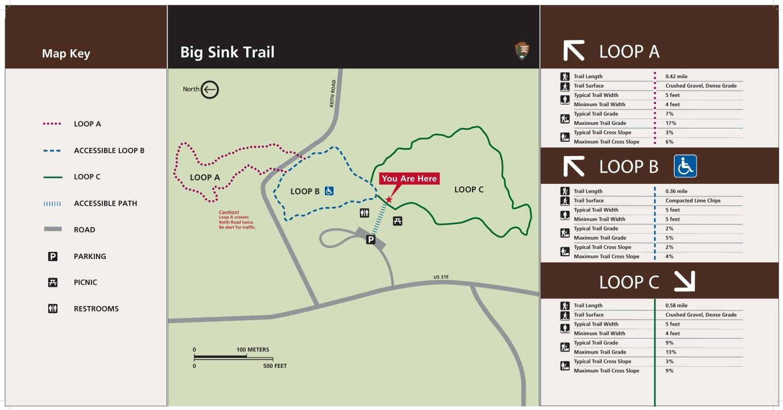
Figure 2. ABLI trailhead upright panel, Harpers Ferry Center
Certain color combinations and shades of color may not be discernable for people who are color blind, including red and green combinations. Make sure that you are knowledgeable about color blindness and design techniques for applying different shades and saturation of colors before you create color combinations. While this map includes red and green combinations, when tested through a greyscale filter, the contrast was effective. Each trail was also identified by a unique patterned line to further differentiate each trail.

ABLI Trailhead Signage: Detail of Tactile Panel
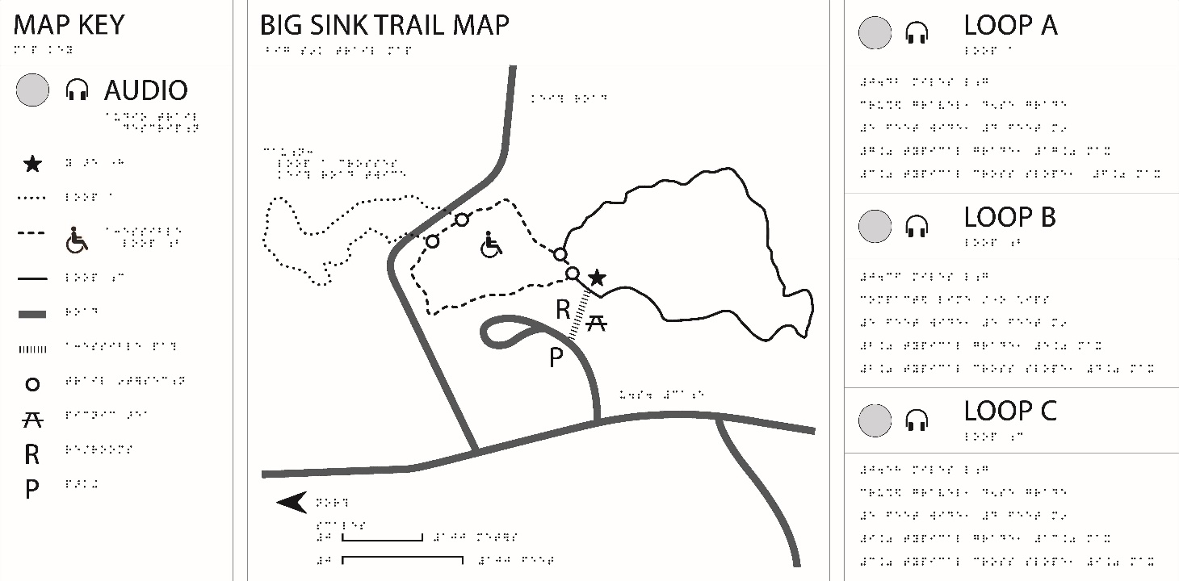
Figure 3. ABLI trailhead horizontal tactile panel, Harpers Ferry Center
Textual information was conveyed in braille with a limited use of words produced as raised characters. Four audio buttons were added. The button on the left plays the description for the Map Key and Big Sink Trail Map. The three buttons on the right play the information under each loop of the trail.

Sitka National Historical Park (SITK)
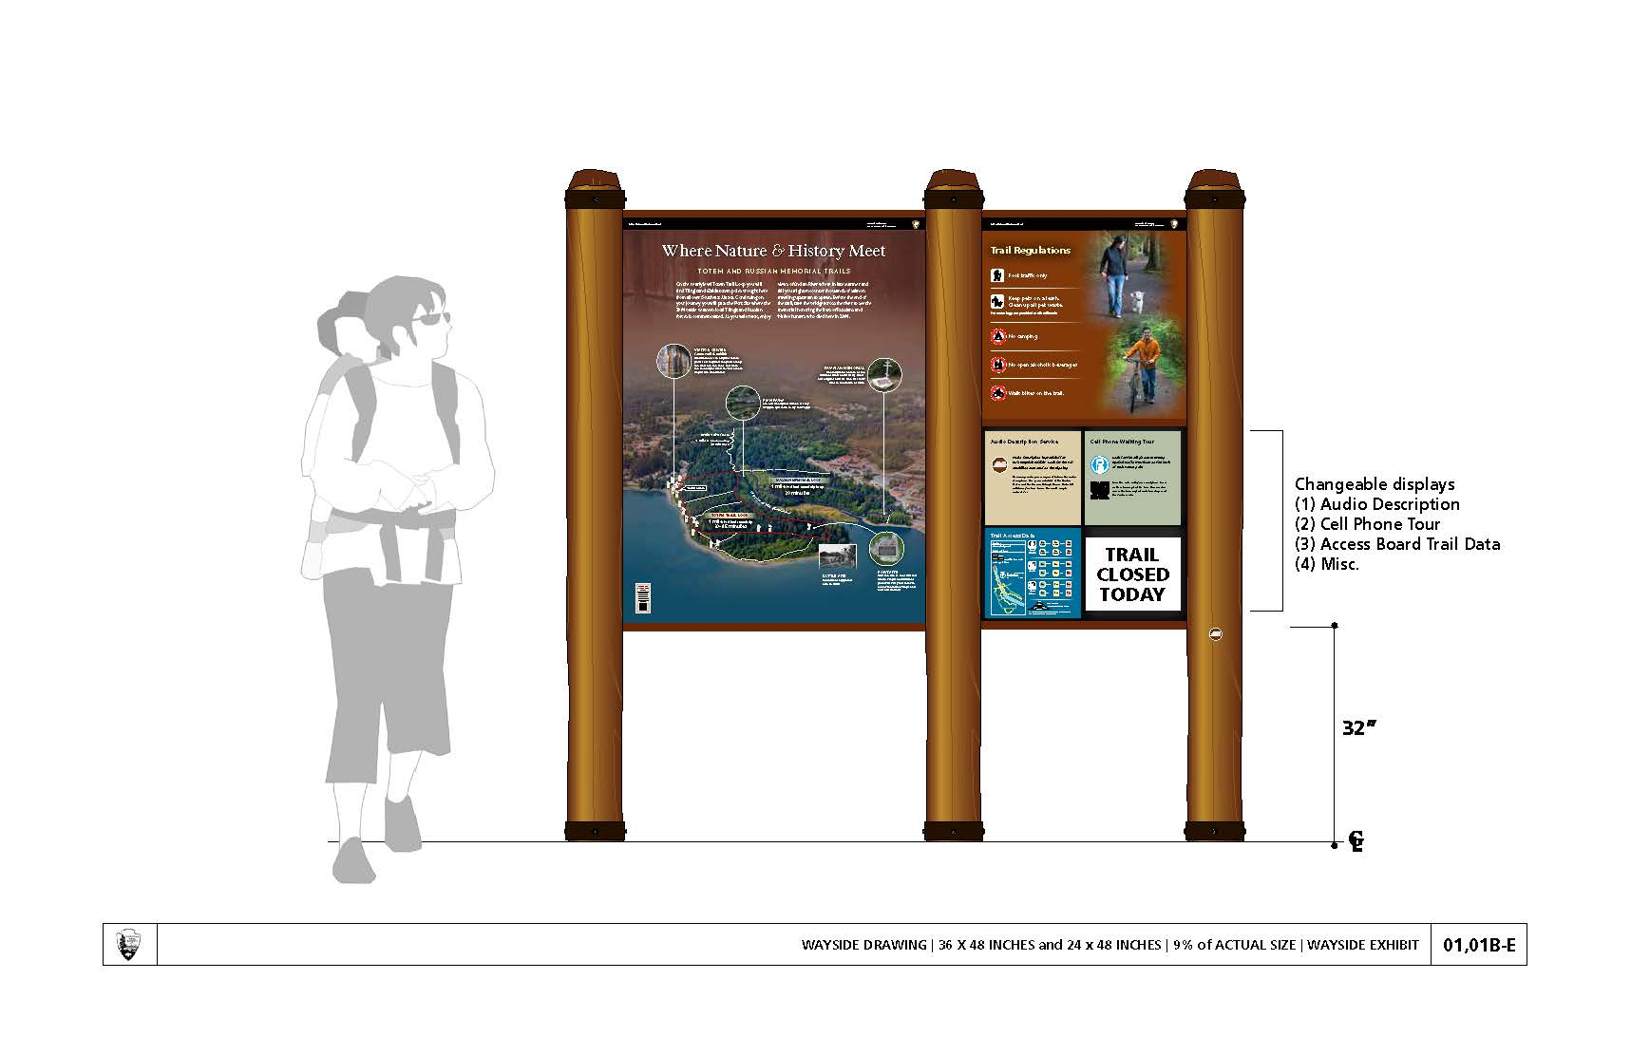
Figure 4. SITK upright interpretive and trailhead panel, Harpers Ferry Center
Trail information is not always static. This conceptual upright panel provides interpretation and trail information. It was designed for flexibility with changeable displays. This makes updating trailhead information easier. Following are two design approaches to trail access data prototyped for Sitka.

SITK Trailhead Characteristics Option One
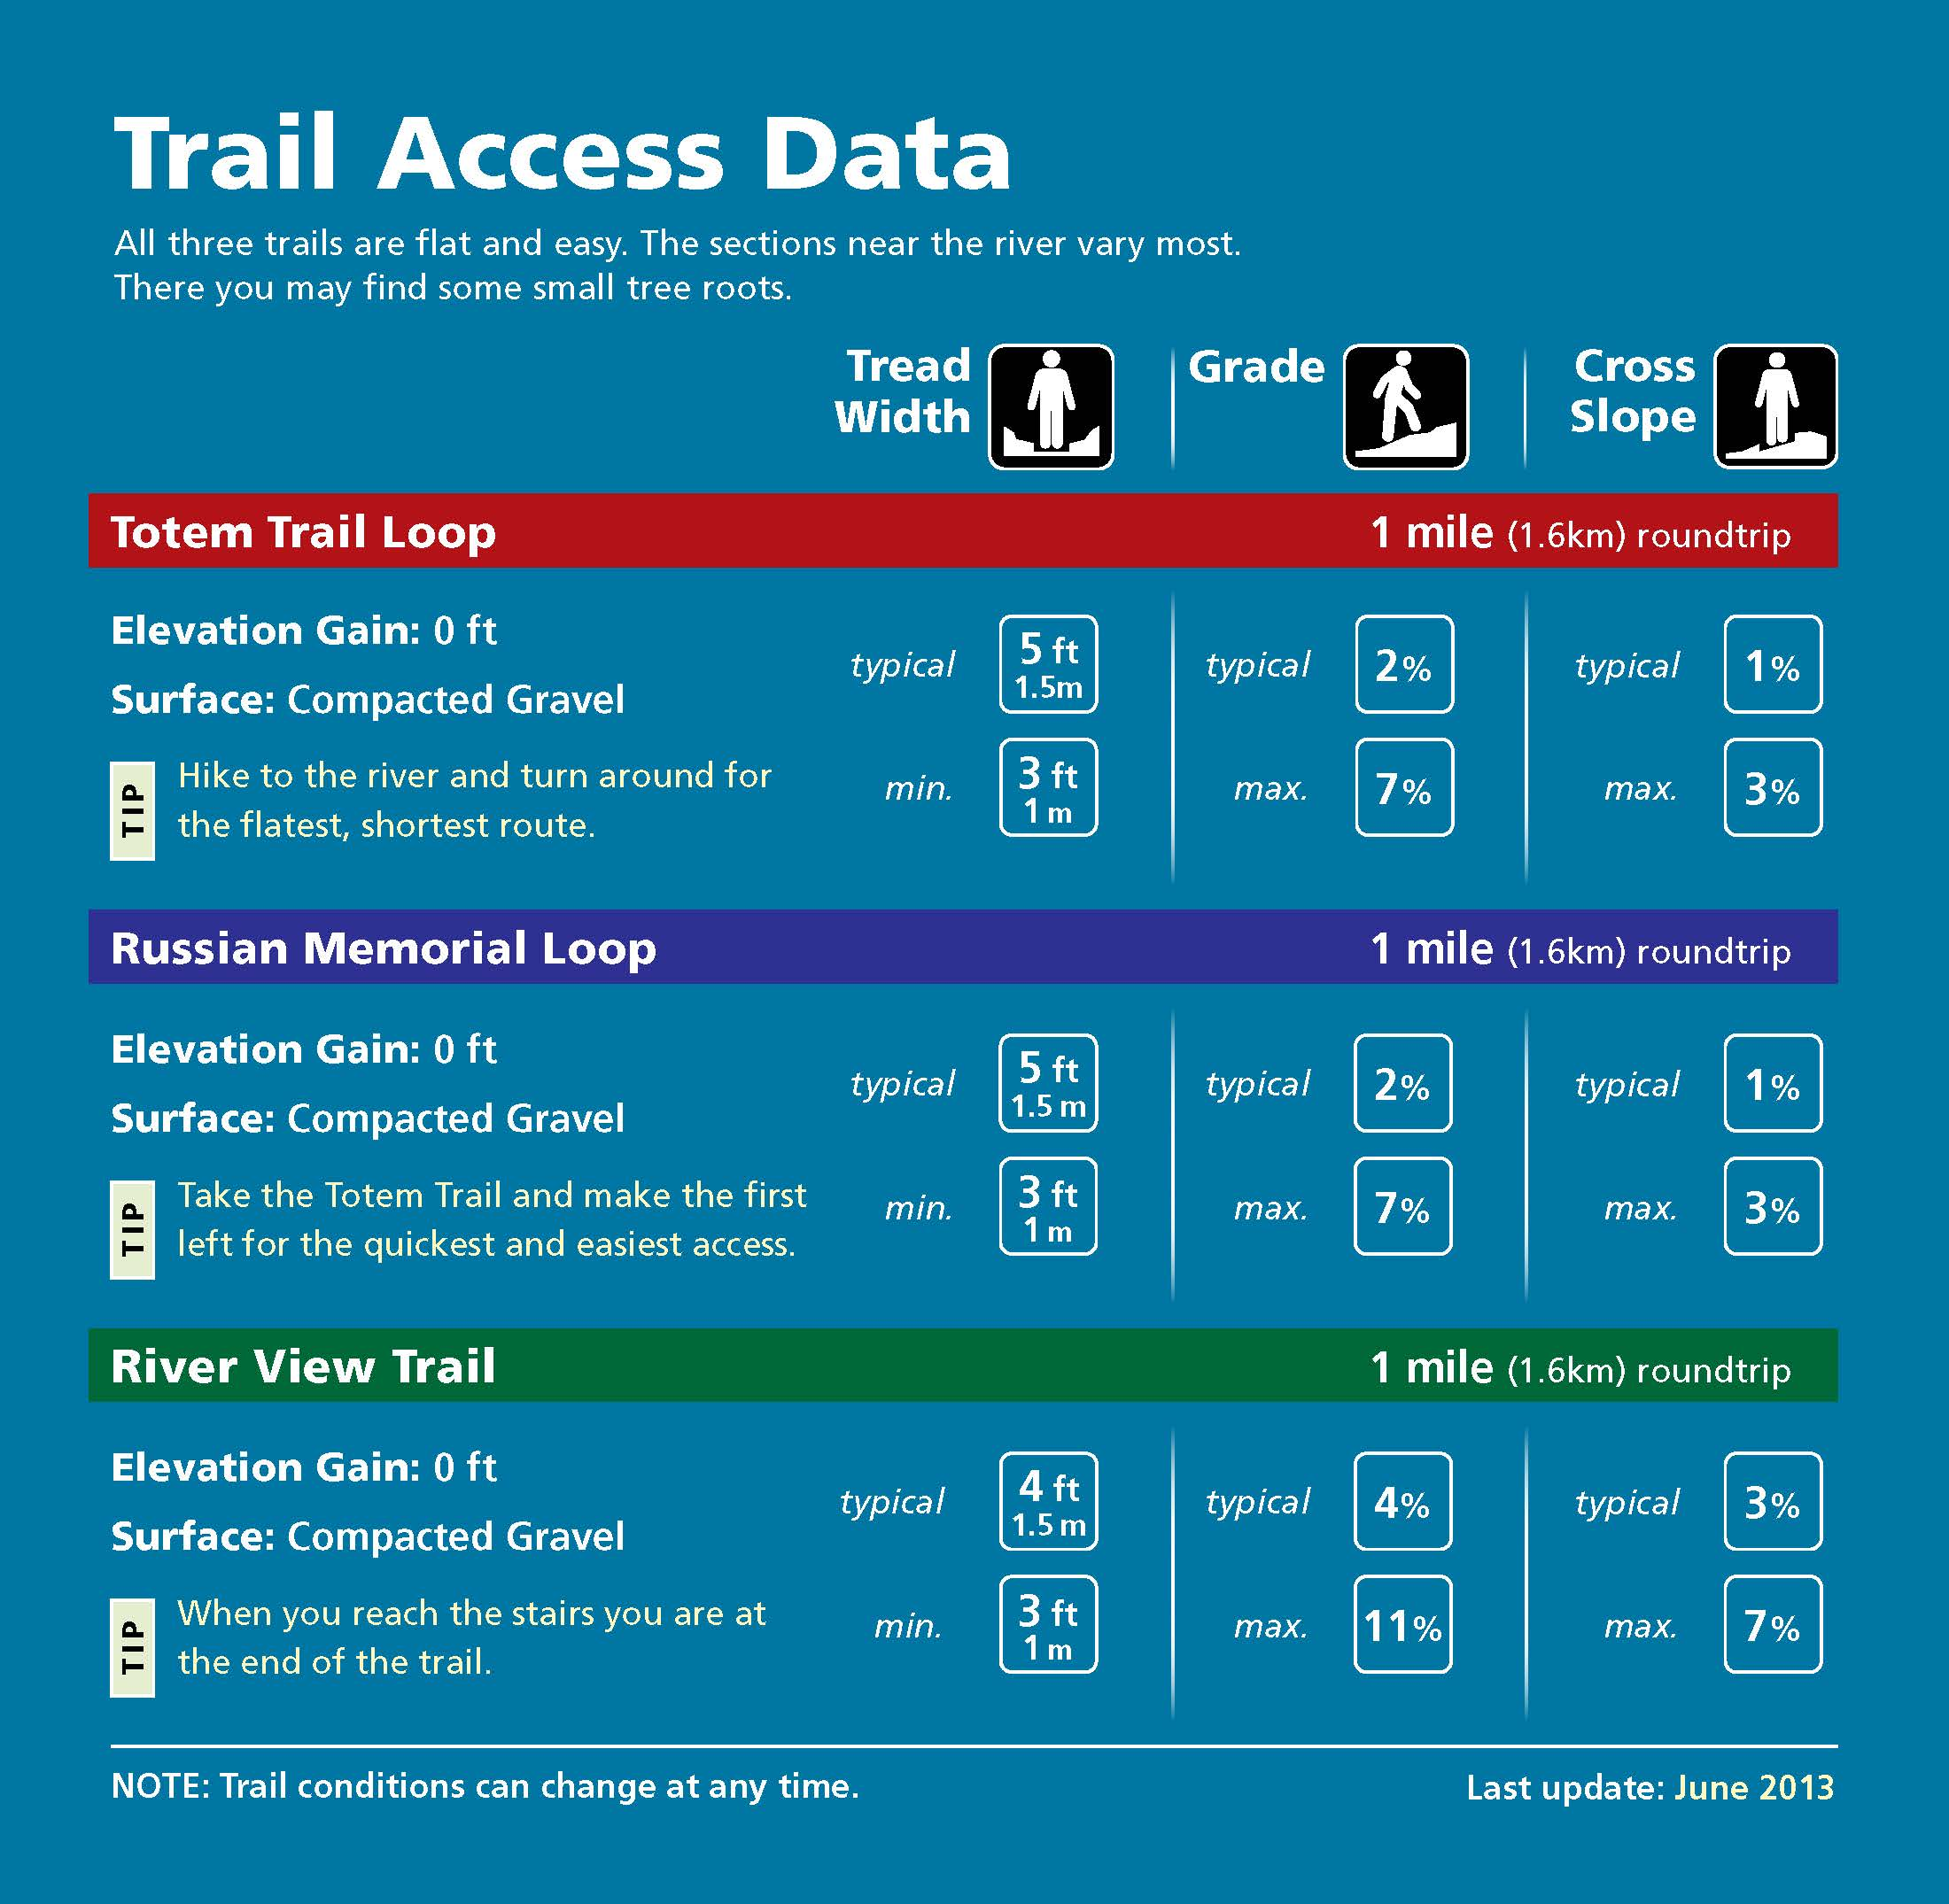
Figure 5 SITK trailhead graphic panel example one, Harpers Ferry Center
In addition to listing requirements, a sentence or two about the trail may help individuals understand this data. This panel states when this information was last updated. This can be useful, especially if weather and other factors may change trail conditions.

SITK Trailhead Characteristics Option Two
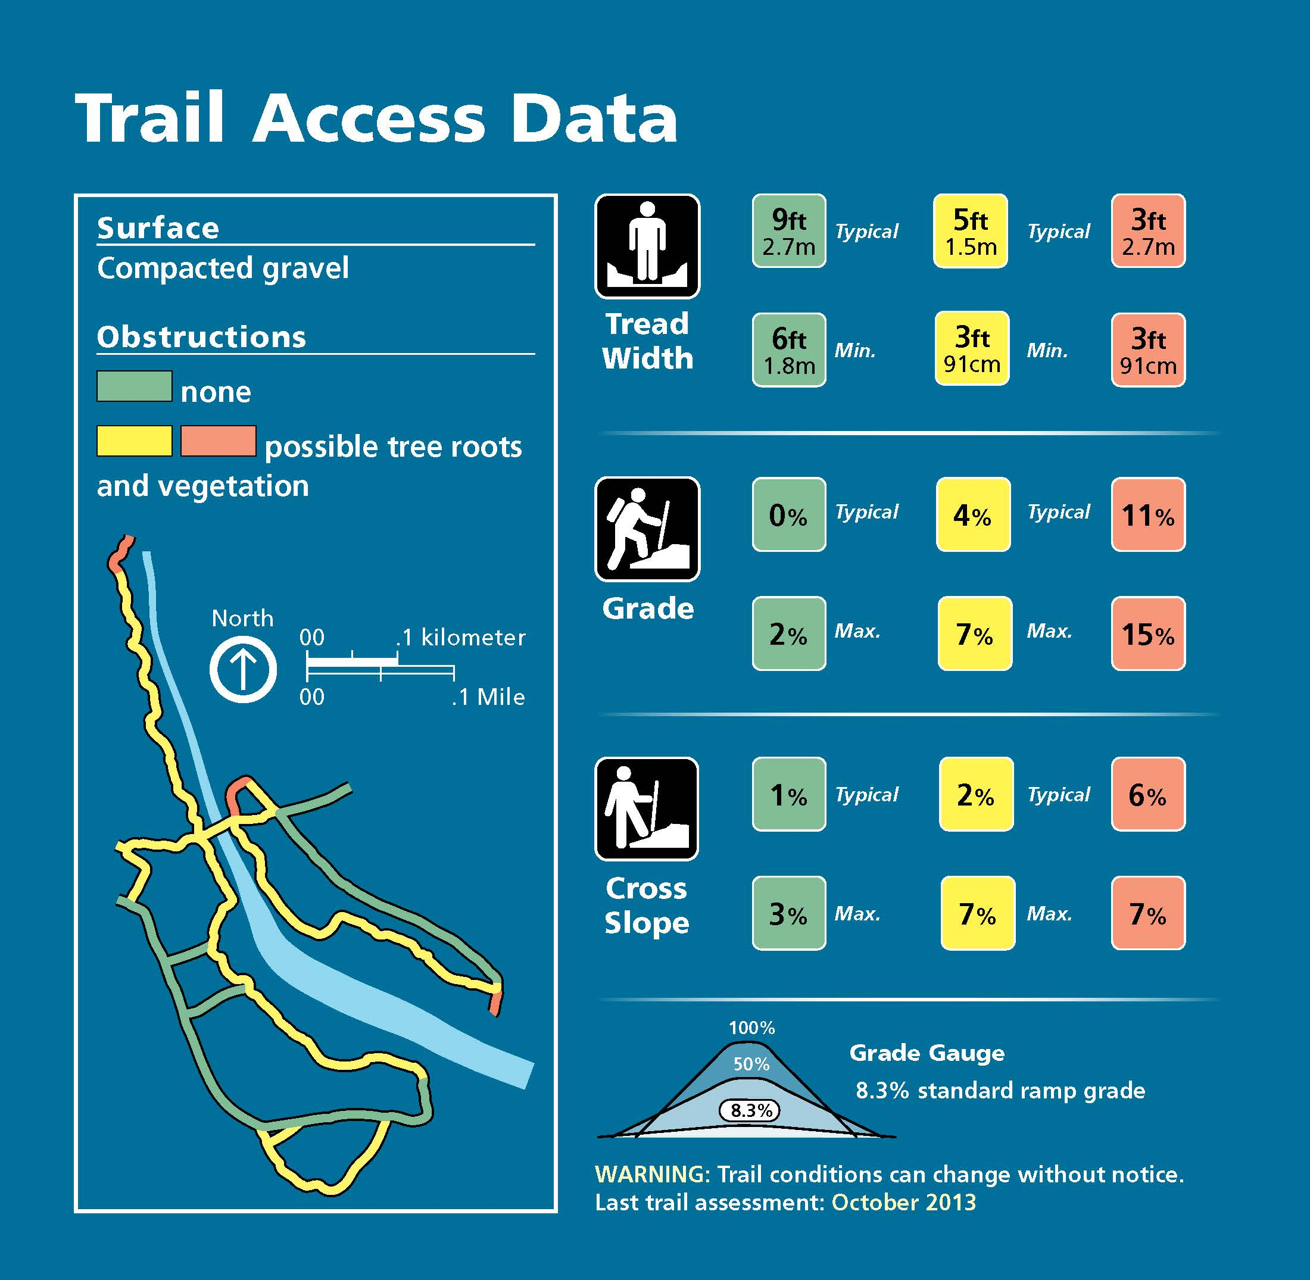
Figure 6. SITK trailhead graphic panel example two, Harpers Ferry Center
If trails have significant changes in grade or slope, pointing this out through text and/or visually may be helpful. Obstructions, such as tree roots, may also have an impact on a person’s ability to use the trail. This information is conveyed through the map and color. Please note, the lengths of the trails are not listed because this information is provided in the interpretive wayside section of the upright panel.

Grand Canyon National Park (GRCA)
Figure 7. GRCA trailhead panel, Harpers Ferry Center
This example presents another approach to graphically representing trail information through text, the visual shape of the trail, and by providing a trail profile.

Sleeping Bear Dunes Draft (SLBD)
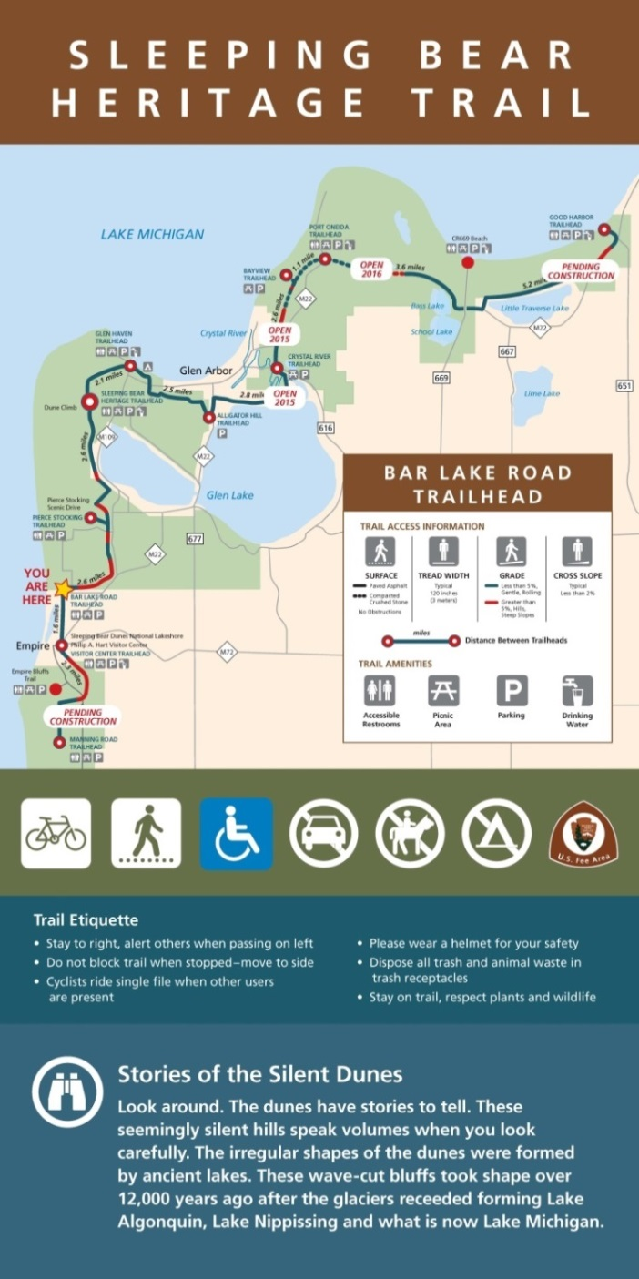
This map combines both interpretation and information in a single panel and map. Because of the area and shape of the site, trail data fit nicely within the landmass outside of the park. This design was a prototype. Some revisions could include the use of upper and lower case instead of all caps and a different approach to the red/green combination used on the trail itself.
Figure 8. SLBD trailhead panel prototype, Sleeping Bear Dunes National Lakeshore

Conclusions and Additional Considerations
- There is no single way to graphically present required data. The length, complexity and uniformity of a trail or trail system should be considered within the graphic design approach.
- Consider illustrating trail conditions through photographs.
- If audio description of waysides or other features is available along the trail, the trailhead signage is a good place to note this, especially if the visitor needs to check out equipment.
- Tactile maps and audio description are not specified within ABAAS’s Outdoor Developed Areas Standards. The National Park Service, however, has a legal obligation to effectively communicate and provide opportunities for visitors with disabilities to participate in and benefit from our programs and services, which includes these products. Design, location, and materials may vary, but it is important to incorporate tactile experiences and maps within our products. Audio description should also be incorporated. Both techniques contribute to effective communication and accessibility for people who are blind, have low vision, have print disabilities or diverse ways of learning.
- Consider testing your designs to ensure that the information is understandable to people with and without disabilities.

More Information
For more information, contact:
Michele Hartley, Media Accessibility Coordinator
Harpers Ferry Center, National Park Service
304-535-6083
michele_hartley@nps.gov

United States Access Board Webpage: “About these Standards.” URL: https://www.access-board.gov/guidelines-and-standards/recreation-facilities/outdoor-developed-areas. Accessed March 22, 2017.
Ibid.

