HISTORIC AMERICAN Landscapes SURVEY

Primary Site NAME

(Secondary Name)

HALS No. XX-XXX

|  |  |
| --- | --- |
| Location: | Enter the street address, city or town, county, and state where the property is located. For large resources, define the general site boundaries.  In a separate paragraph, provide a pair of geographic coordinates in decimal degree format that locate the center or other prominent feature of the landscape. Indicate the datum and source of the coordinates (e.g. WGS 84, USGS EarthExplorer). |
| Owner / Occupant: | Identify the current owner(s) of the property. For rented or leased properties, list current occupants when relevant. For private residences, owner and occupant names may be omitted. |
| Significance: | Provide a succinct (one or two paragraph) statement that summarizes the significant physical characteristics and historical associations of the site. Touch on aspects discussed in greater depth in subsequent sections of the report. Note that the significance statement is the source for indexing terms and Library of Congress searches. |
| Historian(s): | Identify the author(s) of the report, their academic or professional affiliations, and the project year. |

1. Part I. Historical Information
   1. Physical History
      1. Dates of Establishment:

Give key dates in the development of the landscape and cite the sources or evidence used to determine them. If a date is unknown, state “Not known.” If an exact date cannot be determined, a date range or an estimate is indicated using “ca.”

* + 1. Designer, Creator, or Shaper:

Identify the individuals or groups responsible for designing, creating, or shaping the landscape. For cultural landscapes, shapers and creators can the people to which the landscape has been traditionally attributed, such as planters, farmers, communities, and native populations. If the landscape is formally designed, this section may include a brief biographic entry of the landscape architect, designer, master gardener, or horticulturist that created it. The heading of this section can be changed to reflect the appropriate title of the responsible individuals. State “Not known” if applicable.

* + 1. Builders, Contractors, Laborers, and Suppliers:

Identify the relevant builders, craftspeople, laborers, companies, and material suppliers that were responsible for developing the landscape. If the responsible parties are not known, state “Not known.” The heading of this section can be changed to reflect the appropriate title of those involved.

* + 1. Original and Subsequent Owners, Occupants, and Uses:

List the original and subsequent owners and uses of the property. For properties that are leased or rented, provide information on the site’s occupants when relevant.

* + 1. Periods of Development
       1. Original Design and Development:

Describe the original appearance of the site, using early drawings, photographs, and written or oral descriptions when available. Information derived from physical evidence and on-site analysis can also be used. Note that information provided here does not need to be repeated in the Historic Context section of the report (Part I.B.).

* + - 1. Changes and Additions:

Describe significant alterations and additions to the landscape, including information on the dates of the alterations, the individuals involved, and the resultant changes. Organize this information chronologically, devoting a separate paragraph to each major change. If alternations and additions are well articulated here, they do not need to be thoroughly discussed in the Historic Context section of the report (Part I.B.).

* 1. Historic Context

Expand on the significance statement at the beginning of the report by discussing the landscape within the larger context of national, regional, or local history and design. Consider not only the general history of the resource, but also its relationship to its location and the people and events associated with its establishment and evolution. If addressing multiple aspects of the landscape’s history, subheadings can be added to this section.

1. Part II. PHYSICAL Information
   1. Landscape Character

Summarize the qualities and characteristics that distinguish the landscape. Identify the general features of its design or form that convey the significance of the site and describe how these features reflect broader historical or cultural trends. For cultural landscapes, identify the traditional practices that have influenced the development and use of the site. Reserve detailed physical descriptions of specific features for the appropriate headings below.

* 1. Character-Defining Features
     1. Natural Systems and Features:

Describe the natural systems and features that have influenced the development, form, and use of the landscape. These may include aspects of the site’s geology, hydrology, ecology, and climate. Examples of features associated with natural systems include bodies of water, watersheds, geological formations, and ecological habitats.

* + 1. Spatial Organization:

Describe the arrangement of features and forms within the landscape, explaining how the organization and interaction of these elements define the principal spaces and uses of the landscape. For large areas, identify clusters of features, such as residential, agricultural, or industrial centers, that influence the broader organization of the landscape.

* + 1. Land Use:

Describe the principal uses of the land and identify any features that have developed in response to these activities. Examples of features associated with land use include agricultural areas, recreational facilities, and sites of resource extraction or production.

* + 1. Circulation:

Describe the features that facilitate movement through the landscape, identifying their form, function, and material composition. Examples of circulation systems include paths, roads, and canals.

* + 1. Topography:

Describe the topographic configuration of the landscape surface as characterized by the interaction of natural and built forms. Examples of topographic features include slopes, prominences, depressions, earthworks, drainage systems, and terraces.

* + 1. Vegetation:

Identify the principal types of vegetation and plant species, whether indigenous or introduced, that are present in the landscape. When identifying plant species, include both the common and scientific name. Examples of features associated with vegetation include specimen trees, woodlots, orchards, gardens, and native plant communities.

* + 1. Buildings and Structures:

Identify buildings and structures that are present on the site. For buildings and structures that contribute to the character of the landscape, include information on their design, use, and history.

* + 1. Views and Vistas:

Describe the views and vistas, whether naturally-occurring or deliberately contrived, that contribute to the feeling, function, or design of the landscape.

* + 1. Constructed Water Features:

Identify any built features that use water for aesthetic or utilitarian functions within the landscape. Examples of constructed water features include fountains, canals, cascades, pools, and reservoirs.

* + 1. Small-Scale Features:

Identify any objects or other small-scale features that fulfill a functional purpose within the site. Focus on features that contribute to the character of the landscape. Examples of small-scale features include statues, monuments, fences, benches, and signage.

* + 1. Archeological Sites:

Describe any archeological features that contribute to the character of the landscape. These features may include ruins, traces, or deposits that relate to previous occupation or use of the site. Examples of archeological features include road traces, structural ruins, and reforested fields. To ensure confidentiality, do not disclose information regarding the nature or location of an archeological site if it may risk harm to the resource.

1. Part III. Sources of Information
   1. Drawings and Plans

Provide a list of drawings and plans referenced or used in the preparation of this report. Identify the name of the landscape architect/delineator, drawing title, date, location of the original drawings, and any pertinent reference or filing numbers. Include both original drawings and those of any subsequent additions or alterations. Note anything significant, such as features not built as originally planned.

* 1. Historic Views and Photographs

Provide a list of relevant photographs, engravings, and other images. If known, specify the medium, artist, date, publisher, and size. Give the location of the item with pertinent collection and reference information. If the report relies on a large collection of early views or historic photographs from the same source, these may be summarized and cited as a group.

* 1. Interviews

List and interviews used in the preparation of this report, providing the name of the person interviewed, the date and place of the interview, and the person’s association with the resource.

* 1. Selected Sources

Provide a select bibliography of referenced sources. If the written sources are extensive, divide them into primary and secondary, or unpublished and published categories. Citations for unpublished materials should include their archival location and accompanying reference or filing codes. All citations should follow Chicago Manual of Style or Turabian format.

* 1. Likely Sources Not Yet Investigated

When relevant, list any materials or collections not referenced in the report, but known or thought to contain further information. If relevant, include a brief explanation of why the material was not accessed.

1. Part IV. Project Information

Provide general information on the execution of the HALS survey, including the names of individuals responsible for measured drawings, photographs, and historical research; the circumstances under which the project was undertaken; sponsors and participating organizations; and the project year.

Part V. Figures

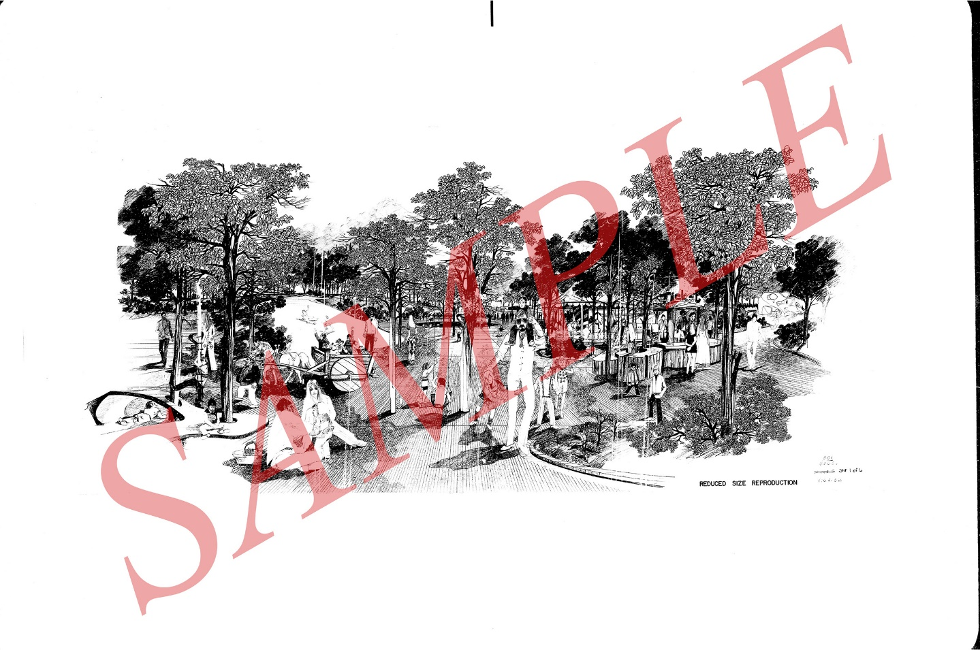

**Fig. 1. Skidmore, Owings and Merrill, Site Perspective No. 1, *Constitution Gardens Base Plan*, 1972**.

Include a description or other supplemental information here, as needed.

(Source: Drawing No. 801/84082, Sheet 1, Electronic Technical Information Center, National Park Service)