HISTORIC AMERICAN Engineering Record

Primary Site NAME

(Secondary Name)

HAER No. XX-XXX

|  |  |
| --- | --- |
| Location: | Enter the street address, city or town, county, and state where the property is located.  In a separate paragraph, provide a pair of geographic coordinates in decimal degree format that locate the center or other prominent feature of the property. Indicate the datum and source of the coordinates (e.g. WGS 84, USGS EarthExplorer). |
| Owner / Occupant: | Identify the current owner of the property. For rented or leased properties, list current occupants when relevant. |
| Present Use: | Provide a brief statement explaining the principal use of the site. |
| Significance: | Include a brief statement that presents the rationale for recording the site, emphasizing its significance in the local, regional, or national context. Highlight the relevant historical and engineering aspects that define the site and make it unique. This significance statement will be expanded in following sections. Note that the significance statement is the source for indexing terms and Library of Congress searches. |
| Historian(s): | Identify the author(s) of the report, their academic or professional affiliations, and the project year. |

1. Part I. Historical Information
   1. Physical History
      1. Date of Construction:

Give the initial date of construction. If unknown, state “Not known.” If an exact date cannot be determined, a date range or an estimate is indicated using “ca.” Include sources for all dates cited.

* + 1. Architect/Engineer:

Identify the architect or engineer responsible for designing the resource. For resources produced by large firms, provide information on key members of the design team, when known. Inclusion of basic biographic information can be included, especially if the architect or engineer is not well known or is a local figure. The heading of this section can be changed to reflect the appropriate title of the designer. State “Not known” or “None” as necessary.

* + 1. Builders, Contractors, and Suppliers:

Identify the relevant construction firms, builders, laborers, or material suppliers that were responsible for constructing the resource. If the responsible parties are not known, state “Not known.” The heading of this section can be changed to reflect the appropriate titles of those involved.

* + 1. Original Plans and Construction:

Provide a capsule description of the original appearance of the site, using drawings, perspectives, and early views when available. Contemporary descriptions from newspapers, contracts, and letters can be quoted or summarized. Physical examination of the site may also contribute to this description. Note that information provided here does not need to be repeated in the Historic Context section of the report (Part I.B.).

* + 1. Alterations and Additions:

Describe significant alterations and additions to the site, including information on the dates of the alterations, the individuals involved, and the resultant changes. Organize this information chronologically, devoting a separate paragraph to each major change. If alternations and additions are well articulated here, they do not need to be thoroughly discussed in the Historic Context section of the report (Part I.B.).

* 1. Historic Context

Expand on the significance statement at the beginning of the report by discussing the site’s place in the context of national, regional, or local history, as well as the history of engineering or technology. Consider not only the general history of the site, but also its relationship to the surrounding area and the people and events associated with its establishment and development. This section should include information on how the resource was constructed and any construction techniques that were used, especially those involving innovative technologies. When available, provide contract information and state how long construction lasted. If addressing multiple aspects of the site’s history, subheadings can be added to this section.

1. Part II. Structural, Design, and Equipment Information
   1. General Statement
      1. Character:

Summarize the architectural or engineering character of the site, with particular emphasis on distinctive or noteworthy features. This section should address what distinguishes the site in terms of design and function, and how these characteristics reflect broader engineering and historical trends. Detailed physical descriptions of the resource should be reserved for the appropriate headings below.

* + 1. Condition:

Provide a general assessment of the resource’s current condition. Information on the condition of specific features can be detailed in the following sections.

* 1. Description of the Exterior
     1. Overall Dimensions:

State the general dimensions of the resource expressed in either numerical dimensions or general terms, such as bays and stories.

* + 1. Foundations:

Describe the building foundations, including information on their material composition, thickness, and relationship to the water table, when applicable.

* + 1. Walls:

Describe the materials and finishes of exterior walls, including information on ornamental features such as quoins, pilasters, and belt courses. Mention details such as the brick bond or stone pattern, color and texture, and the source of materials when known. When a building is stuccoed or re-sided, note the materials underneath, if known. For modern wall assemblies, identify their constituent components, materials, manufacturers, and relationship to the structural system.

* + 1. Structural System and Framing:

Provide a thorough description of the structural system, noting load-bearing walls, framing members, floor systems, and roof framing.

* + 1. Porches, Stoops, and Balconies:

Describe the materials, form, roof type, details, and location of porches, stoops, and balconies.

* + 1. Chimneys and Stacks:

Describe the materials, form, details, and location of each chimney or smokestack.

* + 1. Openings
       1. Doorways and Doors:

Describe the materials, design, and location of exterior doorways.

* + - 1. Windows and Shutters:

Describe the windows, including information on the fenestration pattern, window type (such as casement, double-hung sash, or sliding), sills, lintels, trim, and shutters. If there are a variety of windows, characterize them generally.

* + 1. Roof
       1. Shape and Covering:

Describe the roof shape and materials.

* + - 1. Cornice and Eaves:

Describe any cornices and eaves, including information on their materials, form, notable features, and gutter and downspout systems.

* + - 1. Dormers, Cupolas, and Towers:

Describe any dormers, cupolas, towers, or other notable elements, including information on their design, number, and location.

* 1. Description of the Interior
     1. Floor Plans:

If this HAER survey includes measured drawings or sketch plans, use this section to provide a general description of the site’s layout. If there are no accompanying drawings, provide more specific information here on the arrangement of rooms and other building elements. Start with the lowest floor and proceed to the top. If two or more floors are identical, combine the descriptions.

* + 1. Work Flow:

Describe how and where manufacturing or industrial activities occur within the site.

* + 1. Stairways:

Describe and note the location of stairways, including information on stair types, railings, balusters, and any ornamental features. For prefabricated stairways, note the manufacturer and model numbers when known.

* + 1. Flooring:

Give the material, finish, and color of flooring. For wood floors, describe the width of boards and direction they run. For manufactured surfaces, note the manufacturer and model names when known.

* + 1. Wall and Ceiling Finish:

Describe the interior walls, providing information on finish materials, paneling, and color. Identify the location of specific features discussed. When appropriate, consider the relationship of the finishes to the processes occurring within the building.

* + 1. Openings
       1. Doorways and Doors:

Give a general description of characteristic door types within the property and provide individual descriptions and locations for notable doors. For prefabricated doors, note the manufacturer and model when known.

* + - 1. Windows:

Discuss natural lighting features and provisions for borrowing light from other interior spaces**.** Describe any notable interior trim or other window details.

* + 1. Mechanical Equipment
       1. Heating, Air Conditioning, Ventilation:

Describe the original and current heating, air conditioning, and ventilation systems, with specific information on any extant devices of interest.

* + - 1. Lighting:

Describe the original and current lighting systems, with specific information on any extant fixtures of interest.

* + - 1. Plumbing:

Describe the original and current plumbing systems, with specific information on any extant features of interest.

* 1. Machines

Describe any extant machinery and specify their purpose in the manufacturing or industrial operations of the site. If known, indicate manufacturer names and dates, as well as significant badge plate information, such as model, horsepower, pressure, size (for example loom width, tank capacity, water wheel diameter), or rotations per minute. Process and power connections between machines should be noted where appropriate. Details such as weight and the specifics of electrical connections need not be included unless they are unusually important to the machine’s operation.

* 1. Site Layout

Describe the overall layout of the site, including information on how components are grouped, their relative proximity to one another, and any design considerations made in response to the site’s environment and setting. When applicable, explain how this layout reflects the manufacturing or industrial operations of the site.

1. Part III. Operations and Process
   1. Products

Identify the products manufactured at the site, including information on the raw materials and distribution networks used to create and ship them.

* 1. Operations

Describe the past and/or current manufacturing or industrial processes that have occurred on the property.

* 1. Technology

Describe the machinery and technology used to create the end products. Consider how changes in technology have impacted both the operations and built environment of the site.

* 1. Workers

Provide information on the types of jobs undertaken at the site, the ways they were performed, and any demographic information on the workforce, when available.

1. Part IV. Sources of Information
   1. Drawings

Provide a list of architectural and engineering drawings referenced or used in the preparation of this report. Identify the name of the architect/engineer/delineator, drawing title, date, location of the original drawings, and any pertinent reference or filing numbers. Include both original drawings and those of any subsequent additions or alterations. Note anything significant, such as features not built as originally planned.

* 1. Early Views

Provide a list of relevant photographs, engravings, and other images. If known, specify the medium, artist, date, publisher, and size. Give the location of the item with pertinent collection and reference information. If the report relies on a large collection of materials from the same source, these may be summarized and cited as a group.

* 1. Interviews

List any interviews used in the preparation of this report, providing the name of the person interviewed, the date and place of the interview, and the person’s association with the resource.

* 1. Selected Sources

Provide a select bibliography of referenced sources. If the written sources are extensive, divide them into primary and secondary, or unpublished and published categories. Citations for unpublished materials should include their archival location and accompanying reference or filing codes. All citations should follow Chicago Manual of Style or Turabian format.

* 1. Likely Sources Not Yet Investigated

When relevant, list any materials or collections not referenced in the report, but known or thought to contain further information. If relevant, include a brief explanation of why the material was not accessed.

1. Part IV. Project Information

Provide general information on the execution of the HAER survey, including the names of individuals responsible for measured drawings, photographs, and historical research; sponsors and participating organizations; the circumstances under which the project was undertaken; and the project year.

Part V. Figures

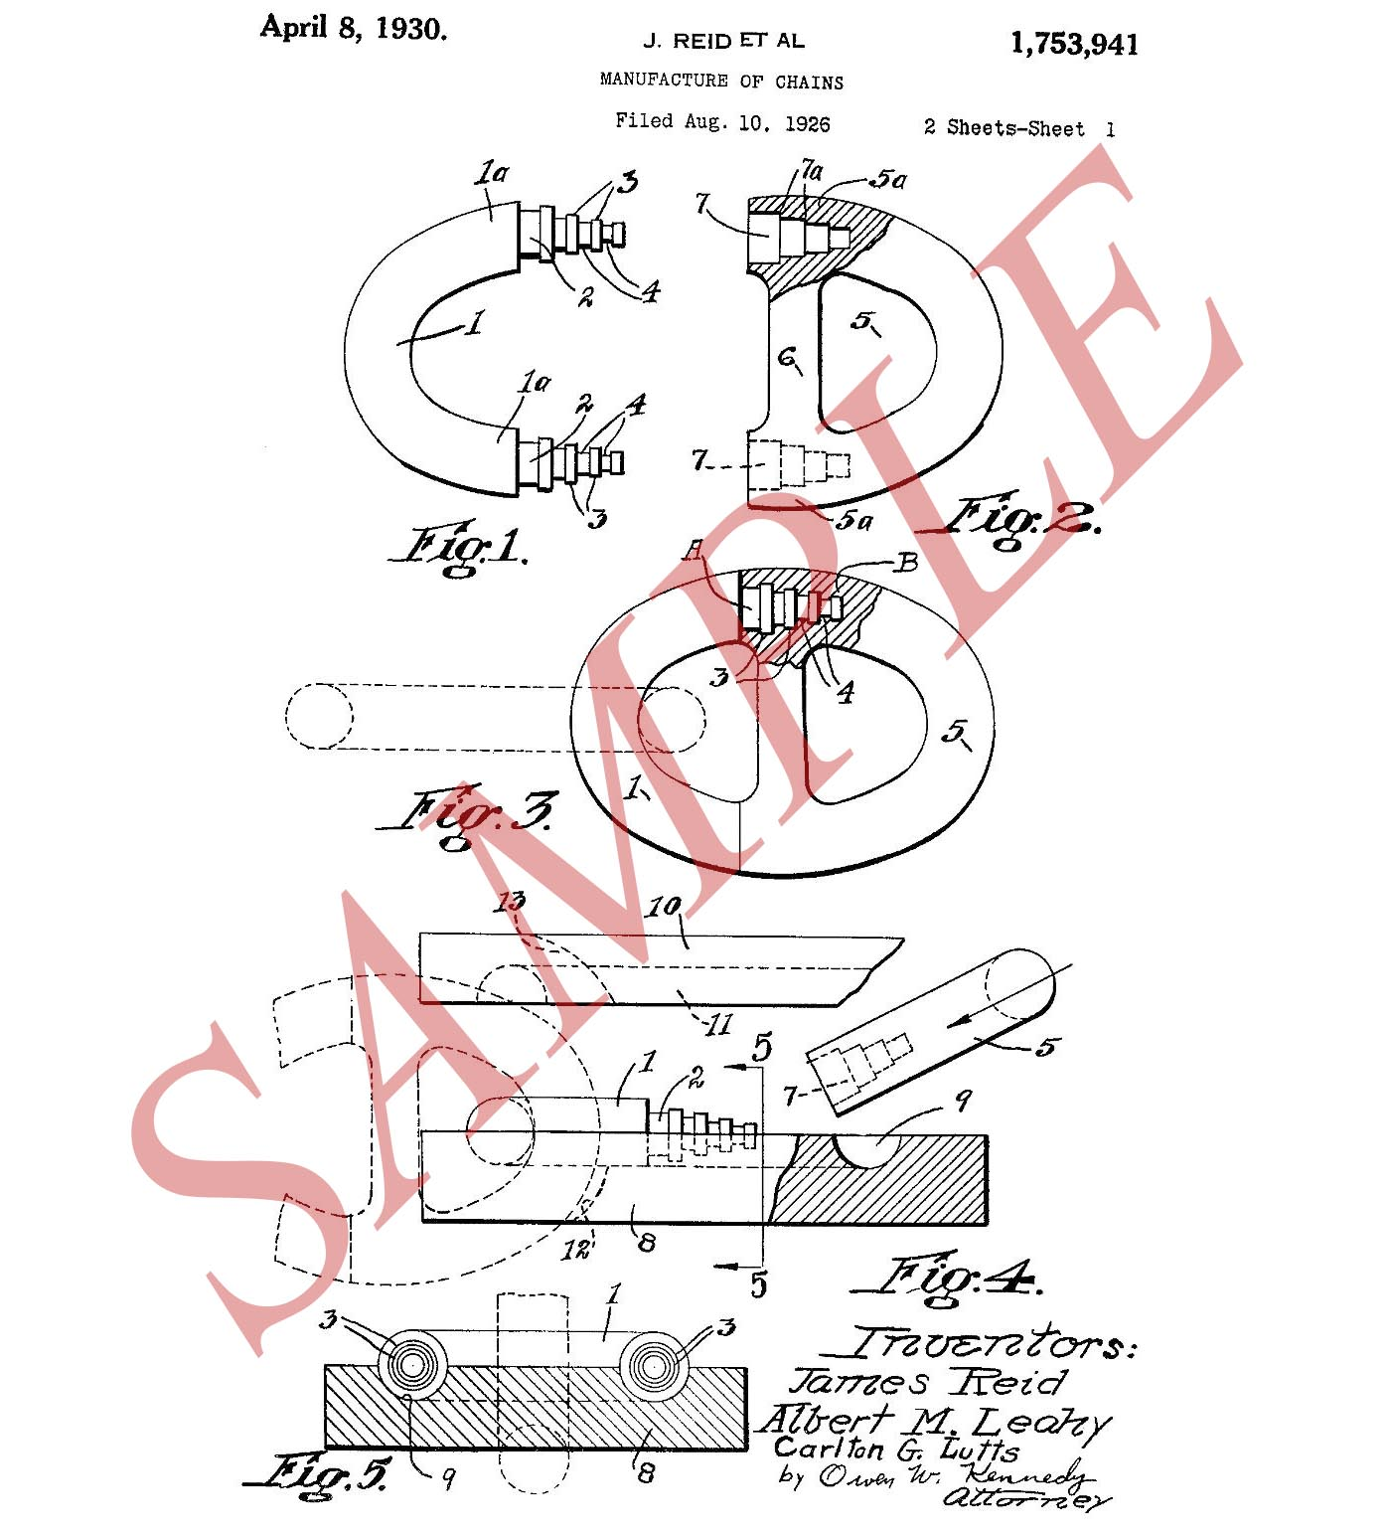

**Fig. 1. Albert M. Leahy, Carlton G. Lutts, and James Reid, “Detachable Chain Link,” 1930.**

Include a description or other supplemental information here, as needed.

(Source: Patent No.1776515-A, United States Patent and Trademark Office)