HISTORIC AMERICAN Engineering Record

Primary Site NAME

(Secondary Name)

HAER No. XX-XXX

|  |  |
| --- | --- |
| Location: | Enter the street address, city or town, county, and state where the property is located.  In a separate paragraph, provide a pair of geographic coordinates in decimal degree format that locate the center or other prominent feature of the property. Indicate the datum and source of the coordinates (e.g. WGS 84, USGS EarthExplorer). |
| Owner / Occupant: | Identify the current owner of the property. For rented or leased properties, list current occupants when relevant. |
| Present Use: | Provide a brief statement explaining the principal use of the structure. |
| Significance: | Include a brief statement that presents the rationale for recording the structure, emphasizing its significance in the local, regional, or national context. Highlight the relevant historical and engineering aspects that define the structure and make it unique. This significance statement will be expanded in following sections. Note that the significance statement is the source for indexing terms and Library of Congress searches. |
| Historian(s): | Identify the author(s) of the report, their academic or professional affiliations, and the project year. |

1. Part I. Historical Information
   1. Physical History
      1. Date of Construction:

Give the initial date of construction. If unknown, state “Not known.” If an exact date cannot be determined, a date range or an estimate is indicated using “ca.” Include sources for all dates cited.

* + 1. Architect/Engineer:

Identify the architect or engineer responsible for designing the resource. For resources produced by large firms, provide information on key members of the design team, when known. Inclusion of basic biographic information can be included, especially if the architect or engineer is not well known or is a local figure. The heading of this section can be changed to reflect the appropriate title of the designer. State “Not known” or “None” as necessary.

* + 1. Builders, Contractors, and Suppliers:

Identify the relevant construction firms, builders, laborers, or material suppliers that were responsible for constructing the resource. If the responsible parties are not known, state “Not known.” The heading of this section can be changed to reflect the appropriate titles of those involved.

* + 1. Original Plans and Construction:

Provide a capsule description of the original appearance of the structure, using drawings, perspectives, and early views when available. Contemporary descriptions from newspapers, contracts, and letters can be quoted or summarized. Physical examination of the structure may also contribute to this description. Note that information provided here does not need to be repeated in the Historic Context section of the report (Part I.B.).

* + 1. Alterations and Additions:

Describe significant alterations and additions to the resource, including information on the dates of the alterations, the individuals involved, and the resultant changes. Organize this information chronologically, devoting a separate paragraph to each major change. If alternations and additions are well articulated here, they do not need to be thoroughly discussed in the Historic Context section of the report (Part I.B.).

* 1. Historic Context

Expand on the significance statement at the beginning of the report by discussing the structure’s place in the context of national, regional, or local history, as well as the history of engineering or technology. Consider not only the general history of the resource, but also its relationship to the surrounding area and the people and events associated with its establishment and development. This section should include information on how the structure was constructed and any construction techniques that were used, especially those involving innovative technologies. When available, provide contract information and state how long construction lasted. If addressing multiple aspects of the structure’s history, subheadings can be added to this section.

1. Part II. Structural and Design Information
   1. General Statement
      1. Character:

Summarize the architectural or engineering character of the structure, with particular emphasis on distinctive or noteworthy features. This section should address what distinguishes the structure in terms of design and function, and how these characteristics reflect broader engineering and historical trends. Detailed physical descriptions of the resource should be reserved for the appropriate headings below.

* + 1. Condition:

Provide a general assessment of the resource’s current condition. Information on the condition of specific features can be detailed in the following sections.

* 1. Description

Since HAER documentation covers a wide range of structures and objects, this template does not provide specific subheadings for this section. The author should organize this section to describe the current appearance of the structure in a logical manner, such as progressing from upper to lower chord, exterior to interior, front to rear, or following mile markers. The following is a list of topics that should be considered when writing the description. These topics can be revised or expanded depending on the characteristics of the documented structure.

* + 1. Overall Dimensions:

State the general shape and dimensions of the resource expressed in either numerical dimensions or general terms, such as bays and stories.

* + 1. Layout:

If this HAER survey includes measured drawings or sketch plans, use this section to provide a general description of the structure’s layout. If there are no accompanying drawings, provide more specific information here on the arrangement and functional adjacencies of the structure’s constituent parts. When describing a linear resource, like a highway or railroad, information about the route should be included.

* + 1. Structural System and Framing:

Provide a thorough description of the structural system, noting framing members, load-bearing walls, foundations, and floor and roof systems, as applicable.

* + 1. Auxiliary Structures:

Describe any auxiliary structures, including information on their development, location, and function. If there is considerable information on given specific auxiliary structure, the information can be placed in a separate short-format report.

* 1. Mechanical Systems and Operations

Describe any important mechanical systems or processes contained within the structure. If the documented subject is a machine, this section can be used to describe how the machine operated. If known, indicate manufacturer names and dates, as well as significant badge plate information, such as model, horsepower, pressure, size, or rotations per minute. Process and power connections between machines should be noted when appropriate.

* 1. Site Information

Include a description of the surrounding landscape and, if relevant, indicate how the structure is sited in response to its setting. The location of any auxiliary structures in relation to the primary structure should also be noted.

1. Part III. Sources of Information
   1. Drawings

Provide a list of architectural and engineering drawings referenced or used in the preparation of this report. Identify the name of the architect/engineer/delineator, drawing title, date, location of the original drawings, and any pertinent reference or filing numbers. Include both original drawings and those of any subsequent additions or alterations. Note anything significant, such as features not built as originally planned.

* 1. Early Views

Provide a list of relevant photographs, engravings, and other images. If known, specify the medium, artist, date, publisher, and size. Give the location of the item with pertinent collection and reference information. If the report relies on a large collection of materials from the same source, these may be summarized and cited as a group.

* 1. Interviews

List any interviews used in the preparation of this report, providing the name of the person interviewed, the date and place of the interview, and the person’s association with the resource.

* 1. Selected Sources

Provide a select bibliography of referenced sources. If the written sources are extensive, divide them into primary and secondary, or unpublished and published categories. Citations for unpublished materials should include their archival location and accompanying reference or filing codes. All citations should follow Chicago Manual of Style or Turabian format.

* 1. Likely Sources Not Yet Investigated

When relevant, list any materials or collections not referenced in the report, but known or thought to contain further information. If relevant, include a brief explanation of why the material was not accessed.

1. Part IV. Project Information

Provide general information on the execution of the HAER survey, including the names of individuals responsible for measured drawings, photographs, and historical research; sponsors and participating organizations; the circumstances under which the project was undertaken; and the project year.

Part V. Figures

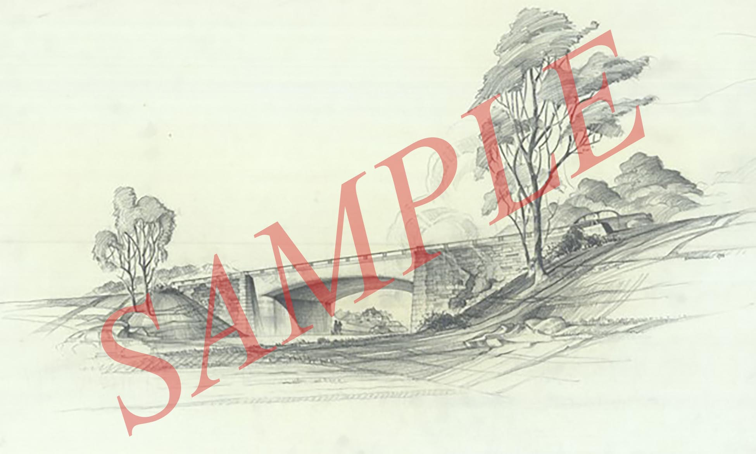

**Fig. 1. Overpass at Branch Avenue, Rendering by William M. Haussmann, Sept. 9, 1942.**

Include a description or other supplemental information here, as needed.

(Source: National Park Service Cartographic Records, Record Group 79, National Archives, College Park, MD)