HISTORIC AMERICAN BUILDINGS SURVEY

Primary Site NAME

(Secondary Name)

HABS No. XX-XXX

|  |  |
| --- | --- |
| Location: | Enter the street address, city or town, county, and state where the property is located.  In a separate paragraph, provide a pair of geographic coordinates in decimal degree format that locate the center or other prominent feature of the property. Indicate the datum and source of the coordinates (e.g. WGS 84, USGS EarthExplorer). |
| Owner / Occupant: | Identify the current owner of the property. For rented or leased properties, list current occupants when relevant. For private residences, owner and occupant names may be omitted. |
| Significance: | Provide a succinct (one or two paragraph) statement that summarizes the significant design qualities and historical associations of the property. Touch on aspects discussed in greater depth in subsequent sections of the report, including the date of construction, designer, and use. Note that the significance statement is the source for indexing terms and Library of Congress searches. |
| Historian(s): | Identify the author(s) of the report, their academic or professional affiliations, and the project year. |

1. Part I. Historical Information
   1. Historical Information
      1. Date of Construction:

Give the initial date of construction and cite the source or evidence that was used to determine this date. If the date is unknown, state “Not known.” If an exact date cannot be determined, a date range or an estimate is indicated using “ca.”

* + 1. Architect:

Identify the architects or other individuals responsible for designing the resource. For resources produced by large firms, provide information on key members of the design team, when known. The heading of this section can be changed to reflect the appropriate title of the designer. State “Not known” if applicable.

* + 1. Original and Subsequent Owners, Occupants, and Uses:

List the original and subsequent owners and uses of the property. For properties that are leased or rented, provide information on building tenants or occupants when relevant.

* + 1. Builders, Contractors, and Suppliers:

Identify the relevant builders, craftspeople, laborers, developers, construction companies, and material suppliers that were responsible for constructing the resource. If the responsible parties are not known, state “Not known.” The heading of this section can be changed to reflect the appropriate title of those involved.

* + 1. Original Plans and Construction:

Provide a capsule description of the resource’s original appearance, using drawings, perspectives, and early views when available. Contemporary descriptions from newspapers, contracts, and letters can also be quoted or summarized. Note that information provided here does not need to be repeated in the Historic Context section of the report (Part I.B.).

* + 1. Alterations and Additions:

Describe significant alterations and additions to the resource, including information on the dates of the alterations, the individuals involved, and the resultant changes. Organize this information chronologically, devoting a separate paragraph to each major change. If alternations and additions are well articulated here, they do not need to be thoroughly discussed in the Historic Context section of the report (Part I.B.).

* 1. Historic Context

Expand on the significance statement at the beginning of the report by discussing the resource within the larger context of national, regional, or local history and design. Consider not only the general history of the resource, but also its relationship to its location and the people and events associated with its establishment and evolution. If addressing multiple aspects of the resource’s history, subheadings can be added to this section.

1. Part II. Architectural Information
   1. General Statement
      1. Architectural Character:

Summarize the architectural style or character of the resource, with particular emphasis on character defining, distinctive, or noteworthy features. This section should address what distinguishes the resource in terms of design and function, and how these characteristics reflect broader historical trends. Detailed physical descriptions of the resource should be reserved for the appropriate headings below.

* + 1. Condition:

Provide a general assessment of the resource’s current condition. Information on the condition of specific features can be detailed in the following sections.

* 1. Description of the Exterior
     1. Overall Dimensions:

State the general shape and dimensions of the resource expressed in either numerical dimensions (rounded to the nearest inch with the front dimension given first) or general terms, such as bays and stories.

* + 1. Foundations:

Describe the building foundations, including information on their material composition, thickness, and relationship to the water table, when applicable.

* + 1. Walls:

Describe the materials and finishes of exterior walls, including information on ornamental features such as quoins, pilasters, and belt courses. Mention details such as the brick bond or stone pattern, color and texture, and the source of materials when known. When a building is stuccoed or re-sided, note the materials underneath, if known. For modern wall assemblies, identify their constituent components, materials, manufacturers, and relationship to the structural system.

* + 1. Structural System and Framing:

Provide a thorough description of the structural system, noting load-bearing wall types, framing members (such as hewn timbers, dimensional lumber, reinforced concrete or steel), floor systems, and roof framing.

* + 1. Porches, Stoops, and Balconies:

Describe the materials, form, roof type, details, and location of porches, stoops, and balconies.

* + 1. Chimneys:

Describe the materials, form, details, and location of each chimney.

* + 1. Openings
       1. Doorways and Doors:

Describe the materials, design, and location of exterior doorways, including information on moldings, surrounds, and other features such as transoms, sidelights, and pediments.

* + - 1. Windows and Shutters:

Describe the building’s windows, including information on the fenestration pattern, window type (such as casement, double-hung sash, or sliding), number of lights or sash divisions, sills, lintels, surrounds, moldings, and shutters. If there are a variety of windows, characterize them generally.

* + 1. Roof
       1. Shape, Covering:

Describe the roof shape (such as gable, hip, or gambrel) and materials.

* + - 1. Cornice, Eaves:

Describe building cornices and eaves, including information on their materials, form, notable features, and gutter and downspout systems.

* + - 1. Dormers, Cupolas, Towers:

Describe building dormers, cupolas, towers, and other notable elements, including information on their design, number, and location.

* 1. Description of the Interior
     1. Floor Plans:

If this HABS survey includes measured drawings or sketch plans, use this section to provide a general description of the resource’s layout. If there are no accompanying drawings, provide more specific information here on the arrangement of rooms and other building elements. Start with the lowest floor and proceed to the top. If two or more floors are identical, combine the descriptions.

* + 1. Stairways:

Describe and note the location of stair types, railings, balusters, and related ornamental features. For prefabricated stairway features, note the manufacturer and model numbers when known.

* + 1. Flooring:

Give the material, finish, and color of flooring. For wood floors, describe the width of boards and direction they run. For manufactured surfaces, like tile, linoleum, and composite wood, note the manufacturer and model or pattern names when known.

* + 1. Wall and Ceiling Finish:

Describe the interior walls, providing information on finish materials, paneling, color, wallpaper, and decorative details of note. Identify the location of specific features being discussed.

* + 1. Openings
       1. Doorways and Doors:

Give a general description of characteristic door types within the property and provide individual descriptions and locations for notable doors, including paneling, color, finish, and surrounds or moldings. For prefabricated doors, note the manufacturer and model when known.

* + - 1. Windows:

Describe any notable interior window features such as moldings, reveals, or other details. Discuss natural lighting features and provisions for borrowed light from other interior spaces if relevant**.**

* + 1. Decorative Features and Trim:

Describe decorative features not addressed above, including information on elements such as chair rails, cornices, baseboards, crown molding, built-in features, fireplace treatments, and other notable ornamental features.

* + 1. Hardware:

Describe original or notable hinges, knobs, locks, latches, and window and fireplace hardware. Note make and model names, if known.

* + 1. Mechanical Equipment
       1. Heating, Air Conditioning, Ventilation:

Describe the original and current heating, air conditioning, and ventilation systems, with specific information on any extant devices of interest.

* + - 1. Lighting:

Describe the original and current lighting systems, with specific information on any extant fixtures of interest.

* + - 1. Plumbing:

Describe the original and current plumbing systems, with specific information on any extant features of interest.

* 1. Site
     1. Historic Landscape Design:

Analyze the relationship of the resource to its environs and discuss any special accommodations made in response to the setting. Include information on the layout, plantings, and other notable landscape elements. Identify the dates of construction and designers, if known.

* + 1. Outbuildings:

Provide descriptions of each auxiliary, dependency, or outbuilding, including information on their development, location, and function. If there is considerable information on given specific outbuilding, the information can be placed in a separate short-format report.

1. Part III. Sources of Information
   1. Architectural Drawings

Provide a list of architectural drawings referenced or used in the preparation of this report. Identify the name of the architect/company/delineator, drawing title, date, location of the original drawings, and any pertinent reference or filing numbers. Include both original drawings and those of any subsequent additions or alterations. Note anything significant, such as features not built as originally planned.

* 1. Early Views

Provide a list of relevant photographs, engravings, and other images. If known, specify the medium, artist, date, publisher, and size. Give the location of the item with pertinent collection and reference information. If the report relies on a large collection of early views or historic photographs from the same source, these may be summarized and cited as a group.

* 1. Interviews

List any interviews used in the preparation of this report, providing the name of the person interviewed, the date and place of the interview, and the person’s association with the resource.

* 1. Selected Sources

Provide a select bibliography of referenced sources. If the written sources are extensive, divide them into primary and secondary, or unpublished and published categories. Citations for unpublished materials should include their archival location and accompanying reference or filing codes. All citations should follow Chicago Manual of Style or Turabian format.

* 1. Likely Sources Not Yet Investigated

When relevant, list any materials or collections not referenced in the report, but known or thought to contain further information. If relevant, include a brief explanation of why the material was not accessed.

1. Part IV. Project Information

Provide general information on the execution of the HABS survey, including the names of individuals responsible for measured drawings, photographs, and historical research; the circumstances under which the project was undertaken; sponsors and participating organizations; and the project year.

Part V. Figures

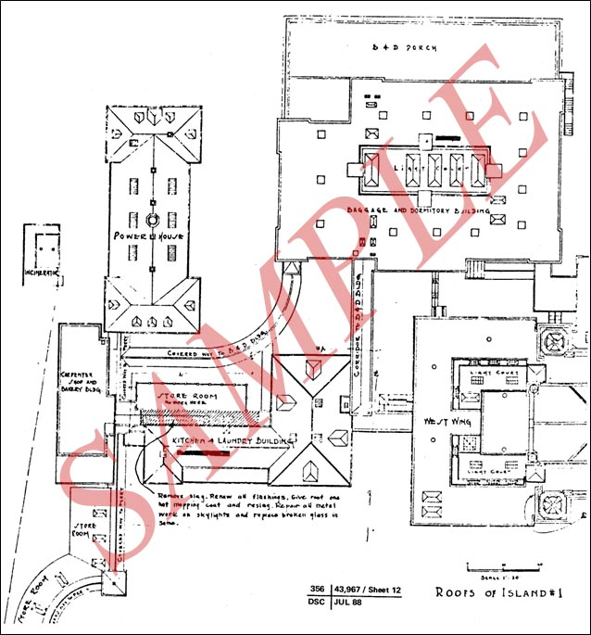

**Fig. 1. Ellis Island, Roofs of Island No. 1, 1932**.

Include a description or other supplemental information here, as needed.

(Drawing No. 356/43967, Sheet 12, Electronic Technical Information Center, National Park Service)