# Program Name: Shenandoah National Park: Gem of the Blue Ridge

**Suggested Grade Level**: 5th

## Maximum Group Size for classroom presentation and activities: 25

**Time Consideration**:

Pre-visit: 30-minute class periods for teacher-led pre-visit activities

Ranger-led Classroom Program: 1 hour

Post-visit: One or more class periods for teacher-led post-visit activities

# Overview

Shenandoah National Park is an important natural and cultural resource in Virginia’s Blue Ridge geographic region. Students in the nine Virginia counties that border this long and narrow national park will discover those resources and the National Park Service mission with ranger-led in-classroom activities such as analyzing artifacts, investigating geologic samples, and writing creative responses while gaining essential classroom knowledge about Virginia’s history, geology and geography.

**Learning Objectives:**

Following the ranger presentation and classroom activities, the students will be able to

1. define the mission of the National Park Service and name three significant geologic features that are protected in national parks;
2. name the five geographic regions of Virginia and locate Shenandoah National Park within the Blue Ridge geographic region;
3. identify the three rock types that can be found in Shenandoah National Park and explain the rock cycle using those rock types;
4. describe three actions people can take to help care for Shenandoah National Park and the environment.

**Virginia Standards of Learning**

Earth and Space Systems

5.8 The student will investigate and understand that Earth constantly changes. Key ideas include

1. Earth’s internal energy causes movement of material within the Earth;
2. plate tectonics describe movement of the crust;
3. the rock cycle models the transformation of rocks;
4. processes such as weathering, erosion, and deposition change the surface of the Earth;
5. fossils and geologic patterns provide evidence of Earth’s change.

Virginia Studies

VS.2 The student will demonstrate knowledge of the physical geography and native peoples, past and present, of Virginia by

b) locating and describing Virginia’s Coastal Plain (Tidewater), Piedmont, Blue Ridge Mountains, Valley and Ridge, and Appalachian Plateau.

### US History: Skills

USI.2 The student will use maps, globes, photographs, pictures, or tables to

c) recognize key geographic features on maps, diagrams, and/or photographs.

# Background Information

Shenandoah National Park provides outstanding educational and recreational opportunities in the Blue Ridge geographic region of Virginia. Shenandoah National Park stretches along the crest of Virginia’s Blue Ridge Mountains from Front Royal to Waynesboro, Virginia, and is bordered by nine counties: Albemarle, Augusta, Greene, Madison, Nelson, Page, Rappahannock, Rockingham, and Warren.

Skyline Drive is the 105 mile-long highway that provides easy access to the park’s nearly 200,000 acres of protected land that include mountain summits, expansive views of the Piedmont and Shenandoah Valley, deep forests, open meadows, meandering streams with cascading waterfalls, abundant wildlife, and remnants of past human residents.

The Earth is undergoing continuous change through the formation, weathering, erosion, and reformation of rock. This process is called the rock cycle. The geologic story of Virginia’s Blue Ridge region is complex. The Blue Ridge Mountains are the result of the forces of plate tectonics. There have been episodes of mountain building when tectonic plates collided. Some parts of the Blue Ridge may have been as tall as the Himalaya Mountains in Asia which are over 20,000 feet tall. Mountain building periods were interspersed with periods when tectonic plates split apart causing lava flows which formed volcanic rock layers. Shallow seas submerged the volcanic rock and the sediment from these ancient oceans eventually formed layers of sedimentary rock.

Tectonic forces folded those rock layers under great heat and pressure and changed many of these rocks into metamorphic rocks, such as greenstone. Over time, the forces of weathering and erosion have worn away the mountains to expose the different rock layers and reveal evidence of ancient geologic events. Today, the highest peak in Shenandoah National Park is just over 4,000 feet tall. Volcanic activity, sedimentation, plate tectonics, and weathering and erosion account for why (metamorphosed) igneous, sedimentary, and metamorphic rock types can be found throughout Shenandoah National Park.

Today, Shenandoah National Park is a collage of mountain forests, historic resorts and camps, 500 miles of trails, the headwaters of three Virginia watersheds: Potomac-Shenandoah, Rappahannock, and James, and almost 80,000 acres of federally designated wilderness. More than a million people each year visit this gem of Virginia’s Blue Ridge Mountains to enjoy the natural and cultural resources preserved in this national park.

## Vocabulary

* **deposition** - process in which sediments, soil and rocks are added to a landform
* **erosion** – the movement of rocks by processes such as gravity, running water, waves, moving ice, and wind
* **geographic regions** – areas with distinctive geographic characteristics. Virginia is divided into five geographic regions: Coastal Plain (Tidewater), Piedmont, Blue Ridge Mountains, Valley and Ridge, and Appalachian Plateau
* **geology** – the study of the earth; its history, physical features and structure, and processes that act upon them
* **igneous rock**- rock formed under conditions of intense heat or produced by the solidification of volcanic magma on or below the Earth's surface
* **lava** – magma that reaches Earth’s surface and cools
* **magma** – hot molten rock deep below Earth’s surface
* **metamorphic rock** - change in the physical structure of rock as a result of long-term heat and pressure, especially a change that increases the rock's hardness and crystalline structure
* **plate tectonics** – a scientific theory that Earth’s crust is made of moving plates
* **preserve** - to keep in existence; make lasting
* **protect** - the act of preventing something from being harmed or damaged, or the state of being kept safe
* **rock cycle** – rocks changing from one into another in a never-ending series of processes
* **sedimentary rock** - rock formed when layers of sediment are cemented together
* **uplift** – a raising of land above the surrounding area
* **weathering** – breaking down rocks into smaller pieces by mechanical and chemical processes such as ice wedging, root wedging, acid rain

**Pre-Ranger Visit Activities**

Complete the following pre-visit activities to prepare the students for the Shenandoah National Park ranger program in your classroom.

**Materials for Pre-Ranger Visit Activities**

student journals (attached: cover page, *What Are National Parks?, Where In The World Is Shenandoah National Park?, Shenandoah Rocks!, Gem of the Blue Ridge* arrowhead), *Geology in National Parks* slide show, maps of Virginia’s geographic regions, and Virginia road maps

1. **What Are *National* Parks?**

Provide each student with a copy of the attached *Student Journal*. Show the *Geology in National Parks* slide show and have the students complete the *What Are National Parks?* page. Begin by asking the students “What are national parks and why do we have them?” (National parks are special places set aside to protect unique natural features, scenery, historic sites or heritage areas for all people to experience and enjoy.) “Many national park areas preserve and protect amazing geologic features.”

Begin the slide show. Pause for each slide to see if students recognize the national park and can identify the geologic formation or process that is featured.

* + Do you recognize any of these places? (Students respond in their journal.)
  + Can you name the geologic feature or process shown in the photo?
  + Have you been to any of these places? (Students respond in their journal.)
  + Do you recognize the scenes from the last three slides? (Images are from Shenandoah National Park.)
  + What do you know about Shenandoah National Park? (Students respond in their journal.)

1. **Where in the World is Shenandoah National Park?**

Use student journal page *Where in the World is Shenandoah National Park?* Display a map of Virginia or use a textbook that depicts Virginia’s geographic regions. Have the students identify, outline, name, and color the geographic regions of Virginia on the journal page. Ask the students:

* + In which Virginia geographic region do you live?
  + In which Virginia geographic region is your school? Have them draw an “X” on the journal map for the correct location of your school.
  + In which Virginia geographic region is Shenandoah National Park? Have them label Shenandoah National Park with “SNP” on their maps.
  + Using a Virginia road map for guidance, have the students write in their journals the directions from the school to the nearest entrance station for Shenandoah National Park.

The students should have their journals to share what they have learned with the park ranger on the day of the classroom program.

**Shenandoah National Park Ranger In-Classroom Program**

The ranger-led classroom program is designed for a 60 minute class period. Approximately 1 week before the classroom program**,** the lead ranger will contact the lead teacher to coordinate the final details of the program day: location, starting time for the program, and whether multiple classes will be scheduled. Share program details with all participating teachers. Allow time for the ranger to set up activities and prepare for the students.

* Please stay in the classroom to assist the students and ranger during the presentation.
* Provide a writing board (chalk, dry erase, or smartboard) and a small table for the ranger’s use.
* The ranger will discuss with students what they have learned from their pre-visit activities. The ranger will cover topics including Shenandoah National Park, the rock cycle and geologic processes, and how geology is important to people.
* Students will participate in lively educational activities led by the ranger and assisted by the teacher.
* The ranger concludes the program with an invitation to visit the park. The teacher is provided with an information packet for the classroom.

**Post-Ranger Visit Activities**

Following the Shenandoah National Park ranger program in your classroom, complete as many of the following post-visit activities as possible to conclude the unit of study. Complete the Program Evaluation Form. Return the program evaluation to:

Shenandoah National Park

3655 US Hwy 211 East

Luray, VA 22835

Attention: Education Office

**Materials for Post-Ranger Visit Activities**

Student Journals

1. **Class Discussion**

Remind the students that the Earth is constantly changing and evolving. Geological change can occur very slowly, as in the formation of sedimentary rock or the weathering of exposed rocks. Change can also occur suddenly, as in a landslide or an erupting volcano. Review how animals, plants, and people use and depend on geologic resources. Ask the students how geologic change can affect living things. How important is geology to living things?

Ask “Now that you realize how important geology is to living things, can you imagine life without geology?” We all live on land that is made of rocks and geologic features and depend on many geologic resources. Ask the students if they think human actions can affect the land and geology. Examples include the mining of metals and coal; drilling for oil and natural gas; farming; using geologic materials for construction; moving earth and rock for the development of homes, stores, and cities; and damming rivers. Remind the students that geologists think it took millions of years to create these resources. Are these resources that we depend on replaceable? If not, how long before the resources are used up?

Ask the students if people should care about geologic resources. Have the students brainstorm ways people can help conserve and protect resources for the future. Examples include recycling aluminum and other metals to reduce mining; using energy-efficient transportation and machines to reduce oil, gas, and coal consumption; following good farming practices to reduce erosion and soil loss; and reducing waste to conserve resources. Introduce the term *stewardship* and have students discuss the reasons why people should conserve resources and protect the land and the environment.

1. **Gem of the Blue Ridge: NPS Arrowhead**

Have the students color and decorate the blank National Park Service arrowhead symbol with words or phrases that were learned about Shenandoah’s geology and things people can do to help Shenandoah National Park “preserve and protect” all park treasures. Share completed artwork with school community and parents.

## Unit Assessment

1. Accurate and thorough responses in journal
2. Participation in classroom discussion and activities
3. Explain rock cycle using rock types found in Shenandoah National Park
4. Arrowhead illustration identifying the main idea of protection and preservation in National Parks

## Going Further

1. Take a field trip to Shenandoah National Park to experience the geology and landforms on a ranger-led program in the park.
2. Conduct research on a particular species of animal or plant found in Shenandoah National Park and create a presentation (PowerPoint, science board, speech, poster) for classmates.
3. Have students write a poem, song, rap, email, blog, short story, or play regarding their experience with the ranger visit or to express their feelings about the park and the importance of preserving and protecting it for future generations.
4. Use technology like Glogster, iMovie, or Kidspiration to create programs or presentations on what the students learned.

## Resources and References

**Pre-Ranger Visit Activities**

Geology in National Parks slide show

<https://www.nps.gov/teachers/classrooms/gem-of-the-blue-ridge.htm>

National Park Service website

Home page <http://www.nps.gov/index.htm>

<http://www.nps.gov/faqs.htm>

<https://www.nps.gov/subjects/geology/index.htm>

### Shenandoah National Park website

### Home page [www.nps.gov/shen](http://www.nps.gov/shen)

<http://www.nps.gov/shen/planyourvisit/directions.htm><http://www.nps.gov/shen/planyourvisit/maps.htm>

<http://www.nps.gov/shen/naturescience/geologicformations.htm>

**Going Further**

Geology Rocks! Field trip

<https://www.nps.gov/teachers/classrooms/geology-our-rockin-earth.htm>

### **Print Resources**

Whisnant, Anne Mitchell, David E. Whisnant, and Timothy Silver. *Shenandoah National Park Official Handbook*. Virginia Beach: Donning, 2011. Print.

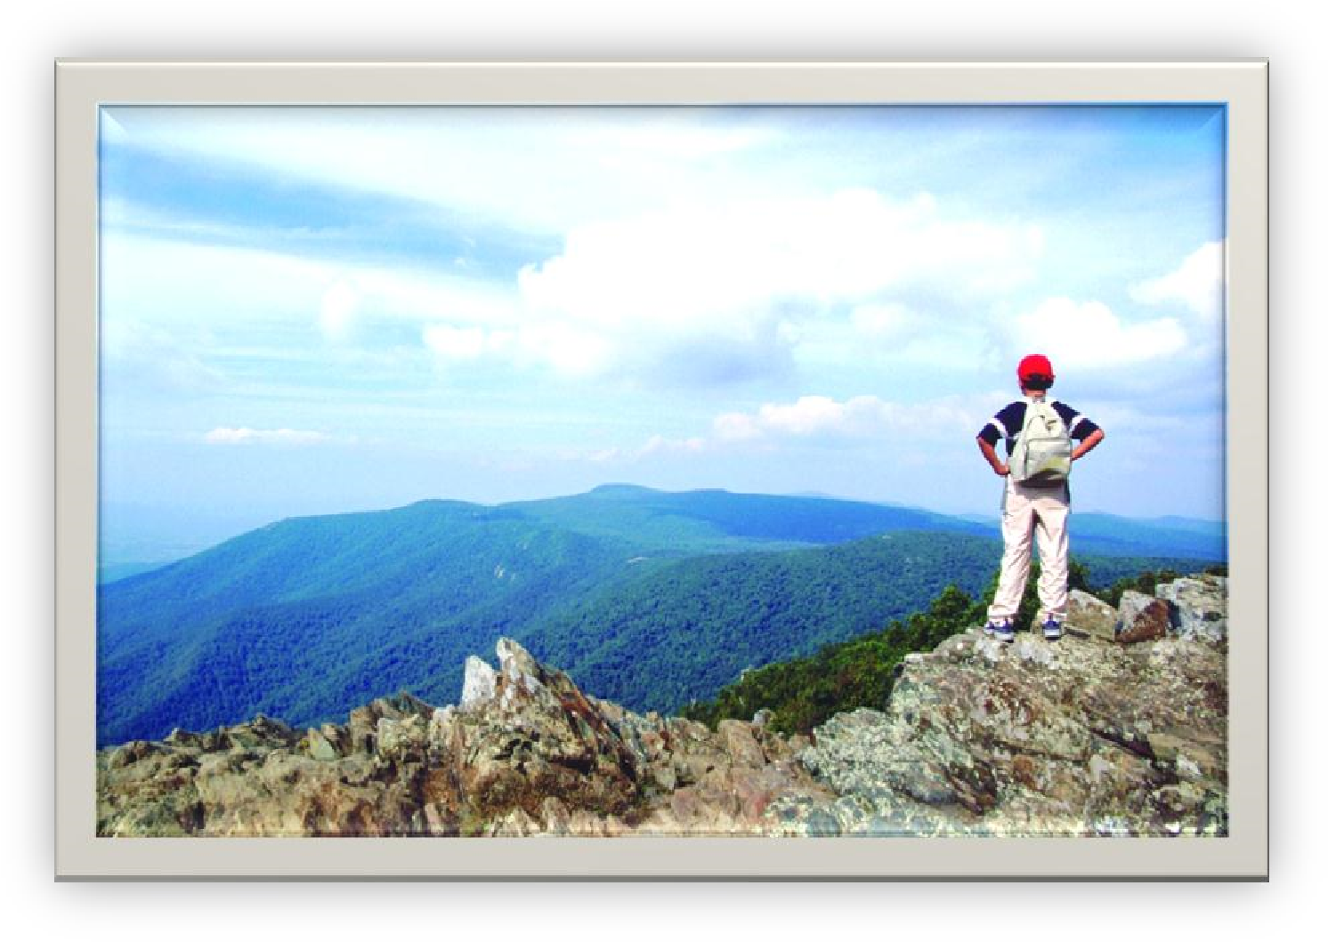

**Shenandoah National Park:**

**Gem of the Blue Ridge**

**Region of Virginia**

**Student Journal**

**Name___________________ Date____________________**

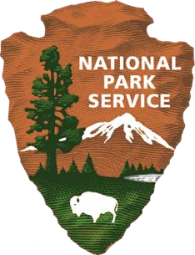

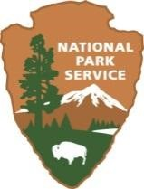**Pre-Ranger Visit Activity #1**



**What Are National Parks?**

National parks I recognize from the pictures in the slides:

_________________________________________________________________

_________________________________________________________________

_________________________________________________________________ _________________________________________________________________

National parks I have been to:

_________________________________________________________________

_________________________________________________________________

_________________________________________________________________ _________________________________________________________________

What I already know about Shenandoah National Park:

_________________________________________________________________

_________________________________________________________________

_________________________________________________________________

_________________________________________________________________

**Pre-Ranger Visit Activity #2**

**Where In The World Is Shenandoah National Park?**

Using your map resources, identify, outline, color, and label the geographic regions of Virginia. Mark your school with an “X”, and Shenandoah National Park with “SNP”.

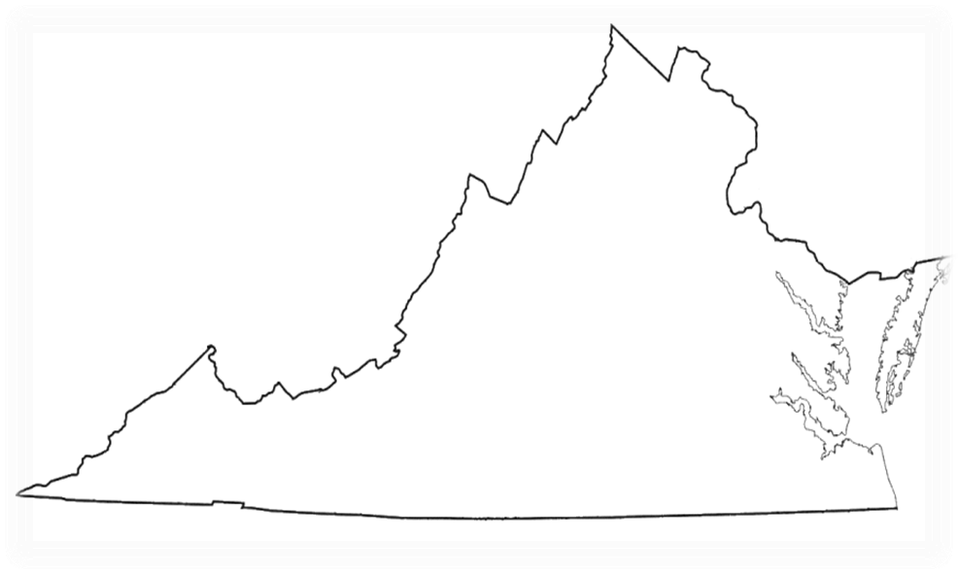

Using a Virginia road map, write out the directions from your school to Shenandoah National Park – stating directions traveled, highway numbers, towns, etc.

**Ranger Program Activity**

**Shenandoah Rocks!**

Each of the rocks in your box represents one of the three types of rocks: sedimentary, igneous or metamorphic. In the spaces below, describe each rock and decide what type of rock it is. Then place each rock on the Rock Cycle chart and be prepared to tell why you think it is that type of rock.

**Part 1**

**Rock 1**

Describe this rock. _______________________________________________________

What type of rock do you think it is? _________________________________________

Why do you think it is that type of rock? ______________________________________

**Rock 2**

Describe this rock. _______________________________________________________

What type of rock do you think it is? _________________________________________

Why do you think it is that type of rock? ______________________________________

**Rock 3**

Describe this rock. _______________________________________________________

What type of rock do you think it is? _________________________________________

Why do you think it is that type of rock? ______________________________________

**Part 2**

### **Shenandoah’s Iconic Mountain: Stony Man**

Look at the photograph and the labeled cross section of Stony Man Mountain. The green-shaded areas on the cross section represent greenstone, a very hard metamorphic rock, which used to be lava.

What happened to the lava? _________________________________________

________________________________________________________________

Where is the sedimentary rock now? __________________________________

________________________________________________________________

Why are there notches in the profile (for the “eyes and mouth”)? _____________

________________________________________________________________

**Post-Ranger Visit Activity #2**

**Gem of the Blue Ridge**

Things I can do to help protect Shenandoah National Park and the environment….

