The Gilded Age

Unit I

Goals:
- Students will become familiar with the term "Gilded Age” and will be able to describe some of its cultural, social and technological characteristics.
- Students will learn about the role of the arts in supporting the “Gilded Age.”
- Students will analyze a primary source for its cultural messages.

Objectives:
- This lesson requires reading, observation, interpretation, research, speaking and/or writing skills.

Supports NH Social Studies Curriculum Standard 16…to employ historical analysis, interpretation, and comprehension to make reasoned judgments and to gain an understanding, perspective and appreciation of history and its uses in contemporary situations, p.25. Supports NH English Language Arts Curriculum Standards 5 and 6: Students will demonstrate competence in using the interactive language processes of reading, writing, speaking, listening, and viewing to gather and organize information in a variety of subject areas p.19, and (6)…to communicate effectively. p. 21.

Instructional Strategies:
- Reading 1.1: Students will read independently and then answer the interpretive questions from the “What Have You Learned?” worksheet (either orally in class discussion or in writing).

- Cooperative Learning: In cooperative learning groups, students will research a topic of their choice (from the lists found in Reading 1.1 and the World Expositions list) and will report their findings to the class.

- Independent Study: Students will describe and analyze the visual clues within a primary source (Frank Leslie’s Centennial Poster). Explain to your students that the use of primary source material provides evidence of cultural themes and historic attitudes, which will encourage their own analytical thinking. Because the fine details are important, the original color illustration should be made available to the class at all times. Students should complete this written exercise on their own time.
Glossary:
bas relief
colossus
commission (n, v)
exposition
patron of the arts philanthropy
primary source
Handouts:
- “Reading 1.1- The Gilded Age”
- World Expositions
- “What Have You Learned?” worksheet

Reading 1.1- The Gilded Age

The period of our Nation’s history from the end of the Civil War to the close of the 19th century has been coined “The Gilded Age." Mark Twain and Dudley Warner first used this term in 1873 in their book, The Gilded Age: a Tale of Today. It was a very dynamic, optimistic and exciting era. Following the Civil War, a newly united America saw years of enormous growth and confidence in its power and wealth. Manufacturing, banking, real estate and transportation industries flourished. Some of the remarkable technology to change people’s lives included the camera, the telephone patented by Alexander Graham Bell in 1877, the incandescent light bulb and the phonograph invented by Thomas A. Edison. Many other innovations, which we take for granted today, were a result of creative and energetic thinking, such as the elevator, dynamo, air brake, air hammer, structural I-beam, the zipper and the typewriter. America experienced the excitement of many achievements. If there were one word to describe the era, it would be a time of immense POSSIBILITY.
Some Gilded Age Highlights:

1869- Transportation: The Central Pacific Railroad connected with the Union Pacific Railroad at Promontory Point, Utah, site of present day Golden Spike National Historic Park. This connection linked east and west. It expanded commercial access to all parts of the US. Steamship travel also made visits to and from Europe very accessible.

1872- Yellowstone, the first U.S. National Park was established.

1880-1884- The “Dakota,” one of the first multi-dwelling structures was built. The apartments were equipped with new conveniences of electricity, plumbing and central heating. The building still stands today on Central Park West, NYC.

1884- The Brooklyn Bridge across the East River became the longest span in the world, an achievement made possible by inexpensive steel.

1886- The Statue of Liberty, a gift from France commemorating the centennial of American Independence, was erected. At 305’ to the top of the torch it was the tallest statue in the world, called a colossus. It generated its own symbolic importance to the influx of immigrants pouring into the US, upon whose labor the Gilded Age would rely.

1891- Augustus Saint-Gaudens’ statue of Diana was mounted on top of Stanford
White’s Madison Square Garden in New York City and immediately became the
tallest building. It was also the first statue to be lighted with electricity.

1894- The first use of the word “skyscraper” appeared in Harper’s Weekly. Multi-floor buildings were made possible by the Otis invention of the elevator.

The Gilded Age:
As commerce expanded, vast private fortunes were made. There was no income tax as we know it today and this excess of wealth stimulated personal and public construction such as extravagant homes, lavish public spaces, museums and libraries to hold private collections. Many of our cultural institutions that we enjoy today are a direct result of this philanthropy. A new class of leisured, wealthy Americans became patrons of the Arts and the artists themselves became participants in promoting and sustaining a high level of culture and refined taste. David Dearinger reports, “more public sculpture was created between 1890 and 1920 than at any other time in the history of this country.” Augustus Saint-Gaudens (1848-1907) was a member of this elite. His artistic training and talent secured his place in the Gilded Age society. He was commissioned to do work for many of the most wealthy, prominent families in America, such as the Vanderbilts. During his career, he created nearly 200 sculptures, which included a great variety of works from large public monuments to gold coins to bas-relief portraits for private clients. In this role, he helped to shape tastes in the Gilded Age.

The social elite indulged in amusements like the theater, opera or vaudeville. Other popular musical tastes included Scott Joplin’s ragtime, music hall entertainment or John Philip Sousa’s band concerts. Music became big business. As many families owned pianos, sheet music was popular and sold well. Singing around the piano was a favorite pastime and included such tunes as: Grandfather’s Clock (1876), There is a Tavern in the Town (1891), Sidewalks of New York (1894), and A Hot time in the Old Town Tonight (1896). Throughout society a very strict hierarchy evolved, which was based on manners, extravagant materialism and displays of wealth.

As public transportation made travel easy, the phenomenon of expositions sprang up. (See list of World Expositions.) They included international displays of technological advances, commemorated historical achievements, while at the same time, looked toward the future. Moreover, they were a form of entertainment that often included a peep into exotic cultures for the curious. Expositions were also very important to artists by providing venues for the display of contemporary art. Expositions popularized art as never before. Each country was invited to send the very best from its painters and sculptors. From an artist’s point-of-view, these expositions served as competitions, provided commercial possibilities and displayed their work to an enormous number of potential patrons.

What made all of this possible?
In summary, the Gilded Age was a product of a wealthy society driven by technological advances, economic growth and a new labor pool of immigrants working at very low wages. This fact, however, is the darker side to this new prosperity that created great disparities of wealth and woeful social injustices in the exploitation of workers.

Compiled from: Teaching With Historic Places, "Saint-Gaudens National Historic Site: Home of a Gilded Age Icon,” James Percoco; Stanny: The Gilded Life of Stanford White, Paul Baker; Art in America in the Gilded Age, Shirley Glubok; The Life and Works of Augustus Saint-Gaudens, Burke Wilkinson; Public Sculpture in 19th century America, David B. Dearanger; and the video America 1900 from the PBS American Experience series.
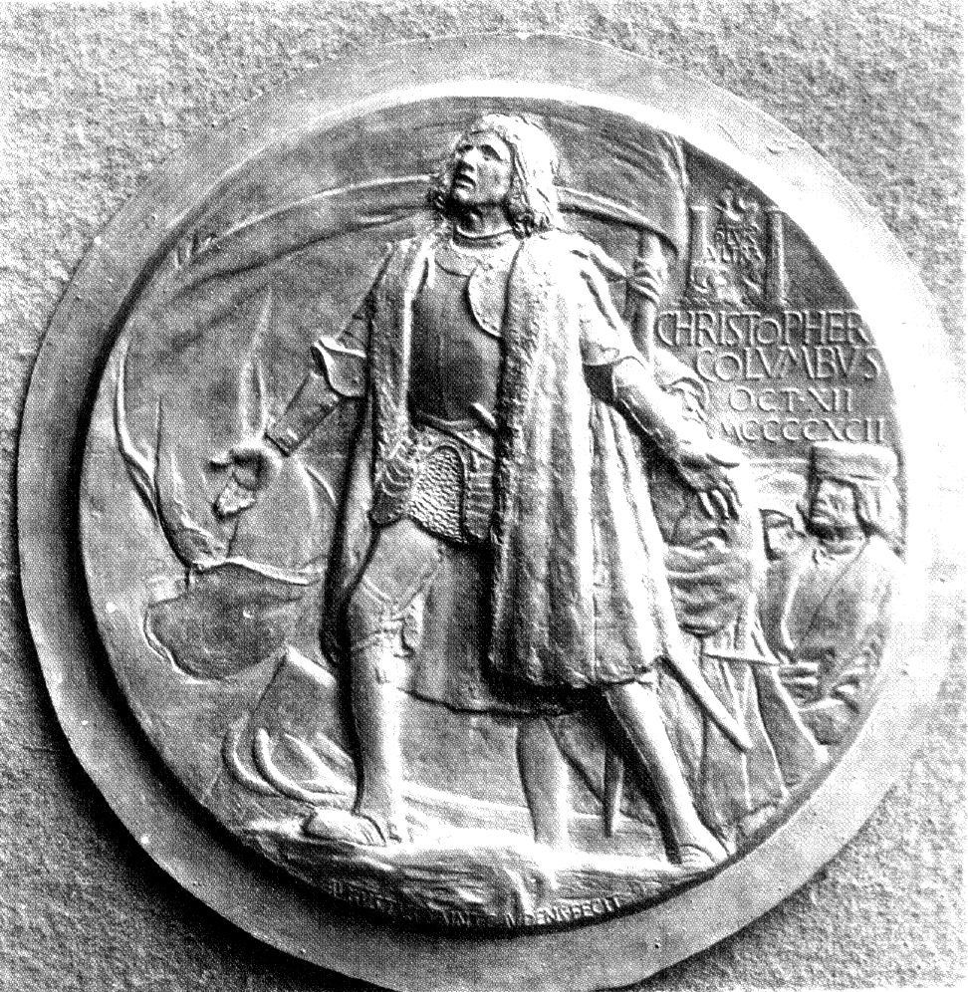
World Expositions

World’s Columbian Exposition Medal (obverse), Saint-Gaudens, 1893

1851- London, England- The Crystal Palace, constructed in Hyde Park, was the first world’s fair.

1867- Paris, France- This Exposition was the young Saint-Gaudens’ primary destination on his first trip abroad.

1876- Philadelphia, Pennsylvania- Centennial Exposition or “World’s Fair.” Commemorated the signing of the Declaration of Independence. Inventions such as a steam power generator, the telephone and typewriter were featured. Saint-Gaudens entered his first full-size sculpture, Hiawatha.

1878- Paris, France- International Exposition. Saint-Gaudens served on the committee to select American entries. Artist friends exhibited and many became members of the Cornish Colony.

1889- Paris, France- The Universal Exposition celebrated the centennial of the French Revolution. The Eiffel Tower was built for this Exposition. John LeFarge, friend of Saint-Gaudens, exhibited his stained glass windows for the first time abroad and was awarded a medal and citation, the French Legion of Honor.

1893- Chicago, Illinois- The World’s Columbian Exposition, or “The Chicago World’s Fair,” celebrated the 400th anniversary of Christopher Columbus’ “discovery” of the Americas. Saint-Gaudens served as principal advisor on sculpture and was responsible for several of his students and acquaintances in securing commissions, such as Daniel Chester French’s Republic and Frederick William MacMonnies’ Columbian Fountain.

1900- Paris, France- The great Universal Exposition where Saint-Gaudens exhibited the Shaw Memorial, the General Sherman, the Puritan and the Amor Caritas, which the French government bought. Saint-Gaudens won the grand prize and was elected to membership in the Legion of Honor.

1901- Buffalo, New York- The Pan-American Exposition; Saint-Gaudens won the Medal of Honor.

1904- St.Louis, Missouri- The Louisiana Purchase Centennial.

1915- San Francisco, California- The Panama-Pacific International Exposition. Many Cornish Colony artists participated in this event.
In 1893, the greatest assembly of artists and architects since the Renaissance created the "White City" of the Columbian Exposition in Chicago. All these buildings were temporary!
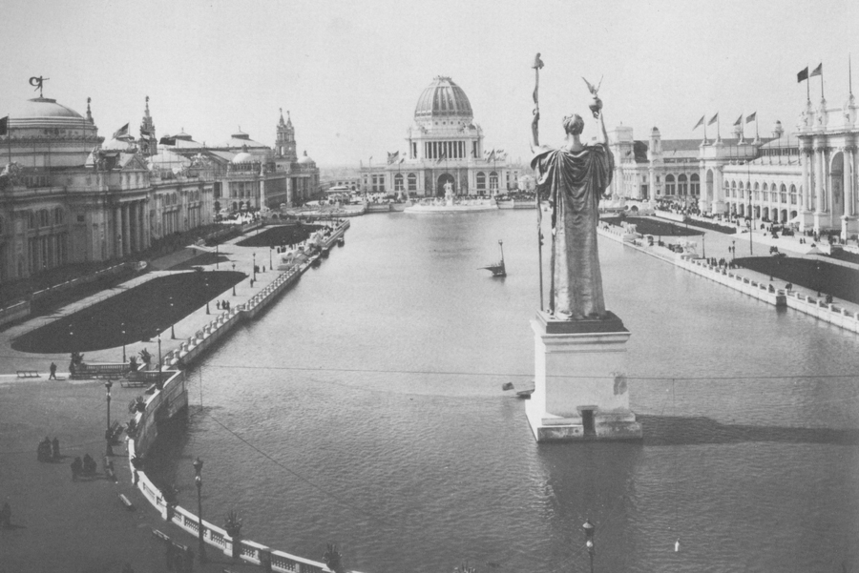
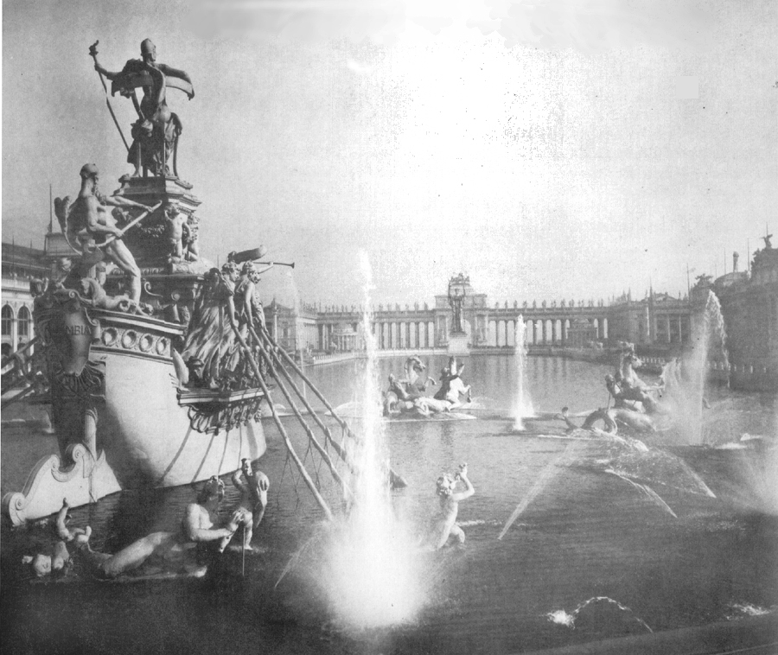

Left: Republic, Daniel Chester French
Right: Columbian Fountain, F.W. MacMonnies

Teacher Guide 1.1: “What Have You Learned?”
Interpretive Questions: After students have completed “Reading 1.1- The Gilded Age,” have them answer the following questions either in writing or in class discussion.

- What were some characteristics of the "Gilded Age?" Give examples.

  - A dynamic outlook, optimism, confidence, industrial growth, inventions, technological advances, transportation changes, wealth, etc.

- After viewing the video, Augustus Saint-Gaudens: An American Original, and reading about the Gilded Age, discuss the statement: "Saint-Gaudens is both a symbol of his age and one of the prominent artists who helped to create it."

  - Saint-Gaudens was a hard working, creative, confident young artist who was friends with and worked among the most illustrious artists of the day. His public monuments celebrated the new strength of the United States. He also produced many important commissions for the rich and famous including portrait busts and bas-reliefs which immortalized the successful. At one time he maintained four studios in New York City, which was the center of social and cultural activity.

- The Gilded Age gave rise to patrons of the arts. What made this possible and what cultural role did patrons serve?

  - The Gilded Age saw the accumulation of tremendous fortunes through science, technology and industrial development. Excess wealth enabled vast collections of art and books to be acquired and promoted public philanthropy in the form of libraries, museums, etc.

- The Gilded Age saw mind-boggling changes brought about by technologies which transformed peoples' lives. Can you list some and describe their impact on society. Do we have radical changes in technology that have had consequential effect on our lives today? To get started you might consider what our lives would be like without the development of:

  - Air travel, space technology, health care, computers, television and the role of the media, microwave ovens, etc.

- The Gilded Age spanned the end of a century. Do you see any parallels to our society today as we move into the 21st century?

Cooperative Learning: The following activities may be done in three small groups. After research, each student group should present their findings to the class.

- Make a time-line of important technologies developed during the second half of the 19th century. Students in this group should each choose one invention to research and report on its impact on society.

- With the help of the Music Teacher, find and bring to class examples of band, ragtime, or sheet music of the popular songs mentioned in the reading. Sing, play or bring to class a recording of the music.

- Expositions or World's Fairs sprang up during the latter half of the 19th century. Use the World Expositions handout to choose a World’s Fair to research and report to the class (especially interesting are the Expositions of 1876, 1893, 1900, and 1915). Discuss what they were, how they represented the spirit of the era and why they were important to artists. Include such facts as: when and where did the exposition take place; who participated; what if anything did it celebrate; who attended and how did they get there.

Independent Study: “A picture is worth a thousand words”

Supports NH Social Studies Curriculum Framework Standard 6, especially: analyze historical documents, artifacts, and other materials for credibility, relevance, and point of view. (Grade 10), p. 26.

Show students the color photo of Frank Leslie’s cover illustration for the Centennial Exposition of 1876. This should be available to the class at all times. In this activity, students will explore the power of the visual image to convey a message and will help to promote visual literacy. Explain to your class that this is a primary source and as such reveals a great deal about the spirit and values of the United States on its 100th birthday celebration. Historians frequently use art to interpret historic events, especially in the pre-photographic era. Art, in this sense, is a visual language, which can be “read” like a written document. Students will sharpen their observation skills and will learn to analyze and express the visual information found in the poster.

- Look at this illustration from Frank Leslie's 1876 publication of The Centennial Exposition and describe what you see. No detail is unimportant. After you have completed your description, analyze the messages that you see.
- Who do the figures represent and how do you know?
- List visual clues that capture the spirit of the event.
- How does this picture reflect American attitudes?
- Discuss how the personification of America positions herself and how this reveals cultural values of the nation and its role in the world at large.

Miss America is presented as the young, dominant figure gesturing to symbols of progress of the United States. The other figures, by their position and posture, are in various relationships to America: Native Americans, England, India, and Africa. The strength of America is represented by transportation, factories, the church and the Capitol building in Washington, D.C.

What Have You Learned?

Interpretive Questions: After you have completed “Reading I-l: The Gilded Age,” you will be asked to answer the following questions in writing or in class discussion:

- What were some characteristics of the "Gilded Age?" Give examples.

- After viewing the video, Augustus Saint-Gaudens: An American Original, and reading about the Gilded Age, discuss the statement: "Saint-Gaudens is both a symbol of his age and one of the prominent artists who helped to create it."

- The Gilded Age gave rise to patrons of the Arts. What made this possible and what cultural role did patrons serve?

- The Gilded Age saw mind-boggling changes brought about by technologies which transformed peoples' lives. Can you list some and describe their impact on society. Do we have radical changes in technology that have had consequential effect on our lives today? To get started you might consider what our lives would be like without the development of:

- Air travel, space technology, health care, computers, television and the role of the media, microwave ovens, etc.

- The Gilded Age spanned the end of a century. Do you see any parallels to our society today as we move into the 21st century?

Cooperative Learning: You will be divided into small, cooperative groups to research one of the following activities. After your group has finished, share your research with the class.

- Make a time-line of important technologies developed during the second half of the 19th century. Students in this group should each choose one invention to research and report on its impact on society.

- With the help of the Music Teacher, find and bring to class examples of band, ragtime, or sheet music of the popular songs mentioned in the reading. Sing, play or bring to class a recording of the music.

- Expositions or World's Fairs sprang up during the latter half of the 19th century. Use the World Expositions handout to choose a World’s Fair to research and report to the class (especially interesting are the Expositions of 1876, 1893, 1900, and 1915). Discuss what they were, how they represented the spirit of the era and why they were important to artists. Include such facts as: when and where did the exposition take place; who participated; what if anything did it celebrate; who attended and how did they get there.

Independent Study: "A picture is worth a thousand words"
The use of primary source material often provides evidence of the historic attitudes and cultural themes a particular era. After looking closely at this illustration, you will be asked to form your own conclusions.

Look at this illustration from Frank Leslie's 1876 publication of The Centennial Exposition and describe what you see. No detail is unimportant. After you have completed your description, analyze the messages that you see.

- Who do the figures represent and how do you know?
- List visual clues that capture the spirit of the event.
- How does this picture reflect American attitudes?
- Discuss how the personification of America positions herself and how this reveals cultural values of the nation and its role in the world at large.

