Sculpture
Unit 3
When one speaks of sculpture today, works in a variety of materials come to mind because the parameters of "sculpture" have been vastly expanded. Mobiles, stabiles, installations and assemblages are all included as forms of sculpture and each may be made out of a variety of materials. The sculpture made by Augustus Saint-Gaudens follows the traditional approach of modeling in clay. It is this process which is explored in the lessons of Unit 3.

Goals:
- Students will be able to identify sculptural terms and types of traditional
sculpture.
- Students will research and write a short, biographical paper of one of the Cornish Colony sculptors (refer to “The Cornish Colony: A List of Members” handout). Footprints of the Past, Circle of Friends, and the CD-ROM will be essential.
- Students will learn how Saint-Gaudens and Cornish Colony sculptors worked.
- Students will learn about the process of modeling in clay and can try the process themselves in related Activities 4, 5, and 6.

Objective:
This unit involves art history, research and writing, note taking and observation applied to analytical skills and hands-on experience with clay.

Supports NH English Language Arts Uses, especially Curriculum Standards #5, #6 and #7 (to grade level) and NH Framework for the Arts, especially Curriculum Standard #4: analyze the visual arts in relation to history and culture, p.40.

Instructional Strategies:
- Guided Discussion: The teacher will lead a discussion about sculpture, introducing students to terms and processes. As the list of glossary words develops from the discussion, the teacher will write them on the blackboard or on chart paper for later reference. (Use the “What Have You Learned?” worksheet to confirm student knowledge.)

- Video: Students will watch Wax Blood/ Bronze Skin (26 min.) about the lost wax casting process used to transform a clay sculpture into bronze.

- Written Assignment: Students will write a short research paper on a Cornish Colony sculptor or a contemporary artist.

- “Learning to Look”: Using the three laminated photographs of “Diana,” students will complete a sculpture analysis worksheet on their own or in cooperative groups.

- Video: Students will watch the video The Medal Maker"(30 min.) about the life and work of the artist Laura Gardin Fraser. (This video provides an excellent gender role model.) This may be followed by Activity 6, "Designing a Medal."

Follow-up Activities:
These activities will provide hands-on experience working with clay and should best be done in conjunction with the Art teacher.
- Activity 4- Sculpture in the Round
- Activity 5- Creating a Bas-Relief
- Activity 6- Designing a Medal or Coin (can be used as a drawing exercise)

Resources/materials to be provided by the teacher:
  - Flip chart/markers
  - Videos: Wax Blood/Bronze Skin and The Medal Maker
  - 3 photos of "Diana"

Handouts
    - “What Have You Learned” worksheet
    - “Assistants of Augustus Saint-Gaudens” handout
    - “Learning to Look:” Sculpture Analysis Worksheet

Glossary Words:
additive process high relief
allegory inscription
armature lost wax casting
bas relief maquette
bronze patina (patination)
plaster pedestal
bust pointing machine
clay sketch portrait
collaborate realistic or representational sculpture
exedra reduction
foundry relief sculpture
freestanding sculpture sculpture in the round
heroic size subtractive process

A Discussion Guide on Sculpture

Engage students in a discussion by beginning with the following questions:

- Each of you probably has a piece of sculpture on you right now. Do you? Examples could be earrings, rings, pendants, belt buckles and especially coins. Coins are an example of bas-relief sculpture (pronounced- baa-relief).
- Where else in your home or community could you find sculpture? List student answers on the blackboard or on chart paper. Answers might include a local Civil War monument, a municipal fountain, gravestones in a cemetery, decorations on buildings, medals, sports trophies, figurines, weather vanes, etc.
- What are some materials sculpture can be made out of? (i.e. stone, clay, plaster, wood, plastic, metals, fabric, found objects, paper, even snow and ice)

We have now considered a variety of places we may see sculpture and a variety of materials in which it is made, but basically, regardless of material or size, traditional sculpture occurs in two forms: sculpture in the round and relief sculpture. Augustus Saint-Gaudens worked in the traditional method of creating sculpture.

  - Sculpture in the round is freestanding or three-dimensional. It has height, width and depth. We can walk around it and look at it from all sides.

  - Relief sculpture is two-dimensional. It has been defined as a "drawing in clay." It is like a coin in which there is a raised image from the background. A relief is meant to be seen from the front only. There are two types of relief sculpture: low relief, also called bas-relief and high relief in which less than 50% of the figure is attached to the background.

What types of sculpture are there?
- Subject matter is often guided by its intended function. Sculpture that is realistic or representational actually portrays a person, place or event without distortion or stylization. A portrait is a popular subject for sculpture. A bust is a three-dimensional portrait, usually showing the figure from the shoulders up. Saint-Gaudens modeled portrait busts before completing his monuments to Admiral David Glasgow Farragut or General William T. Sherman. Saint-Gaudens also did many portraits in bas-relief for friends and wealthy patrons. An allegory is another subject that an artist may choose. It is a human figure used to convey an idea; in the General Sherman monument, Saint-Gaudens included the figure of a woman grasping a palm frond to convey the meaning of Victory. (See photo of Victory.)

How is it made?
- There are two methods in which to make traditional sculpture. In the additive process the artist keeps adding material to build up the whole shape. Modeling with clay is usually an additive process. If the piece is to be big, the sculptor works around an armature, which is an interior, support to hold the clay in place. In the subtractive process of making sculpture, the artist removes pieces (he carves away) from a solid material such as wood, marble or granite.
Where do you put a sculpture?
- A sculpture needs a setting. Public sculpture is frequently mounted on a base, also called a pedestal. Saint-Gaudens collaborated with his friend, the architect Stanford White, who designed a pedestal or architectural setting for several sculptures such as the Adams Memorial, the Standing Lincoln or the monument to General William Tecumseh Sherman. In the Farragut Monument, White designed a pedestal, which incorporated an exedra, or stone bench. The bench forms part of his pedestal. A pedestal raises the sculpture up from the viewer's space and contributes to a monumental effect.

What is an inscription?
- An inscription is when words are incorporated into the composition as part of the overall design. Saint-Gaudens was one of the first American artists to do this.

What size can a sculpture be?
- Sculpture may be made in many sizes from a reduction (less than life-size) to life-size to heroic (larger than life) and finally colossal.

What are the steps involved in modeling a sculpture?
- When an artist conceives his idea for a sculpture he will begin by making a sketch on paper. This is only two-dimensional.
- He now needs to make a clay sketch or maquette to see how the idea will look from all sides. The artist will then model the final sculpture in clay.
- If the work is to be larger or smaller than life, it will be done using a pointing machine. This is a mechanical device, usually operated by assistants, which assures a perfect copy of the original.
- Finally, to make the piece more permanent, a mold will be made and the sculpture may be cast into plaster or bronze. (Bronze is an alloy of the metals copper and tin.) Casting in bronze is done at a foundry in a process called lost wax casting.
- The last step, which is performed between the sculptor and the foundry, is to select a patina or color for the sculpture. The process is called patination and occurs when heated metal, like bronze, is exposed to an acid bath. Patination, or the coloration of metals, will occur naturally over time as the metal surface reacts with its environment (i.e. a bronze statue in the city will turn black from the concentration of carbons in the air and a statue near the ocean will become green, like the Statue of Liberty, reacting to salts from the water). The artist, working with the foundry can choose the desired and final color of his/her sculpture.

Compiled from Children, Clay and Sculpture, by Cathy Weisman and "Bronze Casting" an exhibition pamphlet from The Metropolitan Museum of Art, 1991.

The video Wax Blood/ Bronze Skin should be screened after this discussion. It documents the foundry process of making a cast of Saint-Gaudens' Farragut monument.

Assistants of Augustus Saint-Gaudens
The use of assistants in a sculptor's studio was an acknowledged practice of the nineteenth century. It would have been impossible for Saint-Gaudens to complete the quantity of commissions without the help of talented, young sculptors. Moreover, remembering his early yearning for professional guidance, Saint-Gaudens felt a responsibility to share his skill by teaching a new generation of sculptors. He taught at the Art Students League from 1888 to 1897. From this group, he often selected several of the most promising students to assist in his studios. Even after he became gravely ill, Saint-Gaudens was able to continue, by directing assistants in the completion of his work.

The following is a list of assistants who worked at various times in the New York, Paris and Cornish studios. Each of these men and women went on to remarkable careers of their own. An asterisk indicates a member of the Cornish Colony. (Biographies and examples of their work may be found in the Visual Artists Index on the CD-ROM.)

Assistants:
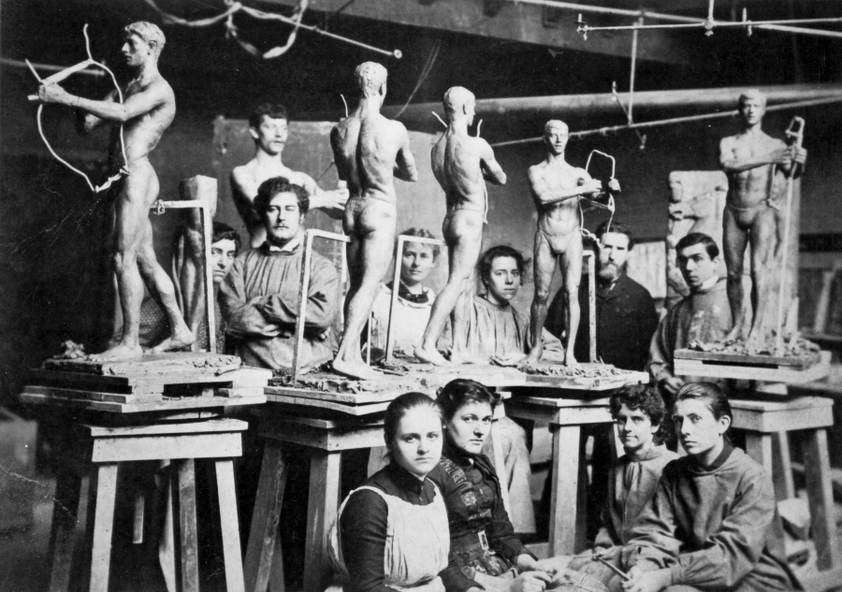
John Flanagan (1865- 1952)
*James E. Fraser (1876-1953)
*Frances Grimes (1869- 1963)
Louis Gudebrod (1872- 1961)
*Henry Hering (1874-1949)
Albert Jaegers (1868- 1925)
Charles Keck (1875-1951)
Mary Lawrence (Tonetti) (1868-1945)
Oscar Lenz (1874-1912)
Frederick W. MacMonnies (1863-1937)
Philip Martiny (1858-1927)
Helen F. Mears (1876-1953)
Saint-Gaudens (back row, second from right) teaching at the Art Students League
Robert T. Paine (1870- 1946)
Bela Pratt (1867-1917)
A. Phimister Proctor (1865-1920)
Rene De Quelin
*Annetta Johnson St. Gaudens (1869-1943)
*Louis St. Gaudens (1854-1913)
*Harry Thrasher (1883-1918)
*Elsie Ward (Hering) (1871-1923)
Adolph Weinman (1870- 1952)

Plaster molders and technical assistants:
Gaetan Ardisson (1856- 1926)
Antonio Tonachel
D. J. Donovan

Sculptors who were members of the Cornish Colony, but not assistants of Saint-Gaudens:
*Herbert Adams (1858-1945)
*Paul Manship (1885-1966)
*Bessie Potter Vonnoh (1872-1955)
*William Zorach (1887-1966)

Teacher Guide Unit 3: “What Have You Learned”

Interpretive Questions: Review with your students the visual arts vocabulary and concepts learned in the guided discussion. Have them answer the following questions in writing or class discussion.

- What are the steps involved in modeling a sculpture?

- Sketch, maquette; and then, with an armature, the artist will create a full size sculpture. If it is to be enlarged, this will be done using a pointing machine. Finally, to make the work permanent, it may be cast into plaster or bronze and will be patinated.

- Saint-Gaudens preferred to work in the additive process of making a sculpture. Define and give examples.

- Saint-Gaudens preferred to work in clay. He modeled both 3-dimensional, freestanding pieces as well as bas-reliefs. Examples of 3-D sculptures would include Admiral Farragut, Lincoln or the Diana weather vane. Examples of relief sculpture would include the Shaw Memorial, Robert Louis Stevenson, and the many bas-relief portraits he completed.

Written Assignment: Complete one of the following exercises.

Supports NH English Language Arts Curriculum Standard #2, especially Enhance...writing by using a variety of sources to provide background information, supporting details, and models of good writing (grade 10), p.15.

- Research a Cornish Colony sculptor: Refer to the handouts “Assistants of Augustus Saint-Gaudens” and “The Cornish Colony: A List of Members.” In your report, include a short biography of the artist, where he or she studied and worked. Describe one example of this artist's work. In what medium was it created? What was the process? Where can this sculptor's work be seen today? If known, for what purpose did the artist make this piece; what was the artist trying to say, and, in your opinion, is it successful or not? Why?

Helpful Resources:
  - Footprints of the Past
  - Circle of Friends
  - CD-ROM

- From your own experience: Both New Hampshire and Vermont have a rich tradition of art and craftwork. Can you think of someone in your community or area who works in the arts? (an actor, painter, sculptor, potter, quilter, photographer, singer, etc). Describe his/her work. How does this artist express ideas and feelings? How do you feel about this person's work? Do you like to work in the arts? If so, describe what you do.

What Have You Learned?

Interpretive Questions: Review with your students the visual arts vocabulary and concepts learned in the guided discussion. Have them answer the following questions in writing or class discussion.

- What are the steps involved in modeling a sculpture?

- Saint-Gaudens preferred to work in the additive process of making a sculpture. Define and give examples.

Written Assignment: Complete one of the following exercises.

- Research a Cornish Colony sculptor: Refer to the handouts “Assistants of Augustus Saint-Gaudens” and “The Cornish Colony: A List of Members.” In your report, include a short biography of the artist, where he or she studied and worked. Describe one example of this artist's work. In what medium was it created? What was the process? Where can this sculptor's work be seen today? If known, for what purpose did the artist make this piece; what was the artist trying to say, and, in your opinion, is it successful or not? Why?

Helpful Resources:
  - Footprints of the Past
  - Circle of Friends
  - CD-ROM

- From your own experience: Both New Hampshire and Vermont have a rich tradition of art and craftwork. Can you think of someone in your community or area who works in the arts? (an actor, painter, sculptor, potter, quilter, photographer, singer, etc). Describe his/her work. How does this artist express ideas and feelings? How do you feel about this person's work? Do you like to work in the arts? If so, describe what you do.

