Whitebark Pine Conservation Plan
Crater Lake National Park
January 2013

Summary

Whitebark pine has been declining throughout Crater Lake National Park for decades due to infection with the non-native pathogen white pine blister rust. Additional climate change-related threats have recently emerged that are hastening the demise of whitebark pine in the park and range-wide. A recent finding by the U.S. Fish and Wildlife Service that listing whitebark pine as a threatened or endangered species under the Endangered Species Act is warranted but precluded by higher priority work has heightened awareness of the need for conserving this species. A formal Whitebark Pine Conservation Program is outlined in this plan with specific management goals and objectives for conservation and restoration work within Crater Lake National Park. The plan also illustrates how Crater Lake National Park’s program fits into the broader range-wide effort to conserve whitebark pine and its associated species.

Prepared by:
Jennifer S.H. Beck, Botanist
Gregory W. Holm, former Terrestrial Ecologist
Table of Contents

Summary 2
I. Introduction 5
A. Purpose and Need 9
B. Whitebark Pine Conservation Strategies 10
II. Whitebark Pine Ecology 11
A. Whitebark Pine Classification and Distribution 12
B. Whitebark Pine Biology 13
C. Whitebark Pine and the Clark’s Nutcracker 15
D. Genetic Diversity 17
E. Whitebark Pine Communities 18
F. Disturbance Regimes 22
G. Traditional Use 22
III. The Decline of Whitebark Pine 23
A. White Pine Blister Rust 23
B. Mountain Pine Beetle 32
C. Dwarf Mistletoe 42
D. Fire Exclusion 46
E. Climate Change 55
IV. Crater Lake Whitebark Pine Conservation Program 58
A. Goals of CRLA’s Whitebark Pine Conservation Program 58
B. Facilitate development of blister rust resistance 60
C. Protect genetic diversity 71
D. Facilitate adaptation to climate change 73
E. Prioritize and implement restoration actions 76
F. Manage adaptively based on the best available knowledge 79
G. Engage the public through education and outreach 81
V. Whitebark Pine Conservation Program Management 83
A. Roles and Responsibilities 84
B. Reporting and Evaluation 85
C. Budget 86
D. Partnerships 87
VI. Conclusion 87
Acknowledgements 88
References 88
Appendices 99

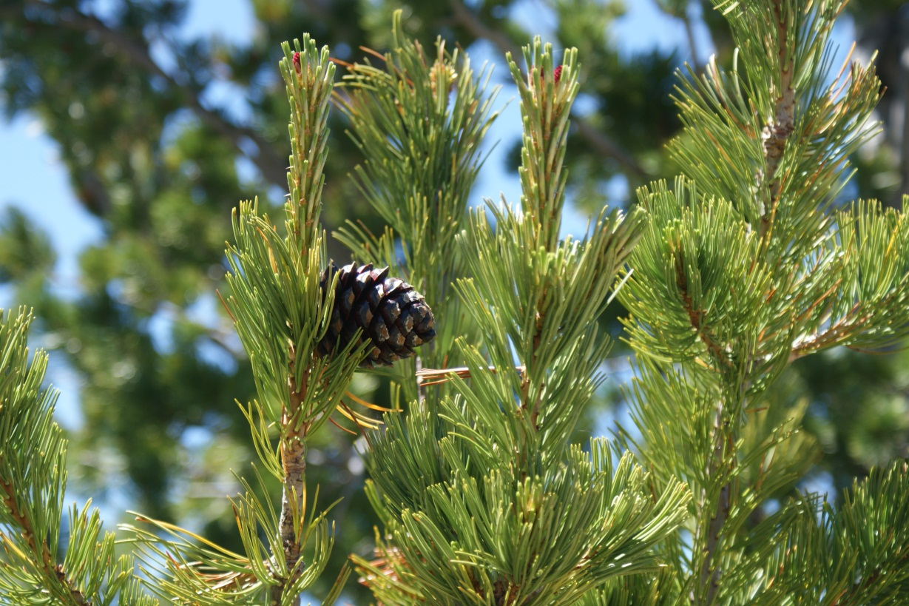
Figure 1. Whitebark pine, Crater Lake National Park.

I. Introduction
Whitebark pine (Pinus albicaulis Engelm.) is a significant resource protected within Crater Lake National Park (hereafter referred to as CRLA). This plan guides the management of whitebark pine within CRLA and outlines strategies for its conservation and restoration. CRLA was established in 1902, dedicated and set apart forever as a public park or pleasure ground for the benefit and enjoyment of the people of the United States. In managing this park, the National Park Service (NPS) was originally charged with “the protection and preservation of the game, fish, timber, and all other natural objects therein.” In 1980, Congress updated the park purpose to “preserve for the benefit, education, and inspiration of the people of the United States certain unique and ancient volcanic features, including Crater Lake, together with significant forest and fish and wildlife resources” (Public Law 96-553).
CRLA lies in southwestern Oregon in the south-central portion of the Cascade Range (Figure 2). The park ranges in elevation from 1158 m in the southwestern corner of the park to just over 2712 m at the summit of Mount Scott. CRLA’s flora is typical of vegetation found throughout the southern Cascade Range. The vegetation is a mosaic of forested and non-forested areas, and ranges from mixed conifer forest dominated by ponderosa pine (Pinus ponderosa var. ponderosa) at lower elevations to mountain hemlock (Tsuga mertensiana) and whitebark pine forest and woodland at higher elevations and along the caldera rim. The park is regarded by many as a sanctuary for native forest and meadow communities.
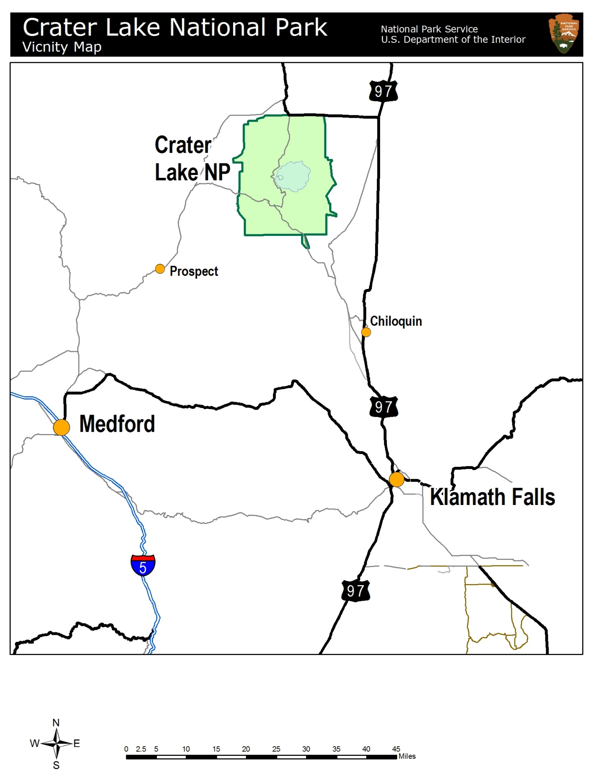
Figure 2. Vicinity of Crater Lake National Park in southwest Oregon. map by Chris Wayne.
Recognizing that there are varying levels of visitor use and park operational demands placed on resources within the park, the CRLA General Management Plan (USDI NPS 2005) established specific management zones to manage impacts of activities within the park. Table 1 (below) summarizes the resource condition and character desired within each zone.
Table 1. Designated management zones within CRLA from the park’s General Management Plan (2005).
BACKCOUNTRY  Biological diversity and ecological integrity  • Managed for wilderness character and values  • Moderate level of management for resource protection and visitor safety  • Minimal evidence of modern civilization  • Subtle onsite controls and restrictions  • Resource modifications would harmonize with the natural environment.  Tolerance for resource degradation in  this zone would be very low | FRONTCOUNTRY  Transition between developed areas  and those managed for natural values  • Managed predominately for natural values  • Subtle site modifications to  accommodate use that harmonizes with natural environment  • Moderate level of management for resource protection  Tolerance for resource degradation  would be low to moderate
Research natural area  Protection for unique habitats and  extraordinary ecological values  • Managed to allow natural processes  to occur without disturbance or  impacts from humans  Tolerance for resource degradation  in this zone would be very low | DEVELOPED ZONE  Resources modified for visitor and  park operational needs  • Not in designated wilderness nor near sensitive resources  • Visitors and facilities would be intensively managed  • Signs of human activity would be fairly obvious
Lake And caldera  Pristine  • Highest level of resource protection  • Low levels of management for  access, resource protection and  visitor safety would be appropriate in  these areas  • Any resource modifications would  be minimal and would harmonize  with the natural environment | TRANSPORTATION ZONE  Resources modified to accommodate  roads and road construction  • Minimize impacts to resources  • Minimize landscape and visual impacts  • Resources modified for essential  visitor and park operational needs
CULTURAL HERITAGE SITE

Maintaining and protecting cultural resources and providing for quality visitor experiences
• Evidence of management activity and resource preservation could be visible to visitors.
• Setting would be predominantly historic
• National register- listed (or eligible) properties would be managed to preserve their documented values.
• Historic scene and the landscape would be managed to maximize their integrity and to support visitor use
• Some minor aspects of the natural and cultural landscape could be modified to protect resources and
accommodate use

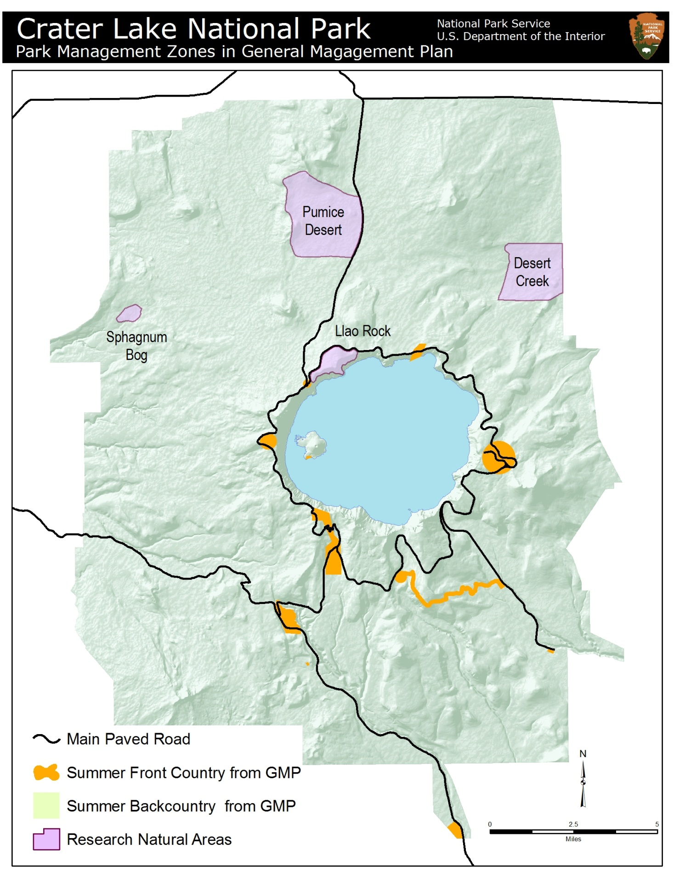
Figure 3. Management Zones within CRLA. Map by Chris Wayne.

A. Purpose and Need

This document is intended to guide research and management of whitebark pines and their associated communities for the foreseeable future. The Whitebark Pine Conservation Plan will be amended as needed based on new information and/or management techniques, or if the species’ listing status changes. As presented below, the overall NPS mission, specific policy guidance regarding resource management, the species’ status as a candidate for listing by the U.S. Fish and Wildlife Service (USFWS), and CRLA’s recognition of whitebark pine as a sensitive and significant resource and an important part of the visitor experience all indicate a need for management of the species.
The NPS has always had an association with the preservation of natural resources. As stated in NPS Management Policies, Chapter 4 (USDI NPS 2006):
The National Park Service will preserve and protect the natural resources, processes, systems, and values of units of the national park system in an unimpaired condition to perpetuate their inherent integrity and to provide present and future generations with the opportunity to enjoy them.
The NPS Management Policies (USDI NPS 2006) further state that the NPS will maintain as parts of natural ecosystems of parks all plants and animals native to park ecosystems. The NPS will successfully maintain native plants and animals by:
- Preserving and restoring the natural abundances, diversities, dynamics, distributions, habitats, and behaviors of native plant and animal populations and the communities and ecosystems in which they occur
- Restoring native plant and animal populations in parks when they have been extirpated by past human-caused actions
- Minimizing human impacts on native plants, animals, populations, communities, and ecosystems, and the processes that sustain them
Whenever possible, natural processes will be relied upon to maintain native plant and animal species and influence natural fluctuations in populations of these species. The NPS may intervene to manage individuals or populations of native species only when such intervention will not cause unacceptable impacts to the populations of the species or to other components and processes of the ecosystems that support them. There are many situations when this will be appropriate and permitted, but in regards to whitebark pine management the most pressing reason is because management is necessary (e.g., a lack of action will result in impairment of whitebark pines at CRLA).
On July 18, 2011, the USFWS determined that listing whitebark pine as threatened or endangered was warranted. However, currently listing whitebark pine was precluded by higher priority actions to amend the Lists of Endangered and Threatened Wildlife and Plants. In its finding, the USFWS concluded that mortality data collected in multiple studies throughout the range of whitebark pine strongly suggests that the species is in range-wide decline, and that the decline in whitebark pine populations likely began sometime following the 1910 introduction of the exotic disease white pine blister rust (Cronartium ribicola). The USFWS also concluded that the present or threatened destruction, modification, or curtailment of the species’ habitat or range, and disease and predation were threats to whitebark pine, and that existing regulatory mechanisms are inadequate to protect whitebark pine and/or its habitat.
In the 1990s, CRLA staff and park visitors became concerned about declines in whitebark pine stands as blister rust-related mortality became more apparent. Several research and monitoring projects were initiated to investigate levels of mortality and decline. Results of studies converged at a disturbing finding: whitebark pine is declining, precipitously so in some areas of the park. A recent and ongoing mountain pine beetle (Dendroctonus ponderosae) outbreak has exacerbated whitebark pine decline park-wide. Whitebark pine is a long-lived species; large cone crops typically are not produced until trees are 60-80 years old (McCaughey and Tomback 2001). Natural genetic resistance against the introduced pathogen white pine blister rust is rare; < 5% of whitebark pines possesses any kind of resistance (Tomback 2007). The plight of whitebark pine begs for management intervention to slow or mitigate against further declines. Whitebark pine is often regarded as a “wilderness species” as it is found at high elevations, often in protected areas such as national parks or wilderness (Tomback et al. 2001b). The fact that human actions (e.g., invasive species introductions, rapid climate warming) have such grave impacts to this species is sobering. It is hoped that through restoration and protective actions this species can continue to serve as an anchor of biodiversity in high elevation ecosystems.

B. Whitebark Pine Conservation Strategies

The CRLA Whitebark Pine Conservation Plan dovetails with broader conservation strategies for whitebark pine, namely the Range-wide Restoration Strategy for Whitebark Pine (Keane et al. 2012) and the Whitebark Pine Restoration Strategy for the Pacific Northwest (Aubrey et al. 2008). The Whitebark Pine Conservation Plan outlines how CRLA will maintain consistency with tactics outlined in the two conservation strategies mentioned above while meeting park resource management goals and objectives, therefore enabling CRLA to partner with other federal land agencies in the monumental effort to conserve and restore whitebark pine communities. The range-wide and Pacific Northwest (PNW) strategies are discussed further in section IV-A.
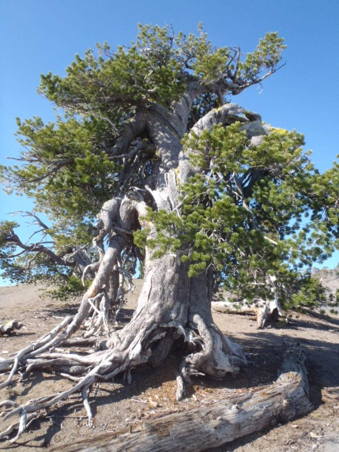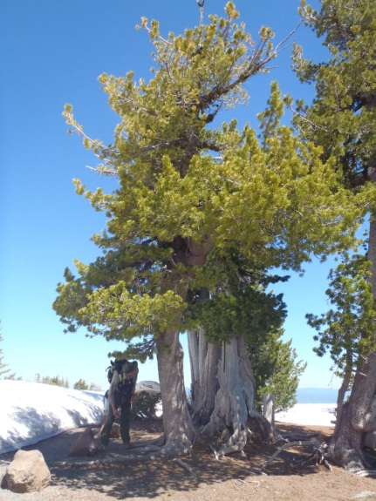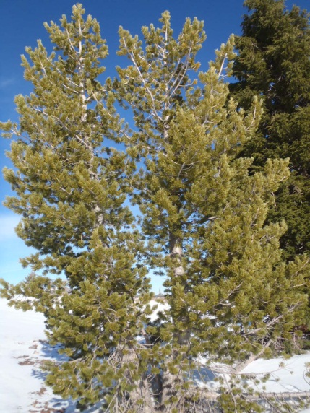
Figure 4. Various forms of whitebark pine at CRLA.
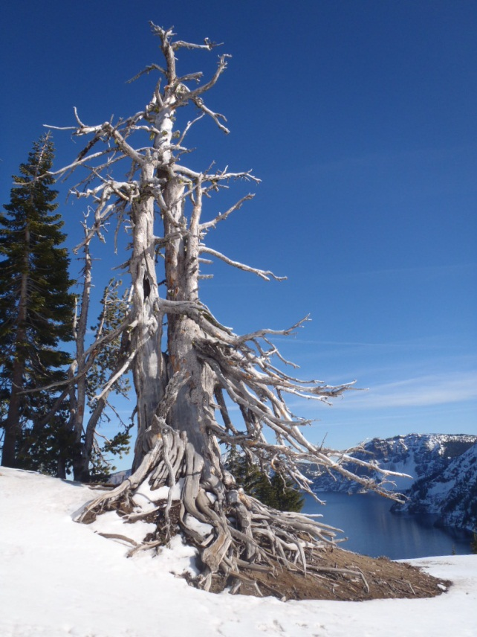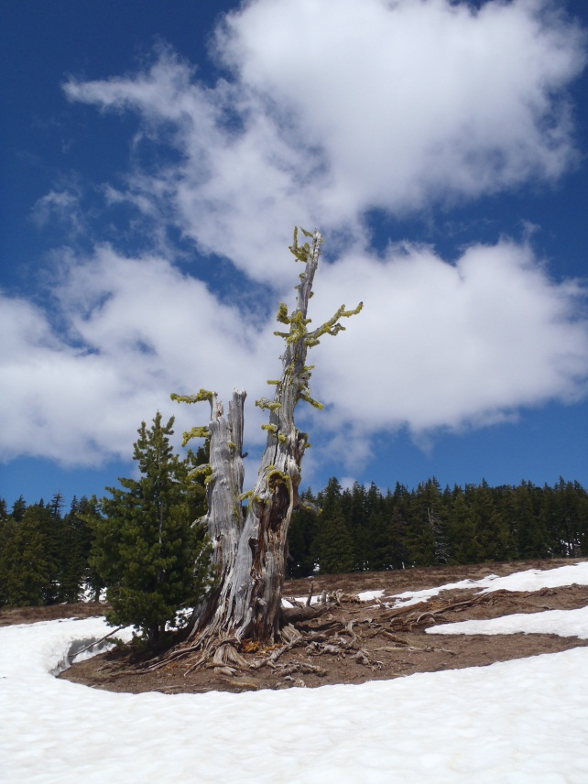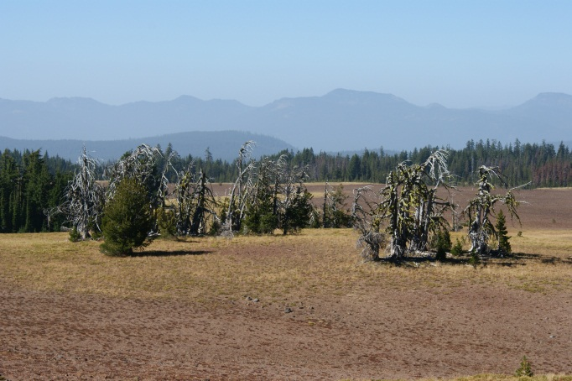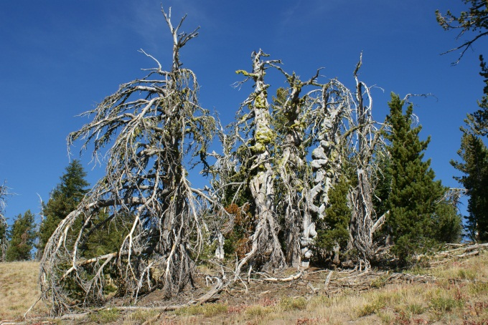
Figure 5. “Gray ghosts” of whitebark pine at CRLA.

II. Whitebark Pine Ecology

It is impossible to view Crater Lake without also seeing whitebark pines. The hardy, long-lived species clings to the caldera rim; forms the dominant forest type of the Mt. Scott and Cloudcap areas; perches along the vertical rock spires of Phantom Ship; and forms forested islands amidst pumice meadows and deserts. Isolated whitebark pine populations are located on the summits of many cinder cones, shield volcanoes, and old lava flows throughout the park, including Red Cone, Union Peak, Crater Peak, Timber Crater, and Grouse Hill. Whitebark pine and their associated communities are critical components of the Crater Lake landscape, and without them, much diversity and many ecosystem services would be lost.
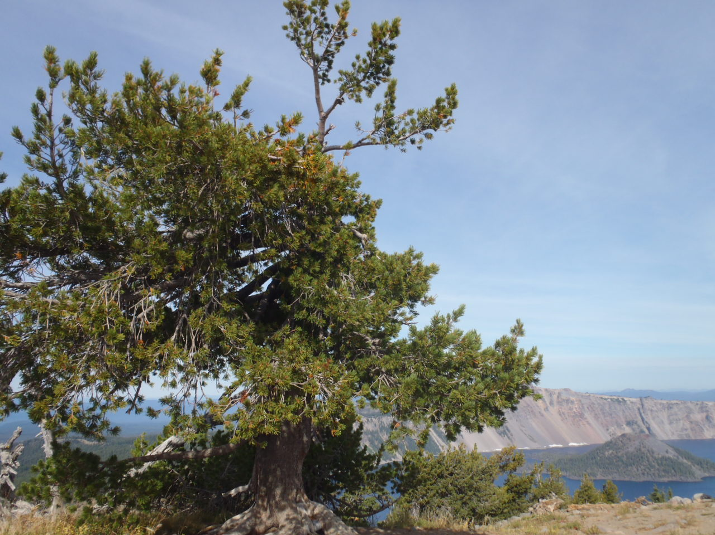
Figure 6. Whitebark pine atop Garfield Peak.

A. Whitebark Pine Classification and Distribution

Whitebark pine is a five-needle white pine (section Strobus of the Pinaceae, or pine family) and the only North American member of the stone pines (subsection Cembrae). There are five species of stone pines worldwide – whitebark pine, and the Swiss, Korean, Japanese, and Siberian stone pines (Lanner 1996; McCaughey and Schmidt 2001). It is believed that Eurasian stone pines migrated to North America via the Pliocene Bering Strait land bridge and differentiated into whitebark pine 600,000 – 1,300,000 years ago (McCaughey and Schmidt 2001). The stone pines are characterized as “bird pines” - they bear indehiscent cones and depend on birds of the nutcracker genus (Nucifraga) to extract and disperse pine seeds (McCaughey and Schmidt 2001).
Whitebark pine grows at high elevations in western North American mountain ranges and has two distinct east-west populations (McCaughey and Schmidt 1990). The western population stretches from the Coast Ranges of British Columbia down the Cascade Range of Washington and Oregon into the Sierra Nevada of California (Arno and Hoff 1989). The eastern population encompasses the northern Rocky Mountains from Alberta to Wyoming (Arno and Hoff 1989). Isolated populations occur in northern Nevada, northeastern Washington, south central Oregon, and northeastern California (Arno and Hoff 1989; McCaughey and Schmidt 1990).
The oldest evidence of whitebark pine in the fossil record traces it to the Yellowstone region, where it has remained for the last 100,000 years (Baker 1990). Glaciations affected the distribution of whitebark pine over recent millennia, causing range expansions and contractions. Isolated populations in central Oregon and northern Nevada may be artifacts of a larger subalpine forest that stretched across the Great Basin and central Oregon, connecting Oregon and Idaho whitebark pine populations (Richardson et al. 2002). Whitebark pine, among other species, colonized areas of Holocene glacial retreat 15,000 – 10,000 years ago; a warm spell 8,000 – 4,000 years ago pushed it upslope to higher elevations (McCaughey and Schmidt 2001). A cooling trend 4,000 years ago is thought to be responsible for the current distribution of whitebark pine (McCaughey and Schmidt 2001). It is believed that Oregon whitebark pine populations remained ice-free during the last glacial maximum and may have served as seed sources for colonizing more northern locations (Richardson et al. 2002).
When Mt. Mazama, the volcano whose collapse created the Crater Lake caldera, erupted approximately 7,700 years ago, it devastated the forested landscape within and surrounding what was to be designated as Crater Lake National Park. According to a study that sampled in a Munson Valley peat bog, the primary tree species to colonize the post-eruption landscape were lodgepole pine (Pinus contorta var. latifolia) and whitebark pine (Hansen 1942).

B. Whitebark Pine Biology

Whitebark pine is a slow-growing and long-lived species with a life span of 500 years or more (Arno and Hoff 1989), with the oldest known individual more than 1,270 years old (Perkins and Swetnam 1996). Whitebark pine reaches reproductive maturity when it is 20-30 years old, but cone crops are light until trees are 60-80 years old (McCaughey and Tomback 2001). Whitebark pine produces large cone crops irregularly; “mast” years typically occur on an interval of 3-5 years (McCaughey and Tomback 2001). The masting habit is thought to be a strategy to outwit cone predators such as cone beetles by providing an inconsistent food supply (Lanner 1996). Good cone production at CRLA was recently observed in 2005, 2006, 2009 (mast year), 2011, and 2012. Trees free of competition with large, full crowns produce the most cones (McCaughey and Tomback 2001).
Whitebark pine inhabits montane and subalpine forests to treeline and suffers cold winters, strong and desiccating winds, and short growing seasons (Arno and Hoff 1989). It tolerates poorly developed soils, intense solar radiation, and summer-drought conditions (Arno and Hoff 1989). Based on records collected at park headquarters from 1931-2012, CRLA has mean January and July temperatures of -3.8°C and 12.8°C, respectively. CRLA receives an average of 1,331 cm of snow per year, with the bulk of precipitation falling from November – March. The maximum snow depth typically occurs on April 1st, and the average April 1st snow depth is 307.3 cm (111.8 cm snow water equivalent). CRLA’s whitebark pines are typically found above 1980 m and are concentrated around the rim of Crater Lake. Pure stands of whitebark pine are found in the Mt. Scott and Cloudcap areas, with isolated stands occupying the windswept summits of higher peaks. CRLA straddles the Cascade crest; therefore, the west side of the park intercepts more precipitation from incoming Pacific storms than the east side. Soils inhabited by whitebark pine at CRLA are derived from past volcanic activity. Ninety percent of CRLA’s soils were deposited by Mt. Mazama pumice and ash plumes and flows. The remaining 10% are found in the southwest and west portions of the park and derived from glacial moraines; these are the oldest soils in the park (Weinheimer 2002). Due to their youthful age, CRLA’s volcanic soils have experienced minimal soil development, which has generally been limited to within 50 cm of the surface (Weinheimer 2002). Most of the soils underlying CRLA’s whitebark pine are classified as cryands, indicating soils derived from volcanic parent materials with a high-elevation temperature regime (Buol et al. 2003). These soils are deep, moderately to excessively well drained, with moderate to rapid permeability, and experience < 50 frost-free days (Weinheimer 2002).
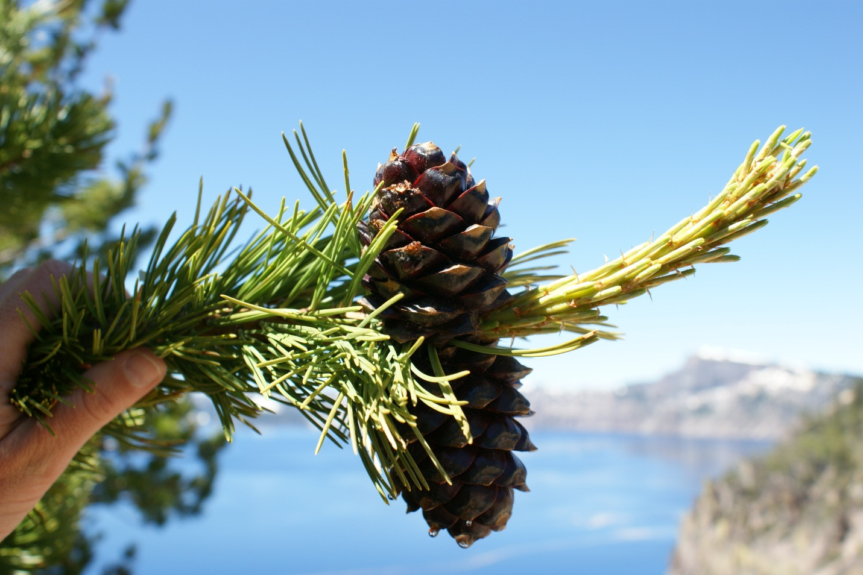
Figure 7. Whitebark pine cones along the rim of Crater Lake.
The ability to germinate and persist on exposed, harsh sites has earned whitebark pine the status of a colonizing or pioneer species. It is capable of forming a soil seed bank with delayed germination of two years or more, which enables seedlings to emerge during favorable conditions – especially adequate moisture (McCaughey and Tomback 2001; Tomback et al. 2001a). This was witnessed at CRLA in 2011; after an especially wet spring with the latest spring snowmelt ever recorded at park headquarters (1931-2011), an abundance of whitebark pine seedlings emerged two years after a mast year. Whitebark pine is among the first species to colonize disturbed areas in subalpine forests (Tomback et al. 2001b). Its seedlings are large with thick stems and quickly develop a deep taproot (McCaughey and Tomback 2001). The presence of ameliorating microsite features such as downed logs or boulders increases seedling survival (McCaughey and Tomback 2001).
Whitebark pines share a co-evolved mutualistic relationship with the Clark’s nutcracker (Nucifraga columbiana) (Tomback 1982). Whitebark pine cone scales lack sclerenchyma tissues found in wind-dispersed pines that shrink and pull the scales apart, allowing seeds to escape (Lanner 1996). Whitebark pine seeds are held within the indehiscent cone, requiring assistance from animals – typically the Clark’s nutcracker – to break apart cone scales and release seeds (Tomback 2001). Another animal that harvests whitebark pine seeds at CRLA is the Douglas squirrel (Tamiasciurus douglasii). It cuts pine cones from trees and buries them whole in caches that are generally unsuitable for seedling germination (Tomback 1982; Siepielski and Benkman 2008).
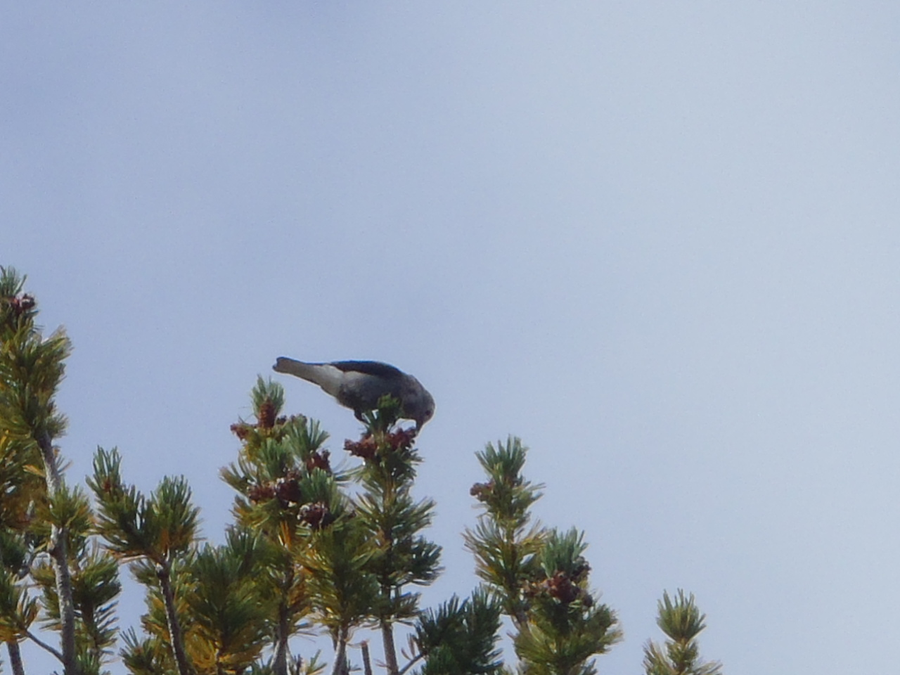
Figure 8. A Clark's nutcracker harvests whitebark pine seeds at the base of Mt. Scott.
Whitebark pine has an open, relatively flat-topped crown with its cones proffered at the ends of branches toward the top of the tree. This growth form provides a clear view of the cone crop for a nutcracker in flight.

C. Whitebark Pine and the Clark’s Nutcracker

The Clark’s nutcracker is well-adapted for the task of extracting and dispersing pine seeds; its strong bill easily dislodges seeds and stores them in a sublingual pouch, which is a nutcracker-exclusive mechanism for transporting pine seeds (Tomback 2001). The nutcracker then stores pine seeds for future retrieval to sustain itself and its offspring during months when food resources are scarce (Tomback 1982). Nutcrackers often store pine seeds in caches of 1-15 seeds, with an average of 3-5 seeds/cache (Tomback 2001). Nutcrackers have been observed storing seeds in temporary caches to presumably maximize foraging time, then relocating them to more distant sites after the harvest is complete (Hutchins and Lanner 1982). Nutcrackers cache seeds locally within a few to several hundred meters of the harvest site (Tomback 2001), and also remotely - long-distance dispersal has been observed to occur over 32 km in distance and 1007 m in elevation (Lorenz 2009; Lorenz et al. 2011).
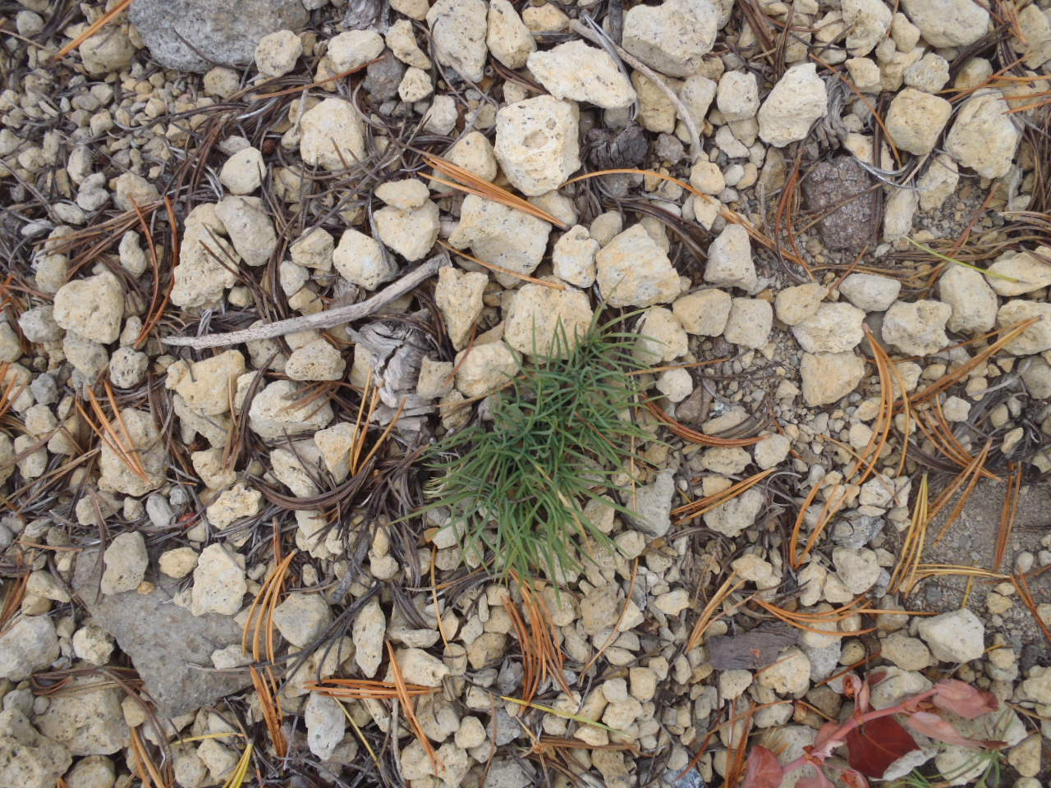
Figure 9. a newly-emerged cache of whitebark pine seedlings on Mt. Scott, 2011.

Nutcrackers select a variety of locations to cache whitebark pine seeds (Tomback 2001), including sites unsuitable for seedling establishment such as above-ground locations (Lorenz et al. 2008; Lorenz et al. 2011). Nutcrackers cache whitebark pine seeds in forested terrain, open areas, recently burned or otherwise disturbed sites, within whitebark pine communities and at lower elevations such as ponderosa pine forests (Tomback 2001). Nutcrackers are ecosystem architects– they affect subalpine ecosystem structure, function, and composition (Tomback 1982; Tomback 2001). They are able to shift whitebark pine above or below its current distribution, which may help whitebark pine respond to climate change (Tomback 2001).
Nutcrackers may be year-round residents of subalpine forests (Lorenz 2009; Lorenz et al. 2011) or transient occupants, inhabiting lower elevation forest types during winter months (Tomback 2001; Lorenz 2009; Lorenz et al. 2011). Casual observations suggest that CRLA hosts resident nutcracker populations (Fisher 1931; Libbey 1933; Ruhle 1947), as nutcrackers have been observed in the park and along the caldera rim during every month of the year (Farner 1952). Additionally, nutcrackers have been observed nesting in whitebark pines along the caldera rim. Crater Lake hosts a healthy emigrant population of nutcrackers, as a great influx arrives in the late summer to harvest the whitebark pine crop (Farner 1952). In addition to frequenting the whitebark pine habitat, nutcrackers have been observed foraging on ponderosa pine (Pinus ponderosa var. ponderosa) (Farner 1952) and sugar pine (Pinus lambertiana) seeds (Murray and Tomback 2010; Turner et al. 2011) in the Panhandle area of the park. Little formal research has been conducted on Clark’s nutcrackers within the park. One study found a nutcracker banded at Rim Village in September, 1950 was found dead in October, 1950 on Mt. Adams, Washington (Farner 1952).
Some caches of whitebark pine seeds go unclaimed, and these may germinate and create new whitebark pine trees. The caching habit of nutcrackers can result in a multi-stemmed growth form where clumps of trees are comprised of genetically different stems originating from individual seeds (Tomback 1982; Linhart and Tomback 1985; Tomback 2001).
The nutcracker is rewarded for its efforts in extracting whitebark pine seeds, as they are the largest conifer seeds found in the subalpine zone (Tomback et al. 2001b). Whitebark pine seeds are high in lipid content, including the amino acid lysine, which is an important component of avian diets (Tomback et al. 2001b).

D. Genetic Diversity

Dispersal activities of the Clark’s nutcracker greatly affect the genetic structure and diversity of whitebark pine populations (Jorgensen and Hamrick 1997; Rogers et al. 1999; Tomback 2001). Since the nutcracker often places seeds derived from one tree or tree cluster in a single cache, the resulting tree cluster is more closely related to itself than to neighboring tree clusters (Furnier et al. 1987; Tomback 2001). Furnier et al. (1987) also found that proximal tree clusters are not more closely related to one another than distal ones, which is another artifact of nutcracker dispersal. The tree cluster growth pattern could lead to more inbreeding (Furnier et al. 1987; Bower and Aitken 2007) as pollen flow is likely among related individuals. Inbreeding is of concern due to its capacity for inbreeding depression, which negatively impacts species’ fitness and survival (Bower and Aitken 2007). Additionally, high rates of inbreeding may lead to higher infection levels and mortality from blister rust (Ward et al. 2006a). Bower and Aitken (2007) reported that while inbreeding was found to occur in whitebark pine, rates were similar to those of wind-dispersed pines, and Oregon populations yielded no evidence of inbreeding depression.
Reports of whitebark pine genetic diversity for southern Oregon are mixed due to variations in sampling design and methodology (Aubry et al. 2008). Jorgensen and Hamrick (1997) found low values for genetic diversity in the Oregon Cascades, while Richardson et al. (2002) reported high values for genetic diversity in the southern Oregon Cascades. The majority of whitebark pine’s genetic diversity is found within rather than among populations (Jorgensen and Hamrick 1997; Bruederle et al. 2001; Bower et al. 2011). This lack of population differentiation is thought to be due to among-population gene flow facilitated by nutcrackers (Bower et al. 2011). However, enough regional differentiation exists within whitebark pine’s range to consider northern, eastern, and southern populations genetically distinct (Aubry et al. 2008). This has led to definition of “seed zones” within which seed transfer should be restricted to avoid maladaptation (Aubry et al. 2008).
Whitebark pine has been found to have a high level of rare alleles that are distributed among populations (Jorgensen and Hamrick 1997). This allelic diversity may help whitebark pine gain resistance to blister rust through evolution of resistant traits (Jorgensen and Hamrick 1997). Therefore, it is critical to maintain among-population diversity as part of a genetic conservation strategy (Aubry et al. 2008).
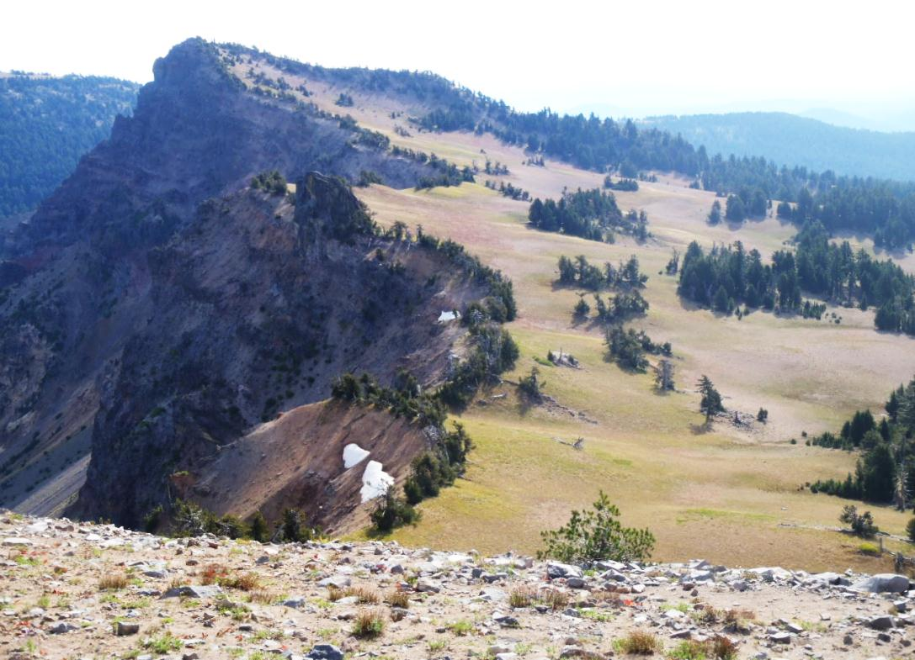
Figure 10. Whitebark pines form a ring along the caldera rim from Garfield Peak to Applegate Peak.

E. Whitebark Pine Communities

Whitebark pine is considered to be a foundation species (Tomback 2007; Tomback et al. 2011), which is defined much as it sounds – a single species that creates the foundation and support for an entire community or ecosystem (Ellison et al. 2005). Whitebark pine is moderately shade tolerant to shade intolerant (Weaver 2001); its large seed contains sufficient reserves to allow it to grow quickly and establish a long taproot (Arno and Hoff 1989). It colonizes disturbed areas such as recent burns and clearcuts (Arno and Hoff 1989) and even areas devastated by mountain pine beetle outbreaks (Larson and Kipfmueller 2010). Whitebark pine plays the role of a facilitator or “nurse” species; its presence ameliorates harsh site conditions and thereby enables establishment of other species (Franklin and Dyrness 1973; Tomback et al. 2001b).
Whitebark pine is also considered a keystone species, as it provides many ecosystem services to subalpine environments. It helps regulate snowmelt, as it accumulates more snow and experiences later snowmelt than more open areas (Tomback et al. 2001b). The presence of whitebark pine communities helps anchor soils in place and reduces soil erosion (Tomback et al. 2001b). This is evident at CRLA, where whitebark pines often grow along the caldera rim and help slow erosion (Figure 10). Whitebark pines also create substantial ecosystem diversity measured by the understory plant species and conifer associates they harbor; the animals that seek food, shelter, and habitat they provide; and the landscape patterns they create as they are admixed with subalpine meadows, montane forests, and treeline communities (Tomback et al. 2001b).
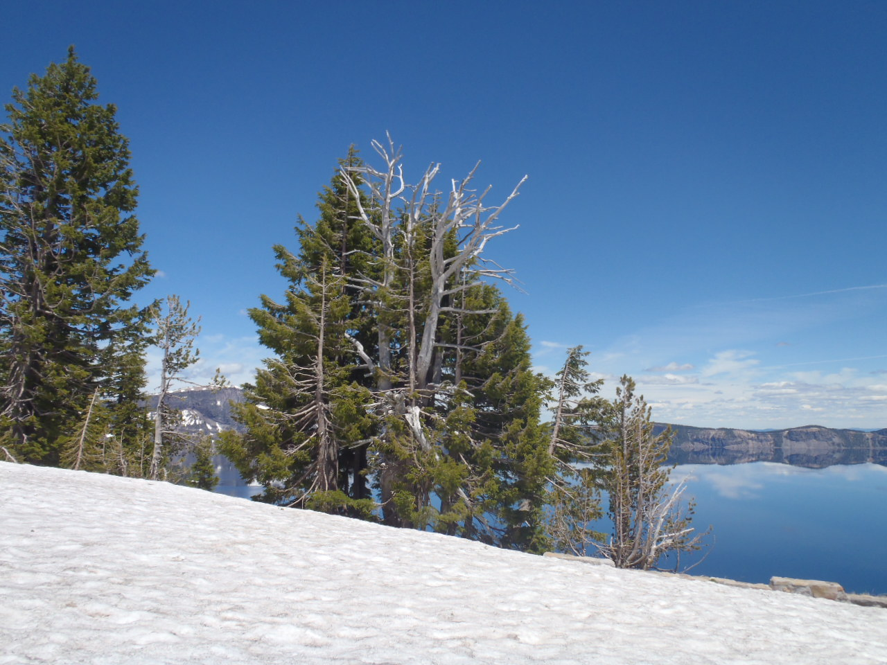
Figure 11. Mountain hemlocks crowd around a dead whitebark pine at Rim Village.

Whitebark pine is considered both a seral and climax species, depending on site conditions (Arno 2001). Where it is seral, it is outcompeted by encroaching shade-tolerant conifers and disturbance such as fire is required for its continued presence on the landscape (Arno 2001). Whitebark pine occurs as a climax species on harsh sites where competition from other conifers is minimal (Arno 2001). At CRLA, both seral and climax whitebark pine communities are present. On moister sites, competition with mountain hemlock (Tsuga mertensiana) is fierce. Especially along the west rim of Crater Lake, whitebark pines are often suppressed by taller mountain hemlocks – including ones whose establishment they may have facilitated (Figure 11). Whitebark pine forms the dominant and climax forest cover on sites where well-drained volcanic soils and/or wind-desiccation limit competition from other conifers (Weaver 2001), such as the Mt. Scott and Cloudcap areas. Along the upper slopes of Mt. Scott, whitebark pine has been sculpted into a krummholz form by powerful winds. Other conifers found in whitebark pine communities at CRLA include Shasta red fir (Abies magnifica x procera), subalpine fir (Abies lasiocarpa var. lasiocarpa), lodgepole pine, western white pine (Pinus monticola), and mountain hemlock.
At CRLA, an abundance of species is associated with whitebark pine. Data from seven long-term monitoring plots installed in whitebark pine communities show a total of 47 understory plant species found within CRLA’s whitebark pine communities (Appendix 1). Additionally, many other species utilize and inhabit whitebark pine communities. At CRLA, at least 35 bird species and 22 mammal species are known to inhabit or otherwise use whitebark pine communities (Appendix 2), with an unknown diversity of reptiles, amphibians, invertebrates, non-vascular plants, fungi, and bacteria.
The current distribution of whitebark pine in the park is estimated at 2,111 ha (Noone and Murray 2012). This includes 384 ha of dominant whitebark pine habitat, 478 ha of co-dominant whitebark pine habitat, 561 ha where whitebark pine is interspersed among other coniferous species, and 688 ha where whitebark pine is found in trace amounts among other coniferous species (Figure 12). This mapping effort was based on a Random Forest model and utilized the park’s Light Detection and Ranging (LiDAR) data acquired in 2010. It also utilized polygons mapped in the field by Michael Murray, former CRLA Terrestrial Ecologist. Results of this recent mapping effort are in marked contrast with a 1936 Vegetation Type Survey conducted by the NPS Branch of Forestry that estimated 225 ha of whitebark pine exist within the park (USDI NPS 1936). The 1936 study identified six whitebark pine vegetation types:
- Whitebark pine/mountain hemlock/pinemat manzanita (Arctostaphylos nevadensis) – 10 ha
- Fleeceflower (Aconogonon davisiae var. davisiae)/whitebark pine/mountain hemlock – 16 ha
- Whitebark pine – 66 ha
- Whitebark pine/mountain hemlock – 77 ha
- Semi-barren – 38 ha
- Whitebark pine/grass – 18 ha
The Klamath Network (KLMN) Inventory and Monitoring program is currently working on a parkwide vegetation map that will include distribution and classification of whitebark pine habitat. This will be the most sophisticated mapping effort in park history, based on aerial imagery, LiDAR data, hundreds of field plots and extensive accuracy assessments. When this is finalized (spring 2014), it will be the definitive source for vegetation mapping at CRLA and will yield essential information on distribution and classification of whitebark pine communities within the park.

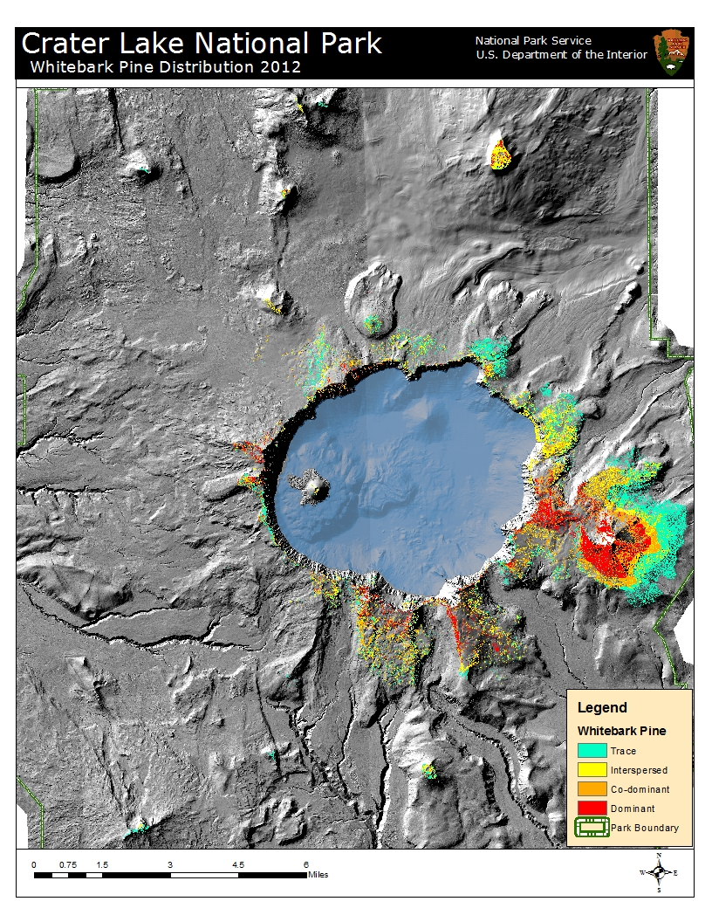
Figure 12. Whitebark pine distribution at CRLA based upon its canopy dominance.

F. Disturbance Regimes

Whitebark pine has evolved with many agents causing damage or mortality such as fire, insects, parasitic plants, fungal pathogens, mammals, and severe weather (Arno and Hoff 1989). It has developed strategies to survive and persist despite the onslaught of biotic and abiotic forces that may impact the species at the individual tree, stand, or landscape level.
Whitebark pine is considered moderately fire-resistant; despite having relatively thin bark (typically < 1 cm thick) it may survive due to patchy fire spread resulting from its sparse understory (Agee 1993; Fryer 2002). Few studies have explored the role of fire in Cascadian whitebark pine communities, and only one study has described the fire regime of whitebark pine communities at CRLA. Siderius and Murray (2005) found that fires within the whitebark pine zone are typically small and patchy due to discontinuous fuels and sparse understory vegetation. They estimated the fire return interval for Cascadian whitebark pine at 9-314 years with an average of 67 years; however, most areas within CRLA were found to encompass the higher end of the range. At CRLA, 82% of whitebark pine stands surveyed contained charcoal indicating past fire events. Fifty six percent of fires were high severity (stand replacing) while 44% of fires were low severity, characterizing a mixed severity fire regime for CRLA’s whitebark pine communities.
Siderius and Murray were unable to detect evidence of past fire in mixed whitebark pine/mountain hemlock stands, and concluded that this forest type infrequently experiences fire. However, without fire, these stands will likely succeed to mountain hemlock dominance (Arno 2001). Carefully managing lightning-caused fires at CRLA is recommended due to its road and trail system providing many management options; its short fire season in the subalpine zone and typically low fire intensities; and its low fuel load (both vertically and horizontally) leading to small and easily controllable fires (Siderius and Murray 2005).
The mountain pine beetle and dwarf mistletoe (Arceuthobium spp.) cause substantial damage to whitebark pine at the stand and sub-stand levels and will be discussed further in sections III-B and III-C. Minor damage is also inflicted by fungi causing stem cankers; wood, root, and butt rots; needle blight; and snow mold (Arno and Hoff 1989). Insects may feed on needles, inner and outer bark, and cones (Arno and Hoff 1989). Mammals may also inflict damage to whitebark pine via bark and cambium gnawing and browsing of foliage; principal offenders include rodents, porcupines, bear, and deer (Weaver 2001).

G. Traditional Use

In other regions, Native American use of whitebark pine seeds as a food source has been documented (Arno and Hoff 1989; Lanner 1996), but at CRLA, it is unclear if this was the case. The area that is now designated as CRLA is near the boundary of traditional Klamath and southern Molala tribal territories (Deur 2008). The use of ponderosa pine within the park for food and medicine has been documented; the collection of sap for medicinal purposes was commonly reported by members of the Klamath tribes (Deur 2008). Ponderosa pine seeds were gathered for food, and the cambium was used as an emergency food source (Deur 2008). Since whitebark pine seeds are also large and nutritious and the relatively low stature of the trees provides for easy gathering, one might surmise that whitebark pine seeds would also be a desired food item for Native Americans. However, most of the high-elevation areas where whitebark pine grows are associated with traditional spiritual use. Crater Lake and the high peaks surrounding the lake were seen as places of high power and upheld with the utmost reverence for their sacred and religious properties (Deur 2008). Access to these high elevation sites was restricted to those involved in spiritual and religious activities (Deur 2008). While resources may have been procured from these areas due to their association with special powers or medicine, there are no documented accounts of Native American use of whitebark pine within CRLA for food or medicinal purposes (Deur, personal communication).
CRLA’s whitebark pine communities are found within the most sacred areas for local Native American tribes. Some of CRLA’s extant whitebark pine was likely present during ancient vision quests, rituals, ceremonies, and other spiritual activities; and it is still privy to such use today.

III. The Decline of Whitebark Pine

Whitebark pine has been declining range-wide for decades due to a convergence of several aligning factors. The introduction of the non-native pathogen white pine blister rust has caused up to 90-100% infection rates in some areas; fire suppression has facilitated the abundance of shade-tolerant conifer species in seral whitebark pine habitat and led to suppression and replacement of whitebark pine by competitor species; warmer temperatures have allowed mountain pine beetles to cause unprecedented levels of mortality in whitebark pine communities; and climate change may push whitebark pine out of much of its current distribution (Tomback et al. 2011). Considered together, these threats point toward an uncertain future for whitebark pine and its associated species.

A. White Pine Blister Rust

i. The blister rust life cycle
White pine blister rust (hereafter referred to as blister rust) was first introduced to western North America in 1910 on a shipment of infected eastern white pine (Pinus strobus) seedlings delivered near Vancouver Island, British Columbia from France (McDonald and Hoff 2001). From that introduction point, the disease rapidly spread throughout white pine species in southwestern Canada and the northwestern United States. Blister rust is currently found throughout the range of whitebark pine with the exception of some isolated populations, although infection rates at specific locales can vary widely based on site-specific factors (Schwandt et al. 2010).
Blister rust is a heteroecious fungus – it requires two hosts to complete its life cycle – and is also macrocyclic – it undergoes five spore stages (Geils and Vogler 2011). The following account of the blister rust life cycle is summarized from McDonald and Hoff (2001). Blister rust creates two kinds of spores on a white pine, and three other spore stages are completed on an “alternate host,” which is typically a currant or gooseberry shrub of the Ribes genus – but may also be a member of the Castilleja or Pedicularis genus within the Orobanchaceae family (McDonald et al. 2006). Pine infection occurs when a basidiospore enters through needle stomata; infection points are often marked with a red or yellow needle spot. The fungus grows into the needle’s vascular bundle and into vascular tissues of the stem where it causes a branch or stem canker. The branch or stem swells as the canker develops, and pycniospores are produced, which then create aecia that resemble orange blisters and produce aeciospores (Figure 13). The aeciospores are capable of long-distance dispersal (over 500 km), and they travel on the wind to infect new alternate (e.g., Ribes, Castilleja, Pedicularis) hosts. Upon finding a receptive leaf surface, the aeciospores grow into uredinia that produce urediniospores. Under conditions of sufficient moisture and cool temperatures, teliospores are produced, which create telial columns and basidiospores – these basidiospores are short-lived and generally travel under 300 m to infect a new pine host.
Aeciospores are timed to be released when alternate hosts’ leaves emerge in the spring; basidiospores are released during cool, moist periods in the fall. Blister rust infection on Ribes or other alternate hosts is annual and dies when the plant senesces; it is perennial on pine hosts (Kendall and Keane 2001). The absence of nearby alternate hosts does not safeguard whitebark pine communities against blister rust, as long-distance basidiospore transport is possible (Kendall and Keane 2001). It is thought that low clouds and fog common to the southern Oregon Cascades during late summer and early autumn may facilitate such spore transport and contribute to whitebark pine blister rust infection (Goheen et al. 2002).
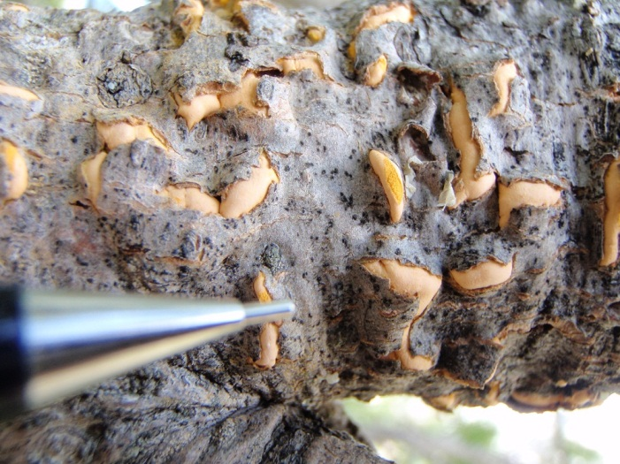
Figure 13. Blister rust aecia and aeciospores on whitebark pine at CRLA. Photo by Elena Thomas.

ii. Blister rust hosts at CRLA
Pine hosts of blister rust at CRLA are whitebark pine, sugar pine, and western white pine. CRLA’s alternate blister rust hosts are members of the Ribes, Castilleja, and Pedicularis genera. Nine Ribes species are known to exist within CRLA (Zika 2003): Siskiyou gooseberry (Ribes binominatum), waxy currant (Ribes cereum var. cereum), Crater Lake currant (Ribes erythrocarpum), whitestem gooseberry (Ribes inerme var. inerme), swamp black gooseberry (Ribes lacustre), gummy gooseberry (Ribes lobbii), shinyleaf gooseberry (Ribes roezlii var. cruentum), red flowering currant (Ribes sanguineum var. sanguineum), and sticky currant (Ribes viscosissimum), and these may serve as alternate hosts to blister rust. Additionally, six kinds of Castilleja: Applegate’s paintbrush (Castilleja applegatei var. applegatei), wavy-leaved paintbrush (Castilleja applegatei var. pinetorum), cobwebby paintbrush (Castilleja arachnoidea), scarlet paintbrush (Castilleja miniata var. miniata), frosted paintbrush (Castilleja pruinosa), and Suksdorf’s paintbrush (Castilleja suksdorfii); and two species of Pedicularis: elephant heads (Pedicularis groenlandica), and sickletop lousewort (Pedicularis racemosa) have been found within CRLA (Zika 2003). Mulvey (2010) observed natural blister rust infection of C. applegatei at CRLA; she also determined that C. arachnoidea and P. groenlandica are susceptible to blister rust infection through field inoculation trials at CRLA. P. racemosa and C. miniata were also observed to have natural blister rust infection at Mt. Hood, Mt. Adams, and Mt. Rainier National Park (Mulvey 2010). The susceptibility of C. pruinosa and C. suksdorfii remains to be studied. Since CRLA’s whitebark pine communities contain a greater abundance of Ribes than Castilleja or Pedicularis, Ribes is probably the more significant alternate host to the blister rust life cycle (Mulvey 2010).

iii. Blister rust’s arrival at CRLA
Blister rust was first discovered in western North American in 1921 in Vancouver, British Columbia (McDonald and Hoff 2001). By 1928, blister rust had spread southward through Oregon down the Coast Range almost to California, and halfway down the Cascade Range (Benedict 1981); it arrived in southern Oregon in 1929 (McDonald and Hoff 2001). It is unclear when blister rust was first discovered within CRLA. A press release produced by the CRLA Office of the Superintendent stated that as of August 7, 1930, extensive surveys had yielded no evidence of blister rust within the park, and it was believed that no blister rust was present within 160 km of the park (USDI NPS 1930). Murray and Rasmussen report that blister rust was found near the park as early as 1935 (USDA 1949, cited in Murray and Rasmussen 2000, 2003). Blister rust was noted to be present within the park in 1936, when NPS Forester Mark Pike made the following observation within the Cloudcap area (Cook 1936):
“Indications of Blister Rust attacks on a few of the pine were noticed but it seemed to be confined almost entirely to young trees from two to three feet in height. No trees killed by Blister Rust were found. It is my opinion that this area will not be seriously damaged by White Pine Blister Rust.”
Blister rust was detected in CRLA during a site visit made from September 27 – October 1st, 1941, by members of the USDA Bureau of Entomology and Plant Quarantine, Division of Plant Disease Control office (Benedict 1941; Leavitt 1941). Surveys were conducted along the caldera rim from Skell Head to Kerr Notch; at the headwaters of Cavern Creek, Sand Creek, and Castle Creek; and in the Annie Creek canyon. Blister rust was confirmed within the Annie Creek canyon, where infections were found on 150 Ribes plants, 7 western white pines, and one sugar pine. The Ribes species afflicted were R. inerme var. inerme, R. viscosissimum, R. binomatum, R. lacustre, and R. cereum var. cereum. No blister rust was encountered in other areas of the park. A letter drafted in response to these findings by CRLA Superintendent E.P. Leavitt indicated that this was the first blister rust infection documented within CRLA (Leavitt 1941).

iv. Blister rust control
The growing blister rust epidemic in the Pacific Northwest led to the expansion of the national Blister Rust Control Program to Oregon. An experimental project was initiated in 1926 on the Rogue River National Forest; a larger Blister Rust Control operation was established in 1933 near Union Creek on the Rogue River National Forest (Benedict 1981). Expertise and assistance from this Union Creek operation were shortly made available for similar Ribes eradication efforts at CRLA. Plans for Blister Rust Control at CRLA raised concerns by park officials about eradicating one of CRLA’s showcase species, the Crater Lake currant:
“…it would be a practically unsurmountable (sic) task to destroy all of the Crater Lake currant in the Park area in the Hudsonian life zone, the higher life zone which we have in Crater Lake National Park. The forest cover is mostly mountain hemlock and the whitebark pine with a few of the true firs appearing which live in the higher elevations. In the particular portion that the currant vine is so abundant, and it offers a vegetative cover for the forest floor that would be left practically bare if the currant vines were destroyed.”
--D.S. Libbey (1932), Assistant Superintendent and Park Naturalist

“In the matter of the White Pine Tree Blister Rust (sic): It seems to be the plan to begin eradication work sometime during the present season, starting in the White-bark Pine area on Cloud Cap (sic). This threatens our prize currant, Ribes erythrocarpum. I am hoping that something can, or will be, done to head this off, at least until we can be shown that the blister is present and the susceptibility of the plant can be studied.”

--E.J. Applegate (1937), Ranger Naturalist
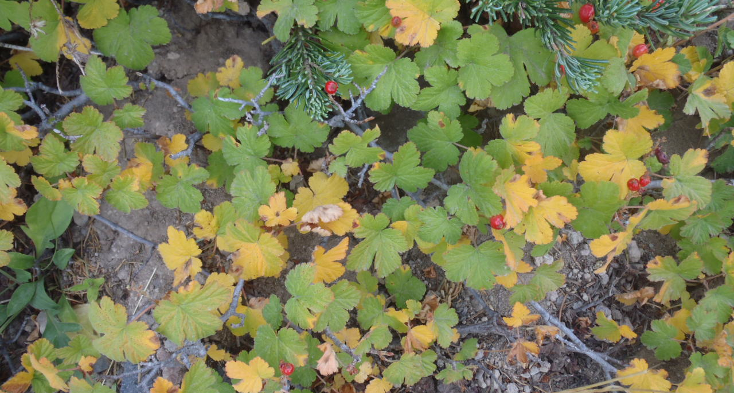
Figure 14. The Crater Lake currant, Ribes erythrocarpum.

Despite these concerns, in 1937 the Cloud Cap Blister Rust Control Unit was established within CRLA and Ribes eradication was performed within a 486 ha area that was later expanded to 1,470 ha in 1939. The Cloudcap area was selected for Ribes eradication work because it contained the park’s largest concentration of pure whitebark pine stands and tree mortality in this area was deemed unacceptable. Sentiments of the period are reflected here by one of the era’s most prominent plant pathologists:
“At a place like Cloud Cap, especially selected as one of the show places of the park, the pines offer the only break in the monotony and bleakness of highlands poor in color and form. They are of the greatest value in framing the magnificent view and in softening harsh outline. Since no other tree form of approximately the same character, in fact of any kind, will take their place once they are gone it appears not only justified but clearly indicated that they be protected from the attacks of blister rust through eradication of Ribes…”
--E.P. Meinecke (1936)
Additional Ribes eradication work was proposed along the entire caldera rim, but since whitebark pine grows in association with other conifer species rather than as the dominant forest cover, it was determined to be impractical. Other proposed projects included a 61 ha unit west of the Cloud Cap Control Unit from the lakeshore to the caldera rim, and a 2,266 ha unit encompassing the Annie Creek Canyon between Annie Springs and the southern park boundary. Excessively steep slopes in both proposed project areas probably contributed to their abandonment.
Ribes eradication within the Cloud Cap Control Unit was executed from 1937-1949 (Table 2). During this time, approximately 150,000 Ribes plants were destroyed through manual removal. This work proved quite difficult especially for R. erythrocarpum due to the presence of many stolons requiring much digging to remove (Wessela 1937). The Cloud Cap Control Unit was last inspected in 1962, upon which several R. erythrocarpum plants were found but without blister rust infection. No blister rust infection was found on whitebark pine.

Table 2. Summary of blister rust control efforts on the Cloud Cap unit.
Work/Year | Hectares of Ribes removal | Total Hectares Surveyed | # Ribes removed
Initial Work, 1937-1939 | 164 | 1,470 | 130,000
Second Work, 1940 | 142 | 463 | 14,000
Third Work, 1949 | 106 | 168 | 6,000
Total | 412 | 2,101 | 150,000

Blister rust infection is damaging to Ribes plants, as it affects productivity and can cause mortality (Zambino 2010). Some level of resistance to blister rust is present within North American Ribes (Zambino 2010). Blister rust infection rates on whitebark pines within the Cloud Cap Control Unit remain the lowest within the park perhaps due to a combination of a drier climate and fewer blister rust alternate hosts.

v. Studying blister rust impacts on CRLA whitebark pine
Several studies have been conducted at CRLA examining blister rust infection in whitebark pine stands, yielding varying results (Table 3). This is partially due to differences in methodology – a principal one being whether infection rates have been determined by the presence of active or inactive cankers (or both). Murray (2011) reports that cankers can be dynamic and switch between active and inactive status. While studying cankers on whitebark pine from 2003-2007 within CRLA, he found that half of all inactive cankers did not reactivate, and suggested that determining blister rust infection based on presence of inactive cankers may overestimate infection rates. Another difference among studies is the size class of whitebark pine for which results are reported. Regardless of the discrepancies among studies, their results clearly point to the fact that blister rust is causing significant decline of CRLA’s whitebark pine.
In the early 1990s, mortality of whitebark pine was observed along the trail to Watchman Lookout. Maffei and Eglitis (1991) noted that approximately 5% of whitebark pine around the summit was killed by blister rust with many more trees infected.
A study initiated in 1999 sampled CRLA’s whitebark pine across 24 plots in the Mt. Scott and Cloudcap areas (Donahue 2000). No blister rust infection was found and no Ribes individuals were encountered; however, the latter may be an artifact of blister rust control efforts (Figure 15). A total of 1,111 trees were sampled; 32% had no observable damage, 64% had some observable damage (primarily weather-related); and 4% were dead (Donahue 2000). Stand density was found to range from 240-1,140 trees/acre with whitebark pine representing 78% of the total stand density and 87% of the seedling density (Donahue 2000). Lack of blister rust infection was thought to be attributable to the location of the study area on the east side of the Cascade Divide, which created climatic conditions unfavorable to the blister rust life cycle (Donahue 2000).
Another study conducted by Murray & Rasmussen (2000, 2003) sampled 1,200 whitebark pines within 24 transects throughout the park. They found 0-20% blister rust infection as determined by presence of active cankers, which was concentrated on the west side of the park. Blister rust infection was present on 8% of all trees > 25 cm diameter at breast height (DBH – which is 1.37 m above the ground); 12% of trees between 0.1 – 24 cm DBH; and 3% of saplings (trees smaller than DBH). Transects with Ribes supported higher blister rust infection rates (12%) than those without Ribes (4%). Murray and Rasmussen calculated these averages by dividing the number of live stems infected by the total number of live and dead stems encountered; the data were later recalculated as the number of live stems infected divided by the total number of live stems encountered, yielding a mean infection rate of 11% for trees > 25cm DBH (Ward et al. 2006a). Those transects without Ribes were located in the Mt. Scott/Cloudcap areas, which may reflect past Blister Rust Control efforts; Murray and Rasmussen felt the drier east-side climate may have contributed to lower incidence of blister rust infection. They estimated that mature whitebark pine were declining at a rate of 0.4% annually, and predicted that by 2050 whitebark pine at CRLA would occupy half of its historic distribution.
Goheen (2000) sampled whitebark pine stands at Llao Rock and along the West Rim, Watchman Lookout, and Mt. Scott trails. She determined blister rust infection by the presence of both active and inactive cankers. This effort yielded an average blister rust infection rate of 51%, with the highest infection rate (67%) occurring along the Mt. Scott trail. The area displaying the highest blister rust-caused mortality (22%) was along the West Rim trail south of the Watchman.
Wittmer (2006) performed a survey of whitebark pine located along the promenade at Rim Village. She found a mortality rate of 29%. Among living trees, she determined a blister rust infection rate of 19.4%.
The KLMN conducted a pilot study within CRLA during the 2009 field season. Twenty whitebark pine monitoring plots were established in this effort. They found a mean blister rust infection rate as determined by presence of active and inactive cankers of 25% (range 0-67%), with trees > 25 cm DBH having an infection rate of 30% (Smith et al. 2011a). Plots with Ribes had a significantly higher incidence of blister rust infection for trees > 15 cm DBH (35%) vs. plots without Ribes (12%). No blister rust infection was observed on Ribes or Castilleja plants. Active cankers were more common in west-side plots (11%) vs. east-side plots (4%); the percentage of trees infected on the west-side was 28.7% vs. 21.6% on the east-side. Overall mortality of whitebark pine > 15 cm DBH was determined at 23%; 20% of that was due to blister rust, 21% from mountain pine beetle, and 5% was from blister rust and mountain pine beetle (54% of dead trees was from unknown causes).
Seven long-term whitebark pine monitoring plots were installed at CRLA in 2003; with the exception of 2008, they have been sampled annually. Utilizing data from 2003-2009 sampling events, Murray (2010) reports an 8% mortality of trees taller than DBH (1.37 m); which represents a 1% annual decline since 2003. When the monitoring plots were installed in 2003, 19% of whitebark pines over 15 cm DBH were already dead; in 2012, 36% of all whitebark pines over 15 cm DBH were dead. This represents a 24% decrease in the number of living whitebark pines over 15 cm DBH from 2003-2012. Of these dead trees, 56% were killed by mountain pine beetle attack. Blister rust infection rates in trees > 15 cm DBH (as determined by both active and inactive cankers) increased from 13% in 2003 to 38% in 2012, perhaps due to greater ability to detect infections in 2012 based on previous monitoring of trees. The active blister rust infection rate in trees > 15 cm DBH was 11% in 2003, and 20% in 2012. Mortality rates and causes vary by location, with the Mt. Scott monitoring plot experiencing no mortality of trees greater than 15 cm DBH from 2003-2012, and the North Junction monitoring plot experiencing a 41% mortality rate of trees in this size class during this time period - primarily from mountain pine beetle attack.
As whitebark pine is one of the KLMN’s Vital Signs, it is the focus of intensive monitoring using standard protocol for high elevation five-needle pines in the NPS Pacific West region (McKinney et al. 2012). This protocol was implemented at CRLA in the summer of 2012, with the establishment of ten plots for long-term monitoring. An additional 20 plots will be installed in 2013-2014 for a total of 30 monitoring plots at CRLA; each plot will be sampled every three years, with 10 plots sampled annually. This monitoring effort will yield invaluable information on trends in CRLA’s whitebark pine communities.

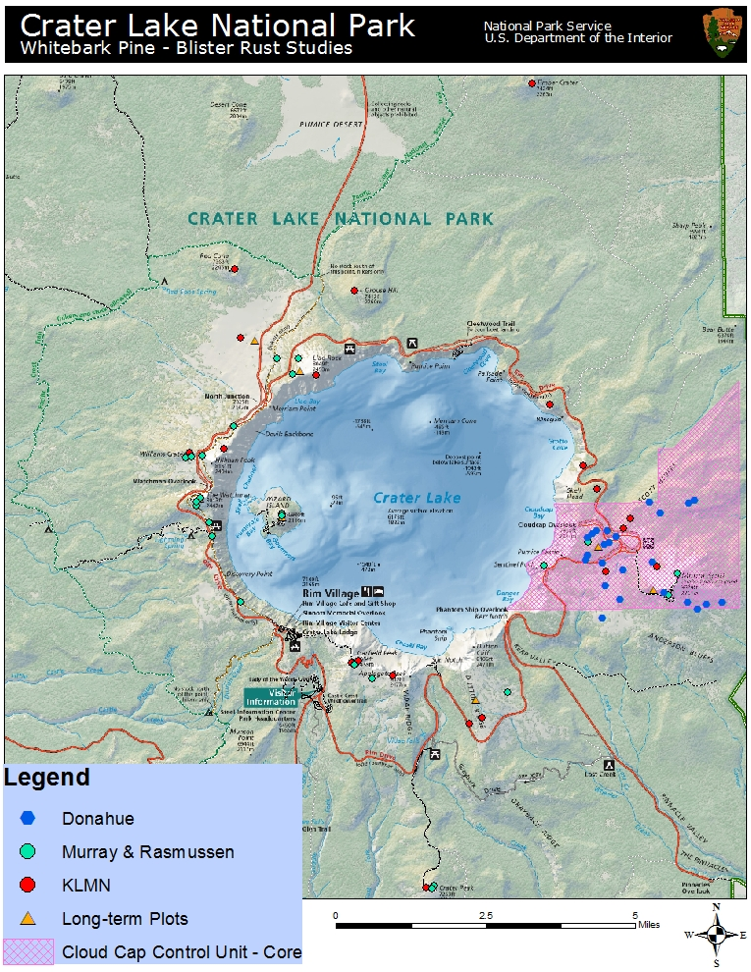
Figure 15. CRLA whitebark pine/blister rust study locations, including Donahue (2000), Murray & Rasmussen (2000), KLMN pilot study (Smith et al. 2011a), and CRLA’s long-term monitoring plots; Goheen (2000) and the new KLMN monitoring plots are not included. The Cloud Cap Blister Rust unit reflects only 486 ha of “Core” Ribes eradication efforts; the extent of the larger 1,470 ha unit remains undocumented at this time.
Table 3. Summary of CRLA blister rust infection rates, 2000-2009.
Location | # Plots | Active BR Infection | Inactive BR Infection | Both Active & Inactive | Source
Anderson Bluffs | 4 | 0% | 0% | 0% | Donahue 2000
 | 1 | 8% | 20% | 28% | Smith et al. 2011a
Applegate | 1 | 12% | na | na | Murray & Rasmussen 2000
 | 1 | 19% | 39% | 58% | Smith et al. 2011a
Castle Rock | 1 | 0% | na | na | Murray & Rasmussen 2000
Cloudcap | 10 | 0% | 0% | 0% | Donahue 2000
 | 1 | 2% | na | na | Murray & Rasmussen 2000
Crater Peak | 2 | 4-10% | na | na | Murray & Rasmussen 2000
 | 1 | 5% | 43% | 48% | Smith et al. 2011a
Discovery Point | 1 | 18% | na | na | Murray & Rasmussen 2000
Dutton Ridge | 1 | 8% | na | na | Murray & Rasmussen 2000
 | 2 | 0-25% | 4-15% | 4-40% | Smith et al. 2011a
Garfield | 1 | 2% | na | na | Murray & Rasmussen 2000
 | 2 | 0-19% | 0% | 0-19% | Smith et al. 2011a
Grouse Hill | 1 | 0% | 14% | 14% | Smith et al. 2011a
Devils Backbone/Hillman | 2 | 12-14% | na | na | Murray & Rasmussen 2000
 | 1 | na | na | 61% | Goheen 2000
 | 1 | 16% | 25% | 41% | Smith et al. 2011a
Llao Rock | 2 | 4-12% | na | na | Murray & Rasmussen 2000
 | 2 | na | na | 49-51% | Goheen 2000
 | 1 | 16% | 22% | 38% | Smith et al. 2011a
Mt. Scott | 6 | 0% | 0% | 0% | Donahue 2000
 | 2 | 0% | na | na | Murray & Rasmussen 2000
 | 1 | na | na | 67% | Goheen 2000
 | 1 | 0% | 0% | 0% | Smith et al. 2011a
North Junction | 1 | 4% | na | na | Murray & Rasmussen 2000
 | 1 | 22% | 11% | 33% | Smith et al. 2011a
Red Cone | 1 | 0% | 18% | 18% | Smith et al. 2011a
Rim Village | na | na | na | 19.4% | Wittmer 2006
Roundtop | 1 | 0% | 0% | 0% | Smith et al. 2011a
Scott Bluffs | 4 | 0% | 0% | 0% | Donahue 2000
 | 2 | 0% | 14-27% | 27% | Smith et al. 2011a
Skell Head | 2 | 0-7% | 2-60% | 2-67% | Smith et al. 2011a
Timber Crater | 1 | 0% | 8% | 8% | Smith et al. 2011a
Watchman | 3 | 2-12% | na | na | Murray & Rasmussen 2000
 | 1 | na | na | 31.5% | Goheen 2000
Watchman South | 2 | 18-20% | na | na | Murray & Rasmussen 2000
 | 1 | na | na | 46% | Goheen 2000
Williams Crater | 2 | 14-18% | na | na | Murray & Rasmussen 2000
 | 1 | 8% | 31% | 39% | Smith et al. 2011a
Wizard Island | 2 | 2% | na | na | Murray & Rasmussen 2000

vi. Blister rust impacts on whitebark pine
Whitebark pine has little natural resistance to blister rust; < 5% of trees in each population possesses genetic resistance (Tomback 2007). The production of cankers on pines disrupts phloem tissues and girdles the stem or branch above the infection site; young trees are quickly killed since the fungus does not have far to travel to reach the bole of the tree, whereas large trees may suffer a prolonged death as individual branches succumb to the fungus (Campbell and Antos 2000; Kendall and Keane 2001). Blister rust reduces the reproductive capacity of whitebark pine by killing cone-bearing branches (Goheen et al. 2002; McKinney and Tomback 2007). This causes a reduction in food supply for the Clark’s nutcracker, which could cause the nutcracker to suspend dispersal activities and endanger the regeneration capacity of the tree (McKinney and Tomback 2007; McKinney et al. 2009). In the northern and central Rocky Mountains, a minimum whitebark pine basal area of 5.0 m²/ha has been determined for whitebark pine stands to sustain foraging nutcracker populations (McKinney et al. 2009).
Blister rust is an ongoing and long-term threat to CRLA’s whitebark pine. All age classes of whitebark pine are killed by the disease (Shoal and Aubrey 2006). Continued infection and mortality may lead to population extinctions and reduce genetic diversity and gene flow, with cascading effects on species dependent on whitebark pine communities and the subsequent reduction in ecosystem services that whitebark pines provide (Schoettle and Sniezko 2007).

B. Mountain Pine Beetle

The mountain pine beetle, hereafter referred to as MPB, is a native insect that has a natural role within whitebark pine communities (Bentz and Schen-Langenheim 2007; Gibson et al. 2008). Its primary host species are lodgepole pine, sugar pine, western white pine, ponderosa pine, and whitebark pine (Furniss and Carolin 1977), all of which are found within CRLA. The MPB is the single most destructive insect in forests of the western U.S. (Furniss and Carolin 1977), and the most damaging insect of whitebark pine forests (Bartos and Gibson 1990). Until the arrival of blister rust, MPB was the leading mortality agent of whitebark pine (Perkins and Roberts 2003). In the Rocky Mountains, beetle remains have been found in Holocene era lake sediments (> 8,500 years ago), linking MPB to ancient whitebark pine forests (Brunelle et al. 2008).

i. Mountain pine beetle life cycle
The following account of the MPB life cycle is taken from Amman (1977) and Safrenyik (1989). Female adult beetles initiate attack on a pine host from June through September, depending on elevation and temperature. The bulk of beetles take flight within the period of a week, but the flight period may last longer than 60 days at high elevations (Gibson et al. 2008; Bentz et al. 2011). Female MPB bore into the bark of a tree and release aggregating chemicals that invite other nearby beetles to join with them in attack with the goal of overwhelming their host’s defenses. Group attack on an individual tree is finished in 1-2 days. The female can also submit an anti-aggregating pheromone that deters overcrowding. After boring through bark, the female creates an egg gallery 25-30 cm in length; a male joins her to mate and then leaves. The female lays eggs in notches cut into the sides of the gallery; the eggs hatch in 1-2 weeks into larvae that feed on phloem tissues perpendicular to the egg gallery, which girdles the tree. The larvae feed through the fall, become dormant, and resume feeding in the spring. The larvae pupate and develop into adults by early- to late-summer. This process takes a year (univoltine) in lower elevation forests, but may take 2 years or more (semivoltine) to complete at higher elevations. MPB are usually present in the forest landscape at some level; at low densities they are considered endemic while periods of large population growth are deemed epidemic. At endemic MPB levels, trees of low vigor or with some preexisting damage are typically attacked; when MPB are in epidemic mode all trees of appropriate diameter and with sufficient phloem thickness are vulnerable.
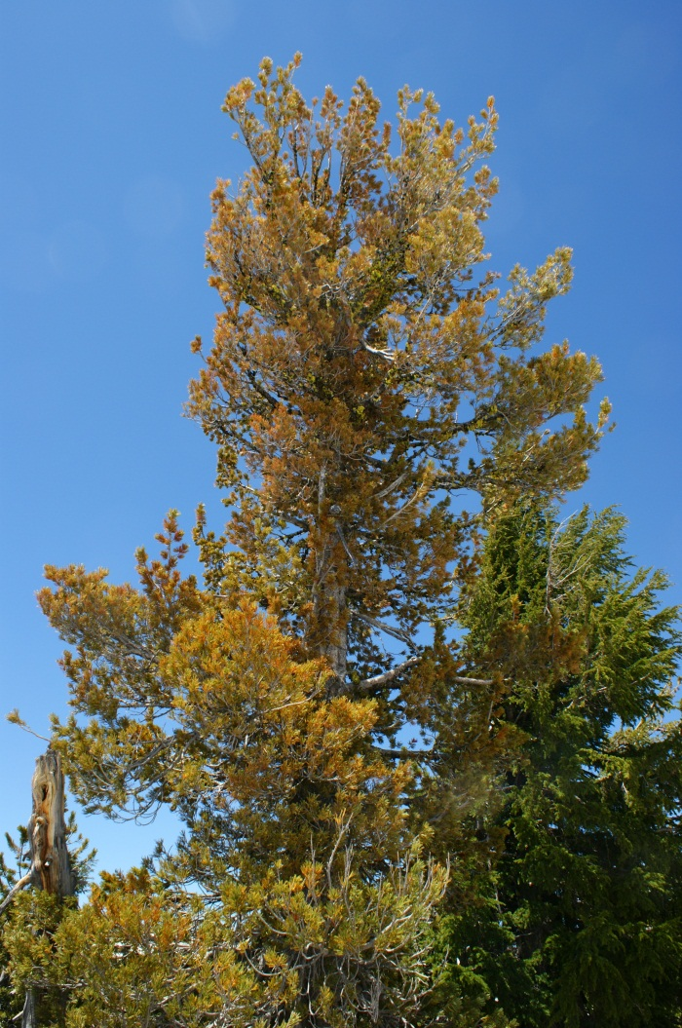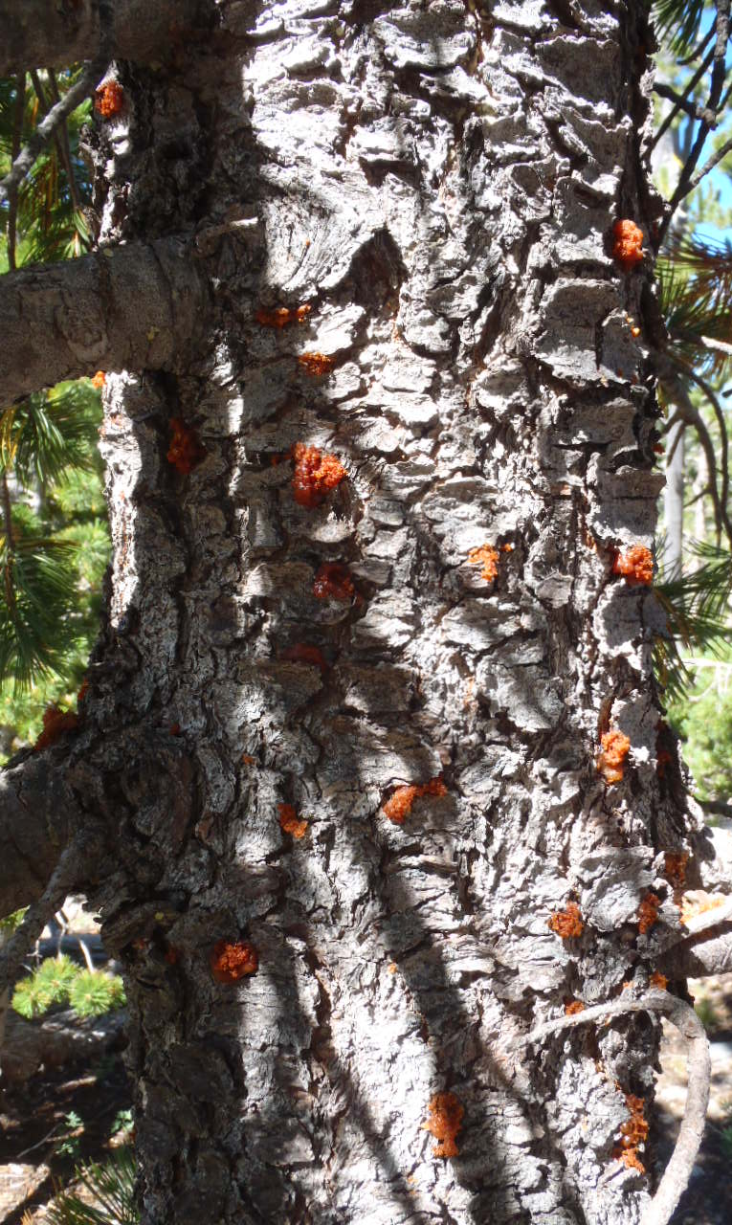
Figure 16. Whitebark pine dying from mountain pine beetle infestation.

While MPB have a historical precedent in whitebark pine communities, the short growing season and cooler temperatures at higher elevations where whitebark pine grow have largely restricted epidemic MPB outbreaks to periods of unusual warmth (Logan and Powell 2001; Perkins and Roberts 2003; Bentz and Schen-Langenheim 2007; Gibson et al. 2008; Logan et al. 2009; Logan et al. 2010). Overwintering MPB larvae are sensitive to extreme cold and may be killed when temperatures dip too low (Amman 1973; Bentz et al. 2011). A more common impact of high elevation climate on MPB is the inability to complete its life cycle in one season (Amman 1973; Logan and Powell 2001). MPB are not known to have diapause – their phenology appears to be strictly under temperature control (Logan and Bentz 1999). They display adaptive phenology - emergence must occur early enough in the season to allow for reproduction but late enough to avoid damaging temperatures; this also must be synchronized with other MPB to facilitate group attack strategies (Logan and Bentz 1999; Logan and Powell 2001). MPB can immediately respond to warmer temperatures by adjusting timing of emergence and synchronicity, enabling them to begin their life cycle earlier and shift from a semivoltine to a univoltine pattern that greatly increases their impact on whitebark pine (Logan and Powell 2001; Bentz et al. 2011). Warmer winter temperatures are allowing for the survival of freeze-intolerant stages of MPB including adults; these second-year adults are able to produce an earlier brood that joins efforts with MPB offspring from new adults (Logan et al. 2010; Bentz et al. 2011). Warmer temperatures at higher elevations can facilitate both univoltine and semivoltine life cycles and provide an array of MPB of differing ages that then attack whitebark pine (Bentz and Schen-Langenheim 2007; Bentz et al. 2011). Whitebark pine is more vulnerable to MPB attack and displays less resistance than other species that have evolved with epidemic MPB outbreaks such as lodgepole pine (Logan et al. 2010).
Perkins and Roberts (2003) found several factors that may predispose a whitebark pine stand to MPB attack. These include larger diameters (> 18 cm); higher basal area (> 10 m²/ha); multi-stemmed trees growing in a cluster; trees stressed by drought or other factors; and trees growing in close proximity to lodgepole pine. Lodgepole pine is regularly affected by epidemic MPB outbreaks and MPB life cycles are typically univoltine in this forest type (Amman 1977); it is thought that MPB originating in lodgepole pine can serve as the source for many whitebark pine attacks (Bartos and Gibson 1991).

ii. Mountain pine beetle at CRLA
CRLA’s forests have evolved with the MPB, and over the past 100 years there have been efforts to document and even control its eruption and progression across the landscape. In 1913, an epidemic MPB outbreak occurred around Diamond Lake on the Umpqua National Forest; by 1915 this outbreak had spread to park lodgepole pine stands (Wickman 1987). In 1923, CRLA sought assistance to slow or stop the progression of the outbreak and received funding for survey work in 1924 and subsequent control work in 1925 (Wickman 1987). This launched CRLA’s Insect Control Project, which involved surveying, locating, and treating trees infested with MPB. Insect control work continued at CRLA through the 1960s. Treatment involved cutting down infested trees and either burning the resulting slash, employing the “sun-curing” or solar method of peeling the bark and exposing the log to sunlight, or in the 1940s spraying the infected log with a mixture of oil and an insecticide (Wickman 1987).
While most of these control efforts were directed at lodgepole pine, all tree species infested with MPB at CRLA were targeted for treatment by the Insect Control Project. In 1933 alone, 147 whitebark pines were treated with the solar method or burned with oil (Solinsky 1933). CRLA’s whitebark pines often grow nearby or in association with lodgepole pine stands, and there is evidence that whitebark pines were impacted by MPB concurrently with other forest types within the park:
“The bark beetle, however, which years ago played havoc in the north part of the park among the lodgepole pines has made sporadic appearances elsewhere. Since most of the trees of the south Rim are hemlocks there is no worry in that respect. But a group of very picturesque old white bark pines on the rim near the Community House are doomed. They are marked for cutting to prevent spreading of this pest. The bark shows pitch tubes in places so thick that it might have been peppered with a shot gun. The trees serve very nicely as an outdoor laboratory for demonstration to those interested, and a bit of bark peeled off will disclose larvae in various stages of development. This particular school for elementary forestry will be closed this week, however, when the axe lays low these infected trees.”
--E.U. Homuth (1928)
A cold snap during the winter of 1932-33 may have been responsible for causing mortality to overwintering MPB and slowing the outbreak of the 1910s-1930s; temperatures of -25°C in December and -27°C in January were recorded within CRLA (Wickman 1987). A survey of whitebark pine stands near Scott Bluffs in 1939 as part of Blister Rust Control work remarked that very few (3%) of trees encountered were > 30 cm DBH; this observation coupled with evidence of past MPB activity led to the assumption that an epidemic MPB outbreak was to blame for the lack of large-diameter whitebark pine (USDI NPS 1939). Additional epidemic MPB outbreaks were recorded around 1946-1948 in the Pinnacles Valley and along Bear Creek (Wickman 1987). CRLA data included in Dolph (1967) show that the 1955-1966 period hosted endemic MPB populations with no large outbreaks. A MPB outbreak in whitebark pine was observed in August 1991 along the Mt. Scott trail; the extent of the outbreak was slightly above endemic levels and attributed to recent drought conditions (Maffei and Eglitis 1991). USDA Forest Service Aerial Detection Survey data (ADS) from 1980-2012 show substantial MPB activity within CRLA peaking around 1983-1986 and during 2007-2012; MPB did not affect whitebark pine on a scale large enough for aerial detection surveys until 2003 (Figures 17-21; Tables 4-5). ADS data utilized in Figures 17-20 and Table 4 include MPB activity in all host species and at all severity levels; data utilized in Figure 21 and Table 5 are specific to MPB activity within whitebark pine stands (severity levels are not distinguished). The ADS data have not been field-verified and are used here for purposes of detecting rough trends in MPB activity at CRLA.
North of the park, Goheen et al. (2002) found that > 50% of whitebark pine killed by MPB was also infected by blister rust. At CRLA, Murray and Rasmussen (2000, 2003) noted MPB-caused whitebark pine mortality in their sampling efforts, but it affected < 2% of trees and was confined to Wizard Island. Using data from long-term whitebark pine monitoring plots (2003-2007) at CRLA, Murray (2010) found that MPB was the principal mortality agent of whitebark pine. Smith et al. (2011b) also reported that MPB was the leading cause of whitebark pine mortality at CRLA. They found widespread MPB activity throughout the park, and noted that 5% of trees killed by MPB were also infected with blister rust (Smith et al. 2011b). Bentz and Schen-Langenheim (2007) modeled MPB emergence from trees attacked in 2004 in a 1,820 m elevation whitebark pine stand near CRLA. Their results showed that MPB displayed a 100% univoltine life cycle under these conditions. The authors stated that voltinism plus other climate-related stressors were facilitating conditions for increased MPB attack in whitebark pine communities.
This most recent (since 2007) MPB outbreak has clearly had a major impact on CRLA’s whitebark pine. Since MPB attack the largest, oldest trees with the highest cone-bearing potential (Kendall and Keane 2001), the impact of MPB outbreaks on wildlife - particularly the Clark’s nutcracker - and whitebark pine regeneration are substantial. MPB may also kill whitebark pine with genetic resistance to blister rust (Logan and Powell 2001; Hicke et al. 2006), further endangering whitebark pine’s continued existence at CRLA.

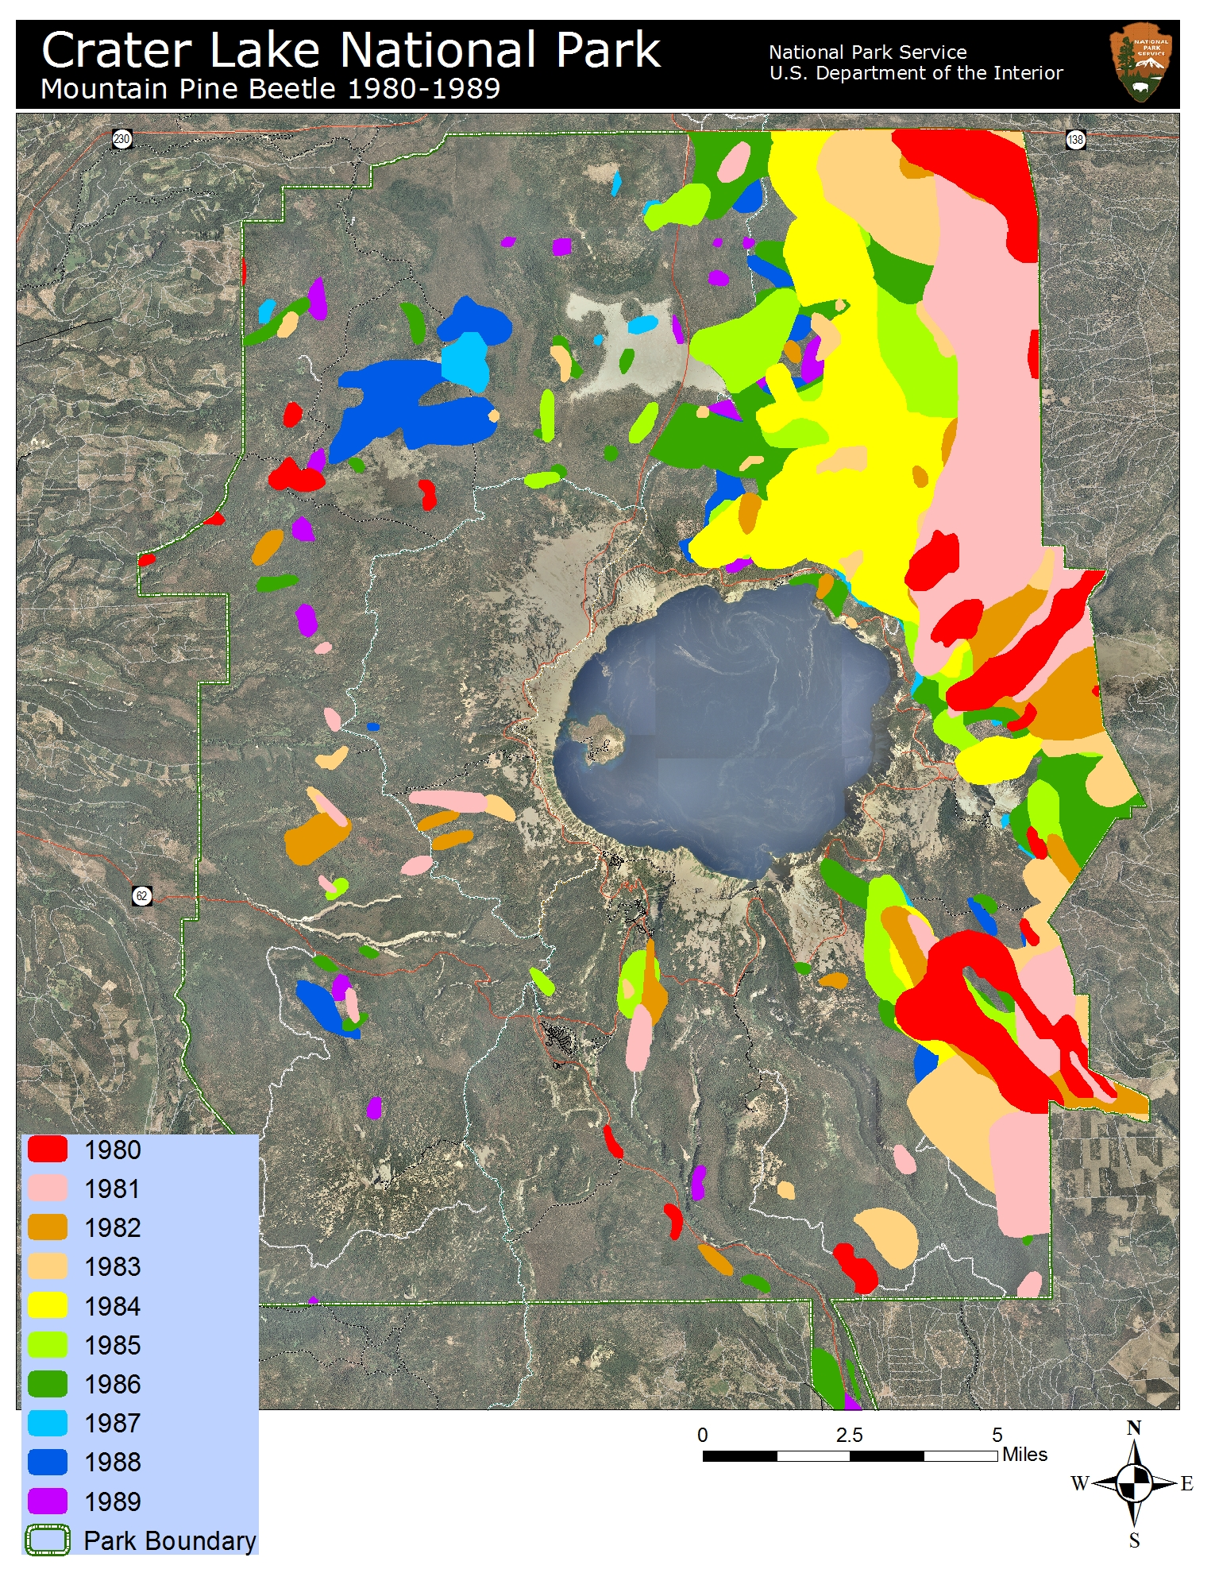
Figure 17. MPB activity at CRLA, 1980-1989 (USFS ADS).
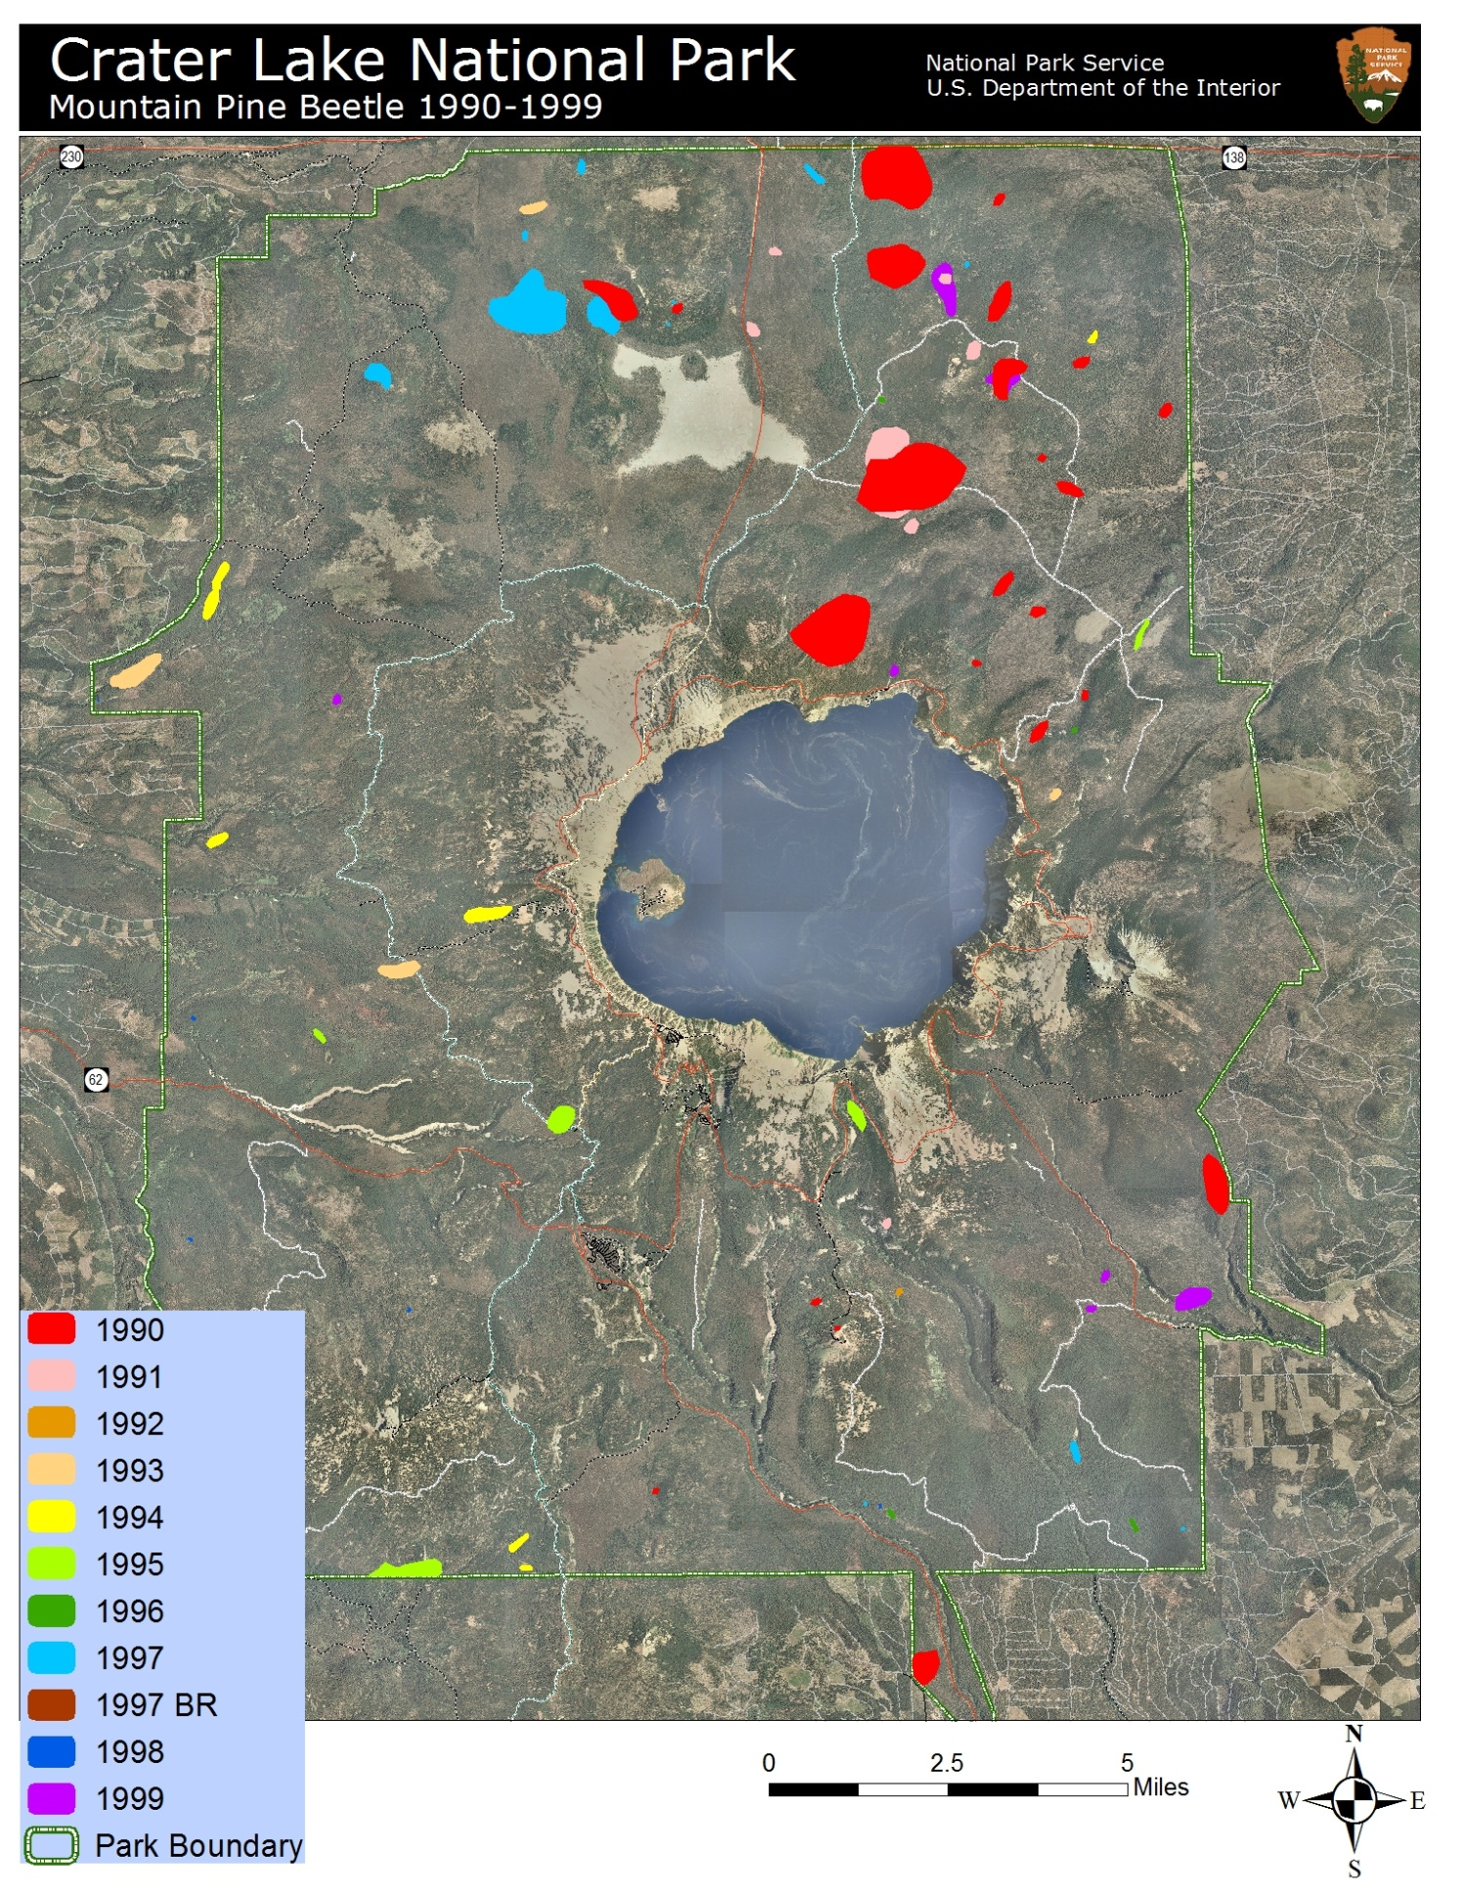
Figure 18. MPB activity at CRLA, 1990-1999 (USFS ADS). ‘BR’ indicates blister rust caused tree mortality.
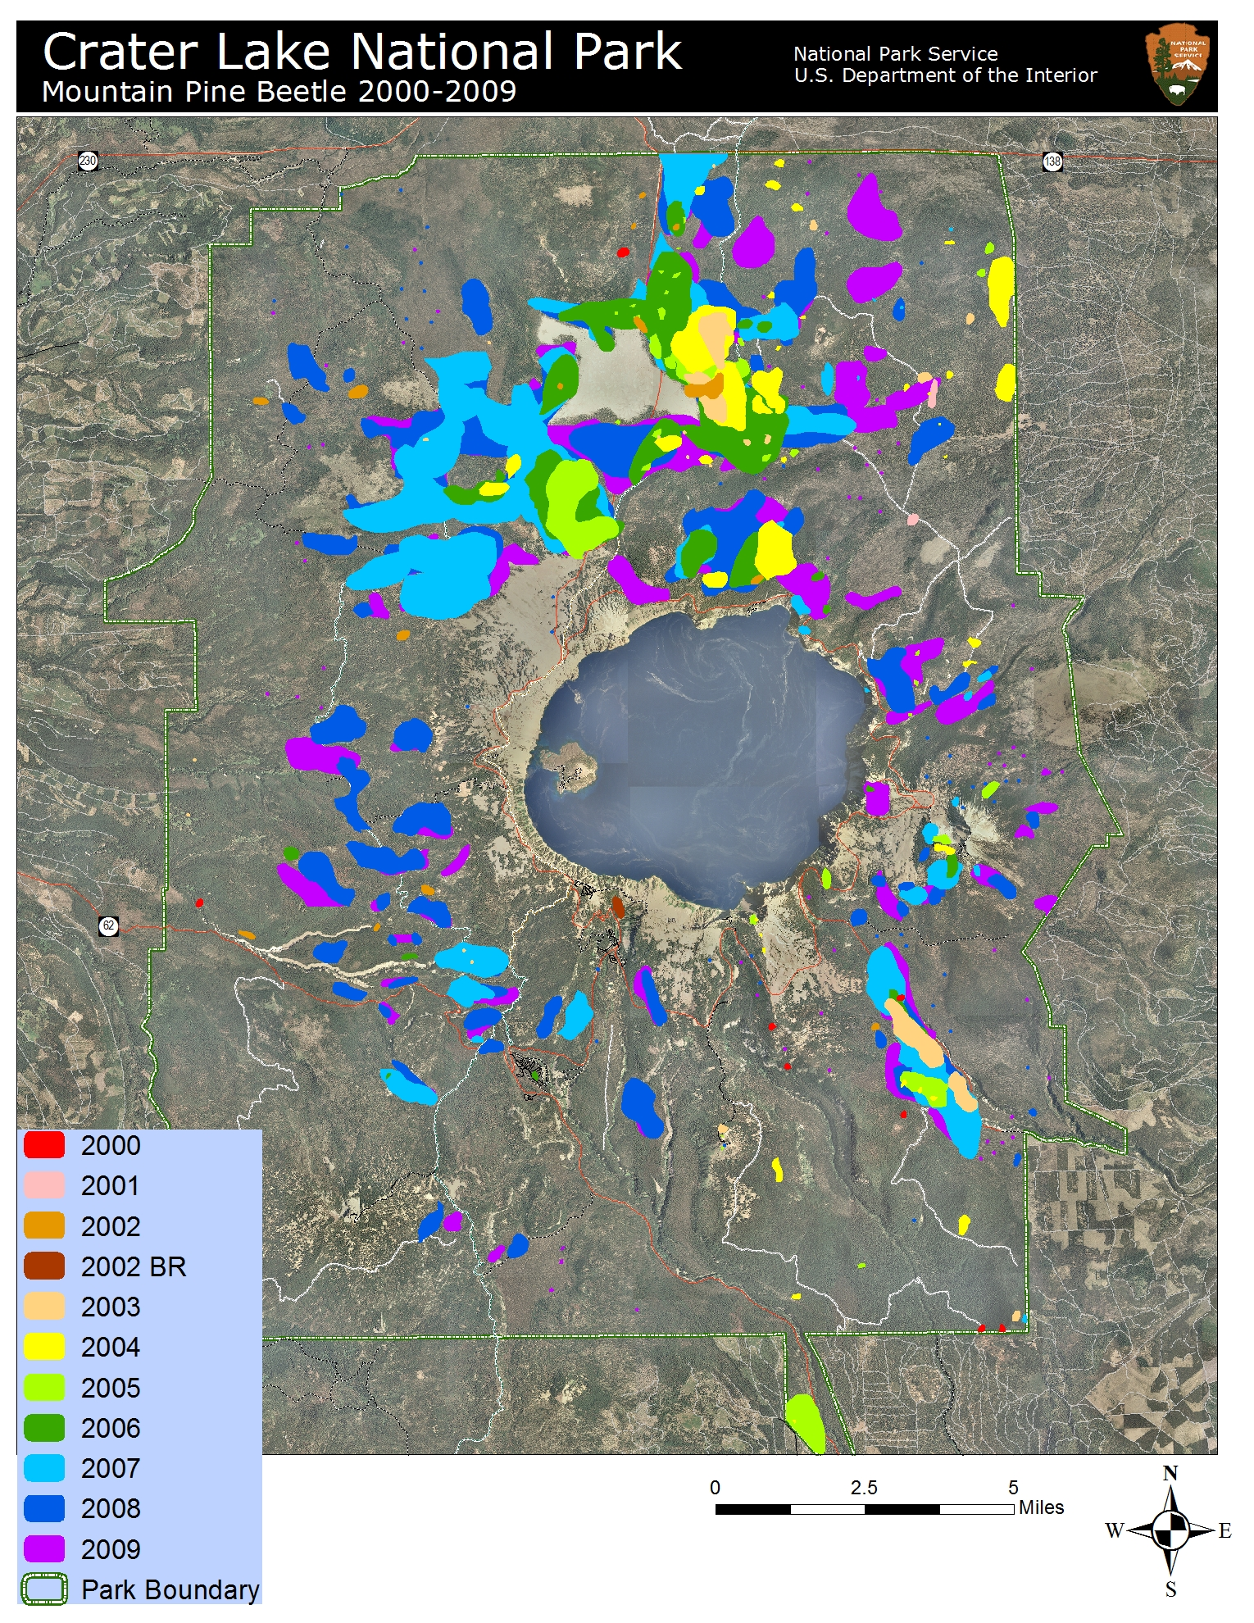
Figure 19. MPB activity at CRLA, 2000-2009 (USFS ADS). ‘BR’ indicates blister rust caused tree mortality.
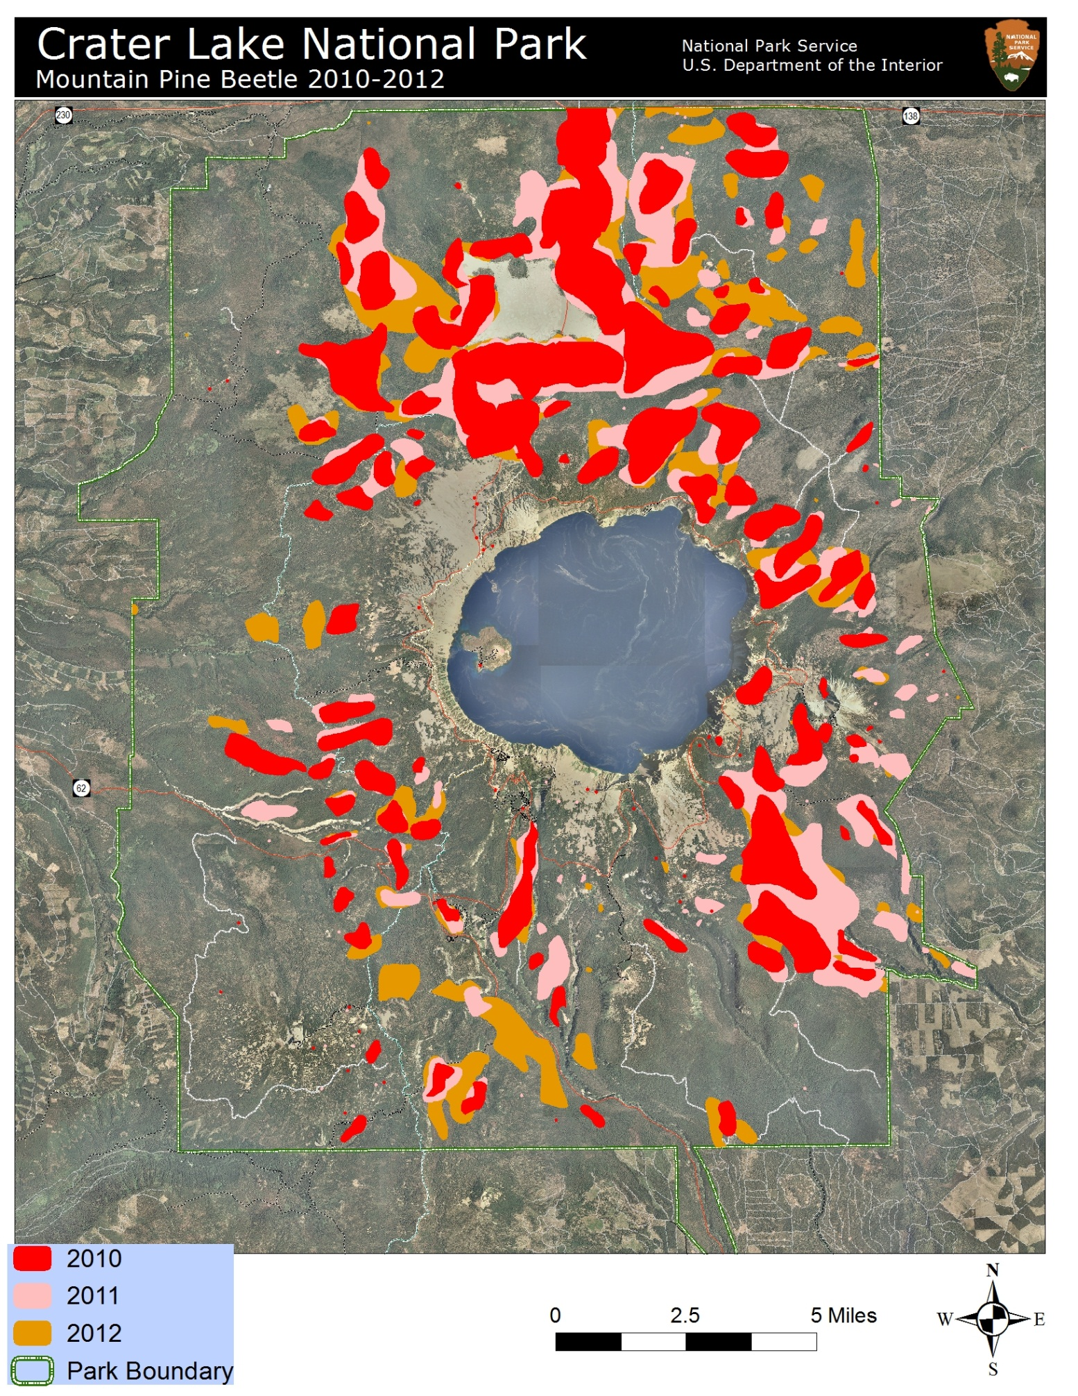
Figure 20. MPB activity at CRLA, 2010-2012 (USFS ADS).
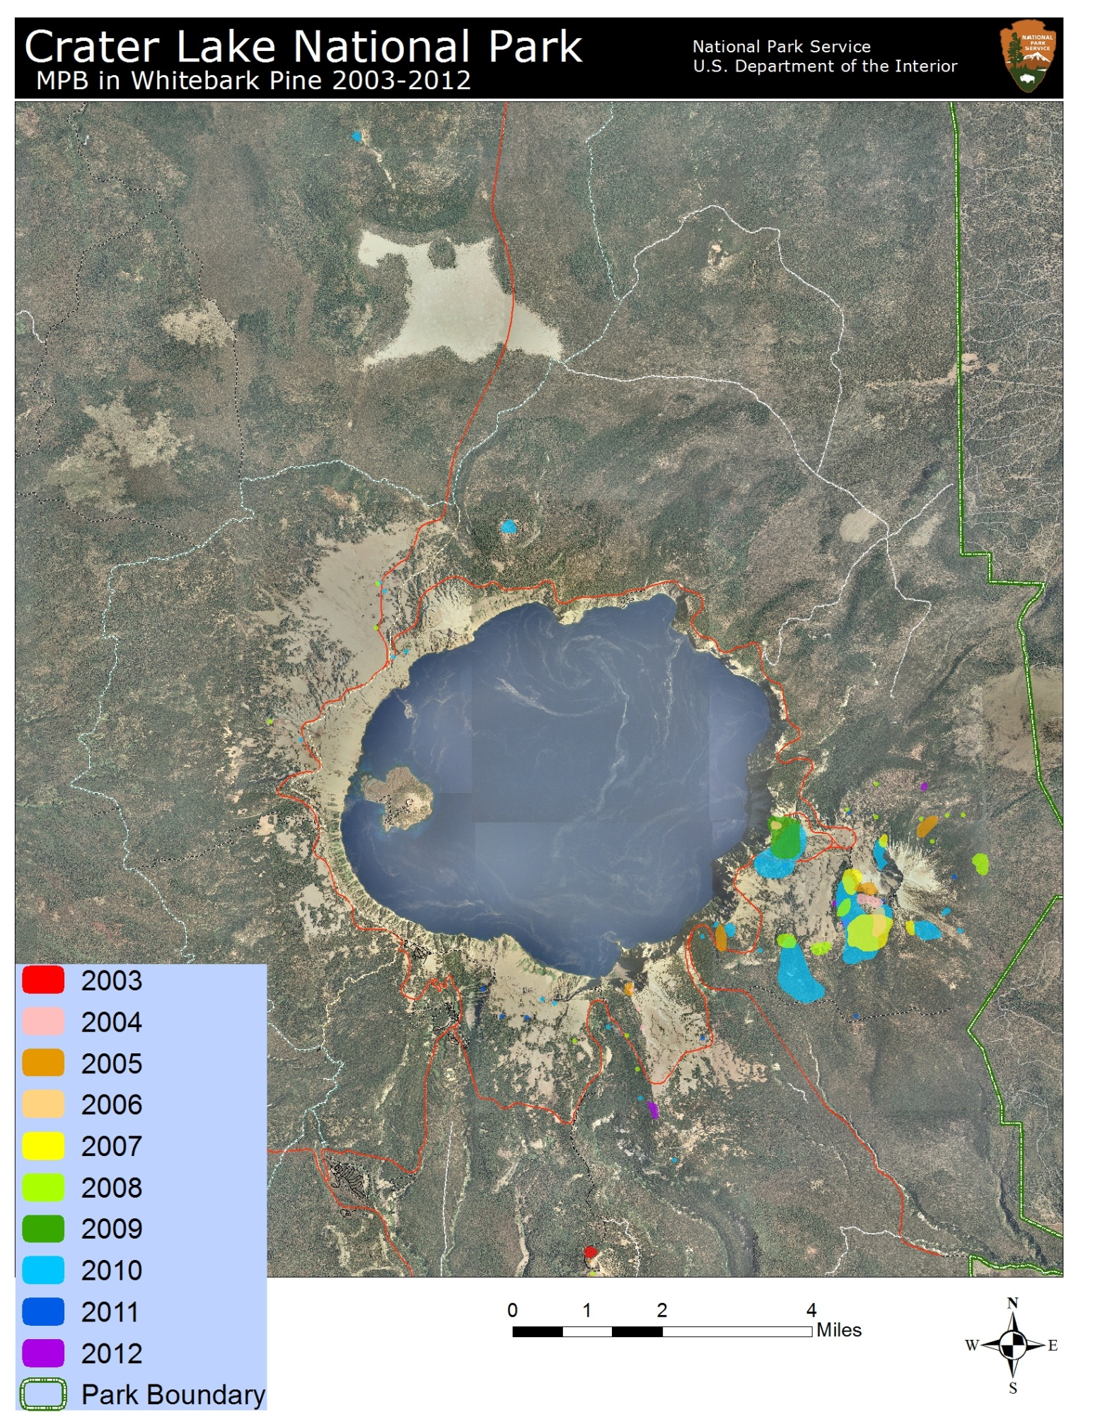
Figure 21. MPB activity in whitebark pine communities, 2003-2012 (USFS ADS).
Table 4. Total area (hectares) affected by MPB at CRLA, 1955-2012. 1955-1966 data from Dolph (1967); 1980-2012 data from USFS R6 ADS. Data for 1950-1954 and 1967-1979 are currently unavailable.
1950s | Ha | 1960s | Ha | 1980s | Ha | 1990s | Ha | 2000s | Ha | 2010s | Ha
1950 |  | 1960 | 1,214 | 1980 | 3,039 | 1990 | 1,055 | 2000 | 29 | 2010 | 9,405
1951 |  | 1961 | 2,590 | 1981 | 5,513 | 1991 | 264 | 2001 | 22 | 2011 | 10,358
1952 |  | 1962 | 2,201 | 1982 | 4,637 | 1992 | 4 | 2002 | 120 | 2012 | 10,048
1953 |  | 1963 | 478 | 1983 | 7,696 | 1993 | 86 | 2003 | 375 | 2013
1954 |  | 1964 | 890 | 1984 | 8,271 | 1994 | 82 | 2004 | 948 | 2014
1955 | 0 | 1965 | 728 | 1985 | 9,860 | 1995 | 106 | 2005 | 784 | 2015
1956 | 518 | 1966 | 1,060 | 1986 | 13,927 | 1996 | 9 | 2006 | 2,390 | 2016
1957 | 0 | 1967 |  | 1987 | 6,456 | 1997 | 259 | 2007 | 4,918 | 2017
1958 | 388 | 1968 |  | 1988 | 5,196 | 1998 | 4 | 2008 | 6,605 | 2018
1959 | 1,424 | 1969 |  | 1989 | 1,590 | 1999 | 118 | 2009 | 6,718 | 2019

Table 5. Total area (ha) affected by MPB at CRLA in whitebark pine forests, 2003-2012 (Data from USFS R6 ADS).
Year | Ha - WBP
2003 | 5
2004 | 14
2005 | 39
2006 | 19
2007 | 89
2008 | 52
2009 | 55
2010 | 348
2011 | 11
2012 | 12
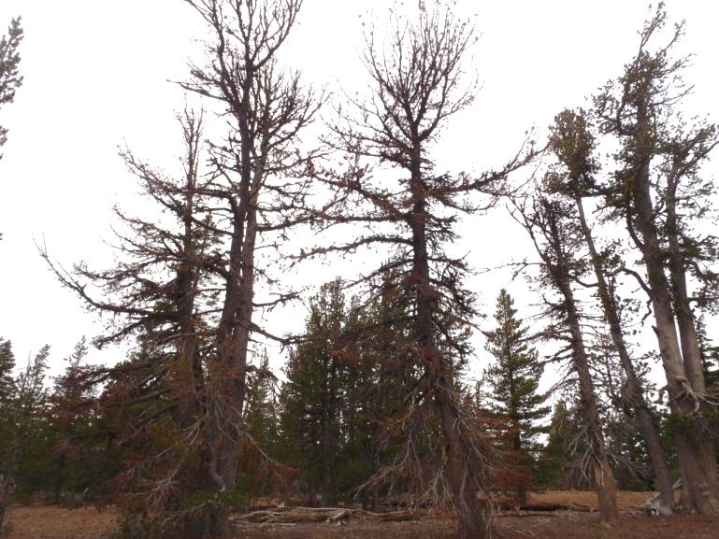
Figure 22. MPB-killed whitebark pines, East Rim Drive.

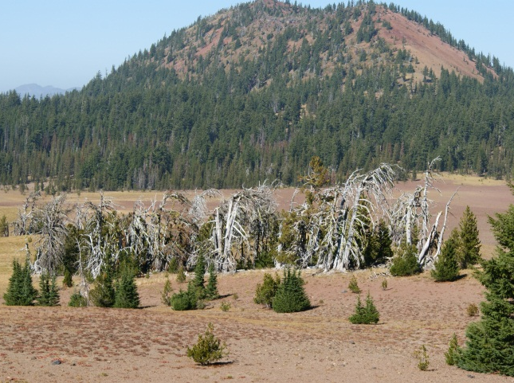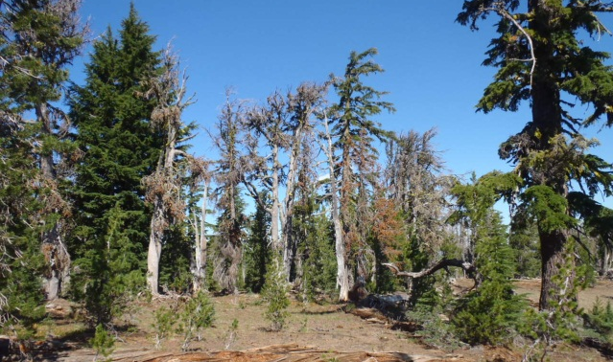
Figure 23. MPB-killed whitebark pines in North Junction (left) and Scott Bluffs (right) areas.

C. Dwarf Mistletoe

Dwarf mistletoe, Arceuthobium spp., is a native, parasitic vascular plant that causes localized impacts to CRLA’s whitebark pine communities. Whitebark pine is usually parasitized by limber pine dwarf mistletoe (A. cyanocarpum) (Arno and Hoff 1989; McCaughey and Tomback 2001), which at CRLA has been recognized incorrectly as hemlock dwarf mistletoe (A. tsugense ssp. mertensianae) due to an erroneous report in Hawksworth and Wiens (1996) (Bob Mathiasen, personal communication).
Both A. cyanocarpum and A. tsugense ssp. mertensianae have been included within the Campylopoda section of the subgenus Vaginata (Nickrent et al. 2004). Recent research performed at the molecular level has determined that several previously recognized species of Arceuthobium within the Campylopoda section are not distinct, including A. cyanocarpum and A. tsugense ssp. mertensianae; these are now included within the species A. campylopodum (Nickrent et al. 2004). These changes are reflected in recent flora revisions for Oregon and California (Oregon Flora Project 2012; Baldwin et al. 2012). However, these taxonomic changes remain controversial and are not fully supported by the forest pathology community.
Lumping of Arceuthobium species within A. campylopodum can obscure host-parasite relationships and cause confusion (Bob Mathiasen, personal communication). Therefore, CRLA follows Arceuthobium taxonomy outlined in Hawksworth and Wiens (1996). The dwarf mistletoe infecting whitebark pines at CRLA has been proven to be A. cyanocarpum using molecular and morphological methods (B. Mathiasen, personal communication). Whitebark pine is also susceptible to infection by lodgepole pine dwarf mistletoe (A. americanum) (Hawksworth and Wiens 1996; Hawksworth et al. 2002), which is also found at CRLA – this infection was reported on whitebark pines on Wizard Island in Jackson and Faller (1973) but has been refuted by subsequent studies (B. Mathiasen, personal communication). While dwarf mistletoe is not as widespread a threat to whitebark pine as blister rust or MPB, it is responsible for pockets of concentrated mortality within CRLA’s whitebark pine communities.
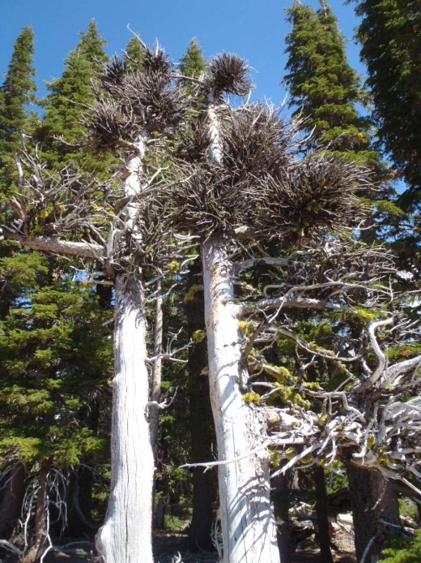
Figure 24. Whitebark pine infected with dwarf mistletoe at CRLA: witches’ brooms on a dwarf mistletoe-killed whitebark pine (left); dwarf mistletoe aerial shoots on whitebark pine branches (right).

i. Dwarf mistletoe life cycle
Infection of a pine host by dwarf mistletoe is an interesting process in that seeds are explosively released by the fruit into “ballistic flight” (Hawksworth et al. 2002) and travel at speeds up to 27 m/sec (Hawksworth and Wiens 1996). Seeds are generally released in late summer, and their range of dispersal is typically < 10 m from the parent plant but can range as far as 16 m (Hawksworth and Wiens 1996). Dispersal by birds and mammals is possible but rare, as seeds cannot survive the digestion process when eaten and can be spread only when seeds are affixed to feathers, fur, or body parts and distributed in a location suitable for host infection (Hawksworth and Geils 1996). Dwarf mistletoe’s sticky seed coat contains viscin that helps it affix to what it hopes is a successful infection site along a shoot segment < 5 years old; it is estimated that 40% of seeds land on tree needles and bark (Hawksworth and Wiens 1996; Hawksworth et al. 2002). Dwarf mistletoe seeds germinate and penetrate the vascular tissue of their host with their own endophytic tissues, gaining access to the tree’s water and carbohydrate reserves (Hawksworth et al. 2002). The host tree may be infected for 3-4 years before dwarf mistletoe aerial shoots emerge; another 1-2 years after shoot emergence are required prior to flowering, and generally one year passes between flowering and seed dispersal (Hawksworth et al. 2002).
Since dispersal of and infection by dwarf mistletoe is a slow, incremental process, infection centers occur in clusters and are vulnerable to local extinctions from fire, disease, or other mortality agents (Hawksworth et al. 2002). Dwarf mistletoe’s relationship with fire is complex, in that stand-replacing fires can eliminate infection centers but patchy, low-intensity fires can actually promote infection since surviving trees serve as vectors to infect new cohorts of trees (Castello et al. 1995; Hawksworth and Wiens 1996; Kipfmueller and Baker 1998; Parker et al. 2006). Dwarf mistletoe seed viability can be destroyed when exposed to smoke for periods > 60 minutes (Zimmerman and Laven 1987). Dwarf mistletoe can make stands more susceptible to beetle attack; resulting mortality combined with flammable witches’ brooms and high fuel loads can set the stage for high severity fire (Parker et al. 2006). Low-severity fire can decrease dwarf mistletoe infection by reducing tree density and contagion and killing infected trees (Parker et al. 2006). Various pathogenic fungi are known to infect dwarf mistletoe affecting shoots, fruits, and seeds and even causing stem cankers (Hawksworth and Geils 1996).
Dwarf mistletoe plays a valuable ecological role in conifer forests by creating habitat, food, and/or foraging sites for many species (Hawksworth and Geils 1996). Animal diversity may be increased in stands affected by dwarf mistletoe due to structural changes caused by infection (Castello et al. 1995). Dwarf mistletoe fruits are eaten by birds and insects; their aerial shoots are eaten by insects, squirrels, chipmunks, porcupines, and deer (Hawksworth and Geils 1996). Witches’ brooms create habitat structures that may be used for nesting and/or foraging sites for birds, mammals, and insects (Hawksworth and Geils 1996). Dwarf mistletoe can also negatively impact wildlife species by killing cone-bearing branches and trees.

ii. Dwarf mistletoe at CRLA
The most notorious dwarf mistletoe infection center for whitebark pine at CRLA is on Wizard Island. Whitebark pines are found along the summit and within the crater (called the “witches cauldron”) of Wizard Island. Dwarf mistletoe was detected on Wizard Island as early as 1933 when it was noted on lodgepole and whitebark pine at the summit (Vinal 1933). By 1966, it had caused substantial mortality of whitebark pine on Wizard Island:
“Whitebark pine is experiencing heavy mortality even though it is characteristically a timberline species. Forty-five percent of all standing stems > 4” DBH are snags. The gnarled, bleached trunks decay very slowly and characterize the windswept crater rim….. Many of the living whitebark pines were heavily parasitized by leafless mistletoe, Arceuthobium americanum, which may increase susceptibility to other mortality factors. White pine blister rust may be a mortality factor, but infestation was not detected.”
-- Jackson and Faller (1973).
In 1966, Jackson and Faller measured live whitebark pine density of 66.2 trees/ha and basal area of 5.85 m²/ha on Wizard Island (Jackson and Faller 1973). Results from CRLA’s long-term whitebark pine monitoring plot on Wizard Island show that from 2003-2011, the percent of living whitebark pine > 15 cm DBH decreased from 67% to 44% and had a 100% mistletoe infection rate. During the same time period (2003-2011), the percent of living whitebark pine 1-15 cm DBH declined from 82% to 46% and mistletoe infection rates increased from 82% to 91%. Seedling whitebark pine (< 1.4 m in height) showed no mistletoe infection in 2003, but by 2011 had an infection rate of 33%. Only one whitebark pine tree (12 cm DBH) in the plot is infected with blister rust; an active infection documented in 2003 has been inactive ever since. Within the plot, 33% of whitebark pines > 15 cm DBH died due to a combination of MPB and mistletoe infection; MPB delivered the final blow to these trees.
Other areas of the park where whitebark pines are documented to have dwarf mistletoe infection include the northeast rim (Nickrent and Stell 1990; Smith et al. 2011a; Thomas 2011 and 2012), Scott Bluffs, Crater Peak (Smith et al. 2011a), and Bear Bluff (Thomas 2011). Efforts to map and document severity of mistletoe infection on whitebark pine commenced during the 2012 field season (Figure 26).
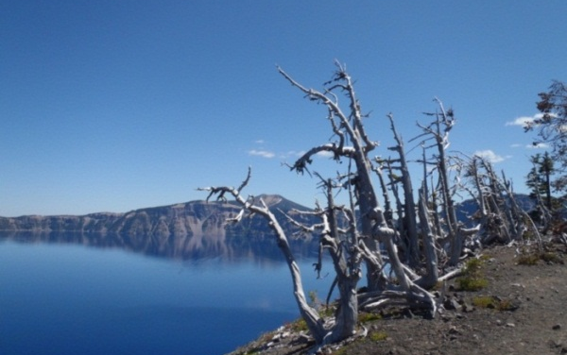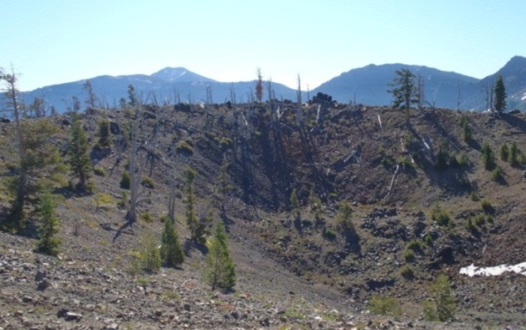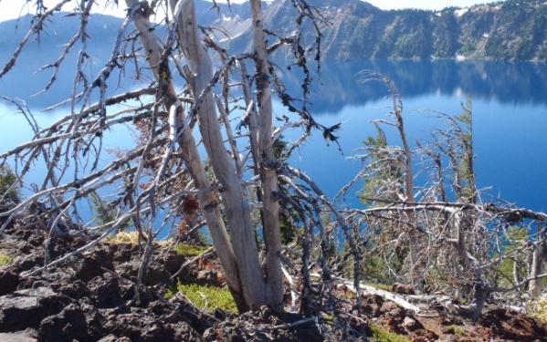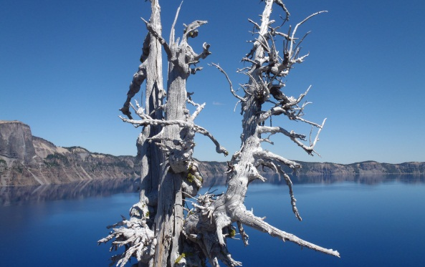
Figure 25. Whitebark pine mortality on Wizard Island, where heavy dwarf mistletoe infection occurs.
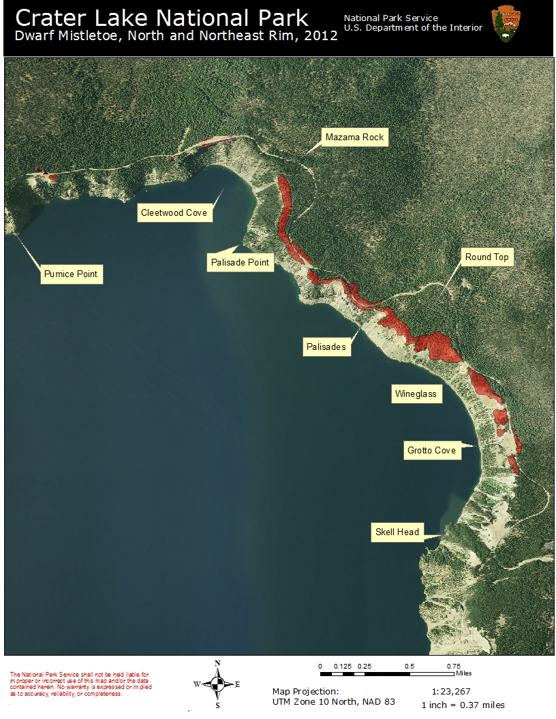
Figure 26. Areas along the north/northeast rim with Dwarf mistletoe-infected whitebark pine as mapped in 2012. Map by Elena Thomas.

D. Fire Exclusion

CRLA maintained an aggressive fire suppression policy from its inception in 1902 until 1976 when a prescribed fire program was implemented (USDI NPS 2012). CRLA has managed lighting-ignited wildland fires to meet resource objectives since 1978. CRLA currently utilizes the Guidance for Implementation of Federal Wildland Fire Management Policy (NIFC 2009), which greatly expands options for wildland fire management within the park. This includes a more flexible approach to managing lightning-caused fires by permitting management of fires for multiple objectives and allowing objectives to change as fire events progress. Despite having the ability to manage natural ignitions and conduct prescribed burns, many constraints placed upon the fire management program (e.g., providing for firefighter and public safety; short growing seasons; lack of personnel and resources; lack of funding; seasonal severity) have continued to limit the amount of fire at CRLA. Often summer thunderstorms spark a dozen or more fires simultaneously, and only a select few can be managed to meet resource objectives while the rest must be extinguished. Lightning-caused fires in whitebark pine habitat are often near the caldera rim, which may affect Rim Drive, Rim Village, and/or several popular trails. Fires in whitebark pine habitat may inconvenience visitors, force closures of some areas, and create smoke impacts to the Crater Lake caldera.
CRLA’s whitebark pine communities have been affected by fire suppression policies and activities at the stand level (Figures 27-32). For Cascadian whitebark pine communities, 57% fewer fires were detected during 1900-2000 compared with 1800-1900; and few fires were detected after 1950 (Siderius and Murray 2005). Fire suppression in whitebark pine communities has contributed to increased competition from shade-tolerant conifers; this can lead to decreased tree vigor and increased susceptibility to blister rust infection, MPB attack, and dwarf mistletoe infection (Kendall and Keane 2001). Siderius and Murray (2005) found that stand volume in Cascadian whitebark pine communities is currently greater than at any time since 1804 and is primarily due to invasion by late-seral species; since 1924, volume of Shasta red fir has increased by 4,200% and volume of subalpine fir has increased by 2,800% (Siderius and Murray 2005). With continued fire suppression, it is projected that shade-tolerant conifers will eventually outcompete whitebark pine on seral sites and gain dominance of whitebark pine communities (Kendall and Keane 2001; Siderius and Murray 2005).
Competition not only reduces whitebark pine vigor, but also reduces cone production since canopy shape and size are affected by competitors (McCaughey and Tomback 2001), which in turn negatively impacts regeneration. Fire reduces competition in whitebark pine stands; creates a mosaic of stand ages that could reduce susceptibility to MPB attack; and creates conditions suitable to whitebark pine regeneration (Kendall and Keane 2001). However, fire also indiscriminately kills whitebark pine of all age classes, including those with genetic resistance to blister rust, MPB, and dwarf mistletoe. Agee (1993) noted that ten years after fire burned through a whitebark pine stand at CRLA, seven whitebark pine trees experienced fire-related mortality but seven whitebark pine seedlings 9-60 cm in height had established post-fire. Murray (2007) reports whitebark pine mortality after small fires at CRLA: after the 2002 Mulligan fire, five whitebark pines were affected by fire; two died from crown torching, one was immediately attacked by MPB and died the next year, and two survived. After the 2004 Dutton fire, trees that survived the fire were attacked and killed by MPB, resulting in total stand-replacement (Murray 2007). In the 2008 Anderson Bluff fire, all whitebark pines within the fire perimeter were found

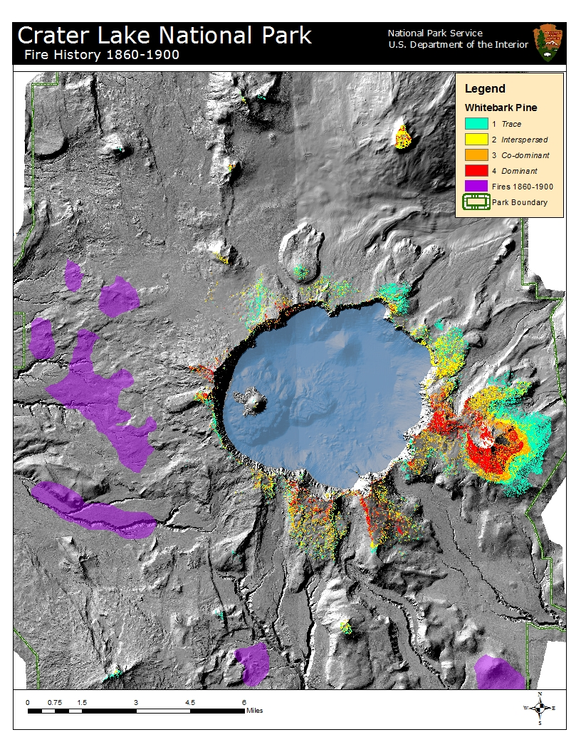
Figure 27. 1860-1900 fire history in relation to whitebark pine distribution.
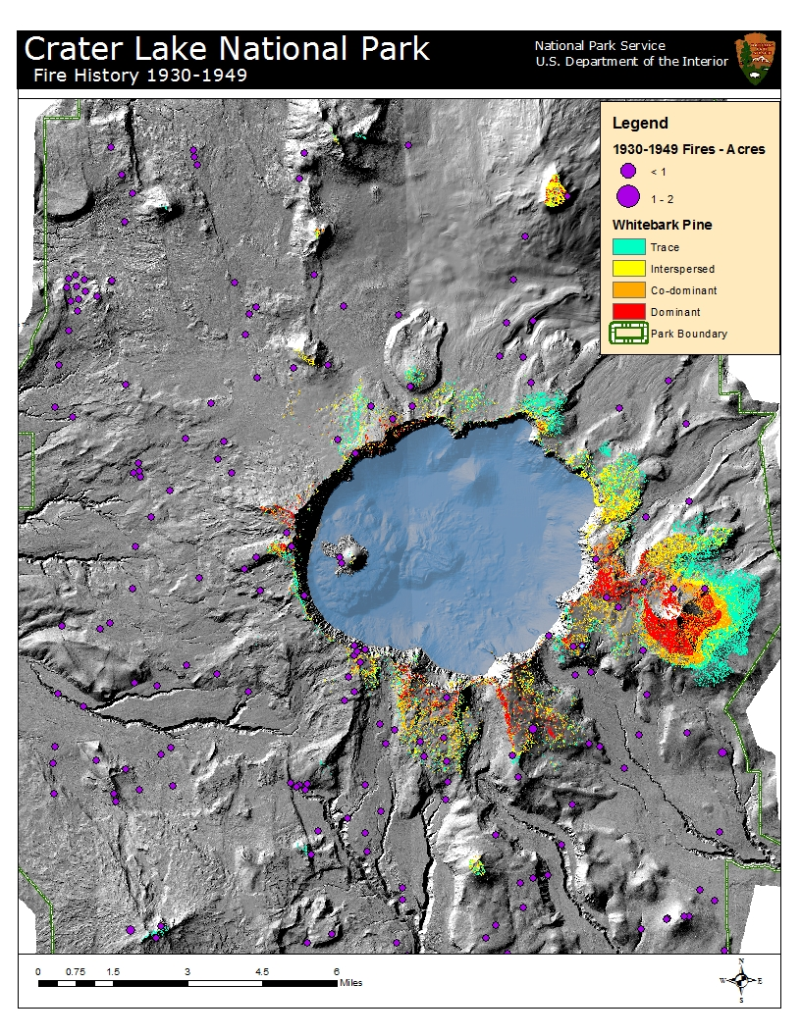
Figure 28. 1930 - 1949 fire history in relation to whitebark pine distribution.
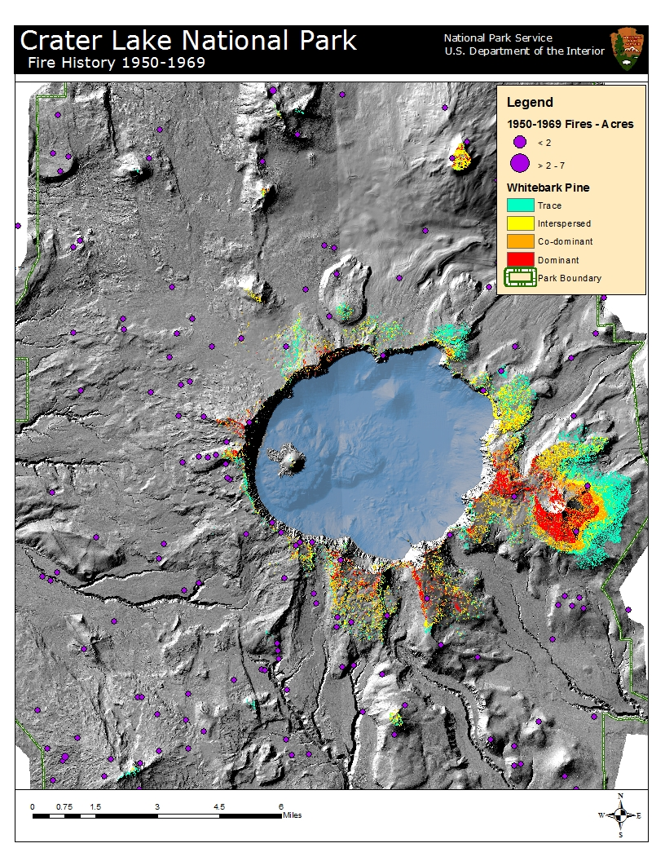
Figure 29. 1950-1969 fire history in relation to whitebark pine distribution.
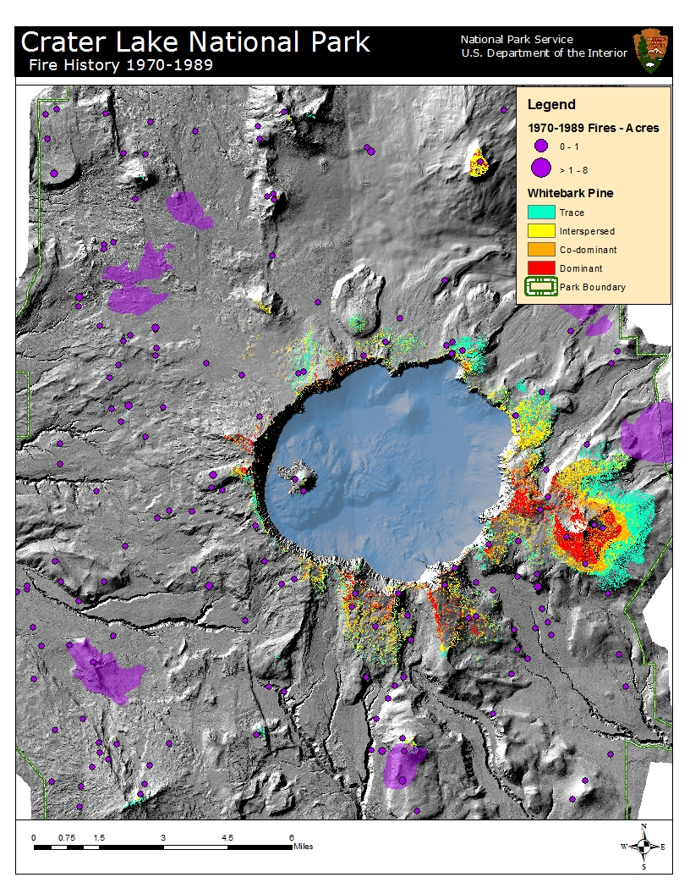
Figure 30. 1970-1989 fire history in relation to whitebark pine distribution.
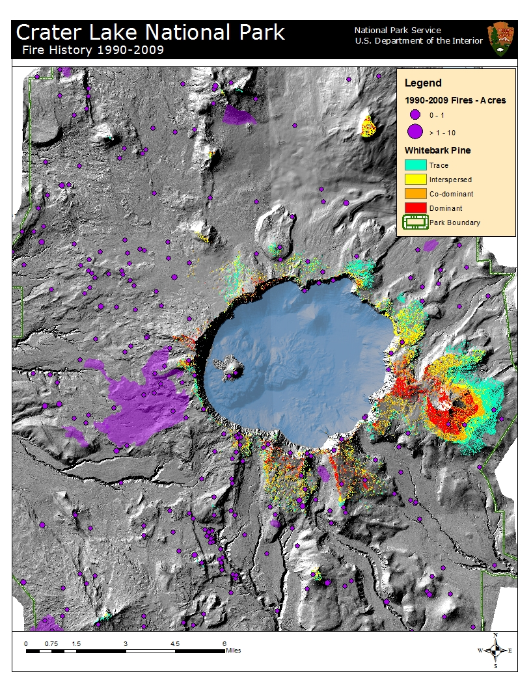
Figure 31. 1990-2009 fire history in relation to whitebark pine distribution.
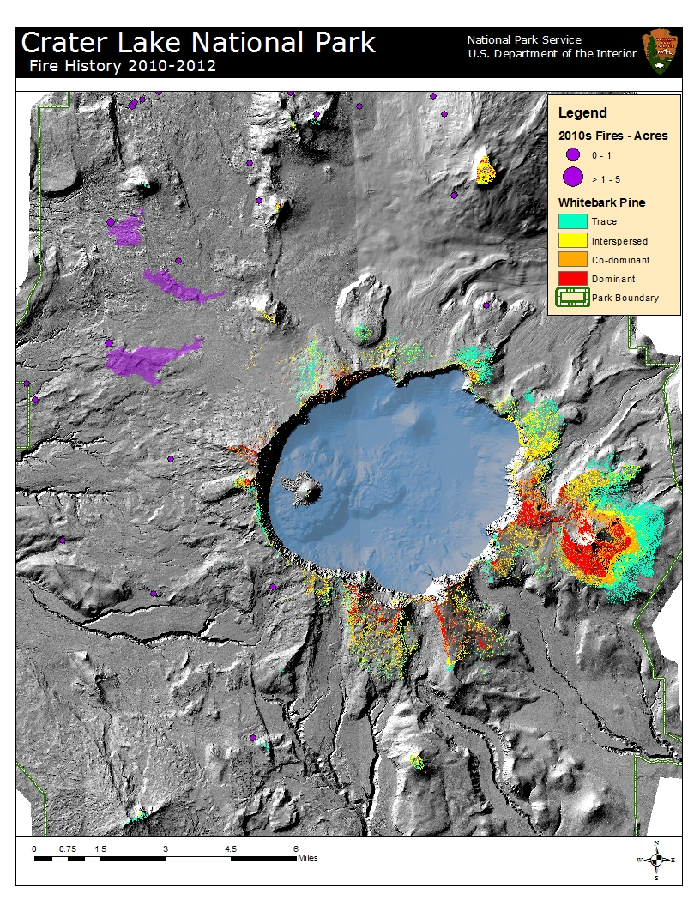
Figure 32. 2010s fire history in relation to whitebark pine distribution.

dead in 2012. However, inside both the 2004 Dutton and 2008 Anderson Bluff fire perimeters, whitebark pine regeneration was found during surveys in summer 2012 (Figures 34-35).
Whitebark pine, including those phenotypically resistant to blister rust, may be protected during fire events. The Resource Advisor (READ) and fire management programs at CRLA have identified and protected phenotypically blister rust-resistant whitebark pines during managed wildfires by reducing ground and ladder fuels around tree bases and crowns to mitigate fire intensities (Murray 2007). Fire personnel are trained to avoid impacts to five-needle pines when possible during fire management operations including ignition, holding, and suppression activities (USDI NPS 2007).
Thinning is an option for reducing competition in whitebark pine stands. Suppressed whitebark pine trees have been shown to “release” after thinning treatments and increase radial growth rates, however there may be a 10-15 year lag before diameter growth commences (Keane et al. 2007). Larger-diameter whitebark pine have shown a greater response to thinning treatments than smaller-diameter trees, which may lead to increased cone production in thinned stands (Keane et al. 2007). Activity fuels resulting from thinning operations may attract secondary bark beetles (e.g., Pityogenes fossifrons), pine engravers (Ips pini) and red turpentine beetles (Dendroctonus valens) that may then attack whitebark pine targeted for restoration (Waring and Six 2005). MPB are attracted to burned areas, so conducting slash burns or prescribed burns post-thinning could invite MPB attack on remaining whitebark pine; thinning treatments may also initially shock whitebark pine through altering microclimatic conditions such as insolation and wind speed, which may increase probability of MPB attack (Waring and Six 2005). It is recommended to conduct restoration treatments such as thinning and/or prescribed burning during periods of low MPB activity and minimal water stress to reduce post-treatment beetle attack (Waring and Six 2005).
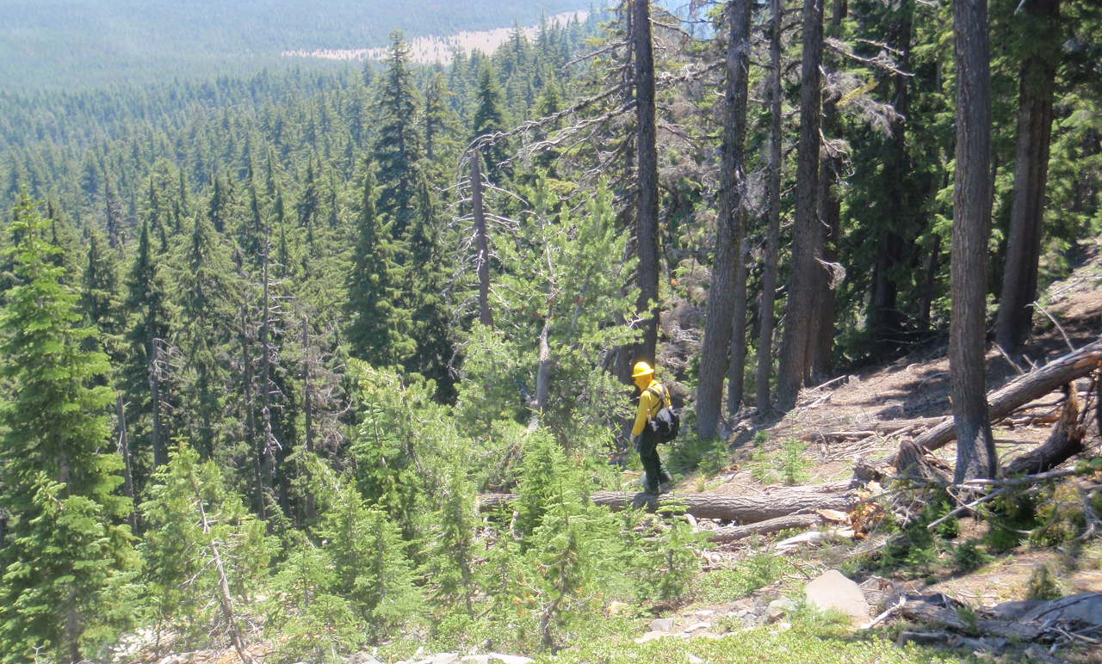
Figure 33. A Resource Advisor inspects a whitebark pine encountered during the 2009 Desert Ridge fire. Photo by Laura Hudson.
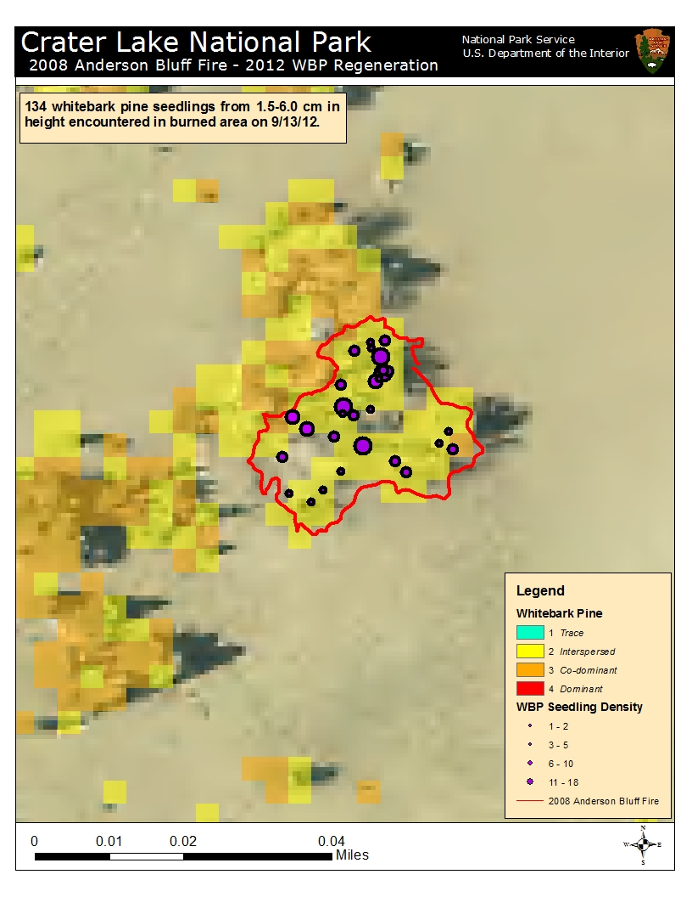
Figure 34. 134 whitebark pine seedlings were found in 2012 inside the 2008 Anderson Bluff fire perimeter.
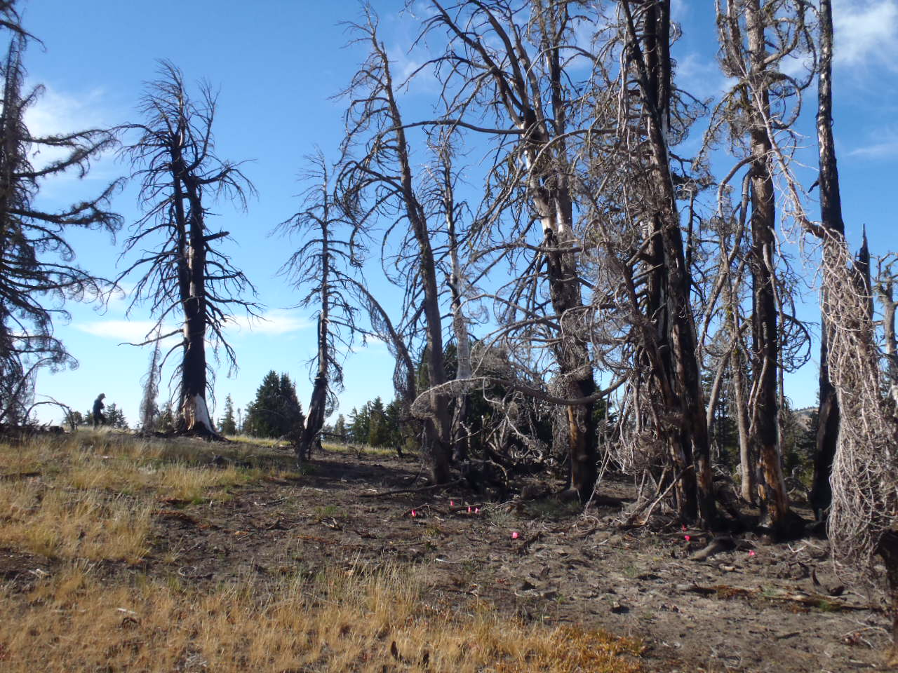
Figure 35. Pink flags mark whitebark pine seedlings inside the 2008 Anderson Bluff fire perimeter.

E. Climate Change

It is hard to imagine the situation worsening for the fate of whitebark pine, but another factor contributing to its decline is rapid global climate change. In the Pacific Northwest, impacts of climate change have been experienced over recent decades. During the 20th century, the Pacific Northwest experienced a temperature increase of 0.8°C (Mote et al. 1999), which exceeded the global average (Mote 2003). In the western U.S. the onset of spring has been occurring earlier as measured by plant phenology (Cayan et al. 2001) and snowmelt (Stewart et al. 2004). Throughout western North America, spring snowpack, as measured by snow water equivalent, has declined especially since 1950 (Mote et al. 2005). Due to warmer temperatures, there has been less snow and more rain received from winter and early spring storms (Knowles et al. 2006). When modeling impacts of future climate, these trajectories generally continue at accelerating rates (Bachelet et al. 2011).

During the 21st century, climate at CRLA is likely to be increasingly warmer. In the Pacific Northwest, a temperature increase of 3-6°C is predicted by the end of the century (Bachelet et al. 2011). Mote and Salathé (2010) conservatively predict an increase of 0.1-0.6°C per decade for the Pacific Northwest with warming being greatest during summer; average increases of 1.1°C by the 2020s, 1.8°C by the 2040s, and 3.0°C by the 2080s are predicted compared to average temperatures from 1970-1999. The outlook for precipitation contains more variability, but most models predict a decrease in summer precipitation for the Pacific Northwest, exacerbating the already dry summer season (Mote and Salathé 2010; Bachelet et al. 2011). Warmer temperatures during snow-bearing months of December-March would increase the amount of precipitation falling as rain rather than snow and contribute to declines in snowpack (Knowles et al. 2006). Analysis by Mote et al. (2005) shows the Oregon Cascades have experienced the greatest reduction in snowpack in the western U.S. due to sensitivity to temperature and reduction in late 20th century precipitation; this trend is expected to continue and worsen due to mild climates experienced in the Cascades vs. more continental locations.

Analysis of CRLA’s historic climate data by Daly et al. (2009) shows significant increases in minimum temperature from 1895-2007. There is also evidence of a longer summer drought season, with significant declines in September precipitation over the same period. Average snowpack depth at CRLA from 1930-2007 has declined slightly with significant decreases seen just outside the park boundary (Daly et al. 2009).

Climate change impacts to forest ecosystems include direct effects such as water stress and indirect effects such as changes to disturbance regimes (McKenzie et al. 2009). CRLA’s whitebark pine communities dominate in droughty soils where competition with other conifers is reduced (Weaver 2001); increased water stress is of particular concern in that it may push whitebark pine past a threshold conducive to regeneration (Larson and Kipfmueller 2010). Increased temperatures have been shown to boost growth rates of high-elevation trees (Salzer et al. 2009) including whitebark pine (Daneshgar 2003) by extending growing season length. However, increases in temperature without corresponding increases in moisture may reduce growth and regeneration of subalpine tree species, especially of moisture-limited species such as mountain hemlock (Peterson and Peterson 2001), but with impacts to CRLA’s whitebark pines as well (Daneshgar 2003). Whitebark pine is more drought-tolerant than other subalpine trees in the Pacific Northwest (Arno and Weaver 1990), and may be favored by warmer, drier summers that reduce competition by late-seral conifers (Weaver 2001). However, warmer temperatures and drier summers have been shown to reduce growth of CRLA’s whitebark pine and shift the period of growth earlier in the season (Daneshgar 2003). Some predictions for climate change impacts to whitebark pine push its range upwards in elevation (Romme and Turner 1991; Weaver 2001; Tomback and Resler 2007; Warwell et al. 2007; Campbell et al. 2011). Warwell et al. (2007) predict a 333 m altitudinal hike in suitable whitebark pine habitat by 2030; by the end of the 21st century, < 3% of the current range of whitebark pine is modeled as suitable habitat. These predictions have grave consequences for CRLA’s whitebark pine. CRLA is a mountain park that has lost the top of its mountain; CRLA’s whitebark pines have no “uphill” to migrate to.

The indirect effects of climate change on whitebark pine are no less disturbing. As trees are under increasing water stress from warmer temperatures and increased summer drought, they become more vulnerable to attack from insects and pathogens (Mattson and Haack 1987; McKenzie et al. 2009; van Mantgem et al. 2009). This can have profound impacts on forest ecosystems when manifested through increased severity or frequency of insect outbreaks and/or wildfires (McKenzie et al. 2009; Littell et al. 2010). The interactions of climate change with blister rust, MPB, dwarf mistletoe, and fire in whitebark pine communities point to the continued decline of whitebark pine. The longer growing season resulting from warmer temperatures may increase blister rust infection (Larson 2010). While warmer, moister conditions may favor blister rust (Kendall and Keane 2001; Tomback and Resler 2007; Larson 2010), warmer and drier conditions could reduce blister rust occurrence (Kliejunas et al. 2008; Larson 2010; Kliejunas 2011; Sturrock et al. 2011). MPB outbreaks are projected to increase in severity and extent at higher elevations with climate change (Williams and Liebhold 2002; Logan et al. 2003; Hicke et al. 2006; Littell et al. 2010). Since whitebark pines have not evolved with regular and recurring epidemic MPB outbreaks and have little resistance to attack, and since MPB indiscriminately kill whitebark pine with genetic resistance to blister rust, this bodes poorly for the survival of whitebark pine communities (Hicke et al. 2006). Water-stressed trees are more susceptible to dwarf mistletoe infection, and warming temperatures could increase dwarf mistletoe reproduction by lengthening its growing season at higher elevations (Kliejunas et al. 2008; Kliejunas 2011).

Increasingly warmer temperatures, an earlier onset of spring, and earlier snowmelt coupled with increased summer drought and dry fuels could lead to longer fire seasons and an increase in the frequency and severity of wildland fires (Whitlock et al. 2003; McKenzie et al. 2004; Westerling et al. 2006). Since fires in whitebark pine habitat are usually easy to control, fires in this habitat may continue to be suppressed due to more pressing needs for firefighting resources to staff lower-elevation fires. This could continue trends of invasion by late-seral conifers and increasing stand densities that could predispose whitebark pine stands to increased water stress and increased attack by insects and pathogens. More frequent fires in whitebark pine habitat could eliminate whitebark pine since trees must be > 60 years of age to reach full cone-bearing potential and existing regeneration could be killed without chance for replacement (Loehman et al. 2011).

Climate change has the potential to alter not only the nature of disturbance regimes but the interactions among them, which could push ecosystems into new configurations and possibly exceed capacity for resilience and resistance (Littell et al. 2010; Turner 2010). While ecosystems have evolved to recover from disturbances, compound disturbances (e.g., combinations of climate change, blister rust, and MPB) may threaten their sustainability (Paine et al. 1998). Some of these interactions will amplify the decline of whitebark pine, such as blister rust and/or climate change predisposing trees to MPB attack; more open stand structures resulting from MPB attack increasing opportunities for blister rust infection; regeneration capacity being substantially affected by the combination of blister rust and MPB; and fires following MPB outbreaks that destroy whitebark pine regeneration (Larson 2010; Larson and Kipfmueller 2010). Occasionally the interactions may be beneficial, as whitebark pine regeneration has been witnessed post-MPB outbreak and this may lead to increased blister rust resistance by providing regeneration opportunities for rust-resistant trees (Larson 2010). But in general, interactions of disturbance regimes in a changing climate contribute to accelerated decline of whitebark pine (Larson and Kipfmueller 2010).

IV. Crater Lake Whitebark Pine Conservation Program

While the picture painted thus far about the fate of CRLA’s whitebark pine has been bleak, there is reason for hope. With the development of range-wide and region-wide whitebark pine conservation strategies, there is a broad effort underway to conserve and restore whitebark pine communities. Conservation strategies focus on developing and promoting natural resistance to blister rust; outplanting whitebark pine seedlings from rust resistant trees; protecting individual trees of genetic or conservation importance with bark beetle repellent and/or fuels treatments; carefully managing natural fire and reducing competition around cone-bearing trees; and focusing work on high-priority stands (Aubrey et al. 2008; Keane et al. 2012). CRLA is committed to partnering with others, including our neighbors and across boundaries and jurisdictions, in whitebark pine conservation and the restoration of whitebark pine habitat. Ultimately, through actions outlined in this plan, CRLA would like to promote and increase resilience and resistance in whitebark pine communities to facilitate their adaptation to climate change and preserve them as a foundation species in the park’s upper elevations.

A. Goals of CRLA’s Whitebark Pine Conservation Program
The range-wide whitebark pine restoration strategy (Keane et al. 2012) highlights four guiding principles that serve as goals for conserving whitebark pine:
- Promote rust resistance.
The most important action in restoring whitebark pine is to ensure that future populations of the species have some resistant to blister rust by increasing the frequency of trees with genetic resistance to the blister rust pathogen.

- Conserve genetic diversity.
The full genetic diversity across the range of whitebark pine must be preserved for the future by collecting and archiving seeds and planting genetically diverse seedlings.

- Save seed sources.
Mature, seed-producing, putatively rust-resistant whitebark pine trees in regions that are experiencing rapid decline must be protected from other native or exotic disturbances so that the apparent rust-resistant seeds can be harvested in the future.

- Employ restoration treatments.
Areas where whitebark pine forests are declining due to insects, disease, or advanced succession should be considered for restoration treatments to create sustainable whitebark pine populations.
The focus of the whitebark pine restoration strategy for the Pacific Northwest region, 2009-2013 (Aubrey et al. 2008) is to “restore and conserve a network of viable populations of whitebark pine and associated species across the Pacific Northwest.” Its goals are to:
- Restore degraded habitat.
Restore areas where whitebark pine habitat has been affected by fire, MPB, or blister rust by planting seed or seedlings, thinning competing trees, or pruning tree infected limbs.

- Protect genetic resources through gene conservation.
Collect whitebark pine seed samples across the Pacific Northwest and protect in long-term storage.

- Increase blister rust resistance in whitebark pine populations.
Increase levels of genetic resistance to blister rust infection in whitebark pine populations through tree selection, resistance screening, and wide use of seed from resistant trees.

- Evaluate the health and status of whitebark pine stands were lacking.
Evaluate units where health, stand condition, and restoration needs are unknown.

- Increase our understanding of the threats to whitebark pine and develop practical and effective restoration techniques.
Work collaboratively with research scientists and land managers in other agencies to increase understanding of the complex and synergistic impacts of blister rust, fire, MPB, and climate change on present and future health and distribution of whitebark pine plant communities.

The goals of the CRLA Whitebark Pine Conservation Program (WPCP) are as follows:
- Facilitate the development of blister rust resistance in whitebark pine populations.

- Maintain genetic diversity of whitebark pine through integrated conservation strategies.

- Increase the resiliency and resistance of whitebark pine communities and promote adaptation to climate change.

- Prioritize whitebark pine restoration actions and conduct treatments in areas of highest ecological need.

- Continue monitoring and research in whitebark pine communities and incorporate findings into management actions.

- Increase awareness of the whitebark pine conservation program through public outreach and education.
The goals of all three conservation plans are similar and their relationship is indicated in Table 6. CRLA has had an active whitebark pine conservation program since 2003 when the first cones were collected to identify blister rust-resistant individuals through resistance screening trials. The CRLA WPCP proposes to continue conservation efforts by meeting management goals through achieving specific conservation objectives and actions. Tables 10-15 outline CRLA’s conservation strategy in relation to each management goal and provide guidance for the next decade (2013-2023) of conservation program work.

Table 6. Goals for whitebark pine conservation at the range-wide, region-wide and park level.
Range-Wide Principles  (Keane et al. 2012) | PNW Region Goals  (Aubrey et al. 2008) | CRLA Goals
Promote rust resistance | Increase blister rust resistance in whitebark pine populations | Facilitate development of blister rust resistance in whitebark pine populations
Conserve genetic diversity | Protect genetic resources through gene conservation | Maintain genetic diversity of whitebark pine through integrated conservation strategies
Protect declining seed sources |  | Increase the resiliency and resistance of whitebark pine communities and promote adaptation to climate change
Employ restoration treatments | Restore degraded habitat  Increase our understanding of the threats to whitebark pine and develop practical and effective restoration techniques | Prioritize whitebark pine restoration actions and conduct treatments in areas of highest ecological need
 | Evaluate the health and status of whitebark pine stands where lacking | Continue monitoring and research in whitebark pine communities and incorporate findings into management actions
 |  | Increase awareness of the whitebark pine conservation program through public outreach and education

The goals of the WPCP are achieved through meeting conservation objectives consisting of actions specified in the sections that follow.

B. Facilitate development of blister rust resistance

i. Identify ‘Parent Trees’ through cone collection and blister rust resistance screening
While blister rust is lethal to most whitebark pines, a small percentage of trees possess levels of natural resistance to either prevent or neutralize infection (Sniezko et al. 2011). Resistance is defined as “the genetically-determined ability of a plant to actively resist inoculation, infection, growth, and sporulation by a pathogen, ranging from complete – pathogen may infect specific tissues but is walled off or dies before extensive establishment and sporulation – to partial – pathogen survives and perhaps sporulates but established infection does not prevent host reproduction or survival” (Vogler et al. 2006). Genetic resistance to blister rust in whitebark pine may be expressed through mechanisms such as needle shed – where infected needles are dropped before fungal mycelium can reach vascular tissues of the stem; short-shoot - the fungus infects the needle but dies when it reaches the short shoot, which is the small appendage that holds the five needles of the fascicle together; and bark reaction – fungal mycelium grows into the stem of the shoot but dies after being “walled off” by cortical cells in the bark (Hoff et al. 2001).
CRLA has been collecting whitebark pine seed for use in screening trials to test for blister rust resistance since 2003. Rust resistance screening is performed at the USFS Dorena Genetic Resource Center (DGRC) in Cottage Grove, Oregon. Operational screening for blister rust resistance in whitebark pine is a process that currently takes seven years from sowing to final assessment; two years are required to grow and artificially inoculate the seedlings and five years are needed to assess levels of resistance and finalize resistance ratings (Sniezko and Kegley 2012). The DGRC assigns resistance ratings of A-F to whitebark pine that are much like grades in school, with ‘A’ showing the highest levels of resistance and ‘F’ indicating the lowest. CRLA deems trees rated at levels A-C rust-resistant and labels these “Parent Trees.” Trees undergoing rust screening trials are called “Candidate Trees.” Trees with low resistance ratings (e.g., ‘D, F’) are called “Susceptible.” Trees that have had cones collected are “Collection Trees.” Whitebark pine cones have been collected at CRLA in 2003, 2005/6, 2009, 2011, and 2012 from a total of 89 trees; 16 of these are Parent Trees, 51 are Candidate Trees, 19 are Susceptible Trees, and 3 trees have not entered trials due to insufficient seed. Occasionally trees need to have their cones recollected due to low seed yields to enable blister rust screening.
Table 7. Summary of CRLA whitebark pine cone collection efforts.
Collection Year | # New Collections | # Recollections | Notes
2003 | 10 | n/a | Final assessment yielded only 1 Parent Tree (‘C’ rating)
2005/6 | 28 | 4 | 4 Parent and 1 Susceptible trees dead due to MPB
2009 | 11 | 1 | 1 Candidate dead from unknown causes; 2 Candidates dead from MPB
2011 | 27 | 7
2012 | 13 | 1

Many of CRLA’s whitebark pine stands are accessible by roads and trails. The 33-mile Rim Drive encircles the Crater Lake caldera and provides access to much whitebark pine habitat on a seasonal basis. Whitebark pine cone collection efforts have been focused within front-country areas with good road access; some limited back-country cone collection has occurred (Figure 36). In 2003, cones were collected from ten whitebark pines within the Rim Village area. 2005/6 cone collections occurred from 28 trees concentrated around the west caldera rim but included several trees growing along the east caldera rim. 2009 cone collections focused on 11 whitebark pines growing along the southeast caldera rim and included trees in remote areas (e.g., Crater Peak, Wizard Island). The 2011 cone collection effort targeted the northeast caldera rim from Pumice Point to the Mt. Scott trailhead; additional collections were made from Munson Valley and Dutton Ridge. 2012 cone collections focused on filling in gaps around the caldera, with collections made in the North Junction area, from Garfield Peak to Applegate Peak, and along Dutton Ridge. Additionally, outlier whitebark pine populations on Union Peak and Grouse Hill were visited and assessed for collection, but use of tree climbers would be required to collect cones in these areas and these were lacking in 2012.
Of the 86 trees that have entered rust resistance trials, 16 Parent trees have been identified thus far by the DGRC; one of these is a confirmed Parent tree based on results of a final rust resistance assessment and fifteen of these have tentative Parent status based on interim results. Four Parent trees have died from MPB attack (two interim ‘A’ rating; two interim ‘B’ ratings). Fifty one Candidate trees are currently undergoing blister rust screening trials; three of these trees have died (two from MPB; one from unknown causes). Nineteen trees have been deemed susceptible to blister rust by the DGRC; one of these trees has died from MPB attack.
In 2013 and beyond, cone collection efforts will be focused on areas with confirmed high blister rust infection rates (e.g., Hillman Peak, Williams Crater), previously uncollected areas within the park (e.g., outlier populations of whitebark pine on Timber Crater and Red Cone), and to augment seed collections from known resistant trees. Additionally, we will collect from trees growing on warm, dry sites (e.g., south aspects, lower elevations) whenever possible to incorporate genotypes that may have adaptations to the predicted warmer temperatures and longer, drier summers of the near future. Collecting cones from more remote areas of the park has the advantage of increasing among-population diversity within CRLA’s seed collection; however, it also limits opportunities for monitoring and protection of Parent and Candidate trees since these locales would likely be triaged in years with high workloads and limited staffing. Cone collections would be made as cones are available (during moderate-good cone years and masting events) and collecting from 10-20 trees would be desirable per collection event.
The cone collection process follows guidelines outlined in Ward et al. (2006b). To ensure that cone collections represent one genetically distinct whitebark pine individual, collections are made from one bole per whitebark pine clump. Each collected bole is marked with a permanent brass tag and its location is recorded using a GPS unit. A Selected Tree Register form is completed for each collected tree and the tree enters the CRLA Collection Tree Monitoring program (Appendix C). Since whitebark pine cones are an attractive food resource for nutcrackers and other wildlife species, cones are caged early in the season (before mid-July) to preserve the seed resource. Cages are removed and cones retrieved in mid-late September when seeds are ripe. This often involves tree climbing, but cones may be accessible by foot using an extendable boat hook or using an orchard ladder. If tree climbing is necessary, all climbers are certified by the USFS National Tree Climbing program. All cone collecting activities must abide by the regulations specified by the National Tree Climbing program, if applicable, and follow protocol outlined in the CRLA Botany Program Job Hazard Analysis.
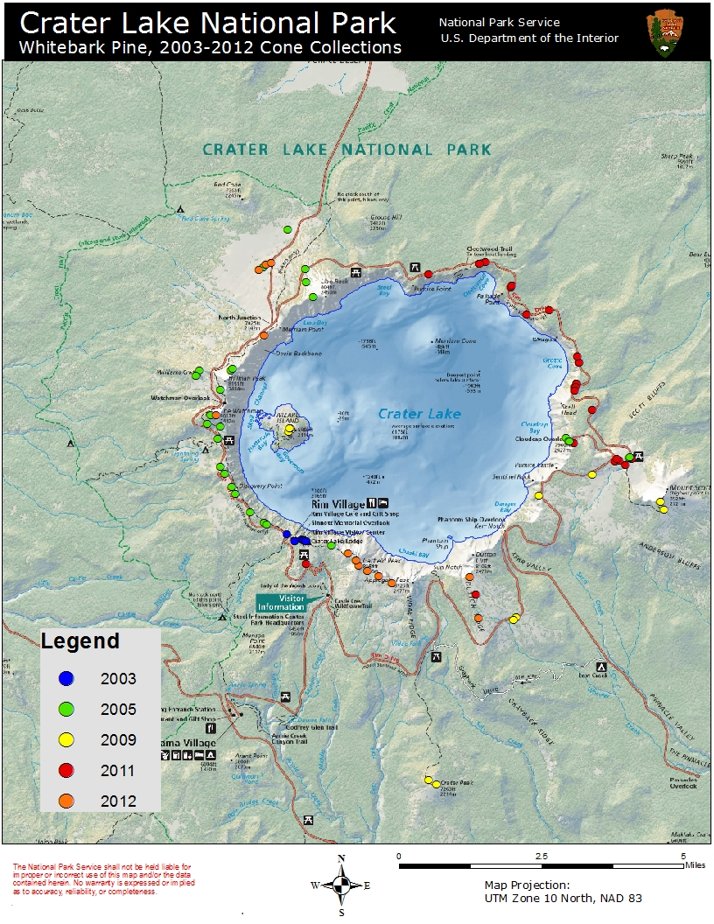
Figure 36. Whitebark pine cone collections representing 89 Collection Trees. Map by Elena Thomas.
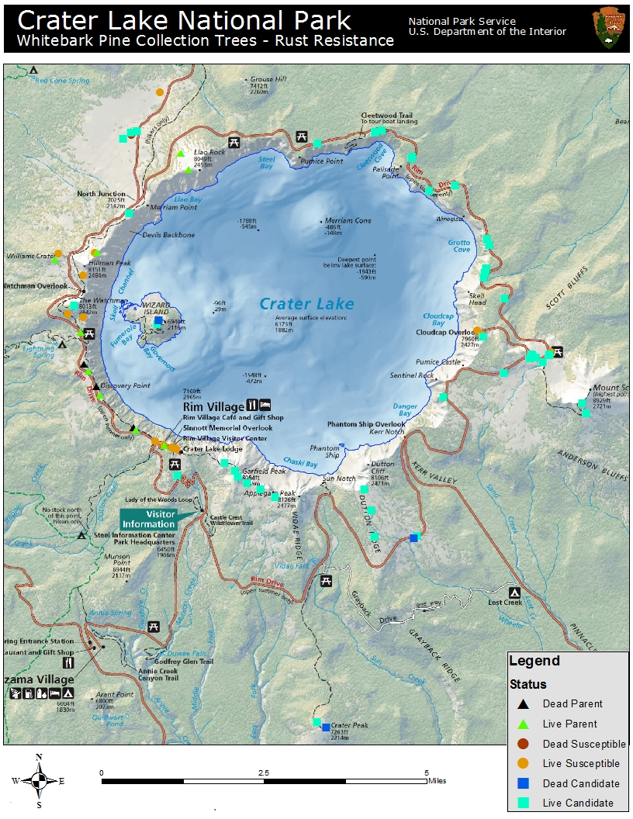
Figure 37. Locations of Parent, Candidate, and susceptible whitebark pines out of 86 total trees that have entered blister rust trials.
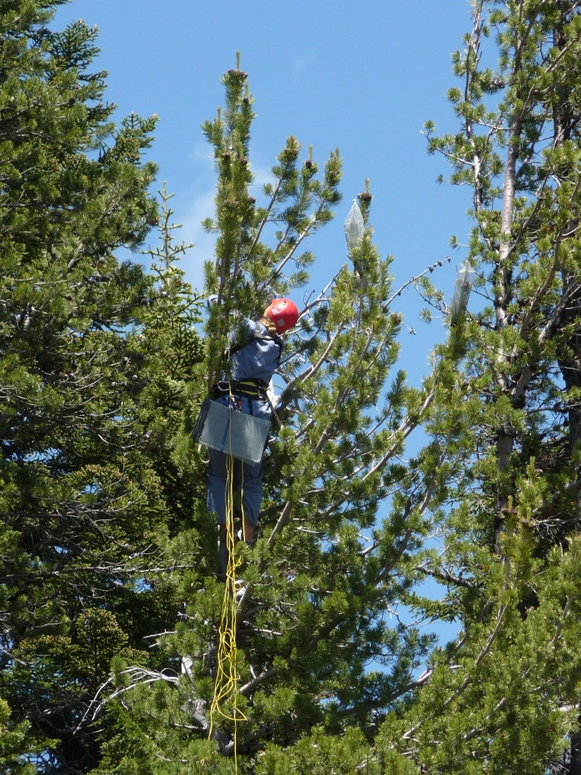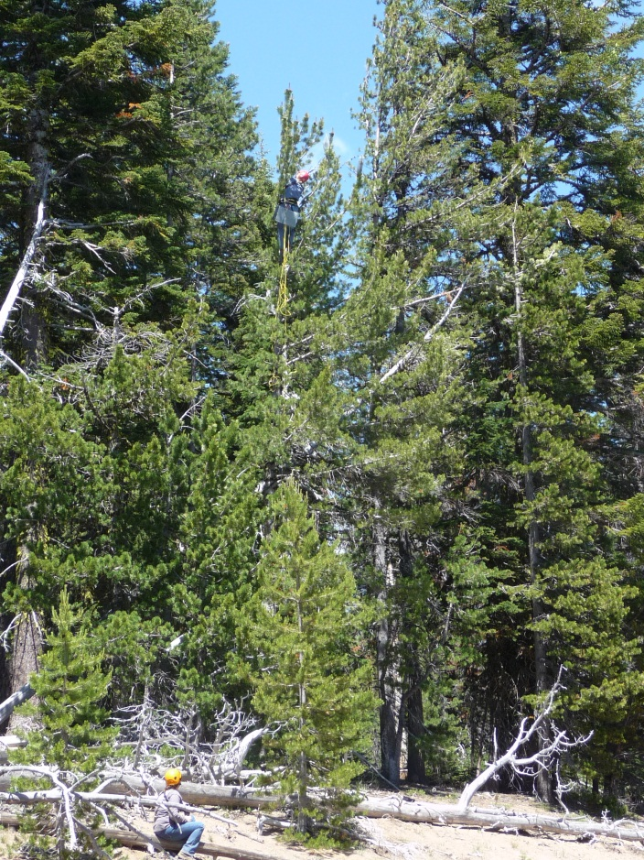
Figure 38. Caging cones on candidate tree CRLA-11-MR-002. Photos by Elena Thomas.

ii. Protection of Parent and Candidate trees
Parent and Candidate trees are protected from MPB attack through annual application of Verbenone. Verbenone is a synthetic chemical that mimics the anti-aggregating pheromone emitted by MPB; it essentially tricks MPB into believing that a treated tree is already fully occupied, thereby deterring MPB attack. Verbenone is not 100% effective against MPB attack and is used at CRLA as a method for potentially reducing the probability of MPB attack on high-value trees (Kegley and Gibson 2011). Verbenone has been applied to Parent and Candidate trees at CRLA since 2004 but lack of consistent application and record keeping has precluded assessments of its efficacy. Verbenone application will continue with priority given to Parent and Candidate trees; Verbenone may also be applied to whitebark pine of ecological or cultural significance as warranted. Verbenone is applied as early as practical in the spring/early summer and application dates are often dictated by snowmelt and road access.
Locations of Parent and Candidate trees are shared with Fire Management staff and with the Maintenance division to reduce chances of inadvertent damage. Parent and Candidate trees are included on the CRLA map of Sensitive Resources and protected through the READ program against impacts from fire management activities. If wildland fire threatens Parent and/or Candidate trees, fuel treatments occur ahead of the fire (as safety allows) to mitigate fire effects, such as reducing proximal ground and aerial fuels; using firing patterns to avoid direct flame impingement; and raking fuels from the base of boles.
A formal monitoring program for Parent and Candidate trees was initiated in 2012 to track the health and condition of these trees on an annual basis. A monitoring plan and associated datasheets for this effort are located in Appendix C. This information is shared annually with the DGRC to link field resistance and status with results of blister rust screening trials.

iii. Restoration planting
A major component of increasing blister rust resistance in CRLA’s whitebark pine stands is planting seedlings from rust-resistant “Parent” trees in designated high priority restoration areas. Outplanting of whitebark pine seedlings at CRLA follows these guidelines adapted from McCaughey et al. (2009):
  - Plant two- to three-year old seedlings with good vigor.
  - Plant in areas free of competition from overstory trees.
  - Plant in areas that currently are or previously were whitebark pine habitat. Avoid afforestation of pumice meadow habitat, as this is a rare and declining resource within CRLA’s higher elevations.
  - Plant in sites with limited competition by understory vegetation. Avoid planting in the middle of rhizomatous species (e.g., mats of Luzula spp.).
  - Avoid planting in open areas with deep soils to reduce possibility of small mammal (e.g., pocket gopher – Thomomys talpoides) predation.
  - Select locations with microclimatic protection such as the north side of stable logs, rocks, and stumps to reduce insolation, increase soil moisture, and decrease impacts from wind and snow.
  - If planting near snags, acknowledge that trees will eventually fall and may damage seedlings. Try to alter spatial pattern of planting to increase chance of seedling survival.
  - Plant during times of increased soil moisture (late fall); water seedlings after planting if feasible.
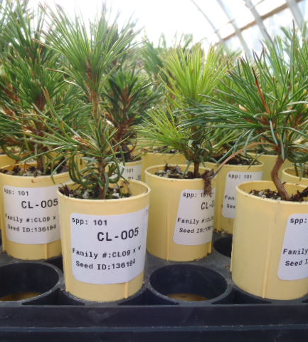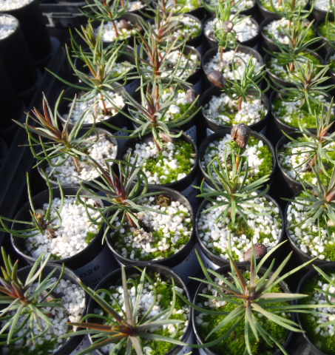
Figure 39. Progeny of CRLA whitebark pine at the DGRC.
There have been three restoration projects at CRLA involving outplanting of whitebark pine seedlings grown at the DGRC from seed collected within CRLA – the 2009 Rim Village and Horse Trail plantings (see Hudson and Thomas 2010), and the 2012 Dutton Ridge/North Junction planting (see Beck et al. 2012). All three plantings utilized a mixture of three year-old seedlings from rust-resistant (Parent) and Susceptible trees. The 2009 Rim Village project utilized an opportunity to revegetate the site of a former parking lot that was removed in 2006. In mid-September 2009, 331 whitebark pine seedlings were planted from 16 CRLA Parent and Susceptible trees at the former parking lot site. Since the planting site was already disturbed, microsite improvements such as addition of large rocks and woody debris were made to the site prior to planting to increase seedling survival. Seedlings were planted in family plots with 1-3 seedlings per planting spot. According to interim blister rust ratings, 107 of the seedlings are from resistant Parent trees (ratings ‘A, B’); 107 are from moderately resistant Parents (rating ‘C’); and 117 are from Susceptible trees (ratings ‘D, F’). Survivorship in 2010, 2011, and 2012 was 97.0%, 91.5%, and 91.2%, respectively, with most mortality attributable to pocket gopher activity. In 2012, blister rust infections were detected on seven seedlings – the infection being fatal for one seedling. Five of the infected seedlings were from Parent tree CL24; one was from Susceptible tree CL01, and one was from Susceptible tree CL23.
Table 8. Status of 2009 Rim Village whitebark pine restoration project by family and interim rust resistance data. Gray shading represents trees that have died since cones were collected in 2005.
Family | Interim Rating | # Seedlings 2009 | # Alive 2012 | Cause of Mortality
CL01 | F | 29 | 29 | n/a
CL03 | A | 20 | 14 | pocket gopher
CL08 | D | 15 | 13 | pocket gopher
CL09 | D | 2 | 1 | pocket gopher
CL10 | A | 28 | 27 | pocket gopher
CL11 | B | 13 | 13 | n/a
CL14 | D | 13 | 12 | pocket gopher
CL15 | C | 1 | 1 | n/a
CL17 | A | 5 | 5 | n/a
CL18 | A | 1 | 1 | n/a
CL20 | D | 5 | 4 | unknown
CL22 | A | 40 | 33 | pocket gopher
CL23 | D | 47 | 47 | n/a
CL24 | C | 106 | 97 | pocket gopher/unknown/blister rust
CL25 | F | 5 | 4 | pocket gopher
CL27 | D | 1 | 1 | n/a

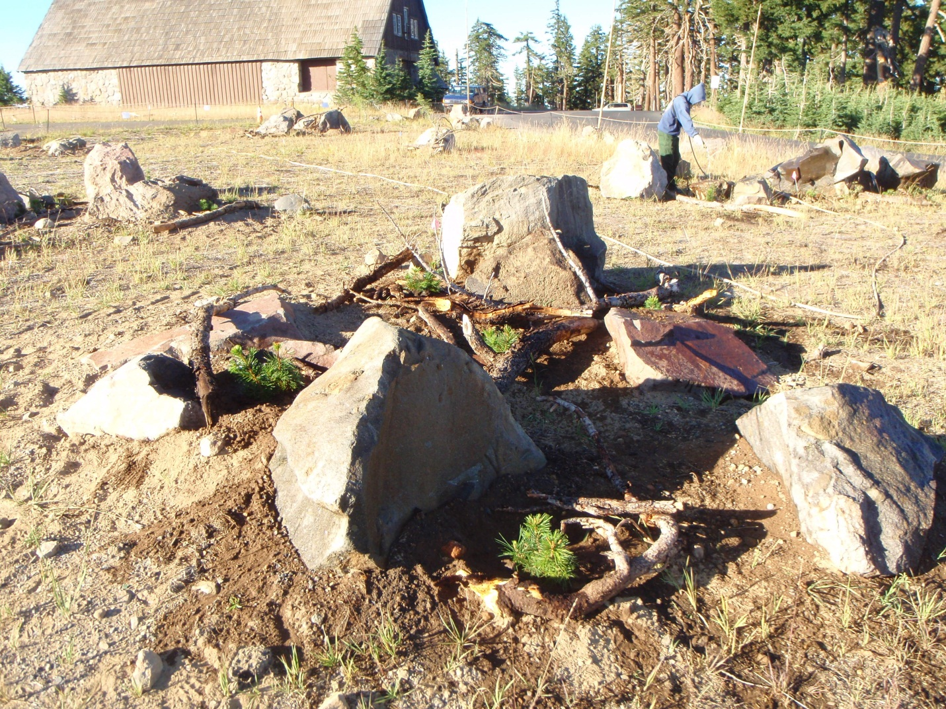
Figure 40. Watering recently planted whitebark pine seedlings within the 2009 Rim Village restoration project. Photo by Steve Thomas.
The second restoration planting of whitebark pine seedlings at CRLA was the 2009 Horse Trail project, which is south of Rim Village. This project incorporated an experimental approach to evaluate whether inoculating seedlings with beneficial fungal endophytes prior to planting increases resistance against blister rust. Endophytes are fungi that live inside plants with no deleterious impacts to their hosts; it is believed that endophytes may be present within all plant species (Ganley et al. 2008). Fungal endophytes have been implicated in boosting their hosts’ resistance to blister rust in western white pine (Ganley et al. 2008), and they may play the same role in whitebark pine (Worapong et al. 2009). A total of 192 whitebark pine seedlings from 5 CRLA Parent and Susceptible trees were planted at the Horse Trail project site; half (E+) had their roots sprayed with a culture from the endophyte Myrothecium roridum, which was obtained from CRLA whitebark pine needles, and half (E-) were controls. However, it was never confirmed if the treated seedlings were successfully inoculated with M. roridum, so any differences between treatments will be observational. Seedlings were planted in family plots with two seedlings planted together at each planting spot. The five families included in this project represent an array of blister rust resistance with interim rust resistance ratings ranging from A-F (CL11 = ‘B’ – this tree is now dead from MPB attack; CL21 = ‘D;’ CL22 = ‘A;’ CL24 = ‘C;’ CL25 = ‘F’) . Survivorship in 2010, 2011, and 2012 was 84.8%, 83.2%, and 79.2%, respectively, with pocket gopher predation the leading cause of mortality. No blister rust infection of seedlings has been confirmed at this planting site.
Table 9. Survival rates and heights of endophyte-inoculated (E+) vs. control (E-) seedlings from 2010-2012.
Year | E+ survival | E- survival | E+ height (cm) | E- height (cm)
2010 | 85.7% | 82.1% | 23.8 | 19.5
2011 | 83.7% | 80.0% | 25.4 | 22.6
2012 | 78.5% | 80.0% | 25.3 | 25.7

Four hundred and sixteen whitebark pine seedlings were planted at Dutton Ridge and North Junction sites in October 2012. This project was a cooperative endeavor between CRLA and the DGRC, Oregon State University, and the Deschutes National Forest. Ten CRLA whitebark pine trees served as seed sources for this planting project, with the number of seedlings per tree ranging between 5 and 56. Eight planting blocks were delineated with fifty two seedlings per block; five blocks were planted at Dutton Ridge and three were planted at North Junction. The two planting sites represent different climates within the park – the North Junction site is slightly wetter due to its position on the west side of the Cascade Crest and the Dutton Ridge site is drier and positioned along the eastern side of the crest. Seedlings will be monitored annually beginning in 2013.
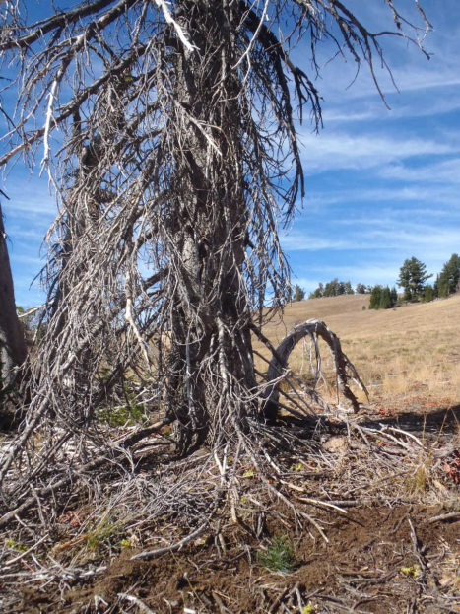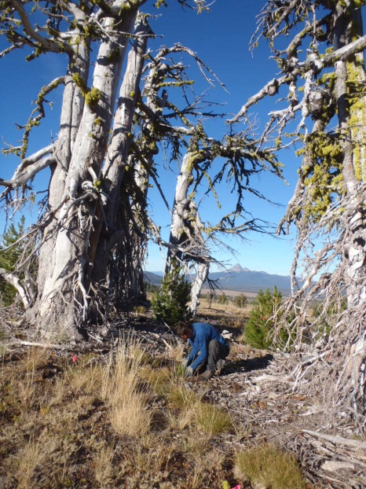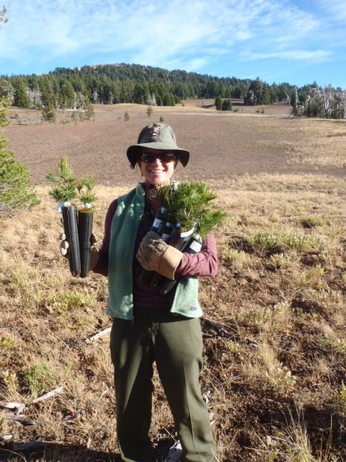
Figure 41. Whitebark pine restoration planting at Dutton Ridge (left) and North Junction (middle, right).
A site-specific restoration plan is developed for each outplanting project that documents restoration objectives, study design, methodology, environmental and climatic conditions relevant to assessing seedling survival, and outlines plans for monitoring seedlings into the future. A site-specific restoration plan template is provided in Appendix D. All outplanting projects require long-term monitoring to determine seedling fate, document success and failure, and contribute to the adaptive management process. Seedlings are monitored annually for health, condition, height, damage, severity of any blister rust infection, and vigor. When possible, restoration outplantings are integrated with research projects to address specific questions and issues.
Table 10. CRLA’s management objectives and actions for increasing blister rust resistance.
CRLA Goal: Facilitate development of blister rust resistance in whitebark pine populations
Objective 1: Identify Parent trees
Action 1a: Collect cones from trees exhibiting phenotypic blister rust resistance |  | Quantity: 10-20 trees per cone collection event
 |  | Frequency: Collect during good-moderate cone years or mast years
Priority 1: Collect cones from areas with high blister rust infection | Priority 2: Collect cones from underrepresented areas for genetic diversity | Priority 3: Collect cones from trees growing on warmer/drier sites
Objective 2: Protect Parent and Candidate trees from MPB, unwanted fire, and other damage
Action 2a: Apply Verbenone to whitebark pine of genetic, ecological, and/or cultural significance |  | Quantity: For 2013—  70 trees (Parents, Candidates, others)
Priority 1: Apply Verbenone to Parent and Candidate trees | Priority 2: Apply Verbenone to ecologically and/or culturally significant trees as warranted | Frequency: Annually
Action 2b: Include Parent and Candidate trees on CRLA Sensitive Map; protect through READ program |  | Frequency: Annually
Action 2c: Communicate locations of Parent and Candidate trees to Maintenance Division to inform Road and Trail work |  | Frequency: Annually
Action 2d: Monitor Parent and Candidate trees for health and condition |  | Frequency: Annually
Objective 3: Outplant seedlings from rust-resistant trees in high priority restoration areas
Action 4a: Outplant seedlings from Parent trees |  | For 2013: Start planning new outplanting project, gain cultural resources clearance
Priority 1: Plant in designated high priority areas | Priority 2: Integrate with research projects if possible
Action 4b: Create site-specific restoration plans for each outplanting project |  | Frequency: Mandatory documentation for each outplanting project
Action 4c: Monitor outplanted seedlings for health and condition |  | Frequency: Annually

C. Protect genetic diversity

Whitebark pine has been considered a sensitive species at CRLA for over a decade due to its decline from blister rust. As such, it has been subject to additional management scrutiny and efforts have been ongoing at reducing unwanted damage from fire management and/or Maintenance division activities. “Minimize impacts to five-needle pines” is a fire management operational objective that appears on all Incident Action Plans and is incorporated into every briefing period. Fire personnel are trained to avoid impacts to five-needle pines through felling, firing, and holding operations. When safety allows, whitebark pines of management concern in the path of fire are pre-treated to mitigate fire’s impacts. An assigned READ coordinates these efforts between fire management leadership and fireline staff. The Maintenance division is responsible for Roads and Trails management and it incorporates whitebark pine protections into its work. Locations of restoration plantings are shared with the Maintenance division.
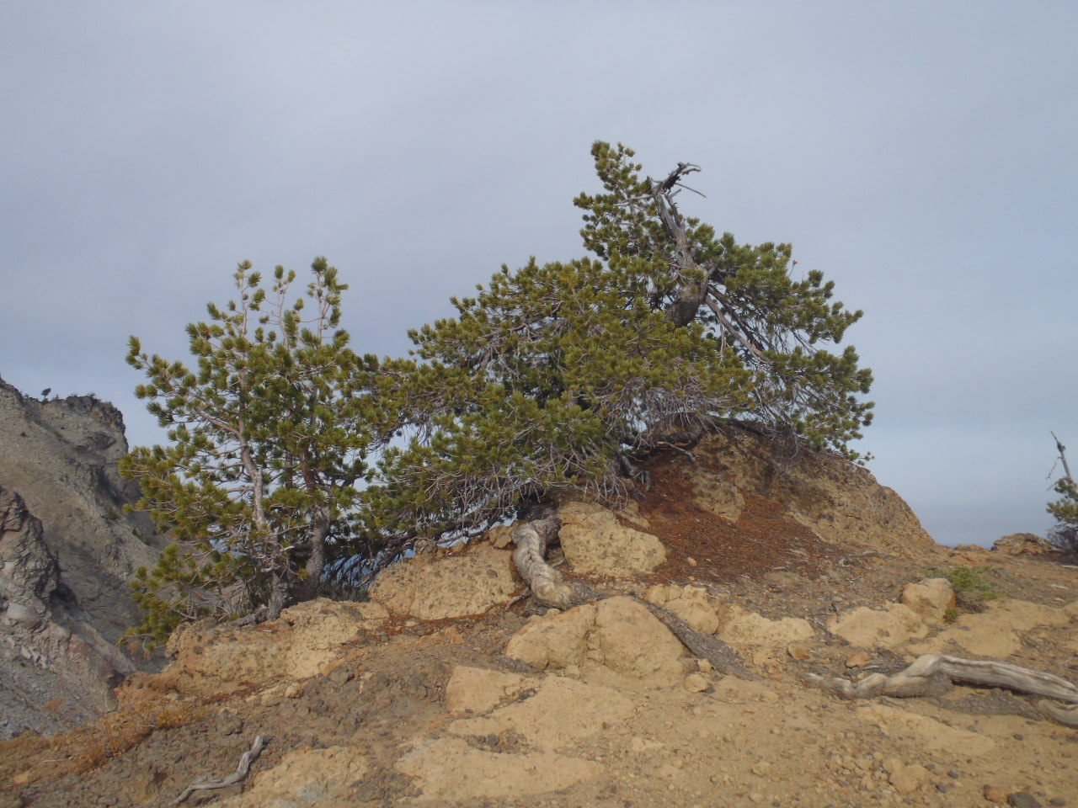
Figure 42. Whitebark pine near Union Peak.
Ex situ conservation of whitebark pine is a safeguard to protect genetic diversity of CRLA’s whitebark pine. A formal ex situ whitebark pine conservation plan (Appendix E) is in development. The DGRC provides long-term storage for CRLA’s whitebark pine seed. Currently, the DGRC maintains 71,056 whitebark pine seeds from 64 CRLA Parent/Candidate trees (Sniezko and Kegley 2012). Some of this seed will be used in blister rust resistance screening trials and restoration plantings, but much of it will be retained in long-term storage. CRLA is pursuing additional long-term whitebark pine seed storage through the USDA National Center for Genetic Resource Protection in Fort Collins, Colorado. CRLA plans to collaborate with the DGRC to collect scion of Parent trees and ecologically significant whitebark pine that could be used for seed sources and/or genetic conservation.
Other ex situ conservation of CRLA whitebark pine involves planting efforts outside of CRLA. Twenty nine seedlings from one CRLA Candidate tree have been included in a DGRC blister rust trial at the Bureau of Land Management’s (BLM) Tyrell Seed Orchard in the Oregon Coast Range (Sniezko and Kegley 2012). Seedlings from two CRLA Candidate trees were planted in the fall of 2011 on the Deschutes National Forest as part of a whitebark pine restoration project. One whitebark pine seedling was planted in the spring of 2012 at the College of Forestry Arboretum, Oregon State University. CRLA has also agreed to participate in additional whitebark pine rust resistance trials in British Columbia, Canada.
Table 11. CRLA’s management objectives and actions for conserving genetic diversity.
CRLA Goal: Maintain genetic diversity of CRLA’s whitebark pine through integrated conservation strategies
Objective 1: Protect whitebark pine from unwanted damage
Action 1a: Continue to work with Fire Management program to minimize direct impacts to whitebark pine |  |  | Frequency: Ongoing
Priority 1: Retain “minimize impacts to five-needle pines” as an operational objective | Priority 2: When safety allows, conduct fuels treatments during wildland fire events to minimize impacts on phenotypically rust-resistant trees and cone-bearing trees |  | Priority 3: Ensure READs are present on all wildland fires to oversee protection and mitigation efforts
Action 1b: Continue to work with Maintenance division to integrate protection measures into project work |  |  | Frequency: Ongoing
Priority 1: Integrate protection measures into road and trail maintenance projects |  | Priority 2: Share locations of outplanting sites
Objective 2: Implement ex situ conservation
Action 2a: Develop ex situ conservation plan |  |  | Frequency: Update as needed
Action 2b: Bank whitebark pine seed in long-term storage |  |  | Frequency: Collect seed for long-term storage
Action 2c: Work with DGRC on scion collection

D. Facilitate adaptation to climate change

Some management strategies that may assist forested ecosystems adapt to climate change include promoting resistance to change; facilitating resilience to allow ecosystem recovery after perturbations; and aiding ecosystems’ response to new conditions (Millar et al. 2007; Stephenson and Millar 2012). Specific actions that may assist CRLA’s whitebark pine adapt to a changing climate include managing wildland fires to alter stand composition and structure to promote forest health; thinning to reduce competition from non-whitebark pine conifer species; and planting seedlings with adaptations to warmer, drier conditions.

i. Promote tree vigor and health
Wildland fire is the most powerful tool available for CRLA resource managers to restore and maintain forest and ecosystem health at the stand to landscape level. Whitebark pine has evolved with wildland fire as an ecosystem process and fire plays an important role in creating and maintaining diversity in whitebark pine habitats (Arno 2001). Murray (2007) reports that fire has a historic role in Cascadian whitebark pine communities, and that basal area of all conifer species within whitebark pine communities has increased substantially since 1924 – especially that of competitor species. Some of CRLA’s whitebark pine stands have experienced substantial mortality due to blister rust and/or MPB, and allowing fire to burn through these areas may cause unacceptable mortality to remaining overstory trees and/or potentially rust-resistant whitebark pine regeneration. Other areas within CRLA’s whitebark pine communities have experienced little overstory tree mortality, with no or low incidence of blister rust infection and/or MPB activity. In these “healthy” stands, continued fire suppression may decrease biodiversity, increase stocking levels – especially those of shade-tolerant conifer species, and reduce available soil moisture. Growing conditions that reduce competition allow for trees to live longer, grow faster, and develop fuller crowns producing a greater number of cones (Hoff et al. 2001). This may increase trees’ ability to fend off MPB attack and endure longer, drier summers; it also may facilitate production of larger cone crops of rust-resistant seed.
Wildland fires in CRLA’s whitebark pine stands have traditionally been small and easy to manage due to sparse, discontinuous fuels and abundant natural fire breaks. Deciding to manage wildland fire in whitebark pine communities at CRLA is made on a case-by-case basis depending on factors such as location and site history (e.g., blister rust infection rate, MPB activity, levels of whitebark pine mortality) coupled with current burning conditions (e.g., risk assessment; resource availability; local and regional fire situation; seasonal severity information – including daily Energy Release Component, predicted weather, and live and dead fuel moisture) and modeling of fire behavior, size, and duration. During this decision process undesired conditions are defined, including levels of unacceptable whitebark pine mortality and maximum desired fire size. As safety allows, each fire area is surveyed for phenotypically rust-resistant and/or ecologically significant whitebark pine and fuel mitigation treatments may be employed to protect high-value trees ahead of burning.
Whitebark pine communities are monitored post-fire to evaluate fire effects and inform fire and resource management. Areas are assessed for post-fire mortality (due to immediate fire impacts or secondary mortality agents such as MPB), seedling regeneration (density by species), and efficacy of fuel mitigation treatments.

ii. Reduce interspecific competition in whitebark pine communities
There may be situations where wildland fire is not the best tool for managing stand composition and structure in whitebark pine communities. Areas with high blister rust infection rates, high whitebark pine mortality, promising rust resistance, and/or close proximity to roads, trails, and/or facilities may require a more precise approach to restoring and maintaining structural and compositional conditions that provide for forest health. Manual thinning of whitebark pine stands would target non-whitebark pine competing with high-value whitebark pine trees and/or stands.
Manual thinning of competing conifer species within whitebark pine communities has not yet been attempted at CRLA. Planning is underway for the first such experimental treatment to be conducted in the Williams Crater area. This project would reduce interspecific competition around high-value whitebark pines; cultural resources clearance has already been obtained and work may commence as early as the 2013 field season. Non-whitebark pine conifer species threatening otherwise healthy whitebark pine will be girdled or felled, depending on size class. A site-specific restoration plan will be developed for this project (see template in Appendix F), and a monitoring strategy will be outlined to track the outcome of this project and its effects on whitebark pine release and response.
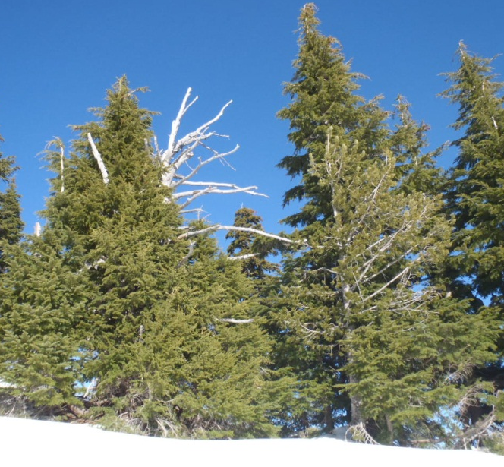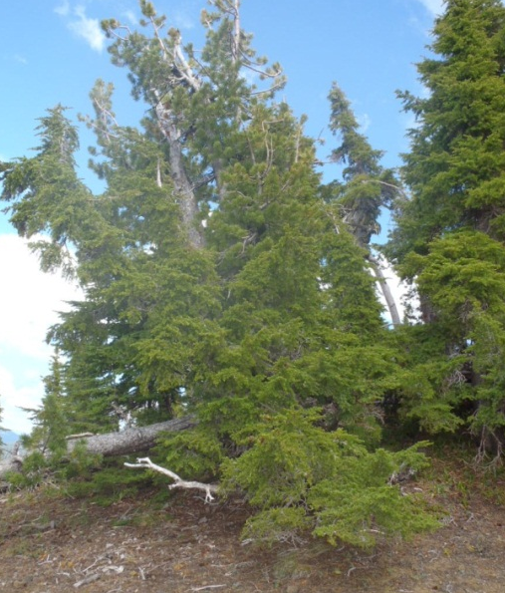
Figure 43. Mountain hemlocks engulf a whitebark pine snag near Discovery Point (left); mountain hemlocks compete with a whitebark pine on Williams Crater (right) .

iii. Introduce genetic stock of whitebark pine adapted to warmer, drier conditions
Another strategy to assist whitebark pine’s adaptation to climate change is to plant seedlings from rust-resistant trees that are already adapted to warmer, drier conditions. Cone collection efforts will include CRLA trees growing at lower elevations and on south-facing slopes. CRLA is currently investigating opportunities to plant whitebark pine seedlings originating from more southerly locations, including the Fremont-Winema National Forest and possibly the Klamath National Forest in California. This is a departure from CRLA’s guidelines for genetic integrity that have been established for restoration projects and which restrict movement of seed within the park and prohibit use of off-park seed. However, in the case of whitebark pine, utilizing outside genetic stock may be necessary to facilitate its adaptation to climate change.
Table 12. CRLA's management objectives and actions for facilitating adaptation to climate change.
CRLA Goal: Increase the resiliency and resistance of CRLA’s whitebark pine communities and promote adaptation to climate change
Objective 1: Promote tree vigor and health
Action 1a: Manage wildland fire to maintain and improve health of whitebark pine stands |  |  | Frequency: Annually
Priority 1: Suppress wildland fire where it is unwanted | Priority 2: Manage wildland fire as an ecosystem process |  | Priority 3: Protect high-value trees during wildland fire events
Action 1b: Monitor whitebark pine stands affected by wildland fire for trends in mortality and recruitment |  |  | Frequency: As opportunity allows
Priority 1: For each burned stand, develop a monitoring strategy commensurate with available resources | Priority 2: Map and install photopoints in burned areas |  | Priority 3: In recently burned areas, track trends in whitebark pine overstory tree mortality and seedling recruitment
Objective 2: Reduce interspecific competition
Action 2a: Implement thinning treatments around trees of genetic, ecological, and/or cultural significance |  |  | Frequency: Implement as projects are developed and compliance is met
Priority 1: Parent trees being threatened by competition | Priority 2: Trees with phenotypic rust-resistance being threatened by competition |  | Priority 3: Trees of ecological importance being threatened by competition
Action 2b: Implement thinning treatments in areas where wildland fire will likely be excluded and high interspecific competition exists |  |  | Frequency: Implement as projects are developed and compliance is met
Priority 1: Designated high priority thinning areas |  | For 2013: Begin planning for Williams Crater Restoration Thinning
Action 2c: Develop site-specific restoration plans for all thinning projects |  |  | Frequency: Mandatory documentation for each thinning project
Action 2d: Monitor thinned areas for response of remaining trees |  |  | Frequency: Dependent on monitoring objectives stated in site-specific restoration plan
Objective 3: Introduce genetic stock of trees with adaptations to warmer/drier conditions
Action 3a: Outplant seedlings of rust-resistant CRLA parent trees growing on warmer/drier sites |  |  | Frequency: Plant as seedlings become available
Action 3b: Outplant seedlings of rust-resistant parent trees from warmer, drier areas within PNW seed zones 7 and 8 and possibly California |  |  | Frequency: Plant as seedlings become available

E. Prioritize and implement restoration actions

In order to be effective, restoration actions need to be prioritized across CRLA’s whitebark pine communities based on need. Restoration will be focused on degraded whitebark pine stands that have suffered high overstory mortality, have little whitebark pine regeneration and are threatened by interspecific competition. Whitebark pine stands that are relatively healthy with little overstory mortality, little interspecific competition and abundant regeneration will not be subject to restoration treatments but will be considered for cone collections and lightning-ignited wildland fire. Treatments made at the individual tree level will focus on high-value trees, such as Parent and Candidate trees and trees of ecological or cultural significance. It is recognized that individual park management zones (e.g., recommended wilderness) have their own requirements and these will be considered and accommodated.
CRLA plans to prioritize whitebark pine restoration actions across the landscape utilizing spatial analysis. Mapping the distribution of whitebark pine by canopy dominance has been recently been completed. Efforts are ongoing or planned to map whitebark pine communities, levels of whitebark pine mortality, blister rust infection rates in whitebark pine communities, areas lacking whitebark pine regeneration, areas impacted by MPB, and mistletoe infection centers. Until those efforts are complete, restoration actions will be prioritized using existing knowledge of conditions.

i. High priority areas for restoration
The highest priority areas for restoration plantings are those with > 50% whitebark pine overstory (≥ 15 cm DBH) mortality, little whitebark pine regeneration, and high blister rust infection rates. Within these areas, targeting sites that may act as climate change refugia is an additional priority for planting. Areas with good road and/or trail access facilitate the logistical end of planting by limiting travel time for planning, planting, watering, and subsequent monitoring and assessments. Easily accessible areas are also suitable for interpreting restoration projects to the visiting public.
Manual thinning treatments to reduce interspecific competition within whitebark pine communities will be focused in areas with high blister rust infection rates, as healthy trees in these areas may serve as critical genetic resources for blister rust resistance. Other whitebark pine stands being threatened by interspecific competition will also be prioritized for treatment, especially where whitebark pines are being suppressed by shade-tolerant species and are vulnerable to elimination.

ii. Employ mitigation measures on high-value trees
Pruning is a tool that CRLA plans to use to potentially extend lifespans of whitebark pines infected with blister rust or dwarf mistletoe. While pruning is time consuming and may be ineffective, it may also prolong the life of individual trees (Hawksworth and Wiens 1996; Burns et al. 2008; Keane et al. 2012). CRLA plans to conduct ‘pathological pruning’ (Burns et al. 2008) on blister rust branch cankers on high-value trees (e.g., Parent and Candidate trees) where no stem cankers are apparent. Guidelines outlined in Burns et al. (2008) would be followed including a) prune when cankers are visible; b) prune cankers within 60 cm of the main stem; and c) prune cankers 5 – 7.6 cm beyond the canker margin. Witches’ brooms caused by dwarf mistletoe infection along stems will also be pruned on high-value whitebark pine trees. Pruning witches’ brooms has been shown to benefit infected trees, at least in the short term (Hawksworth and Wiens 1996).

iii. Special management areas
While restoration treatments will occur in areas of highest ecological need, there are additional factors that must be considered prior to implementing treatments. Portions of CRLA are managed differently than others, and restoration work must abide by administrative requirements specific to each management zone.
Sixty seven percent of CRLA is recommended wilderness and managed as designated wilderness. Restoration actions (planting and thinning) that occur within recommended wilderness will be subject to a “Minimum Requirements” analysis. This analysis ensures that all aspects of restoration work consider and preserve wilderness character as much as practical in their execution. A Minimum Requirement analysis for whitebark pine restoration projects is available in Appendix G.
The Llao Rock Research Natural Area (RNA) encompasses 176 ha inside the caldera and along its northwest slopes. The portions (non-caldera) where restoration work would occur are completely outside CRLA’s recommended wilderness. This is the only RNA at CRLA that contains whitebark pines. The Llao Rock RNA was designated specifically to protect rare plant habitat and increase representation of High Cascades whitebark pine habitat in Oregon’s RNA network. Any whitebark pine restoration work within the Llao Rock RNA would make considerations to limit the footprint of any restoration-related disturbance.
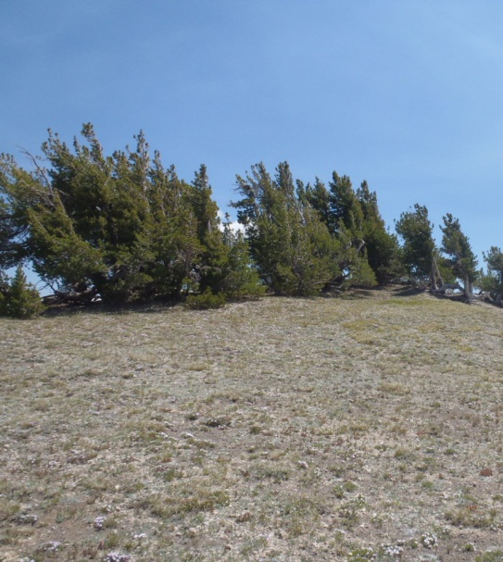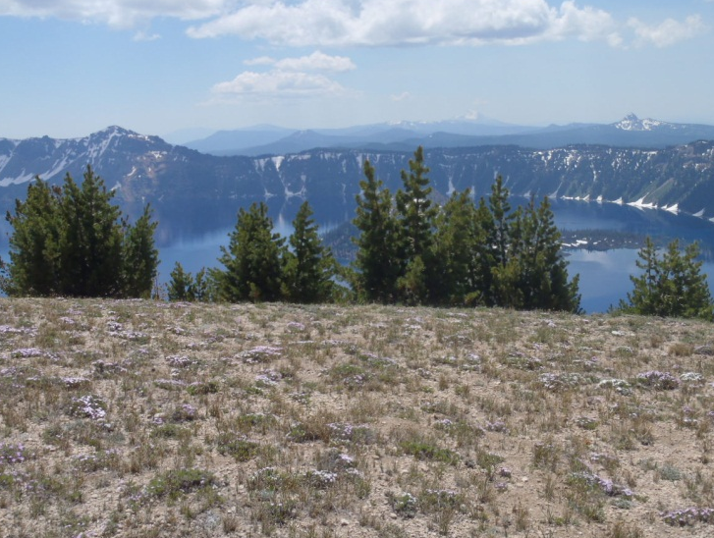
Figure 44. Whitebark pines within the Llao Rock Research Natural Area.
The CRLA General Management Plan (2005) identifies Developed Zones within the park where visitor services and facilities would be concentrated. Restoration planting within developed zones will consider future modification of these areas as needed to accommodate park visitors, and some sites may be deemed unsuitable for plantings. Restoration thinning may occur in this area to release overstory whitebark pine being threatened by interspecific competition, but with careful consideration made to impacts upon cultural landscapes.
Each whitebark pine restoration project (planting and thinning) will be will be analyzed for impacts and/or issues by an interdisciplinary management team to abide by National Environmental Policy Act (NEPA) requirements. Site-specific restoration plans will be entered into the Planning, Environment, and Public Comment (PEPC) web-based program (https://pepc.nps.gov/). Restoration projects will need to receive clearance by cultural resources management staff prior to implementation and will probably require archeological surveys.
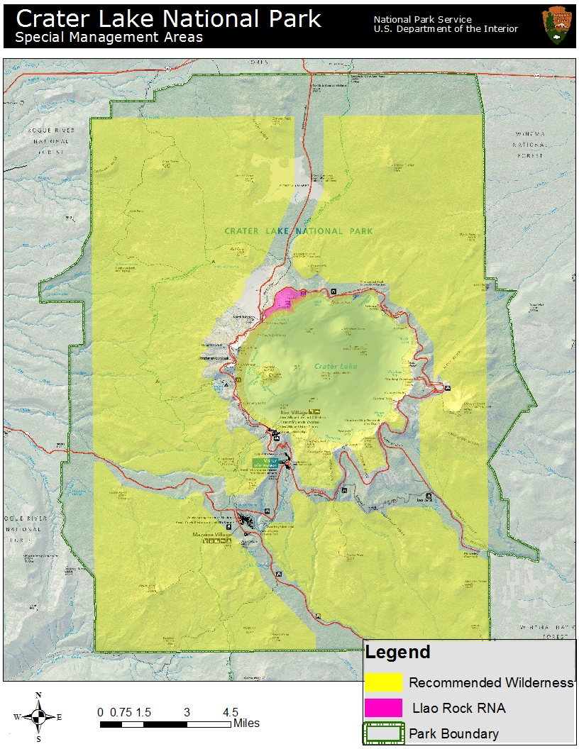
Figure 45. Selected areas of special management consideration. Developed Zone not included on map.
Table 13. CRLA's management objectives and actions for prioritizing restoration treatments.
CRLA Goal: Prioritize restoration actions and conduct treatments in areas of highest ecological need
Objective 1: Conduct restoration treatments in high priority areas
Action 1a: Identify high priority sites for restoration planting |  |  |  |  |  | Frequency: Update as conditions change
Priority 1: Target stands with high canopy mortality | Priority 2: Target stands with high blister rust infection rates |  |  | Priority 3: Target stands with little or no natural regeneration |  |  | Priority 4: Target areas that may serve as climate change refugia
Action 1b: Identify high priority sites for thinning treatments |  |  |  |  |  | Frequency: Update as conditions change
Priority 1: Areas with high blister rust infection and heavy interspecific competition |  | Priority 2: Target stands with heavy interspecific competition |  |  | Priority 3: Areas with high blister rust infection and moderate interspecific competition
Objective 2: Employ mitigation measures on high-value trees
Action 2a: Prune blister rust branch cankers |  |  |  |  |  | Frequency: As staffing allows
Priority 1: Target Parent and Candidate trees |  |  | Priority 2: Target high-value whitebark pines
Action 2b: Prune dwarf mistletoe brooms on branches |  |  |  |  |  | Frequency: As staffing allows
Priority 1: Target Parent and Candidate trees |  |  | Priority 2: Target high-value whitebark pine trees
Objective 3: Acknowledge administrative status of park management zones
Action 3a: Conduct Minimum Requirements analyses as necessary

F. Manage adaptively based on the best available knowledge

Since whitebark pine conservation is a relatively new endeavor at CRLA, practicing adaptive management is critical to ensuring that efforts are focused in the most meaningful and appropriate manner and the most effective restoration techniques are employed. Baseline monitoring within whitebark pine stands allows management to keep abreast of current conditions and rate and direction of any change. Monitoring and research directly inform management of successes and failures of restoration efforts. Maintaining flexibility in management techniques allows for adjusting the course of restoration work as more knowledge is gained and/or conditions change.

i. Monitoring
Monitoring efforts are critical in maintaining knowledge of current conditions within CRLA’s whitebark pine communities. CRLA utilizes two long-term monitoring approaches to track the health and condition of park-wide whitebark pine communities. Whitebark pine is one of the KLMN’s “Vital Signs,” which serve as indicators of the health and status of park ecosystems. As such, whitebark pine is the focus of intensive monitoring utilizing a standardized, peer-reviewed methodology that is employed at all Pacific West Region (PWR) NPS units containing high-elevation five-needle pines (McKinney et al. 2012). This monitoring effort is currently being implemented (summers of 2012-14). The KLMN will install thirty permanent plots at CRLA; these plots will be sampled every three years on a rotating panel basis with 10 plots being sampled each year. In addition to collecting baseline data on whitebark pine stand structure, composition, mortality, and recruitment, data will be collected on blister rust infection rates, levels of MPB-caused mortality, and mistletoe infection.
The other approach is a park-based effort launched in 2003 to track the health of whitebark pine stands within CRLA. This effort established seven monitoring plots in various whitebark pine habitats throughout the park; these plots have been sampled annually from 2003-2011 (with the exception of 2008). The two monitoring approaches are complementary, as each fills at least one data void that the other leaves, and yield important information about blister rust infection rates, trends in whitebark pine mortality, and overall status of CRLA whitebark pine.

ii. Research
Research is another essential component of the WPCP at CRLA as it helps base management decisions upon the best available knowledge and information. CRLA is committed to pursuing and facilitating whitebark pine research and partnering with universities, research scientists, and other federal agencies to increase understanding of whitebark pine ecology and restoration. High-priority research needs at CRLA include:
- Landscape assessment of conditions within CRLA’s whitebark pine communities
- Studies on the Clark’s nutcracker within CRLA
- Assessment of genetic diversity within CRLA’s whitebark pine
- Predictors of MPB attack within CRLA’s whitebark pine
- Post-fire effects within CRLA’s whitebark pine (e.g., mortality, regeneration, MPB activity)
- Studies on success of restoration plantings in relation to topoedaphic conditions and microhabitat structure
- Identifying whitebark pine with resistance to MPB and/or mistletoe
- Identifying climate change refugia within whitebark pine habitat at CRLA
- Response of whitebark pine to release treatments

iii. Adaptive Management
Monitoring and research work enable the practice of adaptive management in whitebark pine conservation at CRLA. Every restoration project will be utilized as a learning opportunity; projects will be monitored and monitoring results integrated into program assessments. Many of the objectives and actions outlined in this plan will need to be adjusted based on new findings and knowledge. The WPCP is constantly evolving based on current knowledge to best utilize available resources to protect, conserve, and restore the whitebark pine resource at CRLA.
Table 14. CRLA's management objectives and actions for monitoring, research, and adaptive management.
CRLA Goal: Continue monitoring and research in whitebark pine communities and incorporate findings into management actions
Objective 1: Continue monitoring whitebark pine
Action 1a: Assist KLMN with monitoring efforts | Frequency: Annually
Action 1b: Continue sampling CRLA long-term monitoring plots | Frequency: Annually
Objective 2: Pursue opportunities to conduct whitebark pine research at CRLA
Action 2a: Identify high priority whitebark pine-related research needs | Frequency: Update as needed
Action 2b: Pursue and facilitate whitebark pine research | Frequency: As needed
Objective 3: Integrate current knowledge and findings into whitebark pine conservation program management
Action 3a: Update whitebark pine conservation plan regularly | Frequency: As needed
Action 3b: Practice adaptive management; integrate new information and knowledge into conservation program as available | Frequency: Annually
Action 3c: Share results and findings of park-wide monitoring | Frequency: As available

G. Engage the public through education and outreach

Communicating goals, activities, and findings of CRLA’s WPCP is essential for increasing the level of public awareness and understanding of the status of whitebark pine in the park. CRLA is fortunate in having a highly skilled Interpretation Division whose work revolves around sharing information with and providing educational opportunities for park visitors and local community members. Through working closely with Interpretation staff, WPCP staff can increase opportunities for public knowledge and engagement in whitebark pine conservation at CRLA and elsewhere.

i. Share information with Interpretation and park staff
WPCP staff will regularly present and share information with the Interpretation Division and other park staff as requested. Integrating whitebark pine conservation into annual Interpretation staff training sessions ensures park Interpreters are briefed on current activities and findings of the WPCP, including park-wide monitoring results and new science. A presentation on whitebark pine conservation through the Casual Conversations with Park Researchers program will be given as requested to all interested park staff.

ii. Educate park visitors
Park Interpretation staff regularly incorporates whitebark pine ecology and its conservation into public programs. Whitebark pine can be a central or peripheral topic for evening campfire programs, trolley tour talks, and talks given at the Crater Lake Lodge. The park’s 40+ Wayside exhibits are currently being updated and replaced; efforts are underway to develop one or more whitebark pine-related Wayside exhibits that can be placed at the Whitebark Pine Picnic Area and/or Rim Village Promenade. Additionally, plans are underway to develop a Wayside exhibit at the 2009 Rim Village restoration planting site to share this project with park visitors. The park newspaper, Reflections, is available free of charge at park visitor centers. A story on whitebark pine conservation is regularly featured every several years and was included in the 2012 summer edition. The Botany staff annually leads several field trips, primarily to Native Plant Society audiences, and whitebark pine conservation is a major discussion theme.

iii. Make information available to the general public
With the recent development of the park’s Facebook page (https://www.facebook.com/CraterLakeNPS), new opportunities are available to share information related to whitebark pine conservation with a broad audience. During the 2013 field season, efforts will be made to post activities of the WPCP to the park Facebook page on a biweekly basis. The CRLA Botany program plans on updating and expanding its sections on the park website (www.nps.gov/crla) to include information on the WPCP. Whitebark pine conservation work at CRLA has been the subject of newspaper, radio, and television stories, and has been featured by the park newspaper, The Herald and News newspaper, and Oregon Public Broadcasting’s Oregon Field Guide and Earthfix programs. The WPCP will continue to work with the media and provide information as requested.

iv. Integrate whitebark pine conservation into educational curriculum
The WPCP plans to work closely with CRLA’s Science and Learning Center (SLC) to create resource briefing statements on whitebark pine that can be used for internal or external use, including on the park website. Additionally, the WPCP plans to work with the SLC to incorporate whitebark pine ecology and conservation into the Classroom at Crater Lake fall program curriculum.
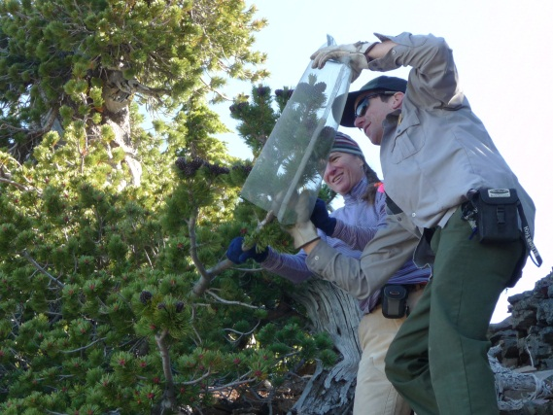
Figure 46. CRLA’s Facebook page (left); a CRLA Interpretive staff member assists with cone caging (right). Photo by Elena Thomas.
Table 15. CRLA's management objectives and actions for whitebark pine-related public outreach and education.
CRLA Goal: Increase awareness of CRLA’s whitebark pine conservation program through public outreach and education
Objective 1: Share information with Interpretation Division and park staff
Action 1a: Present information at Interpretation training sessions | Frequency: Annually
Action 1b: Present at Casual Conversations with Park Researchers | Frequency: As requested
Objective 2: Educate park visitors
Action 2a: Use whitebark pine conservation as a topic of evening programs, trolley tour talks, Lodge talks | Frequency: Annually
Action 2b: Assist with the development of whitebark pine-related park Wayside demonstrations | Frequency: As Waysides are updated (10-15 year lifespan)
Action 2c: Include features in park newspaper | Frequency: Semi-annually
Action 2d: Incorporate whitebark pine conservation into field trip discussions | Frequency: Annually
Objective 3: Make information available to the general public
Action 3a: Utilize social media | Frequency: During summer months – create posts biweekly
Action 3b: Include whitebark pine conservation information on park website | Frequency: Update annually
Action 3c: Respond to information requests from the media | Frequency: As requested
Objective 4: Integrate whitebark pine conservation into educational curriculum
Action 4a: Work with Science and Learning Center to create Resource Briefing Statements | Frequency: Update every three years
Action 4b: Integrate whitebark pine conservation into Classroom at Crater Lake program | Frequency: Annually

V. Whitebark Pine Conservation Program Management

This section outlines the broader operational components of the WPCP and defines some of the anticipated responsibilities of various positions, program needs, and ongoing partnerships that all need to be maintained in order for the WPCP to have the greatest chance for success when trying to meet the specific goals previously outlined in this document.

A. Roles and Responsibilities

The following individuals play important roles in CRLA’s WPCP:
Chief, Resource Preservation and Research – Ensures the CRLA Superintendent has a basic understanding of the importance of the WPCP for the park, how the WPCP addresses broader conservation needs in the region, and the necessity to maintain partnerships with other NPS units, federal agencies, and universities. Works collaboratively with the park Management Team to reduce conflicts with other Division activities, while also looking for opportunities to pool Division resources when it benefits the WPCP. This position also provides the Terrestrial Ecologist and Botanist with timely feedback and oversight to ensure the Division of Resource Preservation and Research (RP&R) meets WPCP management goals and accomplishes annual work plan items while abiding by NPS policies, compliance requirements, and regulations, and addressing any concerns raised by the public.
Terrestrial Ecologist – Provides administrative oversight to the WPCP including soliciting CRLA, the NPS Pacific West Regional office, and other agencies and entities to obtain program funding. Ensures that there is enough funding to proceed with the annual monitoring and proposed projects outlined in the WPCP, and manages associated WPCP budgets. Serves as the Agreements Technical Representative (ATR) for agreements related to the WPCP. Oversees annual WPCP goals and ensures as many priority work items as possible are completed in the context of other competing Terrestrial Program workloads.
Botanist – Serves as the WPCP lead and program manager. Keeps Terrestrial Ecologist informed of program needs related to staffing and equipment, and informs the Terrestrial Ecologist of any issues that might need Division or park input and support to resolve. Maintains and updates the Whitebark Pine Conservation Plan annually or as changes dictate; sets annual and programmatic goals and objectives and ensures they are met; maintains program files and data; schedules WPCP meetings; hires and supervises seasonal staff and creates seasonal work plans and schedules; and collaborates and communicates with partners, cooperators, and researchers.
Lead Biological Science Technician – Serves as leader for the WPCP field crew. Communicates frequently with Botanist and keeps Botanist abreast of work issues and/or needs; completes scheduled field work; coordinates with partners in cone collection efforts; monitors restoration plantings, Parent/Candidate trees, thinning treatments, post-burn sites, and long-term plots; assists with new and ongoing restoration projects; completes annual report summarizing field efforts; and creates and maintains a safe working environment for self, co-workers, and partners.
Biological Science Technician – Works with Lead Biological Science Technician to accomplish scheduled field work.
KLMN Whitebark Pine Protocol Lead – Responsible for implementing whitebark pine Vital Sign monitoring at CRLA. Works closely with Botanist to coordinate monitoring projects and informs Botanist of anticipated work schedules within the park. Communicates monitoring results and reports to Botanist.
Southern Cascades Fire Ecologist – Provides expertise in fire modeling and wildland fire/whitebark pine management decisions. Plays a lead role in formulating “desired future conditions” and resource target conditions for whitebark pine communities within management documents. Collaborates with Botanist to monitor post-fire whitebark pine stands and pursue fire-related research in CRLA’s whitebark pine communities.
Fire Management Officer (FMO) – Implements various protective measures and guidelines outlined within the Fire Management Plan and the WPCP regarding operations in or near whitebark pine stands. On an annual basis, the FMO collaborates with Terrestrial Branch staff and READs to ensure that high-value whitebark pines (e.g. Parent and Candidate trees) and stands are not impacted during fire operations. The FMO also supports aspects of the WPCP through allocation of resources (staff) that can help with managing both natural and prescribed fires and initiating thinning projects. The FMO is involved in formulating “desired future conditions” and resource target conditions for whitebark pine communities within the Resources Management Plan and/or the Resources Stewardship Strategy when this document is developed.

B. Reporting and Evaluation

Under the adaptive management model, it is expected that many of the objectives and actions outlined in the Whitebark Pine Conservation Plan will need to be adjusted based on new findings and knowledge. Through timely reporting and analysis of WPCP activities occurring each year, the Botanist and other RP&R staff will determine what needs to be adjusted, how best to allocate limited funds, and how to properly prioritize research needs.
The items below are intended to highlight and summarize the suggested annual reporting subjects for the WPCP and are based on the goals and objectives of the program as laid out in Section IV.
- Cone collection activities (e.g. location and numbers)
- Updated results from DGRC blister rust resistance testing
- Status of current seed stocks and seedlings housed at DGRC (for restoration planning)
- Planting and status of CRLA seeds in off-park locations
- Banking of seed (ex situ conservation) with DGRC and/or other organizations
- Parent and Candidate tree monitoring
- MBP control activities/Verbenone effectiveness
- Recent MBP activity within CRLA
- Monitoring results from previous restoration plantings (e.g. mortality levels, blister rust infection rates) and lessons learned
- Planning for new restoration projects (e.g., restoration plan status, compliance status, study design, location)
- Findings from long-term monitoring plots
- Fire activity and impacts within whitebark pine stands
- Reporting on new fire monitoring efforts and monitoring results of previously burned areas
- Reporting on new thinning activities and monitoring results of previous thinning
- Summary of KLMN whitebark pine plot data and findings
- Updates and summaries of any research projects within CRLA
- Summary of any new literature pertinent to WPCP

Most of these topics will be addressed within annual WPCP reports. Other reports (e.g. research projects) will be filed and stored within the CRLA Botany office and Terrestrial Branch network directory.
Additionally, to facilitate adaptive management, there will be a semi-annual review of the WPCP. The positions identified in sections A (above) will meet to review new information and provide feedback on whether management strategies need adjustment. As the WPCP is fine-tuned based on new findings and lessons learned, all changes will be documented and the Whitebark Pine Conservation Plan amended as needed. Because annual changes might result in significant changes to the intent of the document over time, there will be five year reviews that determine whether the document has changed significantly enough to require new compliance.

C. Budget

There is a significant amount of resources involved with conducting whitebark pine conservation projects and annual monitoring tasks. The WPCP will have very little chance of making any progress towards conserving the species if it is not continually funded. The current Terrestrial Branch base budget does not provide support for biological science technicians to perform the work identified in the Whitebark Pine Conservation Plan. Previous field work has been funded by proposals written into the NPS Project Management Information System (PMIS) and supported by park entrance fees; funding has also been provided by the USFS Forest Health Protection program. Additional funding from USFS Forest Health Protection, the Crater Lake Natural History Association, CRLA Recreation Fee, and other sources will be pursued.
Typical annual workloads outlined in the Whitebark Pine Conservation Plan would require approximately $15,000-30,000 depending on the employee number and grade, season length and equipment needs:
WPCP Component Cost
1-2 seasonal Biological Science Technicians (Plants) $12,000-24,000
--within the GS-04/05/06 range; approximately 8 pay periods

1 work vehicle (GSA seasonal or rental) for 4 months $2,000-4,000
Equipment and supplies $1,000-2,000
Additionally, funding will be solicited to continue the support received from the DGRC, facilitate tree climbing assistance for cone collection efforts, and develop proposals to collaborate with other agencies and universities on a variety of projects related to the WPCP goals and research needs.

D. Partnerships

Because whitebark pine is not endemic to CRLA, and indeed extends throughout several major mountain ranges across the western U.S. and into Canada, forming and maintaining partnerships is key to managing a successful WPCP within CRLA. Although when compared to the entire range of the species, only a small fraction of a percentage point of whitebark pine occurs within CRLA, there are some unique environments and genetic elements of our populations that make them a unique and important component of the range-wide distribution. Conversely, it would be futile to develop a plan for whitebark pine conservation at CRLA without acknowledging and incorporating the enormous amount of literature and current knowledge about the species throughout its range.
The CRLA WPCP depends upon key partnerships with the DGRC, the Deschutes National Forest, Oregon State University, the USFS Forest Health Protection program, and the KLMN. Relationships to be developed include parks containing whitebark pine within the KLMN (Lassen Volcanic NP), the NPS PWR (Mt. Rainier NP, North Cascades NP, Olympic NP, Yosemite NP, and Sequoia-Kings Canyon NP), adjacent national forests (Fremont-Winema NF, Rogue River-Siskiyou NF, and the Umpqua NF), and local universities (Southern Oregon University and Humboldt State University). Additionally, the CRLA WPCP is honored to partner with region-wide and range-wide efforts to conserve whitebark pine.

VI. Conclusion

The ultimate goal of whitebark pine conservation at CRLA is to preserve and restore whitebark pine as a keystone and foundation species within the park and contribute to broad range-wide conservation efforts. Under the framework of the WPCP, CRLA hopes to maintain, restore, and protect this species within the park and collaborate with other agencies, universities, and individuals to conserve this species range-wide. Despite a negative prognosis, we retain hope that through restoration efforts, monitoring, research, and adaptive management we can maintain healthy whitebark pine communities park-wide and range-wide for many centuries to come.

Acknowledgements

This document was greatly improved through thoughtful comments and suggestions made by Mac Brock, Greg Funderburk, Steve Mark, Marsha McCabe, and Elena Thomas. Maps and photos are by J. Beck unless otherwise noted.

References

Agee, J.K. 1993. Fire Ecology of Pacific Northwest Forests. Island Press, Washington, D.C., USA.
Amman, G.D. 1973. Population changes of the mountain pine beetle in relation to elevation. Environmental Entomology 2(4): 541-547.
Amman, G.D. 1977. Role of the mountain pine beetle in lodgepole pine ecosystems: impact on succession. Pp. 3-18 in W.J. Mattson, editor, The Role of Arthropods in Forest Ecosystems. Springer-Verlag, New York, New York, USA.
Applegate, E.J. 1937. Letter to CRLA Superintendent D.H. Canfield. Contained within the Crater Lake National Park Administrative History files at park headquarters (N18-436).
Arno, S.F. and R.J. Hoff. 1989. Silvics of whitebark pine (Pinus albicaulis). USDA Forest Service, Intermountain Research Station, General Technical Report INT-253, Odgen, Utah, USA.
Arno, S.F. and T. Weaver. 1990. Whitebark pine community types and their patterns on the landscape. Pp. 97-105 in W.C. Schmidt and K.J. McDonald, compilers. Whitebark pine ecosystems – Ecology and management of a high mountain resource. USDA Forest Service, Intermountain Research Station, General Technical Report INT-270, Ogden, Utah, USA.
Arno, S.F. 2001. Community types and natural disturbance processes. Pp. 74-88 in D.F. Tomback, S.F. Arno, and R.E. Keane, editors. Whitebark Pine Communities: Ecology and Restoration. Island Press, Washington, D.C., USA.
Aubry, C., D. Goheen, R. Shoal, T. Ohlson, T. Lorenz, A. Bower, C. Mehmel, and R. Sniezko. 2008. Whitebark pine restoration strategy for the Pacific Northwest region: 2009-2013. Region 6 Report, USDA Forest Service, Pacific Northwest Region, Portland, Oregon, USA.
Bachelet, D., B.R. Johnson, S.D. Bridgham, P.V. Dunn, H.E. Anderson, and B.M. Rogers. 2011. Climate change impacts on western Pacific Northwest prairies and savannas. Northwest Science 85(2): 411-429.
Baker, R.G. 1990. Late quaternary history of whitebark pine in the Rocky Mountains. Pp. 40-47 in W.C. Schmidt and K.J. McDonald, compilers. Proceedings – Symposium on whitebark pine ecosystems: Ecology and management of a high-mountain resource. USDA Forest Service, Intermountain Research Station, General Technical Report INT-270, Ogden, Utah, USA.
Baldwin, B.G., D.H. Goldman, D.J. Keil, R. Patterson, T.J. Rosatti, and D.H. Wilken, editors. 2012. The Jepson manual: vascular plants of California, second edition. University of California Press, Berkeley, California, USA.
Bartos, D.L. and K.E. Gibson. 1990. Insects of whitebark pine with emphasis on mountain pine beetle. Pp. 171-178 in W.C. Schmidt and K.J. McDonald, compilers, Proceedings – Symposium on whitebark pine ecosystems: ecology and management of a high-mountain resource, March 29-31, 1989, Bozeman, Montana. General Technical Report INT-270, USDA Forest Service, Intermountain Research Station, Logan, Utah, USA.
Beck, J., H. Lintz, C. Jensen, and R. Sniezko. 2012. Crater Lake National Park Whitebark Pine Restoration Plan: 2012 Dutton Ridge and North Junction plantings. Unpublished report on file at Crater Lake National Park headquarters.
Benedict, W.V. 1941. Letter to CRLA Superintendent E.P. Leavitt. Contained within the Crater Lake National Park Administrative History files at park headquarters (Y18-696).
Benedict, W.V. 1981. History of white pine blister rust control – a personal account. Report FS-355, USDA Forest Service, Washington, D.C., USA.
Bentz, B.J. and G. Schen-Langenheim. 2007. The mountain pine beetle and whitebark pine waltz: has the music changed? Pp. 43-50 in E.M. Goheen and R.A. Sniezko, technical coordinators. Proceedings of the conference whitebark pine: a Pacific Coast perspective. August 27-31, 2006: Ashland, Oregon. R6-NR-FHP-2007-01. USDA Forest Service, Pacific Northwest Region, Portland, Oregon, USA.
Bentz, B., E. Campbell, K. Gibson, S. Kegley, J. Logan, and D. Six. 2011. Mountain pine beetle in high-elevation five-needle white pine ecosystems. Pp. 78-84 in R.E. Keane, D.F. Tomback, M.P. Murray, and C.M. Smith, editors. The future of high-elevation five-needle pines in western North America: Proceedings of the High Five Symposium. 28-30 June 2010; Missoula, Montana. Proceedings RMRS-P-63. Fort Collins, Colorado, USA.
Bower, A.D. and S.N. Aitken. 2007. Mating system and inbreeding depression in whitebark pine (Pinus albicaulis Engelm.). Tree Genetics and Genomes 3: 379-388.
Bower, A.D., S.C. McLane, A. Eckert, S. Jorgensen, A. Schoettle, and S. Aitken. 2011. Conservation genetics of high elevation five-needle pines. Pp. 98-117 in R.E. Keane, D.F. Tomback, M.P. Murray, and C.M. Smith, editors. The future of high-elevation five-needle pines in western North America: Proceedings of the High Five Symposium. 28-30 June 2010; Missoula, Montana. Proceedings RMRS-P-63. Fort Collins, Colorado, USA.
Bruederle, L.P., D.L. Rogers, K.V. Krutovskii, and D.V. Politov. 2001. Population genetics and evolutionary implications. Pp. 137-153 in D.F. Tomback, S.F. Arno, and R.E. Keane, editors. Whitebark Pine Communities: Ecology and Restoration. Island Press, Washington, D.C., USA.
Brunelle, A., G.E. Rehfeldt, B. Bentz, and A.S. Munson. 2008. Holocene records of Dendroctonus bark beetles in high elevation pine forests of Idaho and Montana, USA. Forest Ecology and Management 255: 836-846.
Buol, S.W., R.J. Southard, R.C. Graham, and P.A. McDaniel. 2003. Soil Genesis and Classification, fifth edition. Iowa State Press, Ames, Iowa, USA.
Burns, K.S., A.W. Schoettle, W.R. Jacobi, and M.F. Mahaolovich. 2008. Options for the management of white pine blister rust in the Rocky Mountain region. USDA Forest Service Rocky Mountain Research Station, General Technical Report RMRS-GTR-206. Fort Collins, Colorado, USA.
Campbell, E.M. and J.A. Antos. 2000. Distribution and severity of white pine blister rust and mountain pine beetle on whitebark pine in British Columbia. Canadian Journal of Forest Research 30: 1051-1059.
Campbell, E.M., R.E. Keane, E.R. Larson, M.P. Murray, A.W Schoettle, and C. Wong. 2011. Disturbance ecology of high-elevation five-needle pine ecosystems in western North America. Pp. 154-163 in R.E. Keane, D.F. Tomback, M.P. Murray, and C.M. Smith, editors. The future of high-elevation five-needle pines in western North America: Proceedings of the High Five Symposium. 28-30 June 2010; Missoula, Montana. Proceedings RMRS-P-63. Fort Collins, Colorado, USA.
Castello, J.D., D.J. Leopold, and P.J. Smallidge. 1995. Pathogens, patterns, and processes in forest ecosystems. BioScience 45(1): 16-24.
Cayan, D.R., S.A. Kammerdiener, M.D. Dettinger, J.M. Caprio, and D.H. Peterson. 2001. Changes in the onset of spring in the western United States. Bulletin of the American Meteorological Society 82(3): 399-415.
Cook, L.F. 1936. Letter from Senior Forester, USDI National Park Service, Branch of Forestry, Western Division to E.P. Meinecke, British Columbia, Canada. Contained within the Crater Lake National Park Administrative History files at park headquarters (Y18-697).
Daly, C., J. Smith, and M. Doggett. 2009. An assessment of temporal and spatial trends in historical climate data for the Klamath network parks. Final report on file at Crater Lake National Park headquarters.
Daneshgar, P.P. 2003. Growth response of whitebark pine to climate in the Pacific Northwest. M.S. Thesis, St. Joseph’s University, Philadelphia, Pennsylvania, USA.
Deur, D. 2008. In the Footprints of Gmukamps: A Traditional Use Study of Crater Lake National Park and Lava Beds National Monument. USDI National Park Service, Pacific West Region: Social Science Series, Publication Number 2008-01. 294 pp.
Deur, D. 2012. Email to J. Beck, January 2012.
Dolph, R.E. Jr. 1967. Mountain pine beetle in the Pacific Northwest 1955-1966. Report issued by the USDA Forest Service, Pacific Northwest Region, Insect and Disease Control Branch, Division of Timber Management.
Donahue, J. 2000. First year results of a program for monitoring the health of whitebark pine (Pinus albicaulis) at Crater Lake National Park. Unpublished report on file at Crater Lake National Park headquarters, Crater Lake, Oregon, USA.
Ellison, A.M., M.S. Bank, B.D. Clinton, E.A. Colburn, K. Elliott, C.R. Ford, D.R. Foster, B.D. Kloeppel, J.D. Knoepp, G.M. Lovett, J. Mohan, D.A. Orwig, N.L. Rodenhouse, W.V. Sobczak, K.A. Stinson, J.K. Stone, C.M. Swan, J. Thompson, B. Von Holle, and J. R. Webster. 2005. Loss of foundation species: consequences for the structure and dynamics of forested ecosystems. Frontiers in Ecology and the Environment 3(9): 479-486.
Farner, D.S. 1952. The Birds of Crater Lake National Park. University of Kansas Press, Lawrence, Kansas, USA.
Fisher, D.C. 1931. Birds. Nature Notes from Crater Lake 4(1).
Franklin, J.F. and C.T. Dyrness. 1973. Natural Vegetation of Oregon and Washington. USDA Forest Service, Pacific Northwest Forest and Range Experiment Station, General Technical Report PNW-8, Portland, Oregon, USA.
Fryer, J.L. 2002. Pinus albicaulis. In: Fire Effects Information System, [Online]. USDA Forest Service, Rocky Mountain Research Station, Fire Sciences Laboratory (Producer). Available: http://www.fs.fed.us/database/feis/
Furnier, G.R., P.Knowles, M.A. Clyde, and B.P. Dancik. 1987. Effects of avian seed dispersal on the genetic structure of whitebark pine populations. Evolution 41(3): 607-612.
Furniss, R.L. and V.M. Carolin. 1977. Western Forest Insects. USDA Forest Service Miscellaneous Publication No. 1339, Washington, D.C., USA.
Ganley, R.J., R.A. Sniezko, and G. Newcombe. 2008. Endophyte-mediated resistance against white pine blister rust in Pinus monticola. Forest Ecology and Management 255: 2751-2760.
Geils, B.W. and D.R. Vogler. 2011. A natural history of Cronartium ribicola. Pp. 210-217 in R.E. Keane, D.F. Tomback, M.P. Murray, and C.M. Smith, editors. The future of high-elevation five-needle pines in western North America: Proceedings of the High Five Symposium. 28-30 June 2010; Missoula, Montana. Proceedings RMRS-P-63. Fort Collins, Colorado, USA.
Gibson, K., K. Skov, S. Kegley, C. Jorgensen, S. Smith, and J. Witcosky. 2008. Mountain pine beetle impacts in high-elevation five-needle pines: current trends and challenges. USDA Forest Service, Forest Health Protection report R1-08-020, Missoula, Montana, USA.
Goheen, E.M. 2000. Unpublished data on file at Crater Lake National Park headquarters.
Goheen, E.M., D.J. Goheen, K. Marshall, R.S. Danchok, J.A. Petrick, and D.E. White. 2002. The status of whitebark pine along the Pacific Crest National Scenic Trail on the Umpqua National Forest. General Technical Report PNW-GTR-530, USDA Forest Service, Pacific Northwest Research Station, Portland, Oregon, USA.
Hansen, H.P. 1942. Post-Mount Mazama forest succession on the east slope of the Central Cascades of Oregon. American Midland Naturalist 27(2): 523-533.
Hawksworth, F.G. and D. Wiens. 1996. Dwarf mistletoes: biology, pathology, and systematics. Agricultural Handbook 709, USDA Forest Service, Washington, D.C., USA.
Hawksworth, F.G. and G.W. Geils. 1996. Biotic associates. Pp. 73-89 in F.G. Hawksworth and D. Wiens, Dwarf mistletoes: biology, pathology, and systematics. Agricultural Handbook 709, USDA Forest Service, Washington, D.C., USA.
Hawksworth, F.G., D. Wiens, and G.W. Geils. 2002. Arceuthobium in North America. Pp. 29-56 in Geils, B.W., J. Cibrían Tovar, and B. Moody, technical coordinators. 2002. Mistletoes of North American conifers. General Technical Report RMRS-GTR-98, USDA Forest Service, Rocky Mountain Research Station, Ogden, Utah, USA.
Hicke, J.A., J.A. Logan, J. Powell, and D.S. Ojima. 2006. Changing temperatures influence suitability for modeled mountain pine beetle (Dendroctonus ponderosae) outbreaks in the western United States. Journal of Geophysical Research 111: G02019.
Hoff, R.J., D.E. Ferguson, G.I. McDonald, and R.E. Keane. 2001. Strategies for managing whitebark pine in the presence of white pine blister rust. Pp. 346-366 in D.F. Tomback, S.F. Arno, and R.E. Keane, editors. Whitebark Pine Communities: Ecology and Restoration. Island Press, Washington, D.C., USA.
Homuth, E.U. 1928. Pests. Nature Notes from Crater Lake 1(2).
Hudson, L.E. and E.K. Thomas. 2010. Whitebark pine restoration under way at Crater Lake: preemptive strike against blister rust based on disease-resistant seedlings. Park Science 27(2): 68-69.
Hutchins, H.E. and R.M. Lanner. 1982. The central role of Clark’s nutcracker in the dispersal and establishment of whitebark pine. Oecologia 55: 192-201.
Jackson, M.T. and A. Faller. 1973. Structural analysis and dynamics of the plant communities of Wizard Island, Crater Lake National Park. Ecological Monographs 43(4): 441-461.
Jorgensen, S.M. and J.L. Hamrick. 1997. Biogeography and population genetics of whitebark pine, Pinus albicaulis. Canadian Journal of Forest Research 27: 1574-1585.
Keane, R.E., K.L. Gray, and L.J. Dickinson. 2007. Whitebark pine diameter growth response to removal of competition. Research Note RMRS-RN-32, USDA Forest Service, Rocky Mountain Research Station, Missoula, Montana, USA.
Keane, R.E., D.F. Tomback, C.A. Aubrey, A.D. Bower, E.M. Campbell, C.L. Cripps, M.B. Jenkins, M.F. Mahalovich, M. Manning, S.T. McKinney, M.P. Murray, D.L. Perkins, D.P. Reinhart, C. Ryan, A.W. Schoettle, and C.M. Smith. 2012. A range-wide restoration strategy for whitebark pine (Pinus albicaulis). General Technical Report RMRS-GTR-279. USDA Forest Service, Rocky Mountain Research Station, Fort Collins, Colorado, USA.
Kendall, K.C. and R.E. Keane. 2001. Whitebark pine decline: infection, mortality, and population trends. Pp. 221-242 in D.F. Tomback, S.F. Arno, and R.E. Keane, editors. Whitebark Pine Communities: Ecology and Restoration. Island Press, Washington, D.C., USA.
Kegley, S. and K. Gibson. 2011. The use of Verbenone to protect whitebark pine from mountain pine beetle. Pg. 96 in R.E. Keane, D.F. Tomback, M.P. Murray, and C.M. Smith, editors. The future of high-elevation five-needle pines in western North America: Proceedings of the High Five Symposium. 28-30 June 2010; Missoula, Montana. Proceedings RMRS-P-63. Fort Collins, Colorado, USA.
Kipfmueller, K.F. and W.L. Baker. 1998. Fires and dwarf mistletoe in a Rocky Mountain lodgepole pine ecosystem. Forest Ecology and Management 108: 77-84.
Kliejunas, J.T., B.W. Geils, J.M. Glaeser, E.M. Goheen, P. Hennon, M.S. Kim, H. Kope, J. Stone, R. Sturrock, and S.J. Frankel. 2008. Climate and forest diseases of western North America: a literature review. USDA Forest Service, available online: http://www.fs.fed.us/wwetac/projects/PDFs/Climate_Forest_Disease_Lit_Review.pdf
Kliejunas, J.T. 2011. A risk assessment of climate change and the impact of forest diseases on forest ecosystems in the western United States and Canada. General Technical Report PSW-GTR-236. USDA Forest Service, Pacific Southwest Research Station, Albany, California, USA.
Knowles, N., M.D. Dettinger, and D.R. Cayan. 2006. Trends in snowfall versus rainfall in the western United States. Journal of Climate 19: 4545-4559.
Lanner, R.M. 1996. Made for Each Other: A Symbiosis of Birds and Pines. Oxford University Press, New York, New York, USA.
Larson, E.R. 2010. Influences of the biophysical environment on blister rust and mountain pine beetle, and their interactions, in whitebark pine forests. Journal of Biogeography 38: 453-470.
Larson, E.R. and K.F. Kipfmueller. 2010. Patterns in whitebark pine regeneration and their relationships to biophysical site characteristics in southwest Montana, central Idaho, and Oregon, USA. Canadian Journal of Forest Research 40: 476-487.
Leavitt, E.P. 1941. Letter to W.V. Benedict. Contained within the Crater Lake National Park Administrative History files at park headquarters (Y18-696).
Libbey, D.S. 1932. Letter to the NPS Director. Contained within the Crater Lake National Park Administrative History files at park headquarters (N18-436).
Libbey, D.S. 1933. Winter Birds. Nature Notes from Crater Lake 6(1).
Linhart, Y.B. and D.F. Tomback. 1985. Seed dispersal by nutcrackers causes multi-trunk growth form in pines. Oecologia 67: 107-110.
Littell, J.S., E.E. Oneil, D. McKenzie, J.A. Hicke, J.A. Lutz, R.A. Norheim, and M.M. Elsner. 2010. Forest ecosystems, disturbance, and climatic change in Washington State, USA. Climatic Change. doi 10.1007/s10584-010-9858-x
Loehman, R.A., A. Corrow, and R.E. Keane. 2011. Modeling climate changes and wildfire interactions: effects on whitebark pine (Pinus albicaulis) and implications for restoration, Glacier National Park, Montana, USA. Pp. 176-189 in R.E. Keane, D.F. Tomback, M.P. Murray, and C.M. Smith, editors. The future of high-elevation five-needle pines in western North America: Proceedings of the High Five Symposium. 28-30 June 2010; Missoula, Montana. Proceedings RMRS-P-63. Fort Collins, Colorado, USA.
Logan, J.A. and B.J. Bentz. 1999. Model analysis of mountain pine beetle (Coleoptera: Scolytidae) seasonality. Environmental Entomology 28(6): 925-934.
Logan, J.A. and J.A. Powell. 2001. Ghost forests, global warming, and the mountain pine beetle (Coleoptera: Scolytidae). American Entomologist 47(3): 160-172.
Logan, J.A., W.W. Macfarlane, and L. Willcox. 2009. Effective monitoring as a basis for adaptive management: a case history of mountain pine beetle in Greater Yellowstone Ecosystem whitebark pine. iForest 2: 19-22 [online: 2009-01-21] URL: http://www.sisef.it/iforest/show.php?id=477
Logan, J.A., W.W. Macfarlane, and L. Willcox. 2010. Whitebark pine vulnerability to climate-driven mountain pine beetle disturbance in the Greater Yellowstone Ecosystem. Ecological Applications 20(4): 895-902.
Lorenz, T.J., C. Aubry, and R. Shoal. 2008. A review of the literature on seed fate in whitebark pine and the life history traits of Clark’s nutcracker and pine squirrels. General Technical Report PNW-GTR-742. USDA Forest Service, Pacific Northwest Research Station, Portland, Oregon, USA.
Lorenz, T.J. 2009. Linking space use and behavior in Clark’s nutcracker: an explanation for seasonal variation in space. M.S. Thesis, Utah State University, Logan, Utah, USA.
Lorenz, T.J., K.A. Sullivan, A.V. Bakian, and C.A. Aubry. 2011. Cache-site selection in Clark’s nutcracker (Nucifraga columbiana). The Auk 128(2): 237-247.
Maffei, H. and A. Eglitis. 1991. Letter to CRLA Superintendent regarding forest pest management site visit to CRLA, August 13-14, 1991. On file at Crater Lake National Park headquarters.
Mathiasen, Bob. 2012. Email correspondence with J. Beck.
Mattson, W.J. and R.A. Haack. 1987. The role of drought in outbreaks of plant-eating insects. BioScience 37(2): 110-118.
McCaughey, W.W. and W.C. Schmidt. 1990. Autecology of whitebark pine. Pp. 85-96 in W.C. Schmidt and K.J. McDonald, compilers. Proceedings – Symposium on whitebark pine ecosystems: Ecology and management of a high-mountain resource. USDA Forest Service, Intermountain Research Station, General Technical Report INT-270, Ogden, Utah, USA.
McCaughey, W.W. and W.C. Schmidt. 2001. Taxonomy, distribution, and history. Pp. 29-40 in D.F. Tomback, S.F. Arno, and R.E. Keane, editors. Whitebark Pine Communities: Ecology and Restoration. Island Press, Washington, D.C., USA.
McCaughey, W.W. and D.F. Tomback. 2001. The natural regeneration process. Pp. 105-120 in D.F. Tomback, S.F. Arno, and R.E. Keane, editors. Whitebark Pine Communities: Ecology and Restoration. Island Press, Washington, D.C., USA.
McCaughey, W., G.L. Scott, and K.L. Izlar. 2009. Whitebark pine planting guidelines. Western Journal of Applied Forestry 24(3): 163-166.
McDonald, G.I. and R.J. Hoff. 2001. Blister rust: an introduced plague. Pp. 193-220 in D.F. Tomback, S.F. Arno, and R.E. Keane, editors. Whitebark Pine Communities: Ecology and Restoration. Island Press, Washington, D.C., USA.
McDonald, G.I., B.A. Richardson, P.J. Zambino, N.B. Klopfenstein, and M.-S. Kim. 2006. Pedicularis and Castilleja are natural hosts of Cronartium ribicola in North America: a first report. Forest Pathology 36: 73-82.
McKenzie, D., Z. Gedalof, D.L. Peterson, and P. Mote. 2004. Climatic change, wildfire, and conservation. Conservation Biology 18(4): 890-902.
McKenzie, D., D.L. Peterson, and J.S. Littell. 2009. Global warming and stress complexes in forests of western North America. Pp. 319-337 in S.V. Krupa, A. Bytnerowicz, M. Arbaugh, A. Riebau, and C. Anderson, editors. Developments in environmental science, wildland fires, and air pollution, volume 8. Elsevier Science, Ltd., Amsterdam.
McKinney, S.T. and D.F. Tomback. 2007. The influence of white pine blister rust on seed dispersal in whitebark pine. Canadian Journal of Forest Research 37: 1044-1057.
McKinney, S.T., C.E. Fielder, and D.F. Tomback. 2009. Invasive pathogen threatens a bird-pine mutualism: implications for sustaining a high-elevation ecosystem. Ecological Applications 19(3): 597-607.
McKinney, S.T., T. Rodhouse, L. Chow, A. Chung-MacCoubrey, G. Dicus, L. Garrett, K. Irvine, S. Mohren, D. Odion, D. Sarr, and L.A. Starcevich. 2012. Monitoring white pine (Pinus albicaulis, P. balfouriana, P. flexilis) community dynamics in the Pacific West Region – Klamath, Sierra Nevada, and Upper Columbia Basin Networks: Narrative version 1.0. Natural Resource Report NPS/PWR/NRR-2012/532. National Park Service, Fort Collins, Colorado, USA.
Meinecke, E.P. 1936. Letter to CRLA staff from Principal Pathologist. Contained within the Crater Lake National Park Administrative History files at park headquarters (Y18-697).
Millar, C.I., N.L. Stephenson, and S.L. Stephens. 2007. Climate change and forests of the future: managing in the face of uncertainty. Ecological Applications 17(8): 2145-2151.
Mote, P.W., D. Canning, D. Fluharty, R. Francis, J. Franklin, A. Hamlet, M. Hershman, M. Holmbeg, K. Idekar, W. Keeton, D. Lettenmaier, R. Leung, N. Mantua, E. Miles, B. Noble, H. Parandvash, D.W. Peterson, A. Snover, and S. Willard. 1999. Impacts of climate variability and change: Pacific Northwest. University of Washington Climate Impacts Group. Available online: http://cses.washington.edu/db/pdf/moteetalgreenbook96.pdf
Mote, P.W. 2003. Trends in temperature and precipitation in the Pacific Northwest during the twentieth century. Northwest Science 77(4): 271-282.
Mote, P.W., A.F. Hamlet, M.P. Clark, and D.P. Lettenmaier. 2005. Declining mountain snowpack in western North America. Bulletin of the American Meteorological Society 86: 39-49.
Mote, P.W. and E.P. Salathé, Jr. 2010. Future climate in the Pacific Northwest. Climatic Change. doi: 10.1007/s10584-010-9848-z
Mulvey, R.L. 2010. Castilleja and Pedicularis are confirmed as telial hosts for white pine blister rust in whitebark pine ecosystems of Oregon and Washington. M.S. Thesis, Oregon State University, Corvallis, Oregon, USA.
Murray, M.P. and M.C. Rasmussen. 2000. Status of whitebark pine in Crater Lake National Park. Unpublished final report, Cooperative Cost-Share Agreement No. H9320000035. Copy on file at USDI NPS, Crater Lake National Park, Crater Lake, Oregon, USA.
Murray, M.P. and M.C. Rasmussen. 2003. Non-native blister rust disease on whitebark pine at Crater Lake National Park. Northwest Science 77(1): 87-90.
Murray, M.P. 2007. Fire and Pacific Coast whitebark pine. Pp. 51-60 in E.M. Goheen and R.A. Sniezko, technical coordinators. Proceedings of the conference whitebark pine: a Pacific Coast perspective. August 27-31, 2006: Ashland, Oregon. R6-NR-FHP-2007-01. USDA Forest Service, Pacific Northwest Region, Portland, Oregon, USA.
Murray, M.P. 2010. Will whitebark pine not fade away? Insight from Crater Lake National Park (2003-2009). Park Science 27(2), ISSN 1090-9966.
Murray, M.P. and D.F. Tomback. 2010. Clark’s nutcrackers harvest sugar pine seeds from cones. Western North American Naturalist 70(3): 413-414.
Murray, M.P. 2011. Annual observations of conspicuous canker activity on whitebark pine (2003-2007). Pp. 235-237 in R.E. Keane, D.F. Tomback, M.P. Murray, and C.M. Smith, editors. The future of high-elevation five-needle pines in western North America: Proceedings of the High Five Symposium. 28-30 June 2010; Missoula, Montana. Proceedings RMRS-P-63. Fort Collins, Colorado, USA.
National Interagency Fire Center. 2009. Guidance for implementation of federal wildland fire management policy. Available at www.nifc.gov
Nickrent, D.L. and A.L. Stell. 1990. Electrophoretic evidence for genetic differentiation in two host races of Hemlock Dwarf Mistletoe (Arceuthobium tsugense). Biochemical Systematics and Ecology 18(4): 267-280.
Nickrent, D.L., M.A. García, M.P. Martín, and R.L. Mathiasen. 2004. A phylogeny of all species of Arceuthobium (Viscaceae) using nuclear and chloroplast DNA sequences. American Journal of Botany 91(1): 125-138.
Noone, M. and M. Murray. 2012. Mapping whitebark pine at Crater Lake. Nutcracker Notes 23: 15-17.
Oregon Flora Project. 2012. Oregon vascular plant checklist. Available online: http://www.oregonflora.org/checklist.php
Paine, R.T., M.J. Tegner, and E.A. Johnson. 1998. Compounded perturbations yield ecological surprises. Ecosystems 1: 535-545.
Parker, T.J., K.M. Clancy, and R.L. Mathiasen. 2006. Interactions among fire, insects and pathogens in coniferous forests of the interior western United States and Canada. Agricultural and Forest Entomology 8: 167-189.
Perkins, D.L. and T.W. Swetnam. 1996. A dendroecological assessment of whitebark pine in the Sawtooth – Salmon River region, Idaho. Canadian Journal of Forest Research 26: 2123-2133.
Perkins, D.L. and D.W. Roberts. 2003. Predictive models of whitebark pine mortality from mountain pine beetle. Forest Ecology and Management 174: 495-510.
Peterson, D.W. and D.L. Peterson. 2001. Mountain hemlock growth responds to climatic variability at annual and decadal time scales. Ecology 82(12): 3330-3345.
Richardson, B.A., S.J. Brunsfeld, and N.B. Klopfenstein. 2002. DNA from bird-dispersed seed and wind-disseminated pollen provides insight into postglacial colonization and population genetic structure of whitebark pine (Pinus albicaulis). Molecular Ecology 11: 215-227.
Rogers, D.L., C.M. Millar, and R.D. Westfall. 1999. Fine-scale genetic structure of whitebark pine (Pinus albicaulis) associations with watershed and growth form. Evolution 53(1): 74-90.
Romme, W.H. and M.G. Turner. 1991. Implications of global climate change for biogeographic patterns in the Greater Yellowstone Ecosystem. Conservation Biology 5(3): 373-386.
Ruhle, G.C. 1947. Birds of the park in winter. Nature Notes from Crater Lake 13.
Safrenyik, L. 1989. Mountain pine beetle: biology overview. Pp. 9-12 in Proceedings: Symposium on the Management of lodgepole pine to minimize losses to the mountain pine beetle. General Technical Report INT-262, USDA Forest Service, Intermountain Forest and Range Experiment Station.
Salzer, M.W., M.K. Hughes, A.G. Bunn, and K.F. Kipfmueller. 2009. Recent unprecedented tree-ring growth in bristlecone pine at the highest elevations and possible causes. Proceedings of the National Academy of Sciences 106(48): 20348-20353.
Schoettle, A.W. and R.A. Sniezko. 2007. Proactive intervention to sustain high-elevation pine ecosystems threatened by white pine blister rust. Journal of Forest Research 12: 327-336.
Schwandt, J.W., I.B. Lockman, J.T. Kliejunas, and J.A. Muir. 2010. Current health issues and management strategies for white pines in the western United States and Canada. Forest Pathology 40: 226-250.
Shoal, R. and C. Aubrey. 2006. Assessment of whitebark pine health on eight national forests in Oregon and Washington. USDA Forest Service, Pacific Northwest Region, Portland, Oregon, USA.
Siderius, J. and M. Murray. 2005. Fire knowledge for managing Cascadian whitebark pine ecosystems: A final report to the Joint Fire Sciences Program (#01B-3-3-26). USDI National Park Service, Crater Lake National Park, Crater Lake, Oregon, USA.
Siepielski, A.M. and C.W. Benkman. 2008. Seed predation and selection exerted by a seed predator influence subalpine tree densities. Ecology 89(10): 2960-2966.
Smith, S.B., D.C. Odion, and D.A. Sarr. 2011a. Klamath Network whitebark pine pilot study, Crater Lake National Park, 2009. National Park Service, Klamath Network, Ashland, Oregon, USA.
Smith, S.B., D.C. Odion, D.A. Sarr, and K.M. Irvine. 2011b. Monitoring direct and indirect climate effects on whitebark pine ecosystems at Crater Lake National Park. Park Science 28(2): 92-94.
Sniezko, R.A., M.F. Mahalovich, A.W. Schoettle, and D.R. Vogler. 2011. Past and current investigations of the genetic resistance to Cronartium ribicola in high-elevation five-needle pines. Pp. 246-264 in R.E. Keane, D.F. Tomback, M.P. Murray, and C.M. Smith, editors. The future of high-elevation five-needle pines in western North America: Proceedings of the High Five Symposium. 28-30 June 2010; Missoula, Montana. Proceedings RMRS-P-63. Fort Collins, Colorado, USA.
Sniezko, R.A. and A.J. Kegley. 2012. Whitebark pine blister rust screening and experimental restoration at Crater Lake National Park: March 2012 update. Unpublished report on file at Crater Lake National Park headquarters.
Solinsky, F.J., III. 1933. Report on the insect control project, spring of 1933. On file at Crater Lake National Park headquarters.
Stephenson, N.L. and C.I. Millar. 2012. Climate change: Wilderness’s greatest challenge. Park Science 28(3): 34-38.
Stewart, I.T., D.R. Cayan, and M.D. Dettinger. 2004. Changes in snowmelt runoff timing in western North America under a ‘business as usual’ climate change scenario. Climatic Change 62: 217-232.
Sturrock, R.N., S.J. Frankel, A.V. Brown, P.E. Hennon, J.T. Kliejunas, K.J. Lewis, J.J. Worrall, and A.J. Woods. 2011. Climate change and forest diseases. Plant Pathology 60: 133-149.
Thomas, E.K. 2011. Crater Lake National Park, whitebark pine conservation program, summer 2011 report. Unpublished report on file at Crater Lake National Park headquarters.
Thomas, E.K. 2012. Crater Lake National Park, whitebark pine conservation program, summer 2012 report. Unpublished report on file at Crater Lake National Park headquarters.
Tomback, D.F. 1982. Dispersal of whitebark pine seeds by Clark’s Nutcracker: a mutualism hypothesis. Journal of Animal Ecology 51: 451-467.
Tomback, D.F. 2001. Clark’s nutcracker: agent of regeneration. Pp. 89-104 in D.F. Tomback, S.F. Arno, and R.E. Keane, editors. Whitebark Pine Communities: Ecology and Restoration. Island Press, Washington, D.C., USA.
Tomback, D.F., A.J. Anderies, K.S. Carsey, M.L. Powell, and S. Mellmann-Brown. 2001a. Delayed seed germination in whitebark pine and regeneration patterns following the Yellowstone fires. Ecology 82(9): 2587-2600.
Tomback, D.F., S.F. Arno, and R.E. Keane. 2001b. The compelling case for management intervention. Pp. 5-25 in D.F. Tomback, S.F. Arno, and R.E. Keane, editors. Whitebark Pine Communities: Ecology and Restoration. Island Press, Washington, D.C., USA.
Tomback, D.F. and K.C. Kendall. 2001. Biodiversity losses: the downward spiral. Pp. 243-262 in D.F. Tomback, S.F. Arno, and R.E. Keane, editors. Whitebark Pine Communities: Ecology and Restoration. Island Press, Washington, D.C., USA.
Tomback, D.F. 2007. Whitebark pine: ecological importance and future outlook. Pp. 6-19 in E.M. Goheen and R.A. Sniezko, technical coordinators. Proceedings of the conference whitebark pine: a Pacific Coast perspective. August 27-31, 2006: Ashland, Oregon. R6-NR-FHP-2007-01. USDA Forest Service, Pacific Northwest Region, Portland, Oregon, USA.
Tomback, D.F. and L.M. Resler. 2007. Invasive pathogens at alpine treeline: consequences for treeline dynamics. Physical Geography 28(5): 397-418.
Tomback, D.F., P. Achuff, A.W. Schoettle, J.W. Schwandt, and R.J. Mastrogiuseppe. 2011. The magnificent high-elevation five-needle white pines: ecological roles and future outlook. Pp. 2-28 in R.E. Keane, D.F. Tomback, M.P. Murray, and C.M. Smith, editors. The future of high-elevation five-needle pines in western North America: Proceedings of the High Five Symposium. 28-30 June 2010; Missoula, Montana. Proceedings RMRS-P-63. Fort Collins, Colorado, USA.
Turner, M.G. 2010. Disturbance and landscape dynamics in a changing world. Ecology 91(10): 2833-2849.
Turner, T.J., D.F. Tomback, B. van Anderson, and M.P. Murray. 2011. Sugar pine seed harvest by Clark’s nutcracker: annual use of a transient resource in Crater Lake National Park, Oregon. Pp. 72-73 in R.E. Keane, D.F. Tomback, M.P. Murray, and C.M. Smith, editors. The future of high-elevation five-needle pines in western North America: Proceedings of the High Five Symposium. 28-30 June 2010; Missoula, Montana. Proceedings RMRS-P-63. Fort Collins, Colorado, USA.
USDA Forest Service, Region 6, Insect and Disease Aerial Detection Survey Data. Available online: http://www.fs.fed.us/r6/nr/fid/data.shtml
USDI National Park Service. 1930. Memorandum to the press. Office of the Superintendent, Crater Lake National Park. Contained within the Crater Lake National Park Administrative History files at park headquarters (Y18-697).
USDI National Park Service. 1936. Report on the Vegetation Type Survey of Crater Lake National Park. NPS Branch of Forestry. Unpublished report on file at Crater Lake National Park headquarters.
USDI National Park Service. 1939. Advance Checking in Crater Lake National Park during 1939 (no author indicated). Contained within the Crater Lake National Park Administrative History files at park headquarters (Y18-698).
USDI National Park Service. 2005. Final General Management Plan/Environmental Impact Statement, Crater Lake National Park. On file at Crater Lake National Park headquarters.
USDI National Park Service. 2006. Management Policies. Available online: http://www.nps.gov/policy/mp2006.pdf
USDI National Park Service. 2007. Resource Advisor Guide, Crater Lake National Park. On file at Crater Lake National Park headquarters.
USDI National Park Service. 2012. Crater Lake National Park Fire Management Plan. On file at Crater Lake National Park headquarters.
van Mantgem, P.J., N.L. Stephenson, J.C. Byrne, L.D. Daniels, J.F. Franklin, P.Z Fulé, M.E. Harmon, A.J. Larson, J.M. Smith, A.H. Taylor, and T.T. Veblen. 2009. Widespread increase of tree mortality rates in the western United States. Science 323: 521-524.
Vinal, W.G. 1933. Wizard Island: it’s succession of life. Nature Notes from Crater Lake 6(4).
Vogler, D.R., A. Delfino-Mix, and A.W. Schoettle. 2006. White pine blister rust in high-elevation white pines: screening for simply-inherited, hypersensitive resistance. Pp. 73-82 in J.C. Guyon, compiler. 2006. Proceedings of the 53rd Western International Forest Disease Work Conference, 2005 September 26-30, Jackson, Wyoming. USDA Forest Service, Intermountain Region, Ogden, Utah, USA.
Ward, K., R. Shoal, and C. Aubry. 2006a. Whitebark pine in Washington and Oregon: a synthesis of current studies and historical data. USDA Forest Service, Pacific Northwest Region, Portland, Oregon, USA.
Ward, K., R. Shoal, and C. Aubry. 2006b. Whitebark pine cone collection manual. USDA Forest Service, Pacific Northwest Region, Portland, Oregon, USA.
Waring, K.M. and D.L. Six. 2005. Distribution of bark beetle attacks after whitebark pine restoration treatments: a case study. Western Journal of Applied Forestry 20(2): 110-116.
Warwell, M.V., G.E. Rehfeldt, and N.L. Crookston. 2007. Modeling contemporary climate profiles of whitebark pine (Pinus albicaulis) and predicting responses to global warming. Pp. 139-142 in E.M. Goheen and R.A. Sniezko, technical coordinators. Proceedings of the conference whitebark pine: a Pacific Coast perspective. August 27-31, 2006: Ashland, Oregon. R6-NR-FHP-2007-01. USDA Forest Service, Pacific Northwest Region, Portland, Oregon, USA.
Weaver, T. 2001. Whitebark pine and its environment. Pp. 41-73 in D.F. Tomback, S.F. Arno, and R.E. Keane, editors. Whitebark Pine Communities: Ecology and Restoration. Island Press, Washington, D.C., USA.
Weinheimer, G. 2002. Soil survey of Crater Lake National Park, Oregon. USDA Natural Resource Conservation Service, USDI National Park Service, USA.
Wessela, C.P. 1937. Memorandum for J. Carlisle Crouch, CRLA Chief Ranger. Contained within the Crater Lake National Park Administrative History files at park headquarters (Y18-697).
Westerling, A.L., H.G. Hidalgo, D.R. Cayan, and T.W. Swetnam. 2006. Warming and earlier spring increase western U.S. wildfire activity. Science 313: 940-943.
Whitlock, C., S.L. Shafer, and J. Marlon. 2003. The role of climate and vegetation change in shaping past and future fire regimes in the northwestern U.S. and the implications for ecosystem management. Forest Ecology and Management 178: 5-21.
Wickman, B. E. 1987. The battle against bark beetles in Crater Lake National Park: 1925-1934. USDA Forest Service, Pacific Northwest Research Station, General Technical Report PNW-GTR-259. Forestry and Range Science Laboratory, La Grande, Oregon, USA.
Williams, D.W. and A.M. Liebhold. 2002. Climate change and the outbreak ranges of two North American bark beetles. Agricultural and Forest Entomology 4: 87-99.
Wittmer, C. 2006. Whitebark pines at Rim Village in Crater Lake National Park. Unpublished report on file at Crater Lake National Park headquarters.
Worapong, J., J. Sun, and G. Newcombe. 2009. First report of Myrothecium roridum from a gymnosperm. North American Fungi 4(6): 1-6.
Zambino, P.J. 2010. Biology and pathology of Ribes and their implications for management of white pine blister rust. Forest Pathology 40: 264-291.
Zika, P.F. 2003. A Crater Lake National Park Vascular Plant Checklist. Crater Lake Natural History Association, Crater Lake, Oregon, USA.
Zimmerman, G.T. and R.D. Laven. 1987. Effects of forest fuels smoke on dwarf mistletoe seed germination. Great Basin Naturalist 47(4): 652-659.

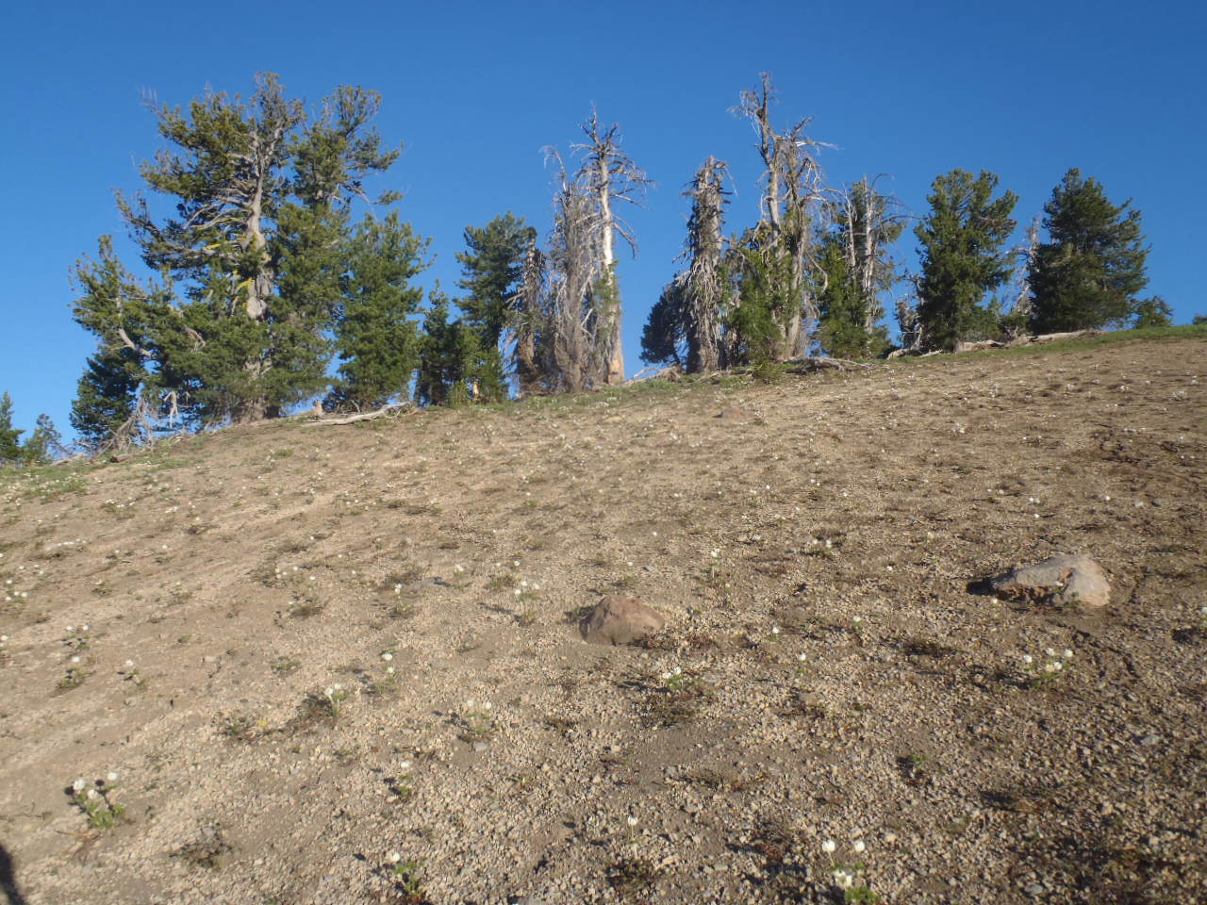
Figure 47. Whitebark pines and mountain pasqueflowers (Anemone occidentalis) on Dutton Ridge.

Appendices

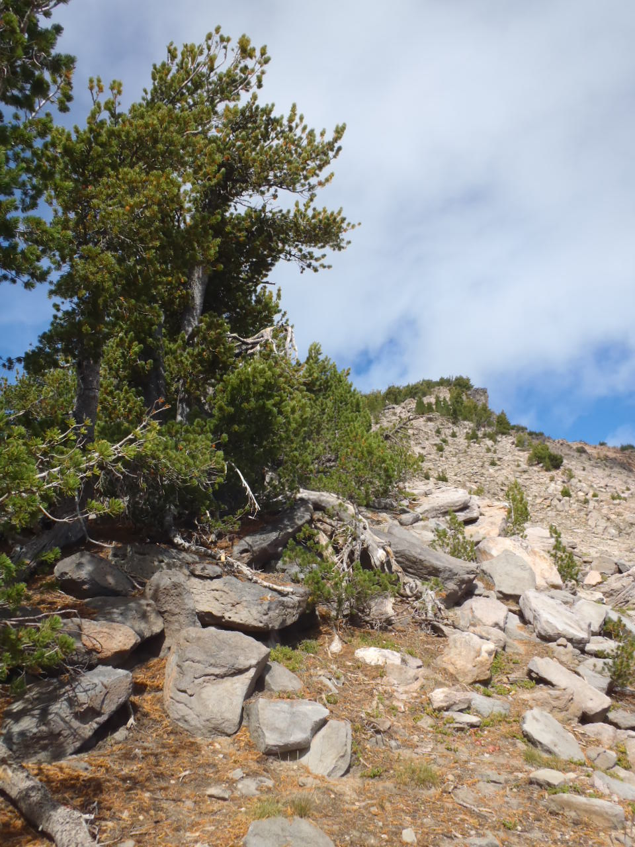
Figure 48. Whitebark pines on the flanks of Mt. Scott.

Appendix A. Understory plant species associated with whitebark pine (data from CRLA’s long-term monitoring plots).
Common Name | Plant Species | North Junction | Mt. Scott | Dutton Ridge | Wizard Island | Cloudcap | Watchman | Llao Rock
California needlegrass | Achnatherum occidentalis ssp. californicum | X |  | X | X | X | X | X
Short-beaked agoseris | Agoseris monticola | X |  |  |  | X |  | X
Alpine pussytoes | Antennaria media |  |  |  |  |  |  | X
Rosy pussytoes | Antennaria rosea |  |  |  |  |  | X | X
Pinemat manzanita | Arctostaphylos nevadensis |  |  |  | X
Pumice sandwort | Eremogone pumicola |  |  | X |  |  |  | X
Heart-leaf arnica | Arnica cordifolia |  |  |  |  | X | X
Cascade aster | Eucephalus ledophyllus |  |  |  |  |  | X
Flatseed rockcress | Boechera howellii |  | X |  |  |  | X
Pussypaws | Calyptridium umbellatum | X |  |  |  | X
Brainerd's sedge | Carex brainerdii | X | X | X |  | X | X | X
Brewer's sedge | Carex breweri |  |  |  |  |  | X | X
Many-ribbed sedge | Carex pachycarpa | X
Applegate's paintbrush | Castilleja applegatei var. applegatei | X | X |  | X | X | X
Cobwebby paintbrush | Castilleja arachnoidea |  |  |  |  |  | X
Scarlet paintbrush | Castilleja miniata var. miniata |  | X
Lace fern | Cheilanthes gracillima |  |  |  | X
Golden chinquapin | Chrysolepis chrysophylla var. chrysophylla | X
Deschampsia | Deschampsia sp. |  |  |  | X
Squirreltail | Elymus elymoides ssp. elymoides | X | X | X | X | X | X | X
Rabbitbrush goldenweed | Ericameria bloomeri |  |  |  |  | X
Greene's goldenweed | Ericameria greenei | X |  |  |  |  | X
Oarleaf buckwheat | Eriogonum pyrolifolium var. pyrolifolium |  | X | X
Sulfur buckwheat | Eriogonum umbellatum var. dumosum | X | X | X | X | X | X
Lesser spreading groundsmoke | Gayophytum diffusum ssp. parviflorum |  |  |  |  | X
Alpine hawkweed | Hieracium gracile |  |  |  |  |  |  | X
Greene's hawkweed | Hieracium greenei |  |  |  | X
Sticky ocean spray | Holodiscus microphyllus var. glabrescens |  |  |  | X
Parry's rush | Juncus parryi |  |  |  |  | X | X | X
Few fruited lomatium | Lomatium martindalei |  | X | X |  | X | X
Anderson's lupine | Lupinus andersonii | X |  | X |  | X | X
Low mountain lupine | Lupinus lepidus var. lobbii |  | X |  |  |  |  | X
Smooth woodrush | Luzula hitchcockii |  |  |  |  | X | X | X
Small-flowered woodrush | Luzula parviflora |  |  | X
Alpine lake agoseris | Nothocaulis alpestris | X |  |  |  |  |  | X
Davidson's penstemon | Penstemon davidsonii var. davidsonii |  | X |  | X |  | X
Mountain phacelia | Phacelia hastata ssp. compacta |  |  | X
Spreading phlox | Phlox diffusa | X |  |  |  |  | X | X
Pinegrass | Poa wheeleri var. wheeleri |  |  |  |  | X | X | X
Fleeceflower | Aconogonon davisiae var. davisiae | X | X | X |  | X | X
Shasta knotweed | Polygonum shastense |  | X
Pink wintergreen | Pyrola asarifolia ssp. asarifolia |  |  |  |  |  | X
White-veined pyrola | Pyrola picta |  |  |  | X
Silvery raillardella | Raillardella argentea |  | X |  |  | X
Crater Lake currant | Ribes erythrocarpum | X |  |  |  |  | X
Downy oatgrass | Trisetum spicatum |  |  |  |  | X | X
Baker's violet | Viola bakeri |  |  | X |  | X
*Bold font indicates potential alternate hosts for blister rust.
Appendix B. Birds and mammals associated with CRLA’s whitebark pine communities.

 | Birds
 | Common Name |  | Species
 | American robin |  | Turdus migratorius
 | Blue grouse |  | Dendragapus obscurus
 | Brown creeper |  | Certhia familiaris
 | Cassin's finch |  | Carpodacus cassinii
 | Clark's nutcracker |  | Nucifraga columbiana
 | Common nighthawk |  | Chordeiles minor
 | Common raven |  | Corvus corax
 | Dark-eyed junco |  | Junco hyemalis
 | Downy woodpecker |  | Picoides pubescens
 | Fox sparrow |  | Passerella iliaca
 | Gray jay |  | Perisoreus canadensis
 | Hairy woodpecker |  | Picoides villosus
 | Horned lark |  | Eremophila alpestris
 | House wren |  | Troglodytes aedon
 | Hummingbirds |  | Various species
 | Mountain bluebird |  | Sialia currucoides
 | Mountain chickadee |  | Poecile gambeli
 | Northern flicker |  | Colaptes auratus
 | Pine grosbeak |  | Pinicola enucleator
 | Pine siskin |  | Carduelis pinus
 | Red crossbill |  | Loxia curvirostra
 | Red-breasted nuthatch |  | Sitta canadensis
 | Red-breated sapsucker |  | Sphyrapicus ruber
 | Steller's jay |  | Cyanocitta stelleri
 | Townsend's warbler |  | Dendroica townsendi
 | Western tanager |  | Piranga ludoviciana
 | White-breasted nuthatch |  | Sitta carolinensis
 | White-crowned sparrow |  | Zonotrichia leucophrys
 | Wilson's warbler |  | Wilsonia pusilla
 | Cooper's hawk |  | Accipiter cooperii
 | Golden eagle |  | Aquila chrysaetos
 | Great horned owl |  | Bubo virginianus
 | Northern goshawk |  | Accipiter gentilis
 | Prairie falcon |  | Falco mexicanus
 | Red-tailed hawk |  | Buteo jamaicensis
Mammals
Common Name |  | Species
Bat (various species)
Belding's ground squirrel |  | Spermophilus beldingi
Bushy-tailed woodrat |  | Neotoma cinerea
Chipmunks |  | Tamias sp.
Common porcupine |  | Erethizon dorsatum
Deer mouse |  | Peromyscus maniculatus
Douglas's squirrel |  | Tamiasciurus douglasii
Golden-mantled  ground squirrel |  | Spermophilus lateralis
Montane vole |  | Microtus montanus
Snowshoe hare |  | Lepus americanus
Western Pocket Gopher |  | Thomomys mazama
Yellow-bellied marmot |  | Marmota flaviventris
American marten |  | Martes americana
Black bear |  | Ursus americanus
Bobcat |  | Lynx rufus
Cougar |  | Puma concolor
Coyote |  | Canis latrans
Elk |  | Cervus elaphus
Long Tailed Weasel |  | Mustela frenata
Mule deer |  | Odocoileus hemionus
Red Fox |  | Vulpes vulpes

*List of birds and mammals adapted from Tomback and Kendall (2001) and tailored to CRLA by G. Holm. This list will be updated as appropriate based on field observations. Gray fields indicate species that may be more common in pumice meadow habitat and/or prey upon species using whitebark pine habitat.
Appendix C

Collection Tree Monitoring Plan
January 2013
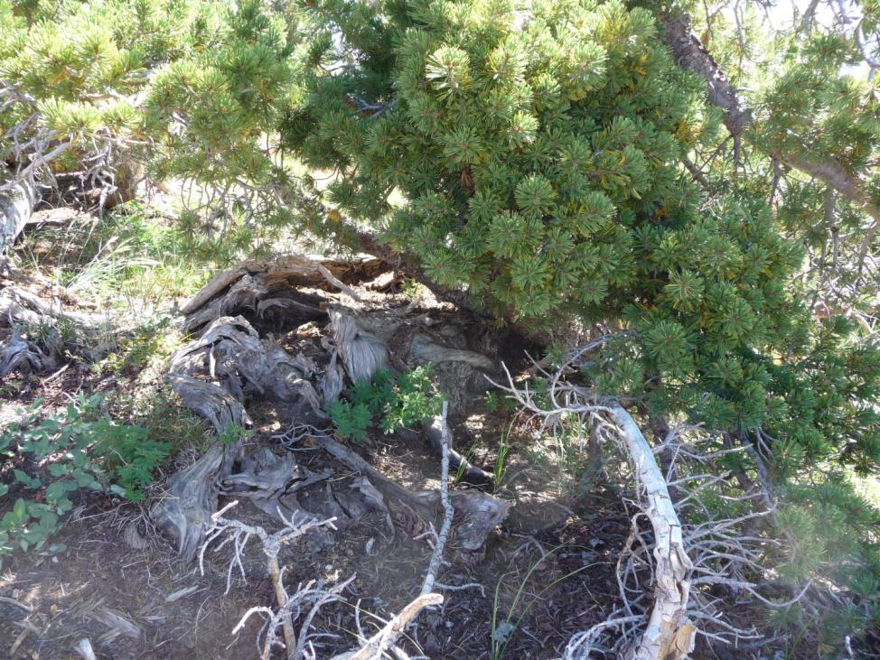
Figure C-1. Candidate tree CRLA-11-DR001. Photo by Elena Thomas.

CRLA has been collecting cones from whitebark pines since 2003 to identify individuals possessing genetic resistance to blister rust. Trees showing promising signs of rust resistance (ratings A-C) are called “Parent trees;” trees currently undergoing rust resistance screening are considered “Candidate trees.” Cones have been collected from a total of 89 whitebark pine from 2003-2011. To date, CRLA has 12 living Parent Trees and 48 living Candidate Trees. Monitoring the health and condition of Parent and Candidate trees and sharing this information with the DGRC is vital to link the fates of source trees to their offspring and compare field resistance over time with results from resistance screening trials.

Monitoring Objectives
Collection trees will be marked with a permanent brass tag positioned appropriately at DBH to discourage removal from park visitors. When trees grow in a clumped pattern, this will be noted and only the collected bole will be tagged.
The following variables will be recorded annually (exceptions noted) for Collection trees:
- Repeat photography of tree (duplication of photo in Selected Tree Register packet)
- Mortality (alive/dead) and cause
- Clumped growth pattern (# boles, # boles collected from)
- Status of tree (healthy, sick, recently dead, dead)
- Status of cone crop (none/light/moderate/heavy)
- Verbenone application (date/amount)
- Blister rust infection
- Severity rating – active, inactive, and total (Six and Newcomb 2005)
- Photos of cankers
- MPB activity
- Severity of attack (none/light/moderate/heavy)
- Signs of attack (pitch-out; resin; frass)
- Photos of attack
- Mistletoe infection
- Species
- Severity (Hawksworth 1977)
- Photos of infection
- Damage
- Nature of damage (animal, mechanical, etc.)
- Photos of damage
- Re-mark coordinates with GPS unit – every five years from initial cone collection
- DBH (metric) – every five years from initial cone collection
- Total tree and crown height (metric) – every five years
- Canopy position – every five years
- Competition assessment – every five years
- Record species and DBH of all non-whitebark pine conifers within canopy dripline

Data Management
Original datasheets will be organized into “archival” plot folders for each tree and stored in WPCP files. Copies will be made of original datasheets and compiled into “field” plot folders. Data will be entered into an Access database with back-ups made daily during periods of data entry. Spatial data are stored at S:\RM\terrestrial_branch\GIS\_UserMaps\007_Whitebark_Pine. Electronic data such as photos, datasheets, the database, and reports are stored at: S:\RM\terrestrial_branch\VEGETATION\WBP\ Collection_Trees_Monitoring. Data will be shared with DGRC on an annual basis.

Parent & Candidate Tree Monitoring Data Sheet – pg. 1
Tree ID: |  |  |  | Date: |  | Recorder(s):
Alive ☐ Dead ☐ |  |  |  | If Dead, cause:
Status (circle one):
Healthy Sick/Struggling Recently Dead

Cone crop (circle one):
None Light Moderate Heavy

Clumped growth pattern:  Yes ☐ No ☐ |  |  | # Boles per clump: |  |  |  | # Boles collected from:
Verbenone Application
Date: |  |  |  | # Packets: |  | Notes:
Blister Rust Assessment
Blister rust present? Yes ☐ No ☐
If yes, complete the following for each active canker:
No. | Type (branch or bole) | Location description
Mountain Pine Beetle Assessment
MPB present? Yes ☐ No ☐
Severity of attack (circle one): Light Moderate Heavy
Describe signs of attack:

Dwarf Mistletoe Assessment
Dwarf mistletoe present? Yes ☐ No ☐
Species:
Rating
Canopy top
Canopy middle
Canopy bottom
Total score:

Parent & Candidate Tree Monitoring Data Sheet – pg. 2
Tree ID: |  | Date:
Damage Assessment
Damage observed:  Yes ☐ No ☐ | Rodent/mammal gnawing:  Yes ☐ No ☐ |  | Mechanical damage:  Yes ☐ No ☐
Drought stress:  Yes ☐ No ☐ | Weather damage:  Yes ☐ No ☐ |  | Other:
New GPS coordinates
Datum and UTM zone:
UTME: | UTMN: |  | Error:
Tree Assessment
DBH (cm): | Total height (m): |  | Live crown height (m):
Canopy Position (circle one)

Dominant Co-dominant Intermediate Sub-canopy Open-grown Krummholtz

Competition Assessment
List all non-whitebark pine conifer species within canopy dripline:
Species |  | DBH
Additional comments:

Status: (H) Healthy, (S) Sick, (R) Recently dead, and (D) Dead
- H = No apparent active blister rust cankers, mountain pine beetle, or dwarf mistletoe infection. Tree may have minor flagging, dead branches, or bark stripping which account for <10% of overall crown or bole. If a tree currently has no active blister rust but has a recorded history of active blister rust, it is considered sick.
- S = Tree has active rust cankers, mountain pine beetle infestation, dwarf mistletoe infection, heavy bark stripping (> 20% of branches/bole with bark stripped or bole of a small tree completely stripped), or current-year die-back/flagging is >10%. As noted above, if a tree has a recorded history of active blister rust, it is considered sick.
- R = Tree which has died since the previous monitoring. Note: A tree is considered living if it has even one branch with some green needles.
- D = Tree which was noted as such in previous years or was noted as “Recently dead” during the previous-year monitoring.
Position: (D) Dominant, (C) Codominant, (I) Intermediate, (S) Subcanopy/Suppressed, (O) Open-grown or isolated, (K) Krummholz
- D = Trees with crown extending above the general level of the crown cover, and which are receiving full sunlight from above and at least partly from the side. These trees are larger than the average trees in the stand and have well-developed crowns, but may be somewhat crowded on the side. In even-aged stands, dominant trees rise somewhat above the general canopy.
- C = Trees with crowns forming the general level of the crown cover and which are receiving full sunlight from above, but comparatively little from the sides. These trees usually have medium-size crowns, and are more or less crowded on the sides.
- I = Trees shorter than those in the two preceding classes, but with crowns either below or extending into the crown cover formed by co-dominant and dominant trees, receiving little direct light from above, and none from the sides; these trees usually have small crowns and are considerably crowded on the sides. These crowns occupy a definitely subordinate position and are subject to strong lateral competition from dominants and codominants, although they may receive some direct light from above through small holes in the canopy.
- S = Trees with crowns below the general level of the crown cover and receiving no direct light from above or from the sides.
- O = Trees which are receiving full sunlight from above and all sides. Typically, these are single trees of the same general height and size as other trees in the area, but where the stand is open and trees are widely separated so dominance is difficult to determine.
- K = Shrub form or wind-shaped

Mistletoe Severity Rating (Hawksworth 1977):
1. Divide live crown into thirds (top, middle, bottom).
2. Rate each third separately. Give each third a rating of 0, 1, or 2 based on descriptions below:
- 0 = No visible infections
- 1 = Light infection (≤ 50% of total branches in the third infected)
- 2 = Heavy infections (> 50% of total branches in the third infected)
3. Add ratings of thirds to obtain overall rating for tree.

References
Hawksworth, F.G. 1977. The six-class dwarf mistletoe rating system. US Forest Service General Technical Report RM-48, Rocky Mountain Forest and Range Experiment Station, Fort Collins, Colorado, USA.

Appendix D

Template for Site-Specific Restoration Plan:
Restoration Plantings
January 2013

- Introduction and background
- Site description
- How/why was site selected
- Administrative classification of site (e.g., proposed wilderness, Research Natural Area)
- Completion date for cultural resources surveys
- Distance to closest access point (e.g., road/trail)
- Physical characteristics of site (e.g., slope, aspect, slope position, elevation)
- Soils
- Overstory cover
- Understory cover
- Available microhabitat structures
- Estimated blister rust infection rate for site
- Whitebark pine mortality levels
- Amount of natural whitebark pine regeneration present
- Presence of encroaching conifers
- MPB mortality levels
- Presence of mistletoe at site
- Fire history
- Restoration objectives
- Study design/planting design/methods – tailor to restoration objectives
- Total number of seedlings per family; known blister rust resistance at time of planting
- Age and condition of seedlings at time of planting (e.g., time elapsed between travel from DGRC to planting at CRLA; details on interim storage)
- Description of planting holes and how they were excavated
- How were seedlings planted (e.g., spatial arrangement; spacing between seedlings; if planted in clusters, how was this determined; how were seedlings transferred from conetainer to hole)
- Scheme for enumerating and identifying seedlings
- How were seedlings/plots monumented/mapped
- Provide location map
- Provide seedling/plot map

- Number of employees involved with planting; specialized equipment needed

- Climate summary
- Weather at time of planting (days since last rain; climate/temp summary)
- Seasonal summary (maximum snowpack depth and date reached; date of snowmelt at park HQ; annual snowpack depth in relation to average snowpack depth)
- Watering info – how often, duration, techniques; date of first snowfall or rainfall
VI. Plans for monitoring and communicating results
- Frequency
- Variables to monitor
- Database/data entry
- Plans for sharing results/adaptive management

Appendix E

CRLA Whitebark Pine ex situ Conservation Plan

In development- to be completed by December 2013.

Appendix F

Template for Site-Specific Restoration Plan:
Manual Thinning

In development - to be completed by December 2013

Appendix G

Template for Wilderness Minimum Requirements Analysis – Whitebark Pine Restoration

In development - to be completed by December 2013

