Teacher’s Guide Contents
Trunk Overview
Movies
Suggested readings
Trunk inventory

Vocabulary
General Civil War Information
Political and Military Figures
Civil War Medicine
Civilian Life
Richmond
Tredegar Iron Works
Activities
Lesson Plans
Puzzles

Primer Resources

Trunk Overview
Bringing a traveling trunk to your classroom will bring the Civil War to life. All of Richmond National Battlefield Park’s traveling trunks can be loaned out for free for two weeks at a time. The trunk contains an equipment guide, magazines about the Civil War, wool uniforms, music, canteens, musket bullets, and movies highlighting local battlefields and ironclads.
This teacher guide will help you use your trunk to the fullest potential in your classroom. The Teacher’s Guide can help you and your students quickly understand major battles around the City of Richmond, highlight the key figures of the Civil War, and give the teacher fun hands-on activities to do with your students in the classroom. Also included in the teacher’s guide are a few items we would like you to keep. At the front of this guide there is a pocket labeled “Please Keep,” you will find a park map, a list of Richmond National Battlefield Park’s education programs and if available a flyer highlighting park events.
After using the trunk in your classroom, we ask that you check all the items to make sure they are back in the trunk and do not need to be replaced. If an item is lost or missing you will receive a call from park staff about replacement or locating the item. Please be mindful of these items and remember other schools and teachers have also requested trunks. Make sure to return the trunk on time and to the park’s Tredegar Visitor Center location where it was picked up.
Movies
Lincoln’s Secret Weapon: The World’s First Ironclad Warship
This 60 minute PBS special covers the life of the Union ironclad the Monitor. Topics covered in the film, building the Monitor, life on board, and the battle of the ironclads.

The Civil War: A Concise History
This 75 minute program features authentic Civil War music, period pictures, battle reenactments, and live action video of the battlefields today.

The Maggie Lena Walker Story
This short film explains the life Maggie Walker had as a civic leader, financier, and business woman during the early 20th century. It also includes 2 short films about Booker T. Washington and 1 short film about Frederick Douglass.

All the Past We Leave Behind
This DVD explains the Civil War battles that took place around Richmond, VA. Starting out with General George B. McClellan’s 1862 campaign and the Seven Days Battles, and then moving to Ulysses S. Grant’s 1864 campaign, and ending with General Robert E. Lee’s surrender in 1865.

Suggested Readings for Class
The following books are not included in this trunk; however these books help to cover topics about the Civil War. Civil War on Sunday can be loaned out from Richmond National Battlefield Park for each your students. However there are limited quantities for loan. Please contact 804-771-2018 to reserve your books.
Civil War on Sunday by Mary Pope Osborne
As part of the Magic Tree House collection this short story is perfect for third to fifth graders. This fictional read can help connect students to the real life of Civil War battles, children of the Civil War and key people.

Ghosts of Belle Isle by Steven K. Smith
This fictional story takes students on an adventure through downtown Richmond, exploring
monuments and Belle Isle which once held Union prisoners of war. Topics for discussion with
Students can include, prisoner life, civilian life, key people, and the 150th anniversary of the
Civil War. Enjoyable reading for fourth through sixth grade.

Inventory of Trunk
Video: Lincoln’s Secret Weapon
Video: Maggie Walker Story
Video: CW Battlefields OR Concise History
CD OR Video: All the Past We Leave Behind
Book: Clara Barton
Book: Richmond Battlefields
Book: Stonewall Jackson
Book: Robert E. Lee
Book: Growing Up Civil War OR Child of CW
Book: Underground Railroad
Book: Ulysses S. Grant
Book: Blue and Grey Cookery
Book: Civil War Plants and Herbs
Book: Black Soldiers
Book: Abraham Lincoln
Book: Civil War Songbook
Book: Cold Harbor History Hunt
Book: Highlights of CW OR Cavalry of CW
Book: NPS Civil War at a Glance
CD: Civil War Melody
Bullets
Fan and handout
USA money
CSA money
Battlefield map
US: kepi
US: shirt
US: blue shirt
US: blue pants
CSA: gray kepi
CSA: cream shirt

CSA: gray jacket
CSA: gray pants
CSA: belt buckle
Woman’s apron
Woman’s dress
Woman’s purse with gloves
Woman’s bonnet
Playing cards
Candle
Toothbrush and powder
Comb
Soap
Pencil and paper
Sewing kit
Cartridge bag (US)
Waist belt (US)
Tin cup
Canteen
Coffee
Hardtack
Plate
Knife
Fork
Spoon
Gum blanket
Haversack
Knapsack
Timeline banner
Ironclad poster

Vocabulary

A
Abolitionist – someone that wants to abolish or end slavery
Agriculture- growing crops or livestock
Amputation- surgically removing a limb such as an arm or leg
Antebellum- a term used to describe the time period in the United States before the Civil War
began
Artillery- the portion of the army that fired cannon
B
Bayonet- a long knife that attached to the end of a rifle or musket for use of charging and stabbing an opponent
Blockade- the effort of the Northern ships to keep ships from entering or leaving Southern ports
Blockade Runners- fast moving ships that attempted to sneak by Northern ships and enter Southern ports with goods
Border States- states that did not officially join the Confederacy but had citizens that sided with the South. These states were Delaware, Kentucky, Maryland, Missouri and West Virginia.
C
Campaign- a series of military operations that attempt to complete an objective
Cash Crop – a crop such as cotton or tobacco that is grown for the purpose of selling to make money
Casualty – killed, wounded or missing in action
Cavalry- soldiers that fight on horseback, they served as the eyes of the army and were often used for scouting
Conscript- a soldier that is drafted into the war. The first draft was implemented in the Civil War when the Confederacy was struggling to get volunteers. Ultimately both sides used the draft to enlist soldiers.
Contraband- Escaped slaves that fled to the Union lines for protection
D
Democratic Party- a political party during the Civil War that opposed a strong Federal government and supported states’ rights and the spread of slavery. Most Southern men were Democrats before the war.
Drill – to practice marching, military formations and how to load and fire a weapon.
Dysentery- intestinal disease that causes severe diarrhea. This was the leading cause of death by disease during the war.

E
Earthworks- barriers made of dirt and logs that protected soldiers from enemy fire
Emancipation - freedom from slavery
Entrenchments- long trenches dug out of the earth with dirt piled into a mound in front; used for defense
F
Federal – a soldier that is loyal to the North (the United States of America)
Foraging- “living off the land”, when soldiers search for food through plundering local homes or gathering from farms
Fortification- something that makes a position stronger such as mounds of earth or stone walls
G
Goober Pea – southern term for a peanut
“Graybacks”- slang for lice
Greenbacks- paper money used in the North after the Legal Tender Act. They were called this due to their color

H
Hardtack – a hard cracker issued to soldiers on both sides of the Civil War. They became rock hard and difficult to eat when they became stale.
Haversack- a square bag carried by soldiers and used to carry their food. These were often covered in tar to make them waterproof.
Housewife- a small sewing kit carried by soldiers to repair their clothing

I
Industry- manufacturing goods from raw materials such as making cloth from cotton
Infantry- foot soldiers, soldiers that march on foot and the bulk of the army
Ironclad – a type of ship with sides covered in iron armor to deflect artillery fire

L
“Lost Cause” – a cultural movement after the Civil War in which the Southern states attempted to cope (both mentally and emotionally) with defeat and Northern military occupation. This movement idealized life in the Antebellum South and exalted Confederate figures such as Robert E. Lee

M
Mason-Dixon Line – a boundary line surveyed in the 1760s that ran between Pennsylvania/Delaware in the north and Maryland/West Virginia in the south. It was a symbolic line between the free states and the slave states.
Monitor – a famous Union ironclad ship, the U.S.S. Monitor fought against the Confederate ironclad, C.S.S. Virginia (also known as the Merrimack), at the Battle of Hampton Roads. Eventually the name Monitor became a class of ironclad ship during the war.
N
Navy- a branch of the military that uses ships to conduct warfare
P
Pontoon Bridge- a bridge created by anchoring boats into a waterway and laying wooden planks across them
R
Reconstruction- the time period following the Civil War in which the South was “reconstructed” by the North
Republican Party- A political party during the Civil War that wanted to stop the spread of slavery and eventually eradicate it. Abraham Lincoln was the first Republican President.
S
Secession- withdrawal from the Federal government of the United States. The southern states attempted to secede from the United States and create their own country. Southerners viewed it as their legal right, Northerners saw it as rebellion.
States’ Rights- a belief that the individual state has more power than the Federal government
U
Union- another name for the North during the Civil War. These states remained loyal to the United States of America.
U.S.C.T. – United States Colored Troops. African-Americans that enlisted in the Union army and became soldiers. One of the most famous of these regiments is the 54th Massachusetts.

V
Volunteer- a person that willingly joins the army because they want to, not because they are forced to.

Y
Yankee – a Northerner; someone loyal to the United States. Also known as a Federal or Union.

Political and Military Figures
Pictures to follow

Abraham Lincoln
Lincoln was born in Hodgenville, Kentucky on February 12, 1809 but grew up in Indiana and Illinois. He enlisted as a militia captain for the Black Hawk War of 1832 and after the war he started to study law, winning a seat on the Illinois State Legislature serving as a Whig. After one term in Congress he joined the Republican Party where he had heated debates with Stephen A. Douglas and this forged him into a prominent anti-slavery figure in national politics. On November 6, 1860 he won the presidential election with no votes from the Southern states. As southern states seceded, Lincoln felt it was his duty to preserve the Union instead of avoiding war and letting it fall apart. After the Battle of Antietam, Lincoln issued the Emancipation Proclamation on January 1, 1863 which freed the slaves in the Southern states making the war about preserving the Union and slavery. In 1864, Lincoln was worried that he would not win reelection due to the drawn out war but with General Grant in charge of the Union Army the war was turning in favor of the Union and Lincoln was reelected. During the War, Lincoln’s administration passed the Revenue Act of 1862 which paid for a majority of the war, Morrill Act of 1862 which established the state university system, and the Homestead Act that encouraged people to settle in the West in exchange for land from the government. He also created the Department of Agriculture, made Thanksgiving an official holiday, and steered the Trent Affair. On April 14, 1865 Abraham Lincoln was assassinated at Ford’s Theatre by Confederate sympathizer, John Wilkes Booth.

Jefferson Davis
Before Jefferson Davis became the first and only President of the Confederacy, he was a planter, politician, and soldier. He served in the US House of Representatives, as Secretary of War, and the Senate until he resigned on January 21, 1861 shortly after Mississippi withdrew from the Union. A month later he was selected to be the provisional President of the Confederacy for 6 years. He was chosen because he could appeal to the moderate and radical factions in the Confederate Congress. Initially he was very popular with the Southerners but his personality did not hold up against the challenges that he faced. Being impatient with people and making unpopular decisions caused a lot of quarrels in his administration. The continuing defeats hurt his popularity and he eventually had to flee Richmond, VA on April 2, 1865 as the Union Army advanced to the city. Jefferson was captured near Irwinville, GA on May 10, 1865 and imprisoned at Fort Monroe, VA for 2 years. He was never tried for treason and in May 1867 he was released where he then traveled to Europe and finally back to the American South where he lived out the rest of his life.

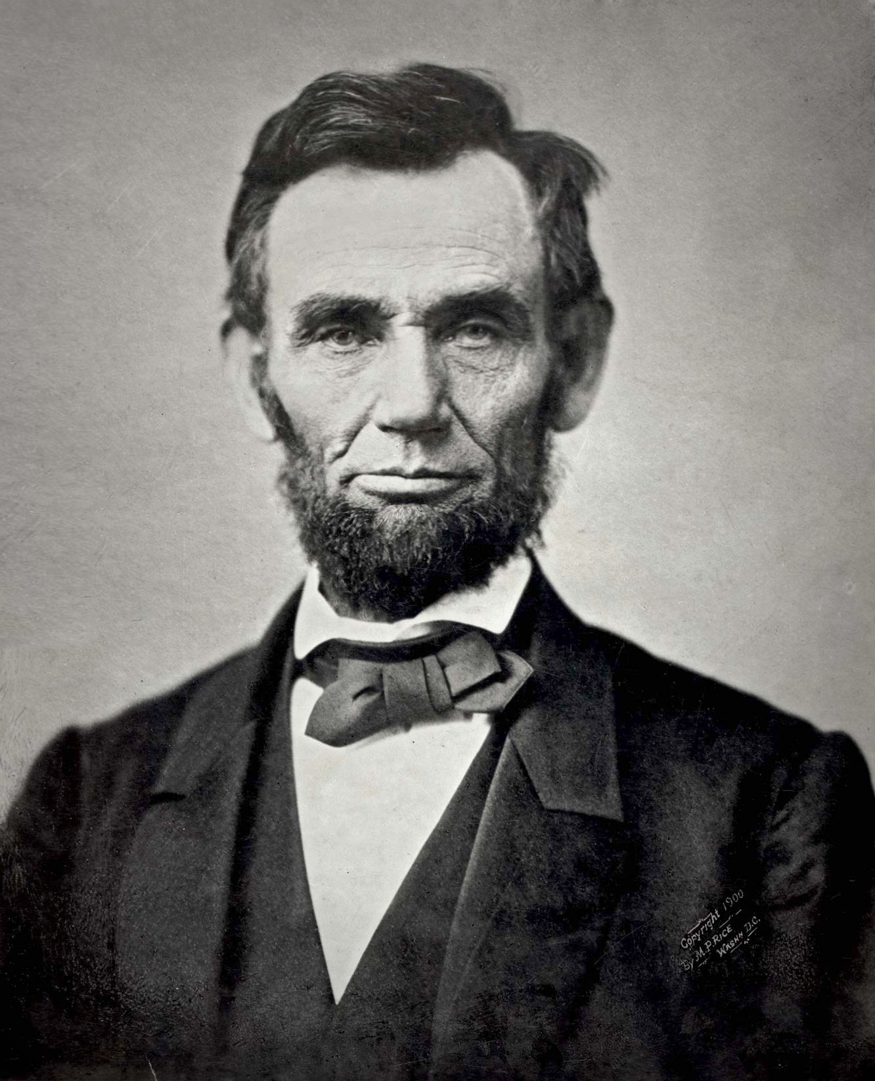
Abraham Lincoln

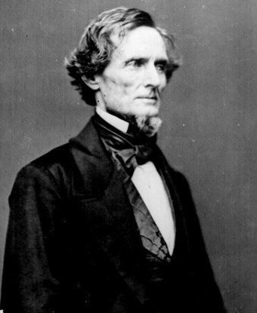
Jefferson Davis

Ulysses S. Grant
In February 1862 Grant had his first major victory at Fort Donelson, TN and because of this President Lincoln promoted him to Major General. After Grant victories at Shiloh, Vicksburg, and Chattanooga, led Lincoln to give him full control of the Union Army to him in 1864. In May 1864 Grant began his Overland Campaign. His plan involved 3 fronts to keep General Lee occupied. It was a series of battles starting at the Wilderness, then Spotsylvania, moving to North Anna, and finally Cold Harbor. Realizing that the Confederate fortifications around Richmond were too strong Grant set his eyes on Petersburg. Petersburg was a major supply hub for Virginia and Richmond itself so he planned to cut off every supply route into Petersburg choking Richmond and Lee’s army of supplies causing Lee to surrender. The Siege of Petersburg lasted roughly 9 and a half months but it accomplished what Grant intended. Lee retreated and headed west where he surrendered to Grant at Appomattox Courthouse. During the war Grant was viewed both favorably and unfavorably. Lincoln and many others were pleased that Grant was keeping pressure on the Confederates wearing them down little by little. For the same reason though, others called him the “Butcher” because using attrition of his own men to kill Confederates was seen as a reckless way to fight a war. Either way, his tactics were able bring the end of the Army of Northern Virginia ultimately leading to the demise of the Confederacy.

Robert E. Lee
Robert E. Lee graduated from West Point in 1829 and fought in the 1846 war with Mexico and distinguished himself. In 1859 he joined the cavalry where he put down John Brown’s Raid at Harpers Ferry. At the outbreak of the Civil War President Lincoln offered Lee the command of the Union forces but Lee declined arguing that he could not fight against his home state of Virginia. Lee was President Jefferson Davis’ military advisor until June 1862 when he was given the command of Army of Northern Virginia. In 1862 he invaded Maryland hoping to shift the war away from Virginia. Unfortunately the Union found out about his plan and the Battle of Antietam took place with heavy casualties. Lee retreated under the cover of darkness and spent the following year defending Fredericksburg and Chancellorsville. With great defensive victories it gave Lee the confidence in his men to make another attack on Union soil. At Gettysburg, Pennsylvania Lee met Union General Meade and fought for three days until July 3, 1863 where it ended with the failure of Pickett’s charge. For the rest of the war Lee was always on the defensive battling the new Union Commander Grant, never being able to get a step ahead. After 9 and a half months of trench warfare around Richmond, VA and Petersburg, VA the Confederate Army was on the retreat until April 9, 1865 where Lee surrendered his Army of Northern Virginia to General Grant.

Thomas Jonathan “Stonewall” Jackson
Jackson graduated West Point in 1846 and served in the Mexican-American War. In 1851 he resigned his military career and became a teacher at Virginia Military Institute. At the start of the American Civil War he signed back up as a Colonel of the Virginia Militia. From then on he had success after success at battles like First Manassas where he earned his title as “Stonewall,” Winchester, Seven Days Battle, Second Manassas, and Sharpsburg and because of all of these victories he was promoted to Lieutenant General. After his huge victory at Chancellorsville on May 2, 1863, he was mortally wounded by friendly fire after doing some reconnaissance at night. His arm had to be amputated and due to complications from pneumonia and died May 10, 1863.

Common Soldier
When people imagine Civil War soldiers they imagine generals and leaders like Grant, Lee, Jackson, and Lincoln but they make up a small portion of the military. The majority of the military is the common soldier, a man that once worked in a factory, own his own farm or had his own business. These are the soldiers who were on the battlefield fighting the enemy. Many of these men volunteered at the beginning of the war remembering the stories they heard from their grandfathers about other wars, but many men were drafted into service.
The common soldier did not have horses or wagons to carry their equipment; they had to carry all of their own equipment which leads to hard decisions for them. When the war started soldiers thought they would take items to make their lives more enjoyable such as toys and games, food, cleaning supplies, extra weapons. These items would make their daily lives much more enjoyable but soldiers realized marching 10 to 15 miles a day with all that extra weight was not worth it. They would toss these items on the side of the road and carry the bare necessities, like their uniform, weapons, ammo, blanket, in order to make their lives easier.

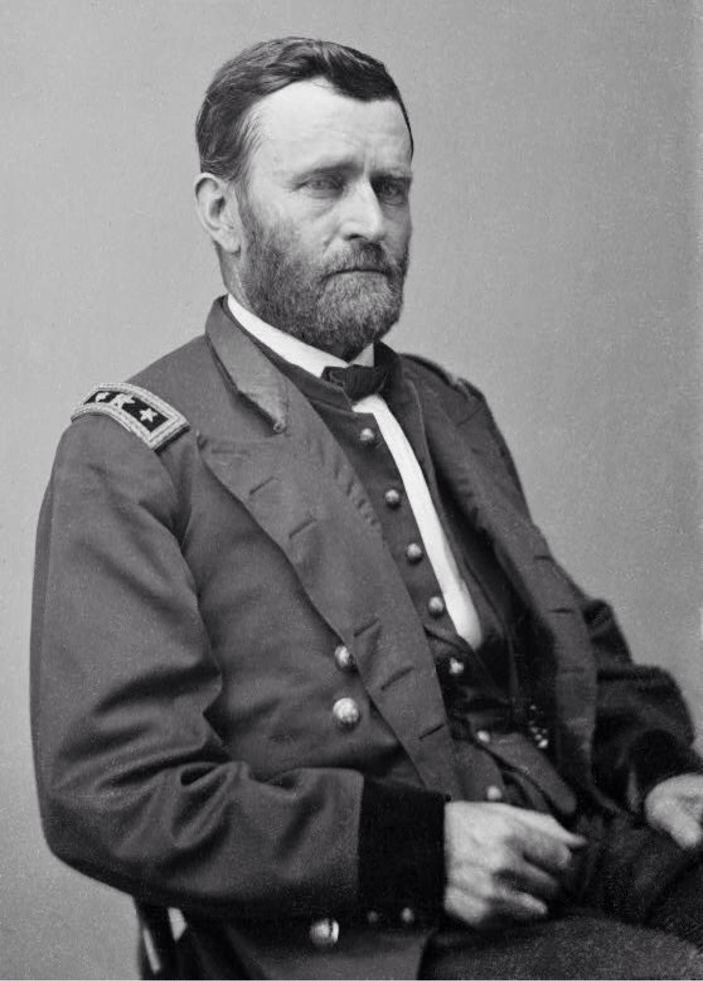
Ulysses S. Grant
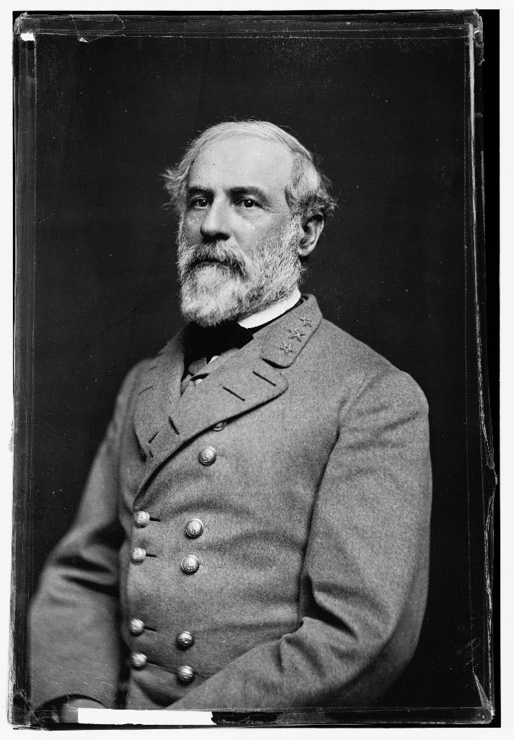
Robert E. Lee

Thomas Jonathan “Stonewall” Jackson

Civil War Medicine
Medicine
Of the 620,000+ soldiers that died in the Civil War, more died from sickness and disease than from battlefield wounds. Bad water, unbalanced diets, unsanitary living conditions and poor hygiene made it easy for soldiers to get sick. Diseases such as dysentery, chronic diarrhea, scarlet fever and measles ran rampant through the camps of both Union and Confederates alike. Doctors did not understand germs or sanitation and as a result, it was not heavily practiced in hospitals and in camps. Some medicines existed but they did little to cure the sicknesses and usually only lessened the symptoms experienced by the soldiers.

Field hospitals were set up close to the battlefields in order to immediately tend to the wounded. Most of these temporary hospitals were set up in the homes or barns of civilians, or in tents close to the fighting. After the Battle of Gaines’ Mill, the Watt House stood in the middle of the battlefield and was quickly converted into a field hospital. When the army left the house the floor was stained with blood and the yard was covered in graves. Wounded soldiers were carried to the field hospitals where surgeons carried out major operations such as bullet extractions and amputations. Despite popular belief, surgeons did use chloroform, ether, and other forms of anesthesia to put their patients to sleep before beginning the operation. If anesthesia was not available, surgeons would at least try to numb the area. Without proper sanitation and care, many of these amputations and operations became infected.

Once the soldiers were tended to in the field hospitals, they were carried by ambulance wagon, train or ship to the closest city. Major cities throughout the country had large hospitals to tend to the sick and wounded, the largest being Chimborazo Hospital in Richmond, Virginia. Doctors and women volunteers serving as nurses could care for the soldiers and help aid in their recovery.

Clara Barton
Clara Barton was known as the “Angel of the Battlefield” and the founder of the American Red Cross. During the Civil War, Barton worked tirelessly in hospitals and on the front lines to make sure there were enough supplies and that wounded soldiers were tended to. After the war she ran the Office of Missing Soldiers and spearheaded “The Search for Missing Men” in an attempt to locate, identify and re-bury the soldiers that had been buried in unmarked graves. Over the course of four years, Barton helped locate, identify or properly bury over 30,000 men. In 1881 she founded the American Red Cross, a group that could respond and help the victims of war and natural disasters.

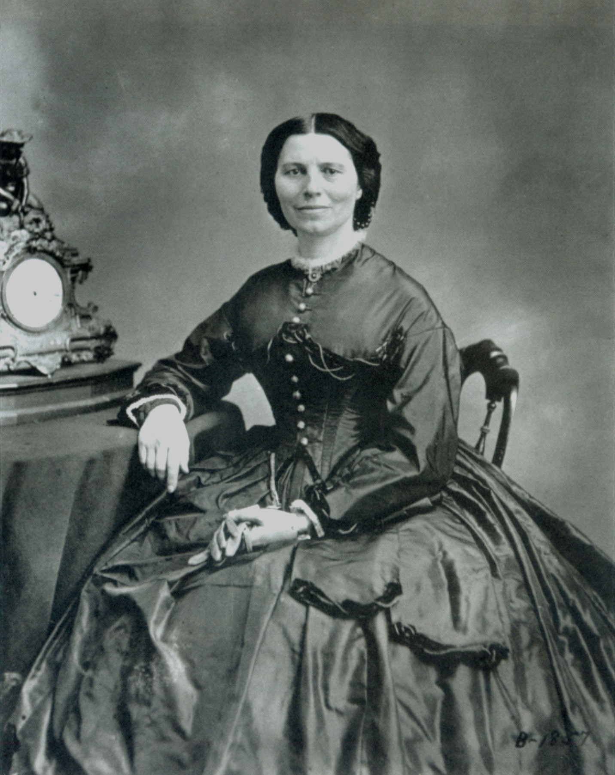
Clara Barton
Civilian Life

Civilian experiences vary during the Civil War. For most civilians, the war was a time of upheaval, shortages and loss. Many family members marched off to fight but never returned. Thousands of soldiers were buried in unmarked graves on distant battlefields. Some that returned were forever changed, whether it was physically, emotionally or mentally. In the South and in parts of the North, the war ravaged the landscape and left ruins in its wake. The Civil War was an extremely difficult time for both the soldiers in the armies and the civilians they left behind.

Many of the battlefields were farms and for the civilians caught in the crossfire, they were forced to evacuate or hide in the cellars of their homes. For the Shelton family during the battle of Totopotomoy Creek, their house was on the battlefield and was hit 50 times by artillery fire while they hid in the basement. Crops were taken or destroyed, homes were used as headquarters for the armies or for field hospitals and for many civilians, their farms became graveyards. Civilians in the South also struggled with inflation and shortages of both food and supplies. As the Union blockade of southern ports strengthened, many civilians had to do without certain items such as paper and thread. Major cities like Richmond became overpopulated from refugees, wounded soldiers and prisoners.

Civilian Life Quotes

“Wherever an army goes it carries destruction to everything, fences, crops, and even the vegetables in the gardens are destroyed and taken by the soldiers, it seems to blast everything that comes in its way.” – Robert Gaines Hale, 55th Virginia

“[Virginia] has become so stricken and poor that it will take a hundred years for her to recover.” – John Haley, 17th Maine

“The country about here is deserted by all except old men, women, and children.” – J. Franklin Dyer, Surgeon, 19th Massachusetts

Richmond

When Virginia seceded, Richmond became the industrial and political capital of the Confederate States of America. For the next four years, the city became a target and a prize that both sides would fight over in numerous bloody and deadly battles. Previously unknown communities and farms around Richmond became famous as the two armies fought viciously across their lands, scarring the landscape with earthworks, trenches and graves.

Seven Pines (May 31, 1862)
In 1862 the Union Army under General George B. McClellan marched up the peninsula from Williamsburg to attack Richmond, Va. The Confederate Army under the command of Joseph E. Johnston quickly moved to intercept McClellan. On the outskirts of Richmond, at Seven Pines, the two forces clashed. Joseph E. Johnston was wounded and as a result the Confederates were forced to choose a new commander: Robert E. Lee.

The Seven Days Battles (June 25 - July 1, 1862)
The Seven Days Battles were a series of bloody engagements in 1862 between the new Confederate commander Robert E. Lee and the Union army under George B. McClellan. General Lee’s plan was to push the Union army away from Richmond and destroy the Union army. At Beaver Dam Creek, Gaines’ Mill, Glendale, and Malvern Hill the two armies met in fierce battles, turning homes and farms into battlefields. The battle of Gaines’ Mill was Lee’s first victory in the Civil War but it came at a heavy cost: 15,000 soldiers were killed, wounded or missing. After seven days of fighting, the Union army was forced away from Richmond but Lee had not been able to destroy the army as he had hoped. McClellan and his Union troops were called back to Washington D.C. after its failure to capture the Confederate capitol.

The Overland Campaign (May 5 - June 12, 1864)
In 1864 the Union armies under General Ulysses S. Grant returned to Richmond in another attempt to capture the Confederate capital. The two armies “soaked Virginia’s soil in blood” as they fought another bloody series of engagements from the Wilderness, Spotsylvania Court House, North Anna, Totopotomoy Creek and Cold Harbor. The battle of Cold Harbor and its crossroads was a key battle in the Overland Campaign since it allowed the Union army a direct path into the city of Richmond. Despite the vicious battle, the Confederates were able to defend the crossroads and stop General Grant’s attempts to capture the Confederate capitol. After being defeated at Cold Harbor and unable to take Richmond yet again, General Grant shifted his armies south of the James River to lay siege to the city of Petersburg instead.

Tredegar Iron Works

Tredegar Iron Works opened in 1837 along the northern bank of the James River. Using water from the nearby James River and Kanawha Canal for power, the iron works set up rolling mills and foundries to produce parts and materials for the booming railroad industry. Tredegar operated for one hundred and twenty years until it finally closed down in 1957.

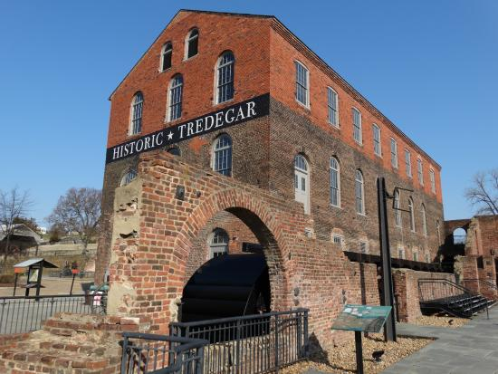
Tredegar Iron Works was the largest iron works in the entire South during the Civil War. Combined with numerous smaller foundries and mills, it made Richmond, Virginia the industrial capital of the southern states. Well known before the war broke out, Tredegar played an instrumental part in supplying the Confederacy with artillery, ammunition and other war-related materials. As tensions raised between the North and South the owner, Joseph Reid Anderson, saw the demand to manufacture goods specifically for the southern states. Despite shortages during the war in iron and manpower, Tredegar was able to produce 1,099 cannon for the southern armies, forts and ships. Tredegar also made the iron armor for the CSS Virginia (also known as the Merrimac) and several other ironclad ships to protect them in battle. After the Civil War, the iron works played an important role in helping rebuild the devastated south.
Tredegar Iron Works - Richmond, Virginia
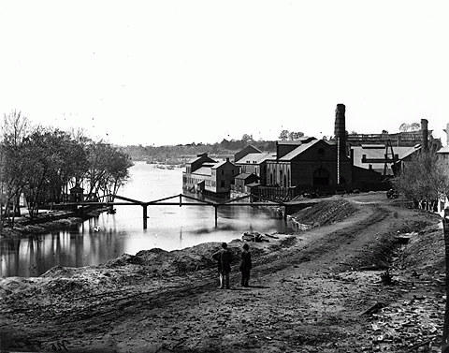
Picture of Haxell Canal and Tredegar Iron Works Foundry building 1865
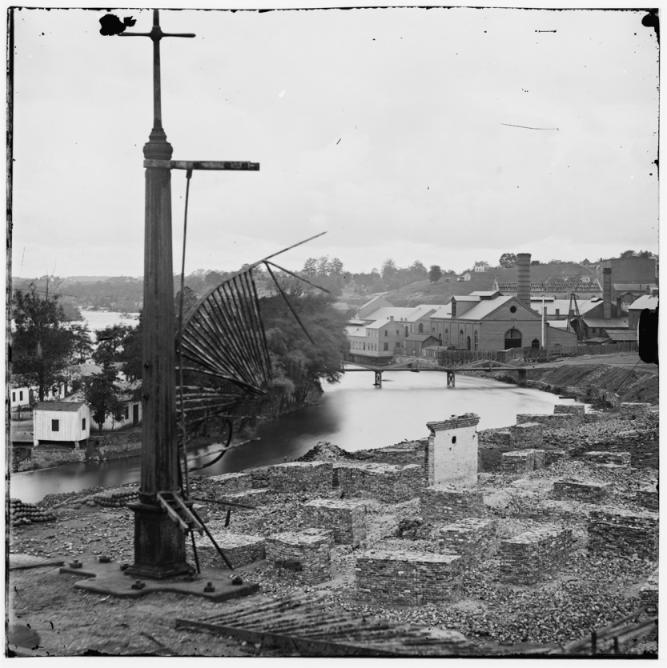
Remains of Confederate Armory Complex with Tredegar Iron Works Foundry building in the background, Brown’s Island can be seen to the left.

Hands On Activities

Pack Your Knapsack
4th – 12th grade
Time: 30-40minutes
Overview:
Students work together in small groups to decide what items they would like to pack in their knapsack to carry into battle. On the battlefield students will explore the life of a common solider through this hands-on activity. Students will use problem solving and teamwork skills to accomplish their task.

Items needed from trunk:
Gum Blanket
Knapsack
Hardtack
Fork
Candle
Uniform jacket
Spoon
Plate
Canteen
Sewing Kit
Pencil and Paper
Tin Cup

Set up: Put the above items from the trunk in the middle of the room either on the floor or on a table. Make sure there is plenty of space for 2 or 3 students to move around the items. Split your class up into to 4 groups. Each group should have a paper and marker to write down their items they want to pack and why. Big pieces of paper work the best.

Procedure
1. After group is split into 4 groups tell them they have just joined the military during the Civil War and this is basic training. Each student needs to pretend they have been given a uniform jacket, pants, a kepi, and shoes. (Best to display a picture of Johnny Reb or Billy Yank)
2. The students will be packing a knapsack (show them what a knapsack looks like) they can only choose 5 items to pack and bring with them as they march for 15 miles a day. Remind them they already received their full uniform.
3. Allow one student from each group to go up to the items, they can choose 1 item to take back to their table. At their table they can work together to decide if they are “packing” that item or not. Students must put items back in the pile and switch with another student. Do this at least 8 times. To help with this ask students what 3 things do we as humans need to survive? Food, Shelter, and Water. This will get them started on at least 3 items.
4. After all the turns are over or about 15 minutes check to see if each group has decided on their 5 items they want to “pack.” One at a time have each group stand in front of the rest of the class to talk about the items they have chosen and why. Students may have trouble at this point naming the items. It is best to have the equipment guide with you to help them. As the students talk about certain items you can fill in with the following information:
Canteen = A canteen would have been with every soldier and carried into battle. Water is one of the three items we have to have in order to survive. Soldiers would use a canteen to carry water, using any water source to fill it up and drink the water. What is in the water that they are drinking? (germs, bacteria, microorganisms). They do not know about germ theory. Germ Theory was created by Louis Pasteur during the war but wasn’t common knowledge until after the war. What can happen to you with all of that bacteria in your body(dysentery). This is dangerous because if you can’t keep water in your body what will happen to you?(dehydrate and die).
Gum blanket or Rubber blanket = This blanket allowed soldiers to sleep comfortably and have shelter. The Union soldiers were all issued a rubber blanket but the Confederate soldiers were not. Why? (Factories). The south did not because they didn’t have as many factories or the access to rubber. Rubber blankets were prized items among the confederate troops, the only way they could get one was by a battlefield requisition know as stealing from dead Union soldiers. This blanket could have been laid on the ground to sleep on, made into a lean to, or wrapped around a soldier to be protected from rain.
Hardtack = Hardtack is a type of food. It is made up of flour and water cooked together to form this hard biscuit. It is called hardtack because of (bang it against the cup to show that it is hard). Soldiers gave hardtack nicknames like tooth dullers, bullet stoppers and worm castle. They are not kept in Ziplock bags so bugs would get inside of the hardtack. To fix this issue soldiers soaked the hardtack in the coffee, bugs float to the top, scrape them off and eat the now soft hardtack.
Sewing Kit = Soldier got one uniform for six months. This means they had to maintain that uniform if it got any holes or lost a button they would need to fix it. The sewing kits were not military issued. Wives, girlfriends, sisters or daughters would make them for their loved ones before they left for war. The sewing kit has a nickname call a “Housewife.”

5. Conclusion to the program is the common soldier had a hard life to live and only could carry items that they absolutely needed in order to survive. Each item they choose was important to a soldier. All of these items were found in soldier’s knapsack. This exercise was important to show you how hard it was for soldiers to pick and choose what they would carry for many months at a time.

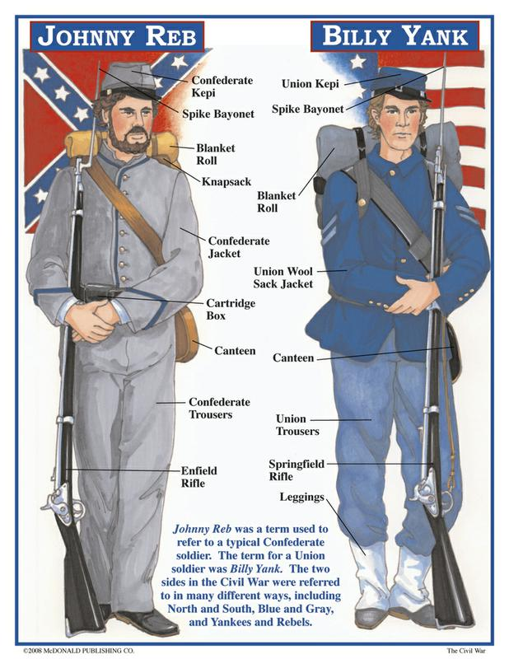

Four Deadliest Items
4th – 12th grade
Time: 20 – 30 minutes
Overview:
Students learn the 4 deadliest items of the Civil War and how they killed people during the war. Once they have learned about each item students can either work together in groups or vote on which item was the deadliest of the Civil War.

Items Needed from Trunk:
1. Canteen
2. Picture of Rifled Musket/ bullets
3. Hardtack
4.Uniform Jacket
Have students sit at their desks or on a floor so they can each see the items up close. Tell the students a little about each item what it is and how it was used. Each item they see killed soldiers during the Civil War. Have the students work together in groups or as a class to rank the items from deadliest to the least deadliest. After the students have ranked the items start with their top answer which most likely is the picture of musket and bullets explain how each item would have killed soldiers.

Musket and Bullets - The bullets of a rifled musket were very large and made of a soft metal called lead. When a rifled musket is fired the bullet is moving much slower than a gun of today. As the bullet travels in the air it keeps slowing down and when the bullet would strike a soldier it would flatten because of the soft metal making a very large wound. The large wound and lack of medical care would cause a soldier to die, due to infections or loss of blood.

Hardtack - It is made up of flour and water cooked together to form a hard biscuit. It is called hardtack because of (bang it against something). Union soldiers gave it nicknames like tooth dullers, bullet stoppers and worm castle. Hardtack would not have been kept in a ziplock bag, so bugs would get inside of the hardtack. To fix this, soldiers could soak the hardtack in the coffee, bugs float to the top, scrape them off and you have good coffee and better tasting hardtack. A couple food groups are missing? (fruits and vegetables). Soldiers were not getting their vitamins and nutrients. Fruits and vegetables do not last long enough so soldiers were getting rotten food. Without fruits and vegetables soldiers were getting a disease called scurvy. Scurvy would make soldiers eyes go bloodshot, their gums bleed and then after many month without eating fruits and vegetables their teeth would start falling out. Now when your parents tell you to eat your fruits and vegetables you will, right?
Soldier’s Jacket - How can the clothes you’re wearing kill you? Do you think soldiers are bathing or washing their clothes often? They are supposed to but they don’t have the time or they are used to their mom doing it for them. Soldiers were infested with lice simply because they are not bathing and bugs biting you can make you sick.

Canteen - How do you think the canteen killed people? (Water). Where do you get your water from today?(faucet, bottled, filter). That water is clean. Soldiers will go to any water source (river, pond, stream) and fill their canteen up, and drink it. What is in the water that they are drinking? (germs, bacteria, microorganisms). They do not know about germ theory. Germ Theory was created by Louis Pasteur during the war but wasn’t common knowledge until after the war. What can happen to you with all of that bacterium in your body? Dysentery, an intestinal disease that causes severe diarrhea. This is dangerous because if you can’t keep water in your body what will happen to you? (dehydrate and die).
Disease was the leading cause of death, during the war.

Conclusion
In short it is disease and poor hygiene that kill most soldiers during the Civil War. There were some groups of people that tried to make the soldiers’ lives better. Organizations like the Sanitation Commission tried to show soldiers the importance of hygiene, where to set up camp, and where to dig latrines.
Life was hard during the war for these soldiers. Some couldn’t handle the stress and hardships and chose to desert the army but most soldiers stayed with the armies for the course of the war until they were sent home or the war ended.

Make Hardtack
Hardtack was a standard part of every common soldier’s ration of food. When soldiers were in camp, they would often make their own hardtack to have with them while on the move from one battle to another. Soldiers would not have access to items like milk, eggs, butter, fruits and vegetables. Hardtack, along with salt pork, and coffee was the majority food they carried with them. Many men would forage for food, buy or trade from farmers, or take crops or animals they found along the way. Making your own hardtack will give you a good idea of the plain foods soldiers ate.

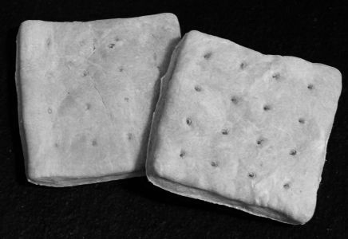
Ingredients
3 ¼ cups of flour
2 teaspoons of salt
1 cup water

Equipment
mixing bowl
mixing spoon (hands work best)
Rolling pin
ruler
table knife
cookie sheet
meat skewer
Plastic storage container

1. Preheat Oven 375 Degrees
2. Measure 3 cups of flour and the salt into mixing bowl. Add water a little at a time, stirring constantly with mixing spoon. When the dough becomes too thick to stir, continue mixing with your hands.
3. Knead the dough with your hands, working it with your fingers like a lump of clay. If the dough is sticky, add more flour. Or, if the dough seems powdery, add water. Shape the dough into a ball.

4. Sprinkle remaining flour on hard surface and place the ball of dough on it.
5. With the rolling pin, roll out the dough into a 9 by 12 inch rectangle about ½ inch thick.
6. With the table knife, cut the dough into 3 inch squares.
7. Use the meat skewer to poke 12 holes in each square
8. Place the squares on the cookie sheet and bake for 25 to 30 minutes. Check at 20 minutes to see if the squares are golden brown.
9. All hardtack to cool for a few minutes. Serve right away or store it for later.

Learn Morse Code
During the Civil War the fastest way to send a message was by telegraph. By the 1860s all cities and towns east of the Mississippi River were connected by telegraph. An operator used short and long taps that traveled through electrical wires sending impulses to the receiving end. The other telegraph operator translated the short and long taps into a message. These messages were capable of traveling hundreds of miles in a matter of a few seconds. The same code was used by naval ships but they used lanterns and flashed the messages instead. With this activity you and a friend will send a message in Morse Code to each other. Using a flashlight or dog training clickers might be easier to decypher.

Materials
2 pencils
2 sheets of paper or note pads
2 flashlights or dog training clickers
Morse Code Guide (see next page)
Partner

1. To practice Morse Code, try having them write out a few simple messages to each other before moving onto flashlights.

2. After they understand the dots and dashes have the students use the flashlights to send messages by taking turns.

3. Have one student write out a short message and then send it via flashlight.

4. The partner will write down the message that they hear and then compare it to the person who sent the message.

5. The students will switch roles and then repeat.

Morse Code Guide

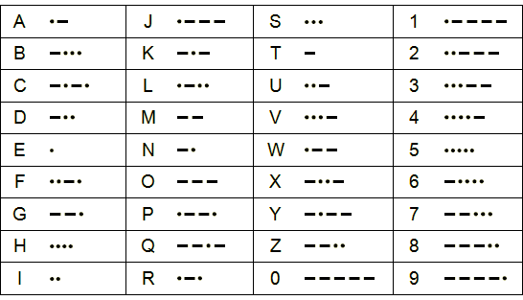

Examples:

It is nice to meet you .. - .. ... -. .. -.-. . - --- -- . . - -.-- --- ..-

What is your name .-- .... .- - .. ... -.-- --- ..- .-. -. .- -- .

How old are you .... --- .-- --- .-.. -.. .- .-. . -.-- --- ..-

Do your homework -.. --- -.-- --- ..- .-. .... --- -- . .-- --- .-. -.-

