**Pu‘ukohol**ā **Heiau National**

**Historic Site**

**Ages 6 Years and Under**

1

Keiki Adventure

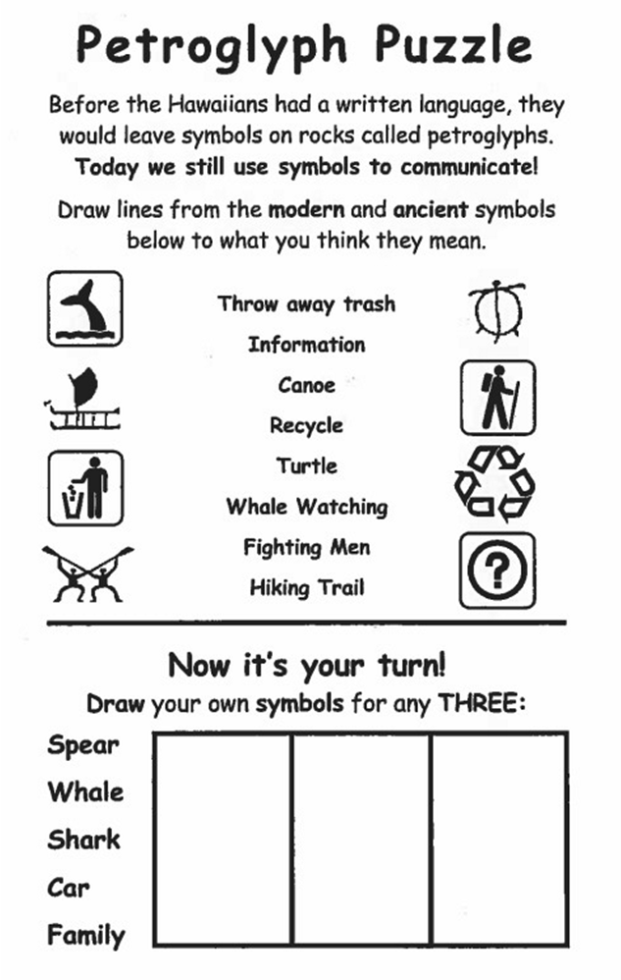

2

3

**Coloring Page**

4

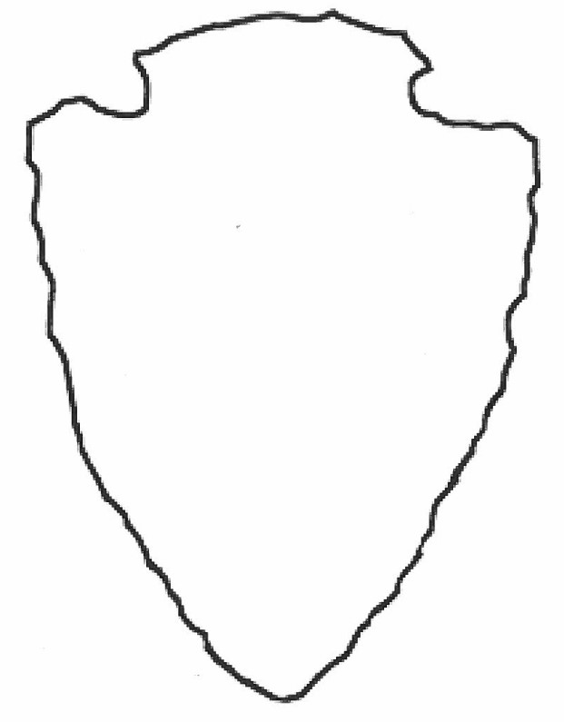

5

**Create Your Patch**

6

7

8