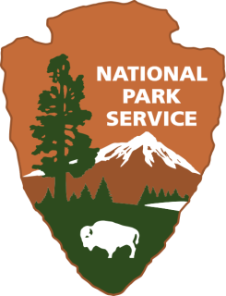

Pipe Spring National Monument
US Department of Interior

BECOME A JUNIOR PARK RANGER!
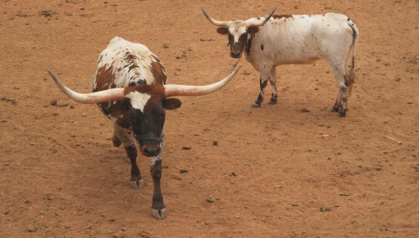
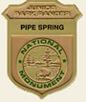

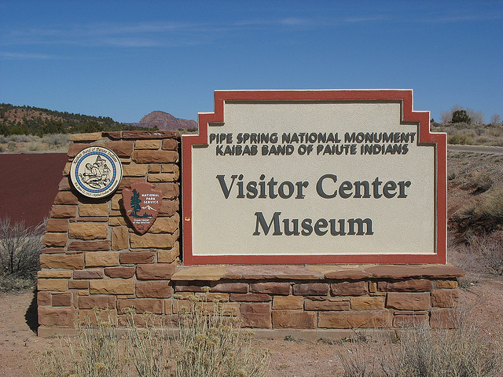

Pipe Spring Scavenger Hunt
Watch for these things as you tour the Monument.
Mark the ones you see with an X. Try to get them all!

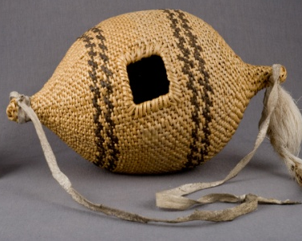
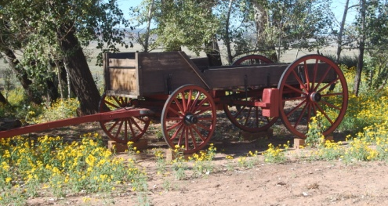
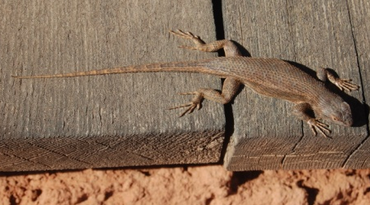

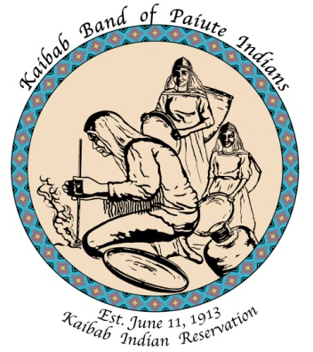
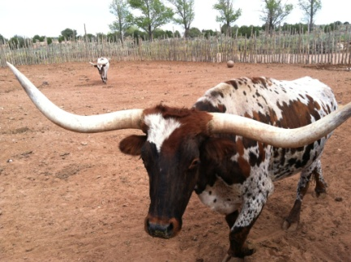
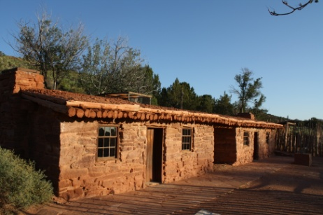

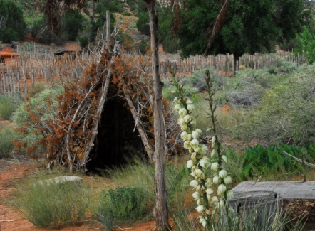
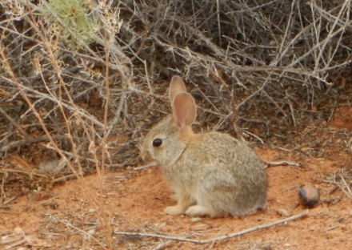
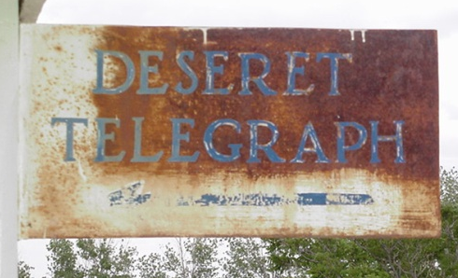

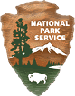
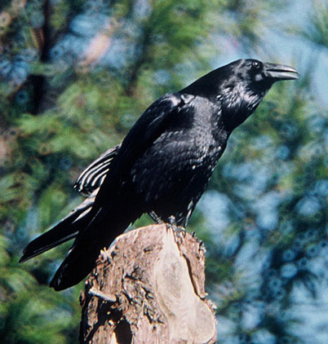
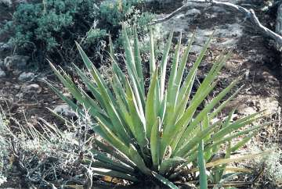

Do your best to answer as many questions as you can. If you need help ask a ranger, volunteer or maintenance person.

EXPLORE THE MUSEUM
Begin your quest by going into the museum using the ramp on the left. The BOLDED CAPITALIZED titles of each section tell you the title of the display with the information you need.

ROLE OF WATER
For centuries, the Kaibab Paiute Indians used the spring to water their gardens. What are three crops they grew here? _______________________, ____________________ and _________________

EVERYTHING SERVES A PURPOSE
To the Paiute Indians, yucca was more than just a desert plant. It was ______________,

____________________, ________________ and _______________.

Can you think of a part of any plant you use? ___________________________________

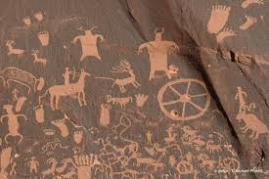
E’NENGWENG, DIORAMA PANEL
A petroglyph is a picture __________________ into stone.

A pictograph is a picture __________________on stone.

Does the picture on the panel show petroglyphs or pictographs? ___________________

Think of a symbol you could use to represent a spring.

Draw it here

Kaibab Lifeways DISPLAY CASE
Look at display the aoos’, #15. Burden baskets were used to carry belongings when the people moved camp. What do you use to carry your belongings with you to school or on vacation? ______________________________________________________________

BELIEFS
The Paiute Indians believed that when they were created they were given the right to use and the duty to ________________________ the lands and resources.

MORMON LIFE AT PIPE SPRING
The ranch produced food to feed the men and women working to build the Church of Jesus Christ Latter Day Saints Temple in St. George, Utah. Every day, the men and boys milked _______ to _______ cows so that the women and girls could make _______ pounds of _________________ and _______ pounds of ________________.

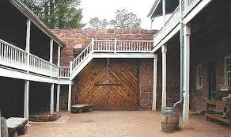
PIPE SPRING, The New Pipe Spring Ranch and Winsor Castle

What were some of the children’s jobs during the building of the fort?

_________________________________________________________________

Are any of your chores similar to theirs? ________________________________

Good job! Now it’s time to go outside.
Animal Tracks at Pipe Spring National Monument
Look for tracks as you explore the grounds, the dirt outside of the garden and corral are good places to look. Circle the animal tracks you see.
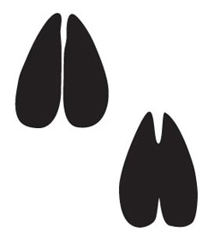
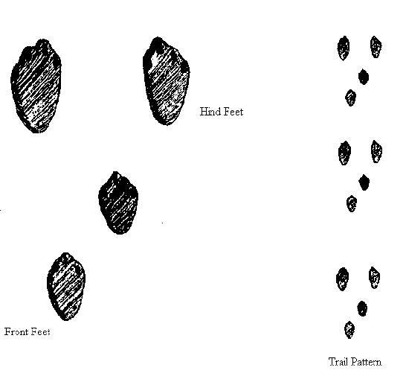
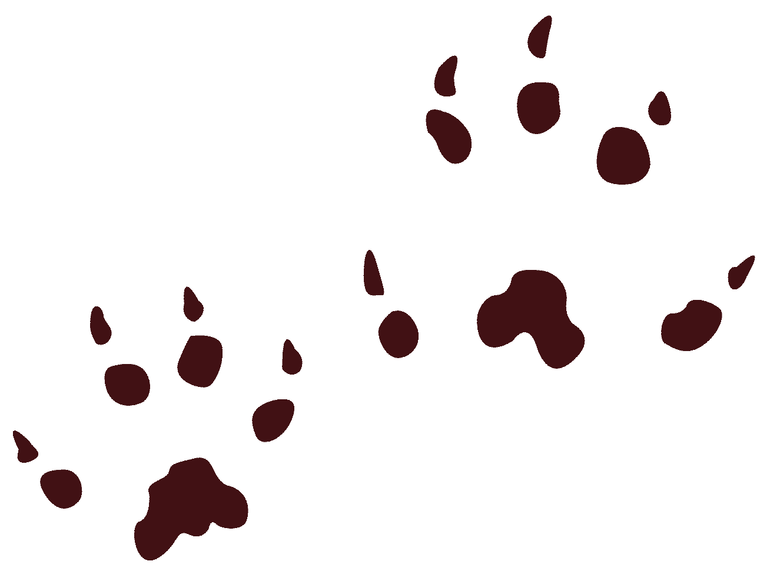
rabbit deer mouse

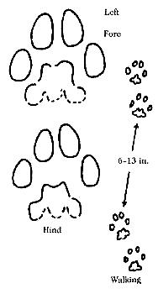
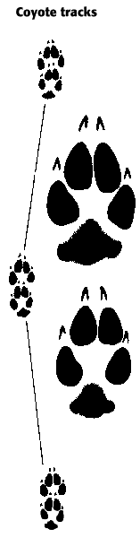
lizard

bobcat
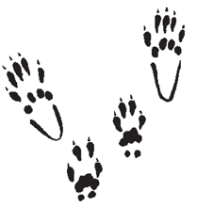
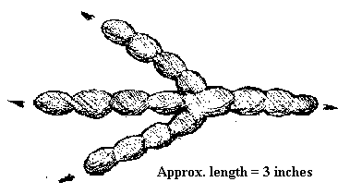
raven squirrel

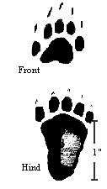
Draw any other tracks you see here. Which animal do you think left the tracks?
skunk

Pipe Spring Archaeology
During your visit at Pipe Spring National Monument, you might see broken pieces of old glass, rusted metal or broken pottery. These historic items are called artifacts and they help us learn about the people who lived here long ago. Please help us protect history by leaving the artifacts where you see them.
Circle the artifacts and put an X on the trash.
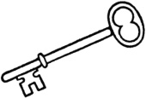
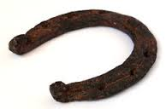
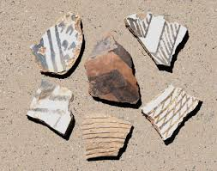

What is a difference between artifacts and trash? _______________________________

________________________________________________________________________

After you leave the visitor center, stop at the first exhibit on your left. Open the gate and go into the Native Grass Exhibit. This is an example of the vegetation that was here before the land was grazed by thousands of cows and sheep. Look at the vegetation inside the fenced area and then look outside the fence. What is different? ________________________________________________________________________

________________________________________________________________________
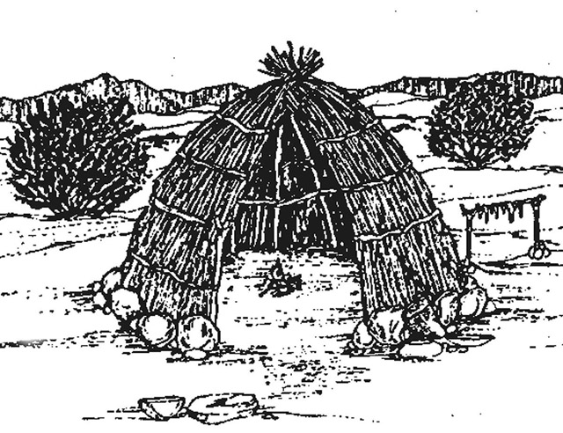
AT HOME IN THE DESERT, the next exhibit is on your right
As hunters and gatherers, the Paiute people walked many miles every year to gather food for their families. When they set up camp they constructed shelters called kahns.
What do you use that serves the same purpose as a kahn? _____________________

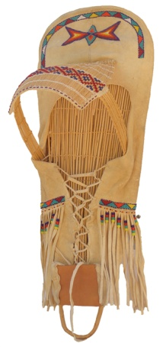
What do you think the Kaibab Paiute people used these items for?

________________ ___________________ __________________

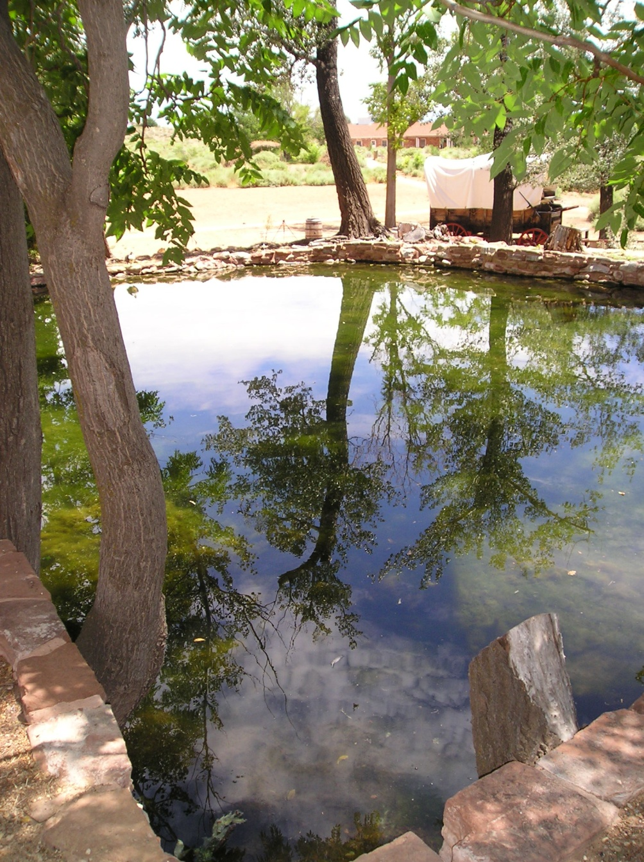
THE PONDS
During the 1870s, the spring poured about 50 gallons of water a minute into the ponds.
How many gallons would flow into the ponds in one hour? __________________
Today, the spring pours about five gallons of water a minute into the ponds.
How many gallons is that in one hour? _________________
Bonus question – What do you think caused the change in the flow of the spring? ________________________
______________________________
______________________________

WEST CABIN
Follow the path to the left, in front of the fort to the West Cabin. This building was used as a bunkhouse for the cowboys who worked here.
Notice the double fireplace in the center. Can you think of a benefit to this kind of fireplace? ______________________________________________________________

Look across the highway to the south. Do you see the big dome-shaped mountain in the distance? That’s Mt. Trumbull, an 8,000 ft. volcano, it is 50 miles away. Wagons from Pipe Spring delivered cheese and butter to the sawmill workers there who were cutting trees to use in the construction of the Temple in St. George.
How long do you think it took a wagon to get there? ___________________________

Imagine it is 1873 and you and your family are taking a wagonload of supplies to the sawmill workers on Mt. Trumbull. Circle the items you would take on your trip.
Draw you and your family in the wagon.

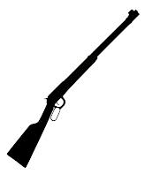
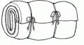
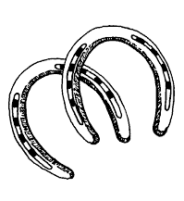
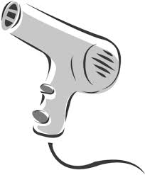
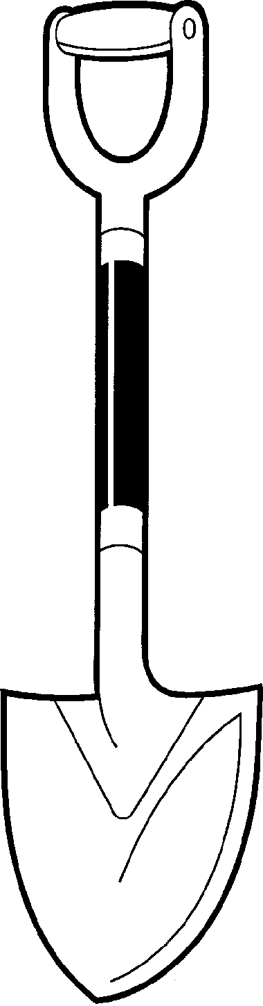
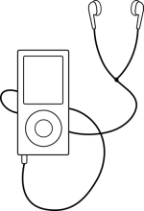

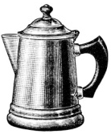
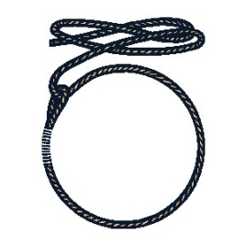

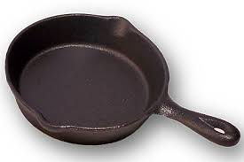

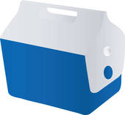
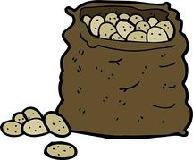

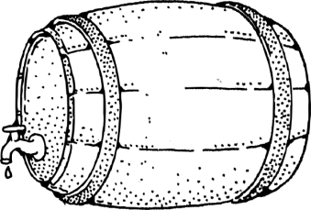

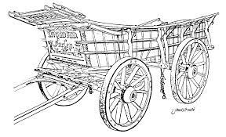

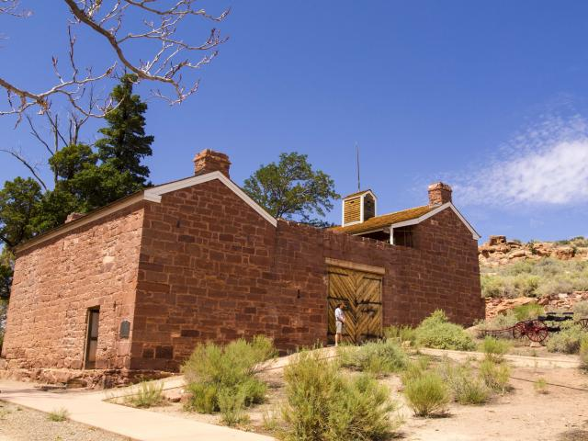
FORT TOUR (optional)

Kitchen
Do you see the unusual cups on the table? Why do you think they were made that way?
_______________________________________
_______________________________________

Children’s Bedroom
About 140 years ago, this was where the children slept. All the children shared one room!
Find an item that is similar to something in your bedroom.
________________________________________________________________________
Find something that is different. _____________________________________________

Telegraph Room
In 1871, the first telegraph station in Arizona Territory began operation at Pipe Spring.

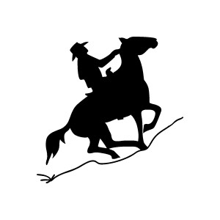
Chose the answer from the pictures then write or draw your answer in the blank.

Prior to 1871, it would take a week or two for the message to get to Salt Lake City. In those days messages were sent by _______________. After 1871, messages sent to Salt Lake City arrived within seconds using a _____________________.
Today, messages from Pipe Spring to Salt Lake City in less than a second, how do we send them? ____________________
Give two (or more) reasons you think Winsor Castle was built at this spot.
________________________________________________________________________________________________________________________________________________
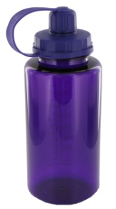
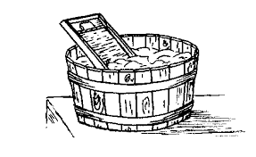
Match the past to the present.

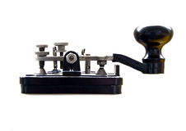

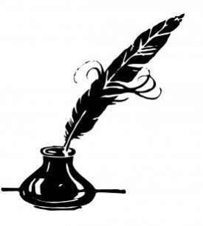
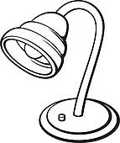

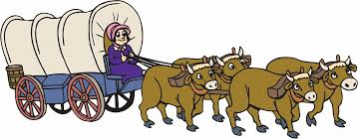

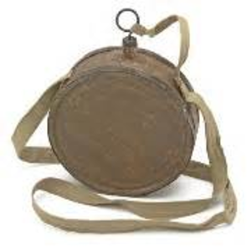

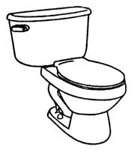
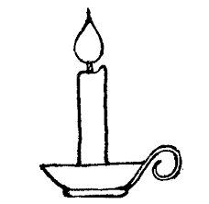

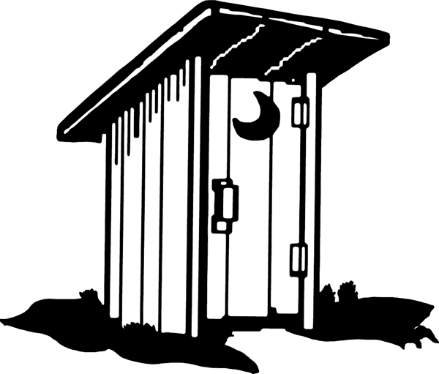

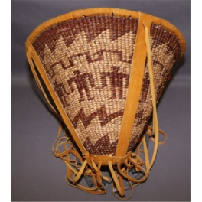

Try and learn these Paiute words. The pronunciations are in parentheses.
suui (sue’ ee)  one, 1 | wai (y)  two, 2 | pai (pie)  three, 3 | wachengwi-y  (watch choong we)  four, 4 | manex-y  (ma nooh’-he)  five, 5
navai (nuv’eye)  six, 6 | navaykaiva  (nuv’ aye, kuv’ah)  seven, 7 | waawachengwi  (wy watch’ choong wi)  eight, 8 | suwaroxomasengwi  (sue wat’ um, mus soong’wi)  nine, 9 | toxomasengwi  (toe’, whem’ mas suey)  ten, 10
angkaxa (ung ah’ hahd), red

angkaxaseak’ad
(ung ha’, sea ah-hahd’), orange

oakare (oh ahk’, ahd), yellow
saxwaxai (sah wah’hi), green
saxwaxar (sah wah’ hahd), blue
toxwaxar (tu wah’ hahd), purple
ontokar (ohn tok’ kwar’d), brown
tukura (tuk wah’d), black
tosaxar (tosaxar), white

Write the color in Paiute and try to pronounce it!
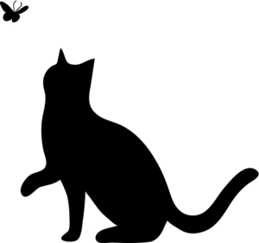

______________________________

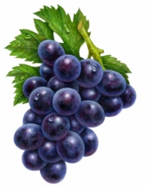

______________________________

______________________________

______________________________

_________________________________
Try your own!

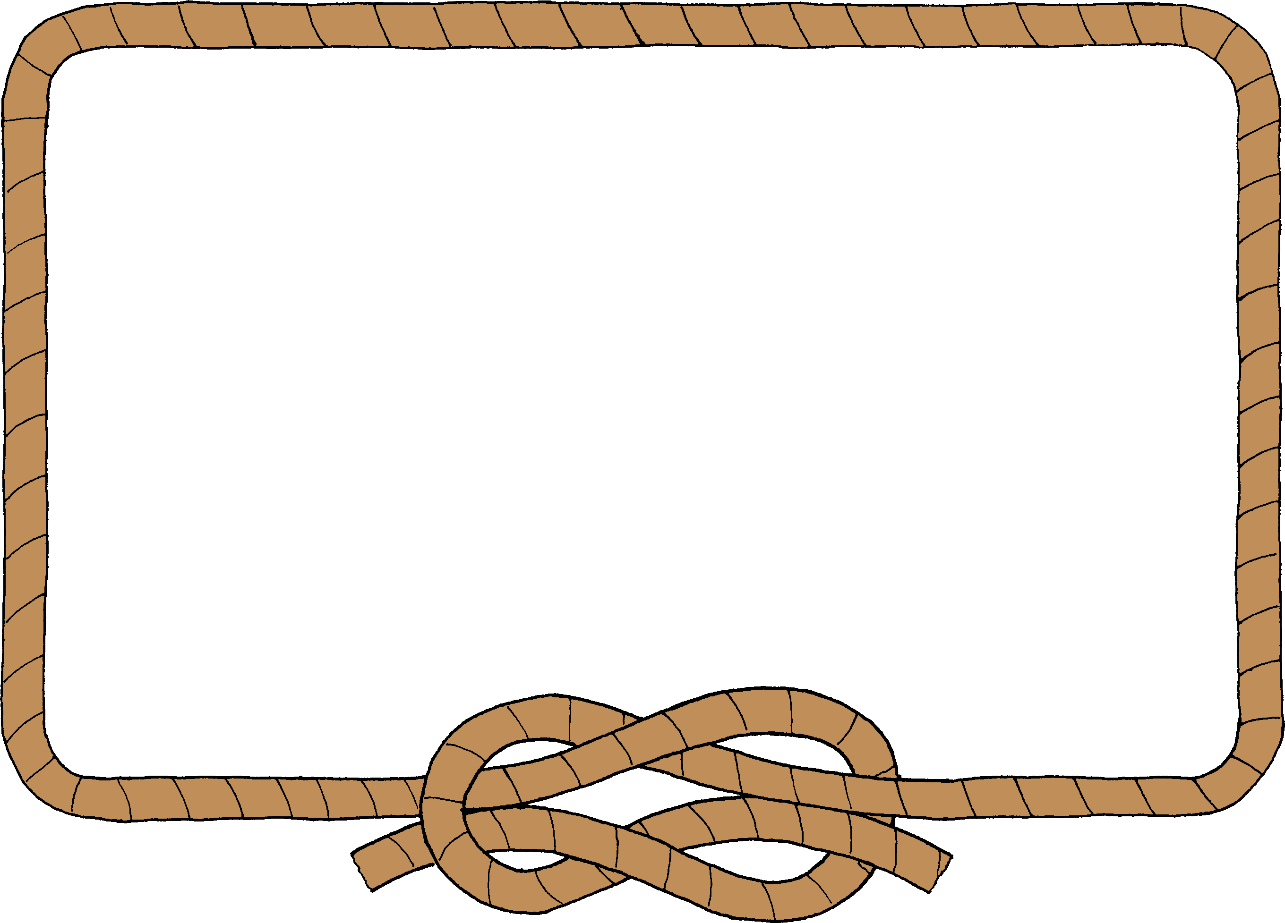

Junior Ranger Pledge
I am proud to be a Junior Ranger for Pipe Spring National Monument.

I promise to continue to learn about the plants, animals and history in my National Parks.

I promise I will proudly share what I learn with my family and friends.

______________________________________
Junior Ranger signature Park stamp

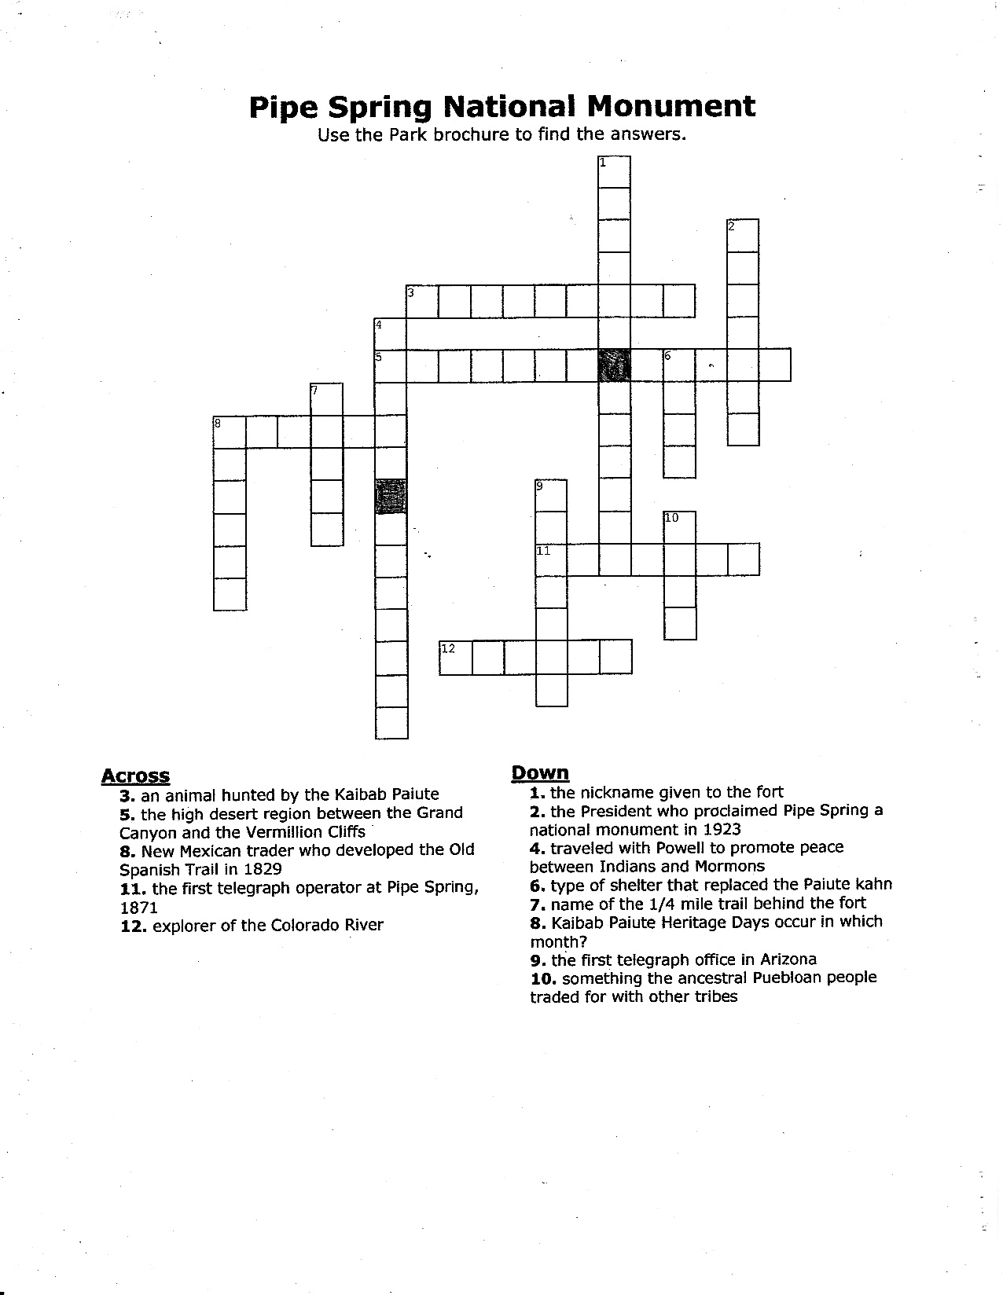
The next pages are for fun in the car.
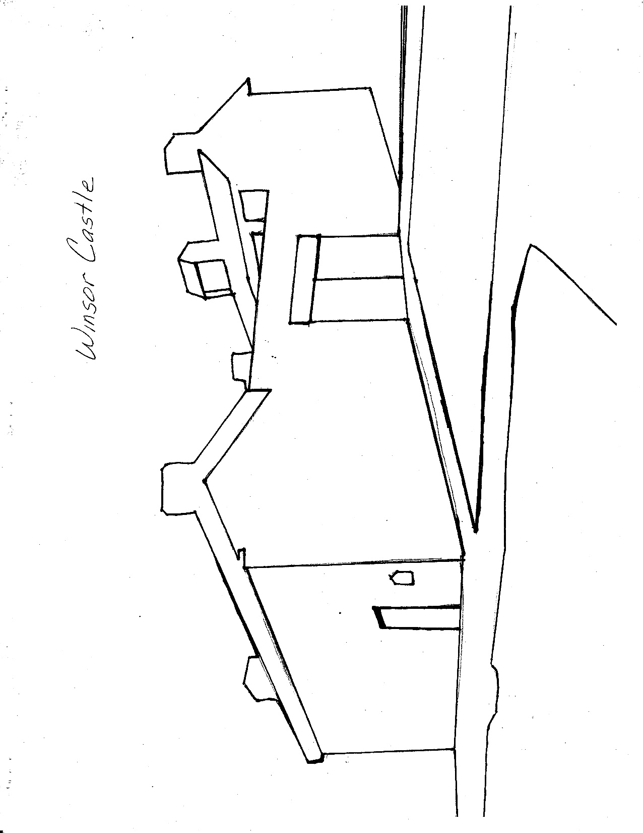
Color Winsor Castle.

