PINNACLES NATIONAL PARK -- AUTHORIZED GUIDE SERVICE ITINERARY
All Authorized Holders must provide an itinerary one week before date of arrival. The itinerary can be a scanned/e-mail, photo copy by US Mail or fax to:

Commercial Use Authorization Coordinator, Pinnacles National Park, 5000 Highway 146, Paicines, CA 95043-9770 Email: Bea_Lujan@nps.gov Office: (831) 389-4427, ext. 4485 FAX (831) 389-4288

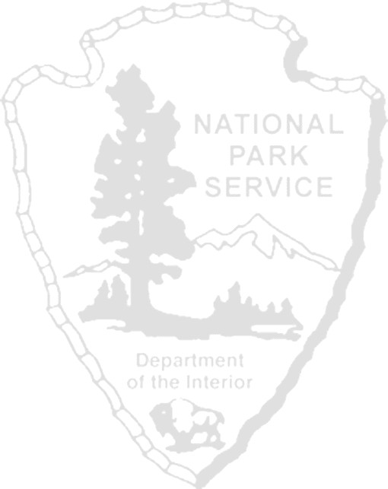
Date of Arrival _________________ Date of Departure: _____________________ Entrance to be used (circle): EAST or WEST

Authorization Holder Name: _____________________________________________________________________________________ Authorized Activity:  Guided Climbing Guided Hiking  Other (specify): __________________________________
Camping at Pinnacles Campground (circle)? YES or NO Camp Site Numbers: _____________________________________
Trip Leaders are required to have a copy of their First Aid and CPR qualifications on file with the CUA Coordinator. If not on file, attach copy to this itinerary.
Name of Trip Leader(s): _________________________________________________________________________________________ Visitor Use Acknowledgement of Risk (Pinnacles template) provided to clients? (circle) YES NO
In case of emergency during the period of this itinerary at Pinnacles, contact:
Name: _________________________________________________________________________________________________ Phone: _________________________________________________________________________________________________
Office Cell Home
Name: __________________________________________________________________________________________________ Phone: __________________________________________________________________________________________________
Office Cell Home

REQUIRED CUA VEHICLE INFORMATION:
Number of Vehicles: ______________ License plate numbers and description (color/make) of all vehicles (list below):
DATES/TIME | LOCATION (TRAILS, CLIMBING ROUTES, ETC.) | # OF GUIDES # OF CLIENTS
PARK USE ONLY BELOW: Copy forwarded to Law Enforcement Office
Reviewed by Permit Coordinator: Signature ________________________________ Date ____________________________________
PINN-152 (Revised 02/2017)

