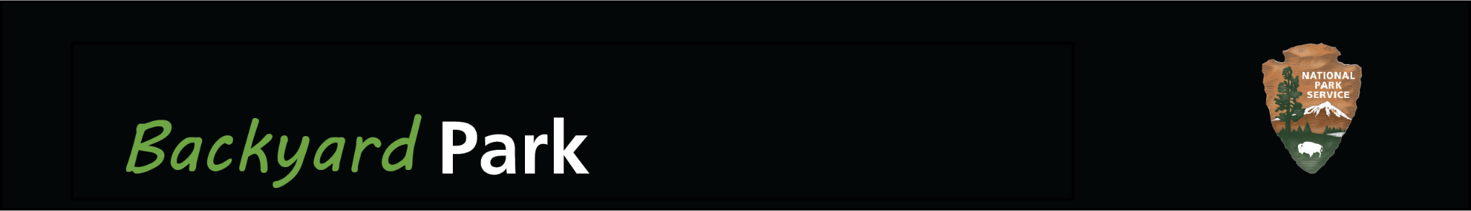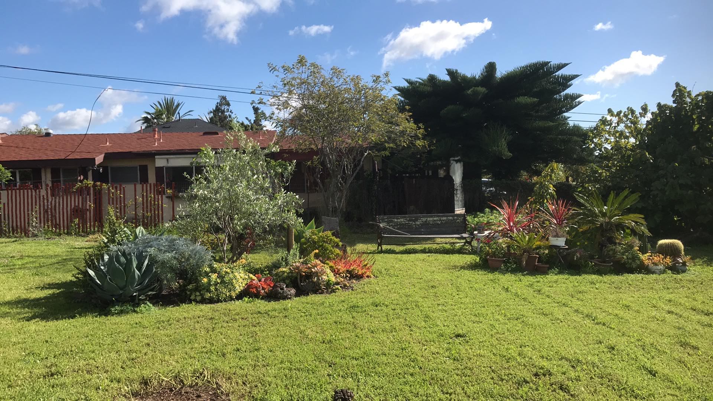

***[insert your park name here]***

***Insert your own photograph or drawing of YOUR backyard, house, or neighborhood!***

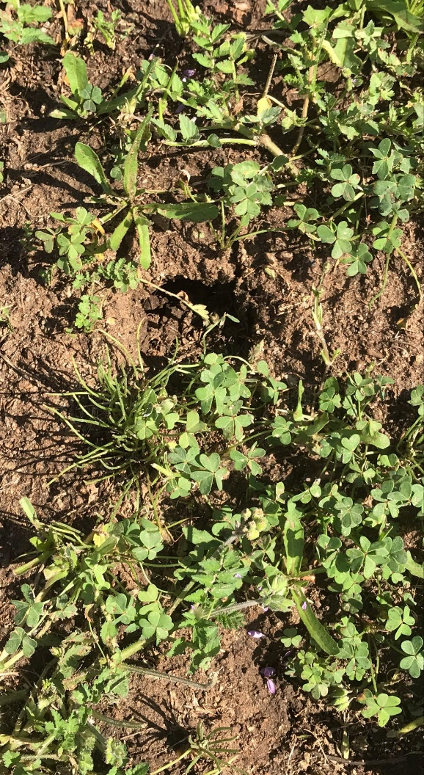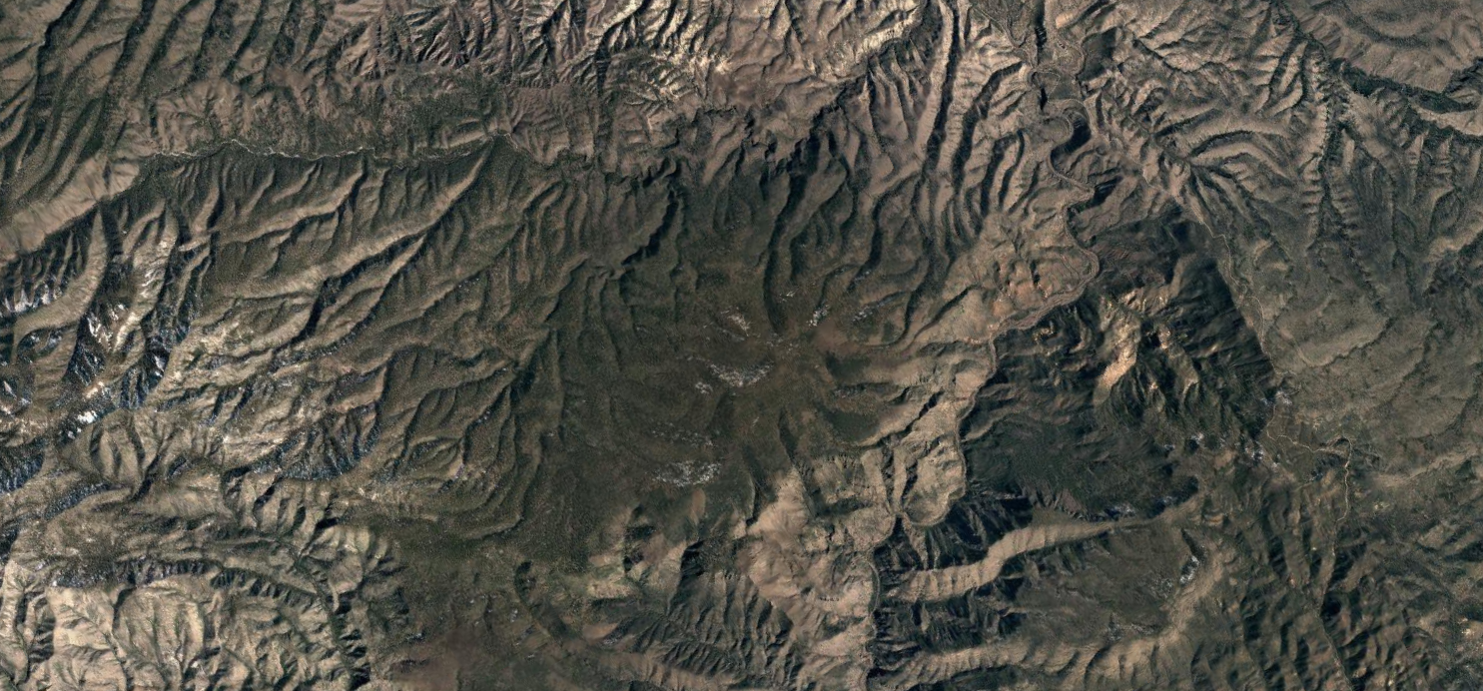

*Even if you can’t get out to our National Parks, imagine that your own backyard, house, or neighborhood was your very own NATIONAL PARK. What would “visitors” find there? Use this template to make a park brochure.*

**Welcome to *[insert park name]* Backyard Park! *[Write about what makes your “park” special. What sights, smells, and sounds can “visitors” expect upon arrival?]***

**Plan Your Visit**

Before exploring the park, make sure to visit our *[visitor center, info kiosk, kitchen table?]* to find information, *[videos, ranger presentations, a well-stocked fridge? What else?].*

**Walking and Hiking Trails**

***[Insert trail name]*** *(mileage)*

*Trail description (What can you see on this trail? Is this a strenuous or easy trail?)*

**Example: Gopher Hole Hill**  (0.01 mile roundtrip). This easy jaunt takes you past a heavily gopher -infested hill by our garage. Wear good footwear and take care not to trip on the gopher holes! Good birding along this trail.

***Insert your own***

***photo here!***

**[Catchy Tagline for your park…]**

**Camping**

*[Does your park offer camping? What are the campgrounds called? Are they tent sites or RV sites? What amenities do they have…flushable toilets? Drinking water? Fire pits?]*

**Rules and Regulations**

*In order to preserve the natural, historical and cultural resources of your park, what rules and regulations do visitors need to follow? How will you make sure people follow* ***‘Leave No Trace’*** *principles in your park?*

**Navigating the Park**

*After printing this out, draw a map of your park! Show roads, trails, bathrooms, and anything else you find important. You can also create a map and then insert it as a picture into this word document.*



***[insert your park name here]***

**An Abundance of Wildlife! *[Or other fun phrase describing the wildlife in your park]***

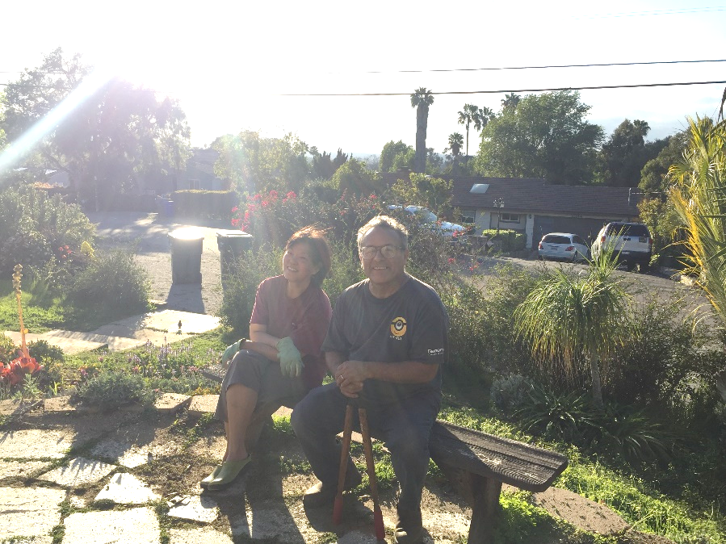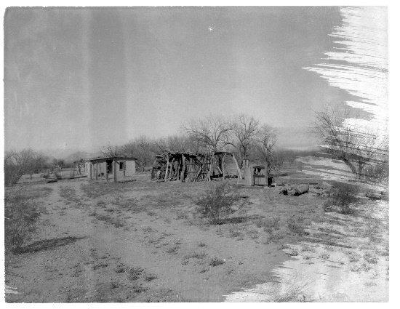

*Put a picture of the “founders” or people that are important to your park!*

*[How was your park founded? When did you or others start living on/near the property…who were the owners before that? Who lives there now and how do they use the space? Feel free to write about your park’s history or make up your own founding story!]*

**History of the Park**

***[Insert animal name]***

*What are some things you could write about?*

* *Places to commonly see this animal in your park*
* *The animal’s diet*
* *What does this animal look like?*
* *What sounds does this animal make?*
* *Other fun facts about the animal*

**Northern Cardinal**

This bird is a common visitor to the outdoor feeders around the park’s backyard porch. The males are bright red, while the females are a more subdued, brown color with very little red. The red pigment in their feathers come from carotenoids in their foods.

**Unidentified Brown Bathroom Spider**

This fun fellow inhabits the dark crevices behind the toilet and sink. This spider subsists off weird bits of lint and hair, but it is beneficial to the bathroom ecosystem because it also feeds upon many of the invasive house insects.

***Pro tip: to insert a photo into the circle frame, go to ‘Shape Format,’ ‘Shape Fill,’ click ‘Picture,’ and ‘insert picture.’***

Our park in the year [*insert year*]!